Machine Learning
Davronbek Malikov

2-dars: Ml turlari va tadbiqlari
Qo’lingizdagi material Machine learning turlari va tadbiqlari mavzusini mustahkamlash uchun qo’shimcha malumotlar va savol-javoblardan iborat.
Table 1: Ml model yaratishdan oldin qilinishi/bilishimiz kerak bo’lgan asosiy ishlar

Savol | Izohlar
Muammo nima? | Muammoni hal qilish uchun zarur ma’lumotlar(data) yig’ilishi  kerak. Masalan, uy narxini predict qilish. Farazlar: muammo bo’yicha asosiy farazlarni ro’yxatini tuzish(manzil,qavat,xonalar  soni, xonalar xajmi).
Nima uchun muammo hal qilinishi  kerak? | Muammoni hal qilishning motivatsiyasi va qanday ehtiyojni  qondirishi. Masalan, biznesdagi muammolarni hal qilish yoki  firibgarlikni aniqlash.
Muammoni qanday hal qilish mumkin? | Muammoni qo’lda qanday hal qilish mumkinligini o’rganish.  Ma’lumot yig’ish, tayyorlash va dasturni loyihalash jarayonlarini  bosqichma-bosqich rejalashtirish.
Yechimning foydalari | Muammoni hal qilish qanday imkoniyatlarni yaratadi va qanday  foyda keltiradi.
Yechimdan foydalanish | Yechimdan qanday foydalaniladi va uning umri qancha bo’ladi?

Bo’lim bo’yicha savollar:
- 1-savol: Jadvaldagi muammo nima qatoridagi uy narxini predict qilish misoliga o’xshash 2 ta misol toping va misoldagidek kerakli farazlar(feature) ro’yhatini tuzing

Question | Description
What is the problem( lets imagine, I am the head of some kind of country which has depopulation issues) | By current information on abutolibs land, the population are decreasing for couple of years in a row. our goal is to find possible solutions. Main features for that case: population’s number divided by years(2024,2025,2026), inflation index, the number of child for one family, population life-style
Why solutions for resolvent of this problem are so important | My ambitions are clear, prevent potential extension of our species in abutolibs land
What are potential solutions for this problem | Preventing and helping out social and financial sides of population’s life( funding financially, helping to organize and live their live better, in other words create comfortable environment)
Positive sides of the solution | This potential solution is efficient and universal.
Use of solution | This is governmental help to reorganize people’s way of life, encourage them to live better. This is not ideal solution but it can help at early period of implementation, then better future solution are going to be implemented

Depopulation Problem: Overview
№ | Question | Description
1 | What is the problem?  (Imagine I am the head of a country facing depopulation.) | According to current data, the population of Abutolib's land has been declining for several years in a row.  Key indicators to track:  - Population size by year (2024, 2025, 2026)  - Inflation index  - Average number of children per family  - Population lifestyle
2 | Why is solving this problem important? | The goal is clear: to prevent the potential extinction of our species in Abutolib's land.
3 | What are the potential solutions? | Support the social and financial side of people's lives: financial assistance (funding), help with organizing daily life, and creating a comfortable environment to live in.
4 | Positive sides of the solution | The solution is efficient and universal.
5 | How will the solution be used? | Through government support that helps people reorganize their way of life and encourages them to live better. The solution is not ideal, but it can help in the early stage of implementation, and improved solutions can follow later.
This is made only for more clear and beautiful design

Question | Description
Lack of sensual contact in future applications | the idea is to make applications- games more futuristic and make it feel more real. This need to more future implementation but if we reach this goal, future products and games going to explode social medias and also it could give user more real senses when character touches grass or object
Reasons for implementation | Nowadays most of the applications are based on 2d/3d worlds where interactions with environment and characters can be numerous though its limited. Deepness of interactions lacks in most ways, that is why implementation of technology could be next step of the future entertainment system
What are potential realization points for this problem | currently we have sensual suits, which are designed for shooters. Users are mainly feel a little electric spark at shooting areas, that’s how they feel any injuries, but with the implementation of this technology any other
Positive sides of the implementation | There are many positive sides, one of them is evolution of future applications, possibility for more tactile and sensual fillings in applications, which can also bring companies more profit
Use of implementation | Mainly this helps to feel deepness of interactions with environment that surrounds character and also this might be next step of vr based applications of movies  Some people are already trying to implement it but there are some difficulties with wires and sensors of the suit, there are some options that are ready for purchase now but sensors are not implemented good enough
Sensory Feedback in Future Applications
№ | Question | Description
1 | Lack of sensory (tactile) contact in future applications | The idea is to make applications and games more futuristic and make them feel more real. This needs further implementation, but if we reach this goal, future products and games could explode on social media, and it could also give users more realistic sensations when a character touches grass or an object.
2 | Reasons for implementation | Nowadays most applications are based on 2D/3D worlds where interactions with the environment and characters can be numerous, though they are limited. Depth of interaction is lacking in most ways, which is why implementing this technology could be the next step of the future entertainment system.
3 | What are the potential realization points for this problem? | Currently we have sensory suits designed for shooters. Users mainly feel a small electric spark in the shooting area, which is how they feel any injuries, but with the implementation of this technology, any other …
4 | Positive sides of the implementation | There are many positive sides: the evolution of future applications, the possibility of more tactile and sensory feelings in applications, which can also bring companies more profit.
5 | How will the implementation be used? | Mainly this helps users feel the depth of interactions with the environment that surrounds the character, and this might be the next step for VR-based applications and movies.  Some people are already trying to implement it, but there are difficulties with the wires and sensors of the suit; there are some options …

- 2-savol: 1- savolda tuzilgan 2 ta misol uchun muammoni yechishdan maqsadni yozing

Lets begin with the potential implementation of the sensor suits. Main goal is to reach new level of technology that can bring more profit and also create new senses form entertainment facilities. It is win-win case for both companies and customers.

To be more specifically target for first example(depopulation problem ) is reaching roots of the problem and help people to live better in order to create enjoyable environment as much as possible that can at least make people more happies thus increase country’s population.

Ml turlari
Mlning asosan 3 xil turi mavjud: Supervised, Unsupervised, Reinforcement. Quyidagi jadvalda yuqorida sanab o’tilganlarga qoshimcha ravishda Ml turlari xaqida malumotlar berilgan.

Supervised Ml
Nazoratli o’rganish - bu o’rganish jarayoni, bunda model kiritilgan ma’lumotlar (input) bilan birga belgilangan chiqish ma’lumotlaridan (output) foydalanadi. Model yangi ma’lumotlar uchun xulosa

Table 2: Mashina O’rganish Turlari, Ularning Tavsifi va Misollari

Tur | Tavsifi | Misollar
Supervised  Learning | O’rganish jarayoni belgilangan  ma’lumotlardan (kiritish va chiqish) foydalanadi, bunda model yangi ma’lumotlar uchun  xulosa qiladi. | - O’quvchilarni yuqori baho  olish/olmasligini bashorat qilish.  - Elektron tijoratda mahsulot narxini bashorat/predict qilish
Unsupervised  Learning | O’rganish jarayoni belgilangan  chiqish ma’lumotlarisiz ma’lumotlar to’plamini o’rganadi va ma’lumotlarni  qidiradi yoki guruhlaydi. | - Mijozlarni guruhlarga ajratish.  - Malumotni tavfsiya qilish.
Reinforcement  Learning | Agent o’z atrofidagi muhit bilan  o’zaro aloqada bo’lib, harakatlari uchun mukofotlar yoki jazolar  orqali o’rganadi. | - O’yinlarda agentlarning  strategiyalari.  - Avtonom haydovchi  mashinalar.
Semi-Supervised  Learning | Bu yondashuv yarim nazoratli  ma’lumotlardan foydalanadi, ya’ni, kiritish ma’lumotlarining bir qismi belgilangan, boshqasi  esa belgilangan emas. | - Tasvirlarni tanib olish, bunda  ba’zi rasmlar belgilangan.
Self-Supervised  Learning | Model o’z-o’zini nazorat qilish  orqali ma’lumotlar ustida o’rganadi, ya’ni u o’ziga o’zi  ma’lumotlarni belgilaydi. | - Tabiy tilni qayta ishlashda  foydalaniladigan til modellarini o’qitish.

chiqarish va bashorat qilish uchun bu ma’lumotlardan o’rganadi. Masalan, o’quvchilar baholarini bashorat qilish yoki elektron tijoratda mahsulot tavsiyalarini berish. Quyidagi jadvalda Supervised Ml yordamida uy narxini predict(bashorat) qilish uchun malumotlar jadvali berilgan.
Table 3: Uy narxini predict qilish uchun dataset

Maydon  (kv.ft) | Yotoqxona | Hammom | Qavatlar | Uy narxi (so’m)
7420 | 4 | 2 | 3 | 13,300,000
8960 | 4 | 4 | 4 | 12,250,000
9960 | 3 | 2 | 2 | 12,250,000
7500 | 4 | 2 | 2 | 12,215,000

Unsupervised Ml
Unsupervised Learning (Nazorat qilinmaydigan O’rganish) Nazorat qilinmaydigan o’rganish - bu o’rganish jarayoni, bunda model belgilangan chiqish ma’lumotlarisiz ma’lumotlar to’plamini o’rganadi va ichki tuzilmalarni qidiradi. Bu turdagi o’rganishda ma’lumotlar o’zaro bog’liqliklariga ko’ra guruhlanadi. Masalan, mijoz segmentatsiyasini amalga oshirish yoki shaxsiylashtirilgan kontent tavsiyalarini berish. Quyidagi jadvalda Unsupervised Ml yordamida mijozlar guruhini shakllantirish uchun malumotlar jadvali berilgan

Table 4: Mijozlar segmentatsiyasi ma’lumotlari

Yosh | Yillik daromad ($) | Sarf qilish qobiliyati balandligi (1-100) | Xarid qilish muddati (oyiga)
25 | 40,000 | 70 | 12
35 | 75,000 | 45 | 8
22 | 30,000 | 80 | 15
45 | 90,000 | 30 | 6
28 | 50,000 | 65 | 10

Reinforcement Ml(Mustahkamlovchi o’rganish)
Mustahkamlovchi o’rganish - bu agent o’z atrofidagi muhit bilan o’zaro aloqada bo’lib, harakatlari uchun mukofotlar yoki jazolar orqali o’rganadi. Agent o’z harakatlarini takomillashtirish va maksimal mukofotga erishish uchun tajriba orttiradi. Masalan, o’yinlarda agentlarning strategiyalarini o’rganishi yoki avtonom haydovchi mashinalarni boshqarishi. Quyidagi jadvalda Reinforcement Ml robot xarakatini nazorat qilish uchun malumotlar berilgan
Table 5: Kuchaytirish o’rganish misol jadvali

Holat | Harakat | Keyingi Holat | Mukofot
(0, 0) | O’ng | (0, 1) | -1
(0, 0) | Past | (1, 0) | 10
(0, 1) | O’ng | (0, 2) | -1
(0, 1) | Chap | (0, 0) | -1
(0, 2) | Past | (1, 2) | -1

Mavzuga doir savollar
- 1-savol: Supervised Ml ga oid 2 ta misol toping va o’zingiz misollardan berilganidek jadval to’ldiring
Ok, lets begin with SML, its based on input and output data and main function of SML is to make new predict information that based on input, output information or like wisely create new result based on given data.
Example 1>>> lets assume that person want to save up some money to their retirement or some kind of big purchase: purchasing apartment, car, life-expenses. We want to predict how much money he will totally save up till his retirement if he starts now and save specific number of money every month, and also lets say if he want to save more or less money the differentiate range are 5-10%. At the end total amount of save money will be represented as result in order to see process of complex percentages and saved up total money.

1. Assumptions
Input | Value
Base monthly saving | $500
Years until retirement | 30 years (360 months)
Expected annual return | 6.0% (compounded monthly)
Scenarios compared | −10%, −5%, Base, +5%, +10% of monthly saving

2. Result: final amount by scenario
Scenario | Monthly saving | Total deposited | Interest earned | Final amount | vs. Base
−10% | $450 | $162,000 | $290,032 | $452,032 | −$50,226
−5% | $475 | $171,000 | $306,145 | $477,145 | −$25,113
Base | $500 | $180,000 | $322,258 | $502,258 | —
+5% | $525 | $189,000 | $338,370 | $527,370 | +$25,113
+10% | $550 | $198,000 | $354,483 | $552,483 | +$50,226

Reading the table: the +10% row shows that saving only $50 more per month adds $50,226 by retirement, because the extra deposits also earn compound interest.

3. Year-by-year growth (how the total builds up)
Year | −10% ($450/mo) | −5% ($475/mo) | Base ($500/mo) | +5% ($525/mo) | +10% ($550/mo)
Year 1 | $5,551 | $5,859 | $6,168 | $6,476 | $6,785
Year 2 | $11,444 | $12,080 | $12,716 | $13,352 | $13,988
Year 3 | $17,701 | $18,685 | $19,668 | $20,651 | $21,635
Year 4 | $24,344 | $25,696 | $27,049 | $28,401 | $29,754
Year 5 | $31,397 | $33,141 | $34,885 | $36,629 | $38,374
Year 6 | $38,884 | $41,044 | $43,204 | $45,365 | $47,525
Year 7 | $46,833 | $49,435 | $52,037 | $54,639 | $57,241
Year 8 | $55,273 | $58,344 | $61,414 | $64,485 | $67,556
Year 9 | $64,233 | $67,801 | $71,370 | $74,938 | $78,507
Year 10 | $73,746 | $77,843 | $81,940 | $86,037 | $90,134
Year 11 | $83,845 | $88,503 | $93,161 | $97,819 | $102,477
Year 12 | $94,568 | $99,821 | $105,075 | $110,329 | $115,583
Year 13 | $105,951 | $111,837 | $117,724 | $123,610 | $129,496
Year 14 | $118,037 | $124,595 | $131,152 | $137,710 | $144,268
Year 15 | $130,868 | $138,139 | $145,409 | $152,680 | $159,950
Year 16 | $144,491 | $152,518 | $160,546 | $168,573 | $176,600
Year 17 | $158,954 | $167,785 | $176,616 | $185,446 | $194,277
Year 18 | $174,309 | $183,993 | $193,677 | $203,360 | $213,044
Year 19 | $190,611 | $201,200 | $211,790 | $222,379 | $232,969
Year 20 | $207,918 | $219,469 | $231,020 | $242,571 | $254,122
Year 21 | $226,293 | $238,865 | $251,437 | $264,009 | $276,581
Year 22 | $245,802 | $259,457 | $273,113 | $286,769 | $300,424
Year 23 | $266,513 | $281,319 | $296,126 | $310,932 | $325,738
Year 24 | $288,502 | $304,530 | $320,558 | $336,586 | $352,614
Year 25 | $311,847 | $329,172 | $346,497 | $363,822 | $381,147
Year 26 | $336,632 | $355,334 | $374,036 | $392,738 | $411,440
Year 27 | $362,946 | $383,110 | $403,273 | $423,437 | $443,601
Year 28 | $390,883 | $412,599 | $434,314 | $456,030 | $477,746
Year 29 | $420,543 | $443,906 | $467,270 | $490,633 | $513,997
Year 30 | $452,032 | $477,145 | $502,258 | $527,370 | $552,483

4. Formula used
Final amount = P × [ ((1 + r)^n − 1) / r ]
P = monthly saving, r = annual return ÷ 12, n = total number of months.
Interest earned = Final amount − Total deposited. Returns are assumed constant; real markets fluctuate, and inflation is not subtracted, so treat the numbers as an estimate.

Example 2>>> good example of SML process can be also represented by weather example. Main factor for prediction of the estimate weather condition are previous examples of weather condition, their features like: humidity, air pollution, UV-index, wind condition and etc. algorithm function will enter input information and search up similar output data with algorithm adjust Mance to make accurate and clear prediction.
Supervised Machine Learning: Weather Prediction Example
Supervised learning = learning from past examples where the correct answer is already known, then using those patterns to predict a new, unseen case.
1. The learning process, step by step
# | SML step | What the algorithm does | Weather example
1 | Collect past data | Gathers many past examples where both the conditions and the outcome are known. | Records of past days: humidity, air pollution, UV index, wind speed, and what the weather actually was.
2 | Define features and label | Features (inputs) describe the situation; the label (output) is the answer to learn. | Features: humidity, AQI, UV index, wind. Label: Sunny / Cloudy / Rainy.
3 | Train the model | Looks for patterns that connect feature values to labels. | High humidity + strong wind + low UV usually meant Rainy; low humidity + high UV meant Sunny.
4 | Compare with real outcome | Predicts on known days and measures the error against the true label. | Model says Cloudy, actual was Rainy → counted as a mistake.
5 | Adjust parameters | Changes its settings (feature weights, number of neighbours) to reduce errors, then repeats 3–4. | Gives humidity more importance and ignores air pollution; accuracy rises round by round (see section 3).
6 | Predict new data | Takes new input, finds the most similar past examples and returns their outcome. | Today's readings are matched to the most similar past days → forecast.
2. Training data: past weather examples
Each row is one past day. The first four columns are the features (input); the last column is the known outcome (label).
Day | Humidity (%) | Air pollution (AQI) | UV index | Wind (km/h) | Weather (label)
D1 | 85 | 30 | 2 | 20 | Rainy
D2 | 90 | 25 | 1 | 25 | Rainy
D3 | 80 | 40 | 3 | 18 | Rainy
D4 | 88 | 28 | 2 | 30 | Rainy
D5 | 55 | 40 | 3 | 22 | Rainy
D6 | 40 | 60 | 8 | 8 | Sunny
D7 | 35 | 70 | 9 | 6 | Sunny
D8 | 45 | 55 | 7 | 10 | Sunny
D9 | 30 | 80 | 10 | 5 | Sunny
D10 | 60 | 50 | 5 | 12 | Cloudy
D11 | 65 | 45 | 4 | 14 | Cloudy
D12 | 70 | 35 | 4 | 16 | Cloudy
D13 | 62 | 52 | 5 | 11 | Cloudy
D14 | 75 | 65 | 6 | 9 | Cloudy
3. Adjusting the algorithm to improve accuracy
The model is tested on the past days: each day is hidden in turn and predicted from the others (leave-one-out test). Parameters are changed round by round and the best-scoring setting is kept.
Round | Setting tried | Correct predictions | Accuracy
Round 1 | Equal weights for all features (1, 1, 1, 1), k = 3 | 11 / 14 | 79%
Round 2 | Humidity ×2 | 12 / 14 | 86%
Round 3 | Humidity ×2, pollution ×0.5 | 12 / 14 | 86%
Round 4 | Humidity ×2, pollution ignored, wind ×0.5 (final) | 13 / 14 | 93%
4. Predicting a new day with the tuned model
New input: humidity 78%, AQI 38, UV index 3, wind 19 km/h. Using the tuned settings from section 3 (humidity counts double, pollution is ignored), the algorithm scales all features to the same range, measures how close each past day is to this input, and takes the 3 most similar days (k = 3 nearest neighbours).
Rank | Similar past day (humidity, AQI, UV, wind) | Distance (smaller = more similar) | Weather
Nearest #1 | D3 (80, 40, 3, 18) | 0.055 | Rainy
Nearest #2 | D1 (85, 30, 2, 20) | 0.201 | Rainy
Nearest #3 | D12 (70, 35, 4, 16) | 0.235 | Cloudy
Vote | 2 of 3 neighbors agree |  | Rainy

Predicted weather: Rainy

- 2-savol: Unsupervised Ml ga oid 2 ta misol toping va o’zingiz misollardan berilganidek jadval to’ldiring
Unsupervised ML is mainly used for structuring information in my point of view cause it mission not to create any new process or information.
It is perfect for making groups and making sections of related information. So lets start with simple example

Example 1>>> right now we in class which consist of students with wide range of categories, smart students, lazy student, student who don’t want to study and etc. we need to categories them into section in order to see who are trying to study and who are not by their attendance status and gpa grades according their results. Lets assume that we have 10 students

Student Classification by Attendance and GPA
Goal: see who is trying to study and who is not, using two measurable results: attendance and GPA. Example class of 10 students (invented data).
1. Classification rules
Each student is placed in one of four groups, depending on whether attendance is at least 80% and whether GPA is at least 3.0 (4.0 scale). These thresholds are assumptions and can be changed.
 | Attendance ≥ 80% | Attendance < 80%
GPA ≥ 3.0 | Top performer | Capable but disengaged
GPA < 3.0 | Hardworking, needs support | At risk
2. Class data and result
Student | Attendance (%) | GPA (4.0) | Category | Group
Student 1 | 96% | 3.9 | Top performer | A
Student 2 | 92% | 3.6 | Top performer | A
Student 3 | 90% | 2.4 | Hardworking, needs support | B
Student 4 | 85% | 2.7 | Hardworking, needs support | B
Student 5 | 82% | 3.1 | Top performer | A
Student 6 | 65% | 3.5 | Capable but disengaged | C
Student 7 | 70% | 3.2 | Capable but disengaged | C
Student 8 | 55% | 2.1 | At risk | D
Student 9 | 40% | 1.6 | At risk | D
Student 10 | 60% | 2.8 | At risk | D
3. Summary by group
Category | Count | Students | Avg attendance / GPA | Recommended action
Top performer | 3 | S1, S2, S5 | 90% / 3.53 | Offer advanced tasks, peer-mentoring roles
Hardworking, needs support | 2 | S3, S4 | 88% / 2.55 | Extra tutoring, review study methods
Capable but disengaged | 2 | S6, S7 | 68% / 3.35 | Talk about motivation, add challenge
At risk | 3 | S8, S9, S10 | 52% / 2.17 | Early intervention, meet with advisor

Example 2>>> also this maybe not most famous example but if we think about dataset and table where all customers information aren’t categorized can be easily done by UML case only what it need is the information which basically means input information, then algorithm works with information and turn them into structured information.
Unsupervised Machine Learning: Customer Data Example
Unsupervised learning = the algorithm receives information only (no categories, no correct answers) and finds structure by itself.
1. Input: uncategorized customer information
Customer | Age | Spending per month ($) | Store visits per month
C1 | 23 | 45 | 12
C2 | 26 | 60 | 10
C3 | 41 | 320 | 4
C4 | 58 | 70 | 2
C5 | 21 | 38 | 14
C6 | 45 | 280 | 5
C7 | 63 | 55 | 1
C8 | 38 | 350 | 6
C9 | 29 | 290 | 5
C10 | 55 | 90 | 2
2. How the algorithm works
# | Step | What the algorithm does | Customer example
1 | Receive unlabeled input | Takes raw data with no categories and no 'right answers'. | Table 1: age, spending, visits only.
2 | Measure similarity | Scales the features and calculates how close customers are to each other. | C1 and C5 are close: young, low spending, many visits.
3 | Group similar records | Forms clusters so that members are alike and clusters differ (k-means, k = 3). | Three groups emerge from the numbers alone.
4 | Output structured data | Adds a cluster number to every record. | Table 2: each customer now has a segment.
5 | Human interprets | People read each group's averages and give it a meaningful name. | 'Big spenders', 'Frequent small buyers', etc.
3. Output: structured information
Customer | Age | Spend ($) | Visits | Cluster | Segment (named by humans)
C1 | 23 | 45 | 12 | Cluster 2 | Frequent small buyers
C2 | 26 | 60 | 10 | Cluster 2 | Frequent small buyers
C3 | 41 | 320 | 4 | Cluster 1 | Big spenders
C4 | 58 | 70 | 2 | Cluster 3 | Occasional shoppers
C5 | 21 | 38 | 14 | Cluster 2 | Frequent small buyers
C6 | 45 | 280 | 5 | Cluster 1 | Big spenders
C7 | 63 | 55 | 1 | Cluster 3 | Occasional shoppers
C8 | 38 | 350 | 6 | Cluster 1 | Big spenders
C9 | 29 | 290 | 5 | Cluster 1 | Big spenders
C10 | 55 | 90 | 2 | Cluster 3 | Occasional shoppers

4. What each discovered group looks like
Segment | Size | Avg age | Avg spend ($) | Avg visits per month
Big spenders | 4 | 38 | 310 | 5.0
Frequent small buyers | 3 | 23 | 48 | 12.0
Occasional shoppers | 3 | 59 | 72 | 1.7

Difference from supervised learning: in the weather example the past days came with known labels (Sunny, Rainy). Here nobody told the algorithm which customer belongs where; it found the groups only from similarity in the numbers.

- 3-savol: Reinforcement Ml ga oid 2 ta misol toping(O’rganilishi kerak bo’lgan mavsular bo’lani sababli jadval to’ldirish shart emas)
Ohh this is the most interesting part of the ML though It pretty hard to implement but Ive got excellent examples for this type of ML. I am sure that you heard about new elon musk project which was related with creation of new supercar. unique feature for this cars was that were able to do backflip in the air by making precisely correct movement in the air and adjusting direction. I am sure that the engine and architecture for this technology are based on reinforcement ML, cause if they tried to do movement algorithm, results would not be so satisfying. Plus product would not be cost-effective.

Second example I took it from my guest lecture from some kind of Korean guy who presented ML lesson, many thing I could not understand but I get that optimization was pretty neat and important part, also there was many algebraic formulas and theories, integrals and most remarkable information that I can remember is that this guy presented some method that uses formulas, methods to see where is temperature of detail is cold and where is pretty hot. He tried to find optimal way to prevent temperature issues with product, shape of it was quite geometric and he watched all of the process by temperature gradient to see exactly where and how process going. In my opinion he tried to find optimal shape that could resist temperature issues, I think that was exactly RML cause shape of the detail was precise and the way of optimization were based of decisions and formulas, methods.

- 4-savol: O’tilgan 2 ta mavzu bo’yicha xulosalaringiz va takfilaringizni yozing

As far as I know from lessons AI/ML sphere are more complex. In order to understand what is ML what is AI we need to understand what are the main components of this sphere and divide them to sections. Lets start from beginning, Artificial Intelligence have several sub-sections that divides roles.
Large language model, Deep learning, Machine Learning all of them are components for AI. 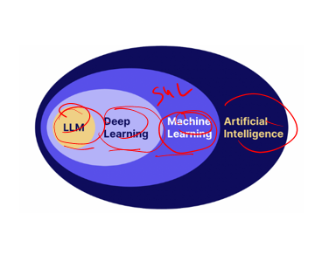
Machine learning itself is not complicated at all, moreover it is more like a function that have input information, output information(not always) and of course goal to achieve. We implement databases with algorithm in order to achieve necessary result. Additionally machine learning also have sub-components which are supervised machine learning, Unsupervised ML, reinforcement ML. supervised ML are mainly targets results based of their values: input and output information, and with good structured data it can predict or achieve goal which it trained for.

But unsupervised ML have a little difference with the supervised one, noticeable difference these is no output data and mainly used for structuring data into sections. Reinforcement ML is the most complicated among all of them, because it is not used for prediction or structuring information, it’s main mission is to make decisions in order to get acceptable result. I even heard about recent discovery from scientist that ejected fly’s brane and don’t know how but they were able to make artificial based intelligent from it. By giving treat and punishing it they could achieve some acceptable points. It could even play some basic games although performance from it were like a 3-6 years old child.

Github
Github yordamida quyidagi qulayliklarga ega bo’lamiz:Jamoaviy ishlarda gurux bo’lib ishlash, Ml loyihalarida ishlash, kodni ulashish va nazorat qilish imkonini beradi.Bulardan tashqari juda ko’plab qulaykiklarga
ega bo’lib uni darslarimiz davomida o’rganib amalda qo’llab boramiz.

Githubni o’rnatish
Quyidagi ketma ketlik yordamida uni o’rnatib olishimiz mumkin:
Quyida Windows uchun ko’rsatilgan boshqa Operatsion sistemga(MacOS, Linux) egalar xam ketma ketlik deyarli bir xil bo’ladi.
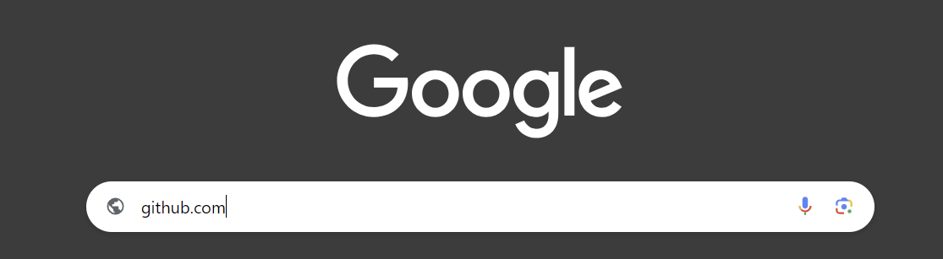
Figure 1: google.com
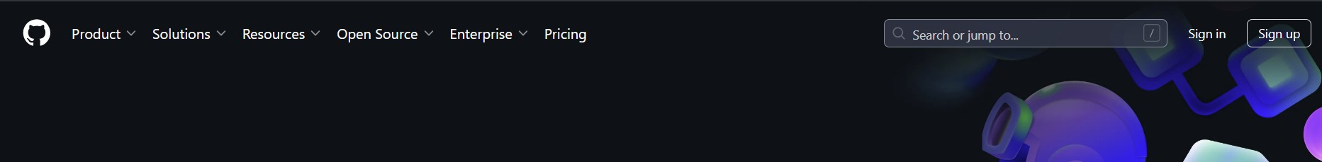
Figure 2: Sign up orqali ro’yhatdan o’tishni boshlash
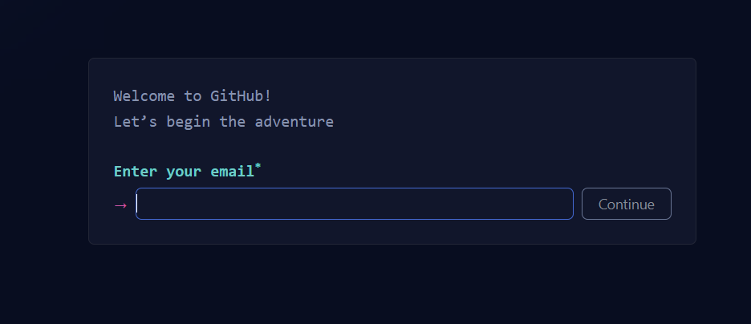
Figure 3: Email kiritish
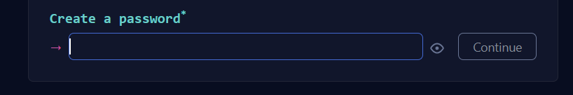
Figure 4: Parol kiritish

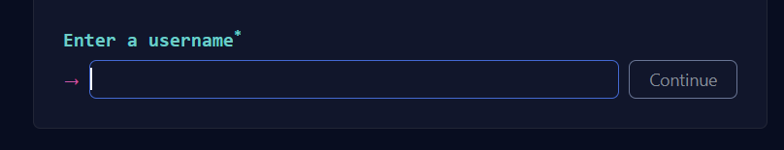
Figure 5: Foydalanuvchi ismini kiritish

Figure 6: Davom etish
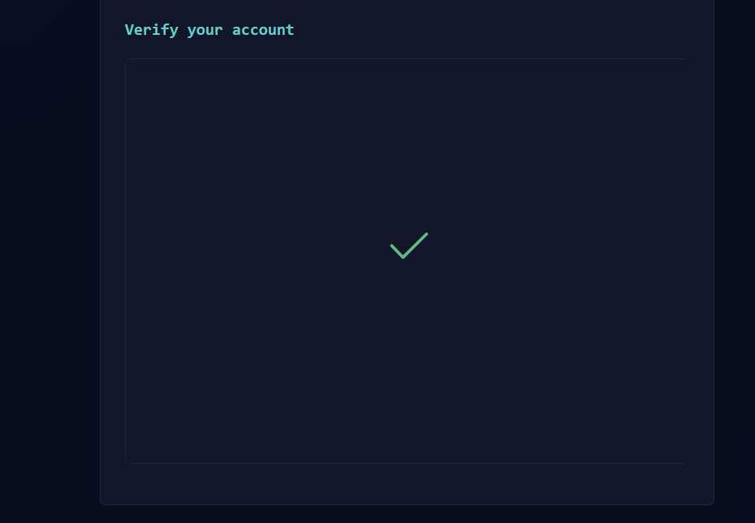
Figure 7: Qisqa topshiriq orqali tasdiqlanish
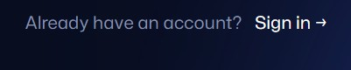
Figure 8: Sign in orqali saytga kirishni boshlash

Repository
Github ochib olganimizdan keyingi vazifa qilinayotgan loyiha/ dars/ vazifa/topshiriqga ko’ra alohida

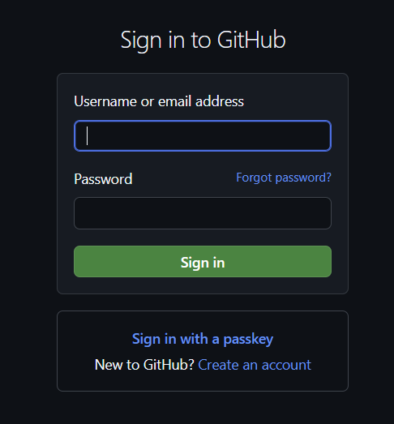
Figure 9: Tanlangan Foydalanuvchi ismi/ email address va Parol yordamida saytga kirish

