NuDrum

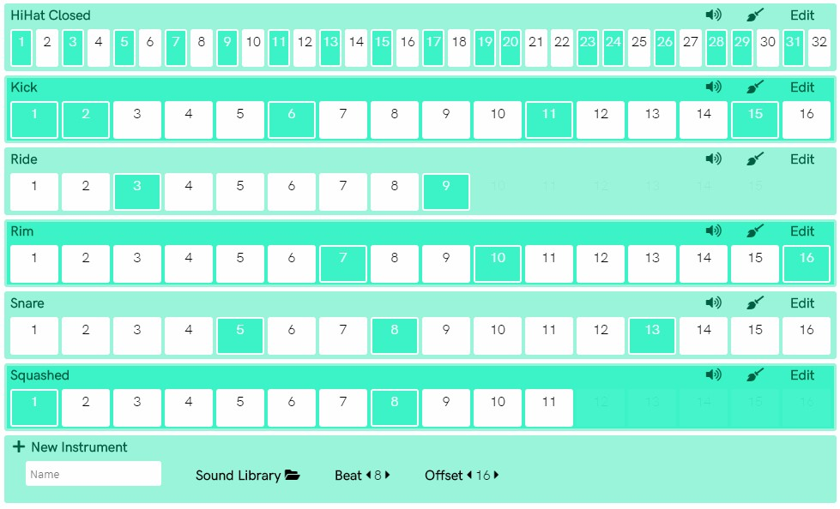Minimalist polyrhythmic and polymetric drum machine  
<https://nudrum.netlify.com/>

# Introduction

The project aims to create a polyrhythmic and polymetric drum machine, through a responsive web interface. These features are limiting to all the instruments available on a drum machine (physical or digital). NuDrum unlike the previous ones, makes every single instrument polyrhythm and polymetric, in order to improve the visual learning of the various rhythmic patterns created by the users using the platform. In addition, it will be available through Google's Firebase services, to upload your own samples to the platform and share rhythmic patterns with the audience.

## What is rhythm?

The sense of rhythm was developed in the early stages of hominid evolution by the forces of natural selection to induce battle trance, promote the development of a defense system of early hominids. In Sub-Saharan Africa it evolved in complex forms such as multi-layered polyrhythm and simultaneous rhythms in more than one time signature.

## What is polyrhythm?

A polyrhythm is the simultaneous use of two or more conflicting rhythms, that are not readily perceived as deriving from one another, or as simple manifestations of the same meter. It can be distinguished from irrational rhythms (tuplets), which can occur within the context of a single part

## What is polymeter?

Rhythm in music is characterized by a repeating sequence of stressed and unstressed beats (strong vs. weak; upbeat vs. downbeat) and divided into bars organized by time signature[1] and tempo indications. In music, time signature always occurs at start of a paper sheet, it represents the rhythm of the piece.

# Source code

This project is Open Source; all the line codes can be downloaded and optimized on Github through the link <https://github.com/toboko/nudrum-drum-machine/>; a demo of the project is available on Netlify through the link <https://nudrum.netlify.com/>.

# How to make music

With NuDrum we can set different time signature and find new amazing pattern.  
On the right of every instrument we can:

1. 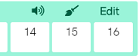Mute the track
2. Clear the row
3. Open the edit menu

The edit menu will slide from the left to the right, standing on the left margin of the screen. Here, we can choose from different options. In the first row (from the left to the right) we can:

1. **volume** - Change the volume
2. **offset** - Change the offset
3. 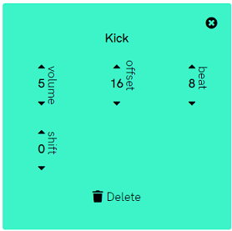**beat** - Change the notes duration

In the second row:

1. **shift** - Shift right (up arrow) or shift left (down arrow)
2. **delete** - Delete the track

## How does beat work

Beat goes from: **4** to **8** to **16** to **32**. The beat represents notes duration [**4**] = 1/4 , [**8**] = 1/8 and so on. Default time signature is **4/4** but changing the offset it possible to turn the time.

In a track with a beat duration of **4** we can have **8** possible offset[2]. In a track with a beat duration of **8** we can have **16** possible offset and so on..

Examples:

[Time in 5/4](https://nudrum.netlify.com/?p=hz6ZR) - If we set beat to **4** (all notes duration are 1/4) and offset to **5** we have obtained a 5/4 time signature.

[Time in 7/8](https://nudrum.netlify.com/?p=E8R6i) - If we set beat to **8** (all notes duration are 1/8) and offset to **7** we have obtained a 7/8 time signature.

# How to create patterns

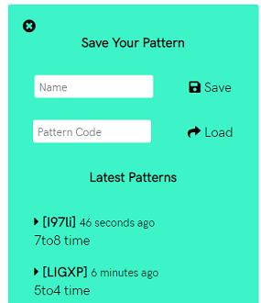Standing on the right margin of the screen we can found the pattern menu. Here we can **Save** our own pattern, setting a proper name or **Load** a previous one knowing its unique code. Unique code is recognizable in the brackets **[ ]**, it's followed by the timestamp and the title.

Every pattern can be easily reached typing NuDrum url, followed by **?p=OurCodeHere** Example - <https://nudrum.netlify.com/?p=63640>

# How to upload

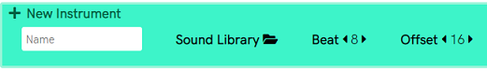The last row track is dedicated to create new instruments. We must choose a name for the instrument, then the sound from the **Sound Library**, the start beat and the offset. Once finished, click on the plus button and try our new sample.

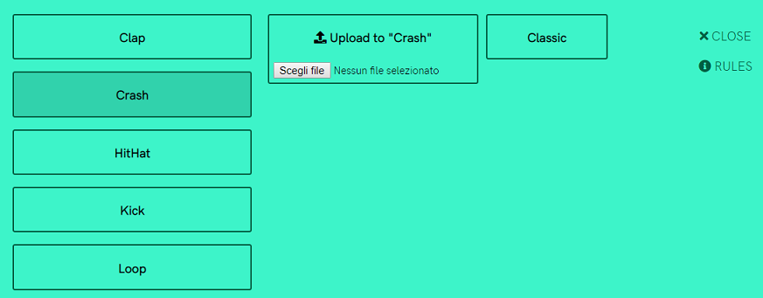We can choose from many sounds or upload ours. Clicking on **Sound Library** will be popup the upload menu. On the left, we can choose the category, then select the sample by clicking on or we can also upload a new one selecting our file and clicking on the icon.

## Storage’s rules

All file are downloaded and uploaded on Firebase Storage. Any operation must be follow some rules to read and write; in particular files are allow to be written into the following paths:

/Clap , /Crash , /HitHat , /Kick , /Ride , /Rim , /Snare , /Tom, /Loop

Every file is subject to the following constraints:

1. File is less than 5MB
2. Content type is an audio
3. Uploaded content type matches audio/.* content type
4. File name is less than 32 characters

# Standalone application

NuDrum ca be built like a standalone app thanks to [Electron](https://electronjs.org/), with the following commands:

git clone https://github.com/toboko/NuDrum  
npm[3] install  
npm start

# Dependencies

[AngularJS](https://github.com/angular/angular.js) is a javascript-based open-source front-end web application framework

[Pizzicato.js](https://github.com/alemangui/pizzicato) simplify the way to create and manipulate sounds with the Web Audio API

[Toastr](https://github.com/CodeSeven/toastr) is a javascript toast notification

[jQuery](https://github.com/jquery/jquery) is javascript library

# Copyright

NuDrum is hosted by [Netlify](https://netlify.com/) and work on [Google Firebase](https://firebase.google.com/) services

Copyright © 2018-2019 All the rights reserved to Nicola Bombaci

# Licence

NuDrum is under Academic Free License 3.0 [(AFL)](https://tldrlegal.com/license/academic-free-license-3.0-(afl))

1. *Usually, modern drum machine can be set on a single time signature forcing performer to play all the rhythm in a strict way*
2. Minimum offset is 4
3. npm library manager is required