The documentation included in this zip folder is standard JavaDoc documentation, generated from extensive JavaDoc comments.

To view the documentation, please open the "index.html" web page inside the "documentation" folder

It provides a very detailed outline of the structure / functionality of my source code

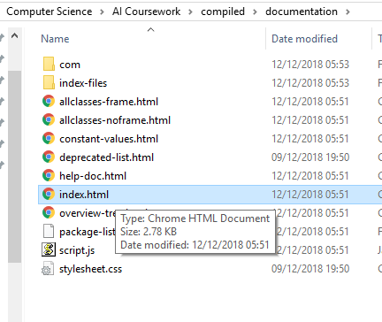

documentation/index.html

Alternatively, you can open the "documentation" folder in a browser and it will automatically load the page.

To run the java program, you can either pass in command line arguments, or use the console to enter

in your jug capacities, at run-time.

You will need to open a console in this directory and run the following:

if 0 capacity arguments are passed, you will be prompted to enter a number once the program starts.

Otherwise, the capacities passed will be validated (only to make sure they're integers).

Finally, the program will log all discovered states generated from the start state.

It will then finish execution, after logging some statistics about the search.