

C++ Notes

Toby Castledine



June 20, 2020

Contents

**No table of contents entries found.**

# Getting started with C++

C++ is not a new programming language; however it is a very popular language used by many businesses today. It was developed by Bjarne Stroustroup at Bell Labs in 1979 and was designed to succeed C. C++ is an object oriented programming language and makes use of concepts such as inheritance, abstraction, encapsulation, and polymorphism.

Knowledge of programming in C is not required for learning C++

C++ is an intermediate level programming language which allows both high and low level programming of libraries that work closely with the hardware. Other object oriented languages do exist such as Java which are based on .NET just like C++.

C++ became widely accepted since its creation and has evolved over time. It has been adopted on many platforms which make use of their own C++ compilers.

## Steps to generating an executable

* Write the C++ code in your chosen IDE
* Run the code and have it compiled.

When the code is compiled it is converted into machine language (or bytes) which the processor will be able to execute upon reading the code you give it. When compiled the processor will do so one file at a time, line by line. If an error is found, then it will return a runtime error message and provide details on what went wrong and where the error was detected.

## First C++ application

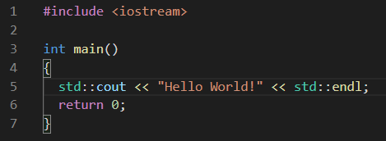

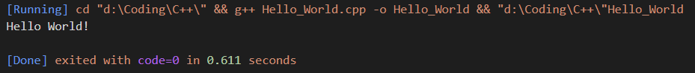

The code above is a basic C++ application which returns the line “Hello World” which will display in the output console as shown.

**Std::cout << “Output sentence”;** = prints output sentence to screen

**<< std::endl;** = Ends the line the text is written on and moves to the next. If the command is followed by another print command and the first one doesn’t end with ‘std::endl’ the printed sentences will appear on the same line together rather than apart.

**Return 0; =** Returns the value to the operating system. This is because the main function named **int main()** which this application is written is defined as an int. Therefore returning 0 is a way of the application telling the operating system that the application ran successfully. This is optional and the application will still work without return 0;

# Anatomy of a C++ program

**What is the problem in declaring Int main()?**

**Can comments be longer than one line?**

Yes, there are 2 different ways of commenting out code:

**//** comments out a single line

**/* text here \*\** comments everything in between no matter how many lines there are.

# Using Variables, Declaring Constants

*Sign* implies positive or negative. When using numbers on a computer they are stored as bits and bytes.

A memory location which is 1 byte contains 8 bits.

Each bit can be a 0 or a 1. Therefore a memory location that is 1 byte can contain a maximum of 2 to the power 8. 256 unique values.

A memory location that is 16 bits large can contain 2 to the power of 16 values. 65,536 unique values.

If the values were unsigned they will be assumed to always be positive numbers and one byte could contain numbers from 0 to 255. Two bytes would contain values ranging from 0 to 65,535.

**What is the difference between a signed and an unsigned integer?**

Unsigned integers always contain positive numerical values whereas signed can contain negative values. If a value is guaranteed to be a positive value then always use unsigned because it is capable of holding twice as many positive values than a signed integer.

**Why should you not use #define to declare a constant?**

The correct way to declare a constant is to use **const**

**e.g.**

**const double pi = 22.0 / 7;**

**Why would you initialize a variable?**

So that you can define what a variable contains. Each variable is a location in memory where the value will be contained. When initialized the type, name and value will be defined. E.g

Int myNumber = 4;

**Consider the enum. What is the value of Queen?**

**Enum YourCards {Ace, Jack, Queen, King};**

2

**What is wrong with this variable name?**

**Int Integer = 0;**

Integer is a reserved word in C++ therefore variables cannot use any reserved keywords as a name.