Supplementary Materials

Supplement 1: 4D PICTURE Collaborators

Supplement 2: Distribution of predictors
The first was the adhere variable, a dichotomous indicator for adhesion of the tumor to nearby organs (135 of 929 patients, @fig-variables). Next was rx, a three-level categorical variable of the three treatment arms from the trial. Third was age as a continuous variable. The mean age was 60 years with a standard deviation of 12 years. The age distribution was left-skewed (@fig-variables). Finally, nodes was a heavily right-skewed variable (median 4 nodes, range of 0 to 33).
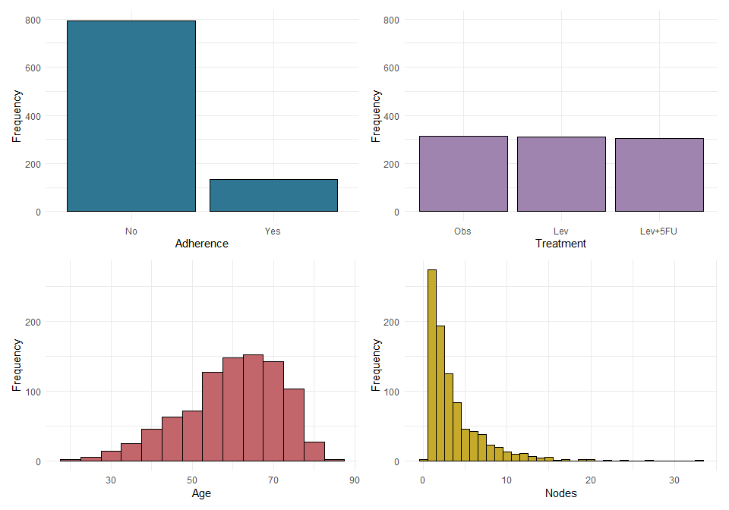
Distribution of 4 prognostic factors in the colon dataset. Adhere: adhesion of the tumor. Treatment with three levels: Obs - Observation; Lev: levimasole; Lev+5FU - levimasole+5-fluorouracil. Age in years. Nodes: number of lymph nodes with detectable cancer.

Supplement 3: Cox model has narrower 95% CI than Kaplan-Meier
The 95% confidence interval of a Cox model prediction for a patient is narrower than that of a Kaplan-Meier curve for the patient with the same treatment. This shows that the Cox model is more certain than the Kaplan-Meier and is therefore expected to have a higher effective sample size.

Supplement 4: Effective sample size of mean patient is N_dev in linear regression
Effective sample size of a mean patient is equal to the development sample size in a linear regression model:
We follow the code by @thomassen2024
library(Hmisc)
getHdata(gusto)
gusto.dat <- gusto
#Create a subset of the data with centers from US region and one non-US region
gusto.dat <- gusto[which(gusto$grpl %in% c(1,2,4) & gusto$grps %in% c(5,9,10,11)),]
## uncorrelated continuous predictors age, height
#plot(gusto.dat$age, gusto.dat$hei)
##Center the variables
gusto.dat$age <- gusto.dat$age- mean(gusto.dat$age)
gusto.dat$hei <- gusto.dat$hei- mean(gusto.dat$hei)
## Calculate effective sample sizes
X_ols <- model.matrix(~age+hei, data=gusto.dat)
XTX <- t(X_ols)%*%X_ols
n_eff_OLS <- numeric(length = nrow(X_ols))
for(i in 1:length(n_eff_OLS)){
A <- solve(XTX)%*%X_ols[i,]
n_eff_OLS[i] <- 1/(t(X_ols[i,])%*%A)
}
neff_all <- data_frame(pat.id = (1:nrow(X_ols)),form="form0", n_eff_OLS = n_eff_OLS)
## Visualisation
#ggplot(neff_all, aes(x=n_eff_OLS))+
# geom_histogram(alpha=0.8, position = "identity")+
# theme_bw()
print(paste0("Maximum effective sample size in development sample: ", round(max(neff_all$n_eff_OLS), 1) ) )
model <- lm(day30~age+hei, data=gusto.dat)
new <- matrix(c(1, 0, 0), nrow = 1, ncol=3)
A <- solve(XTX)%*%t(new)
n_eff <- 1/(new%*%A)
print(paste0("Effective sample size of a patient with mean height and age: ", n_eff))

Supplement 5: Effective sample size in regression models not based on time-to-event data
Effective sample size in linear regression models based on one continuous and one categorical variable are bounded by the number of patients in the same category. Below is an example in the GUSTO data for a linear regression model based on age and sex. The mean (normalized) age is no longer 0, but the mean age within your category (in this case among those with ‘sex’ == ‘female’).
model <- lm(height ~ age + sex, data = gusto.dat)
X_ols <- model.matrix(~age+sex, data=gusto.dat)
XTX <- t(X_ols)%*%X_ols
m_age_sex <- mean(gusto.dat[gusto.dat$sex == "female", "age"])
new <- matrix(c(1, m_age_sex, 1), nrow = 1, ncol=3)
A <- solve(XTX)%*%t(new)
n_eff <- 1/(new%*%A)
print(paste0("Number of patients with your sex: ", sum(gusto.dat$sex == "female")))
print(paste0("Effective sample size of someone with mean age of your sex: ", round(n_eff)))
In logistic regression we borrow information and effective sample size can be higher than in your cohort. Below is the same model based on age and gender, but now using a glm with logit link function:
LR0.fit <- glm(formula = day30 ~ age + sex, data = gusto.dat, family = binomial(link = "logit"))
neff <- c()
cov.beta <- vcov(LR0.fit)
X_LR0 <- model.matrix(LR0.fit)
new <- data.frame(age=0, sex="female")
pred <- predict(LR0.fit, newdata = new, type = "response", se.fit = TRUE)
neff$pi.pred <- pred$fit
neff$pi.se <- pred$se.fit
neff$vary_xnew <- neff$pi.pred*(1-neff$pi.pred)
mm <- matrix(c(1, 0, 1), nrow = 1, ncol = ncol(X_LR0))
neff$n_eff_LR <- 1/((mm %*% (cov.beta %*% t(mm)))*neff$vary_xnew)
print(paste0("Number of patients with your sex: ", sum(gusto.dat$sex == "female")))
print(paste0("Effective sample size of a patient with mean age and your sex based on logistic regression: ",
round(max(neff$n_eff_LR))))
We can prevent this borrowing of information by including an interaction term between age and sex. Below is the same logistic model but now with an interaction term for age and sex:
LR1.fit <- glm(formula = day30 ~ age + sex + age:sex, data = gusto.dat, family = binomial(link = "logit"))
neff <- c()
cov.beta <- vcov(LR1.fit)
X_LR1 <- model.matrix(LR1.fit)
new <- data.frame(age=0, sex="female")
pred <- predict(LR1.fit, newdata = new, type = "response", se.fit = TRUE)
neff$pi.pred <- pred$fit
neff$pi.se <- pred$se.fit
neff$vary_xnew <- neff$pi.pred*(1-neff$pi.pred)
mm <- matrix(c(1, 0, 1, 0), nrow = 1, ncol = ncol(X_LR1))
neff$n_eff_LR <- 1/((mm %*% (cov.beta %*% t(mm)))*neff$vary_xnew)
print(paste0("Number of patients with your gender: ", sum(gusto.dat$sex == "female")))
print(paste0("Effective sample size of a patient with mean age and your gender based on logistic regression with an interaction term: ",
max(neff$n_eff_LR)))
Effective sample size is more than halved, implying that the interaction term removed any borrowing of information.

Supplement 6: Multivariable Cox effective sample size with separate baseline hazards for age

Supplement 7: Heuristic explanation of higher than total sample size
To show the outcomes, we rerun the simulation:
Our assumption/hypothesis is that the effective sample size at the beginning is this $\frac{HR_{new}}{Totalrisk}$ value. We cannot estimate variance before any events, so we analyse this hypothesis at the first event time. As we simulate with a HR of 2, we expect the total risk to be equal to $5000⋅1+5000⋅2=15000$, the effective sample size for a female patient with HR of 1 should have an effective sample size of 15,000 (the denominator) and a male patient with HR of 2 should have an effective sample size of 7,500 (the denominator divided by HR).

Supplement 8: Coefficient variance investigated
We need to investigate this at a time where we have quite a lot of knowledge of the ratio of the two groups in the data. At some point in time, the ratio between the two survival probabilities will be exactly 2. We will evaluate at this time $t$. We can find this by calculating:
First, we look at the first event time and assume no one left the risk set. At the time of the first event, we assume that the number at risk in both groups is still $5000$. This means that $w_{men}$ is: $w_{men}=\frac{1}{5000+2⋅5000}\left\{\frac{2⋅5000}{5000+2⋅5000}−1\right\}=−\frac{1}{45000}$ and $w_{women}=\frac{2}{5000+2⋅5000}\left\{\frac{2⋅5000}{5000+2⋅5000}−0\right\}=\frac{2}{45000}$.
Of course this is not all - the gradient is $exp\left(β^{⊤}X_{new}\right)w$, which is $−\frac{2}{45000}$ for men and $\frac{2}{45000}$ for women. This is as expected, since men and women are both equally distant from the population mean in the risk set. Then the coefficient variance is (for one variable) the squared gradient times the variance of the coefficient, the last of which is constant.
At $t=6.913$, we can calculate the increment of the gradient by hand, which should be $2⋅w_{men}=2⋅\frac{1}{2500+2⋅1250}\left\{\frac{2⋅1250}{2500+2⋅1250}−1\right\}=−2⋅\frac{1}{10000}$ for men and $w_{women}=\frac{1}{2500+2⋅1250}\left\{\frac{2⋅1250}{2500+2⋅1250}−0\right\}=\frac{1}{10000}$ for women. We see that the increment of the gradient is now twice as high for men.

