CHAPTER 1

INTRODUCTION

1.0 Overview
Livestock is one of the strongest pillars of Nigeria's rural economy, holding a large share of household wealth for millions of families across the northern and middle-belt states. The National Bureau of Statistics reports that the livestock sub-sector contributed ₦11.9 trillion, or 5.6 per cent of national Gross Domestic Product, in 2024, and the Federal Ministry of Livestock Development places the sector's total contribution at roughly $32 billion, with a strategic plan to grow that figure substantially by 2030 (Federal Ministry of Livestock Development, 2025). Yet this wealth sits almost entirely outside any verifiable system of ownership record. Cattle, goats and sheep are bought, sold and inherited on the strength of word-of-mouth agreements or handwritten receipts that anyone can forge. This gap has been exploited on a large scale: the Food and Agriculture Organization estimates that Nigeria loses about $432 million every year to cattle rustling alone (Food and Agriculture Organization, 2024), and the Global Initiative Against Transnational Organized Crime describes rustling as having evolved from a community practice into a full illicit economy that finances armed groups and accelerates instability in the North-West and North-Central regions (Global Initiative Against Transnational Organized Crime, 2023). Because a stolen animal carries no identity of its own, it can be resold in a distant market within days and become, in practice, untraceable.

To address this gap, a responsive Web Application will be developed to give every registered animal a unique digital identity and a permanent, tamper-evident ownership history. The platform will work well on standard computer screens and will use adaptive design to adjust its layout for owners, buyers and market officials opening it on mobile phone browsers. Each animal registered on the system receives a software-generated QR identity tag linked to its record, and the application will provide separate dashboards for the people who use it. Owners can register their animals, view their herd, transfer ownership when a sale takes place, and flag an animal as stolen the moment it goes missing. Buyers and verifiers can look up any tag before money changes hands to see the animal's full ownership chain and check whether it has been reported stolen. Beyond simple record-keeping, the system will run automated checks that flag suspicious patterns such as unusually fast resale, which is the common way thieves launder stolen livestock back into legitimate markets.

The entire web application will be built using a full-stack architecture chosen for speed, security, and smooth user interaction. The frontend will be developed using React together with TypeScript, which reduces coding errors, speeds up development, and keeps layouts stable across desktop and mobile screens. For database management and backend services, the platform will use Supabase, which provides a production-ready PostgreSQL database along with built-in authentication and Row Level Security, so that every user can only read and write the records they are permitted to touch. The tamper-evident ledger will be implemented directly on top of this database as an append-only chain of records, where each entry stores the cryptographic hash of the entry before it, generated using standard SHA-256 hashing, so that any secret edit to a past record immediately breaks the chain and becomes visible during verification. Ownership transfers will be secured with digital signatures, ensuring that only the genuine current owner can authorise a sale. By pairing a React with TypeScript frontend with a Supabase and PostgreSQL backend, the application will run smoothly, stay secure, and remain easy to maintain as more owners and animals are added to the system

1.1 Background of the Study & Motivation
For most rural households in northern and central Nigeria, livestock is not simply a farming activity but the family's main store of wealth. Nigeria is the leading livestock producer in West Africa, with herds numbering in the tens of millions of cattle alongside far larger populations of goats and sheep, and the majority of these animals are raised in free-range systems managed by smallholders and nomadic herders rather than by large commercial operations. A single cow can represent several years of savings for a family, and a herd often serves as a household's pension, insurance policy, and bank account at the same time. Because these animals are mobile, valuable, and held almost entirely outside any formal registry, they are also unusually easy to steal and unusually difficult to recover. This combination of high value and zero record-keeping is the condition that the present project sets out to address.
Over the past decade, livestock theft in Nigeria has changed character. What was once opportunistic rural crime has become an organised illicit economy. The Global Initiative Against Transnational Organized Crime describes cattle rustling in Nigeria as having evolved from a community practice into a significant illicit market that delivers material profits to conflict actors, and identifies it as one of a small number of "accelerant" economies, alongside arms trafficking and kidnapping for ransom, that actively fuel instability. Researchers at the same organisation have noted that Nigeria is the country most affected by livestock theft anywhere in Africa. The theft is no longer carried out by individuals but by armed groups operating across state lines, and the proceeds fund further violence. Analysts have documented a practice sometimes called "cattle round-tripping," in which rustlers move stolen animals far from where they were taken, often across state or national borders, then mix them with legally acquired livestock and sell them through informal trading networks to buyers who have no way of knowing what they are purchasing.
The human and economic cost of this is well documented. The Food and Agriculture Organization estimates Nigeria's annual losses to cattle rustling at approximately $432 million (Food and Agriculture Organization, 2024). The Armed Conflict Location and Event Data Project has consistently found that Nigeria's North-West and Middle Belt account for roughly two-thirds of civilian fatalities recorded nationwide, driven by bandit raids and by long-running disputes between pastoralist and farming communities (ACLED, 2023). Research by SBM Intelligence has traced the concentration of this violence to states including Zamfara, Kaduna, Katsina, and Sokoto (SBM Intelligence, 2025) — the same states repeatedly identified in the literature as centres of large-scale rustling. What is important for this project is the mechanism underneath these figures: theft is profitable precisely because a stolen animal can be converted into cash quickly and safely. Remove the ability to resell anonymously, and the economics of the crime change. Existing methods of proving livestock ownership in Nigeria have not kept pace with this threat. Ownership is still established through branding, ear-notching, physical description, community recognition, or handwritten market receipts. Each of these can be defeated. A brand can be altered or obscured, community recognition does not travel across state borders, and a paper receipt can be forged or simply written out by anyone. Modern alternatives such as RFID ear tags and microchips do exist internationally, but they depend on physical hardware, readers, and a central authority to issue and manage them, which places them out of practical reach for the smallholders who suffer most of the losses. The result is a verification gap: at the exact moment a buyer needs to know whether an animal is legitimately owned, there is no source of truth available to consult.
Digital technology has been applied to livestock, but largely for a different purpose. Reviews of blockchain adoption in the livestock sector show that the research has concentrated on agri-food supply chain traceability and quality assurance, using recorded units of information to track products from farm to consumer, and well-known deployments such as IBM Food Trust and QR-code-enabled beef traceability systems were built to shorten trace-back time during food safety investigations rather than to establish who legally owns an animal. The same literature notes that these systems are hardest to adopt in low- and middle-income countries, where smallholders face high onboarding costs and limited digital infrastructure. Very little work applies the core toolkit of cybersecurity — cryptographic hashing, record integrity, digital signatures, and tamper-evidence — directly to the problem of livestock ownership fraud and theft deterrence.
This is the gap that motivates the present project. The technical building blocks required are mature and freely available: cryptographic hash chaining can make a record history tamper-evident, digital signatures can prove that a transfer was authorised by the real owner, and QR codes can link a physical animal to its digital record at almost no cost. What has been missing is a system that assembles these pieces around theft rather than food safety, and delivers them through an interface that an ordinary owner or buyer can use on a phone browser without specialised hardware. Building that system as a React and TypeScript web application on a Supabase PostgreSQL backend keeps the barrier to entry low while still providing production-grade authentication and access control, making a tamper-evident ownership record realistic for the people who actually need it.

1.2 Problem Statement
Despite the scale of livestock ownership in Nigeria and the documented losses to theft, there is currently no reliable mechanism for establishing who owns an animal. The problem this project addresses can be broken down into five specific failures:

1. There is no standardised, verifiable proof of livestock ownership in Nigeria:
Ownership is asserted rather than proved. It rests on branding, ear-notching, physical description, or the word of people who know the owner personally. None of these produce a record that a stranger in another state can check, which means that once an animal leaves its home community, the link between the animal and its rightful owner effectively disappears.

2. Paper records are easy to forge and are often not kept at all.
Where receipts exist, they are handwritten, unstandardised, and carry no security features whatsoever, so anyone can produce one. Among smallholder farmers, who own the majority of Nigeria's livestock, such records are frequently never created in the first place. A document that anyone can write and no one can verify offers no protection against a determined thief.

3. Stolen animals can be resold with no way to trace their true origin or history.
Rustlers deliberately move stolen animals far from where they were taken, often across state borders, and then sell them mixed in with legitimately owned stock. Because there is no history attached to any individual animal, the buyer has no means of detecting that the animal was stolen, and the sale looks identical to an honest one. This is the mechanism that makes livestock theft profitable and low-risk.

4. Ownership disputes have no objective means of resolution
When a farmer, herder, or buyer claims an animal, the dispute is settled by testimony, community influence, or the intervention of local authorities rather than by evidence. There is no neutral record that all parties can consult, so outcomes depend on who is believed rather than on what actually happened. In regions already affected by farmer–herder tension, these unresolved disputes escalate into wider conflict.

5. Existing digital and blockchain agriculture systems are not designed for this problem
The available research and commercial deployments in this space were built for food-supply-chain traceability and quality assurance, tracking products from farm to consumer so that contamination can be traced quickly. They assume a cooperative, formally organised supply chain and are not designed to detect an adversary who is deliberately attempting to disguise an animal's origin. Theft deterrence, ownership fraud, and stolen-animal detection fall outside their scope.

1.3 Aim and Objectives

Aim

The aim of this project is to design and implement a secure, tamper-evident digital system for registering livestock identity, transferring ownership, and detecting theft, tailored to cattle, goat, and sheep owners in Nigeria and delivered as an accessible web application requiring no specialised hardware.

Objectives

The following objectives correspond directly and in order to the five failures identified in Section 1.2, with a sixth objective provided to validate the system as a whole.

1. To design and implement a unique digital identity for every registered animal, linked to a software-generated QR identity tag.
.

2. To design and implement a hash-chained, append-only ledger that makes the ownership record tamper-evident.
his replaces a document anyone can forge with a record no one can silently rewrite.

3. To develop a theft-reporting and stolen-animal flagging feature, with open verification lookup.

4. To build a signature-based ownership-transfer flow that produces an authoritative chain of custody.
.

5. To implement rule-based fraud and anomaly detection targeted specifically at theft patterns.

6. To validate the system's core security claim through a controlled tamper-simulation and attack scenario.

Achieving these six objectives will produce a working web application, built with React and TypeScript on a Supabase PostgreSQL backend, in which livestock ownership can be registered, transferred, verified, and defended against fraud through cryptographic evidence rather than through paper, memory, or trust.

1.4 Risk Assessment

Risk Id | Risk | Likelihood of Occurrence | Impact | Mitigation Strategy
1 | One-month development window before the submission deadline |  | Delayed or incomplete delivery of core features | Keep to a fixed MVP scope; build against the six objectives only; use existing libraries rather than writing components from scratc
2 | Scope creep from adding extra features during development complete and tested |  | Reduced quality and missed deadline | Treat Section 1.4 as binding; optional enhancements attempted only after all six objectives are c
3 | complexity of the cryptographic implementation (hash chaining and digital signatures) Week 1, before building on top of it |  | Bugs in the tamper-detection logic, undermining the system's central claim | Use well-tested standard libraries rather than custom cryptography; write test cases for the chain-verification routine in
5 | Unfamiliarity with Supabase Row Level Security policies |  | Data exposed to users who should not see it, or legitimate users blocked from their own records | Write and test RLS policies table by table as each is created; verify with deliberately unauthorised test accounts before moving on
6 | Dependence on a third-party backend platform (Supabase) | Service downtime or configuration error blocking development or the live demonstration | downtime or configuration error blocking development or the live demonstration | Keep a local export of the database schema and seed data; rehearse the demonstration in advance and record a backup video walkthroug

1.4 Project Scope
This project is scoped as a software system rather than a hardware or field-deployment exercise. It will be delivered as a responsive web application built with React and TypeScript on the frontend and Supabase, running a PostgreSQL database, on the backend, and presented as a working prototype covering the full cycle from registration through transfer, verification, theft reporting, and fraud detection. Every animal registered receives a unique identifier, which the application also renders as a QR code so that the record can be retrieved quickly on a phone; where the code is unavailable, the identifier can be entered manually and returns the same record. No tagging device, reader, chip, or tracking equipment is designed, built, or purchased, since the contribution of this project lies in the integrity of the ownership record rather than in the mechanics of physically marking an animal.The system covers cattle, goats, and sheep, chosen because their individual value justifies giving each animal its own digital identity and because they are the species most consistently identified in the literature as targets of organised rustling in Nigeria. Low-value, high-volume animals such as poultry, fish, and snails are excluded, as the effort of registering each one would exceed the value being protected. The project is framed around Nigeria, with particular attention to the northern and middle-belt states where rustling is most concentrated, although nothing in the design restricts its use elsewhere. The detailed functional and non-functional requirements of the system are set out in Chapter Three.

Certain boundaries are stated deliberately so the work is assessed on what it actually claims. No physical hardware of any kind is developed, including RFID chips, microchips, scanners, or GPS collars. The system does not integrate with real livestock markets, state veterinary offices, or any government database, as such integration would require institutional agreements beyond the reach of a final-year project. There is no field piloting with live farmers or traders, so the system is validated through carefully designed simulated data and controlled test scenarios. No native mobile application is produced, though the responsive design means the platform functions correctly in a mobile browser. Payment processing is excluded, as the system records the authorization of a transfer rather than the money accompanying it. Finally, the project does not build a public, distributed block-chain network with mining or consensus; it implements the cryptographic properties that matter for this problem — hash chaining, append-only history, and digital signatures — within a single trusted application, which is the appropriate choice given the time frame and the absence of multiple independent operators. Beyond these direct boundaries, several external factors shape how the results should be interpreted. The most significant is that the ledger can guarantee a record has not been altered since it was created, but it cannot confirm that the person who first registered an animal was its rightful owner, as that would require a physical verification process outside the software. Real-world adoption would further depend on internet connectivity, phone availability, and digital literacy among rural owners, and on the willingness of markets and security agencies to consult the system before a sale is completed. Legal recognition is a further constraint, since a digital ownership record carries evident weight only if courts and local authorities accept it, and no such framework presently exists in Nigeria. The project is also bound by a fixed one-month development window, which requires the scope above to be held firm, with optional enhancements attempted only if time permits.

1.9 Organizational chart

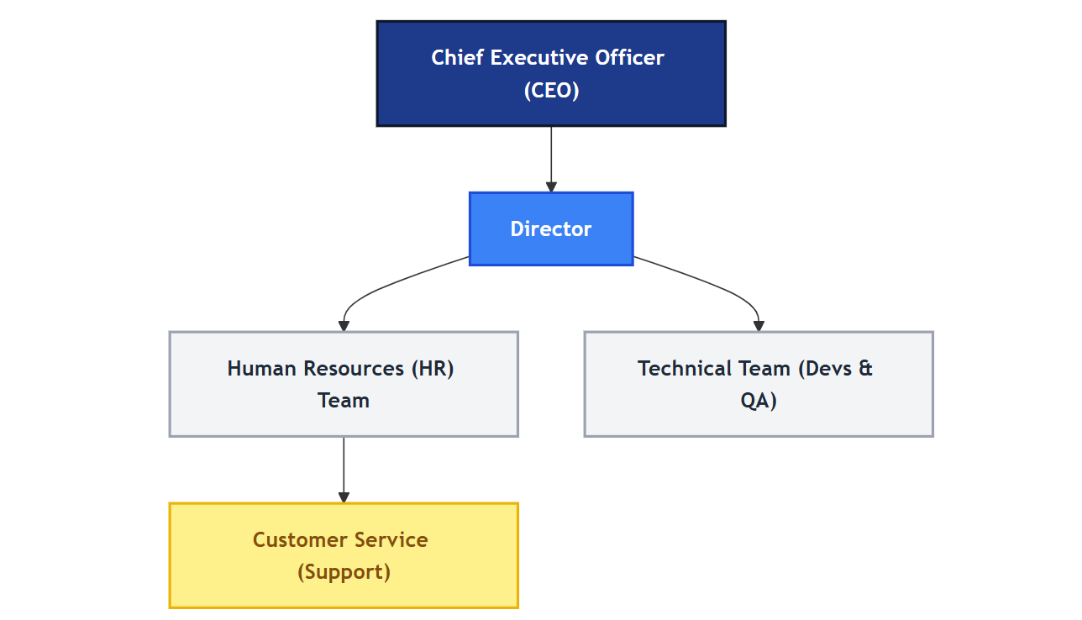

1.6 Chapter Summary

This chapter established the foundation of the study. It began by setting out the economic weight of livestock in Nigeria, where cattle, goats, and sheep function as the primary store of household wealth for millions of rural families, and where the sector contributes a substantial share of national output. Against that backdrop, it identified the central weakness of the sector: this wealth is held almost entirely outside any formal system of ownership record, making it unusually easy to steal and unusually difficult to recover. The chapter then traced how livestock theft in Nigeria has evolved from opportunistic rural crime into an organised illicit economy that finances armed groups, drives conflict in the North-West and Middle Belt, and costs the country hundreds of millions of dollars each year.

The chapter went on to show why existing responses are inadequate. Traditional proof of ownership rests on branding, ear-notching, physical description, or forgeable paper receipts, none of which travel beyond the community where the owner is personally known. Modern alternatives such as RFID tagging depend on hardware and central administration that place them beyond the reach of smallholders. Meanwhile, the substantial body of research on blockchain in agriculture has concentrated almost entirely on food-supply-chain traceability and quality assurance rather than on ownership fraud and theft deterrence. This constitutes the research gap the study addresses.

From this analysis, five specific problems were identified: the absence of verifiable proof of ownership, the forgeability and frequent absence of paper records, the untraceable resale of stolen animals, the lack of any objective basis for resolving ownership disputes, and the mismatch between existing digital agriculture systems and the theft problem. Six objectives were then set out in direct correspondence with these problems, covering digital identity, a hash-chained tamper-evident ledger, theft reporting and open verification, signature-based ownership transfer, rule-based fraud detection, and empirical validation through a controlled tamper simulation. The chapter defined the scope of the work as a software-only web application built with React, TypeScript, and Supabase PostgreSQL, explicitly excluding hardware development, institutional integration, and field piloting, and it acknowledged the external factors that would condition real-world deployment. Finally, the principal risks to delivery were assessed alongside the mitigation strategy for each. The chapter that follows reviews the existing literature on livestock identification, record integrity, and blockchain applications in agriculture in greater depth.

