Gulf vs Newfoundland
Snow Crab Price Differential
February 6, 2026
Prepared for:
Ministry of Fisheries and Aquaculture
Province of Newfoundland
by

John Sackton jsackton@seafoodlink.com
Seafood Datasearch Tel. 617-308-0776
8 White Pine Lane
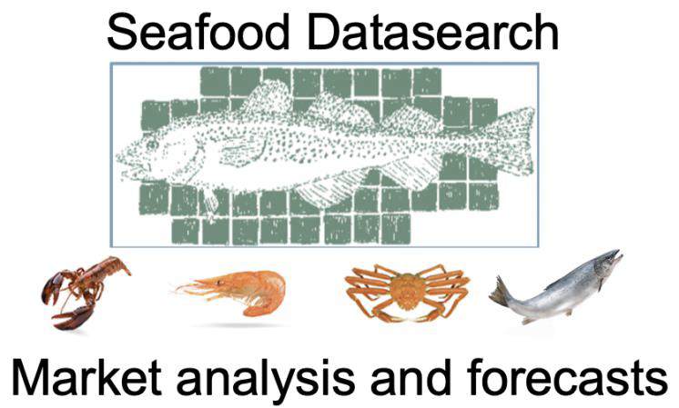
Lexington, MA 02421

Executive Summary 3
Section 1: Introduction 5
Section 2: Supply drives price differential 8
2.1 Changes in the share of Gulf crab over 10 years. 8
Figure 1: Gulf Supply Share vs. Price Differential (Link to interactive chart.) 9
2.2 Ten-Year Statistical Analysis 9
2.3 Historical Regime Shift: From $0.10 Baseline to Structural Premium 10
Figure 2: Historical Market Regimes with Price Differential (Link to interactive chart) 11
Section 3: Why 2025 Was Extreme 13
3.1 Tariff-Induced Front-Loading 13
Figure 3: Tariff Induced Front Loading (Link to interactive chart) 14
3.2 Regional Season Timing: Why Gulf Was Most Affected 15
3.3 Seasonal Pattern Inversion 15
Figure 4: Decomposing the 2025 Price Differential (link to interactive chart) 16
3.4 Buyer Behavior: Retailer Loyalty and the Concentration of Gulf Demand 16
Figure 5: Retailer Response Patterns to Gulf Premium (link to interactive chart) 18
Section 4: Decomposing the 2025 Differential 19
4.1 Structural vs Time Related Components 19
4.2 Monthly Convergence: How the Temporal Premium Dissipated 20
Figure 6: Price Premium Changes and Import Timing (Link to interactive chart) 21
4.3 Size Differences: Why 8-Up Stayed Elevated 22
Figure 7: Gulf Premium by Size Class for Pack Year 2025 (Link to interactive chart) 23
4.4 The Japanese Factor 24
Figure 8: Japanese Purchases of Canadian Snow Crab (Link to interactive chart) 25
Section 5: Data Limitations and Negative Findings 25
Section 6: Implications and Outlook 26
Appendix: Links to Interactive Charts 29

Executive Summary
The 2025 price differential between Gulf and Newfoundland snow crab reached $1.06 per pound on average, with a peak of $1.50 in April. We examined whether this discrepancy reflected market manipulation or could be explained by documented market forces. Our conclusion: the differential was the predictable result of two factors operating simultaneously—a structural supply constraint and a tariff-induced timing distortion.
The Supply Factor
Gulf crab's share of combined Canadian production has collapsed from 55% in 2017 to 22% in 2025. This shift fundamentally changed the market. When Gulf represented half of production, buyers who wanted Gulf crab had options. Volume was sufficient to meet demand, and competitive pressure kept differentials narrow—typically $0.06 to $0.11 per pound.
We found that below 30% supply share, the market behaves differently. The remaining Gulf buyers are those who specifically want Gulf product—retailers with established programs, Japanese importers seeking shell color characteristics for raw preparations, and foodservice accounts with set specifications. These buyers bid against each other rather than switch to Newfoundland crab. Statistical analysis of ten years of data confirms this relationship with high confidence (r = -0.80, p < 0.01). The supply factor alone predicts a differential of approximately $0.53 per pound at 2025's 22% Gulf share.
The Tariff Factor
Supply alone cannot explain the $1.50 April peak. The additional premium came from tariff-induced front-loading. Faced with potential 25% duties there was a tariff panic as buyers compressed a six-month purchasing cycle into less than three months. Between April-July, 92.6% of the total pack crossed the border, compared to 71.8% in 2023.
This front-loading had a bigger impact on Gulf crab. The Gulf season runs six to eight weeks, opening in early April and essentially complete by late May. Nearly 100% of Gulf production fell within the tariff panic window. Newfoundland's longer season—twelve to fourteen weeks, with significant volume in June and early July—meant roughly half its production reached market after the initial rush subsided. The important measure is not actual weeks of the season, but the weeks of peak landings. The Gulf reached its peak landing weeks earlier than did Newfoundland. Buyers competing for scarce Gulf product in April paid premiums based on tariff fears that lessened by the middle of May when the Newfoundland season was at peak production. It means buyers became more confident of getting crab they needed without a tariff risk.
The Evidence for Decomposition
If our framework is correct, front-loading means the premium should dissipate as buyers completed their purchasing. It did. The differential narrowed from $1.47 in April to $0.69 by end of July, when 94% of cumulative imports had crossed the border. By fall, with inventories secured and tariff concerns receding, the differential settled to $0.47-$0.55—essentially the structural baseline predicted by supply share alone.
The differing behavior of product sizes provides additional confirmation of this finding. The 5-8 oz segment—serving retail accounts highly exposed to tariff uncertainty—showed the most volatile premiums, peaking at $1.50 and collapsing by fall. The 8 oz-and-up segment, serving foodservice and specialty buyers with more persistent demand, held premiums in the $0.85-$0.90 range through summer before gradually narrowing.
Implications
The structural component of the differential—approximately $0.50 per pound at current supply shares—reflects persistent market conditions. Gulf quotas are unlikely to return to 50% of Canadian production. Buyers who specifically want Gulf crab will continue to pay premiums for scarcity. This is not market failure; it is how markets allocate limited supply among competing buyers with different preferences.
The temporal component—the additional $0.97 that pushed April's differential above $1.50—was a one-time response to specific trade policy uncertainty. It could recur if similar conditions emerge in 2026, particularly given current low inventories and ongoing USMCA renegotiation concerns. But it is not a permanent feature of the market.
For Newfoundland, the practical response is not to expect the differential to disappear but to understand its components well enough to anticipate future behavior. When Gulf supply tightens, spreads widen. When demand shocks hit early in the season, Newfoundland bears the brunt because in the face of tight inventories, the impact of the shock diminishes as the market gets supplied with crab. When markets normalize, differentials converge toward the baseline dictated primarily by the level of Gulf supply relative to total Canadian production. The 2025 season was extreme, but it was not mysterious. It was the predictable result of identifiable forces operating on a market with known characteristics.

Section 1: Introduction

In 2025 the price differential between Newfoundland snow crab 5-8 sections and New Brunswick 5-8 sections widened to a record level of $1.06 per lb. This discrepancy alarmed harvesters and raised the specter that prices were being set through collusion, not through normal market action.
This paper is an examination of the crab price differential between Newfoundland and New Brunswick. Specifically, the paper seeks to pinpoint the cause of the large price differential and whether data about volume and price and sales patterns can be harnessed to explain how the differential materialized, how it was maintained, and how it disappeared.
At the end of April 2025, the price differential was $1.40. At the beginning of August, it was $0.37. So far in 2026 it has declined to $0.10.
Our experience is that across all wild seafood products, changes in supply are the primary driver of changes in price. So our first idea was to look at whether the supply of Gulf crab had changed relative to the overall levels of Canadian Harvest. For the 2025 pack year, Gulf crab represented only 22.1% of total Canadian crab production. That by far the lowest value in the last ten years. That became the starting point for our research.
Methodology
The question we set out to answer—whether declining Gulf supply drives the price premium over Newfoundland crab—needed statistical testing, not just a description of market conditions. We assembled ten years of data and examined the relationship from multiple angles.
Our primary dataset combines quota allocations from DFO reports for both the Gulf of St. Lawrence and Newfoundland with wholesale price quotations from Urner Barry. We aggregated monthly price observations to pack year averages using the April-March convention that aligns with the fishing season.
The core statistical test examines Gulf's percentage share of combined Gulf plus Newfoundland quota against the absolute price differential—Gulf price minus Newfoundland price in dollars per pound. We found that changes in the amount of Gulf crab available to the market was in fact the primary driver of changes in the price differential.
However, the 2025 season was extreme in other ways, and simply looking at the annual supply changes was not sufficient. We also looked at how the monthly price differential changed during the year. The historical pattern—narrowest differentials at season opening, stable through the year—has inverted. In 2024 and 2025, differentials were widest in April and May, then compressed through the fall. This finding prompted a deeper investigation into what was different about recent seasons.
The answer lies in tariff-induced front-loading. To quantify this, we calculated April-July exports as a percentage of total annual production for pack years 2023 through 2025. We also tracked carryover inventory entering each pack year and the remaining supply available for August through March after the spring shipping rush. This analysis revealed that 2025 was not a normal year—processors shipped 92.6% of total production in just four months, compared to 71.8% in 2023.
We then asked why front-loading would affect Gulf and Newfoundland differently. The answer required mapping the production timing of each fishery. Gulf's season runs roughly six to eight weeks, opening in early April and largely complete by late May. Newfoundland's season stretches twelve to fourteen weeks, with the bulk of production coming in May through July. When the Gulf season closed, Newfoundland had only harvested 45% of its quota.
When we overlaid these production curves against the tariff rush window—the period when buyers were scrambling to get product across the border before potential tariff implementation—the differential impact became clear. Gulf's entire season fell within the panic buying window. Newfoundland's longer season meant some of its production reached market after the initial rush subsided.
This led us to decompose the observed differential into its component parts. We used the regression-predicted differential at 2025's Gulf share level as the structural baseline—approximately $0.53 per pound, reflecting the underlying scarcity driven by quota reductions. The difference between this structural prediction and the actual observed differential represents the temporal component—the additional premium caused by front-loading distortions. In April 2025, this decomposition showed $0.53 structural plus $0.97 temporal, totaling the $1.50 observed. We tracked how the temporal component dissipated month by month as market conditions normalized.
One question we examined was buyer behavior towards Gulf crab during the panic buying window. Were there major buyers who persisted in ordering Gulf crab despite the large price differential. We felt that evidence of this preference would support the idea that buyers competing for a limited supply of Gulf crab in April and May would have a strong impact on the price differential. We found some evidence that this was the case, and certain buyers remained committed to heavy purchases of Gulf crab despite the differential, while others acted more opportunistically. However, we know that in a competitive seafood market when there are shortages, the highest bidders set the market price. This is what happened with Gulf crab this past year as the total quota declined sharply.
We also examined whether larger size categories behaved differently. Comparing 5-8 oz and 8-up section differentials showed that premiums on larger sizes were more persistent through the year, remaining elevated even as the smaller size category converged toward historical norms.
One avenue of investigation proved unproductive but is worth documenting. We attempted to validate our wholesale price findings using Canadian customs export data, comparing prices derived from provincial export statistics for New Brunswick and Newfoundland against Urner Barry quotations for the same months. The correlation was essentially zero. Customs data attributes exports by shipping province rather than catch origin and aggregates all product forms regardless of size or grade. With significant cross-provincial processing—Gulf crab processed in Nova Scotia, for example, appears as Nova Scotia exports—the customs data cannot isolate origin-based premiums. We excluded customs pricing from our differential analysis but note that customs data remains useful for tracking aggregate volumes and seasonal shipping patterns.
The result of this multi-faceted analysis is a clear picture of what drove the 2025 differential spike: a structural scarcity caused by Gulf's declining share of Canadian production, amplified by a temporal distortion caused by tariff-induced front-loading that disproportionately affected Gulf supply. Neither factor alone explains the $1.50 April differential. Together, they do.

Section 2: Supply drives price differential

2.1 Changes in the share of Gulf crab over 10 years.
The share of Gulf crab compared to total snow crab has declined significantly. When Gulf crab represented half of Canadian snow crab production, buyers who wanted Gulf crab had supply options. The volume was sufficient to meet their demand. But as the Gulf's share contracted, the product transitioned from a commodity product to a specialty item. Buyers who specifically wanted Gulf crab faced fewer options, and sellers could extract a higher premium.
We do not have to speculate about why some buyers may prefer Gulf crab. We just have to demonstrate that some of them actually do. Obviously, some in Newfoundland object to this buyer behavior. But a company who is trying to meet buyer demands will segregate that product as they wish- by color, by cleaner shell, or even non-market criteria like association with sealing. Whether companies meet buyer preferences or not does not factor into our analysis of supply and demand. We just have to demonstrate that this differential demand exists.
We assembled ten years of data showing quota allocations from the DFO and wholesale price quotations from Urner Barry. The DFO data provides annual revised quotas for both the Gulf of St. Lawrence and Newfoundland. Urner Barry separates its price quotes by origin, publishing distinct prices for each origin. That gives us a direct measure of what the market is willing to pay for Gulf-origin product.
We aligned the data to pack years using the April-March convention that matches the fishing season. A quota set in calendar year 2024, for example, corresponds to the 2024-25 pack year that runs from April 2024 through March 2025. This alignment ensures we're comparing supply conditions to the prices that prevailed when that crab reached market.
The data reveal a dramatic shift in supply composition. In 2017, Gulf represented 55.4% of combined Gulf and Newfoundland quota—more than half the market. By 2025, that share had collapsed to 22.1%, the lowest level in the data series. Over the same period, the price differential expanded from a typical $0.06-$0.10 per pound to $0.70 per pound—a tenfold increase.
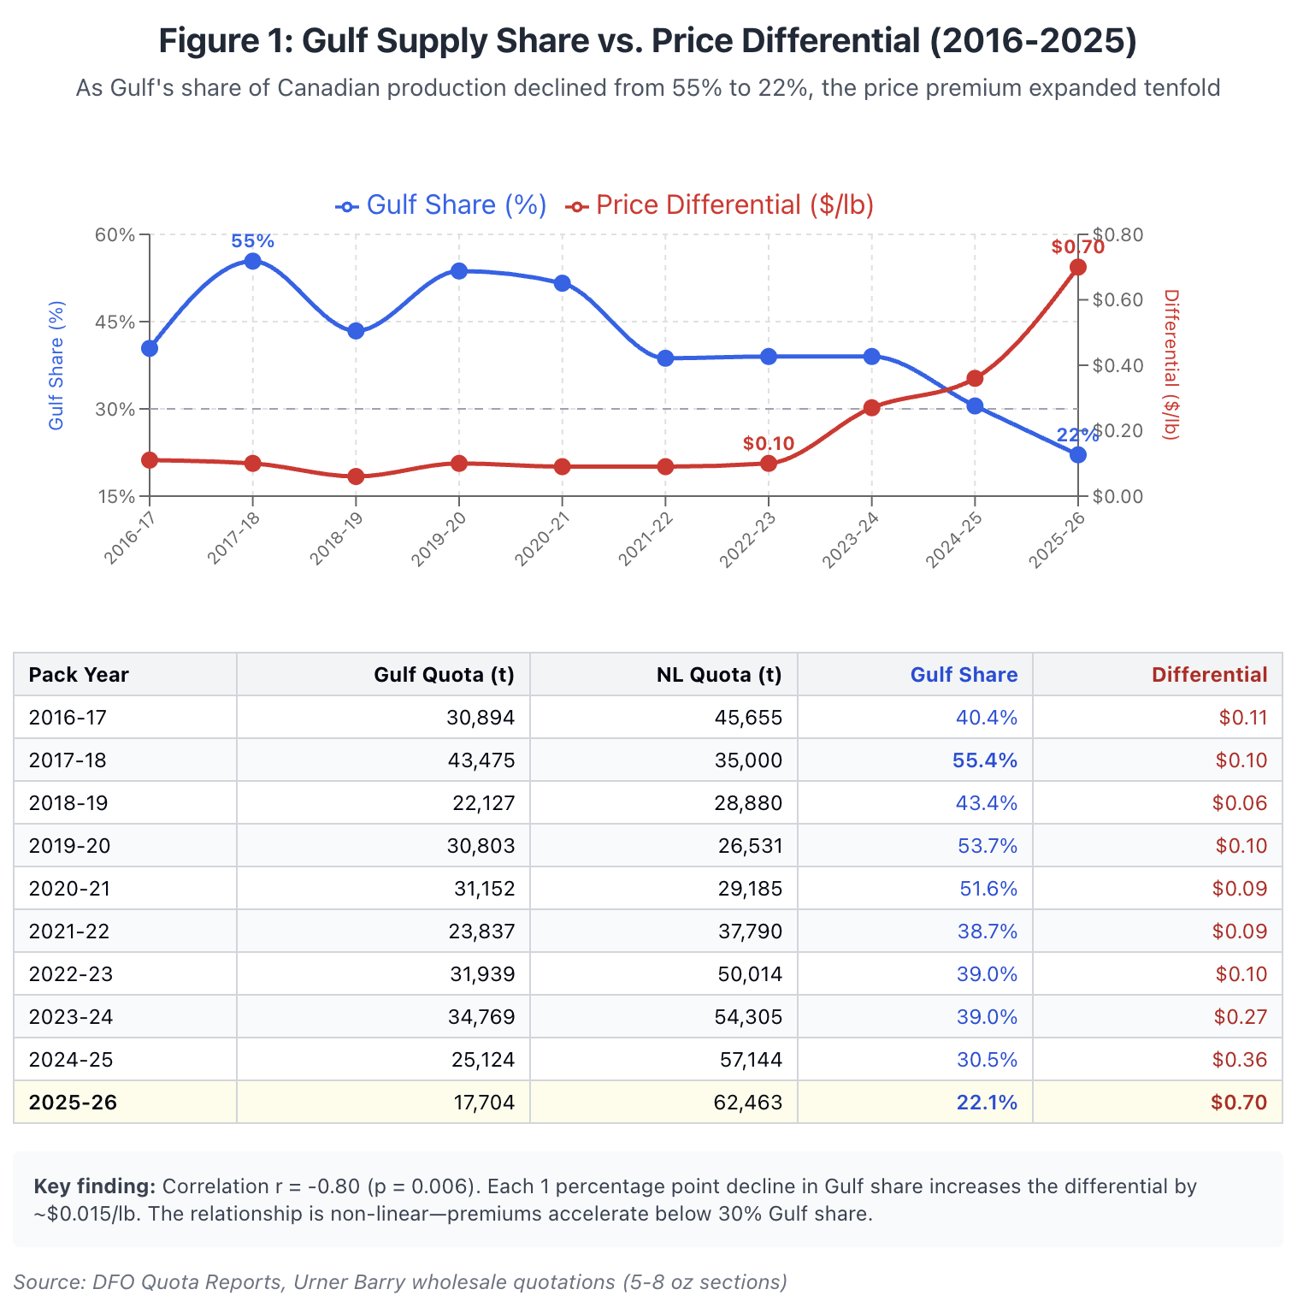

Figure 1: Gulf Supply Share vs. Price Differential (Link to interactive chart.)

The question is whether these two trends are connected, or whether they merely occurred simultaneously.

2.2 Ten-Year Statistical Analysis
The effect of supply on price for Gulf crab is dramatic. The statistical correlation r value of -0.80 shows how strong the connection is. There is less than a 1% chance that this is just coincidence, well above the 95% confidence level assumed in most statistical work.
The total volume of Gulf crab also matters a lot. Each percentage point decline in the Gulf's share adds roughly a penny and a half to the differential. The Gulf's share dropped about 30 percentage points between 2017 and 2025. Multiply that by $0.015 and you get $0.45 — which accounts for the bulk of the premium expansion we observed.

But the relationship isn't a straight line. As the total volume declines, the price differential becomes more pronounced. When the Gulf represents half the market, prices stay close to parity because the overall supply is sufficient for all buyers who want Gulf crab to get it. If Gulf processors push prices too high, buyers shift to Newfoundland and prices correct. This mechanism keeps differentials tight. There are not enough buyers who will pay the premium. If prices are high, they switch to Newfoundland crab, and the market forces keep the differential narrow.

But when the Gulf volume falls below 30% the buyer behavior begins to change. The buyers still purchasing Gulf crab at that point are the ones who specifically want it — those with established relationships with Gulf buyers, those retailers whose customers specifically expect Gulf-origin product, and those buyers who choose Gulf crab for other reasons. These buyers bid against each other, and become less price-sensitive. They'll pay the premium rather than switch.

When we added a quadratic term to the regression — allowing for this acceleration effect — the model's explanatory power jumped from 64% to 94%. The data strongly suggest that below 30% Gulf share, premiums don't just grow, they accelerate.

At 22% Gulf share — the 2025 level — our supply-based model predicts a differential of about $0.53 per pound. The actual differential averaged $0.70 for the pack year and peaked above $1.40 in April. Supply dynamics explain most of the premium, but not all of it. The timing of the harvest and the panic over potential tariffs in April amplified the differential in 2025 and we will discuss that aspect in section 3.

2.3 Historical Regime Shift: From $0.10 Baseline to Structural Premium
For most of the past ten years, Gulf crab traded at a modest premium over Newfoundland, normally between $0.10 and $0.15. Because this was the case for the past 8 years it seemed like a fixture of the market. Harvesters, processors, and buyers all calibrated their expectations around it.
That baseline is now obsolete.

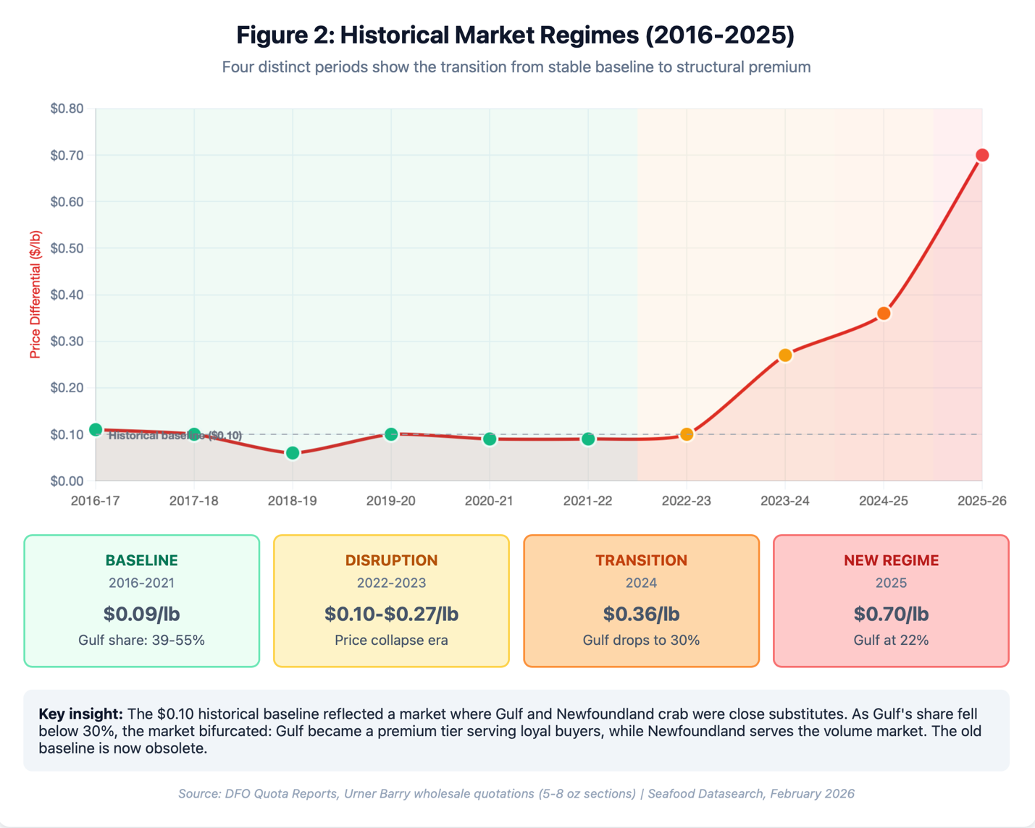

Figure 2: Historical Market Regimes with Price Differential (Link to interactive chart)
Looking at the ten-year record, we can identify four distinct market periods. The first runs from 2016 through 2021. During this era, Gulf represented between 39% and 55% of combined production, and the differential held remarkably stable at $0.06 to $0.11 per pound. Year after year, regardless of whether prices were rising or falling, the gap between Gulf and Newfoundland stayed narrow. This was the period that established the $0.10 baseline in everyone's mental model.
The second period covers 2022 and 2023. These were the years of the post-pandemic price collapse, when wholesale crab prices fell from over $16 per pound to under $6. During this disruption, the differential briefly widened to $0.27 in the 2023-24 pack year — the first signal that something was changing — but any impacts were dwarfed by the broader market chaos as prices collapsed after the run-up in pandemic demand.
The third period is the 2024-25 pack year which was a transition as the Gulf's share of production dropped to 30.5%. This is where statistical models showed the price differential accelerating. The differential expanded to $0.36 — more than triple the historical average.
The fourth period is 2025, which broke all previous patterns. The Gulf share fell to 22%, and the pack year differential averaged $0.70. At its peak in April, the differential reached $1.40.
It was not quality, nor processing choices, nor buyer preferences. Those factors remained largely constant. What changed was supply composition. Gulf went from representing half the market to representing barely a fifth.
The $0.10 baseline differential reflected a market where Gulf and Newfoundland crab were close substitutes competing for the same buyers. That was because the universe of buyers who had a strong preference for New Brunswick crab was much smaller than the volume of production. But when the volume changed so that these buyers were competing for a limited supply, gulf crab became a premium product serving buyers who specifically want it and will pay for scarcity. With the 2025 distribution of crab quotas, Newfoundland serves the volume market, and the Gulf serves a specialty market that wants Gulf crab. If these volume relationships persist, the division of the crab market into these two separate categories will continue. These are increasingly separate categories, and pricing them against undifferentiated market demand no longer makes sense.

Section 3: Why 2025 Was Extreme
The ten-year regression explains the underlying trend—but it cannot explain why the April 2025 differential reached $1.50 per pound when the model predicted roughly $0.53. The additional $0.97 came from somewhere, and finding it required looking beyond quotas to the mechanics of how crab actually moves into the market, and who is buying it.

3.1 Tariff-Induced Front-Loading
Even before the 2025 season opened, we knew tariff chaos was possible. In February of 2025 when Trump was threatening to impose tariffs on Canada I wrote:
If the chaos and turnabout seen in recent weeks continues, the uncertainty about business conditions and costs will have a similar effect on buyers as would an actual tariff. Whether a 25% tariff comes into effect or not becomes less important than the risk that it might happen. This would cause buyers to demand an instability premium to take the risk of holding product."

"But it could also spur more compressed buying. Especially if crab production starts prior to any tariff being finalized, buyers may bid against each other to get product across the border quickly. This happened when the Russian crab ban was announced. At that point buyers had a few months to get product on the water before the cutoff, and they managed to buy almost a year's worth of Russian crab. With Trump the date is unpredictable, but with the uncertainties, buyers may act in a similar fashion even if no tariff has been announced."
-Seafood Datasearch Market Analysis, February 2025

This is exactly what happened. By April, it appeared that Canadian food products would be exempt from tariffs under the USMCA, and Trump had agreed to honor it. But no one was sure that position would stick. The result was huge pressure to get crab across the border as quickly as possible.
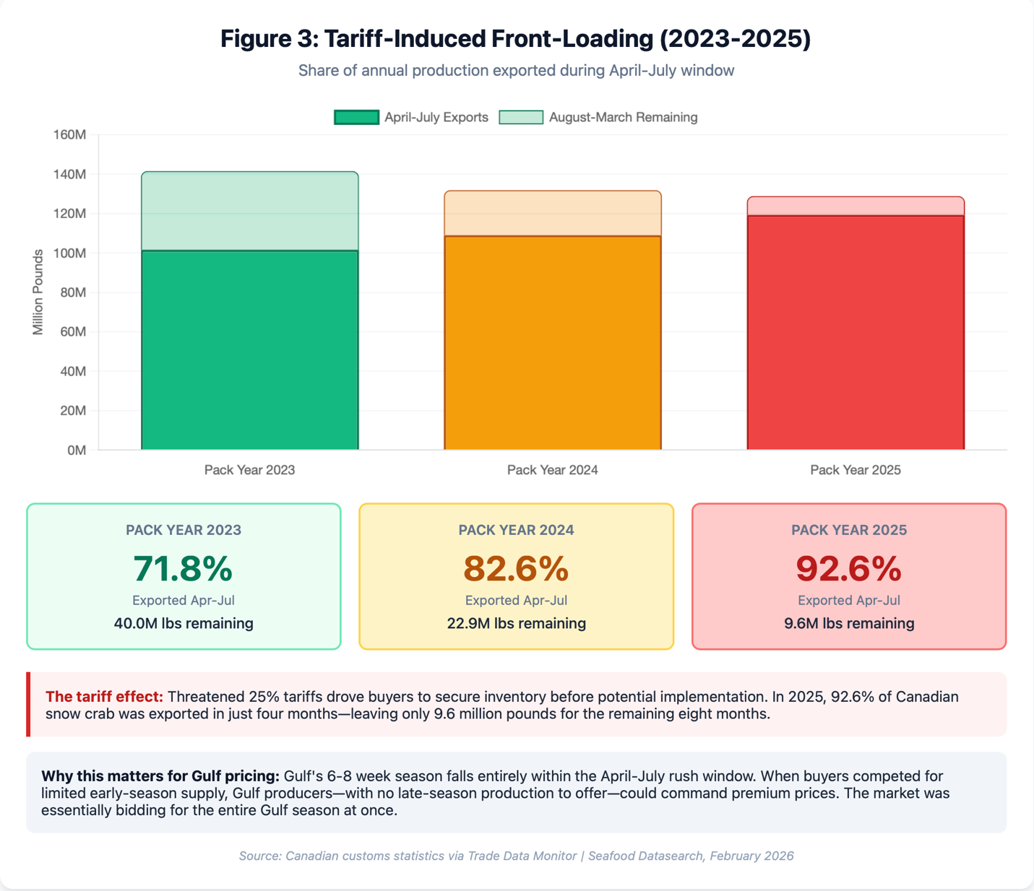

Figure 3: Tariff Induced Front Loading (Link to interactive chart)

In the April-July period, 92.6% of the total pack came across the border. The season began with zero carryover inventory. The moderate prices of the past two years had spurred consumer interest in crab, and both retail and foodservice buyers had little inventory and felt moderately confident about future sales. At the same time, total production declined 9% from 2023 levels (141.6 million pounds to 1
Finally, the U.S. absorbed 92% of April-July total exports as Chinese demand collapsed from 5.3 million pounds in 2023 to just 2.2 million in 2025. Every producer was concentrating almost exclusively on the US market.

3.2 Regional Season Timing: Why Gulf Was Most Affected

The front-loading phenomenon did not affect Gulf and Newfoundland equally. Due to differences in season timing, Gulf crab bore the brunt of the tariff-induced compression.
The Gulf of St. Lawrence season opens in early-to-mid April, peaks in April and the first half of May, and is essentially complete by early June—a total window of six to eight weeks. Newfoundland’s season normally opens later (late April to early May), peaks at the end of May when 50% of total quota is normally landed, and then winds down by the end of June with smaller amounts harvested in July or August. The result was that nearly 100% of the Gulf crab was harvested during the peak tariff panic, while only about 45% of Newfoundland production was harvested during that period.
This meant that the entire Gulf pack was subject to bidding based on uncertainty as well as scarcity, while for Newfoundland by the second half of the season, the tariff uncertainty had begun to recede. In other words, buyers who wanted Newfoundland crab could afford to wait to see where the market was going to settle, and did not need to capture their share of a scarce resource.

3.3 Seasonal Pattern Inversion
This timing mismatch inverted the historical seasonal pattern of the price differential.
In normal years, the differential tends to be narrowest at season opening—when both areas have product available—and widens later in the year as supplies tighten. The 2023 pack year showed this classic pattern: differentials around $0.10 in April widened to $0.35-$0.40 by winter.
In 2025, the pattern reversed. The differential peaked at $1.50 in April, then progressively narrowed through the year—reaching $0.80-$1.10 in June-July, $0.25-$0.45 by fall, and converging to just $0.10 by January 2026.

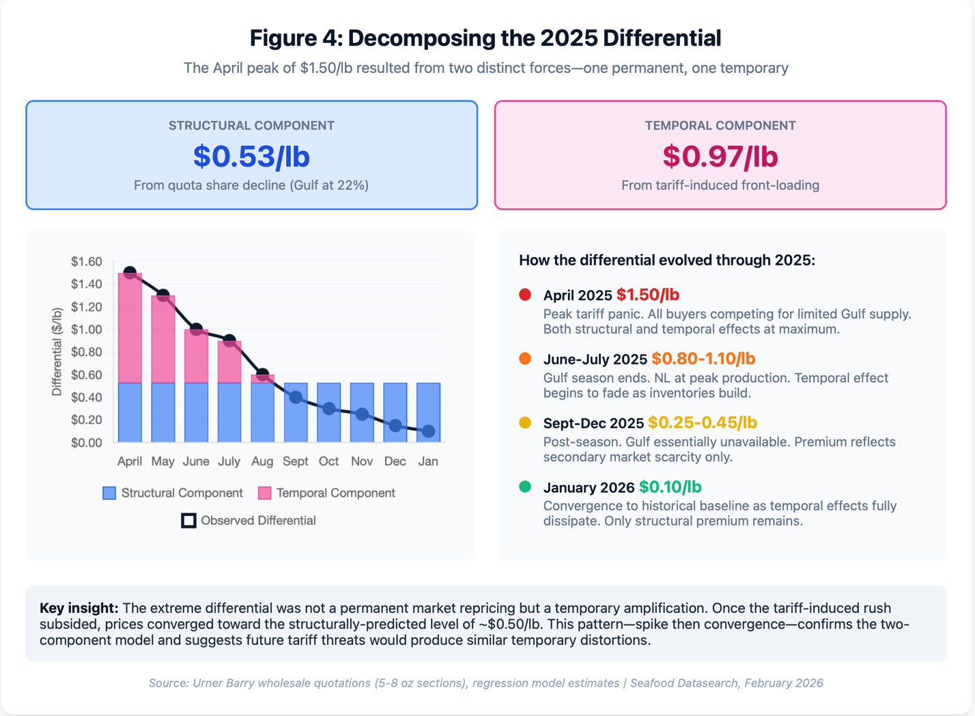

Figure 4: Decomposing the 2025 Price Differential (link to interactive chart)

This inversion makes sense in light of the front-loading dynamic. In April, buyers competed desperately for any available product while tariff uncertainty was highest. The Gulf—with its reduced quota and earlier, shorter season—was the primary target. In the rest of the year as tariff concerns eased and inventories tightened, the market returned to something approaching a more normal price differential when both sources of crab are depleted..
The disappearance of our “tariff premium” by August is particularly telling. One that panic subsided the structural factor of reduced supply accounted for the entire price differential.

3.4 Buyer Behavior: Retailer Loyalty and the Concentration of Gulf Demand
If front-loading explains the supply side of the 2025 spike, we also need to understand how the demand side supported this front loading by bidding up prices, or accepting higher prices. Most snow crab is sold at retail, and the large retail buyers are the ones who set prices during the season when they sign contracts based on their projected annual need for crab.
In order to test the idea that reduced Gulf quotas would lead certain buyers to bid up the price in 2025 we looked for signals that could show us retail buyer behavior. The retailer analysis relies on data from Canadian customs records to U.S. state-level import data. Canadian exports are reported by province of origin, which provides a clean proxy for crab origin: New Brunswick processors handle Gulf of St. Lawrence crab, while Newfoundland processors handle product from the NAFO divisions around the island. Not all provincial data is reliably reported by destination state, but a significant enough portion (30-40%) was reported that way. By tracking monthly exports from each province to each U.S. state, we can see where Gulf crab goes versus where Newfoundland crab goes.
The key metric is "NB Share"—the percentage of a state's combined New Brunswick plus Newfoundland imports that comes from New Brunswick. A state with 50% NB Share is buying Gulf and Newfoundland in equal proportion; a state with 10% NB Share is overwhelmingly buying Newfoundland product.
So the first thing was to measure changes in state level purchases as the percentage of NB crab volume decreased. The analytical question is simple: as Gulf supply tightened from 51.6% of total production in 2020 to 22.1% in 2025, did each state's NB Share track that decline, or did it diverge? We calculated the Pearson correlation between each state's annual NB Share and Gulf's overall supply share across the six-year period.
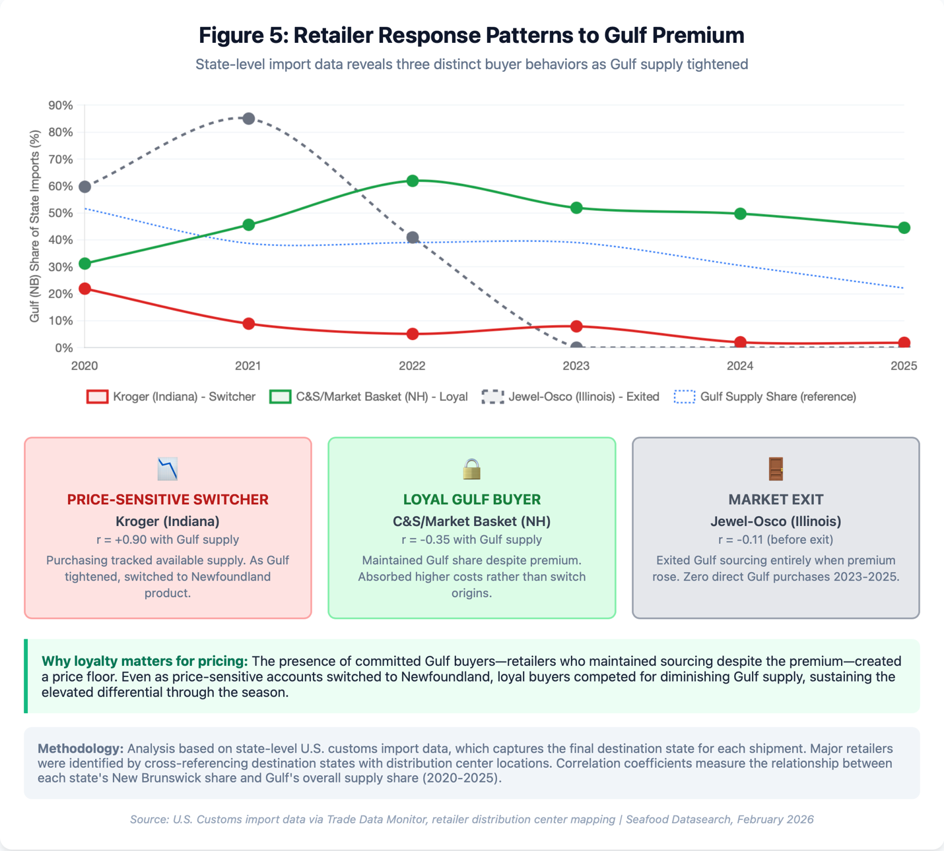

Figure 5: Retailer Response Patterns to Gulf Premium (link to interactive chart)
The challenge with state-level import data is attribution. A shipment arriving in New Jersey could end up at any number of retailers. To make the analysis meaningful, we focused on states where the signal was cleaner—states where a single retailer dominated the distribution infrastructure and where imports bypassed the Massachusetts redistribution hub.
Massachusetts receives nearly half of all Canadian crab exports and redistributes it throughout the Northeast, which obscures where the product actually is sold. We set that market aside and looked for states with direct import patterns. Indiana stood out because it hosts Kroger's Central Division headquarters and multiple distribution centers—imports to Indiana are essentially Kroger imports. New Hampshire is home to C&S Wholesale Grocers' headquarters, the largest wholesale grocery distributor in the country, which supplies Market Basket and other New England chains. Illinois serves Jewel-Osco's primary distribution network. In each case, we could draw a reasonable line from customs data to corporate sourcing decisions.
We also needed sufficient volume and time series consistency. States had to appear in the top tier of import value and show data across all six years from 2020 through 2025 to calculate meaningful correlations. Florida made the cut on volume but presented attribution problems—Publix, Walmart, and Costco all operate major facilities there, so we flagged those findings as lower confidence. The same caution applies to any multi-retailer state where the import data reflects a blend of purchasing decisions rather than a single corporate strategy.
Once we had identified retailers that we could analyze, we looked for any patterns in their purchases of New Brunswick crab. As we anticipated, there were a variety of responses to the increase in premium over time.
A strong positive correlation (like Kroger's r = +0.90) means the state's Gulf purchasing moved in lockstep with Gulf supply—when Gulf was plentiful, they bought it; when it tightened, they switched to Newfoundland. These are price-sensitive buyers who respond to market conditions by switching away from the more expensive product.
A negative correlation (like C&S/Market Basket's r = -0.35) indicates the opposite: the state actually increased its relative Gulf share as supply tightened. These buyers maintained or expanded Gulf sourcing despite rising premiums—absorbing the cost rather than substituting. These types of buyers are loyal to Gulf crab, and competitive bidding among them was a key factor in maintaining the price differential.
Interestingly, Jewel Osco in Illinois appeared to switch entirely away from Gulf crab as the premium increased. Publix had no clear pattern, and appeared to be an opportunistic purchaser, in that how much Gulf crab they purchased had no correlation with the amount of Gulf crab available.
The limitations of the data, where most product comes to Massachusetts first, and that many states have multiple retail distribution centers, meant that in only a few cases could we get a clear signal. Nevertheless, for the retailers we could analyze, the behavior clearly supports our theory that some buyers remained loyal to Gulf crab as volume declined, and bidding among these buyers for a limited supply contributed to the price premium that developed.

Section 4: Decomposing the 2025 Differential

4.1 Structural vs Time Related Components
The April 2025 differential of $1.50 per pound was not a single phenomenon. It was two phenomena stacked on top of each other.
The first component is structural—the predictable premium that emerges when Gulf's share of total Canadian production falls. Our ten-year regression established this relationship with high confidence: as Gulf supply tightens relative to Newfoundland, the Gulf commands an increasing premium. The 2025 quota share representing only 22.1% was the lowest in ten years. The model predicts a differential of approximately $0.53 per pound based on scarcity. This is the baseline premium we would expect in a normal market year with the Gulf at historically low levels.
The second component is temporal—the additional premium caused by the tariff-induced front-loading that compressed an entire year's purchasing into the Gulf’s 8 week season. It is normal to of course land all the crab for the year in a short window. What was different in 2025, in addition to the smaller volume in the Gulf, was the tariff panic. In a normal year buyers will purchase some product during the season and then continue to purchase out of inventory over the next few months, often with informal arrangements where the volumes are expected, but the final price has not been negotiated. This could not work in a year when tariffs could be applied at any point in the future. So both Gulf and Newfoundland buyers had to lock in secure contracts and get product across the border as soon as possible. This distortion amplified the structural scarcity by forcing all buyers to compete for Gulf product simultaneously, rather than spreading demand across a longer cycle. In our model the timing factor accounts for the remaining $0.97 per pound.
Together, these two forces explain the April peak: $0.53 structural plus $0.97 temporal equals $1.50 observed. The decomposition matters because it tells us what to expect going forward. The structural component reflects a real and persistent shift in supply composition—Gulf quotas are unlikely to return to 50% of Canadian production anytime soon. The timing factor reflects a one-time distortion that began unwinding as soon as the tariff panic subsided. It is worth noting that by the time it became clear that the tariff risk had lessened for the season, Gulf production was done, but Newfoundland still had 45% of its quota to catch.

4.2 Monthly Convergence: How the Temporal Premium Dissipated

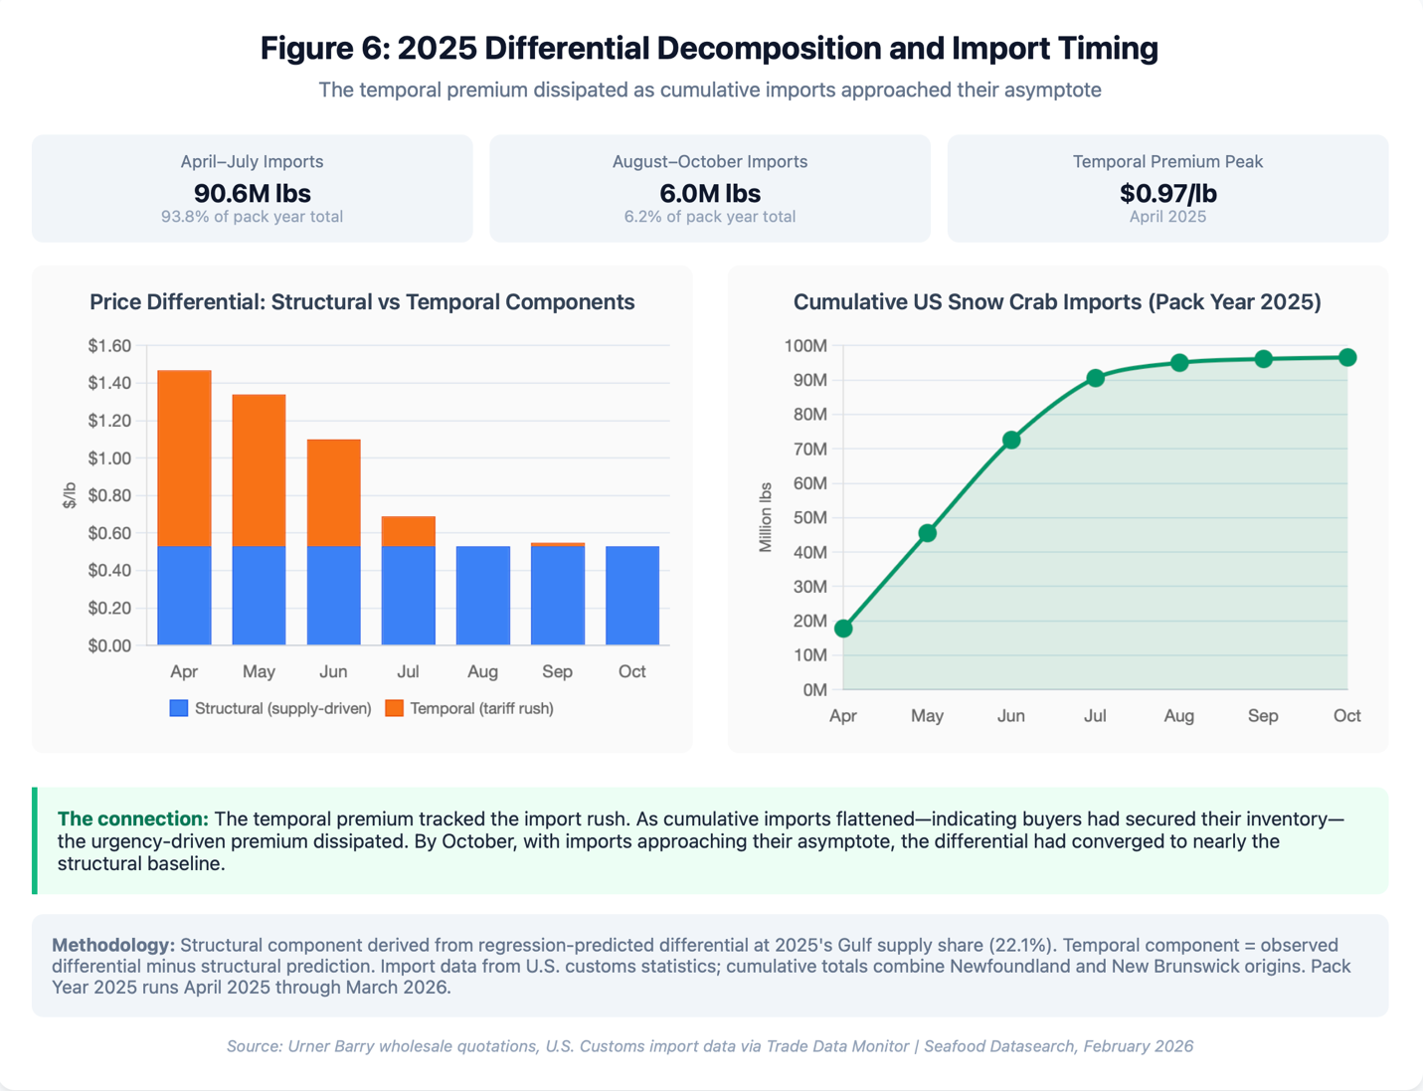

Figure 6: Price Premium Changes and Import Timing (Link to interactive chart)
The decomposition framework predicts a specific pattern: if the temporal premium stems from tariff-driven urgency, it should dissipate as buyers complete their purchasing. If, for example, the premium existed due to some type of market or quality difference, it would be more persistent over time. We can test this by tracking how the differential evolved month-by-month and comparing it to the pace of imports.
The pattern is unmistakable. In April, the total differential stood at $1.47 per pound—our model attributes $0.53 to structural factors and $0.94 to the temporal rush. By May, as cumulative imports reached 45.5 million pounds, the differential had already begun narrowing to $1.34. June brought the steepest import volumes of the season—another 27 million pounds—and the differential dropped to $1.10.
The convergence accelerated through the summer. By the end of July, cumulative imports had reached 90.6 million pounds, representing 93.8 percent of what would ultimately arrive during the pack year. The differential had fallen to $0.69. With the bulk of purchasing complete, the premium to get product over the border quickly had largely evaporated.
August through October tell the rest of the story. These three months added only 6.0 million pounds to the cumulative total—the curve went nearly flat. The differential followed suit, settling into a range of $0.47 to $0.55, essentially at the structural baseline our regression predicted for a year with Gulf's 22 percent supply share.

The timing correlation is not coincidental. Buyers who needed to secure inventory before potential tariff increases had accomplished that goal by midsummer. The September and October markets operated under normal conditions—limited Gulf supply still commanded a premium, but the panic had passed. What remained was the structural reality of a constrained supply source competing against an abundant one.

4.3 Size Differences: Why 8-Up Stayed Elevated

The differential did not behave uniformly across product grades. Comparing the 5-8 oz and 8 -up sizes shows that the premium for 8 ups responded differently than 5-8’s . 5-8 oz is the dominant retail pack size, and it showed the most responsiveness to buyer panic and to the structural factors of scarcity. 8 ups had a more consistent premium, that did not dissipate as much over time. This suggests that for the 8 ups, there is a perceived quality difference that buyers are willing to pay for. It is most likely associated with color and the lack of barnacle scars which is why area 12 crab in the Gulf has been consistently preferred by Japanese buyers selling directly into shell on uses in Japan, such as for shabu shabu and other presentations where the shell is partially present.
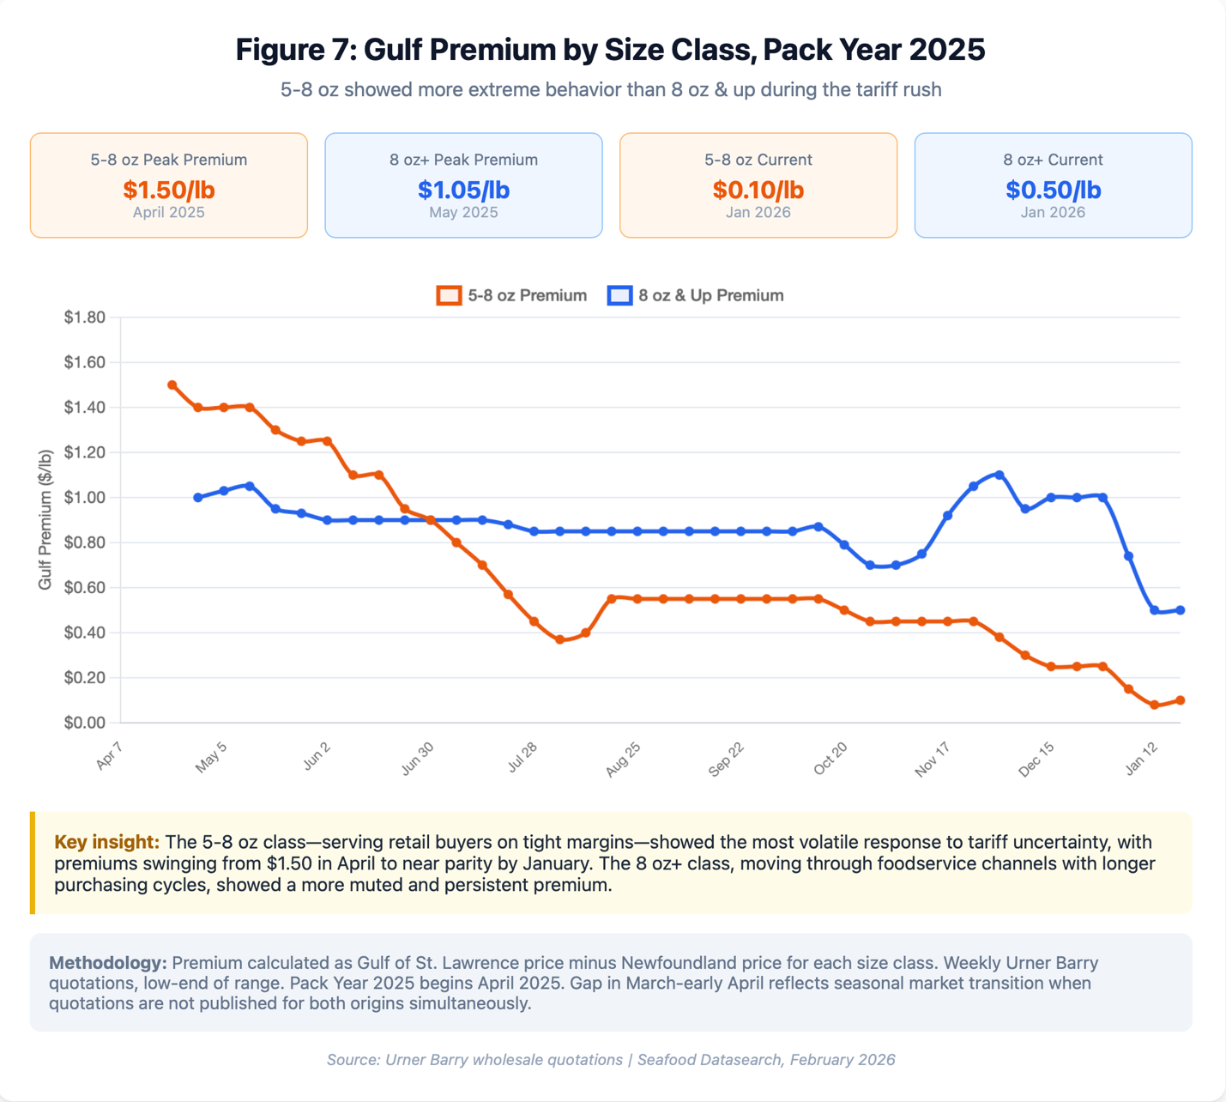

Figure 7: Gulf Premium by Size Class for Pack Year 2025 (Link to interactive chart)
Premiums for the 5-8 oz pack showed more volatility In April Gulf 5-8s had the highest premium of $1.50, well above the premium for 8 ups. But as crab was sold and buyers who needed NB crab filled their orders, the 8 oz premium remained elevated. Through July, August, and into September, it held in the $0.85 to $0.90 range even as the 5-8 gap collapsed.
This divergence makes market sense. The 5-8 ounce segment serves primarily retail accounts predictable promotional calendars and year round sales plans. These buyers were most exposed to tariff uncertainty and had the strongest incentive to front-load purchases.
The 8-up market operates differently. Although some retail buyers seek 8 ups, foodservice has more incentive to buy larger crab. In some presentations, their per lb cost for large crab is lower than their per lb cost for the same presentation with 5-8 oz As a result the 8 up product serves a more price-inelastic customer base. These structural factors muted both the initial spike and the subsequent convergence.
The size class comparison reinforces our core finding: the 2025 differential reflected market behavior, not product quality. The same crab processed the same way, commanded different premiums depending on which buyers were scrambling to secure it.

4.4 The Japanese Factor
The US market was not the only source of demand pressure on Gulf supply. Japanese buyers represent a distinct market segment that specifically seeks Gulf-origin crab and competes directly with American purchasers for limited production.
We obtained provincial-level export data to test whether Japan's purchasing patterns align with the quality differentiation described earlier. The results were striking. Over the past six years, New Brunswick—our proxy for Gulf of St. Lawrence origin—has supplied between 83 and 95 percent of all Canadian snow crab exports to Japan. This is both raw crab and cyrogenic frozen crab, typically not brine-boiled. The brine-boiled crab goes to processing plants in China and Southeast Asia where it is processed into crab meat and then sent to Japan. The Japanese prefer Newfoundland brine-boiled crab because they get a better yield, and because the discoloration that occasionally appears does not matter in this application.

In 2025, all of Japan's Canadian snow crab imports came entirely from the Gulf.
The brighter orange-red shell characteristic area 12 crab commands documented premiums of 20 to 30 percent in Japanese markets. These buyers do not view Newfoundland crab as an acceptable substitute; they are wlling to pay more rather than switch origins when availability tightens.
The practical effect is an additional demand-side driver on Gulf prices. When Japanese buyers compete with American retailers and foodservice distributors for limited Gulf production, they add upward pressure that would not exist if they were willing to source from either origin. The roughly 1,200 to 1,400 tons Japan purchases annually represents a modest share of total production, but these are buyers who will pay premium prices to secure specific product characteristics—exactly the dynamic that amplifies price differentials during supply constraints.

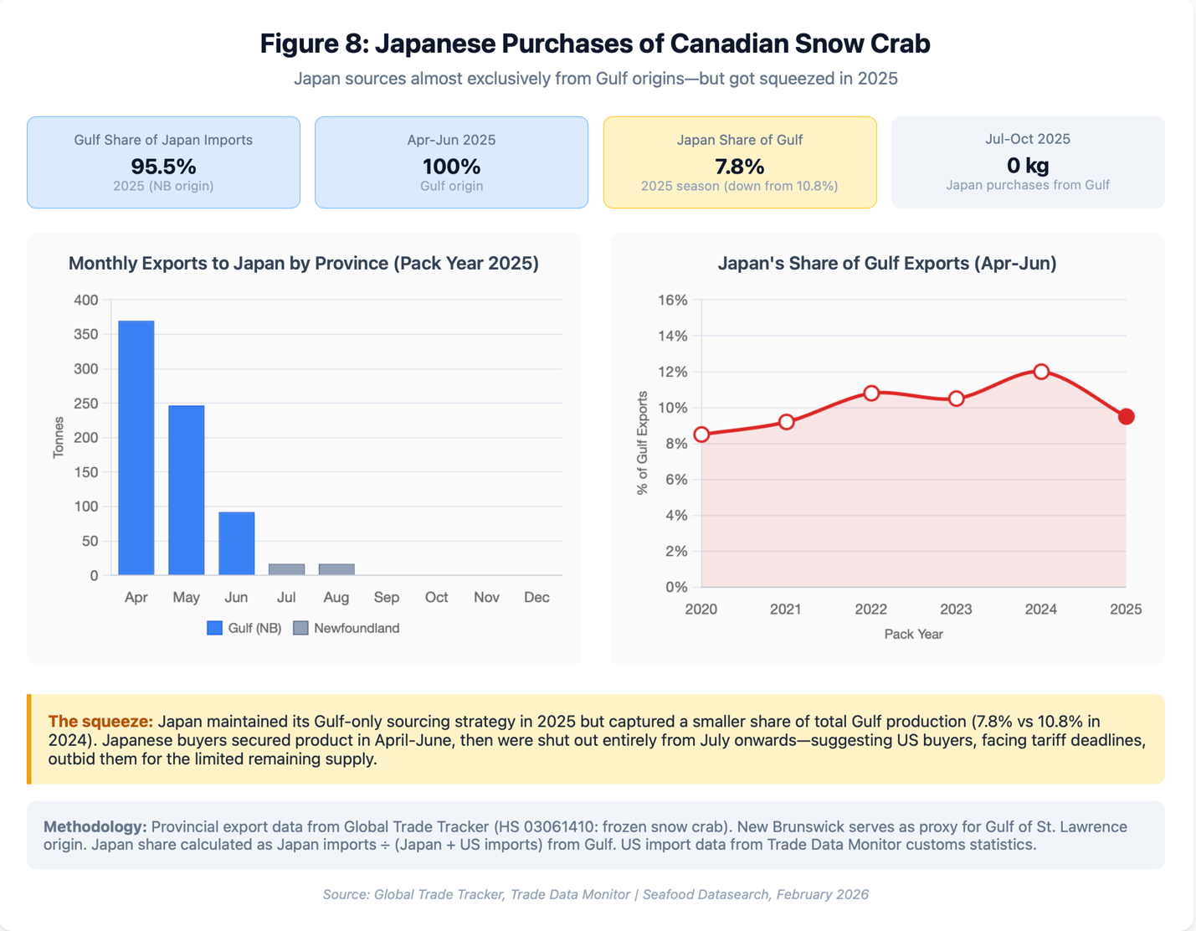

Figure 8: Japanese Purchases of Canadian Snow Crab (Link to interactive chart)

Section 5: Data Limitations and Negative Findings
Any analysis of regional price differentials in Canadian snow crab runs into a fundamental problem: the data that would answer the question directly does not exist in accessible form. Customs statistics do not break out shipments by fishing area or size grade. What crosses the border gets recorded as Canadian snow crab—a mixture of sizes, qualities, and provincial sources collapsed into aggregate figures. We tested whether customs unit values could reveal regional price differences. They could not. Monthly averages swung wildly based on product mix, not market conditions.

We therefore split our data sources by purpose. Customs data measured volume. It does that well. Total pounds by month, is reliable and comprehensive. For prices, we turned to Urner Barry, which publishes separate quotations for Newfoundland and Gulf origin, broken out by size class. This is the only commercial source maintaining consistent origin and grade distinctions over time.

The trade-off is that our price findings apply to the wholesale section market Urner Barry tracks. Direct processor contracts may vary from the Urner Barry quotations. We also cannot observe processor inventories or forward contracting.

Several questions remained beyond our reach. Most importantly we know there is a product-based premium for Gulf crab. Our analysis was that this was not an important factor in the 5-8 premium of Gulf over Newfoundland product. Instead the historical premium of $0.10 to $0.15 may represent something product based, but this effect was obliterated by the much bigger effects of a sever reduction in Gulf crab quota, and the extreme front loading of purchases in 2025 that encompassed the entirety of the Gulf season.

The Japanese trade data confirmed quality-based segmentation exists, but we cannot quantify its contribution to the US wholesale differential.

Section 6: Implications and Outlook
We set out to explain why the price differential between Gulf and Newfoundland snow crab reached record levels in 2025. We found that there were valid factual explanations that could be documented using statistical analysis. We did not find any pattern that suggested collusion or market manipulation on the part of processors who own plants both in the Gulf and Newfoundland. Instead, we found that 2025 fully reflected historical factors that have existed for many years.
Our analysis identified two distinct components operating simultaneously.
The first is structural. When Gulf supply falls below roughly 30 percent of the combined market, the price differential widens predictably. This relationship held across ten years of data with strong statistical significance. The mechanism is straightforward: Gulf crab serves buyer segments—Japanese importers, specific US retail accounts—that prefer or require Gulf crab. When Gulf supply tightens, those buyers bid up prices rather than switch to Newfoundland. The structural premium based on scarcity in 2025 was approximately $0.50 per pound. This structural premium will persist as long as the supply ratio remains in its current range.
The second component is temporal. The April 2025 differential exceeded $1.50—far above what supply contraction alone would predict. The difference traces to tariff-driven purchasing behavior. Faced with potential 25 percent duties, Canadian exporters and US buyers compressed a normal six-month purchasing cycle into three months. This demand surge hit when Gulf product first reached the market before Newfoundland's season had fully ramped up. Gulf producers captured the urgency premium. By the end of June, with inventories secured and the tariff panic receding, the differential converged toward its structural baseline. The tariff-panic premium was real but temporary.
For Newfoundland, the implications are that the lower market price compared to the Gulf is a structural discount that reflects market conditions that policy cannot easily alter. Gulf crab commands premium prices in Japan because of shell color characteristics suited to raw preparations. Gulf crab maintains some loyal US retail accounts built over years of relationship selling. These advantages derive from product characteristics and market history, not from information gaps or coordination failures that government intervention might address. Expecting the structural premium to disappear requires expecting buyer preferences to change. That is possible over longer time horizons but is not a basis for near-term planning.
The timing issue is different. Newfoundland's fishery starts later and runs longer than the Gulf season. In normal years this matters little. In years with demand shocks—tariff threats, supply disruptions elsewhere, unexpected demand surges—the timing mismatch gives the Gulf an advantage if their season starts first. This is especially true in years when there is no carry over inventory and buyers are anxious to secure product immediately, and in years when the total volume of Gulf crab is low so that buyers who do not make immediate contracts risk being locked out of their preferred market. In 2025 these factors were extreme.
They will likely persist into the 2026 season. We know from current crab price behavior that inventories are very dry, and that all the product available from last year has been sold. So there will be dry market pressure on opening prices. But we are also likely to face another round of tariff uncertainty this year. The USMCA, under which food products from Canada and Mexico have no US duties is up for re-negotiation, and if Trump’s erratic behavior continues there very well could be threats and market uncertainty that would impact Canadian seafood exports. In this case we could again see a rush to purchase crab before any adverse trade consequences develop. The issue is not likely to be as extreme as it was in 2025, but it is important to recognize all three factors: lower Gulf quotas, time pressure on purchases, and low inventories will all be present at the start of the 2026 crab season.
Longer term the price differential will be primarily set by the relative market share of Gulf crab, and should it remain low, we should see a gradual erosion of the number of buyers willing to pay the premium. More and more of them will seek some type of substitute. We see the differential settling into a range determined primarily by supply shares. If Gulf quotas hold near current levels—roughly 20 to 25 percent of combined production—the structural premium should run $0.40 to $0.60 per pound under normal market conditions but may erode over time. Crab population growth that boost Gulf quotas would compress the differential; further Gulf quota cuts would widen it.
The Japanese market shows there is a ceiling on Gulf pricing power. Japanese buyers secured only 7.8 percent of Gulf exports in 2025, down from 10.8 percent in 2024. Even buyers willing to pay 20 to 30 percent premiums for specific product characteristics got outbid during the tariff rush. This suggests the 2025 temporal premium was extraordinary by any standard—not a new normal, but a stress test that revealed how far prices can move under extreme conditions.
The differential exists because markets work, not because they fail. Buyers pay more for Gulf crab because they value what Gulf crab offers—scarcity, specific quality attributes, established relationships. Newfoundland crab serves different market segments at different price points. Narrowing the differential requires either changing what buyers value or changing what Newfoundland offers. Neither happens quickly or easily.
The practical response is not to eliminate the differential but to understand it well enough to anticipate its movements and position accordingly. When Gulf supply tightens, expect wider spreads. When demand shocks hit early in the season, expect Newfoundland to bear the brunt. When markets normalize, expect convergence toward structural baselines. The 2025 season was not a mystery—it was the predictable result of identifiable forces operating on a market with known characteristics.

Appendix: Links to Interactive Charts
Figure 1: Gulf Supply Share vs. Price Differential https://data.seafooddatasearch.com/supply_differential_interactive.html
Figure 2: Historical Market Regimes with Price Differential https://data.seafooddatasearch.com/market_regimes_chart.html
Figure 3: Tariff Induced Front Loading https://data.seafooddatasearch.com/tariff_frontloading_chart.html
Figure 4: Decomposing the 2025 Price Differential https://data.seafooddatasearch.com/differential_decomposition_chart.html
Figure 5: Retailer Response Patterns to Gulf Premium https://data.seafooddatasearch.com/retailer_behavior_chart.html
Figure 6: Price Premium Changes and Import Timing https://data.seafooddatasearch.com/differential_and_imports_chart.html
Figure 7: Gulf Premium by Size Class for Pack Year 2025 https://data.seafooddatasearch.com/size_class_differential_chart.html
Figure 8: Japanese Purchases of Canadian Snow Crab https://data.seafooddatasearch.com/japan_gulf_exports_chart.html

