

**地址：广州市天河区五山路 381 号**

**邮编：510641**

**电话：020-22236906**

**网址：www.scut.edu.cn**

To Whom It May Concern,

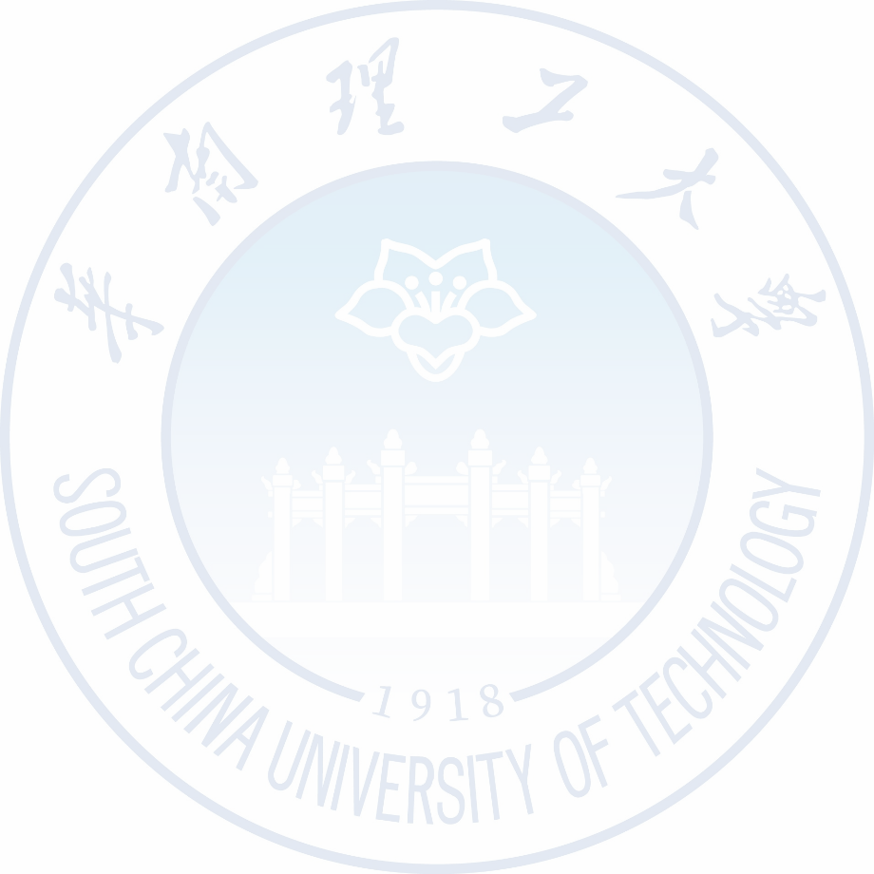

Sincerely,

Professor, Software School, South China University of Technology

Address: 381 Outer Ring East Road, Higher Education Mega Center, Panyu District, Guangzhou City, Guangdong Province, 510006

Email: