My Project Report

Candidate: 118487

Introduction to Multimedia

Computer Science Year 1

Submission date - 10th December 2013

1. Introduction

This report is for the coursework for the Introduction to Multimedia module. This report will briefly outline the steps taken in producing the website as part of the first year of Computer Science at Sussex University and how these steps were accomplished.

1. Design and Development

2.1 Website Development

The idea behind the design of the site was that it would be pleasing to the eye and gave a look of professionalism whilst not making it too complicated. The decision was made very early on to include a horizontal navigation bar running along the top of the page. It was common sense to have navigation allowing the user to easily switch between the pages and the horizontal decision was made due to having read an article on Smashing Magazine’s site (article link in references below) that made the case that vertical navigation bars were ‘an out-of-date method in modern web design’. The decision was then made that the site would be loosely ‘responsive’ in a sense, meaning that the navigation bar and similar elements would stretch along with the page when resized so that it would not matter about the size of the screen. As a result of this and a few other minor additions the website looks the same if viewed from any browser and also mobile devices, however the animation will not work on mobile devices. Having spent a large amount on the internet (probably too much) and after a quick check I realised that most sites use dark colours for the navigation bar and decided that this was a good idea. The site then needed a colour scheme. The colour scheme was reached by my wanting of a dark colour for the navigation bar, I decided on dark grey, and for the site to reflect myself with my favourite colour – blue. However two colours would be too plain and I feared that this would cause the user to lose interest very quickly. The idea was to use two extra colours as well as the dark grey and blue. These colours would have to work well with the dark grey and blue and be eye-catching yet not too bright such as to scare the user off or hurt their eyes. At this point I looked down at the pen that I was using and thought that the colour of the pen would work well. Using Adobe Photoshop the website was drawn up using the colours and an image previously selected and this was the outcome.

Nice orange colour, not too bright. Colour shows on active page and on scroll over with mouse

Simple head and shoulders type photograph. Not bright colours. Goes well with colour scheme

Dark colour for navigation bar, simple and works well with other colours

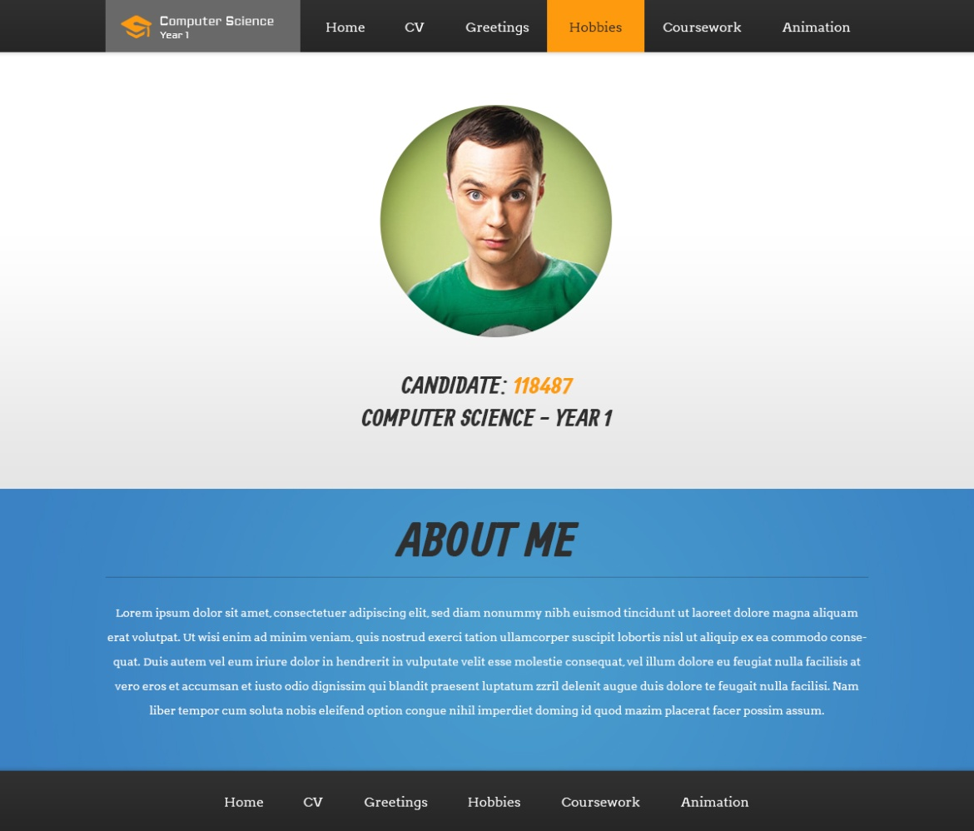

Separate section for text allowing user to easily understand layout

1. Conclusion

Figure 1. Example Homepage with horizontal navigation bar

Navigation at the bottom allowing user to navigate without having to scroll to the top. Replaced with the credit and a simple home link later on, as it seemed redundant.

Having turned the design into HTML and CSS, focus turned to the video greeting. Although the specification for the coursework greeting said ‘This should contain a short (less than 10 second) video clip of you introducing your site’ I came to the conclusion that this would be a little boring a similar to most other sites, so I wanted to do something slightly different. I decided that it would be a nice touch to video myself working on the production of the site and have myself typing out the greeting on-screen. This was made possible with the help of a friend with a video camera. Final Cut Pro was then used to edit the video into its final state. The video was then uploaded to YouTube and embedded on the page, as a result of embedding the video this way the video contains all of the available controls through YouTube such as volume, quality and full screen allowing optimal experience for the user.

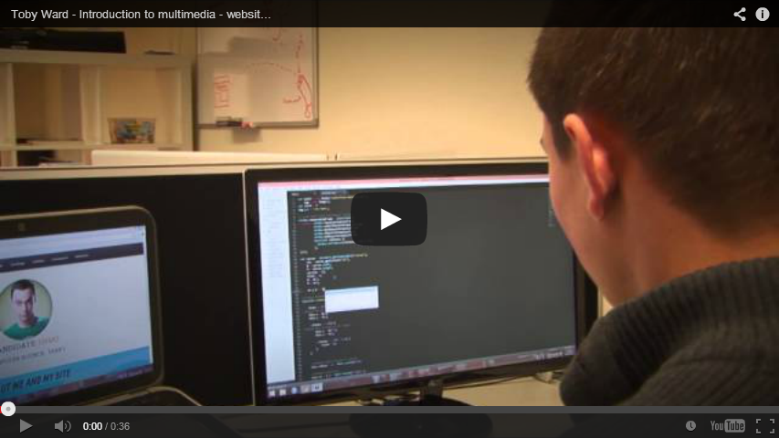

Image 2. Embedded YouTube video greeting

2.2 Animation Development

The animation proved the most complex of the tasks and I really struggled with this part of the coursework. I was able to think of an idea, which was to create a simple music visualiser and was able to implement this. However synchronising this with the music proved more complex than my original thoughts due to the limitations of the musical functions and the complexity of the task and It was already too late to change the idea as that would not have left me with enough time to implement it, so I had no choice but to do the best I could with the existing idea. I have managed to synchronise the music with the animation to a certain extent but am not happy with how I have had to leave it. The shape, motion and colour changes are implemented by the random direction, colours and sizes of the circles that are seen throughout the animation. Due to the animation being the full length of the song I have added controls to the animation allowing the user to pause or skip to any point in the animation as they wish or even mute the sound. The reason for this being that the user may not want to listen to the music for the whole song.

1. Conclusion

I am very happy with the outcome of the project. I was able to implement almost every idea that I came up with whilst planning my website and more as I went along. I am extremely pleased with the design and the video as there were the things that took me the longest to work on and I think that they have turned out very well. I am disappointed with the outcome of the vector animation, I would have liked to do a better job but I just wasn’t able to improve it any more. If I had more time I would have spent a lot more time on the vector animation in order to try to get it perfectly as I wanted.

1. References
2. Louis Lazaris. (2010). *The Case Against Vertical Navigation.* Available: http://www.smashingmagazine.com/2010/01/11/the-case-against-vertical-navigation/. Last accessed 07/12/2013.
3. Sheldon Cooper **[Image]** At:http://ladygeekgirl.wordpress.com/2013/08/10/in-brightest-day-sheldon-cooper/ (Last accessed on 29/11/13)