Modelling and Control of Bidirectional DC-DC Converters for Electric Vehicles
By Chen Jing Wong, Toby

Supervisor: Dr. Salma Alarefi
Assessor: Dr. Li Zhang
Electronic and Electrical Engineering
University of Leeds

Declarations of Academic Integrity

The standard declarations of academic integrity to be signed at Registration and on submission of coursework are set out below.

A. To be signed at Registration:
When you become a registered student of the University at first and any subsequent registration you sign the following authorisation and declaration:

“I confirm that the information I have given on this form is correct. I agree to observe the provisions of the University's Charter, Statutes, Ordinances, Regulations and Codes of Practice for the time being in force. I know that it is my responsibility to be aware of their contents and that I can read them in the Taught Student Guidance (available on the University web site: http://students.leeds.ac.uk/taughtstudentguidance). I acknowledge my obligation under the Paying Fees section in the Guide to pay all charges to the University on demand. I agree to the University processing my personal data (including sensitive data) in accordance with its Code of Practice on Data Protection. I consent to the University making available to third parties (who may be based outside the European Economic Area1 ) any of my work in any form for standards and monitoring purposes including verifying the absence of plagiarised material. I agree that third parties may retain copies of my work for these purposes on the understanding that the third party will not disclose my identity.”

B. To be signed and receipted with all submitted coursework:
The Declaration, in two forms, given below has been approved by the University. Schools may elect to add to this declaration as they see fit provided that the provisions of the University’s Declaration are included.
- For Individual pieces of work
I am aware that the University defines plagiarism as presenting someone else’s work, in whole or in part, as your own. Work means any intellectual output, and typically includes text, data, images, sound or performance. I promise that in the attached submission I have not presented anyone else’s work, in whole or in part, as my own and I have not colluded with others in the preparation of this work. Where I have taken advantage of the work of others, I have given full acknowledgement. I have not resubmitted my own work or part thereof without specific written permission to do so from the University staff concerned when any of this work has been or is being submitted for marks or credits even if in a different module or for a different qualification or completed prior to entry to the University. I have read and understood the University’s published rules on plagiarism and also any more detailed rules specified at School or module level. I know that if I commit plagiarism I can be expelled from the University and that it is my responsibility to be aware of the University’s regulations on plagiarism and their importance. I re-confirm my consent to the University copying and distributing any or all of my work in any form and using third parties (who may be based outside the EU/EEA) to monitor breaches of regulations, to verify whether my work contains plagiarised material, and for quality assurance purposes. I confirm that I have declared all mitigating circumstances that may be relevant to the assessment of this piece of work and that I wish to have taken into account. I am aware of the University’s policy on mitigation and the School’s procedures for the submission of statements and evidence of mitigation. I am aware of the penalties imposed for the late submission of coursework.
- For Group Work
On the understanding that other members of the group have made contributions to the attached submission, I promise ………….. (as in 1 above).

Abstract

Given that the prospect of connected and autonomous electric vehicles has brought the momentum of demanding DC-DC converters to the electrified driving system in the future electronic and electrical industries. There are two main functions of the converters in the EV system, which are matching the battery voltage to the high-voltage DC bus for motor-driving system and controlling the bidirectional power flow capability under steady-state and transient conditions. Therefore, in this project, I will focus on its application and optimization in the performance of EV system at different driving conditions.

This paper designed and reviewed the topology of bidirectional DC-DC converters for EV applications in Simulink using MATLAB. First, the control of bidirectional power flow using soft switching technique was investigated to increase transfer efficiency. Second, the PI controller and PWM control schemes for voltage regulation of bidirectional power control were implemented and compared. Third, the feedback speed control system of a bidirectional DC-DC converter connected between the DC motor and the battery for driving performance was designed and simulated. Fourth, motoring, acceleration and regenerative braking driving conditions were analysed using graphs. Last but not least, the problem of the high-frequency switching ripple of the proposed circuit was addressed and optimized by introducing the topology of interleaved multiphases based on the contemporary industrial challenges. Societal impacts of the project product were evaluated from different perspectives.

Keywords: Electric Vehicles, electrified driving system, bidirectional DC-DC converters, bidirectional power flow, soft switching techniques, PI controller

Acknowledgements

I would like to sincerely express my appreciation and thank to my supervisor throughout this final year project. Not only has she been instilling extensive knowledge from different perspectives to inspire me to explore various possibilities in the field of this project, facilitating my progress and professionalism of my research and simulation, but also guiding and encouraging me to have a right attitude towards final year study. Also, I am grateful that Dr. Benjamin Chong provided suggestions and improvements on my simulation work to provoke my ideas in optimizing my simulation circuit.

Importantly, my parents are my indispensable and emotional-cornerstone role throughout my hectic final year study, who unconditionally support my ups and downs and help me reach to the current point in my great and fulfilled school life.
Contents
Chapter 1 Introduction 1
1.1 Motivation 1
1.2 Background 1
1.2.1 Scope of the design 1
1.2.2 DC-DC converter 2
1.2.3 Buck and boost converters operation 3
1.2.4 Hard Switching 5
1.2.5 Soft-Switching 6
1.2.6 Non-isolated and isolated topologies 6
Chapter 2 Research Challenges and Proposed Solutions 7
2.1 General-purposed power stage model design 7
2.2 High voltage and current ripples 7
2.3 Control and optimization of switches 7
2.4 Stability and flexibility of the control system 7
Chapter 3 Zero Voltage Resonant Transition (ZVRT) soft-switching technology 9
3.1 Introduction 9
3.2 Circuit operation principle 10
Chapter 4 Modelling and Design of a bidirectional DC-DC converter 12
4.1 Introduction to bidirectional DC-DC converters 12
4.1.1 A non-isolated half-bridge bidirectional DC-DC converter operation 12
4.1.2 Circuit operation principle 14
4.2 Design of controlling schemes 17
4.2.1 Selection of switch 17
4.2.2 Pulse Width Modulation (PWM) control scheme 17
4.2.3 Proportional-integral (PI) controller scheme 18
4.3 Simulation results and analysis of the proposed converter 19
4.3.1 Circuit parameter specifications 19
4.3.2 PWM controlling scheme 20
4.3.3 Proportional-integral (PI) controlled method 24
24
4.3.4 Comparison and Evaluation on control schemes 26
Chapter 5 Electric Vehicles application 29
5.1 Battery selection 29
5.2 DC motor selection 29
5.3 Control strategy 30
5.4 Converter circuit design for the speed control 31
5.4.1 Motoring mode 31
5.4.2 Regenerative braking mode 32
5.5 Simulation results and analysis 32
5.5.1 Motoring mode 34
5.5.2 Acceleration mode 36
5.5.3 Regenerating braking mode 38
Chapter 6 Circuit optimization 42
6.1 Other industrial topologies 42
6.1.1 A non-isolated multiphase interleaved bidirectional DC-DC converter 42
6.2 Zero Voltage Resonant Transition (ZVRT) soft switching 46
Chapter 7 Conclusion 48
Chapter 8 Future work 49
8.1 Interleaving and Current-Balancing Control for Interleaved Converters 49
8.2 DC-DC converters in low-voltage application 49
8.3 Digital signal processor 49
8.4 Simulation of zero-voltage zero-current switching (ZVZCS) technology 49
Chapter 9 Appendix 51
9.1 Calculation of section 4.3.1 51
9.2 Detailed Simulink models of the EV motor drive system 52
9.2.1 Basic half-bridge topology 52
9.2.2 Multiphase interleaved topology 52
9.3 Societal impacts 53
9.3.1 Sustainability 53
9.3.2 Ethics 53
9.3.3 Risk management 54
9.3.4 Equality, diversity and inclusivity 55
9.3.5 Safety 56
Chapter 10 Reference 57

Table of Figures

Figure 1. The architecture of basic EV [1] 2
Figure 2. A DC-DC converter model [3] 2
Figure 3. On and off-state operation of Buck converter [4] 3
Figure 4. On and off-state operation of Boost converter [4] 4
Figure 5. Switching and conduction power loss in Hard Switching 5
Figure 6. Voltage and current waveforms in Soft Switching 6
Figure 7. Circuit diagram of the proposed topology with ZVRT [2] 9
Figure 8. Time waveforms of buck and boost operations 10
Figure 9. Generic model of bidirectional power flow 12
Figure 10. Circuit representation of the proposed topology 13
Figure 11. The current flow of the switch-on interval 14
Figure 12. The current flow of the switch-off interval 15
Figure 13. The current flow of the switch-on interval 16
Figure 14. The current flow of the switch-off interval 16
Figure 15. Control system block diagram [12] 19
Figure 16. Simulated circuit of proposed topology using PWM pulses 20
Figure 17(a). Battery current Figure 17(b). Battery voltage 21
Figure 18(a). Battery current Figure 18(b). Battery voltage 22
Figure 19. Simulated circuit of proposed topology using PI controllers [9] 24
Figure 20(a). Battery voltage Figure 20(b). Battery state of charge 25
Figure 21(a). Battery voltage Figure 21(b). Battery state of charge 25
Figure 22. Car battery Voltage Chart [11] 27
Figure 23. Control circuit for the proposed converter [8] 30
Figure 24. Block diagram of feedback speed control system [8] 31
Figure 25. PMDC motor circuit model diagram [15] 32
Figure 26. Simulink model of motor drive system using the basic half-bridge topology 33
Figure 27(a). Motor speed Figure 27(b). Armature current 35
Figure 28(a). Motor speed Figure 28(b). Armature current 37
Figure 29. Four-quadrant operation of the PMDC motor [15] 39
Figure 30(a). Motor speed Figure 30(b). Armature current 39
Figure 31. A non-isolated multiphase interleaved bidirectional DC-DC converter model [2] 42
Figure 32. Simulink model of motor drive system using the multiphase interleaved topology 43
Figure 33(a). The multiphase interleaved topology Figure 33(b). The basic half-bridge topology 44
Figure 34. Three-phase interleaved inductor currents with 120-degree phase shift 46
Figure 35. Waveforms of buck switch 1 Figure 36. Waveforms of boost switch 2 47

List of Tables

Table 1. Charging and discharging principle 18
Table 2. Summary of Calculated Components 19
Table 3. Charging and discharging principle for specific voltage input and output 20
Table 4. Results of the two controlling methods for Buck mode 26
Table 5. Results of the two controlling methods for Boost mode 27
Table 6. Parameters values specifications in the simulation 34

Symbols
- C – Capacitor
- D – Diode
- S – Switch
- K - Duty ratio [dimensionless]
- f _{s} – Switching frequency [s−1]
- V_{batt} – battery voltage [V]
- V_{i} – Input voltage (time averaged) [V]
- v_{i} – Input voltage (time momentaneous) [V]
- V_{o} – Output voltage (time averaged) [V]
- v_{o} – Output voltage (time momentaneous) [V]
- I_{i} – Input current (time averaged) [A]
- i_{i} – Input current (momentaneous) [A]
- Io – Output current (time averaged) [A]
- io – Output current (momentaneous) [A]
- L – Inductor
- i_{L} – inductor current (momentaneous) [A]
- P_{i} – Input power [W]
- P_{o} – Output power [W]
- t_{on} – turn-on interval in a switching cycle [sec]
- t_{off} – turn-off interval in a switching cycle [sec]
- T_{s} – Switching period [sec]

Introduction

Motivation
With the advent of the ever-changing landscape of automotive breakthroughs, disruptive increase in the electronics content in vehicles, such as navigation, audio, infotainment system, onboard computer units, has tremendously led to an increasingly sophisticated in-vehicle communication system, which paved the way for the demand for bi-directional converters to manage different power loads rating of electronic components. This technological innovation has extensively facilitated the utilization of alternative energy sources and unleashed the potential of battery cells in controlling regenerative braking operations and motoring, mitigating the public concern of short driving range and high production costs.

This cutting-edge technology not only optimizes the overall efficiency of transportation electrification but also makes the best use of electrical energy sources to achieve environmental sustainability. More automotive companies are getting involved into the research and development of electric powertrains inside the EVs, especially bidirectional DC-DC converters. More research in EV technology will be conducive to automotive industries, leading to lower production costs, and mass production will come into play. Therefore, the underprivileged can access the electrified-powertrain public transportation or own EV in the future. People from different backgrounds, and ethnicities could enjoy this benefit.

Background

Scope of the design
Within the electrified powertrain of EVs, dc-dc bidirectional converters with energy storage are one of the essential and core devices, which provides different dc voltage levels to computer units, battery charging from and to the grids, consumer electronics, regenerative braking system, and so forth. The block diagram in Figure 1 shown the architecture of a classic battery-powered EV (BEV). It shows that the inverter and dc-dc converter will convert regenerative kinetic energy of the electric motor to electrical energy of the low-voltage battery. Conversely, the dc-dc converter will also draw power from the low-voltage battery to provide higher voltage to high-voltage DC bus for launching, accelerating and slope climbing. Due to its bidirectional power and current flow capability, it is the cornerstone of EVs to attain smooth power transfer between two DC power sources in both directions to fulfill different promising applications, for instance, regenerative braking system between motor and battery, and high propulsion system.

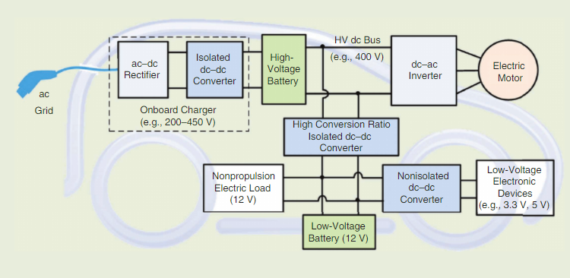
Figure 1. The architecture of basic EV [1]

This research focuses on designing and reviewing the operation of dc-dc bidirectional converters for EVs. The purpose of this design is to review various dc-dc topologies and control schemes for automotive electrification. Underlying circuit operation principles of wide-used dc-dc bidirectional converters in industries are implemented and simulated in this research. Optimization of various control methodologies are investigated for the proposed converter designs based on open research challenges.

DC-DC converter
There are two types of dc-dc converter, which are linear and switched. In this research, only switched-mode DC-DC converters are investigated. It is a high-frequency power conversion circuit which converts the input source current from an unregulated dc voltage to a regulated voltage level desired as shown in below figure 2.
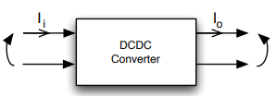
V_{o}
V_{i}
Figure 2. A DC-DC converter model [3]
Regarding to voltage conversion, different required voltage levels can be achieved by controlling the duty ratio of discrete switches for on and off-state period using different control schemes. Boost and buck converters are two fundamental types of DC-DC converters, which have the condition of $V_{i}<V_{o}$ and $V_{i}>V_{o}$ respectively. Assume the efficiency of the converter is $η$, the power relation between input and output is stated below.
$P_{i}η=P_{o}⇒I_{i}V_{i}η=I_{o}V_{o}⟹\left(\frac{V_{i}}{V_{o}}\right)η={\frac{I_{o}}{I}}_{i} , kI_{i}∝I_{o}V_{o}∝P_{o}$
From the equation above, voltage is inversely proportional to current. If the input voltage and the conversion loss are constant, higher input current can provide a higher output voltage and power, which is the case of converting the constant low-voltage battery to high-voltage application for EVs.

Buck and boost converters operation
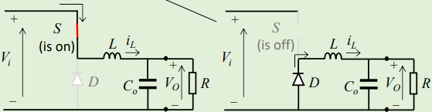
+
+
-
-
Figure 3. On and off-state operation of Buck converter [4]
For buck converter in Figure 3, when S is on, the diode D becomes reverse-biased, the current flowing to the load will charge the stored magnetic energy in L. Part of V_{i} is dropped across the inductor, leading to the stepped-down output voltage. When the switch is off, D becomes forward-biased, decrease in current will induce L releasing its stored energy to oppose the change. The current will keep freewheeling from L to the load and D and decrease linearly. The value of V_{o} is determined by the duty ratio K, which is defined as $V_{o}=V_{in}×K$ , depending on t_{on}. Shorter the turn-on state, lower the output voltage.

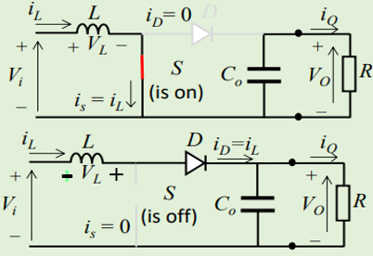
Figure 4. On and off-state operation of Boost converter [4]
For boost converter in Figure 4, assume capacitor C_{o} and inductor L are in the steady state, which undergone the initial charging state. When S is on, the current will keep increasing and L is storing magnetic energy, while C_{o} discharges its energy to the load to maintain the constant output current. When S is off, D is forward biased, decrease in current will induce L to generate a tremendous voltage to oppose the change, releasing its stored energy. The additive inductor voltage on V_{i} will increase capacitor voltage and boost V_{o} to a higher level. Based on $V_{L}=\frac{d∆i_{L}}{dt}$, larger inductance or higher switching frequency can increase V_{L}, then V_{o}. longer the turn-on state, larger the boosted output voltage.

Both converters are under continuous conduction mode (CCM) as the current continuously flows through the inductor L. By comparing the on and off-state equations ^{[4]} due to $∆i_{on}=-∆i_{off}$, input-output voltage relationship of the buck and boost converters can be obtained as $K={\frac{V_{o}}{V}}_{i}$ and $\frac{1}{1-K}={\frac{V_{o}}{V}}_{i}$ respectively. Provided that duty ratio K is always less than 1, therefore buck converter generates an output voltage which is smaller than its input voltage, vice versa for the boost converter. The desired output voltage of both converters can be controlled by the percentage of on-state switch. Ripples in the output voltage and current cannot be neglected because the output current is slightly fluctuating at a level equal to $\frac{V_{o}}{R}$ , even high switching frequency, large inductor and capacitor are selected for practical case.

Hard Switching
Power semiconductor switching devices are widely used in power converter technology, such as IGBTs, BJTs and MOSFETs. They are not ideal, when they are switched between on and off state, the transition time is not instantaneous. Therefore, in figure 5, switching power loss constituted during the turn-on and off crossover interval of the voltage and current waveforms for a transistor is defined as $P_{s}=(W_{crossover\left(on\right)}+W_{crossover\left(off\right)})f_{s}$.
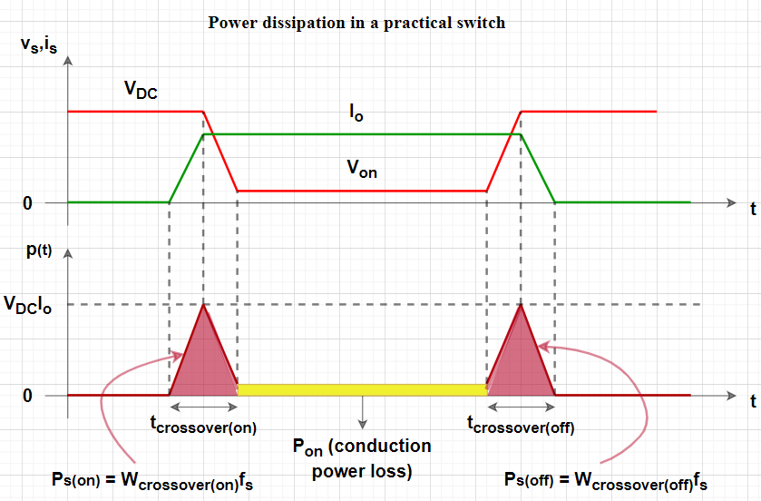
Figure 5. Switching and conduction power loss in Hard Switching
In figure 5, total average power dissipation of a switch is consisted of average switching and conduction power loss P_{on}. However, switching power loss is relatively accounted for large percentage of power loss compared to conduction power loss, especially for high-power EV application. Higher voltage a switch handles, larger the switching power loss. Hard-Switching is high cost in terms of system level and efficiency, because maintenance is often required due to forced changed state by applying current or voltage to third pin, and electromagnetic interference (EMI) is enhanced. In addition, there is a trade-off between higher switching frequency and higher efficiency. Higher the switching frequency, larger the switching power loss, but lower harmonic distortion and output ripples ^{[7]} for power converters, and vice versa.

Soft-Switching
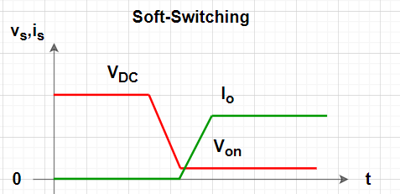
Figure 6. Voltage and current waveforms in Soft Switching
Soft switching refers to a switch is turned on when the voltage is zero, and turned off when the current is zero as shown in figure 6. It is a technique which uses an oscillating circuit to time the switching crossover interval to prevent the overlap of the voltage and current waveforms and set offset for the waveforms ^{[7]}. There are two types of soft-switching schemes, which are self-resonant and forced-resonant circuit. In this research, only non-isolated topology of DC-DC converter is designed and tested, thus self-resonant soft-switching technique which is Zero Voltage Resonant Transition (ZVRT) technique was used to reduce switching power loss and EMI noise and increase efficiency for EV application.

Non-isolated and isolated topologies
There are many different power converters for a wide variety of applications. Non-isolated converter topology is mostly to step up the voltage with a smaller gain ratio (4:1) ^{[17]}, but it is relatively lighter, low device count, cost-effective, efficient and maintain a simple architecture. In addition, a non-isolated Multidevice/port Interleaved Bidirectional Converter is mainly used to provide high power for the propulsion system of the vehicles ^{[19]}. It also provides power from the 12-V dc bus to low-voltage devices at 5 V, 3.3 V.

The isolated converter topology is mostly used in the applications where the output needs to be completely isolated from the input ^{[17]}, which a high frequency transformer is used. The drawbacks of this topology include complexity, electronic noise and high cost for some topologies ^{[17]}.

Research Challenges and Proposed Solutions

General-purposed power stage model design
A well-constructed power stage model is the essentials of the theoretical analysis based on the circuit parameters design of the required motor drive system to realize smooth transition between different operating conditions bidirectionally. On top of that, different bidirectional power stage circuit models can be built on the general basic topology, further optimized the system performance of the PI controller design and power flow. Therefore, a basic half-bridge model will be designed to establish the investigation in all different operating modes, and an optimized topology will be proposed.

High voltage and current ripples
DC-DC converters may undergo fluctuating voltage and current ripples given the situation of high-power applications which comes with a large variance between input and output. The general-purposed power stage model design of a half-bridge non-isolated bidirectional DC-DC converter will be first developed to investigate the effect of the high ripples problem. Then, a non-isolated interleaved multiple phases topology will be tested and simulated to analyse the cancellation effect of high-frequency switching current ripples.

Control and optimization of switches
The issue of hard switching turn-on and turn-off loss hinders the efficiency of the powertrain system. The reverse recovery effect of the diode reduces the switching speed of the switch during the turn-on period, which cannot be neglected. To address the wide range of voltage and power in EV application, ZVRT soft-switching technique will be developed for bidirectional converters to improve reliability because the switches could suffer from excessive switching device stress, which is equal to the output voltage drop across the load ^{[18]}.

Stability and flexibility of the control system
This paper is focus on the EV application, which requires agile speed responsiveness on the bidirectional converter. Pulse Width Modulation (PWM) will be first introduced and used to control the dynamics of the demonstration of the buck and boost mode of the proposed converter, then a PI controller will be used to employ complementary gate switching to achieve the motoring and regenerative braking modes of a motor, required a set of control parameters to achieve stability. This close loop speed control system will be merged with the proposed power converter to model the EV drive system.

Zero Voltage Resonant Transition (ZVRT) soft-switching technology

Introduction
For CCM in section 4, bidirectional DC-DC converters require large-valued inductor to operate, leading to large physical size of inductor, slow mode transition and transient response. Therefore, discontinuous conduction mode (DCM) is used in the motor drive simulation (section 5) to have higher power density and faster response with a small-valued inductor.
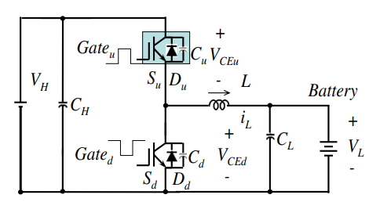
Figure 7. Circuit diagram of the proposed topology with ZVRT [2]

Figure 7 shows the non-isolated half-bridge topology with ZVRT soft switching. To mitigate the switching power loss due to hard-switching in the power stage, ZVRT is introduced to achieve the soft-switching turn-on for advanced power conversion technique. Each MOSFET switch has an antiparallel freewheeling diode to divert the current for fast recovery purpose of the active switch and in parallel with a lossless snubber capacitor.

Circuit operation principle
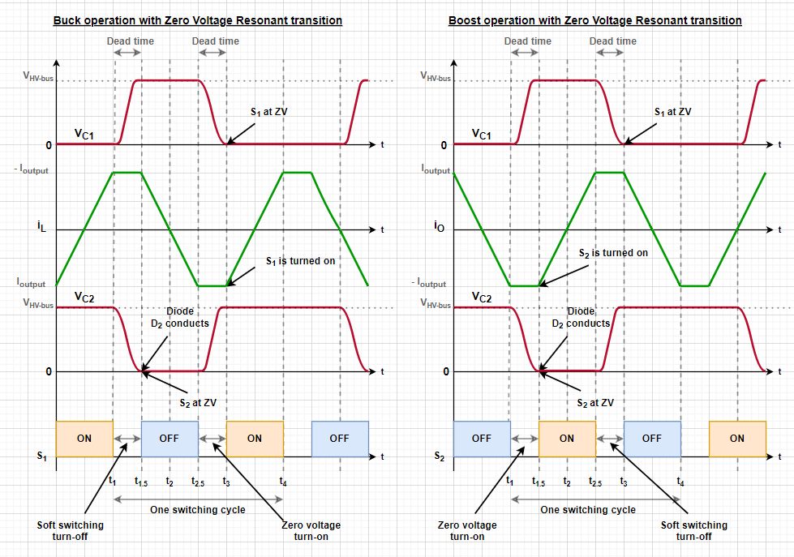
Figure 8. Time waveforms of buck and boost operations

For the buck operation with ZVRT shown in the above time-waveform figure 8, switch S₁ acts as the main switch and switch S₂ acts as a diode. Before t₁, S₁ is on, current flows from the high-voltage bus to the low-voltage battery for charging mode (negative current due to charging operation). During t₁-t_{1.5}, both switches are off and experiencing dead time. V_{C2} is decreasing, as C₂ discharges its energy to the inductor, while i_{L} charges C₁ $(i_{L}=I_{o})$. During t_{1.5}-t_{2.5}, the capacitors C₁ and C₂ are fully charged and discharged respectively, thus V_{C2} become zero, the freewheeling diode D₂ take over i_{L} which is decreasing linearly through D₂ without passing through S₂. Zero-voltage condition is attained for S₂. During dead-time period t_{2.5}-t₃, S₂ creates negative i_{L} which charges C₂, while C₁ discharges. During t₃-t₄, C₁ is fully discharges, thus the main switch S₁ can be turned on at zero-voltage condition. While the negative i_{L} passes through D₁, the voltage difference between V_{HV-bus} and V_{batt} drop across L, thus the negative i_{L} will keep increasing till zero, then changing to positive forward i_{L} flowing through S₁ from high-voltage bus. Boost operation is the opposite case as shown on the right graph in the figure 8.

The switching period will be longer as the device voltage charge and discharge rate are reduced due to additional dead time. More dead time after the on or off state, less efficient the converter will be. It is important to noted that the switch experiences the equal amount of voltage as the output high voltage DC bus when it is turned off. Therefore, both S₁ and S₂ should be operated at zero-voltage condition using ZVRT, eliminating switching loss and stress on switching devices, and zero-turn on losses can be achieved. Moreover, the diodes can have low reverse recovery loss due to natural turn off. Thus, there is always a trade-off between switching frequency and efficiency.

Modelling and Design of a bidirectional DC-DC converter

Introduction to bidirectional DC-DC converters
DC-DC converters can be designed and operated to transfer power in both unidirectional and bidirectional, and bidirectional dc-dc converters are common in transportation electrification. The design criteria of an EV powertrain architecture should be low production cost, high efficiency, light weight and small volume of components. Therefore, requirements of the hardware configuration of a bidirectional dc-dc converter should be low current ripples, controllable system design, low complicity of minimal circuit design and instant bidirectional current flow for charging and discharging modes.
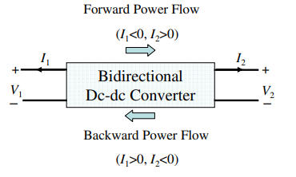
Figure 9. Generic model of bidirectional power flow
Contemporary bidirectional dc-dc converters topologies mostly follow the above generic model to attain buck or boost mode for the DC conversion based on the placement of the energy storage source. For the buck mode, the energy storage source should be put on the high voltage side. For the boost mode, the energy storage source should be put on the low voltage side. The current flow direction between dc units depends on the duty ratio on the switches, which will explain in the following section.

A non-isolated half-bridge bidirectional DC-DC converter operation
In this research, a fundamental transformer-less non-isolated half-bridge topology will be first designed and implemented due to simple configuration, meeting the requirement of low cost, volume and weight. Given that this basic half-bridge topology requires only two switching devices and minimal storage units, occupied size and cost of this topology are minimized, thereby reducing the inductor size and switching conduction loss. The interleaved half-bridge topology derived from this topology could be a better option for EVs as higher efficiency and lower devices stress can be performed ^{[5]}, which will be discussed based on this topology in the following. However, converters using the proposed basic half-bridge topology will suffer from the issue of output current and voltage ripples due to its fluctuating output current, leading to the selection of large output capacitor size.

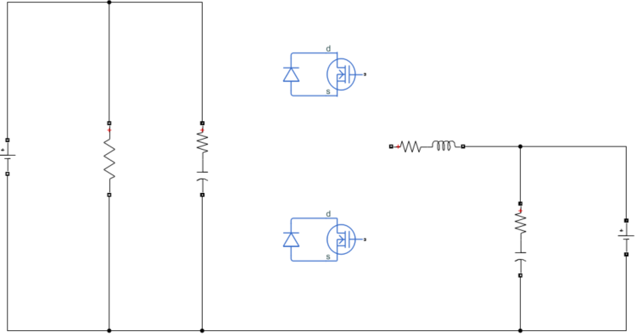
S₂
Load
V_{HV-bus}
2
1
L
S₁
C₁
C₂
D₂
V_{Batt}
D₁
Figure 10. Circuit representation of the proposed topology

In figure 10, the half-bridge bidirectional dc-dc converter controlled by the duty ratio of Pulse-width modulation (PWM) signal is shown. 12V low voltage battery is placed on the low voltage side, while DC motor will be connected to the high voltage DC bus, as shown in the EV architecture in figure 1. This converter boosts up the battery voltage to the high-voltage DC bus rating for EV initial launching, speed acceleration or forward motoring applications, while it operates in buck mode that the DC motor acts as a generator to provide large braking current to charge the battery energy for regenerative braking operation and charge low-voltage auxiliary energy storage due to excess energy on the high-voltage DC bus.
This topology is combined by the buck and boost converters stated in figure 3 and 4 to achieve the bidirectional dc-dc buck-boost converter which has the same operation principle as individual buck and boost converter but sharing the same active and passive elements and is placed between the high-voltage and low-voltage sides for energy transfer. It also operates in continuous conduction mode as the inductor current is continuously flowing in either on or off-state switching. The high-frequency capacitor at the high-voltage side is used as an energy buffer, while a smoothing capacitor at the battery side is used to discharge its energy to maintain constant flow of output current without ripples. The inductor is used as the low-pass filter inductor under buck mode, while used as the boost inductor under boost mode.

Different control algorithms are used to attain a steady and compatible voltage rating to different loads, which will be explained in the following sections.

Circuit operation principle
The proposed converter topology is combined by boost and buck modes, which then operates in two modes separately. For EV application, the high-voltage side of bidirectional DC-DC converters usually acts as an auxiliary power output to supply to inverter, then motor drive. However, we will only focus on the converter for this project, thus DC motor will be connected to the high-voltage side for demonstration. For boost/discharging mode, the current flows from the low-voltage battery to high-voltage DC bus, vice versa for buck/charging mode. In figure 8, a boost switch is constituted by modulation of S2 with its antiparallel diode D2, while a buck switch is constituted by modulation of S1 with its antiparallel diode D1.

Boost mode circuit description
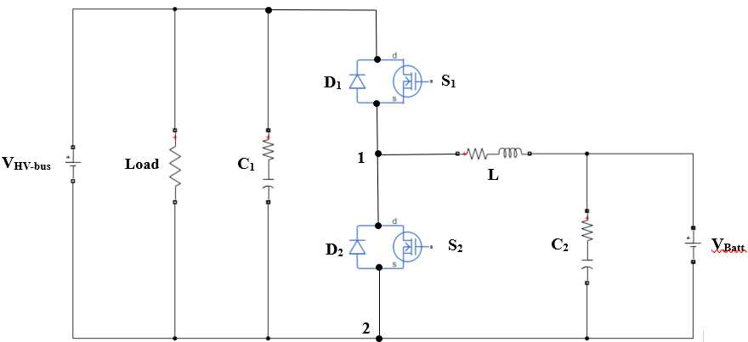
-
+
Figure 11. The current flow of the switch-on interval
There are two intervals involved in the boost mode. The first interval is when the S1 is turned off and S2 is turned on with the two respective diodes in reverse-biased mode. The inductor is storing energy and the inductor current keeps increasing. By Kirchhoff’s voltage law (KVL),
$V_{L}=V_{batt}=L\frac{∆i_{S2\left(on\right)}}{t_{S2\left(on\right)}}=L\frac{∆i_{S2\left(on\right)}}{K_{S2}T_{s}}$
-
+
Figure 12. The current flow of the switch-off interval
The second interval is when both S1and S2 are turned off with the only diode D1 associating with S1 in forward-biased mode as shown in above figure. The inductor current is decreasing, thus the inductor will create a force causing the current to continue flowing through D1 to the high-voltage side. The additive voltage generated by the inductor will created a larger output voltage than V_{batt} to attain high-voltage rating. By KVL,
$V_{HV-bus}=V_{batt}+V_{L}=V_{batt}+L\frac{∆i_{S2\left(off\right)}}{t_{S2\left(off\right)}}=V_{batt}+L\frac{∆i_{S2\left(off\right)}}{(1-K_{S2})T_{s}}$

Buck mode circuit description
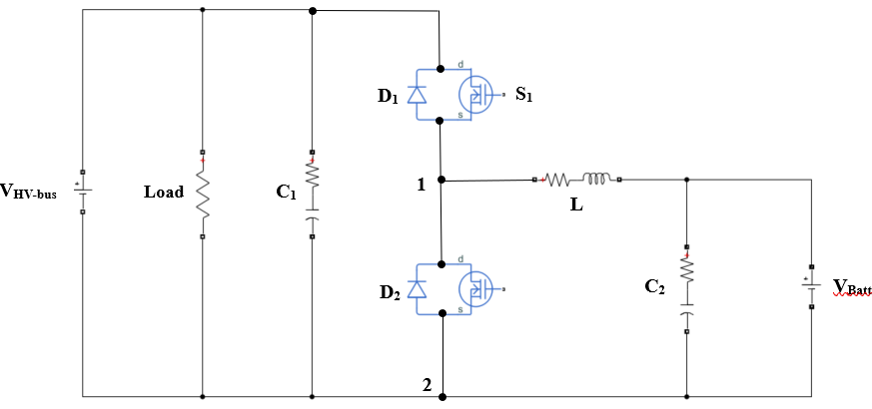
+
-
+
-
Figure 13. The current flow of the switch-on interval
There are two intervals involved in the buck mode as well. The first interval is when the S1 is turned on and S2 is turned off with the two respective diodes in reverse-biased mode. Part of the input voltage is applied across inductor, leading to smaller output voltage. By KVL,
$V_{batt}=V_{HV-bus}-V_{L}=L\frac{∆i_{S1\left(on\right)}}{t_{S1\left(on\right)}}=L\frac{∆i_{S1\left(on\right)}}{K_{S1}T_{s}}$

-
+
+
-
Figure 14. The current flow of the switch-off interval
The second interval is when both S1and S2 are turned off with the only diode D2 associating with S2 in forward-biased mode, enabling the inductor current to flow continuously to maintain constant current. By KVL,
$V_{batt}=V_{L}=L\frac{∆i_{S1\left(off\right)}}{t_{S1\left(off\right)}}=L\frac{∆i_{S1\left(off\right)}}{(1-K_{S1})T_{s}}$

Design of controlling schemes

Selection of switch
To attain the bidirectional power flow capability, current passing through switches and diodes can no longer flow in one direction. Therefore, combination of a unidirectional semiconductor power switch in parallel with a freewheeling diode are utilized in bidirectional dc-dc converters, such as power Bipolar Junction Transistor (BJT), power Metal Oxide Semiconductor Field Effect Transistor (MOSFET) or Insulated Gate Bipolar Transistor (IGBT).

MOSFET will be used in this research due to its several characteristics. This device is fully and independently controllable for on and off state by applying predetermined control signal of current on the gate terminal. It has the highest switching frequency among switch cells, which can linearize the fluctuation of the inductor current and its ripple. At the same time, from the equation $V=L\frac{dI}{dt}$, higher switching frequency $\frac{dI}{dt}$ means higher output voltage which can be boosted. Also, it has relatively low power consumption and output noise, which are beneficial to the efficiency and performance of EVs. The power diode in antiparallel is compatible for most converter applications as it can quickly recover from the reverse-biased condition in a relatively high switching frequency.

Pulse Width Modulation (PWM) control scheme
PWM switching is a common control scheme used for most DC-DC converters. Duty ratio K is defined as $K=\frac{t_{on}}{T_{s}}$ which refers to proportion of the t_{on} interval within one switching cycle. By controlling K of the triggering pulses of the MOSFETs from a PWM generator, specific switch cell can be turned on and off for certain interval, thus constant input voltage of the converter can be varied to a range of average output voltage with a constant period of the PWM signal.
For the half-bridge topology, by varying K from 0 to 1, we can control the power flow direction and boost/buck operation. The average current can flow through either direction, depending on the magnitude of average voltage V₁₂ across S₂ and the output voltage V_{O} as shown in figure 8, as current flow from higher potential to lower potential. The control of the bidirectional power flow in the circuit is determined by the comparison between K and the ratio between the battery voltage V_{batt} and high-voltage bus voltage V_{HV-bus}.

 | Charging / Discharging principle | Comparison in duty ratio K
No power flow | $$V_{HV-bus}*K_{S1}= V_{12,avg}=V_{batt}$$ | $$K_{S1}=\frac{V_{batt}}{V_{HV-bus}}$$
Buck operation (forward power flow) | $$V_{HV-bus}*K_{S1}= V_{12,avg}>V_{batt}$$  $$(Charging mode)$$ | $$K_{S1}>\frac{V_{batt}}{V_{HV-bus}}$$
Boost operation (backward power flow) | $$V_{HV-bus}*{(1-K}_{S2})= V_{12,avg}<V_{batt}$$  $$(Discharging mode)$$ | $${1-K}_{S2}<\frac{V_{batt}}{V_{HV-bus}}$$
Table 1. Charging and discharging principle
Table 1 summarizes the operation principle of the half-bridge converter. S₁ and S₂ are turn on and off alternately, which has the relationship of $K_{S1}{=1-K}_{S2}$. For buck operation, forward power flow is attained as $V_{12,avg}>V_{batt}$ for charging mode, which is controlled by adjusting the duty ratio of K_{S1} larger than the ratio between V_{batt} and V_{HV-bus}. For boost operation, backward power flow is attained as $V_{12,avg}<V_{batt}$ for discharging mode, which is controlled by adjusting the duty ratio of K_{S1} smaller than the ratio between V_{batt} and V_{HV-bus}. Noted that K_{S2} must be less than 1, otherwise the inductor current will be increasing to infinity, the practical switch cells will be damaged and the input supply will be overloaded.

Proportional-integral (PI) controller scheme
The same circuit topology of the converter is controlled by PI controllers to assess various performances and reduce or eliminate the steady state error. The bidirectional power flow operation of the converter is based on two PI controllers to determine the charging and discharging modes of the battery ^{[9]} as illustrated in figure 16. The first PI controller includes two reference current generations based on voltage control of desired voltage outputs for battery charging or discharging mode. The second PI controller is to create triggering pulses with duty ratio K based on the PI current control of the battery. To combine these two modes, a switch was still used to determine charging or discharging based on the existence of the 240V high-voltage DC bus.
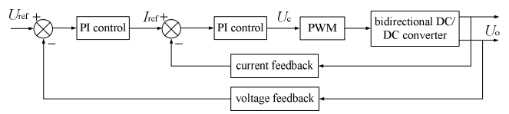
Figure 15. Control system block diagram [12]
The transfer function of PI controller is defined as below ^{[10]},
$$G\left(s\right)=K_{p}+\frac{K_{i}}{s} - (1)$$
Where $K_{p}$ and $K_{i}$ are the proportional and integral gain respectively, calculated by the Ziegler Nichols tuning method ^{[10]}. For discharging and charging voltage-controlled PI controllers, the $K_{p}$ and $K_{i}$ are 0.5 and 100, and 0.9 and 60 respectively. For current-controlled PI controller, the $K_{p}$ and $K_{i}$ are 0.4 and 200. The reference duty ratio for the PWM control signals of the MOSFET switches is calculated using the $K_{p}$ and $K_{i}$ with the limiter and is compared with a high frequency saw tooth signal.

Simulation results and analysis of the proposed converter

Circuit parameter specifications

Components value setup
Battery voltage $V_{batt}=12 V$
Battery rated capacity = 10 Ah
High-voltage DC bus $V_{HV-bus}=240 V$
Switching frequency $F_{s}= 10 kHz$
Switching period $T_{S}=\frac{1}{F_{s}}=0.1 ms$

Component | Buck / Charging mode | Boost / Discharging mode
Inductor | $$927 uH$$ | $$927 uH$$
Capacitor | $$128 uF (C_{2})$$ | $$6789 uF (C_{1})$$
Table 2. Summary of Calculated Components

PWM controlling scheme
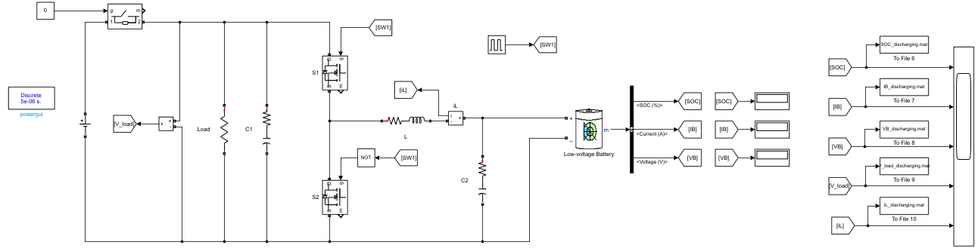
Figure 16. Simulated circuit of proposed topology using PWM pulses
Performance of the simple bidirectional DC-DC converter was simulated with different duty ratios of a 10 kHz PWM signal for buck and boost modes using MATLAB/SIMULINK. The following table illustrates the charging/ discharging principle in operating this circuit, which depends on the comparison between K and the ratio between the 12 V battery voltage V_{batt} and 240 V high-voltage bus voltage V_{HV-bus}. MOSFET switch resistance, internal diode resistance, inductor and capacitor parasitic resistances were considered in this circuit. The capacitor values were sufficiently large so the load current and output voltage are relatively constant, that the output capacitances on the high-voltage DC bus side and battery side have the value of 6789 uF and 128 uF respectively as calculated above. Given the physical size and cost were not considerations in simulation, the inductor was calculated to be 927 uH as larger the inductor value, lower the switching frequency and current ripple, thus lower switching loss and steadier voltage output. The simulation was conducted for (a) battery current, (b) battery voltage, (c) inductor current, (d) current ripple, (e) battery state of charge and (f) load voltage.

 | Charging / Discharging principle | Comparison in duty ratio K
No power flow | $$240*K_{S1}= V_{12,avg}=12$$ | $$K_{S1}=\frac{12}{240}=5\%$$
Buck operation (forward power flow) | $$240*K_{S1}= V_{12,avg}>12$$  $$(Charging mode)$$ | $$K_{S1}>5\%$$
Boost operation (backward power flow) | $$240*{(1-K}_{S2})= V_{12,avg}<12$$  $$(Discharging mode)$$ | $${1-K}_{S2}<5\%$$
Table 3. Charging and discharging principle for specific voltage input and output

Charging/ Buck mode
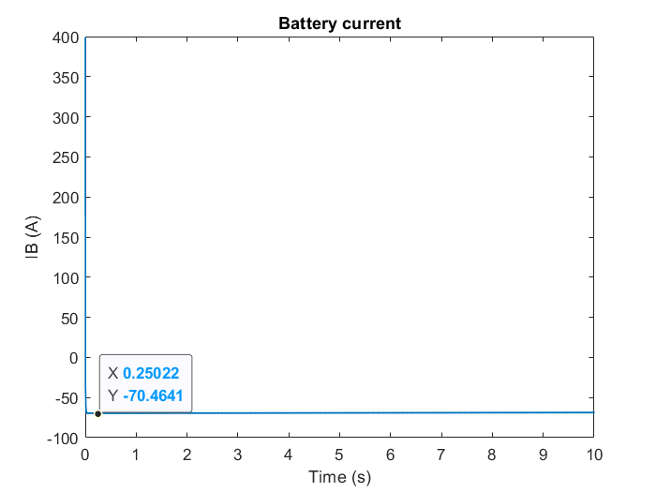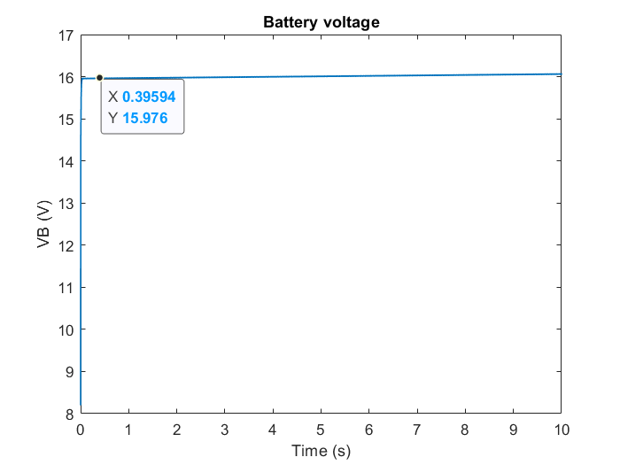
Figure 17(a). Battery current Figure 17(b). Battery voltage

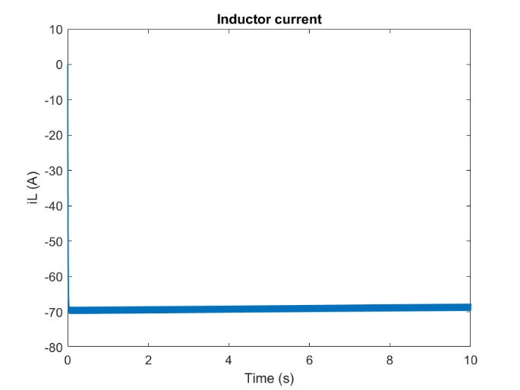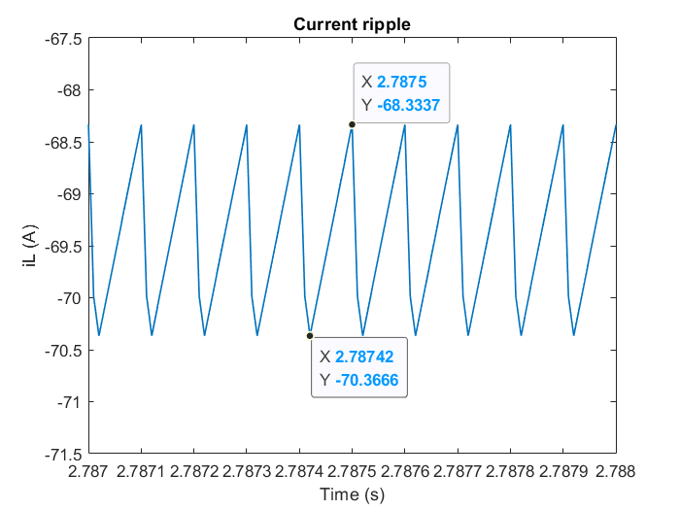
Figure 17(c). Inductor current Figure 17(d). Current ripple
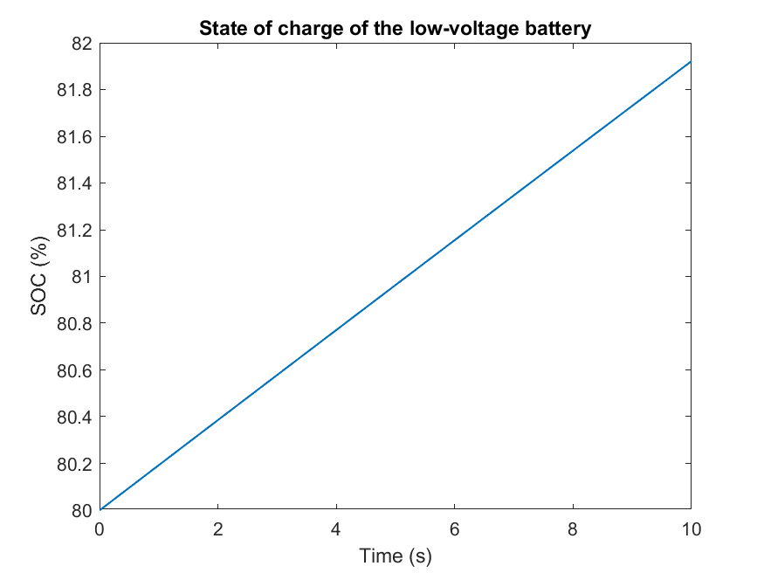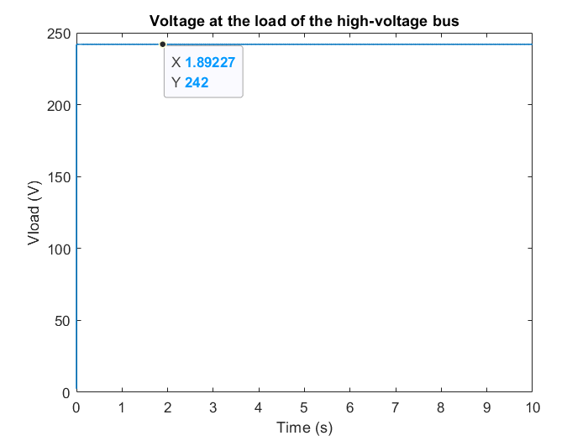
Figure 17(e). Battery state of charge Figure 17(f). Load voltage
When the voltage source is activated (the switch determining the mode is on) and the duty ratio is above 5%, the battery is in charging mode and the load will be supplied from the voltage source. This case is usually for the regenerative braking from the motor to charge the low-voltage battery.

During the simulated 10 secs, the duty ratio was set to 6%, figure 17(e) and (f) show the voltage input from the high-voltage DC bus was around 242 V, charging the battery from 80 %, while the battery current was steadily at -70.5 A which was negative as the current direction was towards the battery as shown in figure 17(a). Figure 17(b) shows the battery voltage output was steadily at 15.98 V, which is few volts higher than the battery nominal voltage rating. There is an acceptable operating range of K to control the right amount of voltage going in the battery, which is slightly higher than the battery nominal voltage. Figure 17(c) and (d) show the current ripple of the negative inductor current fluctuated between -70.4 A and -68.3 A, which is relatively small as the large inductor value.

Discharging/ Boost mode
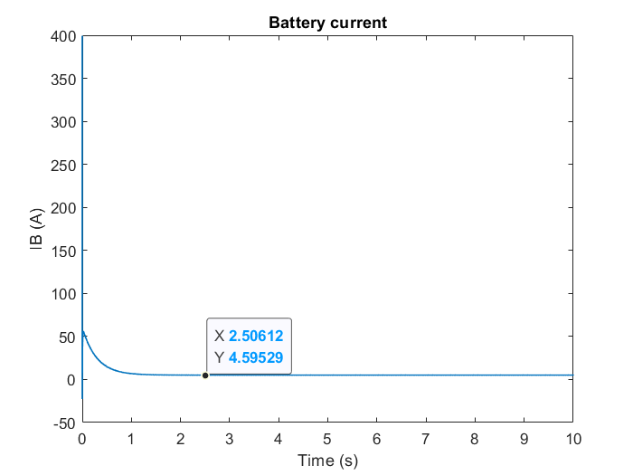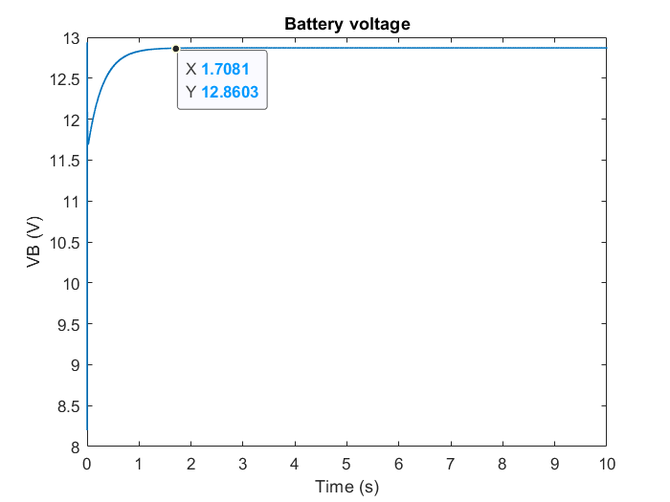
Figure 18(a). Battery current Figure 18(b). Battery voltage

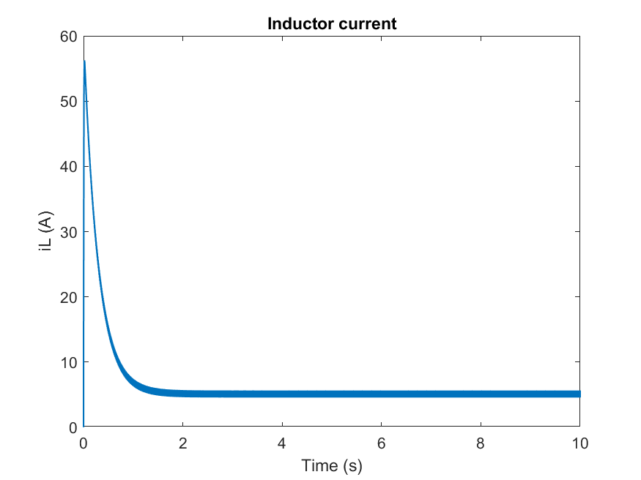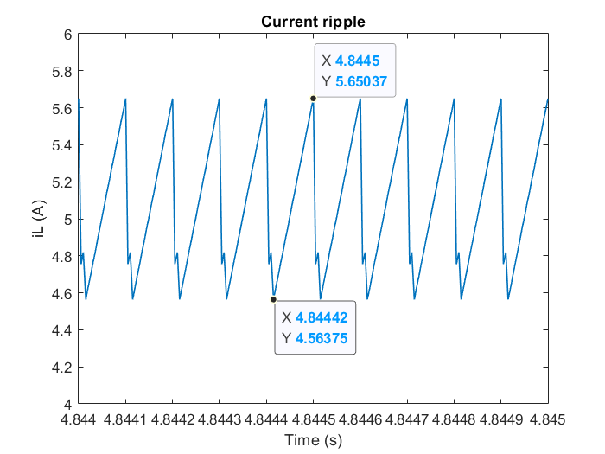
Figure 18(c). Inductor current Figure 18(d). Current ripple
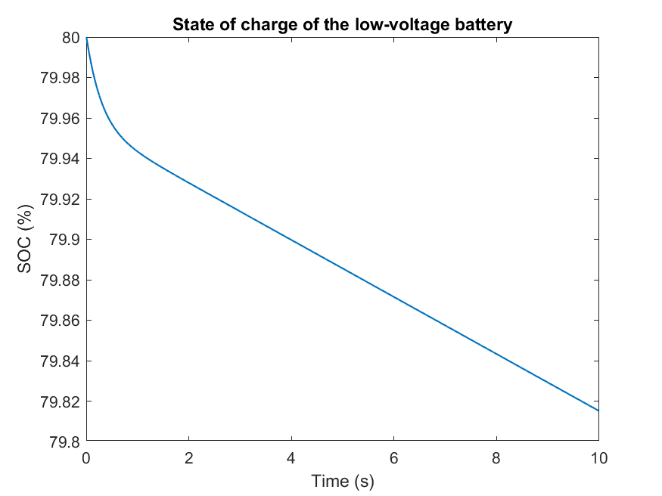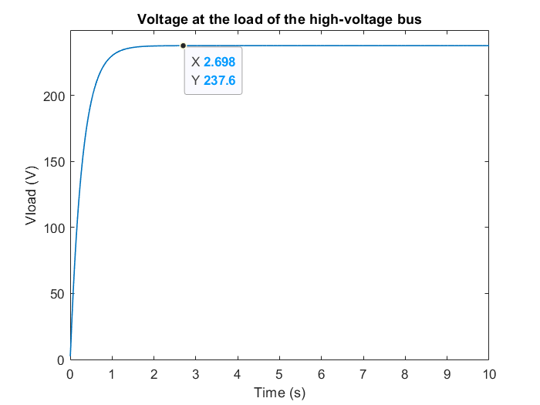
Figure 18(e). Battery state of charge Figure 18(f). Load voltage
When the voltage source is deactivated (the switch is off) and the duty ratio is below 5%, the battery is in discharging mode and the load will be supplied from the battery. This case is usually the auxiliary propelling energy from the low-voltage battery for the initial launching and speed acceleration.

During the simulated 10 secs, the duty ratio was set to 4%, figure 18(e) and (f) show the output waveform of the high-voltage DC bus voltage was around 237.6 V with a rising time of 2.698 sec for 12 V battery voltage input, and the SOC of the battery was decreasing from 80 %, while the battery current was steadily at 4.6 A which was positive as the current direction was towards the high-voltage DC bus as shown in figure 18(a). There was current ripple of the positive inductor current fluctuating between 4.56 A – 5.65 A due to switching circuit as shown in figure 18(c) and (d).

Proportional-integral (PI) controlled method
Switch state

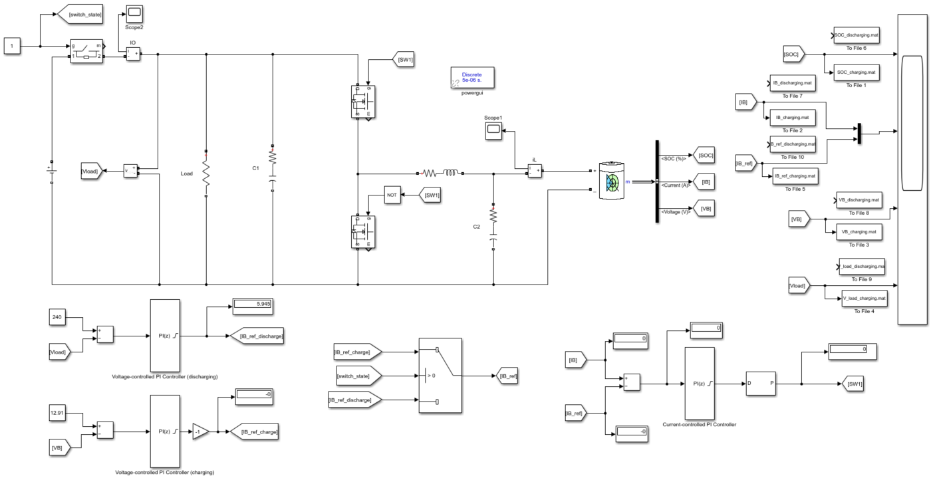
First PI controller
Detect discharging or charging mode
Second PI controller
V_{Batt}
V_{HV-bus}

Figure 19. Simulated circuit of proposed topology using PI controllers [9]
All components in the circuit were set up as the same as previous PWM method.

Charging/ Buck mode
Charging mode will be automatically on when the high-voltage DC source V_{HV-bus} is enabled, the switch is on, and will use the reference current generation of the charging mode. The reference of the voltage of this mode is chosen to be 12.99V which is determined by the open circuit voltage at the 80% SOC as some battery companies separate the constant current and voltage sides at 80% SOC level ^{[9]} to prevent battery from degradation.
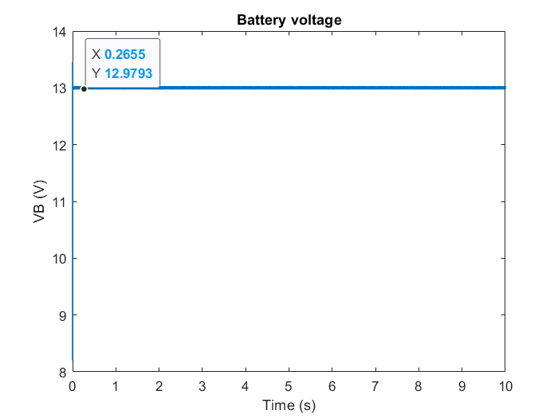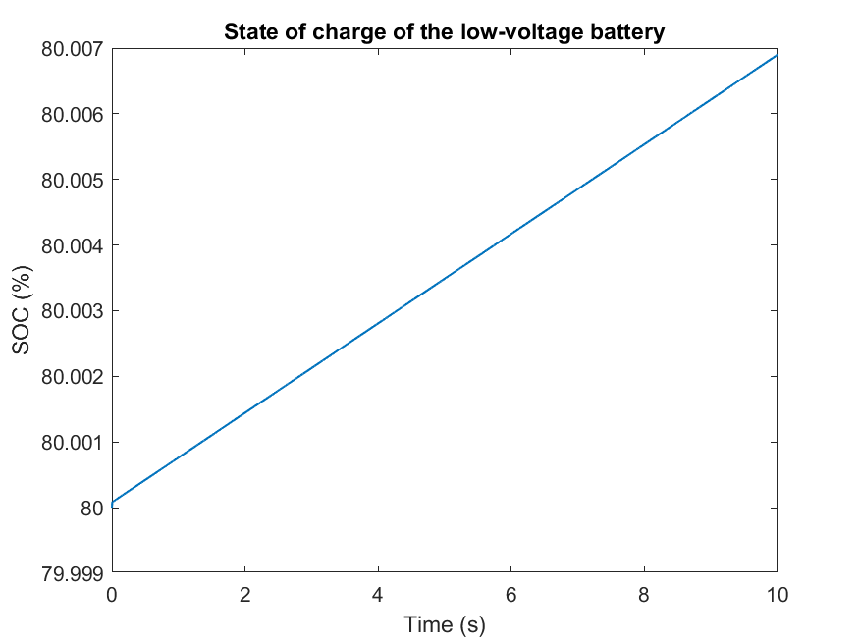
Figure 20(a). Battery voltage Figure 20(b). Battery state of charge
Figures 20(a) and (b) show the output waveform of the battery voltage maintained around 12.98 V for 240V high-voltage DC voltage input, which is close to the chosen reference voltage for the PI controller, while the SOC of the battery was increasing from 80 %.

Discharging/ Boost mode
Discharging mode will be automatically on when the high-voltage DC source V_{HV-bus} is disabled, the switch is on, and will use the reference current generation battery of the discharging mode. The reference of the voltage of this mode is chosen to be 240V which is determined by 240V high-voltage DC bus.
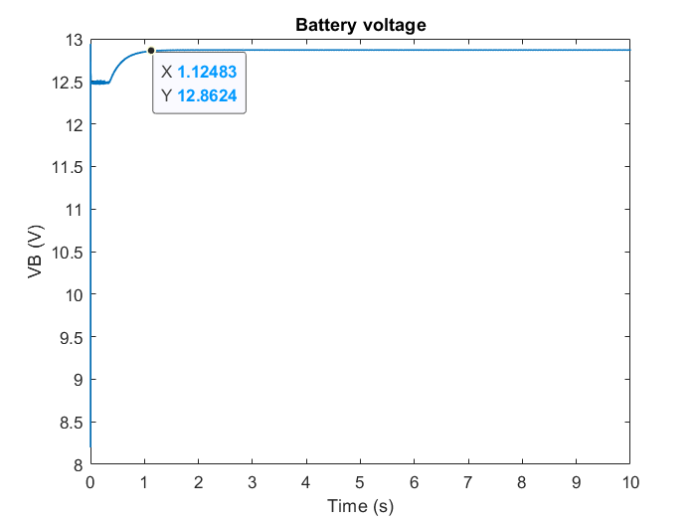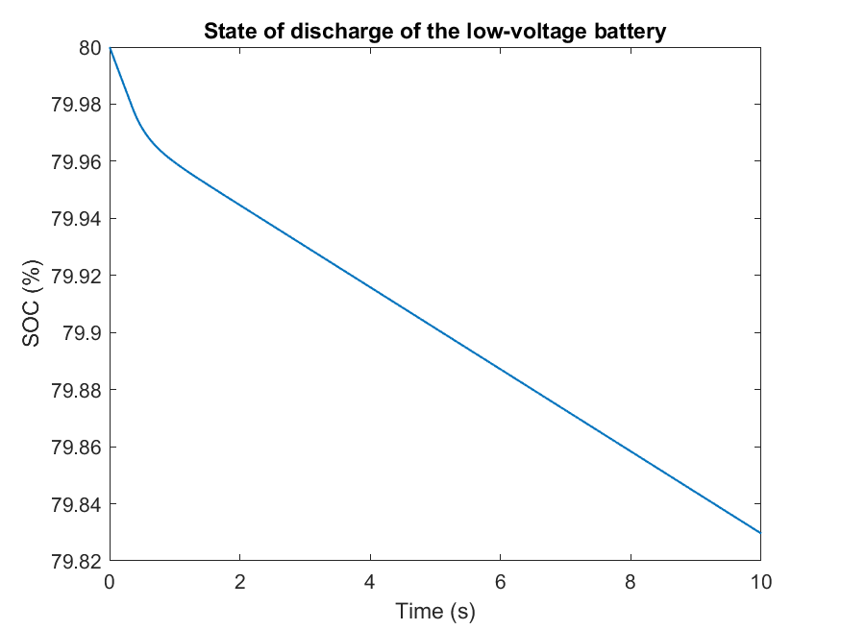Figure 21(a). Battery voltage Figure 21(b). Battery state of charge
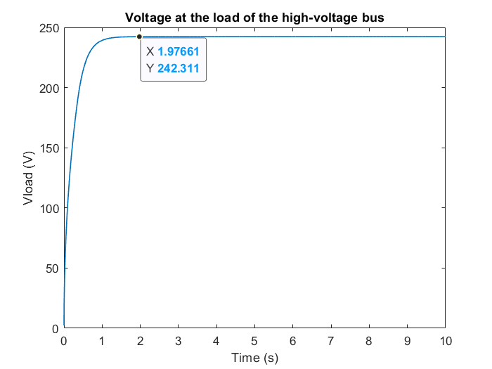
Figure 21(c). Load voltage
Figures 21(b) and (c) show the output waveform of the high-voltage DC bus voltage was around 242.3 V with a rising time of 1.977 sec for 12 V battery voltage input, while the SOC of the battery was decreasing from 80 %.

Figure 21(a) shows the battery voltage decreased shortly in the first 0.41 sec, then reached the slightly higher running voltage 12.86 V. Take EV application as example, because the high-voltage consumption of the starting motor draws tremendous current to launch the engine, the current drain has caused the internal battery voltage drop of the initial battery voltage output.

Comparison and Evaluation on control schemes
Buck/ Charging mode
Input (V) | PWM-controlled output (V) | PI-controlled output (V) | Open circuit voltage at the 80% SOC
238 | 15.89 | 13 | 12.99
240 | 15.98 | 12.98 | 12.99
242 | 15.99 | 13 | 12.99
Table 4. Results of the two controlling methods for Buck mode
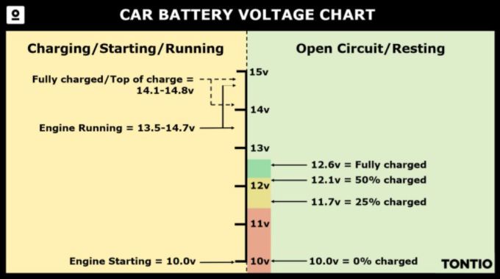
Figure 22. Car battery Voltage Chart [11]
In table 4, all voltage outputs are larger than the 12V battery nominal voltage because exceeded voltage is needed to overcome the current through the internal resistance of the battery. The excess voltage or energy will not charge the battery, instead it will boil the battery fluid due to resistance heating, heating up the battery and reducing battery life. Heat dissipation is an important factor affecting car performance, therefore, PI controlling method is more suitable for EV application, as its voltage outputs from different voltage inputs are relatively more comparable to the 12.99V reference voltage than the PWM controlling method, which is approximately within the top of the charge in figure 22.

Boost/ Discharging mode
Input (V) | PWM-controlled output (V) | Rising time (s) (PWM) | PI-controlled output (V) | Rising time (s) (PI)
10 | 198.35 | 2.95 | 202.27 | 2.05
12 | 237.60 | 2.70 | 242.3 | 1.98
14 | 276.77 | 3.05 | 240.01 | 3.02
Table 5. Results of the two controlling methods for Boost mode
In table 5, the voltage outputs of the PI-controlling method from different voltage inputs are also relatively more comparable to the 240V high-voltage DC bus rating than the PWM-controlling method. The reaction time of EVs to attain a certain speed with enough power is also one of the factors for good EV performance. The rising time to 240V of PI-controlling method is relatively faster than that of PWM-controlling method.
In conclusion, the PI-controlling method is a more compatible scheme to control a bidirectional DC-DC converters for EV system, as it can attain more closer to the required output voltage. This PI controller enables the regenerative recharging/ discharging of the battery from/to the high-voltage DC bus voltage for controlling the inverter input generally and regulates a proper voltage level.

Electric Vehicles application

Regarding different powertrains of EV, conversions between different regulated voltage levels entail at least one DC-DC converter to interface battery, fuel cell or supercapacitor to the DC-link voltage bus. To maximize the efficiency of the motor drive, the voltage level of the energy storage system (ESS) can be increased to reduce the high current and the associated power loss ^{[13]}, it will increase the cost, size and weight of the EV system. A half bridge non-isolated power converter topology is used for the motor drive because the device stress, lower losses due to lesser number of components compared to cuk converters and bidirectional cascade ^{[13]}. Therefore, its boost mode can reduce the power loss while its buck mode can facilitate the reverse power flow to the energy storages during regenerative braking. Different driving conditions were simulated and analysed based on this EV system model.

Battery selection

Lithium-ion battery was used because it is widely used in automotive industry, like Tesla Model 3, due to its high energy density, long battery lifecycle, high temperature tolerance, reliability and compact size, it also has promising features like low memory effect, high specific energy of 100Wh/kg and high specific power 300 W/kg ^{[8]}.

DC motor selection
Leading automotive companies, such as Tesla, BMW and Toyota, normally use high performance capability of Induction motors or Permanent Magnet Synchronous Motors (PMSM) ^{[14]} to attain requested acceleration torque and braking torque for bidirectional rotation. A separately excited Permanent Magnet DC (PMDC) motor is used as load to present this EV system model. This type of motor is not suitable for modern EV application due to weight and efficiency considerations ^{[14]}, but it was used in this model to illustrate the general EV system.

The torque developed at the output shaft is linearly proportional to the armature current, torque thus can be regulated accordingly with the current. The equation ^{[15]} is defined as below,
$$T=k_{T}I_{A} - (2)$$
The high-voltage DC bus of the proposed converter is connected to the motor armature input voltage, which is equal to the voltage summation of armature resistance, inductance and induced emf. The equation ^{[14]} is defined as below,
$$V_{in}=I_{A}R_{A}+L_{A}\left(\frac{di_{A}}{dt}\right)+e - (3)$$
Since the field current is independent of armature current and magnetic field, thus $k_{T}$ is constant ^{[15]}. The induced emf in the general DC machine structure can be defined as below ^{[15]},
$$e=k_{T}ω - (4)$$

Control strategy
To drive the EV at a desired speed, its corresponding output voltage level must be regulated by a bidirectional converter by considering the input and output requirements. A PI controller is used as a control circuit as figure 23 shown, to allow instant response without oscillation for rapid speed change commands. For this control scheme, motor speed $ω_{motor}$ is constantly being feedbacked to the input of the PI controller to compare with the inputted reference speed $ω_{ref}$, the error signal produced by the PI system is then compared with a high frequency saw tooth signal equalling to the switching frequency, creating Pulse Width Modulated (PWM) complementary switching signals for the bidirectional converter to attain the output voltage for the desired speed of the DC motor.
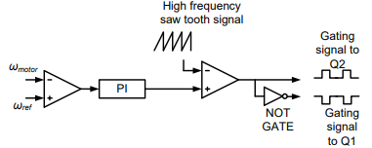
Figure 23. Control circuit for the proposed converter [8]
The block diagram of the EV system model in the figure 24 illustrates the closed loop operation of the DC motor drive. This feedback speed control system adjusts the duty ratio K of the switching control signals based on the inputted speed command. The PI controller is chosen due to higher performance as stated in section 4.4.4, also reducing the steady state error between the measured motor speed $ω_{motor}$ and reference speed $ω_{ref}$ ^{[16]}. The transfer function of PI controller is stated as the equation 1 in the above section 4.3.3, while the proportional and integral gains are set by Ziegler Nichols tuning method with final tuning of integral gain to adjust the transient performance and overshoot oscillation.
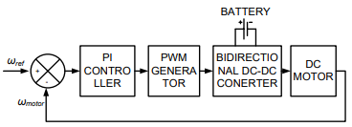
Figure 24. Block diagram of feedback speed control system [8]

Converter circuit design for the speed control
A converter circuit for EV application must allow bidirectional power flow to accommodate different driving conditions. Therefore, a unified controller with a mode switching logic ^{[13]} was introduced to allow smooth transitions between motoring and regenerative modes.

For this simulation, the proposed non-isolated converter topology has relatively small step-up ratio (less than 4:1) ^{[17]} compared to the isolated topology, thus the maximum armature voltage of the motor is around 48 V, while the battery voltage is 12 V. Take the desired output voltage as 48 V, referring to equation (7) ^{[13]}, to operate in boost mode / discharging mode, the boost switch (S₂) of the converter should be operated at 0.75 of its duty ratio(K_{S2}), while K_{S1} should be at 0.25 due to complementary switching scheme was applied to the switches using the equation (6).
$$\frac{V_{batt}}{V_{arm}}=K_{S1}=\frac{T_{S1\left(on\right)}}{T_{S1\left(on\right)}+T_{S1\left(off\right)}} - (5)$$
$$K_{S2}=1-K_{S1}- (6)$$
$$\frac{V_{arm}}{V_{batt}}=\frac{1}{1-K_{S2}} - \left(7\right)$$

To attain different speed transitions, a PI controller introduced from previous section was used to vary the armature voltage based on fixed battery voltage ^{[13]} by adjusting the duty ratio of the switches automatically to achieve the desired output voltage for certain speed for motoring mode.

Motoring mode
According to the below circuit model diagram ^{[15]}, assume the inductance of the armature is sufficiently small, the armature current flows from the controlled output voltage of the power converter circuit into the armature circuit of the motor, then the mechanical power drives the load. This DC machine is considered as a motor when the mechanical power is positive ^{[15]}. Both the developed torque and the armature current are positive, thus the back emf is always smaller than the input voltage by an amount of $I_{A}R_{A}$ as the equation (8) shown. Based on the table 6 of the parameter values in the next section 5.5, to maintain the speed at 80 rad/s for motoring mode, the PI controller must adjust K_{S2} to 0.71 and K_{S1} to 0.29 to provide 41.4 V as the armature voltage, calculated by the equation (2), (3) and (4).
$$V_{in}=I_{A}R_{A}+e - (8)$$

Regenerative braking mode
During the braking motion of an EV, DC machine is considered as a generator, the mechanical system provides the power for the machine as a power supply due to the mechanical power is negative ^{[15]}. Both the developed torque and the armature current are negative, thus the back emf is always larger than the input voltage by an amount of $I_{A}R_{A}$ as the equation (9) shown.
$$V_{in}=e-I_{A}R_{A} - (9)$$

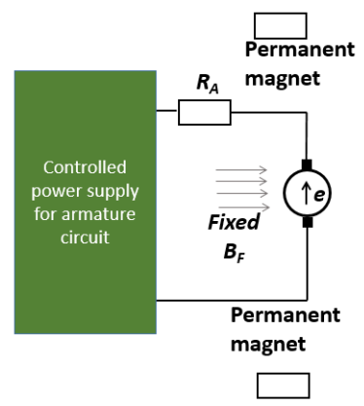
Figure 25. PMDC motor circuit model diagram [15]

Simulation results and analysis
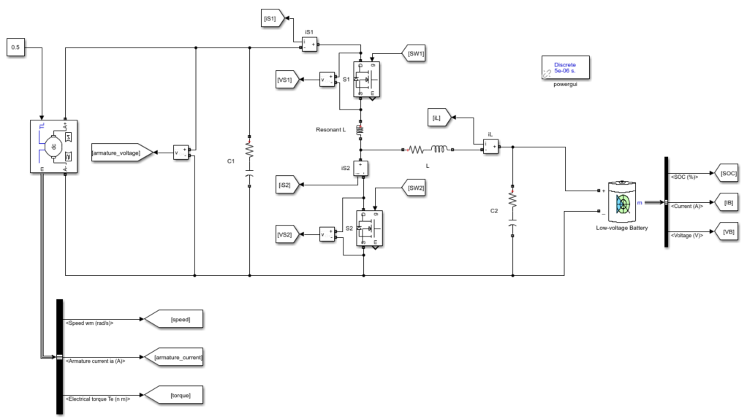
Figure 26. Simulink model of motor drive system using the basic half-bridge topology
The EV system model and its PI controller scheme were simulated in different driving conditions in Simulink to investigate the performance and effectiveness of the proposed bidirectional converter. The MOSFET switch resistance, internal diode resistance, inductor and capacitor parasitic resistances were considered in this circuit, which required tuning of the parameters of the PI controller to attain the precise output voltage. A smaller step-up ratio was used due to the non-isolated topology, thus the speed of this DC motor drive model is limited to 90 rad/s as the limited output voltage is less than 48 V. In order to attain a higher and steady speed for efficient EV application, either increasing the voltage level of the ESS by introducing more number of the cells in the battery pack of the ESS ^{[13]} or inserting a transformer for high voltage gain, but these options will need to comply with vehicular constraints. This simulation was conducted based on a lower speed DC motor using the non-isolated half-bridge converter as proposed, therefore the components values are scaled down, besides the switching frequency is tuned up to lower the output ripple. The following table is the component parameter values used to test the motor drive model.

Component parameters | Values
Battery voltage | 12 V
Battery’s rated capacity | 10 Ah
Battery’s internal resistance | 0.012 $Ω$
Capacitance in the high-voltage side (C₁) | 100 $μF$
Capacitance in the low-voltage side (C₂) | 5 $μF$
Inductance | 320 $μH$
Resonant inductance | 17.4 $μH$
Armature resistance (motor) | 1.4 $Ω$
Armature inductance (motor) | 0.028 $mH$
Torque constant (motor) | 0.5 $NmA^{-1}$
Inertia (motor) | 0.05215 $kgm^{2}$
Viscous friction coefficient (motor) | 0.002953 $Nms$
Torque (motor) | 0.5 $Nm$
Proportional gain (PI controller) | 0.1
Integral gain (PI controller) | 0.0045
Table 6. Parameters values specifications in the simulation
Different waveforms were obtained to evaluate the motor drive applied to different driving conditions, corresponding to motor speed, armature current, torque, battery state of charge (SOC), battery voltage, battery current, battery and motor power, and battery and motor energy.

Three driving conditions were simulated in 10 sec by inputting the desired reference speed and constant torque demand of 0.5 Nm. There are three driving conditions which are motoring, acceleration and regenerative braking modes to be analysed.

Motoring mode
This motoring condition is a steady state operation which is driving the motor at 80 rad/s for 10 sec. In figure 27(a), it reached the desired speed 80.47 rad/s at around 2.47 sec, which can be responsive and faster if higher voltage of ESS is applied. In figure 27(b) and (c), armature current and torque are shown and they are directly proportional to each other by a torque constant $k_{T}$. In figure 27(d), the battery was operated in discharging mode from 80%, requiring higher discharging rate to provide initial launching for the machine, then discharging in a steady rate for maintaining at the desired speed. In figure 27(e) and (f), battery voltage is slightly higher than 12 V nominal voltage to overcome its internal resistance, while large current is needed for initial launching, then reduced and oscillated at around its nominal battery current. In figure 27(g) and (i), large power and energy are required for initial launching, then the power between the high and low voltage side are similar, which involves power loss in the circuit as shown in figure 27(h). The conversion efficiency is around 88%.
Steady state speed for motoring mode
Initial launching
Figure 27(a). Motor speed Figure 27(b). Armature current
Figure 27(c). Torque Figure 27(d). Battery state of charge
Figure 27(e). Battery voltage Figure 27(f). Battery current

Figure 27(g). Battery and motor power Figure 27(h). Detailed waveforms of power
Figure 27(i). Battery and motor energy

Acceleration mode
This acceleration condition is a transient state operation which is driving the motor from 40 rad/s to 80 rad/s, which emulated the acceleration motion of an EV. At the time of 5 sec, which is the time of acceleration occurs, speed was increasing from 42.82 rad/s to 80.44 rad/s in figure 28(a). In figure 28(b) and (c), it shows increase in speed demands for an increase in torque and current. The battery discharging rate was increased as shown in figure 28(d) and (e), so as the power and energy shown in figure 28(f) and (g).
Figure 28(a). Motor speed Figure 28(b). Armature current
Acceleration
Figure 28(c). Torque Figure 28(d). Battery state of charge
Figure 28(e). Battery current Figure 28(f). Battery and motor power
Figure 28(g). Battery and motor energy

Regenerating braking mode
This regenerating braking condition is a transient state operation which is driving the motor from 80 rad/s to 40 rad/s, which emulated the slowing-down and downhill motion of an EV. In figure 30(a), (b) and (c), in the first 5 sec, positive current and torque are applied to the motor to maintain at the speed of 80.44 rad/s for motoring mode. At the time of 5 sec, which is the time of regenerative braking occurs, speed was decreasing from 80.44 rad/s to 42.82 rad/s in figure 30(a). In figure 30(b) and (c), both current and torque were experiencing negative direction, as the current needs to flow in an opposite direction to the battery. The current first decreased, then increased back to a positive value for the motoring mode, because the inertia of the motor prevents the speed to change instantly due to the change in developed torque of the machine ^{[15]}. In figure 29, the requirement of the decrease in speed will decrease the armature voltage from operating point A to B. However, due to the presence of machine’s inertia, the motor must be in regenerating mode to develop negative torque and current till the point X, which converts the kinetic energy to electrical energy flowing back to the battery. Finally, the motor decelerates until it reached the desired speed at point B for motoring mode.
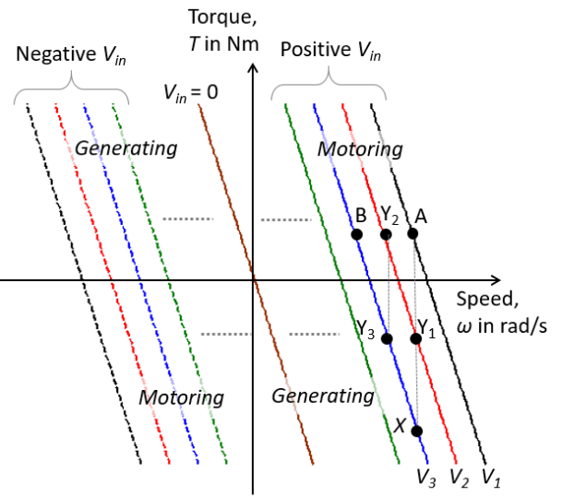
Figure 29. Four-quadrant operation of the PMDC motor [15]
In figure 30(d), the battery was operated in recharging mode, the motor acted like a generator to convert the kinetic energy from the braking motion to the electrical energy of the motor, then transferring to the battery. The battery was recharged with negative current from at that transient state period as shown in figure 30(d), (f) and (g). In figure 30(h) and (i), the battery and motor power were negative due to the recharging process, so as their energies were decreased. The total energy recovered in this regenerative braking mode was 46.26J as shown in figure 30(e).
Figure 30(a). Motor speed Figure 30(b). Armature current
Figure 30(c). Torque Figure 30(d). Battery state of charge
Regenerative braking
Figure 30(e). Recharging process of the battery Figure 30(f). Battery voltage
Figure 30(g). Battery current Figure 30(h). Battery and motor power
Figure 30(i). Battery and motor energy

Circuit optimization

Other industrial topologies
For the controller design purpose, the previous section 5 used the most basic half-bridge power converter topology to illustrate the performance of the feedback speed control EV system. However, as the demand for higher voltage of the motor drive increases, not only can more significant high current and voltage ripples, volume and weight be suffered by the basic half-bridge topology, but also the large variance in magnitude between the voltage input and output ^{[17]}. Therefore, a multiphase interleaved topology will be introduced to optimize the motor drive system in the previous section 5 and alleviate the problems stated in this section.

A non-isolated multiphase interleaved bidirectional DC-DC converter
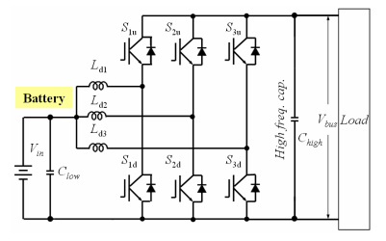
Figure 31. A non-isolated multiphase interleaved bidirectional DC-DC converter model [2]
Given that the DCM operation introduces a considerable amount of current and voltage ripples, a half-bridge interleaved multiphase DC-DC converter topology in figure 31 is considered to increase the performance for the motor drive system as it can reduce the input and output voltage and current ripples ^{[17]}, also the volume and weight of the capacitors and inductors due to the even-distributed stress among the phases. However, this topology still has the limitation of maximum step-up ratio of 4 due to the circuit impedance of its non-isolated topology ^{[17]}. Higher step-up ratio for higher EV performance can be achieved by using two series cascaded step-up converters ^{[17]} or full-bridge isolated topology.

Simulation results and analysis
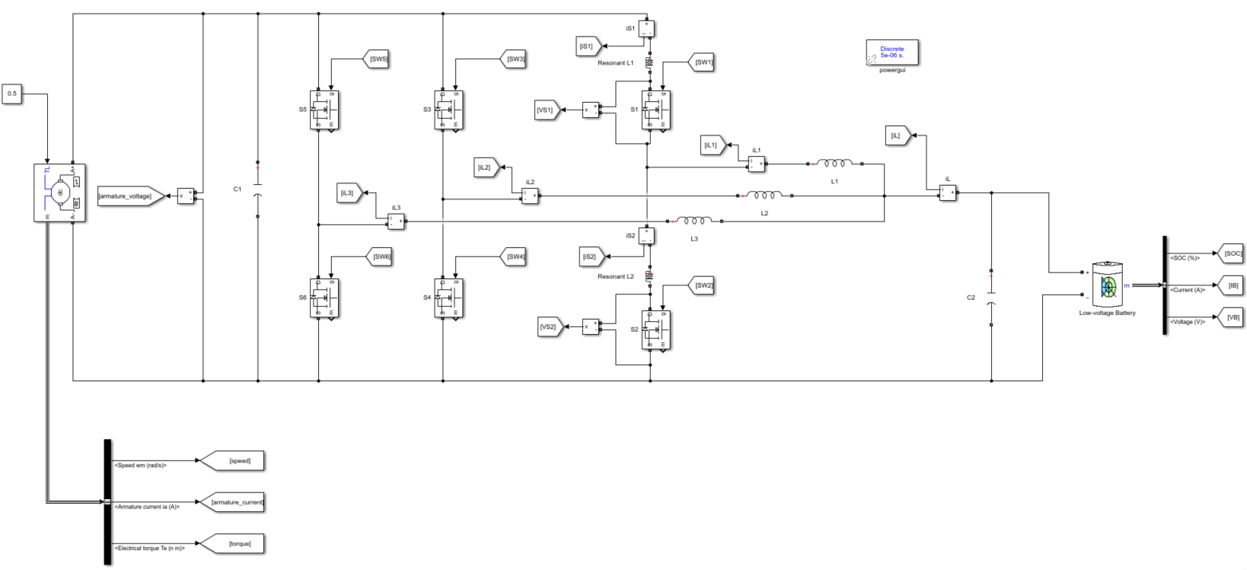
Figure 32. Simulink model of motor drive system using the multiphase interleaved topology

Figure 32 is the Simulink model circuit of the optimized topology. It was simulated to drive the motor at 80 rad/s for 10 sec. The below left column figures are the results using multiphase interleaved topology, while the right column is the basic half-bridge topology. In figure 33(a), it reached the desired speed 70.57 rad/s at around 0.87 sec which is much faster than 2.47 sec using the basic topology in figure 33(b). In figure 33(b) and (c), the armature output ripple of the multiphase topology is smaller than that of the basic topology during the steady-state period. Form figure 33(c) to (j), all input and output voltage and current values of the multiphase topology are lower than that of the basic topology. In figure 33(k) and (l), the conversion efficiency increased from 88% to 91%.

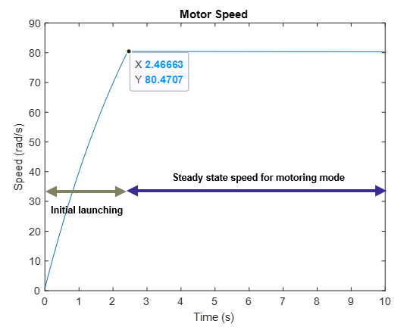
Initial launching
Steady state speed for motoring mode
Figure 33(a). The multiphase interleaved topology Figure 33(b). The basic half-bridge topology
Figure 33(c). The multiphase interleaved topology Figure 33(d). The basic half-bridge topology
Figure 33(e). The multiphase interleaved topology Figure 33(f). The basic half-bridge topology

Figure 33(g). The multiphase interleaved topology Figure 33(h). The basic half-bridge topology
Figure 33(i). The multiphase interleaved topology Figure 33(j). The basic half-bridge topology
Figure 33(k). The multiphase interleaved topology Figure 33(l). The basic half-bridge topology

Power converters in EV application require low input current ripples and output voltage ripples, low electromagnetic interference, bidirectionality, high efficiency and reliability, low cost and compact size or volume ^{[19]}. The three-phase interleaved topology was thus used, that 120-degree shift between each phase as shown in figure 34.
Figure 34. Three-phase interleaved inductor currents with 120-degree phase shift

Thus, the ripple of the total current going into the capacitors was reduced, then smaller capacitance with ripple cancellation in both low and high sides can be used for acceptable voltage ripple, so as the inductor size of each phase can be further minimized in DCM operation. The ripple current can be reduced by the interleaving phase-lag currents going into the sensitive voltage source ^{[20]}. This technique allows the current to be shared among switches, thus reducing the current rating of switches and the device stress.

Zero Voltage Resonant Transition (ZVRT) soft switching
DCM operation had been used for the EV motor drive model, which can allow more compact size of circuit model. However, its associated consequences are inductor voltage parasitic ringing and hard switching turn-off loss due to the device output capacitance ^{[2]}.
ZVT
ZVT
Figure 35. Waveforms of buck switch 1 Figure 36. Waveforms of boost switch 2
Therefore, ZVRT technique was introduced to eliminate the turn-on loss for the high-frequency motor drive operation. In figure 35 and 36, the voltage waveforms reached the load voltage, suffered from excessive voltage stress in this half bridge topology. For this, ZVRT uses resonant techniques to force the voltage in a semiconductor switch to zero ^{[18]}, thus the current through each switch started increasing at zero voltage condition in both graphs, eliminating the hard switching turn-on loss and achieving zero-voltage switching.

Conclusion

In this paper, the proposed non-isolated half-bridge power converter has been evaluated for EV applications. The PI-controlling complementary-switching scheme is simulated and approved to have a more efficient and dynamic performance in terms of manipulating the speed variation. The performance of the EV motor drive model is verified through different speed transitions which are motoring mode, acceleration mode and regenerative braking mode. Furthermore, different design optimizations are applied to the proposed bidirectional DC-DC converter to attain significant switching power loss reduction. The multiphase interleaving topology is further applied to allow high power density, efficiency and reliability of the high-power EV system, achieving a full-loaded efficiency of 91%. The overall bidirectional DC-DC converter for EV applications possess a compact size, zero-voltage switching, and also minimized switching loss and noise.

Future work

Interleaving and Current-Balancing Control for Interleaved Converters
There is a possibility of uneven current distribution for multiphase circuit model, which increase the current stress on the switches ^{[2]}. Therefore, a current-balancing layer can be further included to have a better control on the interleaved DC-DC converters.

DC-DC converters in low-voltage application
Thanks to the cutting-edge EV architecture, low-voltage power devices are necessary for digital controllers, sensors for autonomous vehicles, computing control units for vehicle control, internal communication. 12-V low-voltage battery pack in the powertrain faced challenges relating to auxiliary power module (APM) design, which are a wide range of input and output, high rating of current and power, and bidirectional power flow. Thus, an isolated two-stage dc-dc converter with a high step-down ratio for the low power application can be introduced, where the front-end stage of the interleaved buck converter addresses the wide voltage range requirement and relies on the matrix transformer technology to avoid the high turn-off current, thereby providing high efficiency. Not only does the bidirectional feature allows more low power consumption of electronic devices for driving systems, but also provides emergency power in the case of the insufficient main high-voltage battery.

Digital signal processor
To further improve the power flow smooth transition control for different driving conditions, a current regulator is needed to maintain a stable current flow control for discharging and recharging processes to attain constant bus voltage ^{[2]}. Both the battery discharging mode for the large-power demanded acceleration and the battery recharging mode for the future power needs require different operating points, therefore a high-end digital signal processor can be investigated for the complex decision process of the controller implementation and mode transition control ^{[2]}. This digital system control unit can allow instant energy transfer without any intermediate mode, which further facilitates the speed and dynamic performance of the current sharing between EV modules.

Simulation of zero-voltage zero-current switching (ZVZCS) technology
Zero-voltage switching is only implemented in this paper for the proposed circuit model, allowing zero turn-on loss, while the DCM operation will considerably increase turn-off loss as the main switch is turned off at twice the load current ^{[2]}. Therefore, more future work has to be researched on ZVZCS technology to achieve zero-voltage and zero-current conditions even under maximum load current, minimizing the switching power loss in a high-frequency switching application.

Appendix

Calculation of section 4.3.1

Buck / Charging mode calculation
Duty ratio:
$K_{S1}=\frac{V_{batt}}{V_{HV-bus}}=\frac{12}{240}=0.05$
Ideal on-time of switch 1:
$t_{on}=K_{S1}T_{s}=0.05×0.1e-3=5 us$
Output ripple voltage $∆v_{o}=1\%×12=0.12 V$
Full-load current $I_{o(max)}= I_{0(rms)} ×\sqrt{2}=4.348 ×\sqrt{2}=6.149 A$
Minimum current in CCM at 10% of the full-load current $I_{ccm}= 6.149×10\%=0.6149 A$

Inductance [5]:
$L=\frac{\left(V_{HV-bus}-V_{batt}\right)K_{S1}}{f_{s}×2I_{ccm}}=\frac{\left(V_{HV-bus}-V_{batt}\right)t_{on}}{2I_{ccm}}=\frac{\left(240-12\right)5e-6}{2×0.6149}=926.98 uH$
Inductor Current Ripple [4]:
$∆i=\frac{K_{S1}T_{s}}{L}\left(V_{HV-bus}-V_{batt}\right)=\frac{5e-6}{926.98e-6}\left(240-12\right)=1.23 A$
Output Capacitance on battery side (C₂) [4]:
$C_{2}=\frac{\left(V_{HV-bus}-V_{batt}\right)}{8{f_{s}}^{2}∆v_{o}L}K_{S1}=\frac{\left(240-12\right)}{8×{10e3}^{2}×0.12×926.98e-6}0.05=128.10 uF$

Boost / Discharging mode calculation [5]
Duty ratio:
$K_{S2}=1-\frac{V_{batt}}{V_{HV-bus}}=1-\frac{12}{240}=0.95$
Ideal on-time of switch 1:
$t_{on}=K_{S2}T_{s}=0.95×0.1e-3=95 us$
Output ripple voltage $∆v_{o}=1\%×240=2.4 V$
Load current: $\frac{I_{i}}{I_{0(rms)}}=\frac{1}{1-K_{S2}}=≫\frac{4.348}{I_{0\left(rms\right)}}=20=≫I_{0\left(rms\right)}=0.2174 A$
Full-load current $I_{o(max)}= I_{0(rms)} ×\sqrt{2}=0.2174 ×\sqrt{2}=0.3075 A$
Minimum current in CCM at 10% of the full-load current $I_{ccm}= 0.3075×10\%=0.03075 A$

Inductance [5]:
$L=\frac{K_{S2}{\left(1-K_{S2}\right)}^{2}}{{2f}_{s}}(\frac{V_{o}}{I_{ccm}})=\frac{0.95{\left(1-0.95\right)}^{2}}{2×10e3}(\frac{240}{0.03075})=926.83 uH$
Inductor Current Ripple [4]:
$∆i=\frac{K_{S2}T_{s}}{L}\left(V_{batt}\right)=\frac{95e-6}{926.83e-6}\left(12\right)=1.23 A$
Output Capacitance on the high-voltage DC bus side (C₁) [4]:
$C_{1}=\left(\frac{V_{o}}{∆v_{o}}\right)\left(\frac{K_{S2}}{Rf_{s}}\right)=\left(\frac{240}{2.4}\right)\left(\frac{0.95}{1.4×10e3}\right)=6785.57 uF$

Detailed Simulink models of the EV motor drive system

Basic half-bridge topology
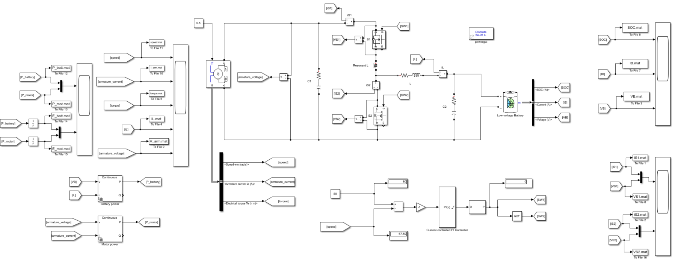

Multiphase interleaved topology
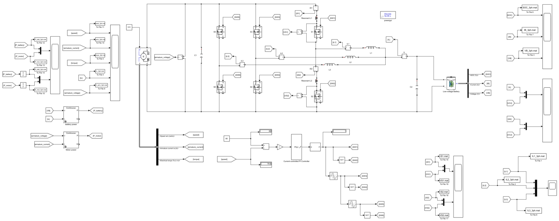

Societal impacts

Sustainability
The product of this project is software simulation which does not involve hardware implementation, thus there are no difficulties to replace and maintaining components in a complete system in software, despite different topologies of DC-DC converters circuit take considerable simulation time due to complex architecture and the increasing number of components. More research and optimization conducted, more sustainable of the use of resources for the final result of the project. If the design of the DC-DC converter hardware implementation, more efficient topologies may include more components used and higher complexity, the time and production costs will be massive.
From the facet of techno-centric concerns, it facilitates the technology of the battery lifecycle. The bidirectional capability of DC-DC converters allows engineers from worldwide to continue to deploy new techniques to prevent the degradation of lithium-ion batteries in an EV from time spent at full charge, further improving battery health.
From the facet of socio-centric concerns, bidirectional DC-DC converters can improve the EV customer experience. With increasing higher quality in driving experience from the public, more electronic devices are included inside vehicles, higher efficient DC-DC converters are used for the low voltage applications to improve user experience.
From the facet of eco-centric concerns, electronic waste from EVs can have a second life. The production of EVs necessitates both DC-DC converters, which is a complementary demand for batteries. Therefore, the overall manufacturing process of vehicle integration and raw material extraction creates inevitable environmental footprints. After the usage of EVs, disposals of EVs will create electronic wastes of battery cells and loads of converters. The sustainable strategies to combat these global issues are the extraction of the raw materials from the electronic wastes, also the disposable high-capacity EV batteries can be reused for second-life energy storage.

Ethics
If this project is hardware implementation, the physical implementation of DC-DC converters must connect with battery cells to carry out voltage conversion. The construction of the electronic module involves different kinds of power electronic devices and battery cells, demanding for raw material extraction of lithium and cobalt in low-developed countries. This has provoked the ethical dilemma of cobalt mining using child labor, environmental footprint caused by the CO2 emission of processing lithium, and the catastrophic risk in reusing the lithium batteries for energy storage. The public is acutely vulnerable to engineers, thereby as a comprehensive engineer, we have the responsibility to minimize these adverse impacts to the society based on code of ethics and professionalism, for instance, regulation and enforcement in law must have come into the practice for the amount of extraction in certain controversial raw materials or technology invention in new battery cell involving in other less controversial raw materials.

Risk management

Imbalance between study workload and project work
To mitigate the risk of inconsistent progress and time crashing between assignments, throughout the project, I would use online project management software Wrike to track my progress as shown in the above Gantt chart, which shows precise timeframes for each small task and project dependencies. Additionally, I will use the progress journals to record down the tasks I have committed per week and set the objectives for the next week at the end of the week. Meanwhile, Reminder app on phone will record down every deadline and preparation time of the assignments from other modules to have a time-organised schedule with resting timeframes.

Difficulties in the understanding of concepts acquired
To mitigate the risk of misunderstanding certain concepts in this project, for the research work, the Online MathWorks platform could be managed to foster my concept interpretation via tutorial videos in the case of difficult times in the self-learning process. If the supervisor is not available during a certain timeframe, I would first mark down the challenges and doubts during the unavailable period, then deal with them after the supervisor is available. In the case of an urgent issue, I would get advice from the teachers in the same field or course mates.

Technical issue
To mitigate the risk of PC breakdown, school OneDrive is also used to group all the background readings, progress journals, meeting summary, and draft to allow easier tracking of my progress whenever using IT cluster on campus or laptop.

Equality, diversity and inclusivity
Regarding equality, the advancement in power electronics and the government incentives provide more opportunities to the public. The application of bidirectional converters in V2G technology reduces the overall cost of owning an EV by putting their battery to use when the car is parked and not being driven. Moreover, the regenerative braking system based on the bidirectional feature can be applied to every EV and hybrid EV, which provides a high opportunity for the increased driving range to every driver of electric-involved vehicles. Additionally, most countries have managed to only manufacture EVs in the coming decade, like the UK in 2030. The government also planned to increase more EV charging stations around the UK. Therefore, policies can allow everyone to have an equal opportunity to access this technology.

Regarding diversity, EV technology benefits the quality of life worldwide. Provided that the widespread calls for EVs in this era, many automotive manufacturers manage to produce EVs by using diversified topologies of bidirectional DC-DC converters for different production lines to keep up with the trend. The public can select a wide variety of EVs nowadays for their needs, some low-income households in low-developed countries or drivers using internal combustion engines might not take the advantage of this technology due to the prohibitively expensive price of EVs. Given that EV production is still in an infancy period, more advanced technology will be appearing in the automotive industry, lower production costs, and simplistic design will come into play. The underprivileged can still access the electrified-powertrain public transportation in the future. People from different social hierarchies, backgrounds, and ethnicities could enjoy this benefit.

Regarding inclusivity, people from all walks of life can be benefited from this technology. In the not-too-distant future, every driver using electric chargers from the grids can contribute their spare energy storage to the community when their cars are idle. Not only could this V2G technology provide a cost-efficient form of local energy storage, but develop a more democratic system where everyone can benefit. The energy storage charged by millions of cars can be the backup electricity when it comes to blackout or outage. Furthermore, level 5 autonomous vehicles will be released in the coming decades by utilizing advanced converters technology, which renders precious opportunities for the disabled to be driven by the EVs themselves.

Safety
As all the simulation will be conducted on MATLAB software, safety is not a necessary concern for this project. It will be noticed by the supervisor if the case of hardware implementation.

Reference

[1] J. Chen, M.-K. Nguyen, Z. Yao, and C. Wang, “DC-DC Converters for Transportation Electrification: Topologies, Control, and Future Challenges,” Research Gate. [Online]. Available: https://www.researchgate.net/publication/352135677_DC-DC_Converters_for_Transportation_Electrification_Topologies_Control_and_Future_Challenges. [Accessed: 20-Nov-2021].

[2] J. Zhang, “Bidirectional DC-DC Power Converter Design Optimization, Modeling and Control ,” vtechworks, 30-Jan-2008. [Online]. Available: https://vtechworks.lib.vt.edu/handle/10919/26126. [Accessed: 20-Nov-2021].

[3] M. Hedlund, “Design and construction of a bidirectional DCDC converter for an EV application ,” diva-portal. [Online]. Available: https://www.diva-portal.org/smash/get/diva2:301346/FULLTEXT01.pdf;Design. [Accessed: 25-Jan-2022].

[4] Dr Benjamin Chong, S2020, DC-DC converters, lecture notes, ELEC 2530 Power Electronics, University of Leeds, delivered 28 September 2020

[5] A. Agatep and M. Ung, “Design and simulation of V2G bidirectional inverter and DC-DC converter,” DigitalCommons@CalPoly. [Online]. Available: https://digitalcommons.calpoly.edu/eesp/120/. [Accessed: 20-Nov-2021].

[6] Dr Benjamin Chong, S2020, Introduction to Power Devices, lecture notes, ELEC 2530 Power Electronics, University of Leeds, delivered 28 September 2020

[7] T. Pre-Switch, “Hard-switching, soft-switching, pre-switching,” Pre, 29-May-2018. [Online]. Available: https://www.pre-switch.com/single-post/2018/05/28/hard-switching-soft-switching-pre-switching. [Accessed: 25-Dec-2021].

[8] P. Pany, R. K. Singh, and R. K. Tripathi, “Bidirectional DC-DC converter fed drive for Electric Vehicle System,” International Journal of Engineering, Science and Technology. [Online]. Available: https://www.ajol.info/index.php/ijest/article/view/68426. [Accessed: 25-Nov-2021].

[9] Osama Hebala ,“Battery charging/discharging controller,” MathWorks. [Online]. Available: https://www.mathworks.com/matlabcentral/fileexchange/91750-battery-charging-discharging-controller. [Accessed: 16-Mar-2022].

[10] “PID Controller,” Wikipedia, 30-Mar-2022. [Online]. Available: https://en.wikipedia.org/wiki/PID_controller. [Accessed: 01-Apr-2022].

[11] “Car battery voltage,” Tontio, 05-Feb-2022. [Online]. Available: https://tontio.com/auto-guides/car-battery/car-battery-voltage/. [Accessed: 20-Mar-2022].

[12] S. Du, R. Guo, and L. Wang, “Research on bidirectional DC/DC converter for electric vehicle,” Scientific.Net, 05-Dec-2014. [Online]. Available: https://www.scientific.net/AMM.701-702.1169. [Accessed: 20-Mar-2022].

[13] M. C. Joshi and S. Samanta, "Modeling and control of bidirectional DC-DC converter fed PMDC motor for electric vehicles," 2013 Annual IEEE India Conference (INDICON), 2013, pp. 1-6, doi: 10.1109/INDCON.2013.6726091.

[14] K. B. Kumar, “Simulation of Electric Vehicle Drive with Matlab/Simulink,” ResearchGate, 27-May-2020. [Online]. Available: https://www.researchgate.net/publication/349338696_Simulation_of_Electric_Vehicle_Drive_with_MatlabSimulink.

[15] Dr Benjamin Chong, S2022, DC Machines, lecture notes, ELEC 3565 Electric Machines, University of Leeds, delivered 20 February 2022

[16] J. A. Mane and A. M. Jain, "Design, modelling and control of bidirectional DC-DC converter (for EV)," 2015 International Conference on Emerging Research in Electronics, Computer Science and Technology (ICERECT), 2015, pp. 294-297, doi: 10.1109/ERECT.2015.7499029.

[17] S. Soylu (Ed.) Electric Vehicles - Modelling and Simulations. London, United Kingdom, IntechOpen, 2011 [Online]. Available from: https://www.intechopen.com/books/447 doi: 10.5772/958

[18] S. N. Manias, “Zero Current Switching,” ScienceDirect, 06-Jan-2017. [Online]. Available: https://www.sciencedirect.com/topics/engineering/zero-current-switching. [Accessed: 02-Apr-2022].

[19] Chakraborty, S.; Vu, H.-N.; Hasan, M.M.; Tran, D.-D.; Baghdadi, M.E.; Hegazy, O. DC-DC Converter Topologies for Electric Vehicles, Plug-in Hybrid Electric Vehicles and Fast Charging Stations: State of the Art and Future Trends. Energies 2019, 12, 1569. https://doi.org/10.3390/en12081569

[20] J. Zhang, J. -S. Lai, R. -Y. Kim and W. Yu, "High-Power Density Design of a Soft-Switching High-Power Bidirectional dc–dc Converter," in IEEE Transactions on Power Electronics, vol. 22, no. 4, pp. 1145-1153, July 2007, doi: 10.1109/TPEL.2007.900462.

