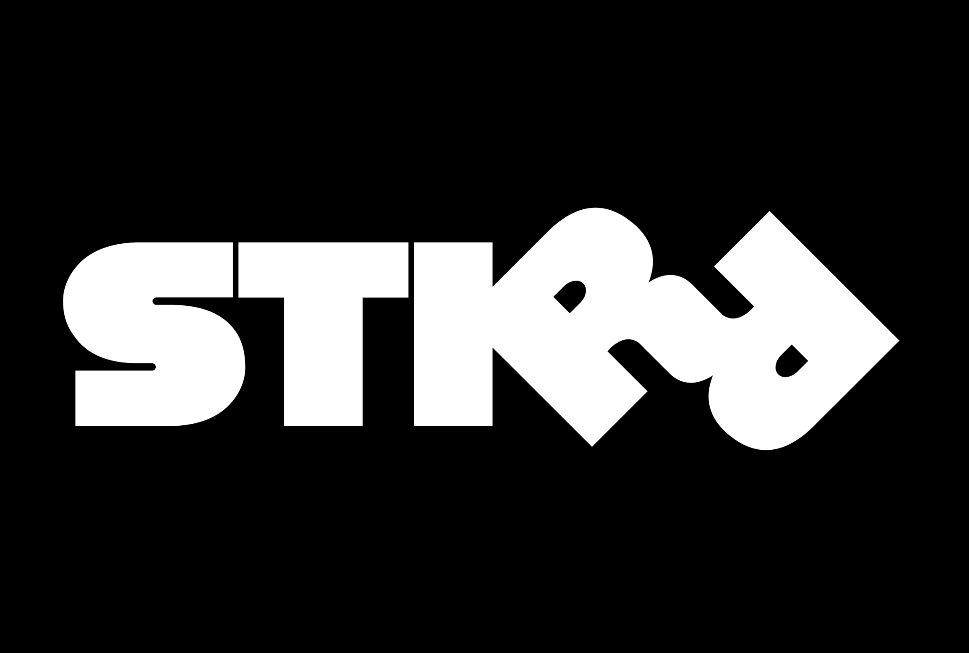
Platform Engineering

STIRR Discover:
Live Video Discovery for Claude Cowork Artifacts
Todd Carter
STIRR Platform Engineering
April 2026

SECTION 1
What This Is
STIRR Discover is a Claude Cowork plugin that surfaces live streaming video inside AI conversations. It transforms Claude from a text-only assistant into a content discovery platform — powered by STIRR’s VODLIX API, 70,000+ global IPTV channels, and real-time HLS streams.
✖ Before (Tubi/ChatGPT) | → | ✔ After (STIRR/Cowork)
Links out to external app | → | Video plays inline in the conversation
Text-only content cards | → | Full branded UI with live badges, tabs, player
Single content source | → | STIRR + BBC + 70K IPTV + VOD library
No broadcast context | → | Intent-aware: WATCH / KNOW / browse
Core System
MCP Server | Skill (SKILL.md) | Artifact UI
5 tools · VODLIX API + iptv-org | Intent detection · artifact generation | HTML · channel grid · player · tabs
Core Principle
MCP Server searches the content
Skill understands the intent
Artifact renders the experience
User watches without leaving Claude
Content Sources
Source | Channels | Access Method
STIRR Local Stations | 70+ | VODLIX API (HTTP Basic auth)
STIRR VOD Library | Thousands | VODLIX API (v2/search, v2/videos/list)
Global News | 8 in POC | Public HLS (ABC, CBS, DW, France 24, NHK, Al Jazeera, CGTN, Euronews)
BBC Channels | 10 in POC | stirr-iptv-feeds (Akamai/CloudFront HLS)
iptv-org Database | 70,000+ | Public API (channels.json, streams.json)

SECTION 2
MCP Server (5 Tools)
A Node.js MCP server using stdio transport that gives Claude direct access to STIRR’s content backend and the global IPTV ecosystem.
Tool Reference
Tool | Source | Description
search_stirr_content | VODLIX API | Full-text search across STIRR’s VOD library (v2/search)
get_stirr_live_channels | VODLIX API | Live channel listings (v2/videos/list, content_type=4)
search_iptv_channels | iptv-org | Search 70,000+ global channels by name/country/category
get_iptv_streams | iptv-org | Retrieve HLS stream URLs for any iptv-org channel
get_stirr_local_news | VODLIX API | STIRR local station lookup by market or call sign
Plugin Structure
File | Purpose
.claude-plugin/plugin.json | Plugin manifest (name, version, skill/MCP references)
.mcp.json | MCP server config with env var bindings
mcp-server/server.js | Node.js MCP server (stdio transport, 5 tools)
skills/stirr-discover/SKILL.md | Claude instructions for intent detection + artifact generation
skills/stirr-discover/references/ | VODLIX API reference, iptv-org docs, artifact templates
Intent Model
Intent | Focus | Example Query
WATCH | Discovery + passive | Put something on · Find something similar · What’s next?
KNOW | Context + information | What am I watching? · What’s on screen? · What’s this about?
BROWSE | Navigation + explore | What channels are available? · Show me news · What’s live?

SECTION 3
The Blocker: Artifact Sandbox
The plugin is fully functional with one critical blocker: Cowork’s artifact sandbox blocks all network access. We tested every approach systematically.
Test Results
Test | Result | Error
MP4 <video> element | Blocked | Media load rejected by URL safety check
fetch() to HTTPS | Blocked | Failed to fetch
HLS.js + CORS proxy | Blocked | manifestLoadError (HTTP 0)
fetch() to localhost | Blocked | Failed to fetch
iframe src to localhost | Blocked | No request received by server
Cloudflare tunnel (HTTPS) | Blocked | Failed to fetch
Core Insight
Script tags from CDN load (HLS.js loads successfully)
But all runtime network access is blocked:
fetch(), XHR, <video src>, <audio src>, WebSocket
To any host: localhost, public HTTPS, tunnels
The sandbox blocks all outbound network from artifacts. This prevents not just video playback but any media-rich plugin experience. The streams themselves are verified working — they play perfectly in Safari, VLC, and the browser. The only gap is the sandbox.
Proposed Platform Solutions
Approach | Description | Scope
Allowlisted network per plugin | Plugins declare permitted domains in manifest. Sandbox permits media to those domains only. | Scoped, auditable
Native video artifact type | First-class <video> component in artifact system. Claude generates video artifacts like HTML/React. | Platform feature
Relaxed sandbox for media | Allow <video> and <audio> src while keeping fetch/XHR restricted. Media consumes, doesn’t exfiltrate. | Minimal change

SECTION 4
Phased Roadmap
With the sandbox unlock, STIRR Discover expands in three phases:
Phase | Name | Description
P1 | News-First Inline Playback | Live local news from 70+ STIRR stations, global news, BBC. User says “what’s happening in Seattle?” and gets KOMO playing inline.
P2 | Chapterized Player | Adapt for long-form content using beeexplayer. Chapter navigation, seek-to-moment, AI-generated segment summaries.
P3 | Video Tapestries | Multi-source video experiences. “Show me how networks are covering the election” generates a tapestry of live feeds with AI analysis.
Beyond STIRR
The same plugin architecture applies to Skillshare’s how-to video library. “Teach me watercolor techniques” surfaces relevant lessons playing inline with AI-guided learning. This is a pattern, not a one-off.
Why This Matters for Anthropic
Value | Details
Platform differentiation | No AI platform has native live video. ChatGPT links out. Gemini links out. Claude would be first.
Plugin ecosystem signal | Enabling video unlocks audio, podcasts, live events, sports — every content provider becomes a plugin partner.
Enterprise value | Companies use video for training, news monitoring, competitive intelligence. Inline playback makes these conversational.
Community reach | iptv-org alone surfaces 70,000+ channels from 250+ countries. Global community with a reason to use Cowork plugins.
The Ask
We’re requesting a 20-minute meeting to demo the working plugin and discuss enabling inline media playback in Cowork artifacts.
- Live demo of the STIRR Discover artifact UI
- Walk through sandbox test results and proposed solutions
- Discuss timeline for media element support
- Explore potential as a flagship media plugin in Claude Marketplace
Everything is built and ready.
The only gap is the sandbox. Let’s close it together.

Todd Carter
CEO, STIRR / Thinking Media
todd@thinkingmedia.ai

