Customer Feedback Report for Healthcare Services

# Introduction

This report presents a comprehensive analysis of customer feedback collected through a survey conducted by MedPlus AB, focusing on healthcare services in Stockholm and Gothenburg. The survey, led by Project Lead Thomas Ochman, involved 45 respondents and was conducted on September 15, 2024. The analysis aims to provide insights into customer satisfaction and identify areas for improvement in service delivery, in alignment with generally accepted standards for healthcare services.

# Findings

## Customer Attribute Breakdown

In Quality Function Deployment (QFD), customer attributes are derived from direct feedback provided by customers through statements reflecting their experiences. Each statement is evaluated and categorized into primary, secondary, and tertiary attributes, allowing for a structured understanding of customer needs. This process helps prioritize attributes based on their importance to customer satisfaction, facilitating targeted improvements in service delivery.

|  |  |  |
| --- | --- | --- |
| Primary Attribute | Secondary Attribute | Tertiary Attribute |
| Appointment Management | Scheduling Process | Ease of booking appointments |
|  |  | Availability of appointment slots |
|  | Waiting Time | Time spent waiting for appointment |
|  |  | Time on hold during calls |
| Staff Interaction | Staff Professionalism | Politeness of staff |
|  |  | Communication skills of staff |
|  | Responsiveness | Timeliness of responses |
|  |  | Attention to patient needs |
| Facility Environment | Cleanliness | Hygiene standards |
|  |  | Maintenance of facilities |
|  | Comfort | Waiting area comfort |
|  |  | Overall atmosphere |
| Billing and Insurance | Transparency | Clarity of billing process |
|  |  | Insurance handling |
| Technology and Accessibility | Online Services | Ease of use of the website |
|  |  | Access to medical records |

## Relative Importance of Customer Attributes

|  |  |
| --- | --- |
| Customer Attribute | Relative Importance (%) |
| Appointment Management | 26.18% |
| Staff Interaction | 26.47% |
| Facility Environment | 23.24% |
| Billing and Insurance | 12.65% |
| Technology and Accessibility | 11.47% |

## Relative Importance Chart

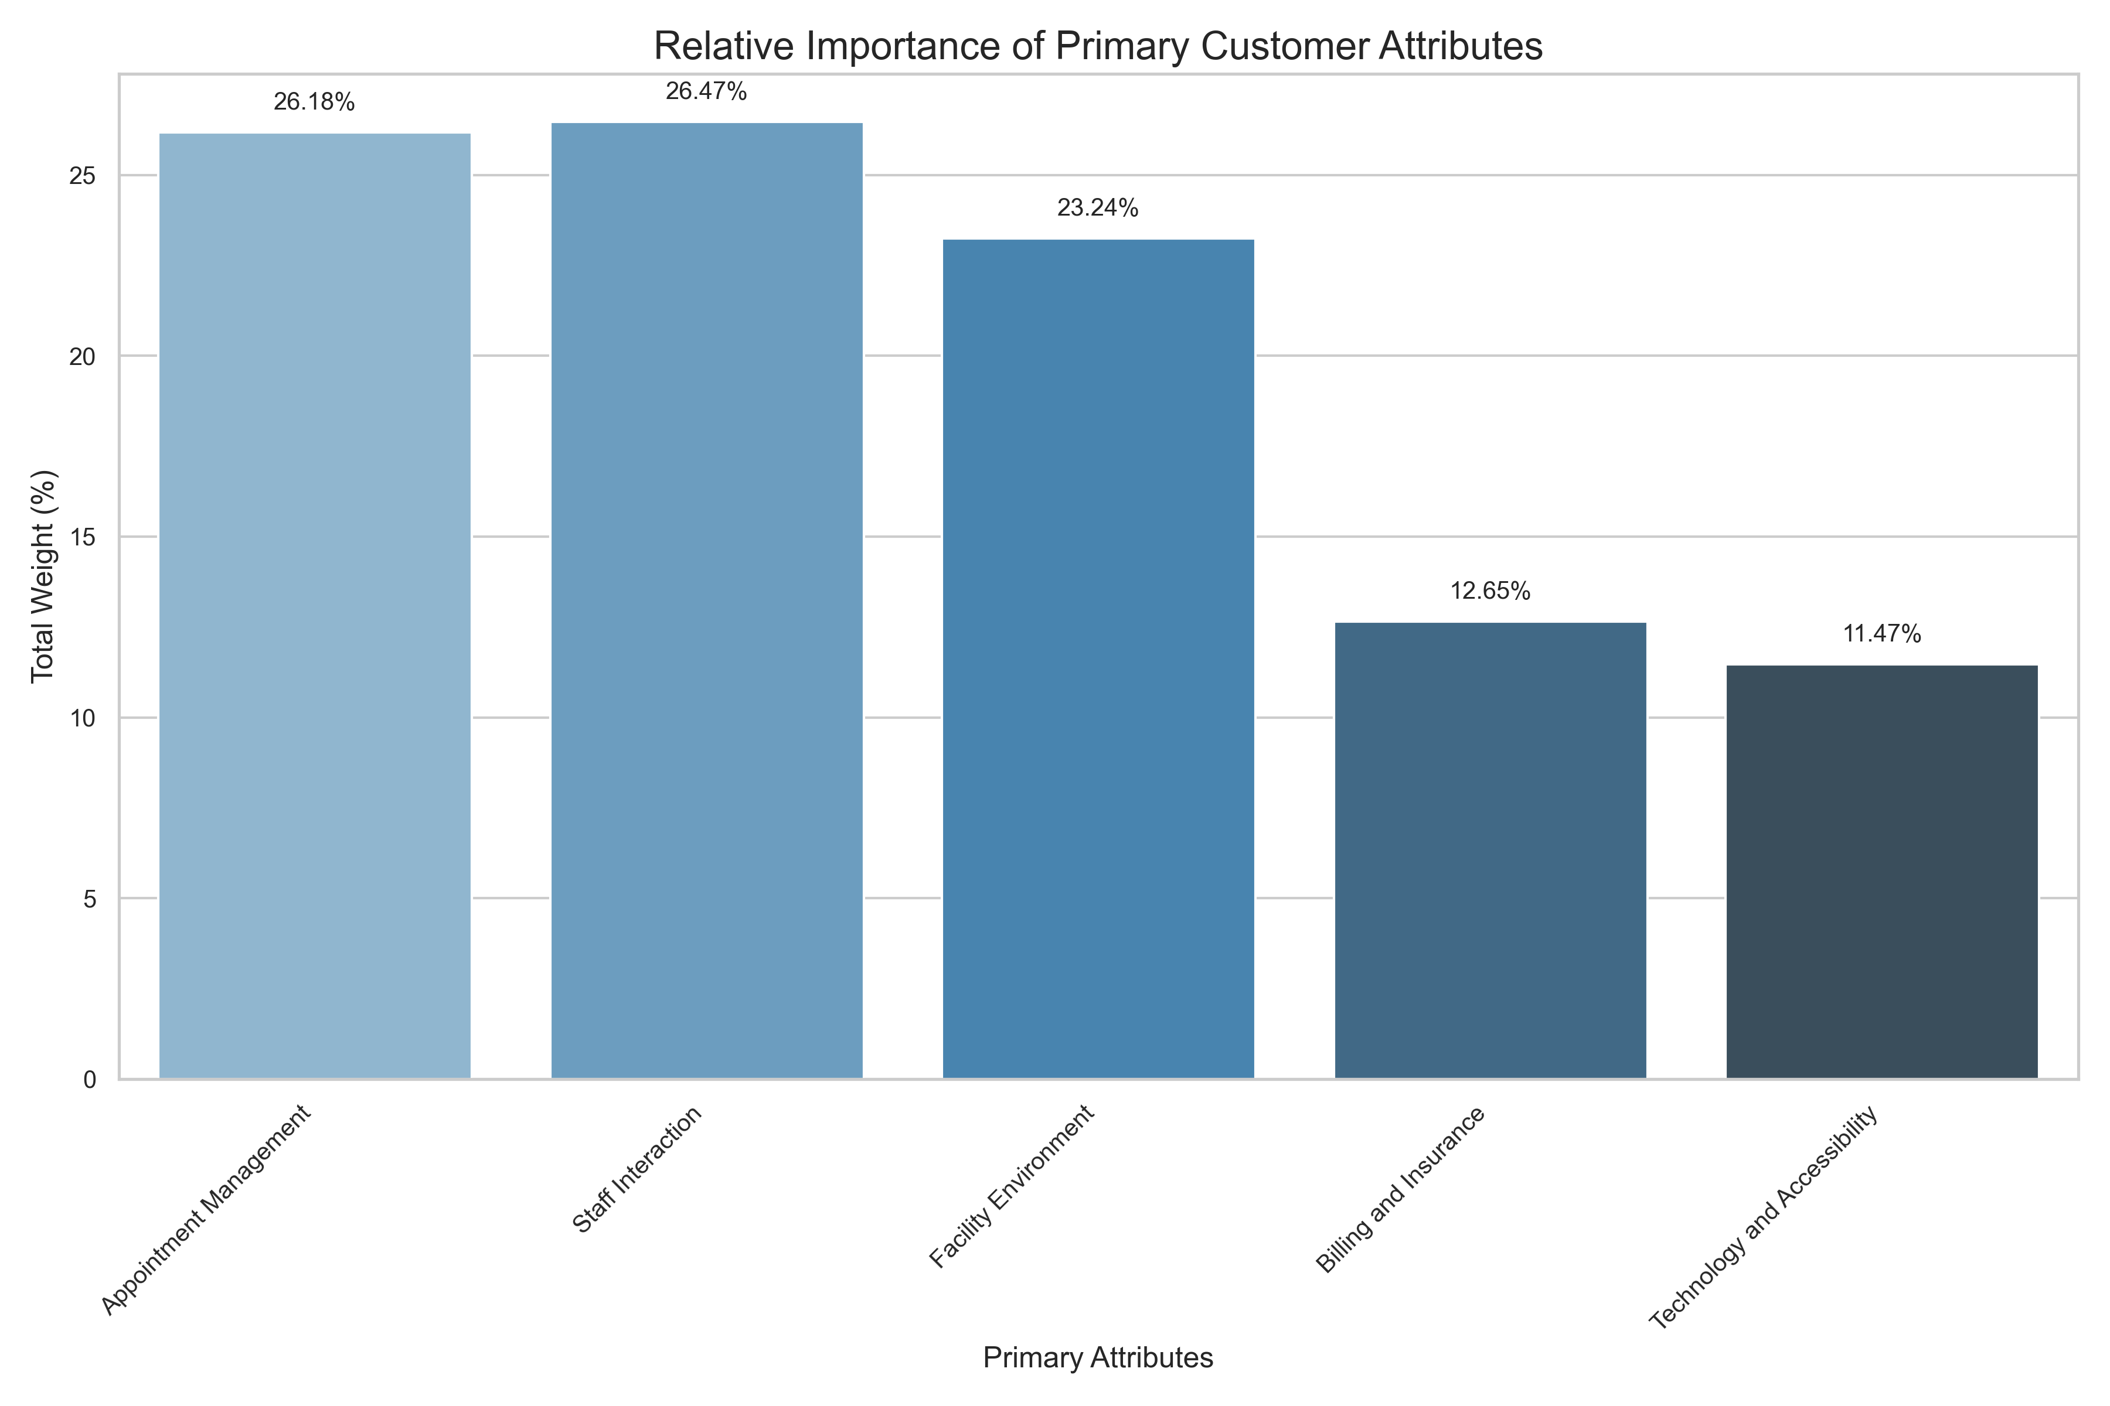

# Business Analysis

The analysis of the survey results reveals several key findings: 1. Appointment Management: Customers appreciate the ease of booking appointments online, with scores of 0.9 and 0.8 for related statements. However, there are concerns regarding the availability of appointment slots, with a significant negative score (-0.6) indicating that some respondents had to reschedule due to unavailability. 2. Staff Interaction: High scores (1.0 and 0.9) reflect positive feedback on staff professionalism and communication skills, although there are notable concerns regarding the clarity of communication from some staff members, leading to negative scores (-0.7 and -0.5). 3. Facility Environment: While cleanliness received positive feedback (0.9), there are significant issues with hygiene standards and comfort in waiting areas, as indicated by negative scores (-0.8 and -0.5). 4. Billing and Insurance: Transparency in the billing process is viewed positively (0.8), but negative feedback regarding additional charges and rude interactions with billing staff highlights a need for improvement. 5. Technology and Accessibility: The online services aspect is generally well-received (0.9), but there are critical concerns about the accessibility of medical records and the user-friendliness of the website, particularly for older patients, which received negative scores (-0.6 and -0.4). Overall, the most critical attributes based on their relative importance are Appointment Management (26.18%) and Staff Interaction (26.47%).

# Recommendations

Based on the analysis, the following recommendations are proposed for operations management: 1. Enhance Appointment Availability: Implement strategies to increase the availability of appointment slots to reduce rescheduling instances. 2. Improve Communication Skills: Provide training for staff to enhance communication skills, ensuring clarity and understanding, especially for non-native speakers. 3. Address Facility Cleanliness and Comfort: Conduct regular audits of facility cleanliness and comfort, particularly in waiting areas and bathrooms, to ensure high hygiene standards. 4. Revise Billing Processes: Improve the transparency of the billing process by clearly communicating potential additional charges upfront and training billing staff in customer service best practices. 5. Upgrade Online Services: Invest in updating the patient portal to enhance functionality, particularly for accessing medical records and making it more user-friendly for older patients.

# Conclusion

In conclusion, the analysis of customer feedback for MedPlus AB highlights both strengths and areas for improvement in service delivery. While customers express satisfaction with appointment management and staff professionalism, significant concerns regarding appointment availability, communication clarity, facility cleanliness, and online accessibility must be addressed. By implementing the recommended actions, MedPlus AB can enhance customer satisfaction and ensure a higher quality of healthcare services.

# Appendix: Statements by Sentiment

|  |  |  |  |
| --- | --- | --- | --- |
| Primary Attribute | Positive Statements | Neutral Statements | Negative Statements |
| Appointment Management | I love the fact that we can book online. (0.90) The appointment scheduling process was simple and quick. (0.80) I found the appointment scheduling process to be very easy. (0.90) I got an appointment within a week of my call. (0.80) I had my choice of days. (0.70) I was in the doctor’s office on schedule. (0.80) I appreciated that I didn’t have to wait long to be seen. (0.90) I spent little time on the phone. (0.60) | - | I had to reschedule due to unavailability of slots. (-0.60) The wait time in the clinic was way too long. (-0.70) I had to wait on hold for 15 minutes before speaking to someone. (-0.70) Long time on hold. (-0.50) |
| Staff Interaction | Staff was great! Love them. (1.00) The nurses are polite and professional, I feel safe here. (0.90) The receptionist was friendly but seemed distracted. (0.40) The doctor explained everything very clearly and patiently. (0.90) My questions were answered accurately and timely. (0.90) The doctor showed concern for my symptoms. (0.90) | - | I could not understand my doctor. His English was bad. (-0.70) The nurse spoke too quickly for me to understand everything. (-0.50) I could not reach the nurse over the phone. (-0.70) Responsiveness of personnel too slow. (-0.60) I felt rushed during my consultation with the doctor. (-0.60) I was scared and nobody comforted me. (-0.90) |
| Facility Environment | I love how clean the clinic was during my visit. (0.90) The clinic was clean and well-organized. (0.90) The facility was outdated but well-maintained. (0.30) The waiting area was spacious and well-lit. (0.80) The waiting room was comfortable, but a little crowded. (0.30) The facility had a welcoming environment with a nice seating area. (0.90) The clinic was conveniently located in a central area. (0.90) | - | The waiting room is dirty and crowded. I'm scared to catch a disease. (-0.80) I was not impressed with the hygiene standards. (-0.70) The bathrooms needed more attention. (-0.40) The chairs in the waiting room were uncomfortable. (-0.50) The clinic should have more parking spaces, it was crowded. (-0.50) |
| Billing and Insurance | The billing process was transparent. (0.80) My insurance claim was processed without any issues. (0.80) The front desk helped me understand my insurance coverage. (0.80) | - | I was not informed about additional charges before my visit. (-0.70) The billing clerk was rude. (-0.80) I wish there were more payment options available. (-0.40) |
| Technology and Accessibility | The clinic’s website was easy to use. (0.90) | - | The website should be more user-friendly for older patients. (-0.40) The online appointment system was convenient, but my medical records were missing. (-0.60) I wish I could access my test results directly on the website. (-0.60) I couldn't find my medical history on the patient portal. (-0.70) The patient portal is outdated and lacks proper functionality. (-0.70) |