**Chess Online by Virtual Reality**

Mr.Pasawee Laearun1, Mr.Jatupon Thassaboot2, Mr.Visarut Invisate3,

Mr.Vichien Donram4, Dr. **Kanuengnij Kubola5**

1,2,3,4Princess Chulabhorn’s College Chonburi (Regional science school), Nongchak, Banbuang,Chonburi, Thailand, 20170

5Faculty of Informatics, Burapha University, Saen Sook Sub-district, Mueang District, Chonburi, Thailand 20131

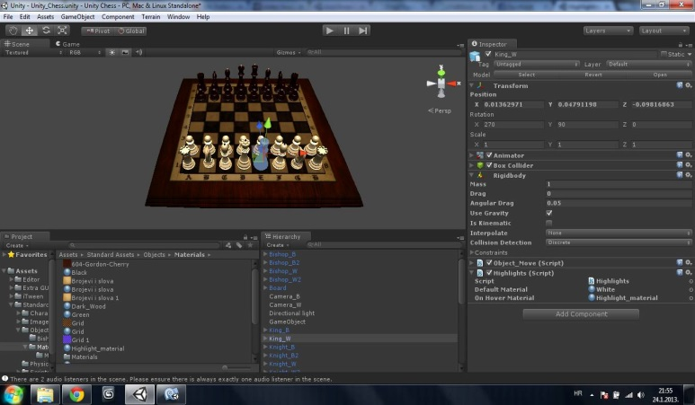

# Abstract

The research objective is to create chess online by virtual reality. We will create Chess Online by Virtual Realityby using Unity online game program, creating chess by using Blender program. And writing motion detection program by using library of OpenCV.To check the motion detection of each chess piece we use Open CV function to take chessboard photo and create x,y axis, puts on chess board .Then write the function for Open CV to find each chess into coordinate system x,y . Open CV processed,it will sent the position to the chess online game. The chess online game will set x, y coordinate system from image processing with coordinate x, y of each chess in chess online game. When the chess piece in the chess board move, the chess in chess online game will also move following the positions. And chess online game will check the chess rules that can check that the chess play correctly or not.

When chess online by virtual reality is created and tested, we found that chess online by virtual reality could check the chess rules and playing of the chess on the chess board correctly.

**Keywords:** Chess Online, Virtual Reality