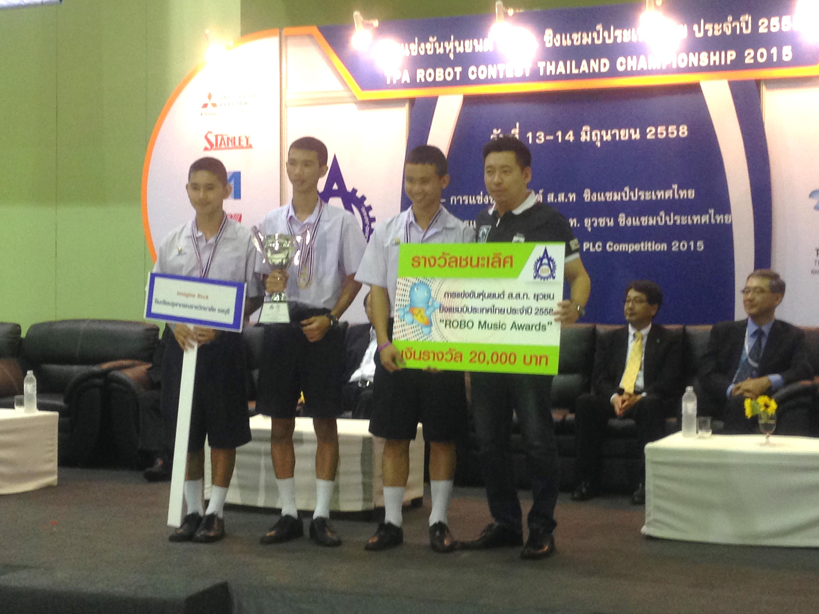

Mr.Settha Jan-on1

Mr.Phontakorn Chanprasoet2and

Mr.Chanathip Nirandaropas3

Advisor: Mr.Vichien Donram4

Special Advisor: Assoc.prof.TeerawatPragobpul.5

1,2,3,4PrincessChulabhorn’s College Chonburi, Nongchak, Banbuang,Chonburi,Thailand, 20170

5Faculty of science,Kingmongkut’s Institute of Technology Ladkrabang, Ladkrabang, Bangkok, Thailand 10520

**Abstract**

The objective is to create automatic music robots by using Pneumatic system and PLC. The purpose of learning the Pneumatics system and PLC is to create an automatic robot. 296 representative sample were asked for their opinion. These representatives included teachers, junior secondary students and senior secondary students from Princess Chulabhorn's College school in academic year 2015.

When the automatic music robots were finished and tested we found that the automatic music robots could play music perfectly. They were on rhythm of every song on the bass and drum set. While asking for opinions we found that many teachers and students thought the automatic music robots show was great. The average score was 4.67

**Keywords:** Pneumatic, Ladder, Programmable logic controller [PLC]

**The study about apply Pneumatics system with PLC to create automatic music robot**.

**Introduction**

Nowadays the world is continuously producing new technology such as phones, computers and now robots. The robots will have a variety of forms such as rescue robot ,sport robot and an industrial robot. The robot can create different results, depending on programs and equipment. During most of secondary school, they used a motor to create the robot. We had an idea to improve the new era of the robot by using new technology instead of a simple motor. The multiple program was easy to work. The new technology used for the robot were consisted of a pneumatics system and PLC, Our goal was to create a new innovative robot that had not been invented in Thailand yet. To complete this we would have to study projects, name is the study pneumatics with PLC to create the automatic music robots.

**Materials and Methods**

**Materials**

1. Programmable Logic Controller [PLC]  
 2. Made program by Ladder language with visilogic program.  
 3. Microsoft Office Excel 2013  
 4. Computer  
 5. Pneumatics system  
 5.1 Air tank  
 5.2 Air compressor  
 5.3 Service unit  
 5.4 Pressure regulator  
 5.5 Solenoid valveviz.solenoid valve3/2 and solenoid valve 5/2   
 5.6 Cylinderviz.single-acting cylinder and double-acting cylinder  
 5.7 Silencer

5.8 Air pipe size 4” , 6”, 8”

5.9 Air pipe fitting  
 6. Electronic circuit  
 6.1 Breaker  
 6.2 Power supply  
 6.3 Expansion adapter module  
 6.4 Servo drive  
 6.5 Servo motor  
 6.6 Relay  
 6.7 Terminal  
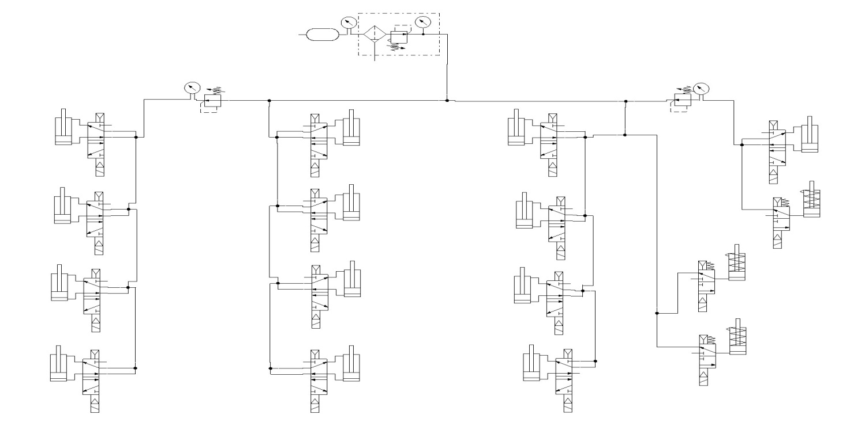 6.8 Switch  
 6.9 Photo sensor

7. Drum set and bass

**Methods**

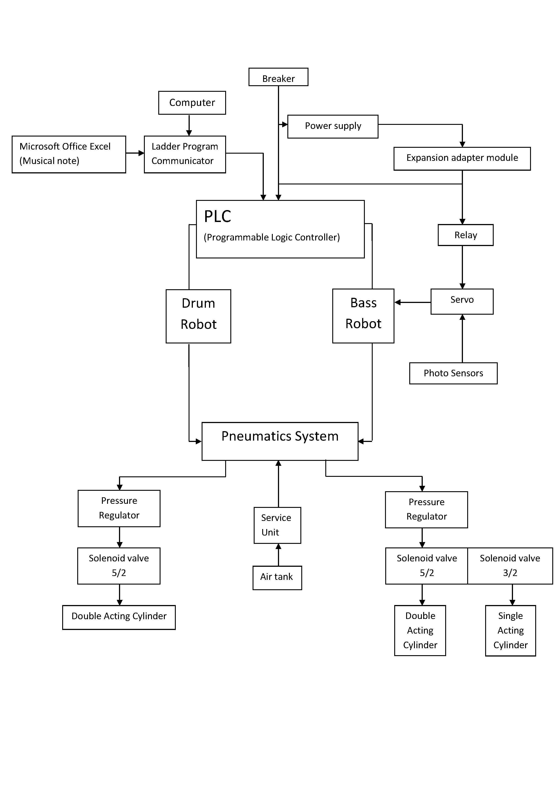1. Collect the file of pneumatic system and PLC.  
2. Explore and collect the files about the robot  
3. Input the file and analyze the problems and design the processing for the robot.

**Figure1.** Process of robots

4. Made a pneumatic circuit of drum robot and bass robot.

**Figure2**. Pneumatic circuit of drum robot and bass robot.

5. Create the drum robot structure and assembly bass robot structure.

6. We made a control program to control the robots by using Ladder language with visilogic program by PWM, compared and the functions by creating a table.

7. We made musical notes in Microsoft Office Excel 2013 then we imported music in the visilogic program in PLC to commands the robot to produce the correct rhythm and so the robots could play music

8. Improve the programs for the robots.

9. Exhibit the automatic music robot applied by the pneumatics system and PLC. After the process we tested the robots and asked opinions by using a survey form.

10. Created the science project.

**Results and Discussion**

**Results**

**1. Result of processing automatic music robot**

**1.1 Automatic music robot-type drum**

The automatic music robot-type drum or automatic drum robot starts running by an air tank compressor air pressure and air flow to a service unit for clean air to regulate air pressure. It show 4-7 bars and flows through pneumatics system of the automatic drum robot. It’s divided into 2 parts. First the air flows to 4 normally open solenoid valves 5/2 and flows to double-acting cylinders to work with 4 cymbals. Second the air flows in to pressure regulator to it regulates air pressure and checks the degree on a gauge valve and flows to the normally open 4 solenoid valves 5/2 and then to double-acting cylinders this works for 4 drums by pressing a switch to start.

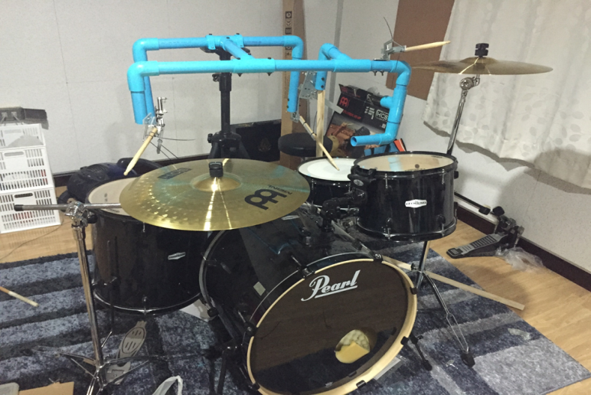**Figure 3.**Automatic drum robot.

**1.2 Automatic music robot-type bass**

Automatic music robot-type bass or automatic bass robot starts running by an air tank compressor. Air pressure and air flows to a service unit for clean air to regulate air pressure to 4-7 bars and flows through the pneumatics system of the automatic bass robot. It’s divided into 2 parts. First part, divided into 2 ports, first way air flows to 4 normally open solenoid valves 5/2 and then flows to double-acting cylinders to work with 4 bass strings, second the air flows to 3 normally open solenoid valves 3/2 and flows to single-acting cylinders to work with 3 bass strings. Second part, the air flows into a pressure regulator to regulate air pressure and to check the degree on the gauge valve and flows to normally open 1 solenoid valve 5/2 and the double-acting cylinders to work with 2 bass strings by pressing a switch to start.

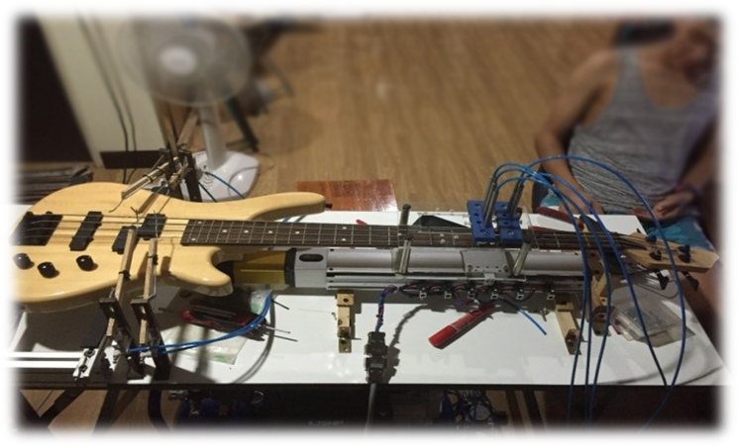

**Figure 4.**Automatic bass robot.

**2. Result of data analysis of automatic music robot.**

|  |  |  |  |
| --- | --- | --- | --- |
| Opinion | Student and teacher(n=296) | | Opinion degree |
|  | S.D. |
| 1. The attractiveness of the product | 4.77 | 0.42 | Highest |
| 2.Absoluteness of music | 4.64 | 0.49 | Highest |
| 3. Creativeness of the product | 4.53 | 0.55 | Highest |
| 4. Used modern technology | 4.70 | 0.48 | Highest |
| 5. Application of the robot with music | 4.68 | 0.48 | Highest |
| 6. Motivating viewers in the creative of the product | 4.69 | 0.51 | Highest |
| 7. Suitability of the product | 4.69 | 0.49 | Highest |
| Summary | 4.67 | 0.33 | Highest |

**Table 1.** Opinion, Mean, S.D.

Table 1. We found the student’s and teacher’s opinions about the automatic music robot applied by a pneumatics system with PLC show. The outcomes of opinions were very high. Overall was at the highest opinion was the attractiveness of the product with the average of 4.77, Second was used modern technology with the average of 4.70, third is motivating viewers in the creativeness of the product and Suitability of the product with the average of 4.69, fourth is the application of the robot with music with the average of 4.68, fifth is absoluteness of music with the average of 4.64, Last is the Creativeness of the product with the average of 4.53, The overall average was 4.67.

**Discussion**

When we applied the pneumatics system with the PLC it became clear the automatic music robot could play music. The musical notes were created by using Microsoft Office Excel 2013 and we imported music from the Visilogic program in PLC to command the robot to respond correctly to the rhythm. The automatic music robots could also play along with humans.

After creating the automatic music robot, applying the pneumatics system with the PLC finish and we collect opinion survey forms from 296 representative samples asking the opinion of students and teachers about the music robots at Princess Chulabhorn's College Chonburi school in academic year 2015. We found the opinions from the automatic music robots in all of the above were at the highest level and overall were at the highest level by the average of 4.67. Because the project is new and creates interest. We used the pneumatics system and PLC knowledge and this is used for engineering in higher education and applied the project.

**Conclusions**

1. The automatic music robots include an automatic drum robot and an automatic bass robot. So, 2 robots can play music together according to made music notes.

2. Student’s and teacher’s opinions from the automatic music robots overall were very high. The highest opinion is the attractiveness of the product by average of 4.77, second is use modern technology with the average of 4.70, third is motivating viewers in the creativeness of the product and Suitability of the product with the average of 4.69. Last is Creativeness of the product with the average of 4.53 and the overall average was 4.67.

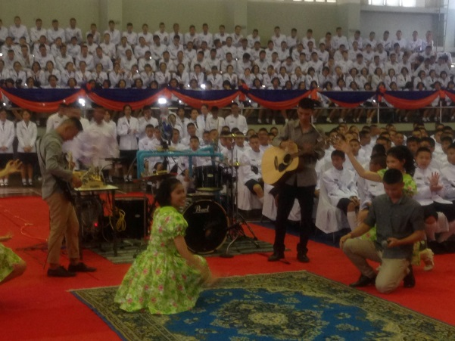

**Acknowledgments**

The computer project is a study about applied pneumatics systems with PLC to create an automatic music robot. The completetion of the project was supported by our advisor

Mr. Vichien Donram , he supported problems we found and facilitated this project.

We are grateful for our special advisor professor associate, Teerawat Pragobpul from faculty of science at King Mongkut’s Institute of Technology Ladkrabang.

We would also express our appreciation to Settha Jan-on’s father for sharing suggestions to create robots , also for buying equipment for this project. We are also immensely grateful for

Ms. Sunantha Pairin , Mrs. Saranporn Naka and Ms. Lillian Brown the teachers of the foreign language for their comments, We are proud to have the opportunity to Princess Chulabhorn’s College Chonburi school for start this project.

Nevertheless, we express our gratitude toward our families and colleagues for their kind co-operation and encouragement which helped us in the completion of this project.

**References**

[1.] ThananchaiLeephakpreeda. 2004.   
**Pneumatics and Hydraulics : Systems and   
Control.**Bangkok :Thammasat University   
 Press.

[2.] ฐิฑารีย์ถมยา. (2554). **นิวแมติกส์และนิวแมติกส์  
ไฟฟ้าเบื้องต้น.** พิมพ์ครั้งที่17. กรุงเทพฯ : สมาคม  
ส่งเสริมเทคโนโลยี (ไทย-ญี่ปุ่น).

[3.] ณรงค์ตันชีวะวงศ์. (2551). **นิวแมติกส์และ  
ไฮดรอลิกส์เบื้องต้น.** พิมพ์ครั้งที่10. กรุงเทพฯ:  
สมาคมส่งเสริมเทคโนโลยี (ไทย-ญี่ปุ่น).

[4.] เด่นคอกพิมาย. (2552). **การควบคุมนิวแมติก  
สำหรับอุตสาหกรรมอัตโนมัติ.** กรุงเทพฯ : ท้อป.

