**HW2:**

Students: Qiyi Song, Lixin Yan

a) The Five Indices downloaded are:

|  |  |  |  |  |
| --- | --- | --- | --- | --- |
| Country/District | Index Name | Start Date | End date | File Name |
| US | S&P500 | 1980-01-02 | 2018-02-21 | ^GSPC.csv |
| Japan | Nikkei 225 | 1980-01-02 | 2018-02-22 | ^N225.csv |
| Europe | ESTX50 EUR P | 1986-12-31 | 2018-02-22 | ^STOXX50E.csv |
| German | DAX | 1987-12-30 | 2018-02-22 | ^GDAXI.csv |
| France | CAC | 1990-03-01 | 2018-02-22 | ^FCHI.csv |

The data listed above are downloaded from Yahoo Finance.

The risk-free rate used here is the 3-Month Treasury Constant Maturity Rate downloaded from FRED from 1982-01-04 to 2018-02-22.

b)

a. The average daily excess returns for each day in [T-10, T+10] across the whole observation period for different country/district are plotted below:

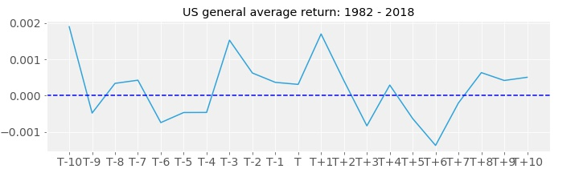

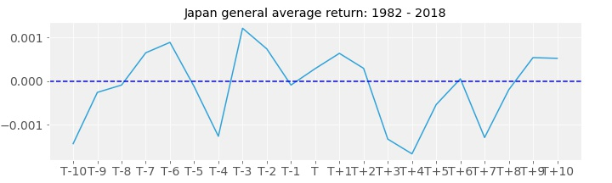

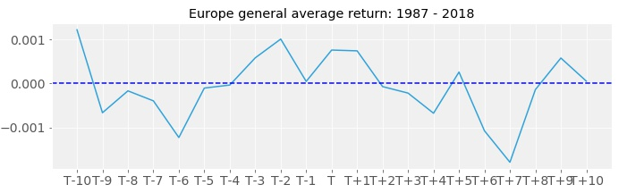

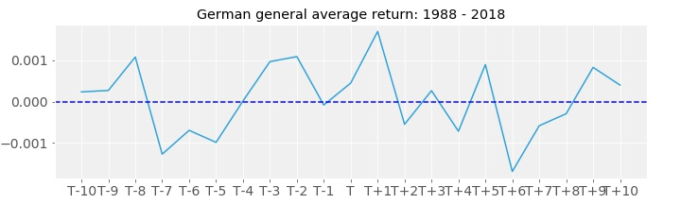

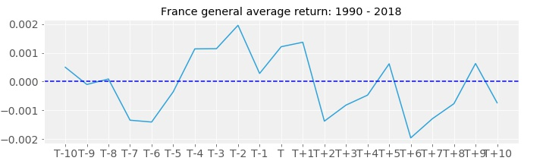

From those plots, we could observe that, for most of the indices, the daily returns during [T-4, T+1] are positive. But if we plot the average daily returns by year, this effect is not that significant.

b. The effect could be caused by the increase in the distribution and the immediate reinvestment of the pension fund. At the end of each month, pension fund might receive the distributions and then invest those distributions into the indices. As a result, the demand of the indices increases and hence causes the increase in the indices and the positive returns.

c. To test the interpretation, we could find an index that is not favored by the pension fund and study the historical returns of this index. If this index does not have the turn of the month effect, we might consider the interpretation as a reasonable guess. But if this index also has the turn of the month effect, we might need to find other interpretations.

c) The trading rule could be, buy the equity index, which has the turn of the month effect. on T-4 and sell it at the closing time on T+1. By doing so, we could collect the positive return from T-3 to T+1.

Below are the sharp ratios for the trading rule in each country or district. The sharp ratio is the annualized Sharp Ratio. Since the trading rule is executed on a monthly basis, the annualized Sharp Ratio could be calculated as: $Ann SR=\sqrt{12}*\frac{{mean(r}_{td}-r_{f})}{{sd(r}_{td}-r_{f})}$

$r_{td}$ is the return for the trading rule in each month.

|  |  |  |  |  |
| --- | --- | --- | --- | --- |
| Country/District | Index Name | Start Date | End date | Sharp Ratio |
| US | S&P500 | 1980-01-02 | 2/21/18 | 0.7356 |
| Japan | Nikkei 225 | 1980-01-02 | 2/22/18 | 0.3359 |
| Europe | ESTX50 EUR P | 1986-12-31 | 2/22/18 | 0.5207 |
| German | DAX | 1987-12-30 | 2/22/18 | 0.5903 |
| France | CAC | 1990-03-01 | 2/22/18 | 0.7528 |

The cum returns for the execution of the trading rule in each country/district are plotted below. We could observe that the turn of the month effect is most significant in US and France.

In Japan, the cum return of the trading rule fluctuates a lot and the total cum return is as high as other countries.

For Europe, German and France, the cum returns have pretty similar shapes and all have a little drop in recent years. This means the turn of the month effect is disappearing in recent years.

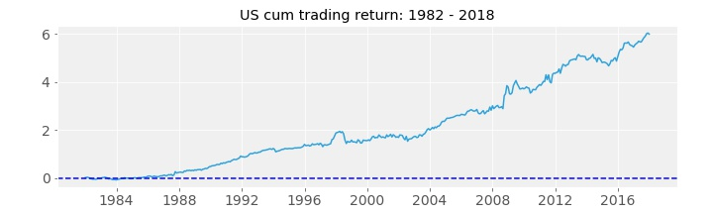

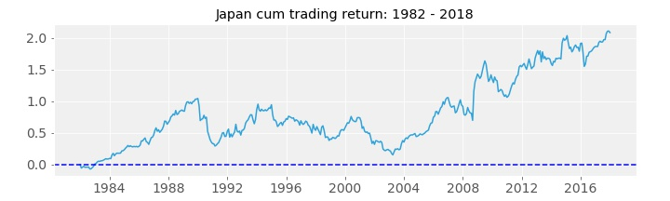

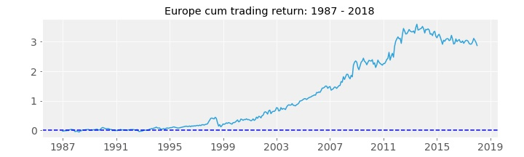

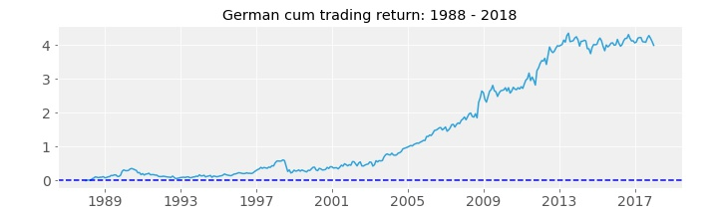

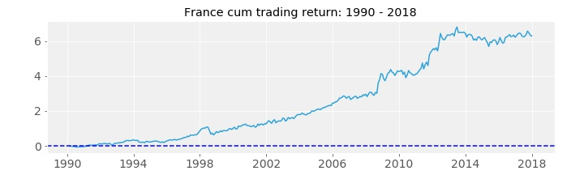

d)