# 京东私有云

<https://mp.weixin.qq.com/s/2YTb0VyPdkNh-IIz-IMR3A>

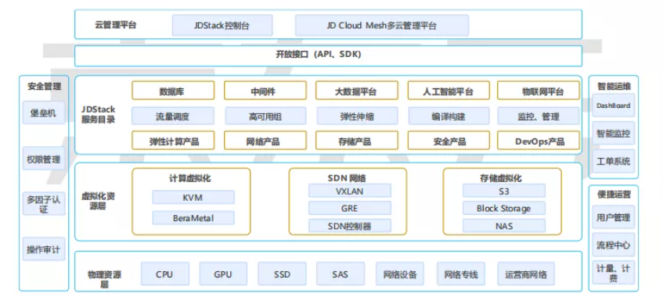

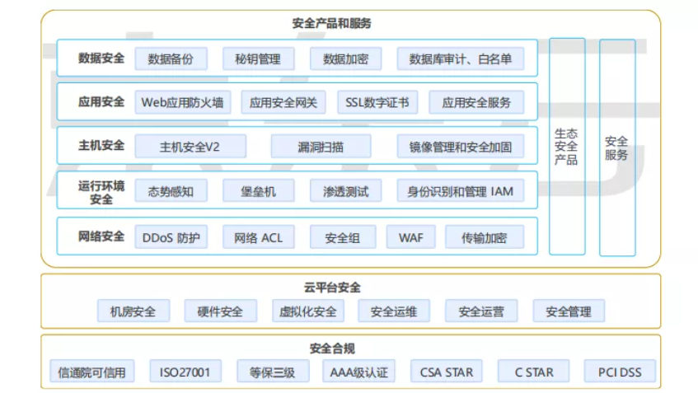

# AZ可用区

同一个Region内不同可用区的ping时延在1-3ms

<https://www.cnblogs.com/sammyliu/p/8900697.html>

<https://www.cnblogs.com/sammyliu/p/8902556.html>

# AWS架构

<https://www.cnblogs.com/sammyliu/p/8902556.html>

# 阿里云架构

<https://www.cnblogs.com/sammyliu/p/8900697.html>