使用Openshift

以ruby-ex应用为例

ruby-ex是一个简单的用ruby语言编写的网站，网站主页是一个静态页面。

从代码到发布



### 修改代码

[margin@cloud-sz-kolla-b13-01 openshift]$ git clone https://github.com/todaygood/ruby-ex.git

Cloning into 'ruby-ex'...

remote: Counting objects: 13, done.

remote: Total 13 (delta 0), reused 0 (delta 0), pack-reused 13

Unpacking objects: 100% (13/13), done.

[margin@cloud-sz-kolla-b13-01 openshift]$ ls

openshift-psap origin origin-web-catalog origin-web-common origin-web-console ruby-ex

[margin@cloud-sz-kolla-b13-01 openshift]$ cd ruby-ex/

[margin@cloud-sz-kolla-b13-01 ruby-ex]$ ls

config.ru Gemfile Gemfile.lock README.md

[margin@cloud-sz-kolla-b13-01 ruby-ex]$ vim README.md

[margin@cloud-sz-kolla-b13-01 ruby-ex]$ vim config.ru

[margin@cloud-sz-kolla-b13-01 ruby-ex]$ vim README.md

[margin@cloud-sz-kolla-b13-01 ruby-ex]$ vim Gemfile

[margin@cloud-sz-kolla-b13-01 ruby-ex]$ vim config.ru

[margin@cloud-sz-kolla-b13-01 ruby-ex]$ git status

# On branch master

# Changes not staged for commit:

# (use "git add <file>..." to update what will be committed)

# (use "git checkout -- <file>..." to discard changes in working directory)

#

# modified: config.ru

#

no changes added to commit (use "git add" and/or "git commit -a")

[margin@cloud-sz-kolla-b13-01 ruby-ex]$ git commit -a -m "modify one"

[master b142a1b] modify one

1 file changed, 1 insertion(+), 1 deletion(-)

[margin@cloud-sz-kolla-b13-01 ruby-ex]$ git push

Username for 'https://github.com': todaygood

Password for 'https://todaygood@github.com':

Counting objects: 5, done.

Delta compression using up to 112 threads.

Compressing objects: 100% (3/3), done.

Writing objects: 100% (3/3), 292 bytes | 0 bytes/s, done.

Total 3 (delta 2), reused 0 (delta 0)

remote: Resolving deltas: 100% (2/2), completed with 2 local objects.

To https://github.com/todaygood/ruby-ex.git

f63d076..b142a1b master -> master

[margin@cloud-sz-kolla-b13-01 ruby-ex]$

手动build

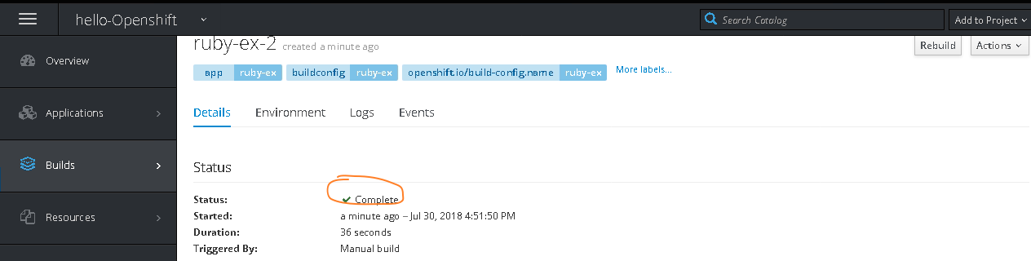

回到Overview，点击ruby-ex的Link

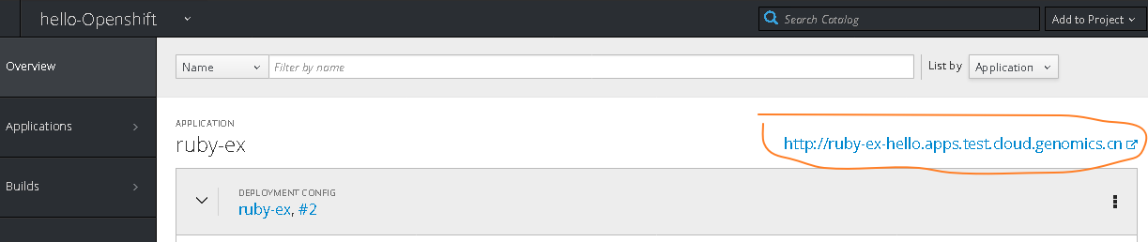



# Ref

<https://github.com/xiaoping378/blog/blob/master/posts/openshift%E5%AE%9E%E8%B7%B5-DevOps%E5%AE%9E%E6%88%98-0.md>

# bwa 业务容器化

这种业务就是一个job

<http://bio-bwa.sourceforge.net/>

<https://github.com/lh3/bwa>

分析数据下载地址

<https://www.sanger.ac.uk/resources/downloads/human/>

<http://asia.ensembl.org/Homo_sapiens/Info/Index>

[root@ose2 bwa-0.7.17]# wget ftp://ftp.ensembl.org/pub/release-93/fasta/homo_sapiens/dna/Homo_sapiens.GRCh38.dna.chromoso

me.16.fa.gz

解压到data目录中

[root@ose2 bwa-0.7.17]# cd data/

[root@ose2 data]# ls

Homo_sapiens.GRCh38.dna.chromosome.16.fa

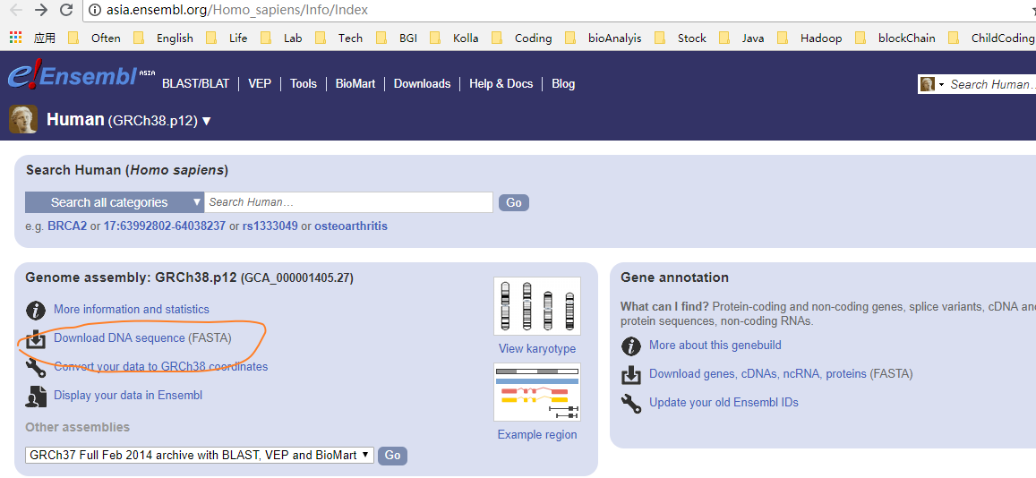

[root@ose2 bwa-0.7.17]# ./bwa index data/Homo_sapiens.GRCh38.dna.chromosome.16.fa

[bwa_index] Pack FASTA... 1.23 sec

[bwa_index] Construct BWT for the packed sequence...

[BWTIncCreate] textLength=180676690, availableWord=24713060

[BWTIncConstructFromPacked] 10 iterations done. 40765026 characters processed.

[BWTIncConstructFromPacked] 20 iterations done. 75309378 characters processed.

[BWTIncConstructFromPacked] 30 iterations done. 106008434 characters processed.

[BWTIncConstructFromPacked] 40 iterations done. 133289794 characters processed.

[BWTIncConstructFromPacked] 50 iterations done. 157533522 characters processed.

[BWTIncConstructFromPacked] 60 iterations done. 179077362 characters processed.

[bwt_gen] Finished constructing BWT in 61 iterations.

[bwa_index] 86.42 seconds elapse.

[bwa_index] Update BWT... 0.74 sec

[bwa_index] Pack forward-only FASTA... 0.74 sec

[bwa_index] Construct SA from BWT and Occ... 38.17 sec

[main] Version: 0.7.17-r1188

[main] CMD: ./bwa index data/Homo_sapiens.GRCh38.dna.chromosome.16.fa

[main] Real time: 128.182 sec; CPU: 127.312 sec

[root@ose2 bwa-0.7.17]# cd data/

可以看到生成了一些文件

[root@ose2 data]# ls

Homo_sapiens.GRCh38.dna.chromosome.16.fa Homo_sapiens.GRCh38.dna.chromosome.16.fa.bwt hs38.alt.sam

Homo_sapiens.GRCh38.dna.chromosome.16.fa.amb Homo_sapiens.GRCh38.dna.chromosome.16.fa.pac

Homo_sapiens.GRCh38.dna.chromosome.16.fa.ann Homo_sapiens.GRCh38.dna.chromosome.16.fa.sa

数据源：

<https://genome.ucsc.edu/ENCODE/downloads.html>

<https://www.biostars.org/p/113856/>

<http://www.internationalgenome.org/category/fastq/>

<https://mp.weixin.qq.com/s/rdTFTFg0rZOIa2_tuFEOUA>

biocontainers doc

<http://biocontainers.pro/docs/101/running-example/>

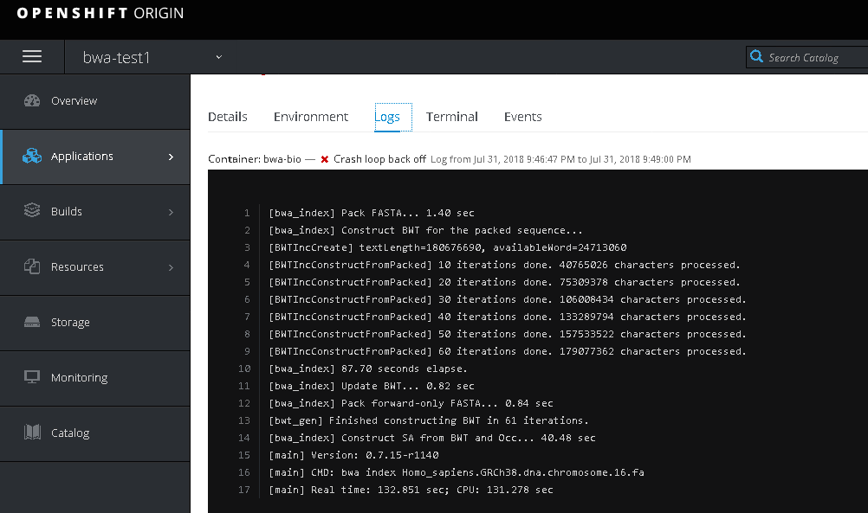

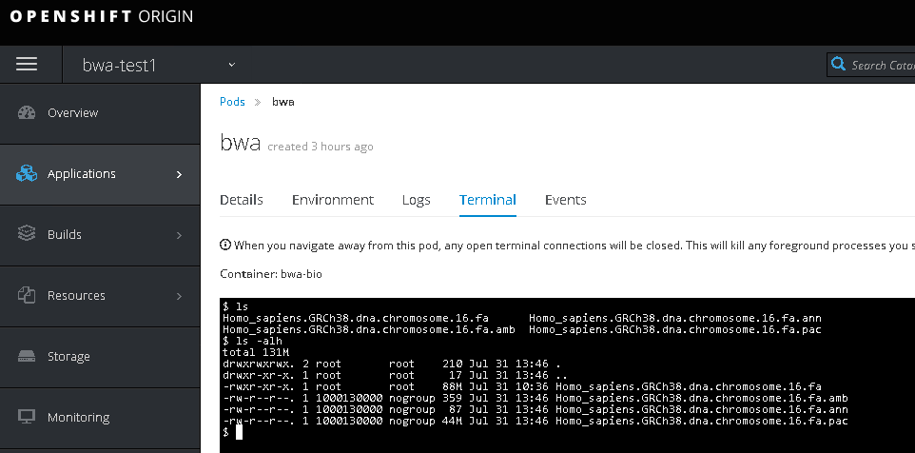

# 存储设备的网络

是否只需要 node节点和 存储设备 网络互通就可以了？