五段式上涨 ，

三段式上涨

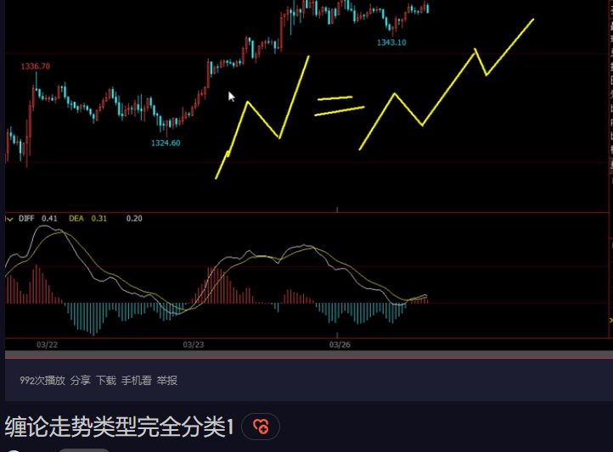

六种走势类型

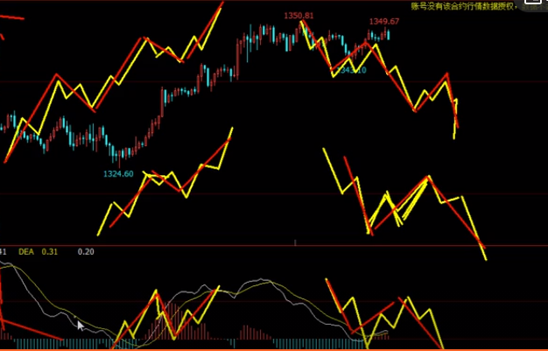

# [部署vCenter Server Appliance 6.7](https://www.cnblogs.com/straycats/p/10708304.html)

<https://www.cnblogs.com/straycats/p/10708304.html>

<https://blog.csdn.net/rfidgroup/article/details/102955077>