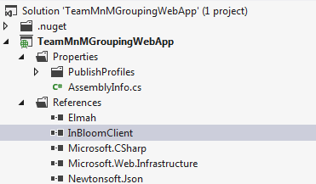

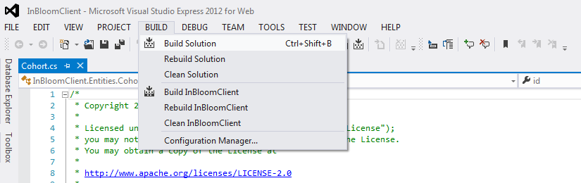

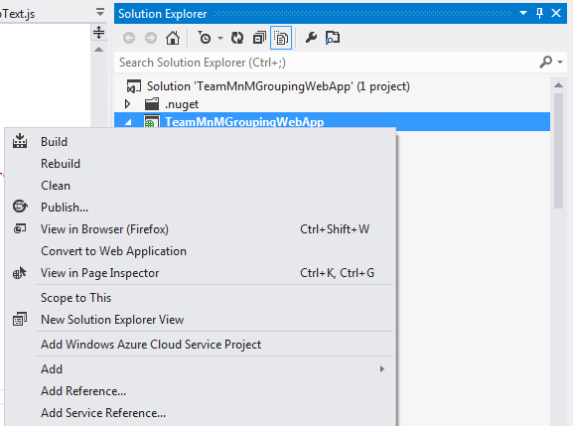
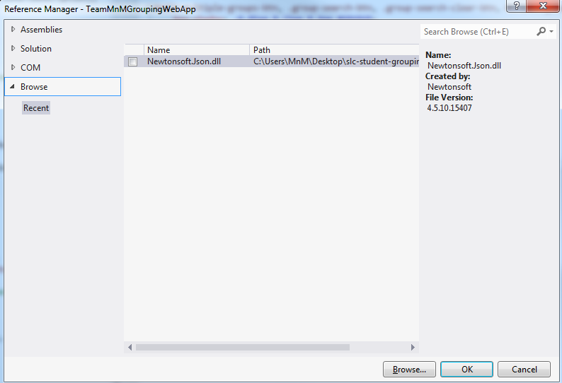
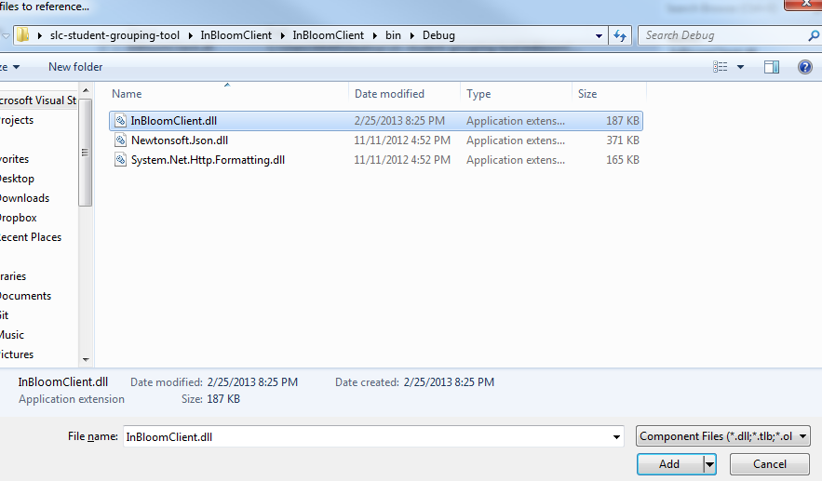
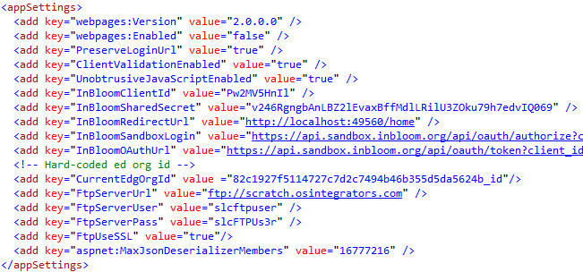
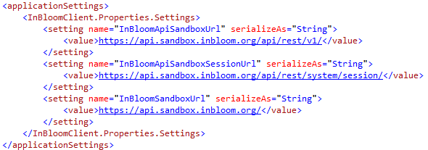
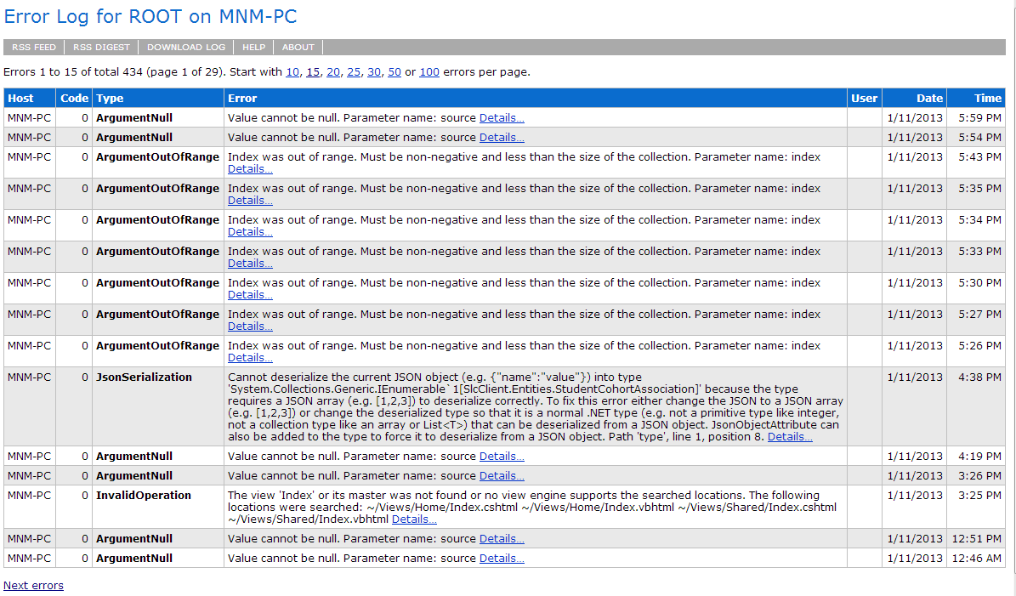
System Installation
The Student Group Tool is a web application developed using the .NET 4.5 framework on Visual Studio 2012. It can be installed on a stand-alone IIS server or on a Windows Azure Website instance.

Requirements:
- .NET 4.5 runtime
- IIS version 7+
In order to build the Student Grouping Tool application, you must make sure that the TeamMnMGroupingWebApp contains the reference to the InBloomClient library. To do this follow these steps:
- Open the TeamMnmGroupingWebApp in Visual Studio 2012
- Under the Solution Explorer expand TeamMnmGroupingWebApp
- Expand the References folder
- Make sure the InBloomClient reference is there (as shown in the figure below). If it is not, there will be an exclamation mark next to the name.
If there is an exclamation mark next to InBloomClient, follow these steps to build the application:
- Open the InBloomClient project in Visual Studio 2012
- Go to the Build menu
- Click on Build Solution. This will generate the required assemblies.
- Open the TeamMnMGroupingWebApp project in Visual Studio 2012
- Under Solution Explorer right-click on TeamMnMGroupingWebApp

- Click on Add Reference. This should pop up a window.

- Click on the Browse tab on the left
- Click on the Browse… button. This should pop up another window
- Browse to \InBloomClient\InBloomClient\bin\Debug

- Select the InBloomClient.dll file
- Go to the Build Menu
- Click on Build Solution
- The Student Grouping Tool application should be built and ready to deploy
The TeamMnMGroupingWebApp project contains a web.config file that defines the following credentials and authentication endpoints to authenticate against the inBloom APIs:
- InBloomClientId – unique id assigned by inBloom for accessing the APIs
- InBloomSharedSecret – secret code assigned by inBloom for accessing the APIs. To be used with the clientId
- InBloomRedirectUrl – the url to redirect to upon successful login
- InBloomSandboxLogin – the oauth authorization URL
- InBloomOAuthUrl – the oauth token URL
Figure - Web Config Details
These credentials (shown in Figure 1) must be configured for the Sandbox account that will be used for the web application.

Publishing to Windows Azure
- Sign up for a Windows Azure account at http://www.windowsazure.com/en-us/
- Log into the Windows Azure portal with your account
- Click on the ‘Websites’ tab on the left
- Create a new website
- Once created, download the Publish profile for that website
- In Visual Studio, right click on the TeamMnMGroupingWebApp project
- Click on ‘Publish’ and the Publishing wizard will appear
- Click on ‘Import’ and select the publish profile you just downloaded
- Click on the ‘Publish’ button at the bottom of the window
- The Student Grouping Tool app will be published to your Windows Azure website instance

Configuration
The inBloom Client project contains an app.config file that defines the following URLs for accessing the inBloom API endpoints:
- InBloomSandboxUrl – root inBloom sandbox URL
- InBloomApiSandboxUrl – inBloom API Sandbox URL used to make the API calls agains
- InBloomApiSandboxSessionUrl – URL used to retrieve the user info, such as the user id, whether the user is authenticated, and the user’s roles.

Figure - inBloom Endpoint Configs

Educational Organization ID
The Educational Organization ID (EdOrgId) is required to create cohorts. Because we are using the sample data set, there is no EdOrgId associated with the existing users, therefore we hard-code this ID for the user Amy Kopel (akopel) in the web.config file. However, the code for retrieving the EdOrgId associated with the current authenticated user has already been implemented. If the code cannot find the associated EdOrgId, then it will fall back to using the hard-coded one specified in the web.config file.
Figure - Hardcoded Educational Org Id in Web.config

Error Logging
All exceptions thrown by the application are logged using the elmah library. The error logs can be accessed through the path root/elmah.axd. For security purposes remote access has been disabled, meaning that the logs can only be accessed locally (i.e. localhost) or by manually downloading the log files.
Figure - Elmah Error Console
The elmah configuration can be found in the web.config file. You can specify which directory to save the log files to, as well as the path to access the elmah error logs screen (shown in Figure 4). For more information on elmah please visit http://code.google.com/p/elmah/wiki/DotNetSlackersArticle.

If the web application is hosted on the cloud, such as Windows Azure, then instead of accessing the logs locally, the logs can be downloaded and consolidated into reports using the elmah Log Download tool at http://code.google.com/p/elmah/wiki/ErrorLogDownloadApplications.

