This application is designed to make it easy for students to be placed in groups via a drag-and-drop interface. A user can create multiple groups and assign multiple students to each group. A student can be in multiple groups. Colors are used to visually differentiate the groups.

The application consists of two main screens:
- Group Selection Screen
- Multiple Groups Edit Screen

Group Selection Screen
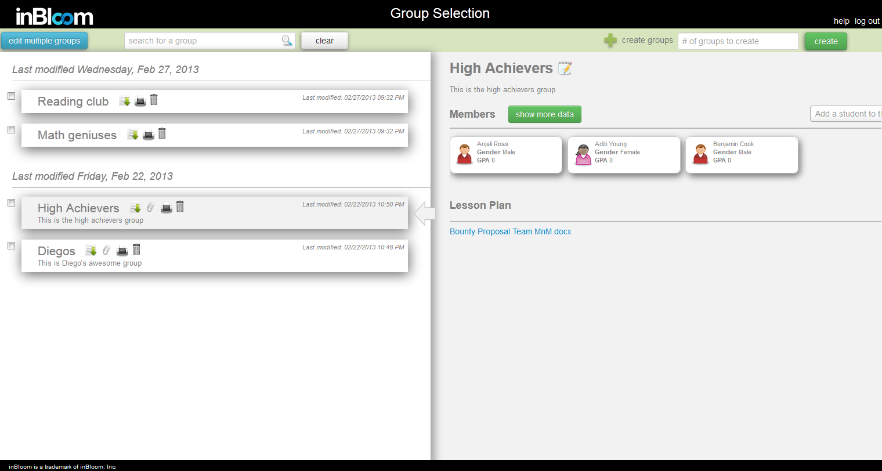
Figure - Group Selection Screen

This screen is the main page of the application and it allows the user to edit one group at a time, or select multiple groups for simultaneous editing. If multiple groups are selected for editing, the application will redirect the user to the Multiple Groups Edit screen and add the selected groups to the current workspace. The following stories describe the features offered in the Group Selection screen:
- As a teacher, I want to be able to see a list of groups with Name and Description that I have access to, sorted by Last Modified Date
- As a teacher, I want to be able to specify the number of new groups I want to create and create them
- As a teacher, I want to be able to search for any groups I have access to and edit them
- As a teacher, I want to be able to click on each group and see full details of that group including Name, Description, list of students, lesson plan
- As a teacher, I want to be able to add data element to the group in the detail view
- As a teacher, I want to be able to search for and add my students to the group in the detail view
- As a teacher, I want to be able to view all the information I have access to about a student
- As a teacher, I want to be able to attach/delete a file (lesson plan) to the group in the detail view
- As a teacher, I want the system to invalidate my session after 20 minutes of inactivity so I have to login again
- As a teacher, I want to be able to edit name and description for each group

Multiple Groups Edit Screen
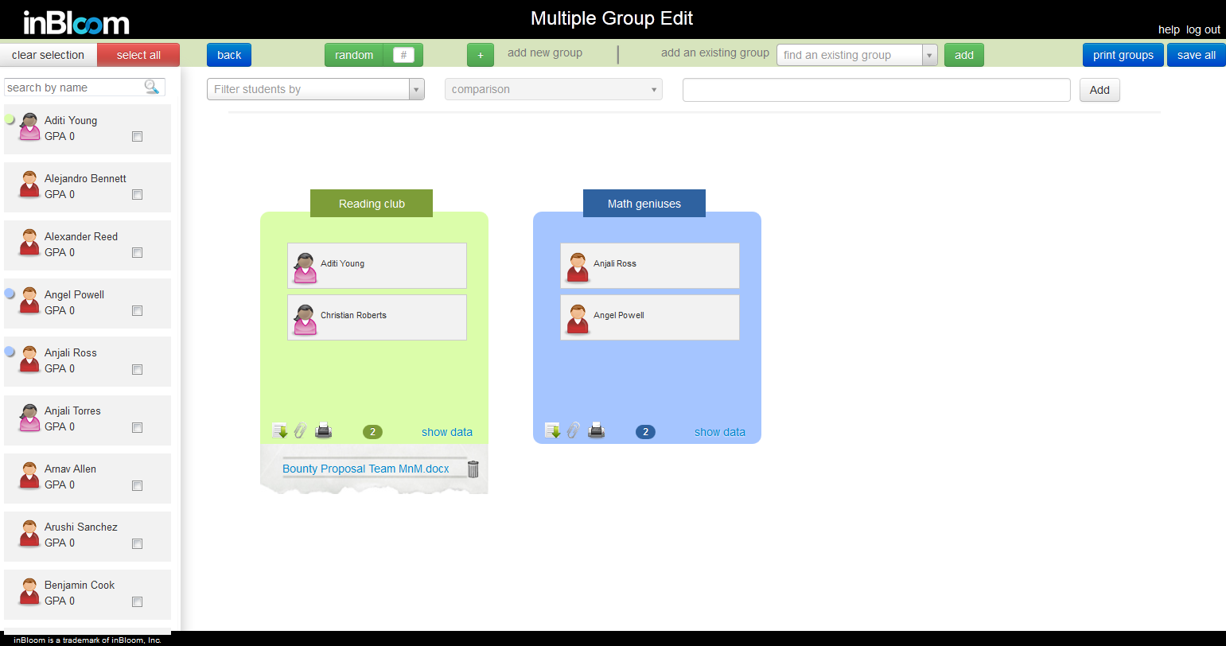
Figure - Multiple Groups Edit Screen

This screen allows the user to edit multiple groups simultaneously. It also provides a drag and drop interface for assigning students to groups, as well as filtering functionality to filter through the list of students based on specified student data attributes such as GPA, disabilities, and grade level.
- As a teacher, I want to be able to see a list of all my students in order to put them into groups
- As a teacher, I want to be able to expand/collapse data element in my groups
- As a teacher, I want to be able to select all my students in the student list
- As a teacher, I want to be able to search the student list by name
- As a teacher, I want to be able to drag and drop students onto different groups
- As a teacher, I want to be able to tell which group the student is currently in by color circles that corresponds to the group color
- As a teacher, I want to be able to remove students from each group
- As a teacher, I want to be able to view all the information I have access to about a student
- As a teacher, I want to be able to add existing groups to the group set I'm editing
- As a teacher, I want to be able to add new group to the group set I'm editing
- As a teacher, I want to be able to remove groups on my edit screen but not removing them from the database
- As a teacher, I want to be able to filter my student list
- As a teacher, I want to be able to add data element to my groups
- As a teacher, I want to be able to assign my students to random groups by specifying how many students I want in a group
- As a teacher, I want to be able to edit name and description for each group
- As a teacher, I want to see different color for each group I'm editing
- As a teacher, I want to be able to view additional details (sections, assessments, GPA, learning styles) for each student by click on them
- As a teacher, I want to be able to delete/save each group
- As a teacher, I want to be able to save all my edit at once
- As a teacher, I want to be able to attach/remove a file (lesson plan) to each group
- As a teacher, I want to be able to click on "full profile" on each student in the group and it should bring me to the inBloom student dashboard profile page
- As a teacher, I want to be able to assign students to groups randomly even after they have all been assigned. The system should give me a warning before doing so.
- As a teacher, I want to be able to download a file containing the group's name, description and list of students.
- As a teacher, I want to be able to print out a list of students that belong to a group along with the group name and description.
- As a teacher, I want to be able to print out a list of students that belong to each group on screen.

Security
This application retrieves and displays student Personal Identifiable Information (PII) from the inBloom data stores. In order to protect this information, none of the data is saved outside of the inBloom data stores nor cached on the browser with the exception of the file/lesson plan that can be attached to each group.

After 20 minutes of idleness on either screen, the application will notify the user that he/she has been logged out and must re-authenticate to continue using the application. Ten seconds after the warning, the application will automatically log out and redirect the user to the login page. This is to prevent student information from being browsed by others if the teacher forgets to log out or has to walk away for more than 20 minutes.

In order to retrieve data from the inBloom data stores, an access token must be obtained through the inBloom REST API’s Oauth authentication mechanism. This token is kept in the user session and expires after 20 minutes, forcing the user to re-authenticate. Without the access token, each request made to the application will be redirected to the inBloom Authentication page.

