System Requirements
  - Browser: IE9+, Chrome 21+, Firefox 16+
  - Minimum resolution: 1280 x 768

Using the Student Grouping Tool
The Student Grouping Tool Application provides the following functionalities:

Group Selection Screen
Allows the user to edit one group at a time, or select multiple groups for simultaneous editing. It is the main page of the application. The following is a complete list of all features in this page and how to use them:

Search for groups by name
- The user can search for groups by typing the group name into the textbox at the upper left corner of the top bar. As the user types in each letter of the group name, the list of groups will be filtered accordingly.
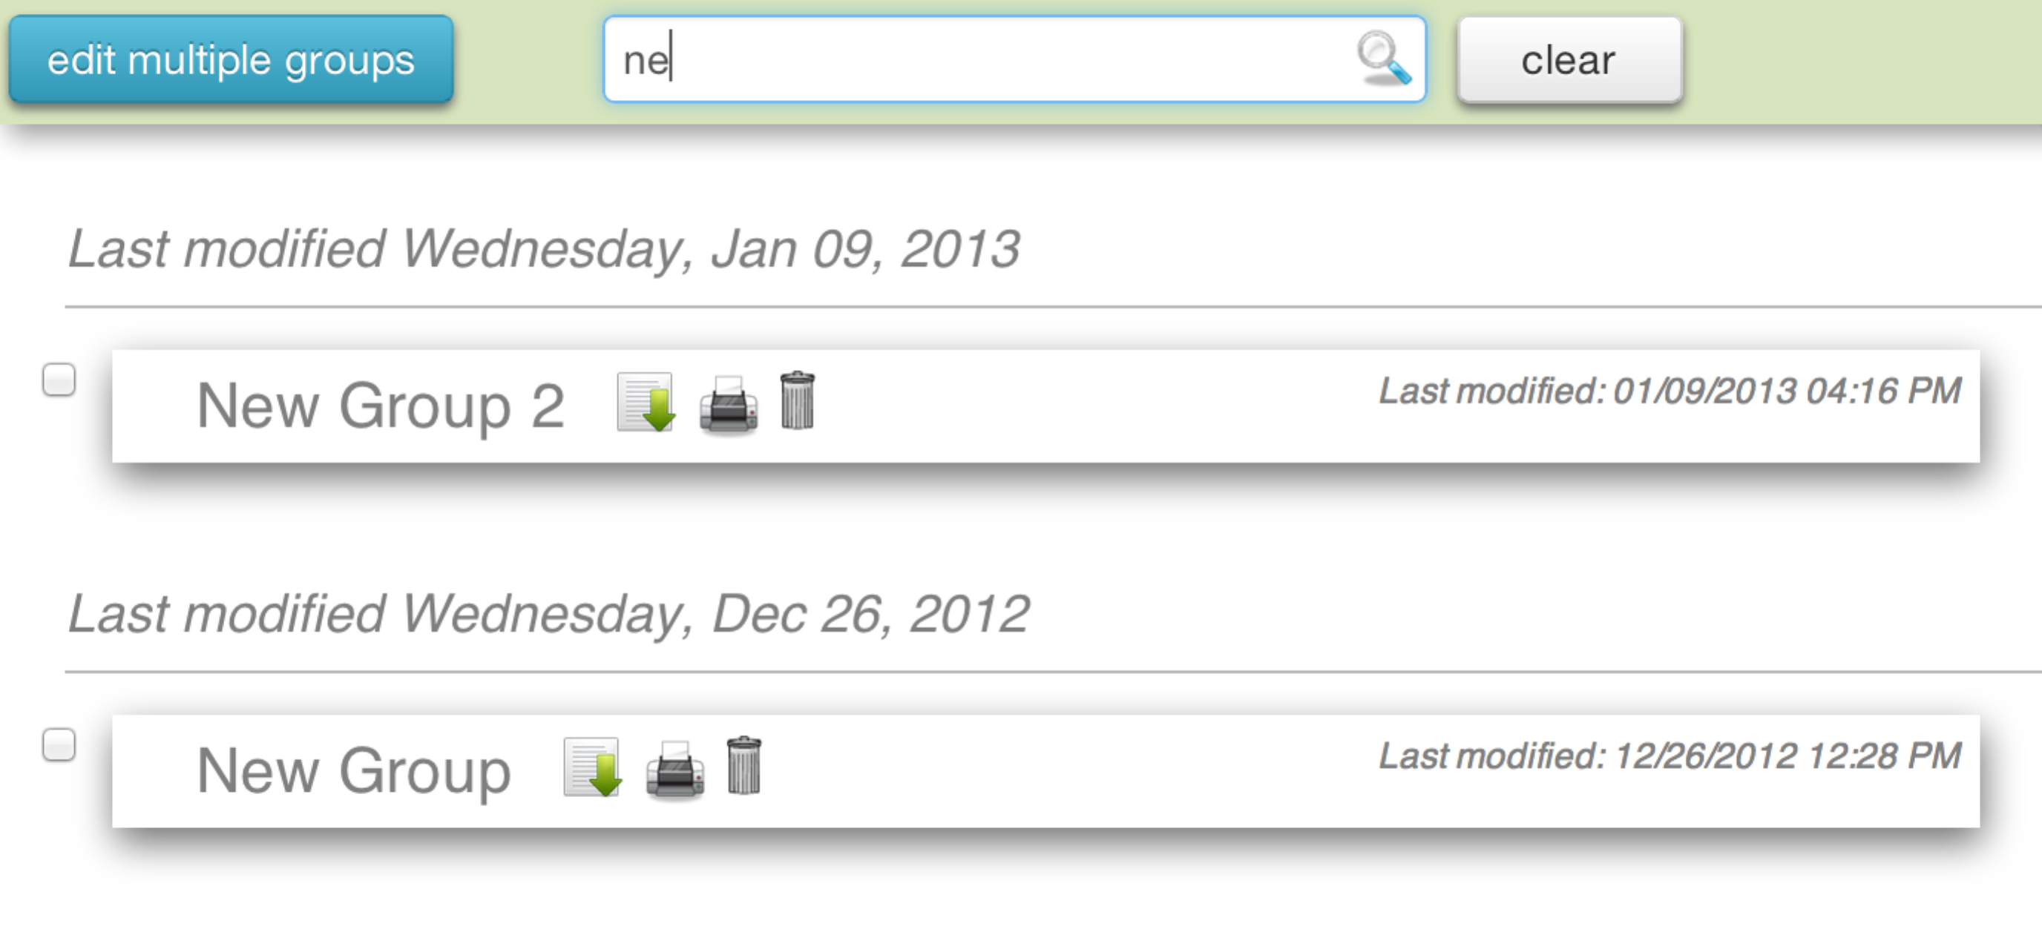

Edit cohort name and description
- After selecting a group from the left panel, click on the group name or description to edit them. Once the edit is done, click outside of the group name or description textboxes or the  icon to save the changes.

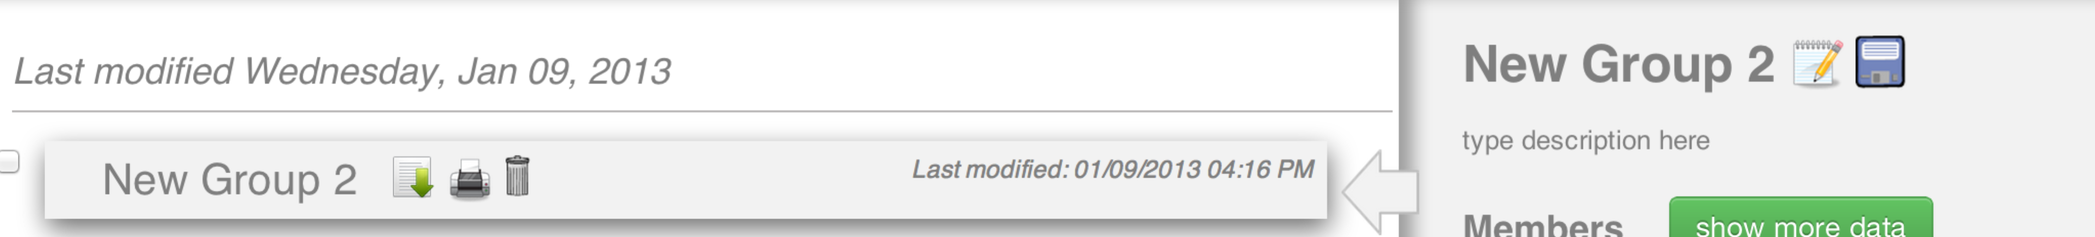

Download, print and delete groups
- To download the group details, simply click on the icon  to the right of the group name.
- To print out the details of a group, simply click on the  icon to the right of the group name.
- To delete a group, simply click on the icon to the right of the group name.

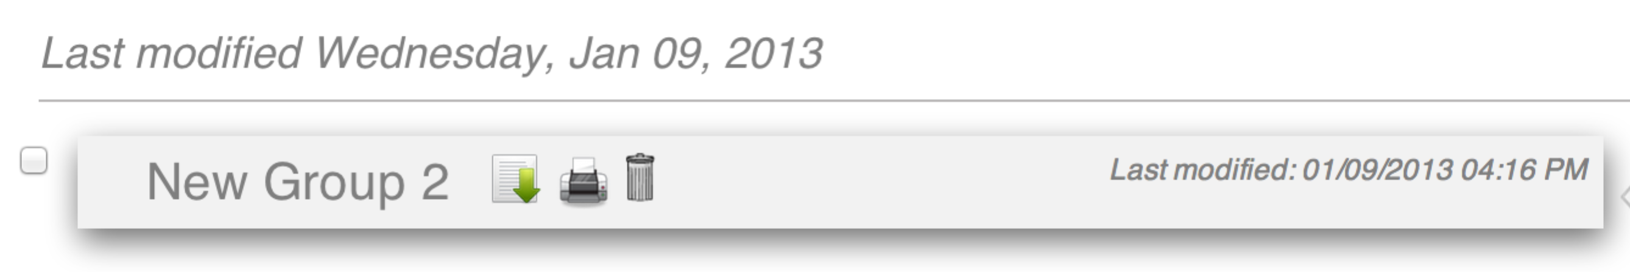

Download the attached lesson plan from a group
- If there is a lesson plan attached to the group, there will be a icon to the right of the group name. Clicking on it will download the lesson plan and prompt the user to save it on his/her machine.

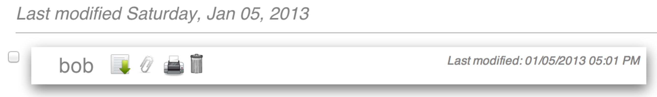

Assign/Remove students to groups
- To add a student to the selected group, select a student from the student dropdown list and click on the ‘Add’ button.
- To remove a student from the selected group, hover over the student and click on the icon on the top left corner of the student.

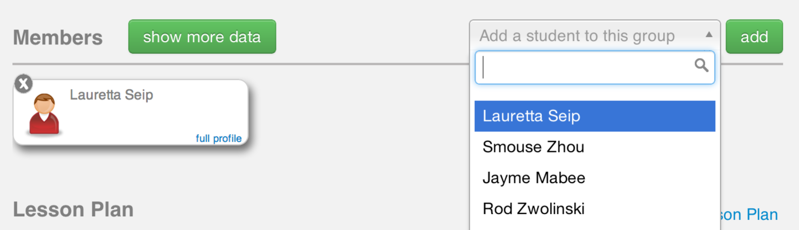

Associate student data elements with a group
- To add/remove student data elements associated with a group, click on the ‘show more data’ button. A window will pop up with the available student data attributes to associate with the cohort. When done selecting, click on the ‘Ok’ button.

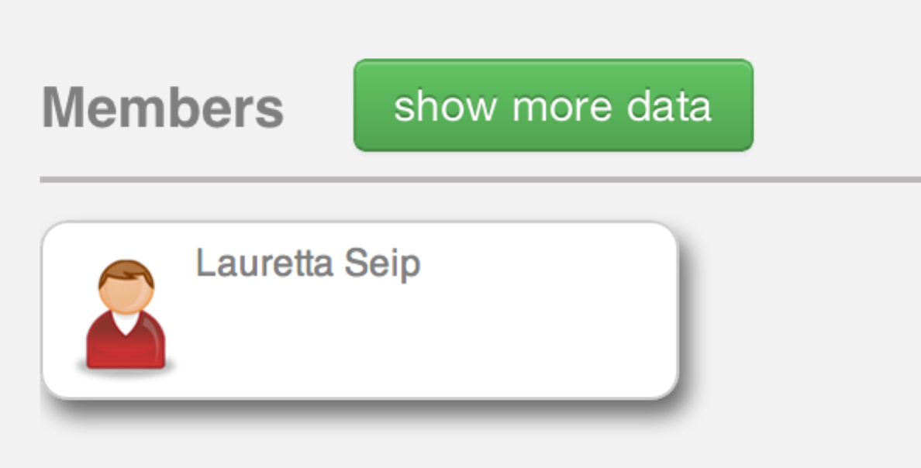

Attach/remove lesson plans to group
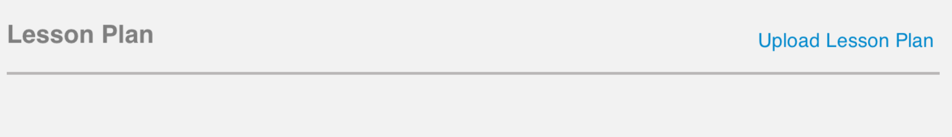
- You can only add a lesson plan if there isn’t one attached already. To add a lesson plan, click on ‘Upload Lesson Plan’. A file browser dialog will appear. Once you choose a file, the filename should appear under the ‘Lesson Plan’ header.
- To remove an attached lesson plan, click on the icon to the right of the attached lesson plan’s name.

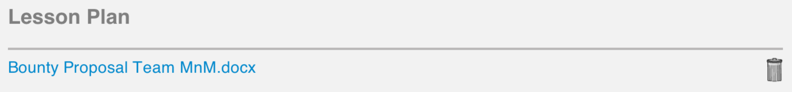

Save changes to a group back to the server
- To save changes, click on the icon. The user will be notified if the save was completed successfully or if there were errors saving back to the server.

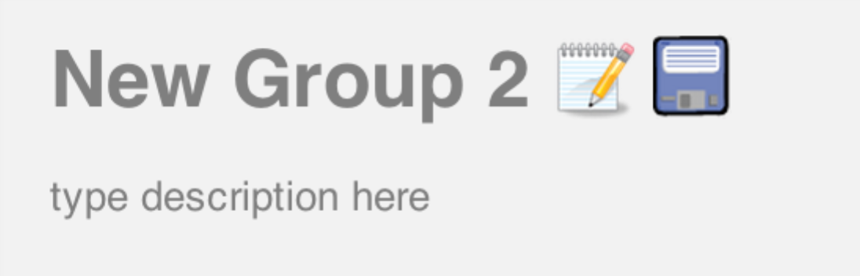

- If the user clicks on the icon, the application will redirect the user to the Multiple Groups Edit page with the selected group added to the current workspace.

Select multiple groups and edit on Multiple Group Edits screen (brings up the multiple group edits screen)
- To select multiple groups to edit, click on the checkbox to the left each group name. Then click on the ‘edit multiple groups’ button. The user will be redirected to the Multiple Group Edits screen with the selected groups added to the current workspace.

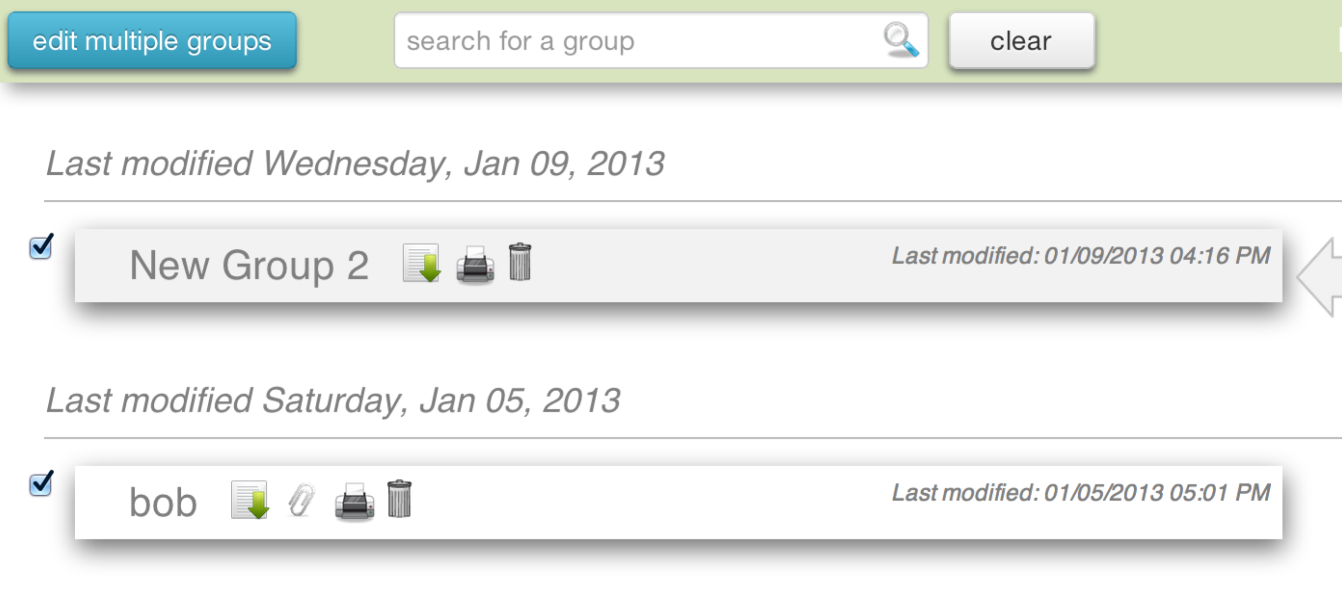

Create a specified number of new groups (brings up the multiple group edits screen)
- To create new groups, specify the number of groups to create in the create groups textbox on the top bar and click on the ‘create’ button. The user will be redirected to the Multiple Group Edits screen with the specified number of new groups created in the current workspace.

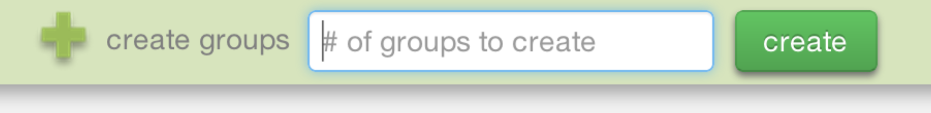

Log out of the application
- To log out of the application, simply click on ‘log out’ at the top right corner of the screen. This will redirect the user to the inBloom login screen.

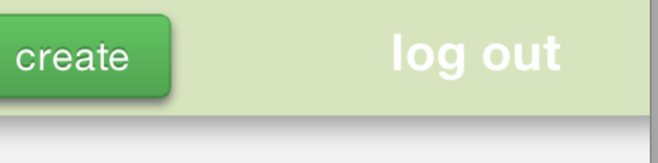

Multiple Group Edits Screen
Allows the user to edit multiple groups simultaneously. The groups being edited are shown in the current workspace. The following is a complete list of all features in this page and how to use them:

Create new groups
- To create new groups, click on the button. This will add a new unsaved group to the current workspace.

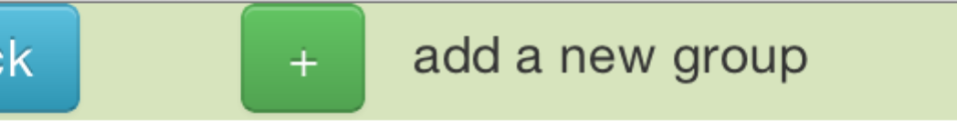

Add existing groups to the workspace
- To add an existing group to the current workspace, select a group from the group dropdown list on the top bar and click on the ‘add’ button. This will add the selected group to the current workspace.

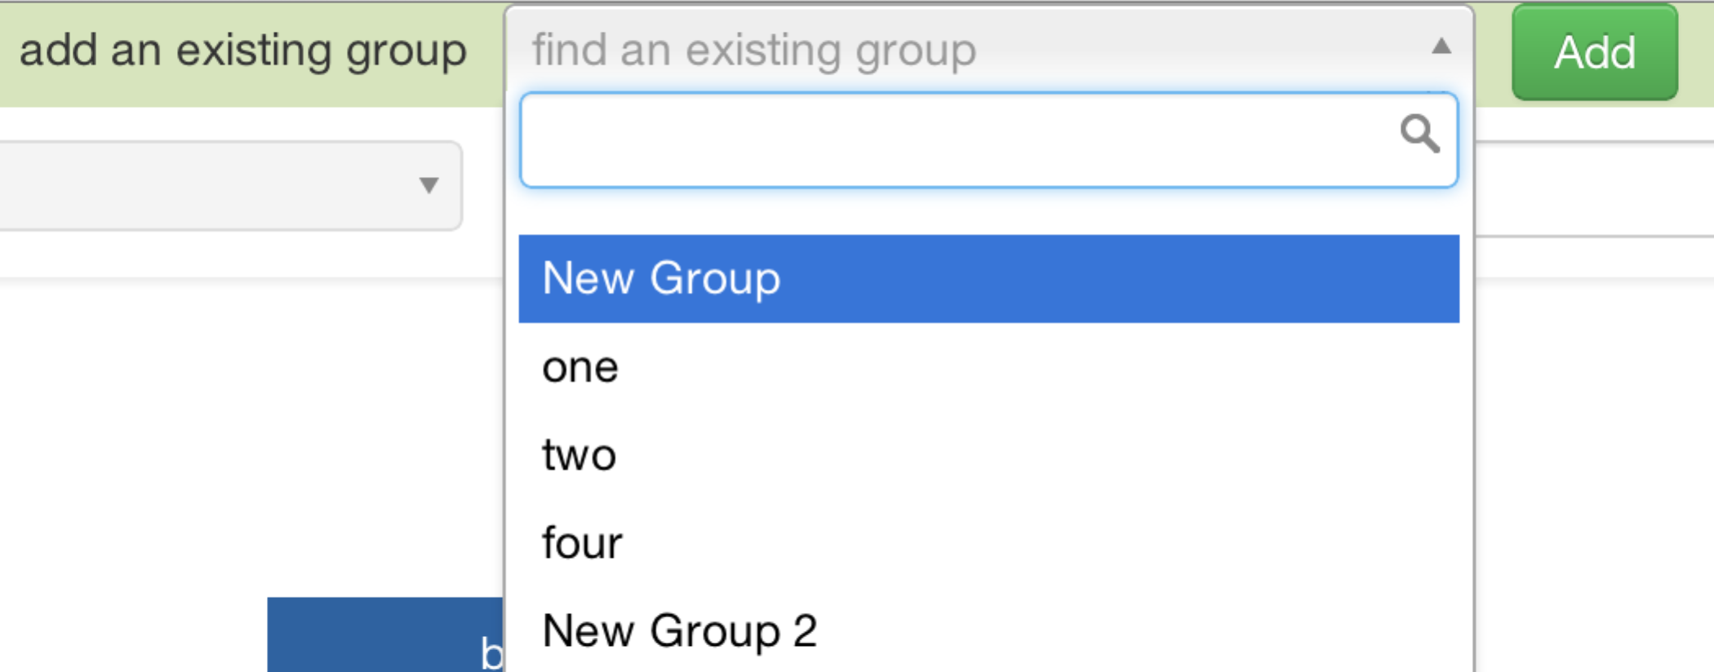

Edit the name and description of groups
- To edit the group name, click on it and it will become editable.
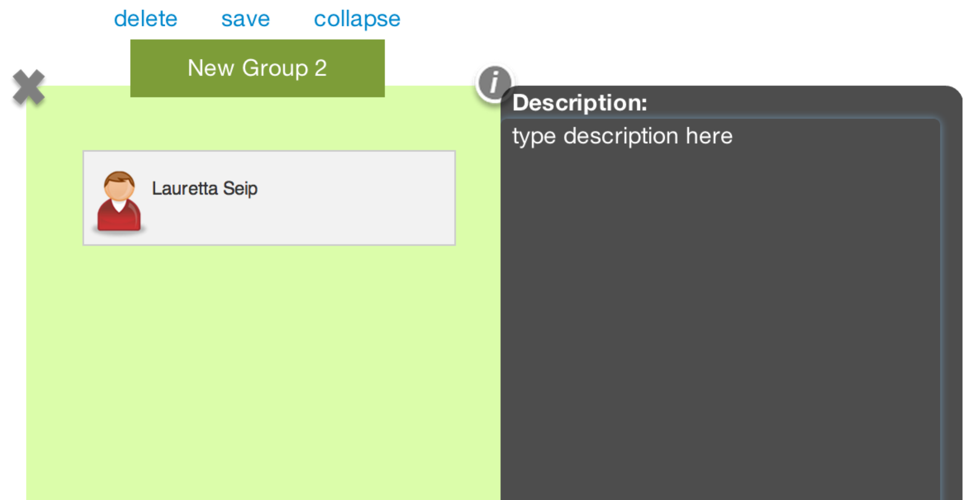
- To edit the description, hover over a group and click on the icon. This will display a panel to the right of the group. This panel contains the group’s description. Click on the description text to make it editable. If there is no description, click directly below the ‘Description’ text and a textbox will appear.

Additional group controls
- Click on the icon on the bottom left corner of the group to download the group details.
- Click on the  icon. This will prompt the user to choose a file. After the user has chosen the file, the name of the file will appear underneath the group.
- Click on the icon on the bottom left corner of the group to print out the details of the group.
- If there is a lesson plan attached, it will appear underneath the group. Click on the name of the lesson plan to download it.
- To remove the attached lesson plan, click on the icon next to the name of the lesson plan.

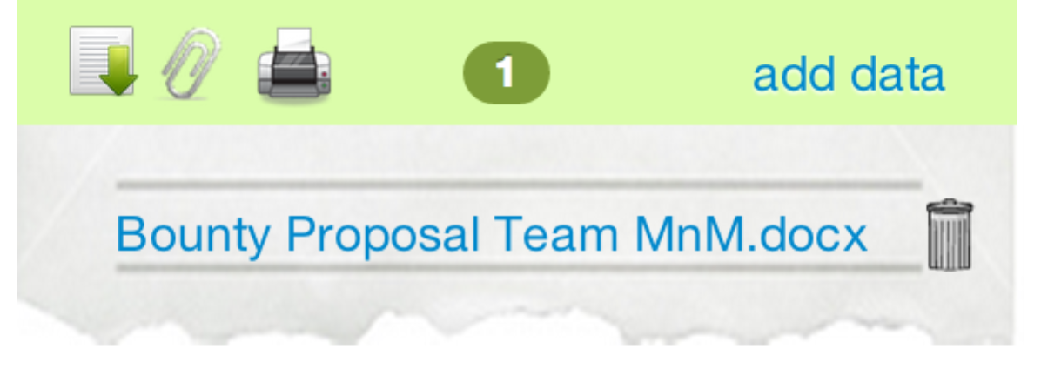

Save changes to a group back to the server
- To save the group changes, hover over a group and click on the ‘save’ button.

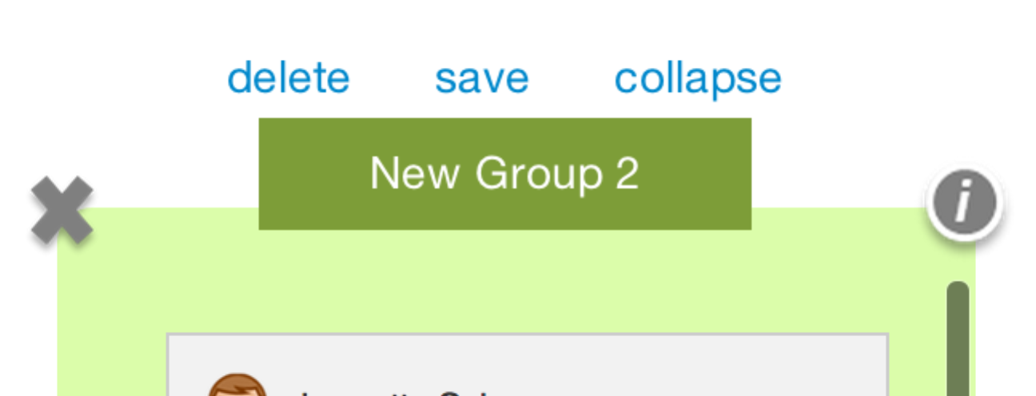

- Click on the icon to remove the group from the current workspace (does not delete the group permanently)
- Click on the ‘delete’ button to permanently delete the group

Filter the list of students
- To filter a student by name, simply type the name of the student into the textbox at the top of the student list.

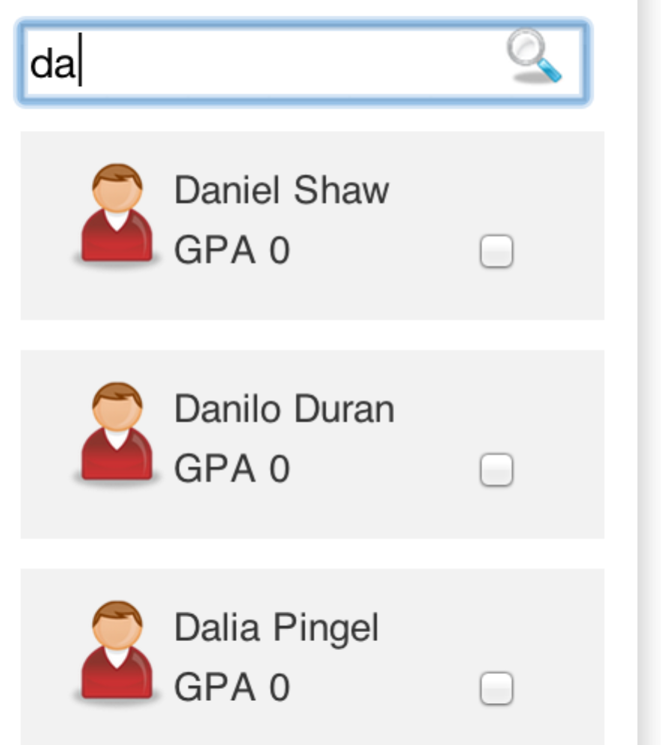

- To filter students by other attributes, select an attribute to filter by, then a comparison operator and then a value to compare to. For example GPA > 3.0

Drag students to groups and between groups
- To drag multiple students to a group, check the checkboxes of the students you would like to drag and then drag them over to a group.

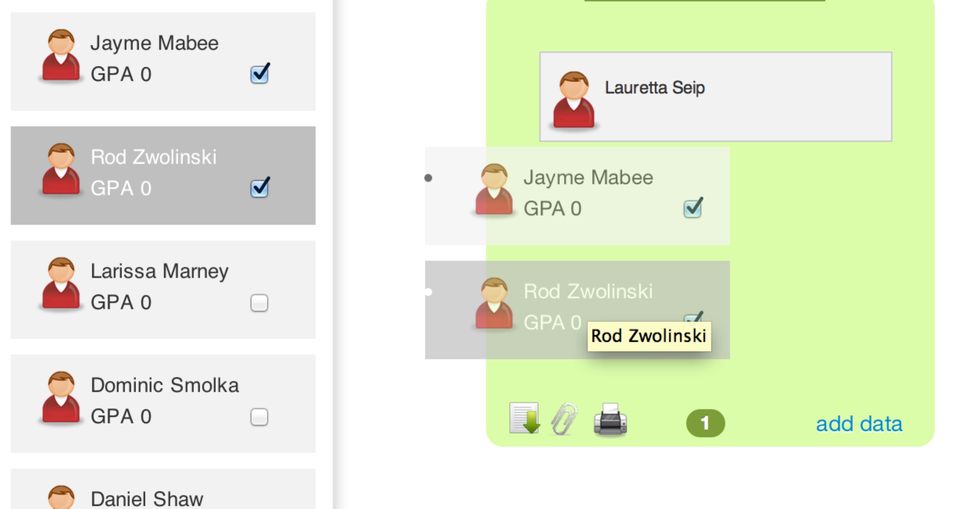

Remove students from groups
- To remove a student from a group, hover over a student and click on the icon on the top right corner.

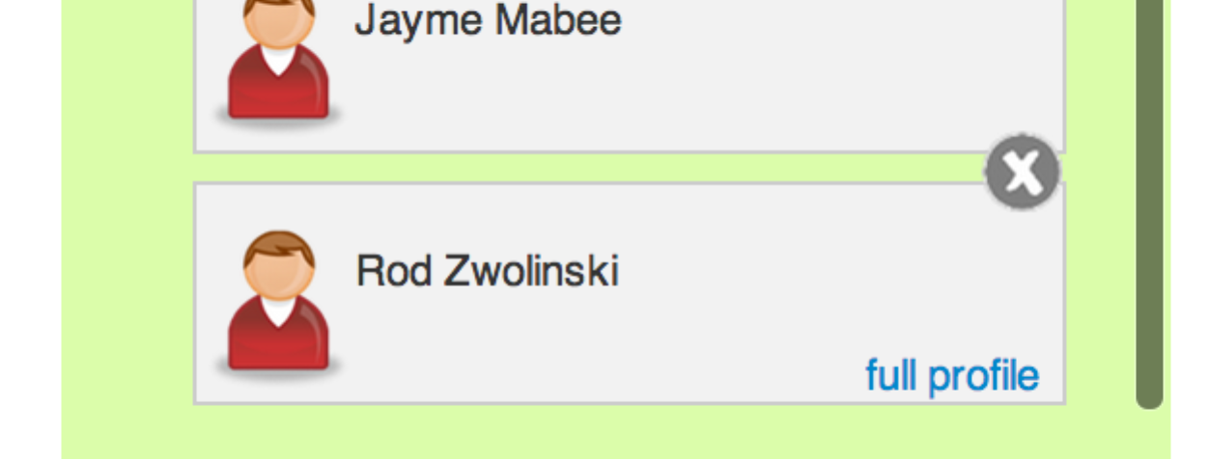

Associate student data elements with groups
- Click on the ‘add data’ link at the bottom right corner of the group. This will pop up a panel to the right of the group where you can select the student data attributes to associate with the cohort.

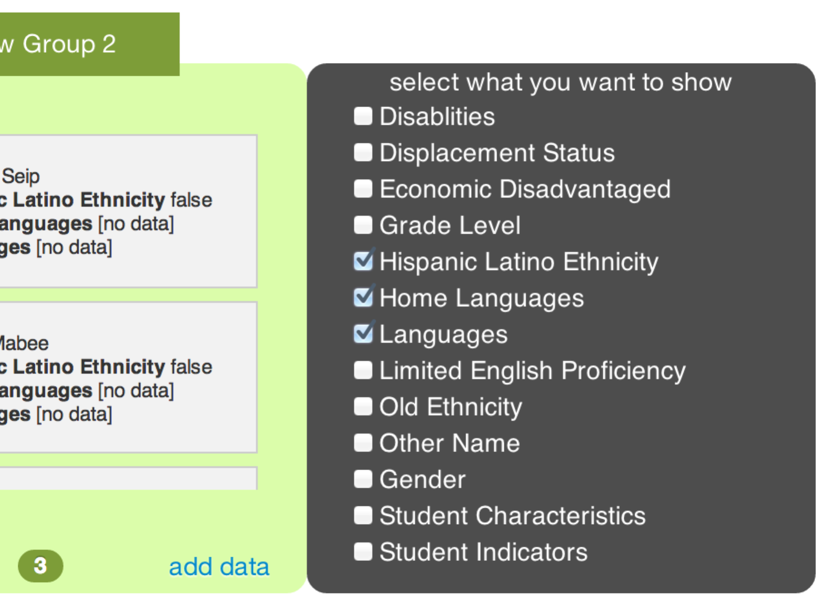

Randomly assign students into groups
- Specify the number of students to assign to each group on the left hand side of the top bar and click on the ‘random’ button next to it.

Save changes to all the groups back to the server
- Click on the ‘save all’ button on the top right of the top bar to save changes to ALL groups.

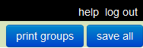

Print out the details for all the groups
- Click on the ‘print groups’ button on the top right corner of the top bar to print out the details for all the groups in the current workspace. Each group will be printed on a different page.

Log out of the application
- Click on ‘log out’ at the top right corner of the top bar to log out of the application. This will redirect the user to the login page.

Troubleshooting
- Login Error
  - Your session has expired. Try refreshing the page.
  - If problem persists, clear the browser history and delete cookies.
  - Restart the browser.
- Error saving group
  - Your session might have expired. Try refreshing the page.
  - If problem persists, clear the browser history and delete cookies.
  - Restart the browser.
- I can’t print the group details in IE9
  - Go to Tools menu
  - Click on the Security tab
  - Uncheck the Enable Protected Mode option
  - Restart the browser
- I have reached the Error page. What do I do?
  - The page provides a link for you to click
  - Click on it and it will take you back to the inBloom login screen

FAQ
- How do I drag multiple students to a group?
In order to drag and drop multiple students to a group you must select the checkbox inside the student box. Once all the students you want to drag are selected, drag them over to a group.
- Why does random mess up my current groups?
Random reassigns every single student in the list into groups of the students. The number of students in each group is specified by the user. Students that have already been assigned to groups will be shuffled around and randomly assigned to other groups.

- Why can’t I change an existing group’s name?
Currently there is a limitation with the API that does not allow us to make changes to the group name.

- How many lesson plans can I attach to a group?

One

- Why doesn’t Save All work in IE9?

IE9 does not support uploading multiple files, therefore when attempting to save more than one group with a file attachment, the Save All option will fail.

- Where is the Save button on the Group Selection screen?

The Save button will only appear if you have made changes to a group.

- Why is there no student for me to select on the MultipleGroupEdit screen?

There might not be any students associated with your school, please contact your system admin to fix this issue.

