G25 Analytical LCMS Operation Guide

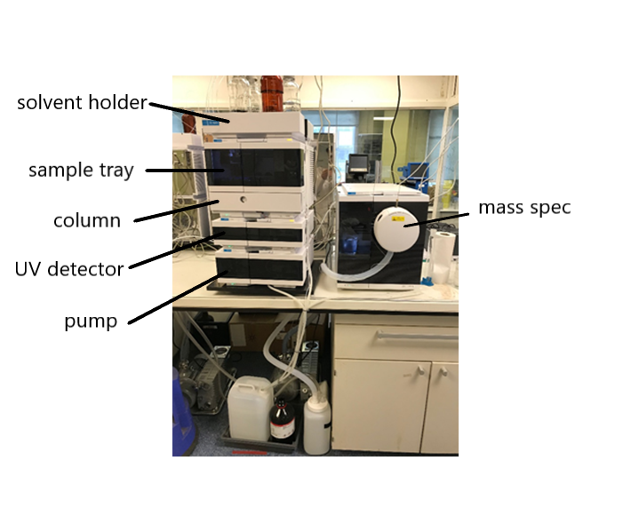

# **Contents**

Contents 2

Introduction and Basics 3

LCMS Supplies from MyFinance 3

Solvent Storage 3

Creating a New Method 4

Sample Preparation 4

Making the Sample 4

Before Running a Sample 5

Running Sequence Injections 6

LCMS is Free 6

LCMS is Busy 6

Data Analysis 7

Common Problems 7

Excessive Injection Amount 7

Strange Peaks with 44 Da Difference 8

Peaks with 282 Da 8

# **Introduction and Basics**

This guide is written on how to use the analytical LCMS. It is not a substitute for full training.

The LCMS is a temperamental instrument and a series of basic rules must be established for smooth running for the system and minimise downtime:

* Sample concentrations (typically 0.01-0.1 mg/mL) and injection volumes (typically 0.1-1.0 µL) should be kept as low as possible. Always start with lower concentrations and smaller injection volumes.
* Samples must be completely dissolved: no solids are allowed in the sample vial. In addition, samples must *not* be saturated.
* All samples must be filtered through a 0.22 µL syringe filter.
* In general, non-volatiles (e.g. polymers, inorganic salts including Pd and Ni), corrosives, or ion pairing reagents (e.g. TFA, strong acids, DMSO) must not be injected into the LCMS.
* LCMS (HPLC permissible) grade solvents must be used for samples *and* gradient.
* Both hands must be ungloved while using the LCMS computers.
* Do not stop another person’s run: use the “Run Control > Queue Sequence…” function and “Add to Back of Queue”.
* A basic wash (WASH.M) must be your last run.
* Only edit your own methods.
* Maximum of four samples can be submitted at a time (not including the wash). If you need to inject more, submit multiple sequences, each with a maximum of four samples.
* **If you contaminate, block, or otherwise damage the LCMS, you are responsible for restoring it to working order immediately.**

## LCMS Supplies from MyFinance

* LCMS water, 2.5 L (10777404)
* LCMS acetonitrile, 2.5 L (10616653)
* LCMS formic acid, 50 mL (10596814)
* Nylon syringe filter, 0.22 µL, 13 mm, 100 (ANN1322)
* Glass vials, 2 mL, 100 (5182-0716)
* Vial caps, 100 (5190-7024)
* PES Bottle Top Filter, 0.22 µm, 500 mL, 45 mm neck (BC604)

## Solvent Storage

* Store LCMS solvents in a glass bottle only (preferably one that held LCMS organic solvent).
* Do not invert the bottle so that the solvent is in contact with the plastic cap – contact with any plastic must be avoided.
* Do not wash the bottle with detergent – only wash with the solvent it will hold.
* All water on the LCMS (mobile phase and sample solvent) must be filtered through a 0.22 µm membrane (Biotage hood) discarded within 72 h since bacterial grow is *fast*.

## Creating a New Method

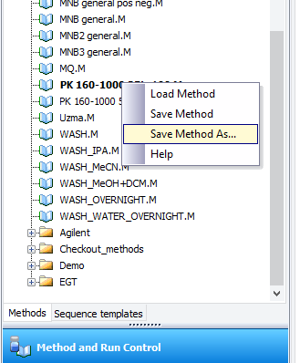

1. Open a method that is like the desired method.
2. Right-click on the loaded method and select “Save Method As…” (right).
3. Rename this to something, starting with your initials (e.g. PK1 150-1000 25to100ov15.M)
4. To edit the method, while it is open, go to “Instrument > Set up instrument method…” (below).
5. Edit the gradient to your needs (generally, starting with low organic (0-50%) and ending with organic (95-100%).
6. *Stoptime* should be set as the final time in the gradient, plus 0.01 min.
7. *Posttime* should be set to 1 min to allow re-equilibration.
8. Under “Instrument > Set up MSD Signals…”, you can change mass detection settings:
9. Polarity of the detector (positive or negative ESI)
10. Mass range will depend on your needs, for most, 150 to 800 will be suitable.
11. Threshold can be set higher (e.g. 5000) to block noise from the MS trace.
12. Under “Method > Run Time Checklist…”, set “Post-Run Command/Macro” to “Turn Instrument Standby”.
13. Right-click your new method and “Save Method”.
14. Sequence templates can be created similarly.

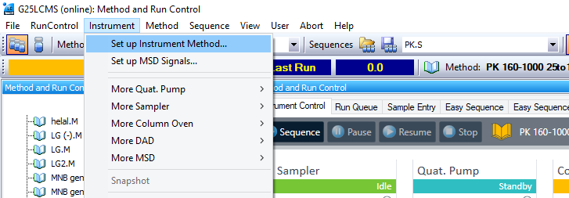

# **Sample Preparation**

## Making the Sample

1. At the balance, measure about 0.01-0.1 mg of material into a vial; this should be a tiny speck.
2. Dissolve in *ca.* 2 mL of desired LCMS/HPLC solvent (usually acetonitrile or methanol).
3. Always dissolve into a new vial – do not reuse vials, even if washed with acetone since this will result in plasticiser contamination.
4. If your compounds are easily ionised, a further dilution is required: take 1-2 drops (*ca*. 0.05-0.1 mL) and dissolve in 1-2 mL of HPLC/LCMS solvent.
5. Free amines (1°/2°/3°) and pyridines are easily ionised and will need a second dilution (examples below).



1. Charged compounds (e.g. pyridinium salts, ammonium compounds) must have a second or third dilution (examples below).



1. Filter your newly diluted solution through a 0.22 µm syringe filter into a new LCMS vial.
2. Do not reuse LCMS vials.
3. Do not reuse filters or syringes.
4. Close the cap.

## Before Running a Sample

1. Check your sample follows the basic rules: no visible solids, 0.01-0.1 mg/mL and filtered through a 0.22 µm syringe filter.
2. Check solvent volumes and replace the solvent if it will below 0.10 L during your sequence.
3. For organic solvents (typically MeCN, *i*-PrOH, or MeOH):
4. Empty the solvent bottle.
5. Rinse the solvent bottle (×2) with the HPLC/LCMS organic solvent to be filled.
6. Fill the bottle with organic solvent.
7. Add LCMS-grade HCO2H: 0.05% (v/v) – HCO2H (0.5 mL) in solvent (1 L).
8. For water (H2O):
9. Empty the solvent bottle.
10. Attach the bottle top filter, filter some HPLC/LCMS water (~100 mL), rinse bottle with filtrate and repeat (×3)
11. Reattach bottle top filter, filter through HPLC/LCMS water (1 L)
12. Add the HCO2H: 0.05% (v/v) – HCO2H (0.5 mL) in solvent (1 L).
13. If solvents were refilled, update the values on the LCMS computer.

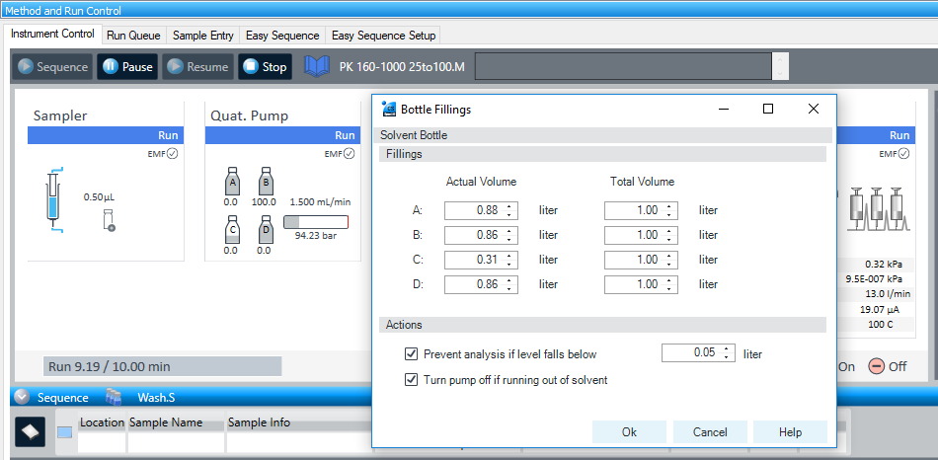

## Running Sequence Injections

### LCMS is Free

1. Open your sequence template under "File > Load > Sequence Template..."
2. If you don't have your own template, open another user's template and "File > Save As > Sequence Template..."
3. Open the sequence table under "Sequence > Sequence Table..."
4. Ensure it is your own template that is open.
5. Enter sample details into the table: sample location (P1/P2 and vial location), sample name, method (if visible, click <browse> to select manually), injection volume (start with 0.5 µL).
6. Repeat for each sample.
7. Right-click on the table and “Append Lines...” will add lines to the sequence.
8. “Filldown” will fill the info fields for multiple samples automatically.
9. Your final sample must be WASH.M with no sample location and no injection volume.
10. Click “Run”.

### LCMS is Busy

1. Go to "Run Control > Queue Sequence..."
2. Open your sequence template and press OK.
3. Enter sample details into the table: sample location (P1/P2 and vial location), sample name, method (if visible, click <browse> to select manually), injection volume (start with 0.5 µL).
4. Repeat for each sample.
5. Right-click on the table and “Append Lines...” will add lines to the sequence.
6. “Filldown” will fill the info fields for multiple samples automatically.
7. Your final sample must be WASH.M with no sample location and no injection volume.
8. Press "Next"
9. Ensure "Subdirectory" is under your initials.
10. Shutdown procedure should have "Post-Sequence command/macro" ticked and set to "Turn Instrument Standby".
11. Click "Next” then "Add to Back of Queue"

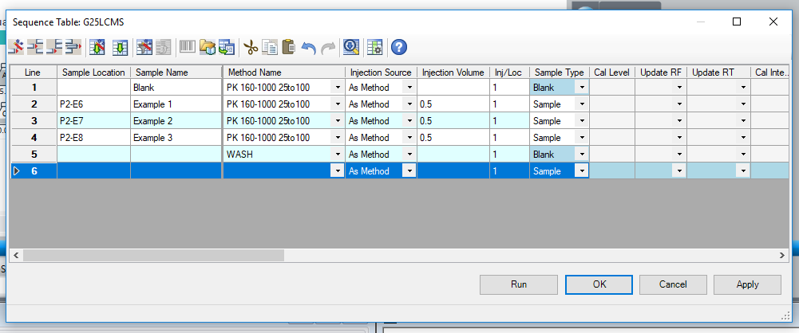

# **Data Analysis**

1. Open “ChemStation (offline)” from the desktop.
2. Find your subdirectory location.
3. Your sequence will be saved in its own entry.
4. Double-click to open an entry and load the data.
5. To view mass spectra from MSD TIC:
6. Select “Spectrum Mode”
7. Click peak apex (or any time) position button
8. Click on the peak or time on the MSD TIC trace to view the mass spectrum at that time.
9. You can save a report as a PDF by right-clicking the entry and selecting “Preview Report”

# **Common Problems**

## Excessive Injection Amount

Issue

Too much sample was injected (i.e. over-injection), resulting in the analyte being visible on the MS trace throughout the chromatogram or carried over to subsequent runs.

Cause

Either concentration of the sample was too high, or the injection volume was too large. Notice how the peak does not return to 0 in the MS TIC.

Solution

Dilute the sample by taking one drop and dissolving in another 1-2 mL of LCMS solvent. Run the WASH.S sequence then a blank on your method to check if the peak has disappeared. If not, run the WASH_IPA.S sequence (ca. 1 h) and if that fails, try the WASH_MeOH+DCM.S sequence with HPLC dichloromethane connected to Line D. Some contaminants like trifluoroacetic acid are particularly sticky and will need to be leached out over time with several overnight runs at low flow rates.

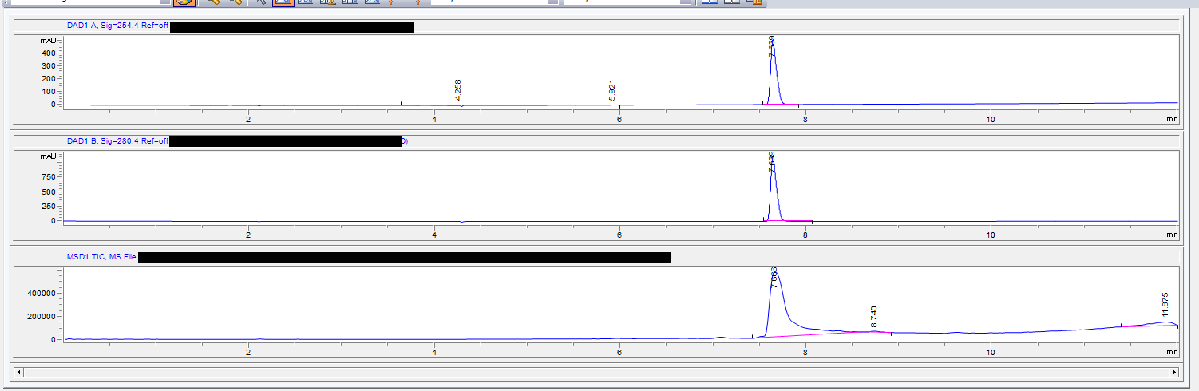

## Strange Peaks with 44 Da Difference

Issue

A large peak appears with many masses with a difference of 44 Da.

Cause

This is polyethylene glycol contamination (PEG). Sources include dirty solvent, detergent use, and plasticiser contamination from contact with plastics.

Solution

Do not wash bottles for LCMS solvent with detergent and avoid any plastic contact. Run a blank (no injection) then a solvent injection (i.e. only the sample solvent in a vial) to identify the source of contamination. If the blank is contaminated, then the system needs cleaning. If only the solvent injection is dirty, your injection solvent needs to be discarded.

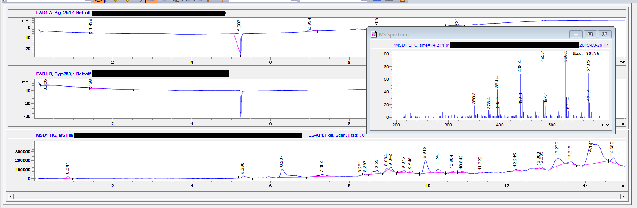

## Peaks with 282 Da

Issue

A peak appears at high organic (i.e. >90% MeCN in H2O), often broad, with mass of 282 Da.

Cause

Plasticiser contamination (probably oleamide) in your sample or a recent sample. This peak generally carries over several runs and is caused by improper solvent storage, typically after contact with plastic such as those in some vial caps or washing with acetone from a squirt bottle.

Solution

Wash the instrument by running the WASH_iPrOH.S sequence (this will take *ca*. 1 h) and test a blank. If this does not remove that contaminant, try the WASH_DCM/MeOH.S with Line D connected to dichloromethane.

Find the source of contamination based on previous experiments and inform the user. LCMS solvents should never be stored in vials with plastic film caps (glass vials with Teflon are generally compatible) or typical lab glassware (e.g. round bottom flasks). Only store LCMS solvents in detergent-free glass bottles – a good choice is a 1 L bottle that came with LCMS grade solvent.

