[Title]

[Author]

School of XXXX, YYYY University

Course code: Name of Course

Faculty Name

March 16, 2022

# [Title]

Begin writing the introduction here… The title of the paper is centered above the first paragraph as a Level 1 heading. Avoid the title “Introduction,” since the beginning of the paper is known to be the introduction.

The number of headings needed for a paper depends on the complexity of the document. Use only the number of headings necessary to identify distinct sections in your paper. When two levels are needed, use Levels 1 and 2. If using a level 2 heading, the document should include a level 1 heading and at least two level 2 headings. When three levels are needed, use Levels 1, 2, and 3. If including a level 3 heading, the document should include a level 1 heading, at least two level 2 headings, and at least two level three headings as subsections of a level 2 section.

# Level One Heading Identifying First Topic After the Introduction

Begin writing the first paragraph here… If the paper requires a main section after the introduction, use a Level 1 heading. For example, if the next section after the introduction is a discussion on the study’s method, the section could be labeled “Method.”

## Level Two Heading to Identify Each Subtopic of the Section

Begin writing the first paragraph here… For subsections of any Level 1 heading, use Level 2 headings. Headings should not include numbers or letters.

## Level Two Heading to Identify an Additional Subtopic of the Section

Begin writing the first paragraph of the section here… Use the same level heading for topics of the equal importance. For example, in a literature review, all major themes would have the same headings.

***Level Three Heading to Identify a Subsection of the Second Subtopic***

Begin writing the first paragraph of the section here… For any subtopics of level 2, use Level 3 headings.

### Level Three Heading to Identify an Additional Subsection of the Second Subtopic

Begin writing the first paragraph of the section here… Level headings may not be required, but how many headings are included in the paper depends on the paper’s complexity.

# Level One Heading Identifying the Next Major Topic

Begin writing the first paragraph here… If the paper requires another main section, use a Level 1 heading.

## Level Two Heading to Identify Subtopic of the Section

Begin writing the first paragraph here… For subsections of any Level 1 heading, use Level 2 headings.

## Level Two Heading to Identify an Additional Subtopic of the Section

Begin writing the first paragraph of the section here… Use the same level heading for topics of the equal importance.

# Method

The method of the research was automated using an R script and run in RStudio (see Appendix).

# Conclusion

Begin writing the conclusion here… Use the conclusion section for wrapping up all the main ideas discussed in the paper and for showing how all the main points relate to the thesis statement to help support the claim made in the thesis. Avoid introducing new ideas in the conclusion or beginning with “In conclusion.”

# References

American Psychological Association. (2020). *Publication manual of the American Psychological Association* (7th ed.). https://doi.org/10.1037/0000165-000

Dery, M. (2018). *Born to be posthumous: The eccentric life and mysterious genius of Edward Gory*. Little, Brown and Company.

Kim, Y.-S. G., Petscher, Y., Wanzek, J., & Al Otaiba, S. (2018). Relations between reading and writing: A longitudinal examination from grades 3 to 6. *Reading & Writing*, *31*(7), 1591–1618. https://doi.org /10.1007/s11145-018-9855-4

# Tables

**Table 1**

|  |
| --- |
| *Statistics for iris$*PetalWidth *by* Species *(*n *= 150)* |

| *Species* | *n* | *Mean* | *SD* | *Skewness* | *Kurtosis* |
| --- | --- | --- | --- | --- | --- |
| setosa | 50 | 0.25 | 0.11 | 1.22 | 4.43 |
| versicolor | 50 | 1.33 | 0.20 | -0.03 | 2.51 |
| virginica | 50 | 2.03 | 0.27 | -0.13 | 2.34 |

|  |
| --- |
| *Note*. Group sizes were balanced. Coloring (blue=Yes, red=No, grey=NA) indicated if a Shapiro-Wilk test of normality failed to reject the null hypothesis that the data were sampled from a population that was normally distributed (*p*>0.05). |

# Figures

**Figure 1**

|  |
| --- |
| *Boxplot of iris$*PetalWidth *by* Species *(*n *= 150)* |

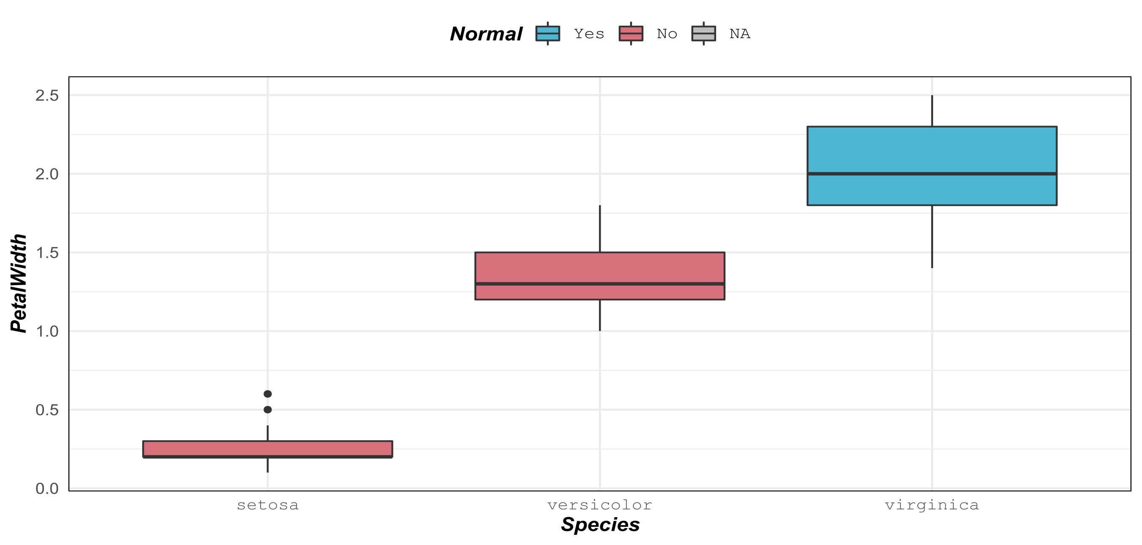

|  |
| --- |
| *Note*. Outliers were observed. Coloring indicated if a Shapiro-Wilk test of normality failed to reject the null hypothesis that the data were sampled from a population that was normally distributed (*p*>0.05). |

# Appendix

The R code below was used in RStudio to automate the method of the research.

#######################################################################

# Load libraries.

#######################################################################

library(apatfa)

library(flextable)

library(tidyverse)

library(utils)

#######################################################################

# Define styles.

#######################################################################

styles <- get_styles()

set_apa_defaults()

#######################################################################

# Initialize the list of table, figure, and appendix content.

#######################################################################

init_tfas()

#######################################################################

# Add an appendix containing this R code.

#######################################################################

add_appendix("aCode", function(x, brief, ...) {

file_name <- getSrcFilename(function(){})

x %>%

add_md("The R code below was used in RStudio to ",

"automate the method of the research.") %>%

add_code_file(file_name, head = brief)

})

#######################################################################

# Add styling for your own data frame.

#######################################################################

gsub("[.]", "", names(iris)) -> names(iris)

styles %>% add_styling(iris) -> styles

#######################################################################

title <- title_n("Statistics for iris$PetalWidth by Species", iris)

#######################################################################

note_that("Group sizes were balanced.") %>%

note_normal("Coloring (blue=Yes, red=No, grey=NA)") %>%

note_intro() -> notes

col_keys <- c("Species", "n", "Mean", "SD", "Skewness", "Kurtosis")

iris %>%

group_by(Species) %>%

summarize(dstats = dstats(PetalWidth),

Normal = is_normal(PetalWidth)) %>%

unnest(dstats) %>%

flextable(col_keys = col_keys) %>%

colformat_double() %>%

bg(j = c("Skewness", "Kurtosis"),

source = "Normal",

bg = function(Normal) styles$colors.yes_no_na[[Normal]]) %>%

styler(styles) %>%

add_table(bookmark = "tStatsPetalWidthBySpecies",

title = title,

styles = styles,

notes = notes, wide = FALSE)

#######################################################################

title <- title_n("Boxplot of iris$PetalWidth by Species", iris)

#######################################################################

iris %>%

group_by(Species) %>%

mutate(Normal = is_normal(PetalWidth)) %>%

ungroup() %>%

ggplot(aes(Species, PetalWidth, fill = Normal)) +

geom_boxplot() +

scale_fill_yes_no_na() +

theme(axis.text.x = styles$mono) -> fig

note_that("Outliers were observed.") %>%

note_normal() %>%

note_intro() -> notes

add_figure(fig, "fBoxplotPetalWidthBySpecies", title, styles,

notes = notes, wide = TRUE)

#######################################################################

# Generate sections for Tables, Figures, and Appendices in APA 7 style.

#######################################################################

apa_docx(here = function() {})