APPENDIX A

Production rates

A1 Recalculation of nucleonic surface production rates

The sea level, high latitude (SLHL) production rate of Kubik et al. (1998) has been determined from a ¹⁴C dendrochronologically-dated landslide at Köfels (Austria). The total surface production rate for ¹⁰Be is 5.75±0.24 ¹⁰Be atoms/g(qtz)/yr which is in excellent agreement with the revised rate of Nishiizumi et al. (1996; 1989) of 5.80 ¹⁰Be atoms/g(qtz)/yr. But both values have been determined using the altitude/latitude scaling of Lal (1991), which assumes that the muon contribution to the total SLHL production rate is about 16% (Lal, 1991; Nishiizumi et al., 1989). However, there are strong indications that the relative muon contribution is much lower (Stone et al., 1998, and references therein). Use of the reduced muon contribution requires a recalculation of the SLHL ¹⁰Be and ²⁶Al production rate.

The ¹⁰Be and ²⁶Al production rates of Kubik et al. (1998) were chosen based on the availability of all relevant data necessary for the calculations. The production rates of the four quartz samples have been calculated and corrected for shielding by mountains, snow, vegetation and sample size as well as for radioactive decay through time with the following equation:
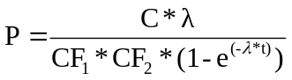 (A1.1)
where C is the measured nuclide concentration (atoms/g(qtz)/y), CF₁ the correction factor for shielding by mountains, CF₂ the correction factor for shielding by snow, vegetation and sample size, λ the decay constant (/y) and t the exposure of the material by the landslide (t = 9800 y). The corresponding error of the production rate is calculated from the relative errors of measured concentration, correction factor CF₁ and CF₂. The total production rate at Koefels is the weighted mean (Eq. A1.2) and weighted error (Eq. A1.3) out of the four samples.
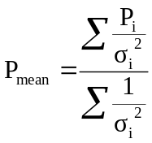 (A1.2)

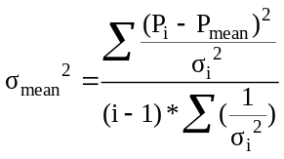 (A1.3)
The Heisinger muon production was scaled to the Köfels altitude and latitude using Lal’s Table 1 (Lal, 1991). The Heisinger muon production rate was also scaled using the pressure difference from sea level p(sl) (g/cm²) to Köfels p(Köfels) (g/cm²) and an absorption mean free path (Λ_{μ}) of 247 g/cm² (Rossi, 1952) with the following equation:
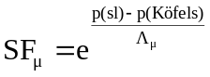 (A1.4)
The muonic scaling factors from these two methods are within 0.3%. The intensity of muons at sea level is reduced at the geomagnetic equator. According to Allkofer (1975), the reduction of the muon component at sea level becomes negligible above 30° geomagnetic latitude (latitude of Köfels: 47°), but has to be considered for latitude <30° (Fig. A1.1). The nucleonic component at the Köfels site (mean weighted corrected production rate minus muon contribution) was then scaled down to SLHL using Table 2 of Lal (1991) resulting in a nucleonic production rate of 5.22±0.22 atoms/g(qtz)/yr for ¹⁰Be and 33.61 atoms/g(qtz)/yr for ²⁶Al. Including muons, this results in a total surface production rate at SLHL for ¹⁰Be of 5.37±0.22 atoms/g(qtz)/yr and ²⁶Al of 34.71 atoms/g(qtz)/yr, respectively.

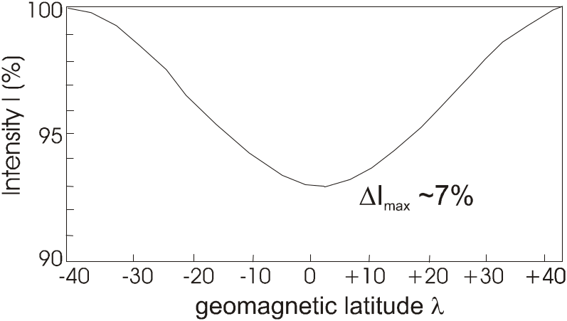
Fig. A1.1: Latitude effect of the muonic component at sea level. The latitude effect results in a 7% decreased muonic production rate at the equator. From Allkofer (1975)

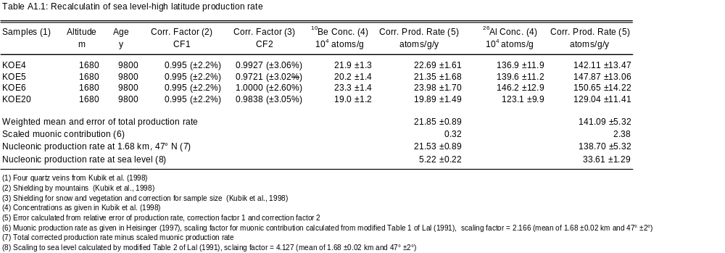

A2 Scaling to sample altitude and latitude

The scaling factors used for calculation in this study is based on a spreadsheet provided by P. W. Kubik (Paul Scherrer Institut, c/o Particle Physics, ETH Hönggerberg). The spreadsheet relies on the scaling factors proposed by Lal in Table 1 and 2 (Lal, 1991). The scaling factors proposed by Lal (1991) rely on experimental data which contain some irregularities. In the spreadsheet of P. W. Kubik, the scaling does not rely on the experimental data set, but uses values fitted through the experimental data. Using the fitted scaling instead of the measured smoothes out the observed irregularities in the measured data. A further advantage of the improved spreadsheet is that the muon contribution to the total cosmogenic nuclide production rate can be adjusted independently. The values used by Lal (1991) of 16% of muon contribution to the total production of cosmogenic nuclides can be replaced by the now better accepted values of Heisinger (1997). As calculated in Appendix A1, the muon contribution used in this study is 2.8 %.
However, the scaling factors of Lal (1991) are based on the assumption of an axial geomagnetic dipole field to describe the lateral variation of cosmic ray flux. After 1958 it became generally accepted that by only considering a non-dipole field the cosmic ray flux at sea level could be described accurately. Therefore, Dunai (2000) presents new scaling factors taking into account the non-dipole field. Additionally, only adsorption free path-length determinations are used that were obtained at elevations relevant for methods utilising in situ produced cosmogenic nuclides. While the actual production rates used in this thesis were the ones based on Lal’s approach, the new scaling factors, which can be easily calculated by the step by step method published in Dunai (Appendix, 2000), are used in the error estimate of erosion rate calculation (see Appendix B1).

A3 Correction of the production rates for variations of the paleomagnetic field

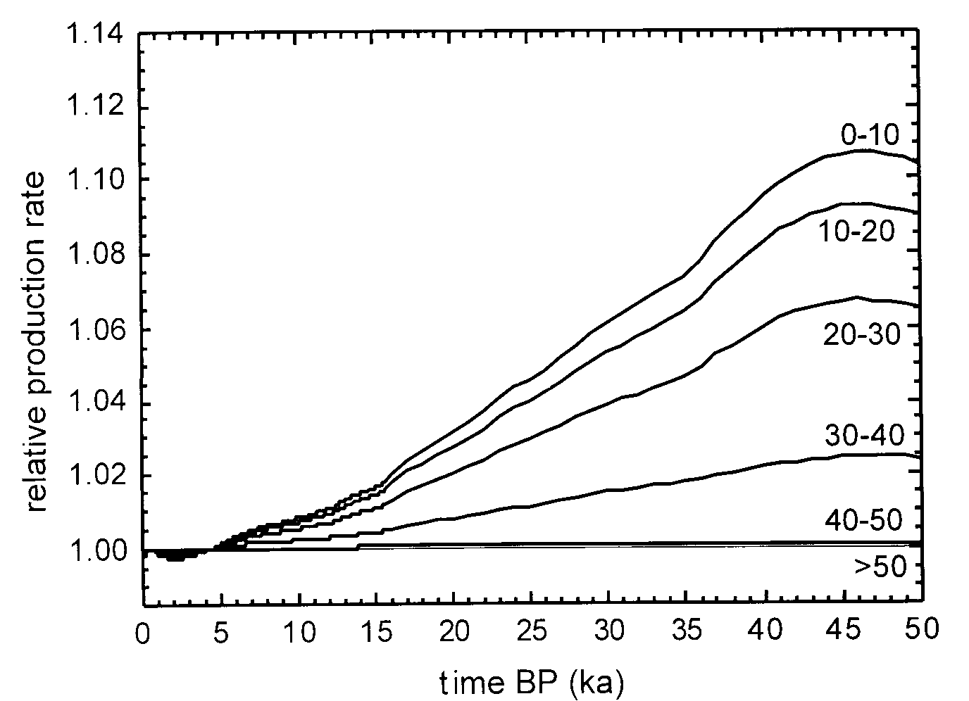The time-dependence for the production of cosmogenic nuclides can be solved with the work of Cerling and Craig (1994), and the combination of Lal (1991) and Frank et al. (1997). A far more comfortable way is given by the model calculations of Masarik et al. (2001) which is used in this work (Fig. A3.1 and A3.2). The variations of the relative mean production rate is given for different time spans and latitudes.

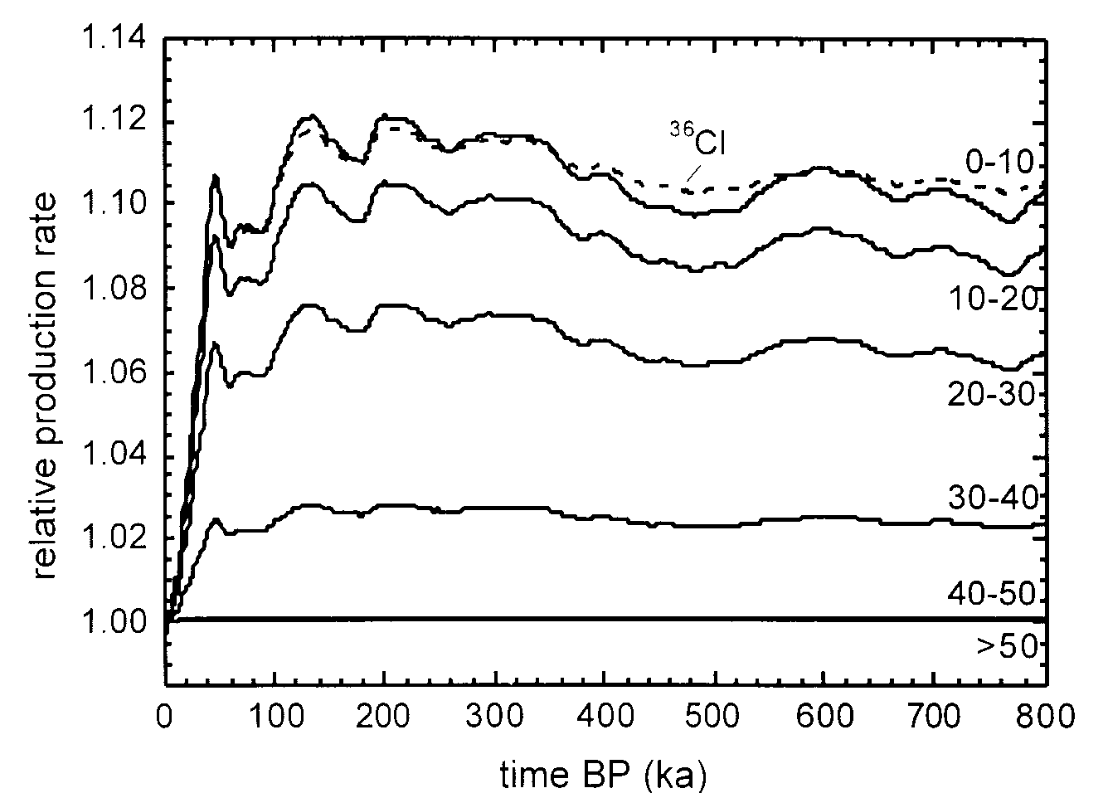
Fig. A3.1 and A3.2: Figure to be used to correct production rates for paleomagnetic field variations. Shown are relative time-integrated production rates of cosmogenic nuclides in samples exposed between the time given on the abcissa and the present-day. The curves are based on the paleo-field reconstructions. The different curves are for various latitude bins (in degrees). The solid lines are for stable nuclides, the dashed line is the apparent mean production rate for ³⁶Cl (half-live 300kyr) at 0-10 deg, i.e. taking into account that an early excursion of the magnetic field affects the present-day concentration of a radionuclide less than more recent field excursion of the same magnitude and duration. For practical purposes, this effect is negligible for the other radionuclides commonly used for in-situ exposure dating.
From Masarik et al. (2001).

A4 Depth dependence of nucleonic and muon production rates

Because over time material is exhumed from great depth, erosion rates are more sensitive to muon contributions than surface exposure ages, where the nucleonic production is dominant. A good quantification of muon attenuation with depth is therefore important for erosion rate calculations. The Heisinger (1998) muon production rates in quartz was used, because they are in good agreement with the other published muon contributions (Stone et al., 1998). In addition, Heisinger also supplies both the surface production rates and the formalisms to calculate the dependence on depth below the surface.
For the calculation of the cosmogenic nuclide production below the surface, the nucleonic and the muonic components are again treated separately. For the nucleonic production below the surface the depth dependency of Masarik and Reedy has been used (Masarik and Reedy, 1995). A zenith angle dependence similar to that in the atmosphere (Nishiizumi et al., 1989) has been taken into account. The depth dependencies of the stopped and the fast muons have been extracted from Heisinger (1998).
To be able to express the relation of measured concentration to the steady state erosion rate in the conventionally used exponential format (Lal, 1991), the complex depth dependencies of both the nucleonic and the muonic components were developed up to a depth of about 400 m into a series of exponential functions. The depth dependence of each of the nucleonic, fast and stopped muonic production rates P_{(z)}, respectively, is given as a function of 4 exponential terms (equation A4.1):
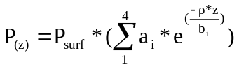 (A4.1)
where P_{surf} (atoms/g(qtz)/yr) is the surface production rate, ρ the density (2.7 g/cm³), z the depth (cm), a_{i} (dimensionless) and b_{i} (g/cm²) are coefficients for the depth scaling. For each production mechanism, the series of 4 exponential functions were sufficient to reproduce the depth dependency of the total production down to any depth to better than 1%.
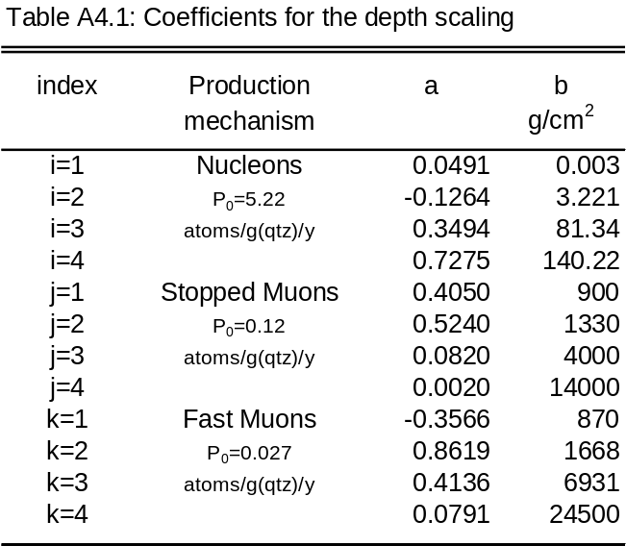

The measured concentration can then be converted into erosion rates with the following equation:
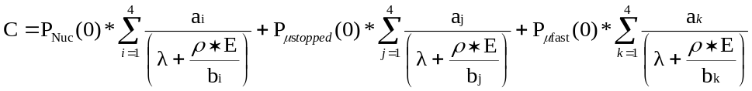 (A4.2)
Here, E (cm/yr) is the erosion rate, λ (/yr) is the decay constant, ρ is the rock density (g/cm³), and P_{Nuc}(0), P_{μstopped}(0) and P_{μfast}(0) are the local surface production rates of cosmogenic nuclides by nucleonic, stopped and fast muons, respectively. a_{i,j,k} (dimensionless) and b_{i,j,k} (g/cm²) are the coefficients for the depth scaling of the production rates (Table A4.1). The b_{i,j,k} should not be thought of as real physical 1/e attenuation lengths or mean absorption paths but only as parameters in the development of the complex depth functions into an exponential format.

A4.1. Derivation of the depth dependence of nucleonic production rate

Masarik and Reedy profile

P_{total} (atoms/cm²/yr): Total production rate in a depth profile
P₀ = 5.22 atoms/g(qtz)/yr: Production rate at surface
x (g/cm²): Depth
Λ = 157 g/cm²: Absorption mean free path
L = 12 g/cm²: Neutron flux

0 < x < L: P(x) = P₀
L < x < : P(x) = P₀*e^{-x/Λ}

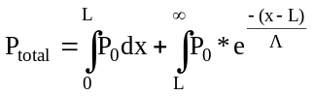
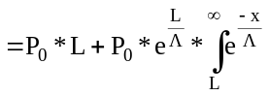
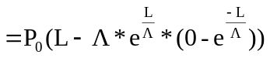
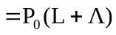 (A4.3)
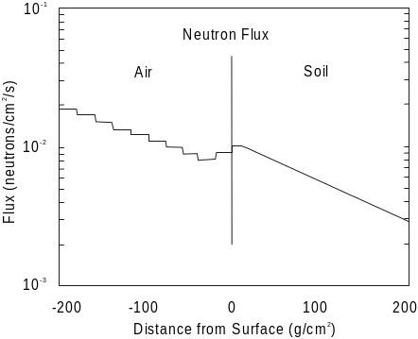Figure A4.1: The calculated flux of neutrons on either side of the air-surface, which shows boundary effects for ~10-20 g/cm² on both side of this boundary. From Masarik and Reedy (1995)
Zenith angle dependence

P_{x} (atoms/cm²/yr): Production rate at depth
P₀ = 5.65267 atoms/g(qtz)/yr: Production rate at surface from Masarik and Reedy
x (g/cm²): Depth
A_{i} (dimensionless): Coefficients for depth scaling
B_{i} (g/cm²): Coefficients for depth scaling
y = sinθ
m = 2.3
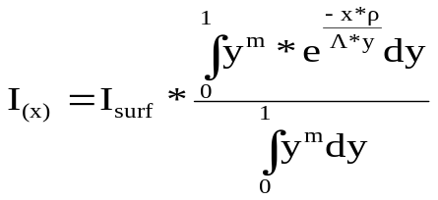 (A4.4)
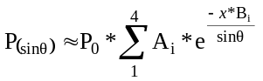 (A4.5)
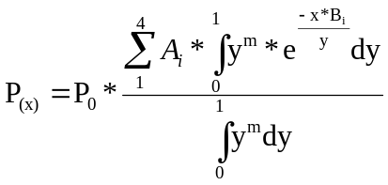
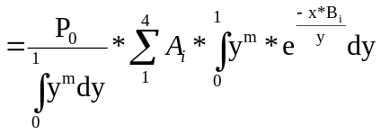
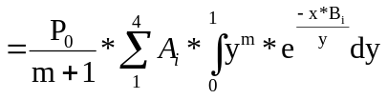 (A4.6)

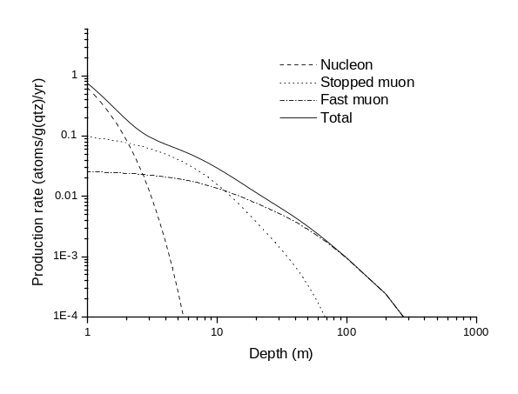Calculate for given A_{i} and B_{i} values the production rate at depth expressed as fraction of the surface production rate. Use Mathematica or Maple. Fit the values resulting from the equation with an equation as A4.1. down to 400 m.
Figure A4.2: Depth dependence of nucleonic, fast and stopped muon ¹⁰Be production rate.

A4.2. Depth dependence of the stopped muonic production rate

The determination of depth dependence of stopped muonic production rate is based on thesis of Heisinger (1997). The calculation procedure is the following:

- calculated I_{V}(x) as given in Heisinger’s equation 1.2
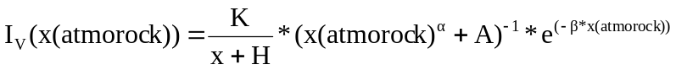 (A4.7)
α = 1.68
K = 270.7 m.w.e.
A = 75
H = 200 m.w.e.
β = 5.5 x 10⁻⁴
x(atmorock) = x + x(atmodepth) (m.w.e.)
x(atmodepth) = 10.33 m.w.e.

- differentiate equation A4.7 with maple/mathematica or by hand: d(I_{V})/dh
- calculate n(x) from Heisinger’s thesis page 16
(A4.8)

- calculate Θ_{μ-}(x) from Heisinger’s equation 1.9
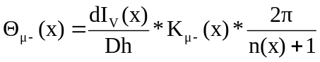 (A4.9)
K_{μ-} = 0.442

- calculate Pm-(x) from Heisinger’s equation 5.2
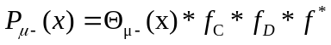 (A4.10)
f_{C} = 0.704
f_{D} = 0.176
f* = 0.0045

fit depth-dependence function with a function as given in equation A4.1

A4.3. Depth dependence of the fast muonic production rate

The determination of depth dependence of fast muonic production rate is based on the thesis of Heisinger (1997). To calculate the coefficients for the fast muonic production rate with depth, the P_{μfast} from Figure 5.1 in Heisinger’s thesis has been modelled. Equation 1.16 from Heisinger’s thesis, which would describe the depth dependence of fast muons, has not been used as there are uncertainties in the correctitude of the equation (Pers. com. P.W. Kubik, 2000). The equation in question is under revision by Nolte and Heisinger.

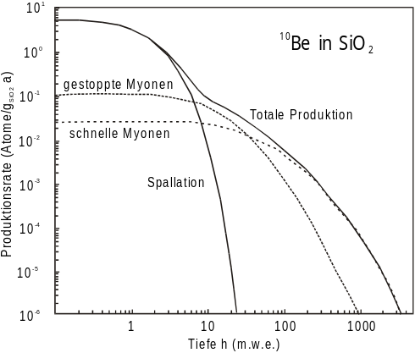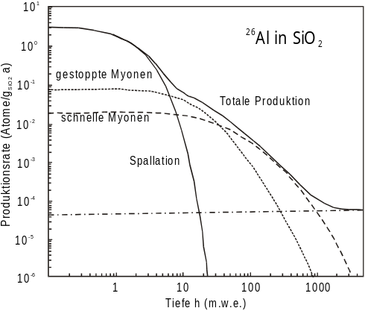
Fig. A4.4: Calculated in-situ production of ¹⁰Be and ²⁶Al in quartz in dependence of depth. From Heisinger (1998).

