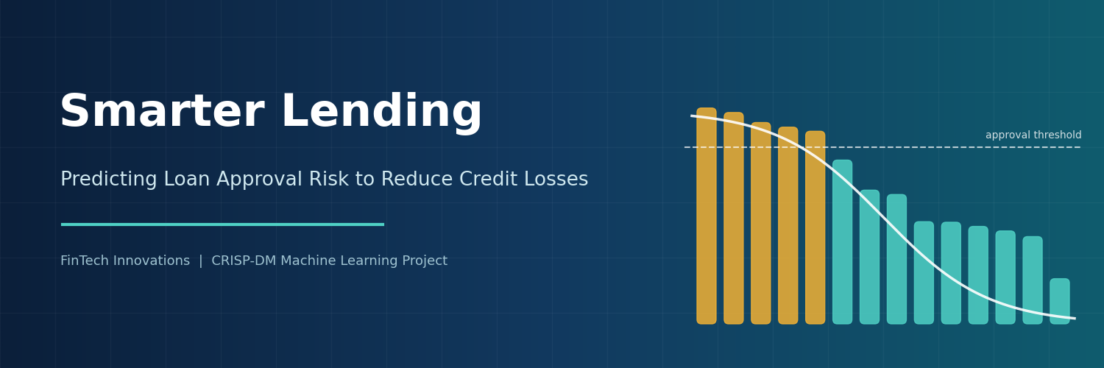
Smarter Lending
A Cost-Sensitive Machine Learning Approach to Loan Approval

Prepared for: FinTech Innovations, Risk Management and Lending Leadership
Prepared by: Todd Harper, Data Science Engineer
Date: September 2026
Framework: CRISP-DM (Cross-Industry Standard Process for Data Mining)
Contents
Executive Summary
1. Business Understanding
2. Data Understanding
3. Data Preparation
4. Modeling
5. Evaluation
6. What Drives the Decisions
7. Recommendations for Implementation
8. Potential Improvements
Appendix: Technical Summary

Executive Summary
FinTech Innovations reviews loan applications manually. The process is slow and inconsistent, and every error is expensive: approving a loan that defaults costs about $50,000, while denying a creditworthy applicant forfeits about $8,000 in profit. This project developed a machine learning model to support those decisions.

41%  lower cost of errors vs. denying all applicants | $3.1M  saved on 4,000 test applicants | 96%  of approvals were creditworthy | 0.97  ROC-AUC (risk ranking accuracy)

Key Findings
- The model substantially reduces losses. On 4,000 applicants it had never seen, total error costs fell to $4.51 million, compared with $7.65 million for denying everyone and $152.2 million for approving everyone. That is roughly $785 saved per application screened.
- It is deliberately cautious. Because a bad approval costs 6.25 times as much as a wrongly denied good applicant, the model makes very few costly approvals (21 bad approvals out of 545) and accepts that it approves only about 55% of creditworthy applicants.
- Affordability drives decisions. Total debt-to-income ratio and annual income are by far the strongest predictors. Loan size and term, unemployment, bankruptcy, and prior defaults also matter.
- Fairness requires review. Although age and marital status were excluded from the model, approval rates still differ across age groups and income levels through correlated financial factors.

Recommendation
Deploy the model as a decision-support tool rather than a fully automated decision-maker. Auto-approve clearly low-risk applicants, flag clearly high-risk applicants, and route borderline cases to loan officers. Begin with a monitored pilot, complete a fair-lending review before launch, and monitor performance and fairness monthly.

1. Business Understanding

1.1 The Current Process and Its Limitations
Loan officers currently review each application by hand. This approach is slow, which limits volume and delays decisions; inconsistent, because different officers may judge similar applicants differently; vulnerable to unconscious bias, which creates regulatory exposure; and limited in its ability to detect complex patterns across many financial and behavioral variables.

1.2 Stakeholders
Stakeholder | Primary need
Loan officers | A fast, explainable risk signal that supports their judgment
Risk management | Fewer defaults and lower credit losses
Business leadership | Continued approval of creditworthy applicants to protect revenue
Compliance and regulators | Transparent, non-discriminatory decisions that can be explained to applicants
Applicants | Fast, fair, and consistent decisions

1.3 The Cost of Model Errors
Error type | What happens | Estimated cost
False approval | An applicant is approved and later defaults | $50,000 (principal and collection costs)
False denial | A creditworthy applicant is rejected | $8,000 (lost profit)

A false approval costs about 6.25 times as much as a false denial. Approving an applicant is only worthwhile when the probability of repayment exceeds roughly 86% (50,000 / 58,000), far stricter than a standard 50% cutoff. This asymmetry shaped every modeling decision in the project.

1.4 Approach and Success Criteria
A classification approach was chosen because the business decision is binary (approve or deny), and a probabilistic classifier still produces a risk score that officers can use. Accuracy was rejected as a primary metric because the classes are imbalanced and it treats both error types as equally costly. Instead, the project tracked:
Metric | Purpose
Business cost (custom) | False approvals × $50,000 + false denials × $8,000. The primary objective; lower is better.
Precision | Share of approvals that are creditworthy; limits costly false approvals.
Recall | Share of creditworthy applicants approved; guards against rejecting too many good customers.
F0.5 score | Balances precision and recall, weighting precision more heavily.
ROC-AUC | Quality of the risk ranking, independent of the decision threshold.

The model had to beat two naive baselines on the 4,000-applicant test set: denying everyone ($7,648,000) and approving everyone ($152,200,000).

2. Data Understanding
The analysis used 20,000 historical loan applications with 35 variables covering income, debt, assets, credit history, employment, and loan characteristics. The target variable, LoanApproved, shows that 23.9% of applicants were approved and 76.1% were denied, an imbalance that makes accuracy misleading.

2.1 Key Relationships
- Income is the strongest single signal (correlation +0.60 with approval), followed by total debt-to-income ratio (−0.41).
- Education shows a clear ordered pattern: approval rates rise from 14% (high school) to 44% (doctorate).
- Adverse credit events matter: applicants with a bankruptcy were approved 11% of the time, versus 25% without.
- Several variables are nearly duplicates, including age and years of experience (correlation 0.98) and annual and monthly income (0.99).

2.2 Data Quality Issues
Issue | Detail | Action
Income stored as text | Values formatted as "$39,948.00" | Converted to numbers
Missing values | Marital status 6.7%, education 4.5%, savings balance 2.9% | Imputed within the pipeline
Suspicious missing pattern | All 901 applicants with missing education were denied | Treated as a data artifact; not used as a signal
Clipped incomes | 584 incomes at exactly $15,000 and 26 at $300,000 | Documented as a limitation
Target leakage | RiskScore and lender-set interest rates reveal the outcome | Removed from the features
Skewed finances | Balances, assets, and liabilities heavily right-skewed | Log-transformed

3. Data Preparation

3.1 Features Excluded from the Model
Feature(s) | Reason for exclusion
RiskScore | Target leakage: an alternative outcome variable that strongly determines approval
InterestRate, BaseInterestRate, MonthlyLoanPayment | Set by the lender after assessing risk, so not available at decision time
MonthlyIncome | Redundant with annual income
Age, MaritalStatus | Protected characteristics under the Equal Credit Opportunity Act; retained only for fairness analysis
Experience | Near-perfect proxy for age

3.2 Preprocessing Pipeline
All preprocessing was built as a scikit-learn Pipeline with a ColumnTransformer, so every step is learned from training data only and applied identically to new applications. This prevents data leakage and guarantees consistent processing in production.
Feature group | Processing steps
Numeric (credit score, ratios, counts) | Median imputation, then standard scaling
Skewed financial (income, balances, assets) | Median imputation, log transform, and scaling, combined through a FeatureUnion with a missing-value flag for savings balance
Ordinal (education level) | Ordered encoding from high school to doctorate, then scaling
Nominal (employment, home ownership, purpose) | Most-frequent imputation, then one-hot encoding

The final pipeline turns 26 raw features into 33 model-ready features with no missing values. The data was split 80/20 into training (16,000) and test (4,000) sets, stratified to preserve the approval rate.

4. Modeling

4.1 Models and Validation
Three approaches were compared: a "deny everyone" baseline, logistic regression (chosen for interpretability), and a random forest (to test whether a more complex model adds value). Each was evaluated with 5-fold stratified cross-validation on the training set, tracking all five metrics.

4.2 Baseline Results
Model (untuned) | Cost per fold | Precision | Recall | ROC-AUC
Deny all applicants | $6,118,400 | — | 0.000 | 0.500
Logistic regression | $6,635,600 | 0.850 | 0.813 | 0.970
Logistic regression (balanced weights) | $13,519,200 | 0.730 | 0.925 | 0.970
Random forest | $6,714,000 | 0.847 | 0.761 | 0.964

A key early finding: no untuned model beat simply denying everyone. Despite strong ranking ability, each false approval cost $50,000, outweighing the value of the good loans approved. The standard remedy for class imbalance ("balanced" weights) doubled the cost, because it pushed the model to approve more applicants, which is exactly the wrong direction for this business.

4.3 Hyperparameter Tuning
Logistic regression was tuned with a grid search over 30 combinations of regularization strength, class weighting, and a preprocessing option (about 11 seconds). The random forest was tuned with a randomized search over 10 sampled combinations of tree count, depth, leaf size, and class weighting (about 2 minutes). Both searches selected the model with the lowest business cost.
The decisive setting was cost-sensitive class weighting. Weighting denied-class errors 6.25 times more heavily, matching the $50,000-to-$8,000 cost ratio, reduced logistic regression's cost from $6.6 million to $3.5 million per fold. Regularization strength had a moderate effect, and the imputation strategy made no meaningful difference.

4.4 Model Selection
Tuned model | Cost per fold | Precision | Recall | ROC-AUC
Logistic regression (selected) | $3,540,400 | 0.964 | 0.550 | 0.970
Random forest | $4,203,200 | 0.962 | 0.418 | 0.960

Logistic regression won on every metric, trained far faster, and offers coefficients that can be explained to regulators and applicants. Final settings: regularization C = 0.3 and class weights of 6.25 (denied) to 1 (approved). Because the cost ratio is built into training, the standard 0.5 decision threshold was already near-optimal: the best cross-validated threshold (0.46) was only 0.5% cheaper.

5. Evaluation

5.1 Test Set Performance
The final model was evaluated once on the 4,000 held-out applicants (956 creditworthy, 3,044 not), which were never used during training or tuning.
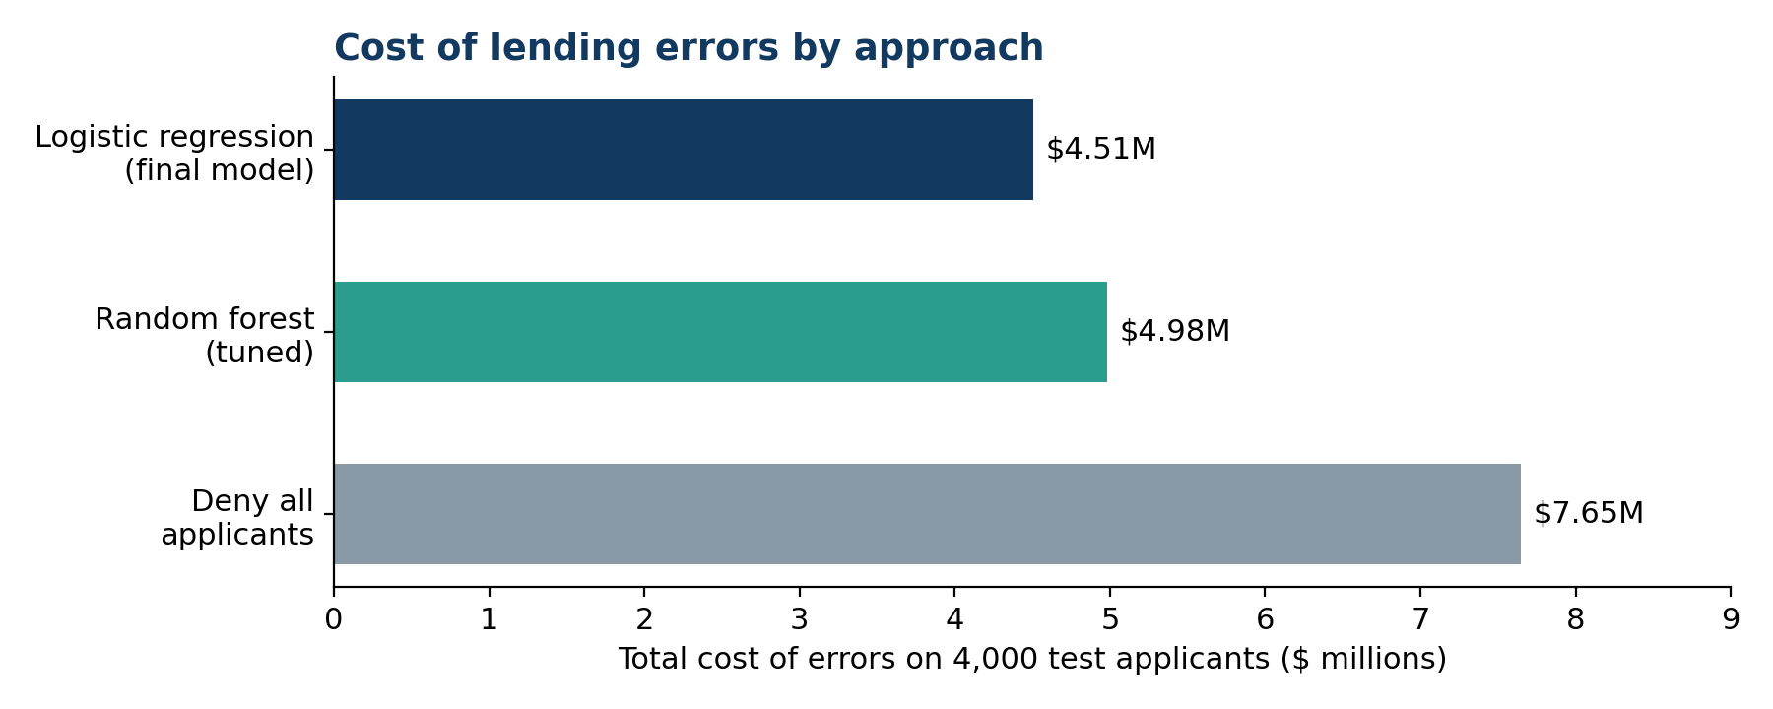
Figure 1. Total cost of lending errors on the test set.
Metric | Result | Target | Status
Business cost | $4,506,000 | Below both baselines | Met (41% below deny-all)
Precision | 0.961 | ≥ 0.90 | Met
Recall | 0.548 | ≥ 0.70 | Not met (by design)
F0.5 score | 0.835 | — | Strong
ROC-AUC | 0.969 | ≥ 0.80 | Met

The cost breaks down as 21 false approvals ($1,050,000) and 432 false denials ($3,456,000). The recall target was not met, and this is a deliberate consequence of optimizing for cost: each additional bad approval costs as much as six missed good ones, so the cost-optimal model accepts lower recall. Test results closely matched cross-validation (precision 0.961 vs. 0.964; ROC-AUC 0.969 vs. 0.970), confirming the model generalizes well.
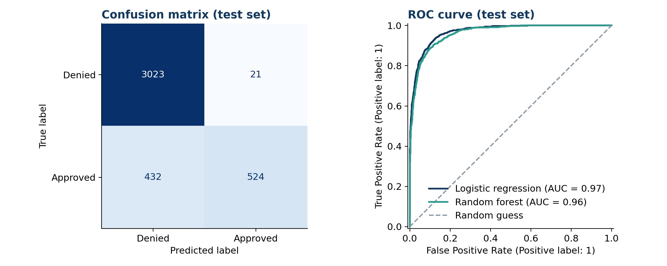
Figure 2. Confusion matrix and ROC curves on the test set.

5.2 Performance Across Segments
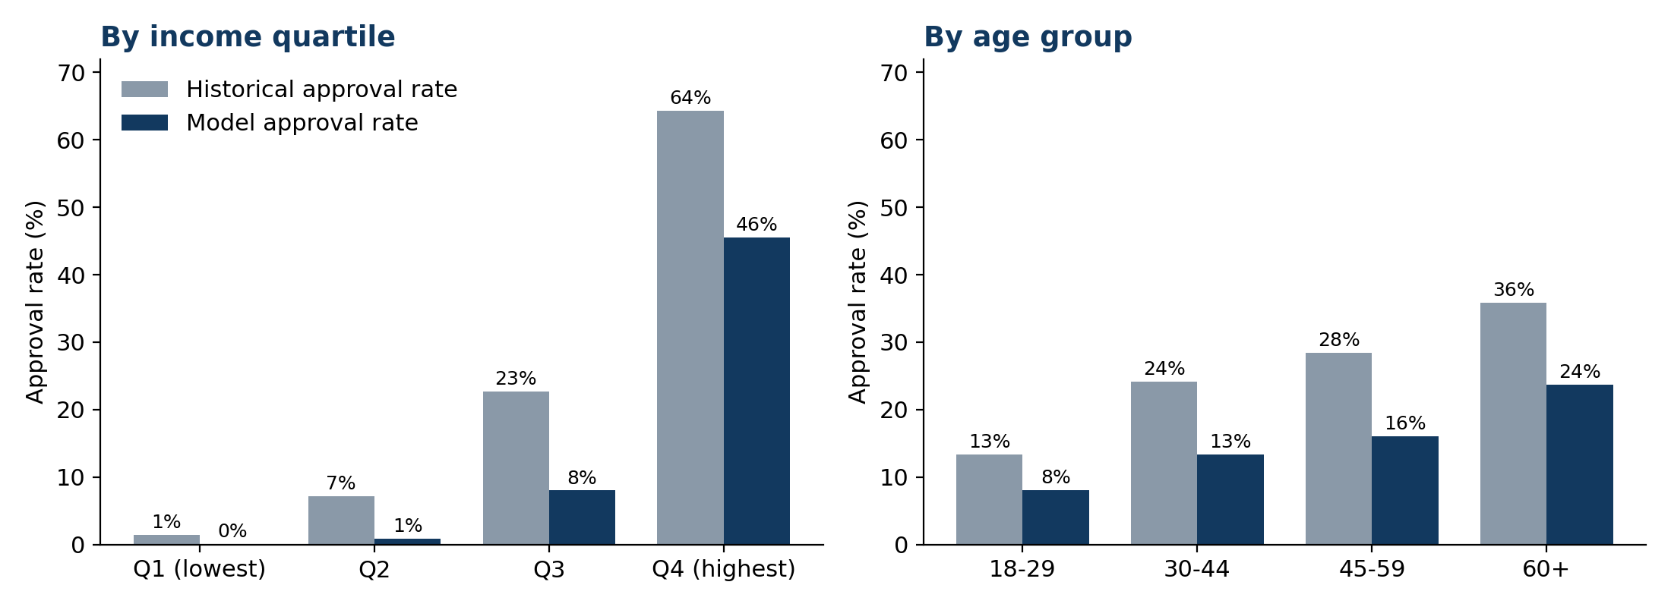
Figure 3. Historical vs. model approval rates by income quartile and age group (test set).
- Income: the model approves 68% of creditworthy applicants in the highest income quartile but only 7% in the lowest. Low-income applicants who would repay are almost always denied.
- Credit score: recall rises from 0.42 for scores under 550 to 0.78 for scores of 650 and above. No applicants scored above 712, so performance on prime borrowers is untested.
- Employment: precision is lowest for unemployed applicants (0.89 vs. 0.97 for employed), so their approvals carry more risk.
- Loan purpose: performance is consistent across purposes, with no group systematically disadvantaged.

5.3 Fairness and Limitations
Age. Although age was excluded, model approval rates rise from 8% for ages 18 to 29 to 24% for ages 60 and over. The youngest group is approved at 0.34 times the rate of the oldest, below the four-fifths (0.80) guideline used to flag potential disparate impact. The gap mirrors the historical data and arises through age-correlated factors such as income, assets, and credit history length. Recall is similar across age groups (0.53 to 0.62), but the approval gap still requires fair-lending review.
Marital status. Approval rates are similar across groups (12% to 14%), with no meaningful disparity.
Limitations.
- The target reflects past approval decisions, not actual repayment, so the model learns to replicate past decisions, including any biases in them.
- Total debt-to-income ratio may include the proposed loan payment, which depends on the lender-set interest rate; its role should be validated using application-time data only.
- The dataset shows signs of synthetic preparation (the missing-education pattern and clipped incomes), so real-world performance may differ.
- The model approves only about 55% of creditworthy applicants, forgoing some profitable loans.

6. What Drives the Decisions
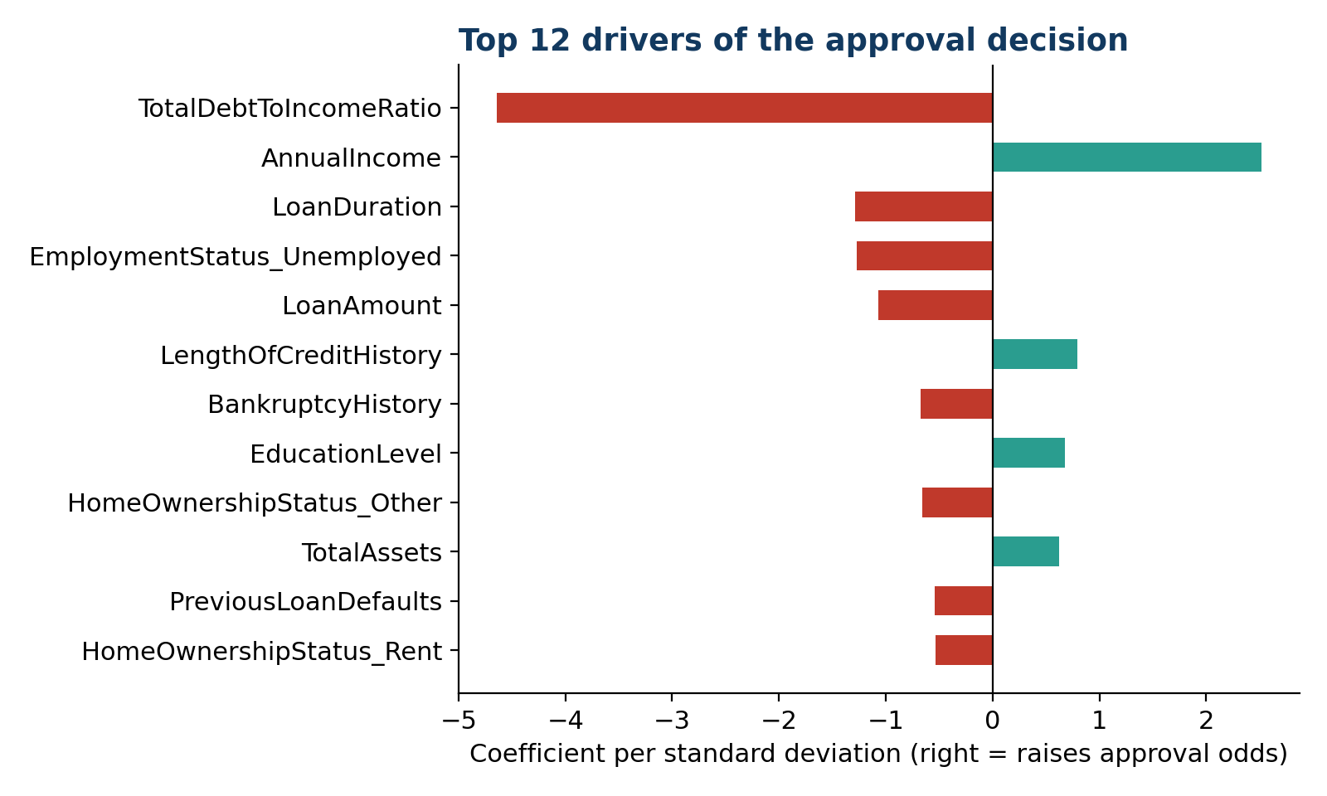
Figure 4. Logistic regression coefficients on standardized features.
The model is primarily an affordability model. Total debt-to-income ratio (coefficient −4.64) and annual income (+2.52) dominate; permuting either feature causes by far the largest drop in performance. Larger and longer loans lower approval odds, as do unemployment, bankruptcy, and prior defaults, while a longer credit history, higher education, and greater assets raise them. Credit score has a surprisingly small effect (+0.43), likely because the dataset contains no applicants above 712 and debt-to-income already captures much of the same risk. Several variables, including credit inquiries, open credit lines, and utility payment history, contribute almost nothing.

Business Recommendations from the Drivers
- Make debt-to-income central to screening. Set clear thresholds for automatic review, since it is the single strongest risk signal.
- Counter-offer smaller or shorter loans. Because loan size and term lower approval odds, offering reduced terms could convert some denials into safe approvals and recover part of the $8,000 lost per denied good applicant.
- Create a review path for lower-income applicants. Creditworthy low-income applicants with low debt ratios should go to human review rather than automatic denial.
- Streamline the application. Variables that add no predictive value could be dropped from data collection to reduce applicant friction.

7. Recommendations for Implementation
- Decision support first. Use the model's probability as a risk score: auto-approve low-risk applicants, flag high-risk ones, and route borderline scores to loan officers.
- Pilot and compare. Run the model alongside the manual process for a trial period and compare decisions and outcomes before relying on it.
- Fair-lending review. Have compliance review the age and income approval gaps before launch, and monitor approval rates by protected group on an ongoing basis.
- Explainable decisions. Use the coefficients to generate the main reasons behind each denial, such as a high debt-to-income ratio, supporting required adverse action notices.
- Monitoring and retraining. Track approval rates, default rates, and input data monthly, and retrain when performance drifts or economic conditions change.
- Keep costs current. Recalculate the $50,000 and $8,000 cost estimates regularly and update the class weights so the model stays aligned with business economics.

8. Potential Improvements
- Train on actual repayment outcomes rather than historical approval decisions, so the model learns true default risk.
- Validate debt-to-income using only information available at application time to rule out leakage from lender-set interest rates.
- Engineer new features such as loan-to-income ratio, liquidity ratios, credit score bands, and seasonality from application dates.
- Test additional models such as gradient boosting, and calibrate probabilities if scores will be shown to officers.
- Apply fairness-aware techniques to reduce the age-group approval gap while monitoring the effect on cost.
- Broaden the data to include applicants with credit scores above 712 and incomes outside the clipped range.
- Use loan-specific economics, replacing fixed cost estimates with profit and loss projections based on each loan's amount and term.

Appendix: Technical Summary
Item | Detail
Data | financial_loan_data.csv: 20,000 applications, 35 variables
Split | 80% training (16,000) / 20% test (4,000), stratified, random_state = 42
Validation | 5-fold stratified cross-validation with shuffling
Final model | Logistic regression, C = 0.3, class_weight = {0: 6.25, 1: 1}, max_iter = 1000
Preprocessing | ColumnTransformer with numeric, skewed (FeatureUnion with MissingIndicator), ordinal, and one-hot flows
Decision threshold | 0.5 (cost-optimal threshold 0.46 was only 0.5% cheaper)
Selection metric | Custom business cost: false approvals × $50,000 + false denials × $8,000
Tools | Python, pandas, scikit-learn, matplotlib, seaborn

