Exam 70-480: Programming in HTML5 with JavaScript and CSS3

Todd J. Knoblock

17 Jul 2017

The Programming in HTML5 with JavaScript and CSS3 is intended to test the knowledge on the following areas: Implement and manipulate document structures and objects that includes creating document structure in HTML and implement various APIs; Implement program flow by using switch statements, if/then statements and implement exception handling; Access and secure data by validating user input using HTML5 elements or JavaScript; and Use CSS3 in applications to style different aspects/attributes of the webpage.

Programming in HTML5 with JavaScript and CSS3 exam is the first exam for two different Microsoft Certified Solutions Developer (MCSD) Certification paths. The two MCSD paths involved are Windows Store Apps – HTML and Web Application. Any IT professionals seeking to demonstrate their ability to build innovative solutions across multiple technologies, both on-premises and in the cloud.

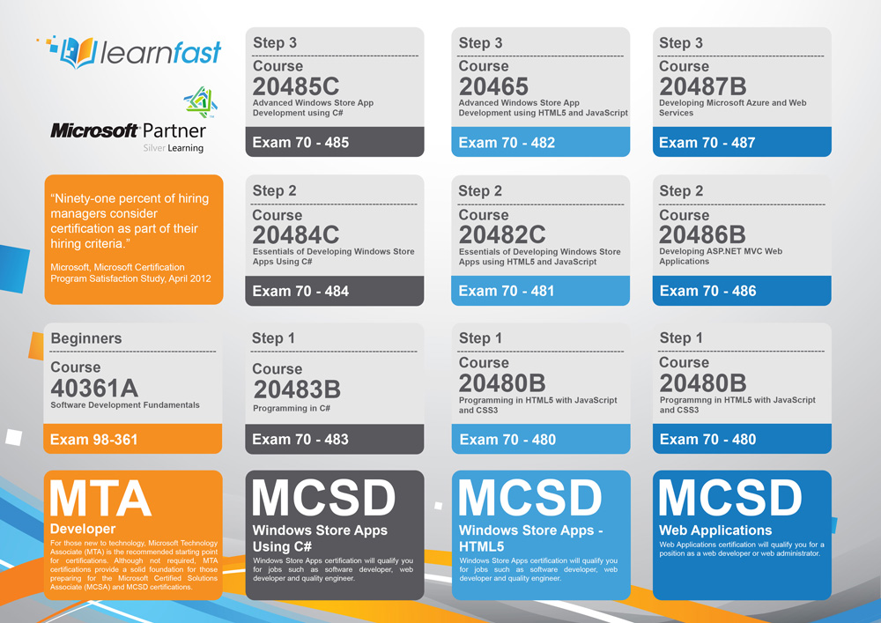

Conducting an online search for Exam 70-480 will result in hundreds of resources available. The resources vary from free to paid services and manuals to example questions/answers. The Microsoft Learning website provides direct links to purchase study and test material and can be found at www.microsoft.com/en-us/learning/exam-70-480.aspx. A few other resources to consider are the following:

* Exam Ref 70-480: Programming in HTML5 with JavaScript and CSS3

Published: August 15, 2014

* Developing in HTML5 with JavaScript and CSS3 Jump Start at <https://mva.microsoft.com/en-US/training-courses/developing-in-html5-with-javascript-and-css3-jump-start-8223?l=lCnp5kIy_5104984382>
* https://borntolearn.mslearn.net/certification/p/wiki?es=storeAppHTML5&ec=480

The MCSD certification path is attractive to employers seeking candidates with programming and developing experience in HTML, CSS3 and JavaScript. Passing the 70-480 examination is a stepping stone to the full MCSD certification. Employers may hire candidates that have only passed this one exam, but it would likely be expected to obtain the remaining certifications within a set timeline.

The Cloud Application Development track only covers a small portion of the HTML5 and CSS3 topics. A basic teaching and knowledge is expected of these two topics in order to get a web application to cosmetically look appealing. There is very little discussions about JavaScript and no topics that instruct the developer to create any JavaScript functions for a web application. In my opinion, the three topics are important to know and understand during the Cloud Application Development process and should be discussed more than it actually is.

As an inspiring Front-End Developer, this certification path is essential in obtaining a job in the civilian workforce. As stated before, an employer may not require it at the initial hire, but eventually it will be required in order to stay at the company for long-term. I plan to study and possibly take the necessary steps to obtain this certification as I progress in becoming a Front-End Developer.