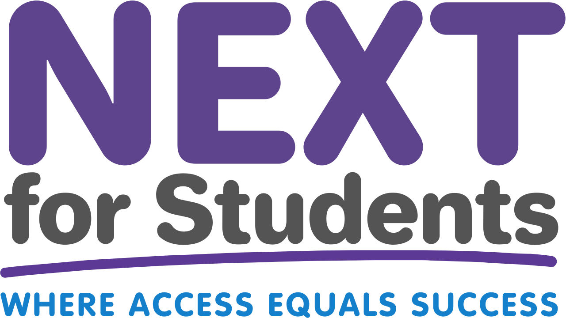

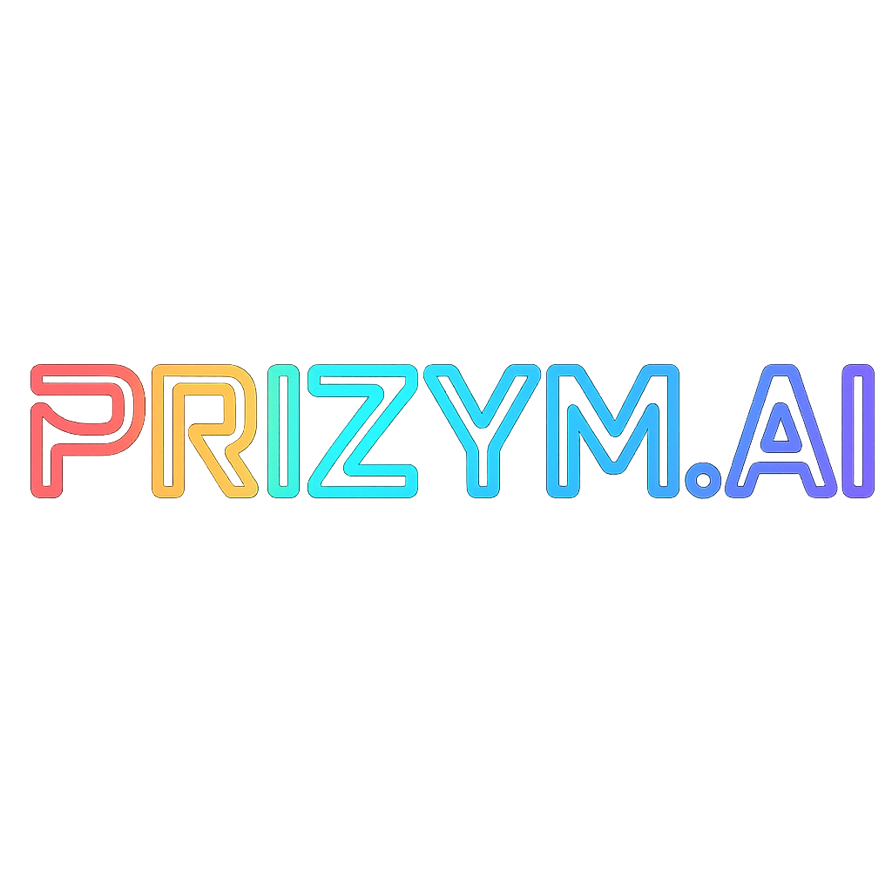

# NEXT by Starbazaar

*Empowering Every Young Adult to Navigate What’s Next*

## Overview

NEXT by Starbazaar is a two-sided platform supporting career discovery and access for students and the programs that serve them. With a mobile app (NEXT for Students) and web dashboard (NEXT for Programs), we provide real-time visibility, matching, and planning tools for underserved youth, educators, and equity-focused partners.

From high schoolers and foster youth to homeschoolers, military-bound students, 2-year and 4-year degree seekers, and career transitioners — NEXT empowers users to plan their future and gain visibility into opportunities that fit them.

## Who We Serve

- High school students (grades 9–12)  
- Foster youth & unaccompanied minors  
- HBCU-bound and equity-focused students  
- Homeschoolers & online learners  
- CTE/vocational/trade students  
- Military-aspiring youth  
- 2- and 4-year college students  
- Career transitioners & adult learners  
- Disconnected or NEET youth

## Platform Breakdown

* 📱 NEXT for Students (Mobile App)

• Starsyn career assessment for identity & fit  
• AI-powered future goals roadmap  
• Visual StarSignature profile  
• Micro-achievements & gamified progress tracking

* 🧭 NEXT for Programs (Web Dashboard)

• Anonymous student discovery tools  
• Filters by traits, readiness, and future goals  
• Smart outreach + dashboards  
• Partner-branded pages, no student data exposure

## Our Intelligence Engine: Starsyn

Starsyn is our adaptive, AI-powered assessment framework that evaluates a student’s personality, skills, and emerging goals. It combines psychometrics, trait modeling, and behavioral signals to generate a ‘StarSignature’ — a visual and data-driven fingerprint of a student’s career identity.

### How Starsyn Works

- Identifies a Primary Trait Cluster (Main Starsyn)  
- Reveals 4–5 Secondary Influences (Rising Signs)  
- Maps skills into 6 color-coded categories (Skill Planets)  
- Builds a radar-style visualization to show alignment  
- Recommends pathways: College, Bootcamp, Trades, Military, Career

## Why We’re Different

- Built for equity-first: foster youth, homeschoolers, CTE learners  
- AI generates insights, not just interest surveys  
- No GPA/test-score gating — skills and goals drive access  
- Anonymous discovery: programs filter by fit, not background  
- Portable digital identity: students own their career fingerprint

## Mobile App Preview

[Placeholder for Mobile App Screenshot or UI Mockup]

## Get Involved

We’re seeking funders, board members, and equity-aligned partners to help us pilot across schools, HBCUs, and workforce networks. With your support, we can bring real-time career navigation to students who need it most.