**TensorFlow Serving**

* TensorFlow Serving is a flexible, high-performance system designed for serving machine learning models in production environments.
* It was developed by Google and is part of the TensorFlow ecosystem.
* TensorFlow Serving allows you to deploy trained models and make them available for inference (predictions) via a consistent API, typically through a REST

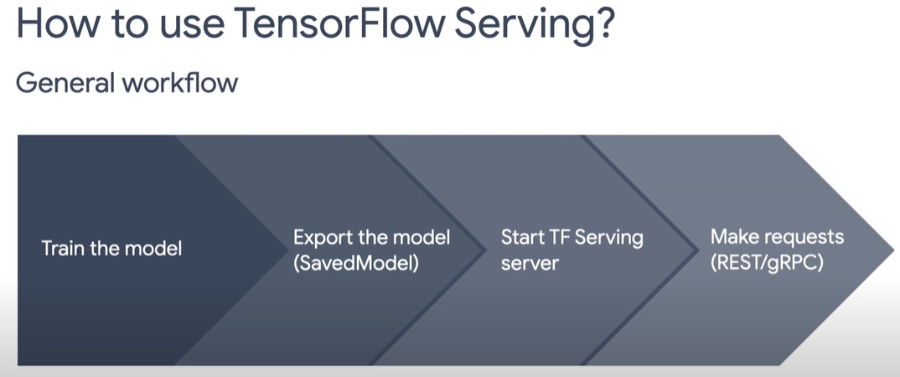

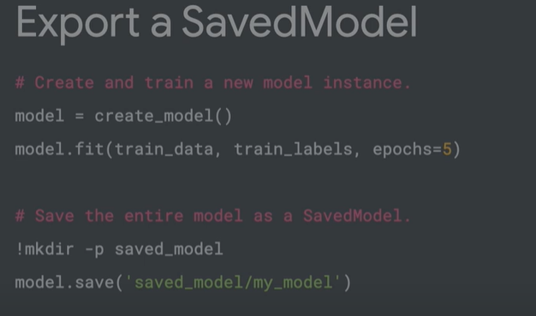

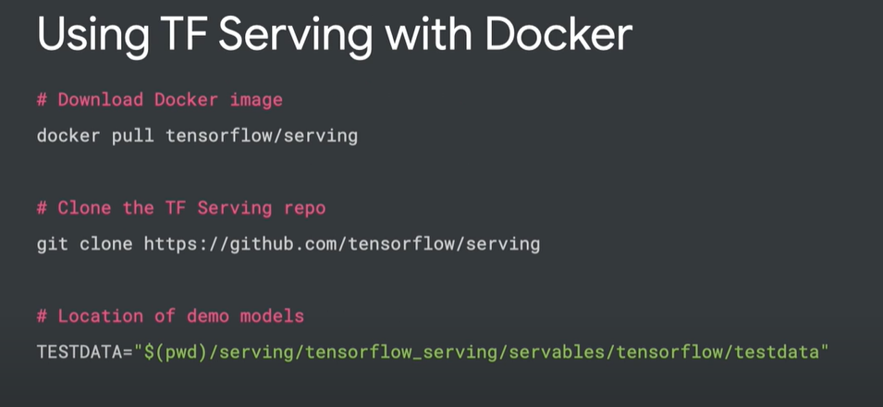

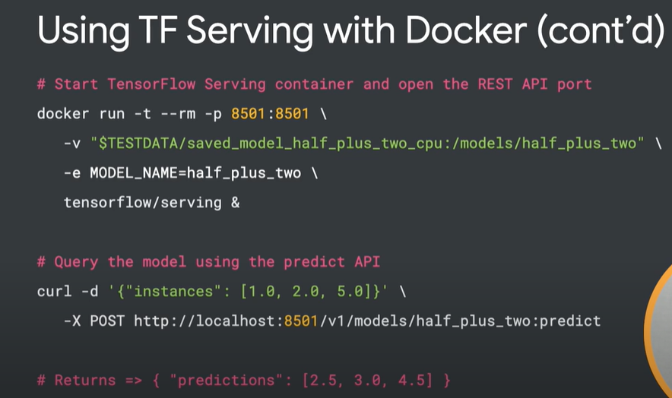

<https://www.tensorflow.org/tfx/tutorials/serving/rest_simple>

https://keras.io/examples/keras_recipes/tf_serving/

https://www.tensorflow.org/tfx/serving/docker

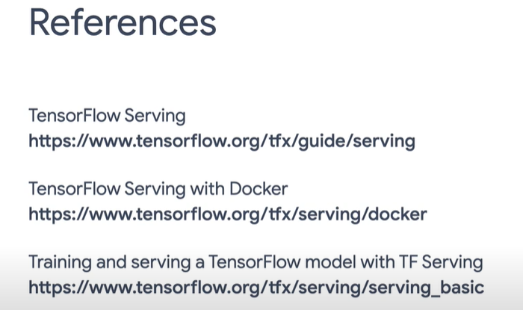

**Docker**

[Docker](https://www.docker.com/) is a computer program that makes it easy for developers to package applications or software in a manner that is easily reproducible on another machine.

Docker makes use of containers, which allows you to package an application along with its libraries and dependencies as a single package that can be deployed in another environment.

Links:

<https://docs.docker.com/desktop/install/windows-install/>

https://www.simplilearn.com/tutorials/docker-tutorial/install-docker-on-windows