# Sonic Pi Hack

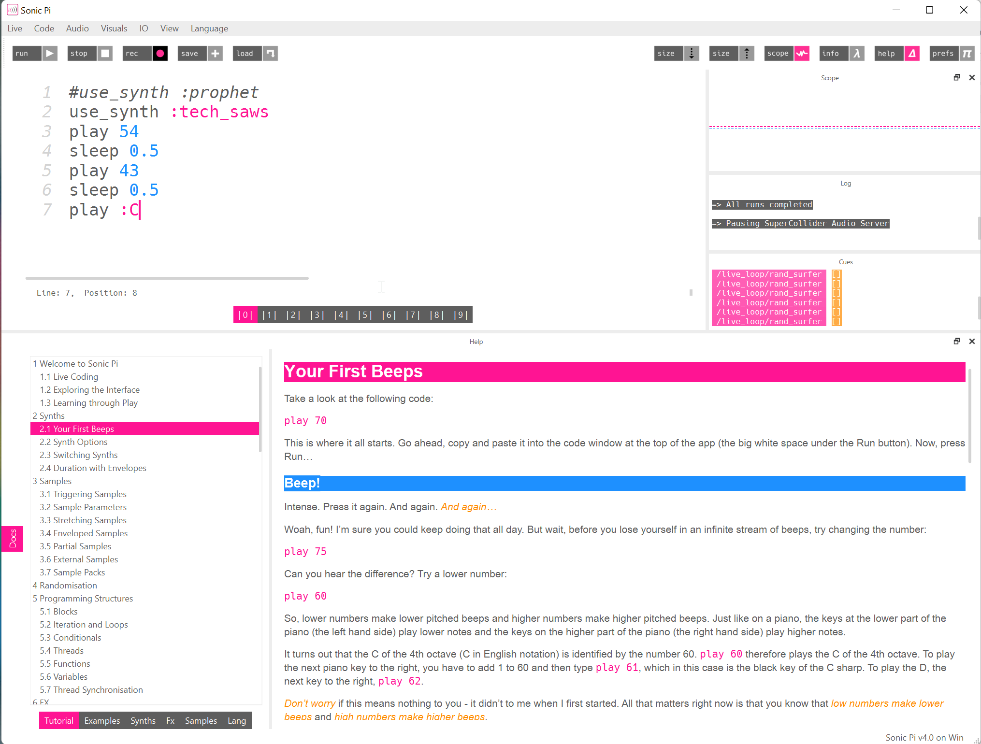

Visualizer

Logs

Help Info

Help Index

Code Windows

Code Editor

Control Buttons

# Guided Tour

## #1 First Beeps

**[Tutorial 2.1]**

## #2 Synth

You can use different synthesizers. Have a look at the Synths Tab then look at **[Tutorial 2.3]**

## #3 Samples

**[ Tutorial 3.1 ]**

## #4 Loops

**[Tutorial 5.2 | Iteration]** and **[Tutorial 5.2 | Looping]**

## #5 Live Loop

**[Tutorial 9.2 | Live Loop]**

## #6 FX

**[Tutorial 6.1 | Iteration]**

## #7 Examples

**[Examples]** and load from the examples folder.

## Shortcut Cheat sheet

See Tutorial B.2 for a full list of keyboard shortcuts

M-/ - Comment/Uncomment current line or selection