PZL M-18B DROMADER
For X-Plane 11
v 1.01

Quick guide

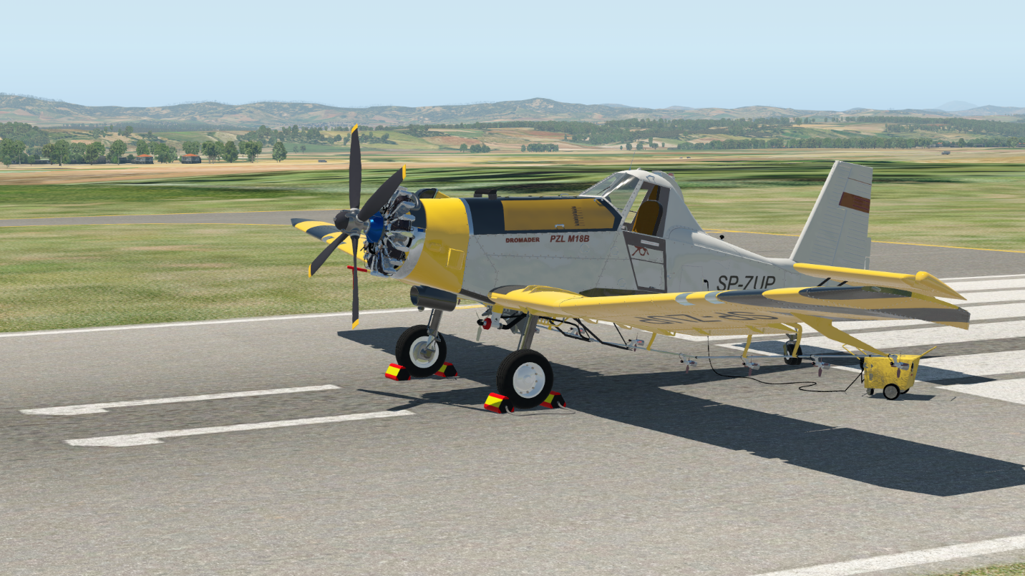

Freeware and Open Source
https://github.com/todirbg/PZL-M-18

1. Overview
The PZL-Mielec M-18 Dromader is a single engine agricultural aircraft that is manufactured by PZL-Mielec in Poland. The aircraft is used mainly as a cropduster or firefighting machine.
More info:
https://en.wikipedia.org/wiki/PZL-Mielec_M-18_Dromader
http://pzlmielec.pl/en/offer/products/m18-dromader/general-description/

This model is created using only freely available on the internet data and is far from perfect representation of the real plane. Use for fun only!

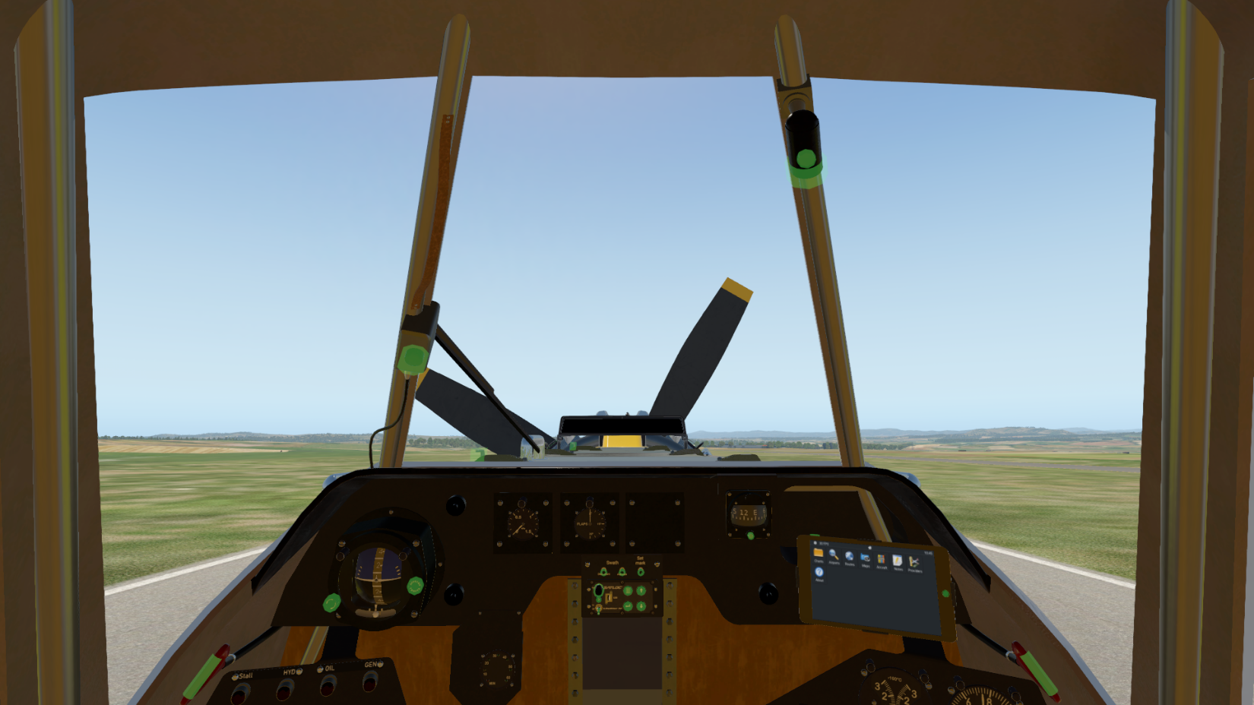
2. Controls and instruments
1
2
3
4
5
6
7
8
9
20
20
12
10
11
13
14
15
16
17
18
19
1. Wiper speed control.
2. Internal light brightness control.
3. Internal light direction control.
4. Propeller manual rotation.
5. Tank cover handle.
6. LiteStar lightbar(visible only with AG equipment attached).
7. AGK49 artificial horizon.
8. AGK49 horizon line adjust control.
9. AKG49 cage control.
10. Boom pressure gauge(reading in MPA).
11. Flaps indicator.
12. Compass.
13. Compass lock control.
14. Avitab.
15. Avitab On/Off switch.
16. Avitab Home button.
17. LiteStar IV control panel.
18. Foaming agent tank indicator.
19. Chemical tank window.
20. Emergency door release handles.
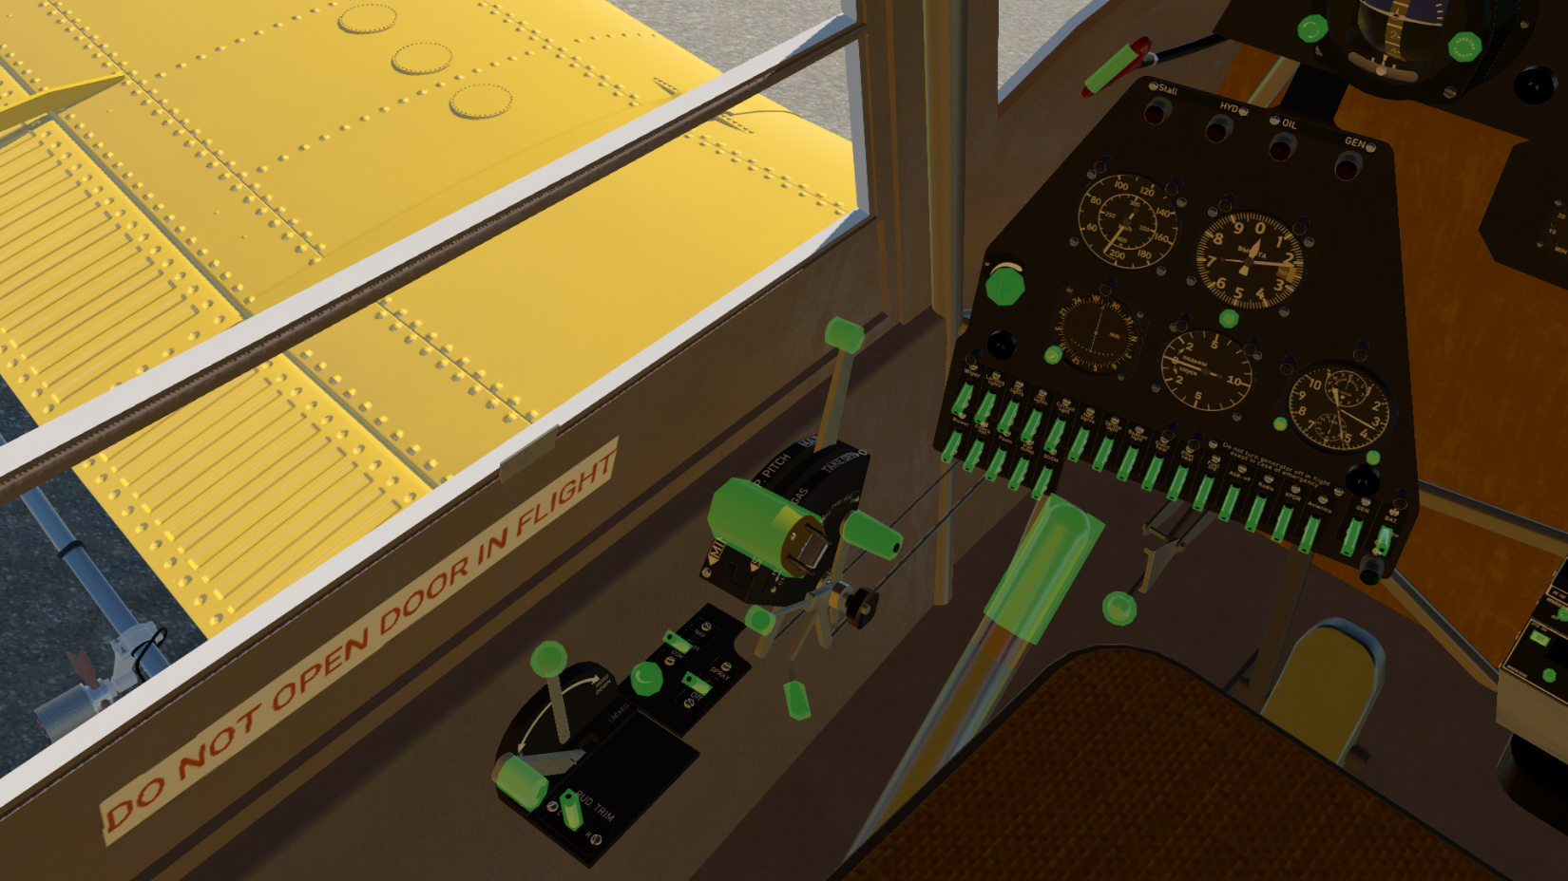
20
21
22
23
24
25
26
27
28
29
30
31
32
33
34
35
364
37
38
39
40
41
42
44
43
45
46
47
48
49
50
51
52
53
54
55
56
57
58
59
60
61
62
63
64
65
66
67
121
21. Airspeed indicator (Km/h).
22. Altitude indicator (meters X 100).
23. Pressure adjust knob (mm/hg).
24. Instruments lights adjust knob.
25. Ki208 VOR indicator.
26. Ki208 heading knob.
27. Vertical speed indicator (m/s).
28. AChS-1 clock.
29. Time of flight start/stop/reset control.
30. Timer start/stop/reset control.
31. Prop pitch lever.
32. Throttle.
33. Carb heating lever.
34. Oil radiator flap handle.
35. Tension lever (not modeled).
36. Emergency load dump lever.
37. Left break lever.
38. Manual pitch trim lever.
39. Tail wheel lock.
40. Electric rudder trim.
41. Wiper fuse.
42. Landing light fuse.
43. Taxi light fuse.
44. Instruments lights fuse.
45. Cockpit light fuse.
46. NAV lights fuse.
47. Strobe light fuse.
48. Beacon light fuse.
49. Static port heating fuse.
50. Pitot tube heating fuse.
51. Fuel indicators fuse.
52. AGK49 artificial horizon fuse.
53. Radios fuse.
54. Transponder fuse.
55. Master avionics fuse.
56. Generator fuse.
57. Bus power selector switch.
58. Cockpit blower fuse.
59. Emergency electric hydraulic pump fuse.
60. Foaming agent add switch.
61. Hydraulic load dump switch.
62. Boom pump switch.
63. Left rudder pedal.
64. Annunciator panel.
65. Audio volume.
66. Audio radio/nav switch.
67. Spray toggle switch.

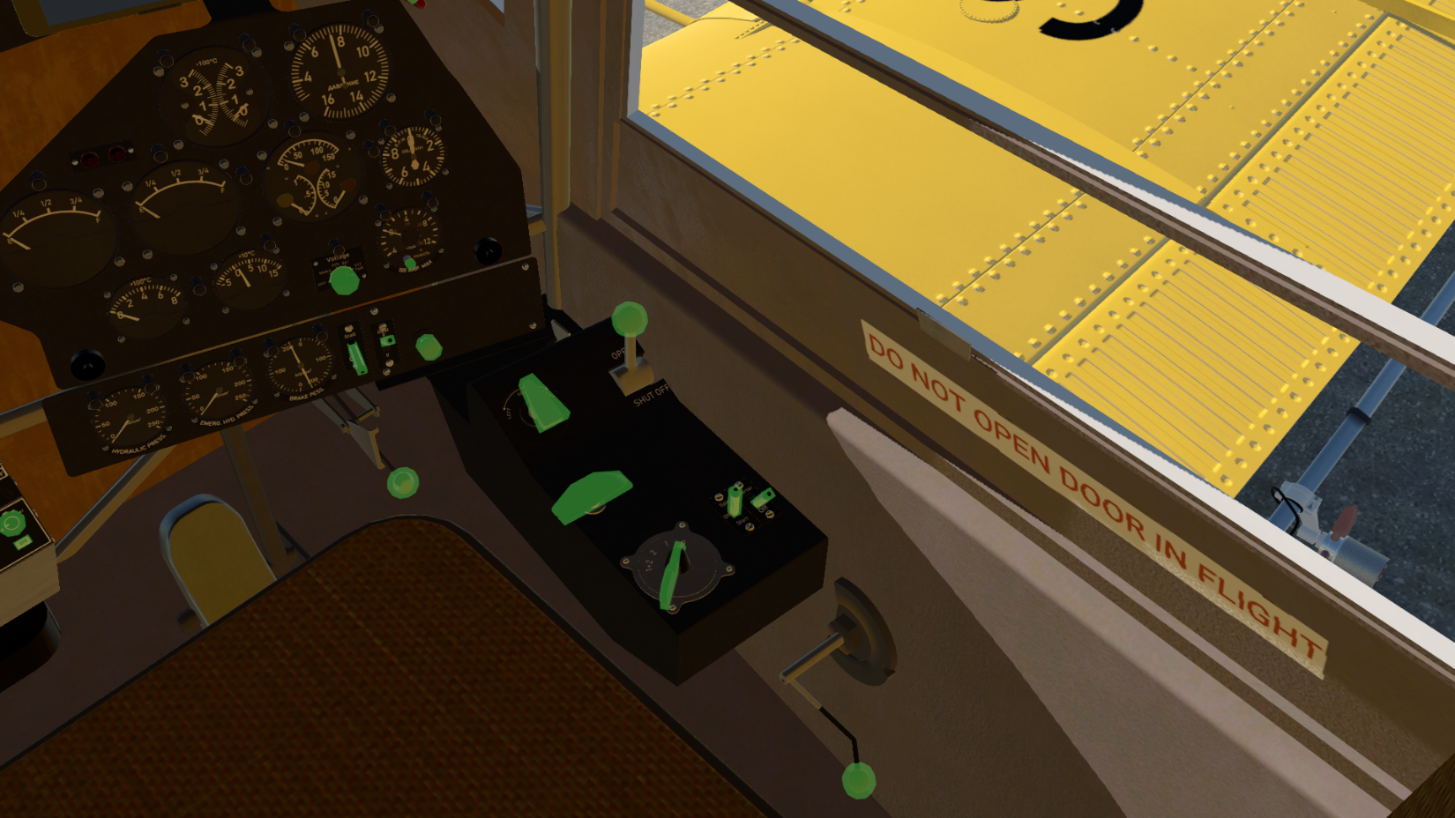
68
69
70
71
72
73
74
75
76
77
78
79
80
82
81
83
84
85
86
90
91
94
93
89
88
87
92
95
96
97
68. Cylinder head temperature indicator (deg C).
69. Manifold pressure indicator (mm/hg).
70. Left fuel tank low light.
71. Right fuel tank low light.
72. Left fuel tank indicator.
73. Right fuel tank indicator.
74. Oil temperature indicator (deg C).
75. Fuel pressure indicator (kg/cm2).
76. Oil pressure indicator (kg/cm2).
77. Engine speed RPM
78. EGT indicator (deg C).
79. Carburetor air temperature indicator (deg C).
80. Voltmeter/Ammeter indicator.
81. Show current bus voltage button.
82. Voltmeter/Ammeter indicator source selector knob.
83. Stall bell fuse.
84. Cockpit heating control.
85. Engine mixture lever.
86. Right brake handle.
87. Fuel tank selector.
88. Fuel cutoff lever.
89. Cylinder primer handle.
90. Inertial starter Spin/Start switch.
91. Inertial starter fuse.
92. Magnetos control.
93. Manual fuel pump handle.
94. Engine driven hydraulic pump pressure indicator.
95. Electric hydraulic pump pressure indicator.
96. Wheel brakes hydraulic pressure.
97. Right rudder pedal.

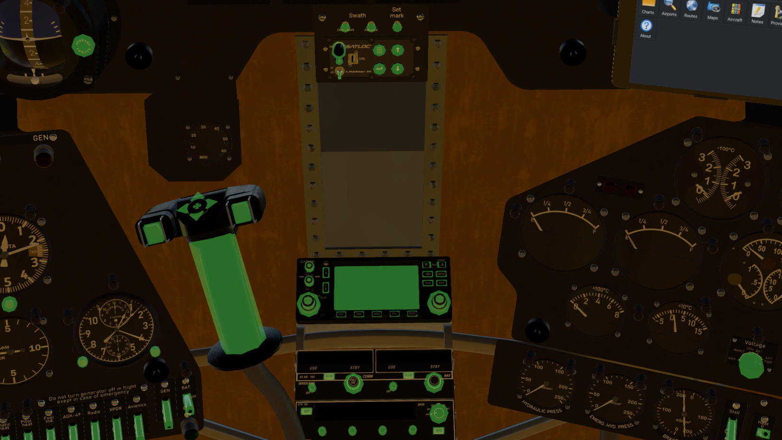
100
99
18
101
102
103
104
105
17
19
98
98. Emergency hydraulic load dump trigger(Front of the stick)
99. Electric pitch/roll trim.
100. Hydraulic dump switch.
101. Flap switch.
102. Stick manipulator.
103. Garmin G430 GPS.
104. Kx155 Radio/Nav
105. Kt70 TSO transponder.
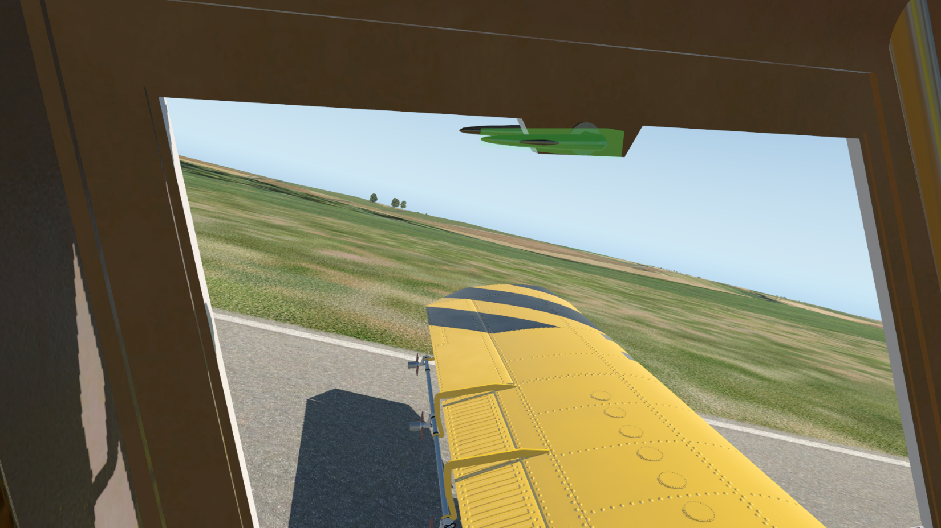
106
106. Door handle.
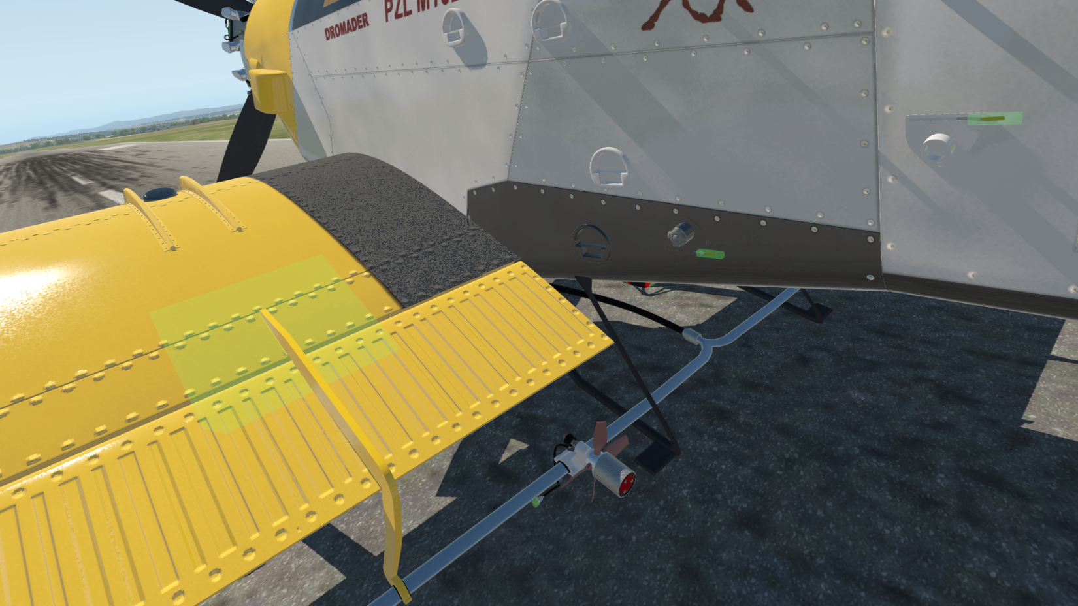
107
109
108
110
107. AG equipment attach/detach click zone (On the ground/engine off only).
108. Foaming agent refill handle.
109. Water/Chemical refill handle.
110. Spray quantity selector. 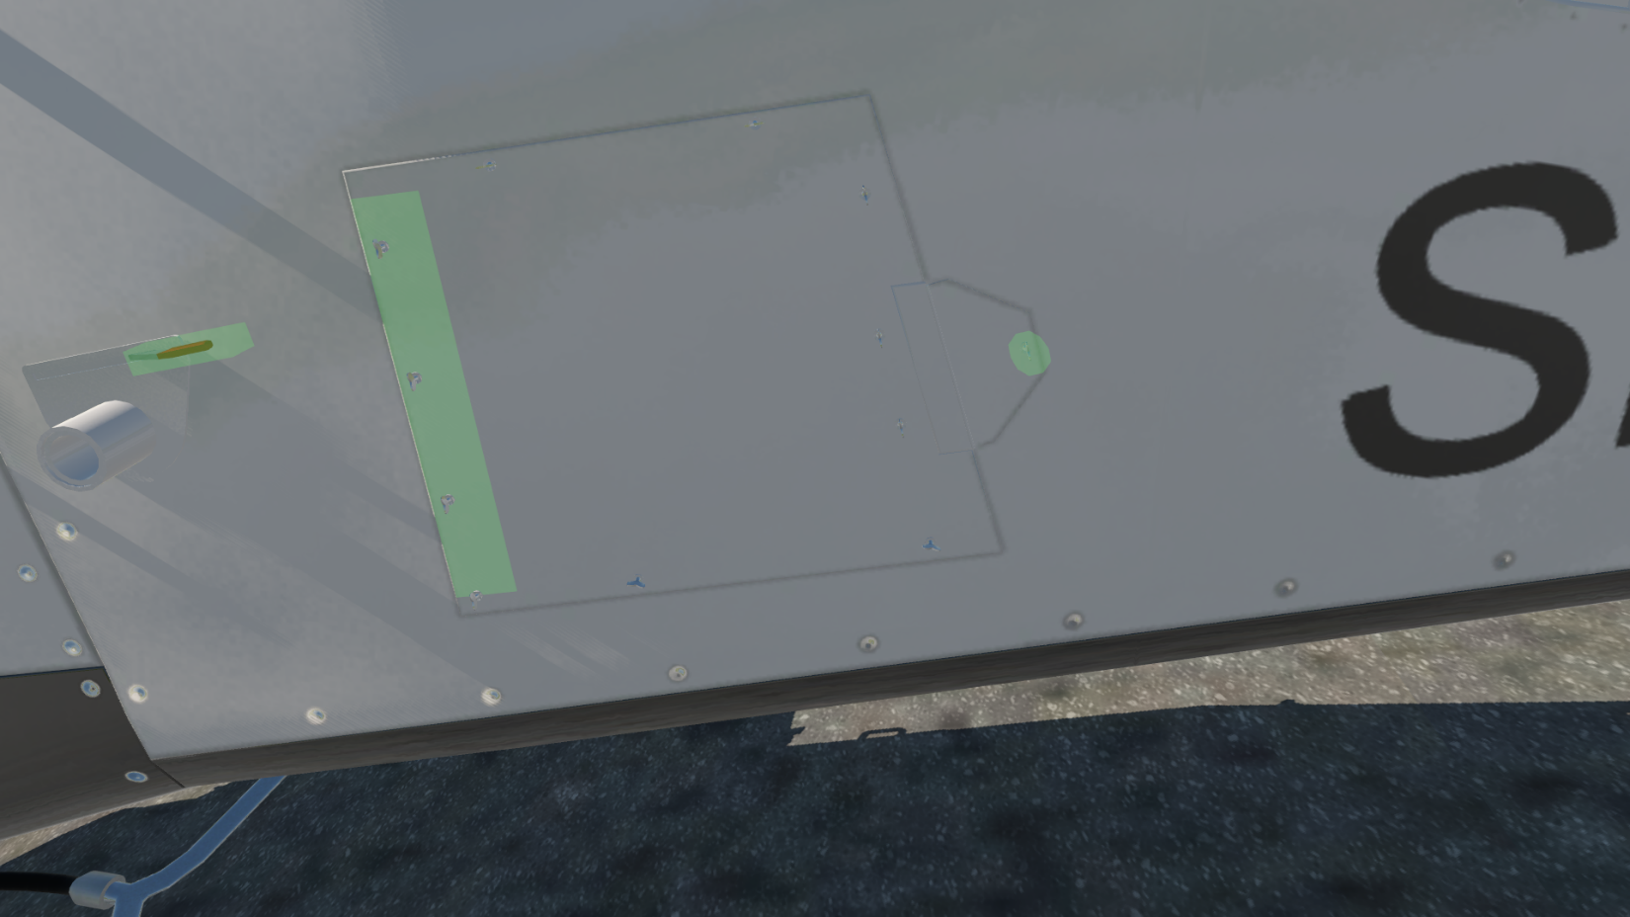
109
111
112
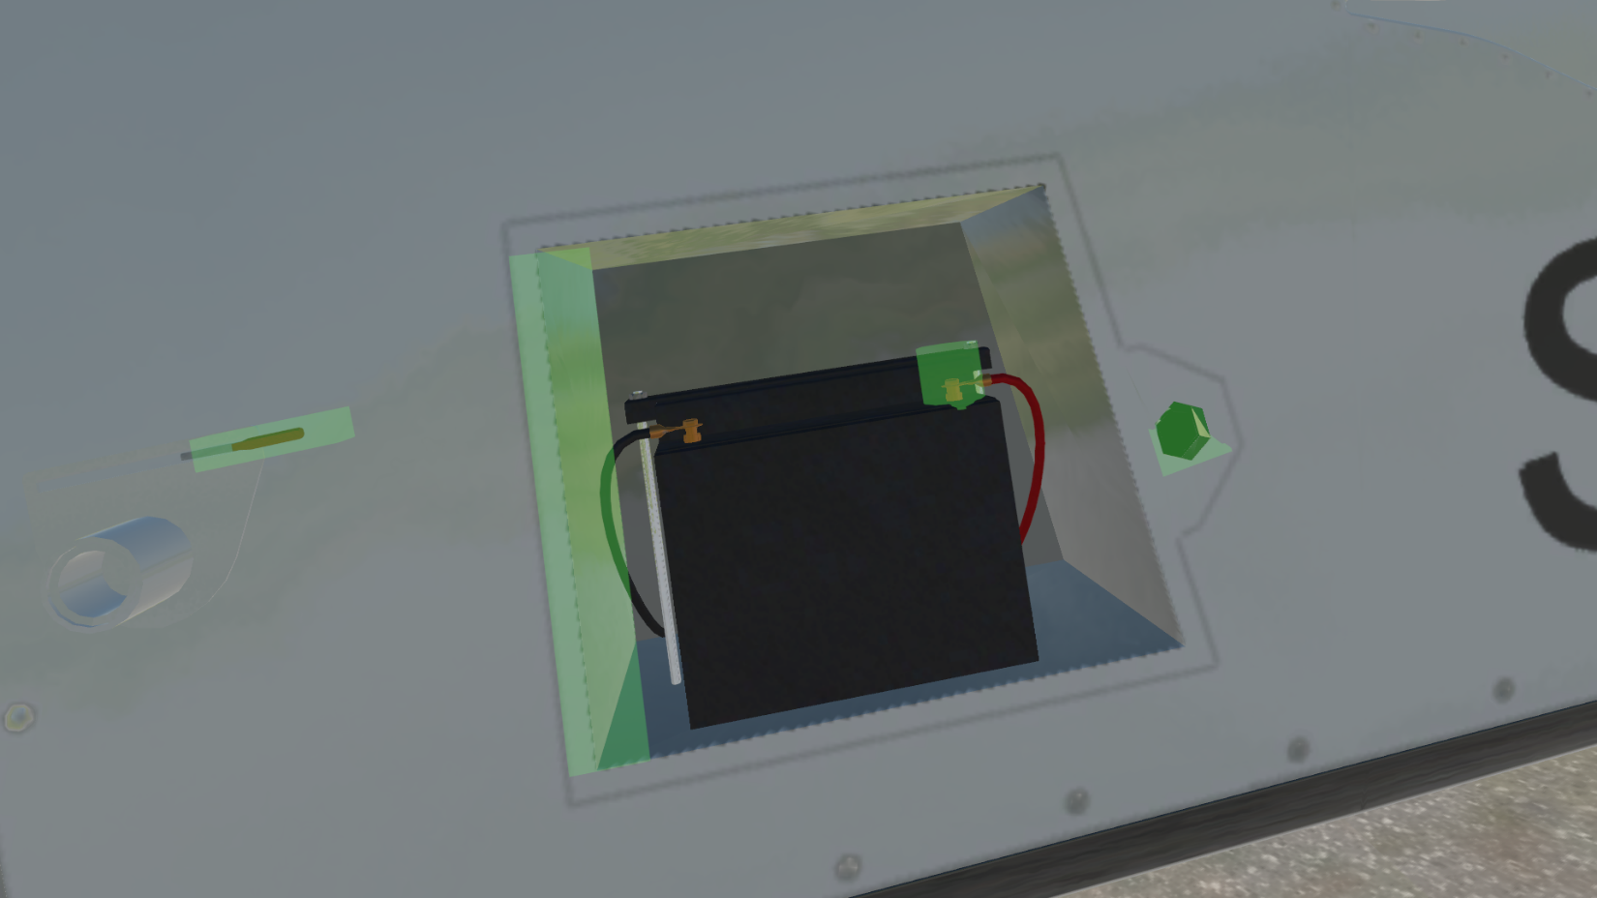
111
114
113
109
111. Battery cover attach/detach manipulator.
112. External power cover handle.
113. Battery connect/disconnect.
114. GPU connect/disconnect manipulator.
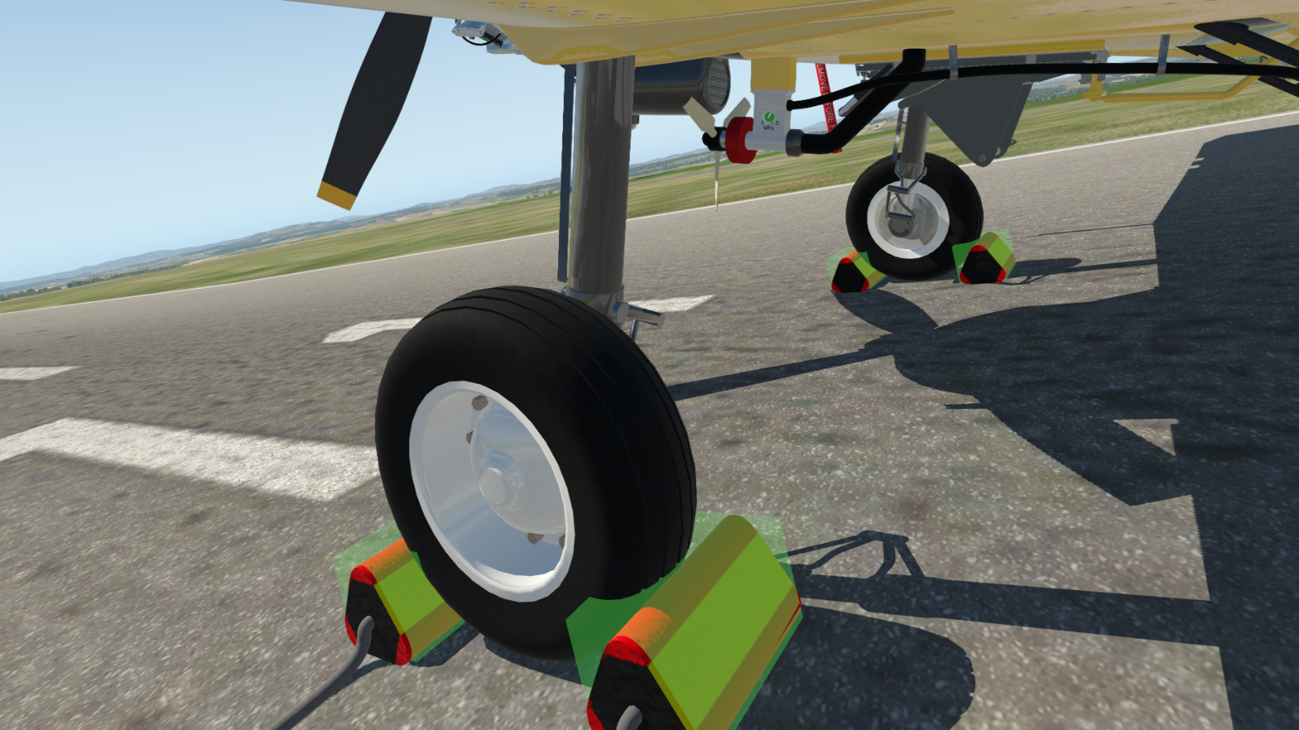
115
116
116
116
116
4
115. Boom pressure adjust knob (0-1.5 MPa).
116. Add/remove wheel chocks.
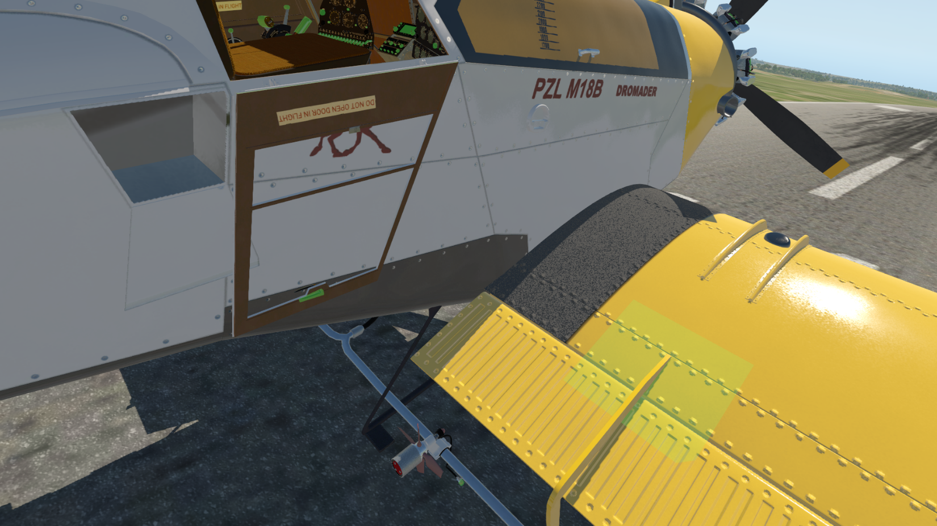
107
117
106
4
110
122
117. Baggage door handle (visible only with right door closed).
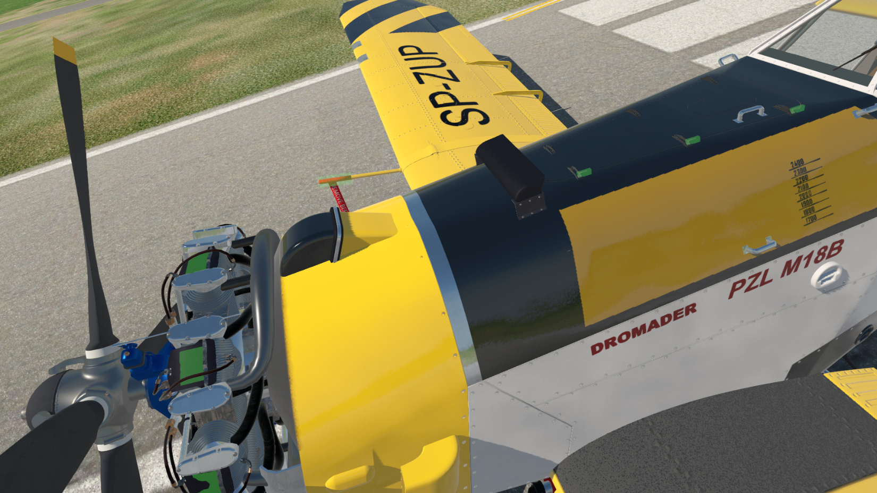
118
1190
1190
5
5
5
6
4
118. Add/remove pitot tube cover.
119. Add/remove cylinder head shields.

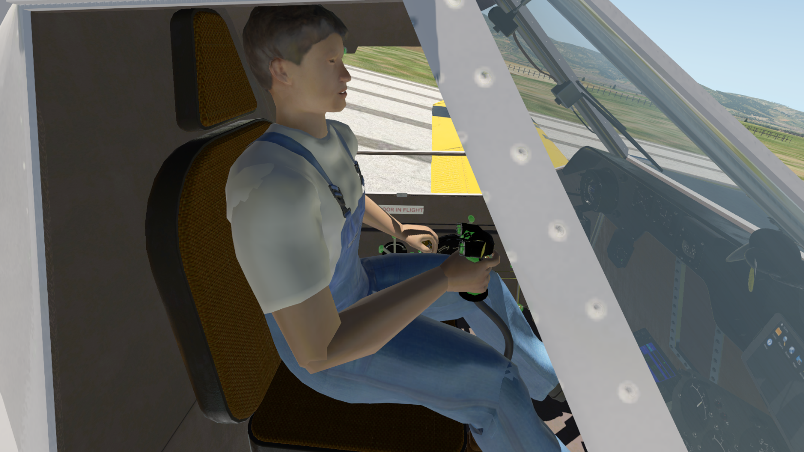
120
121
120. Show/hide pilot figure in inside view.
121. Toggle smoker.(new feature. Switch near the spray switch)
122. Close door manipulator(visible only when door is open)
If you want to see the pilot in 3D cockpit use the clickspot(115) on the seat under the pilots bottom. The setting is saved.
3. Limits modeled in X-Plane.
(May not be real world)
Airframe:
G limit +3.4 g, -1.4 g
Wight 5300 kg
VNE 280km/h
VFE 200km/h
Engine:
Max RPM 2300 no more than 30 sec.
Max CHT 235C continuous, 250C no more than 5 min
Min CHT below 50C no more than 1200 rmp for 1 min.
Max MP 1100 mm/hg short time.
MAX Oil temp 100C.
4. Engine start up.
This is the minimal procedure needed to start up the engine in X-Plane and not a complete or realistic checklist.
1. Check battery lead is connected(113) by opening the battery bay cover (111). Or/and connect external GPU(112; 114)
2. Check brake levers(37, 86) in parking position and wheel chocks set.
3. Check pitot tube cover(118) removed.
4. Depending on the outside air temperature remove/install cylinder head shields(119). Recommended remove above 15C.
5. Put the Bus selector switch(57) to appropriate position.
6. Press the Voltmeter/Ammeter indicator switch(81) and check voltage on the indicator(80).
7. Check Voltmeter/Ammeter indicator source switch is on Amp.
8. Switch on fuel indicators.
9. Switch on minimal required external/internal lights and radios if needed.
10. Switch on Emergency electric hydraulic pump(59).
11. Check fuel cutoff valve(88) is in open position and fuel selector is set to tank that has fuel.
12. Use the hand fuel pump(93) to raise the fuel pressure on the fuel pressure indicator(75) to more than 0.3 kg/cm2.
13. If the engine is cold(CHT below 30C) use the priming handle(89) to prime the cylinders. 5-6 full primes no more!
14. Set magnetos(92) to both.
15. Set starter fuse(91) to on.
16. Apply some throttle.
17. Make sure the mixture lever is in full forward position. In full forward the mixture is automatic set for max power. Any other position is manual mixture.
18. Push the inertial starter switch(90) to Spin and hold it there. Watch the Voltmeter/Ammeter indicator(80) spike. Hold the switch until the needle stops dropping and then pull it back to Start position. If there are too many consumers on the bus and the current spikes beyond 100A the bus selector switch(57) will reset itself to “Off” position. Disable some systems and try again. The engine should start, else the inertia starer has enough momentum to turn it only for few seconds.
19. If the engine is cold(less than 30C) it will rattle as a grumpy old rattlesnake until it is heated. Use the throttle to keep the RPM above 500 and bellow 1200.
20. Switch on the generator(56) and all required systems.
21. Set starter fuse(91) to off.
22. Warm up the engine to about 100C. Do not exceed 1200 rpm when the cylinder head temperature is below 50C.
23. Check wheel chocks are removed, and all doors are closed.
24. Go have fun 😊
4. Fire fighting
Dromader can carry up to 2200kg of water and 60l foaming agent.
Use switch 60 to enable foaming agent mix. Adding the foaming agent will make the water dump effect more “puffy”.
The Dromader has 2 modes of dumping water on fires:
1. Water bomb
In this mode all the water in the tank is dropped as a bomb on the fire. To do this use the emergency release handle(36) or the trigger(93 with enabled dump hydraulic system 61). Those are mapped to the default X-Plane water dump command sim/flight_controls/jettison_payload or custom command custom/dromader/water/jettison_payload_up and custom/dromader/water/jettison_payload_down. All custom Dromader command can be found in keyboard shortcuts under custom/Dromader. After the water is dumped return the handle to its default position to close the hatch or refilling the tank will not be possible. Once initiated water dump can not be stopped.
2. Slow releasing of the water in approximately 7 second using a hydraulicly operated hatch. To use this mode, enable dump hydraulic system(switch 61), press and hold the hydraulic dump switch(100) located on the stick. Or map a key to custom command custom/dromader/water/hyd_drop_toggle . In this mode the water will be dumped at a lesser rate as long as the switch is pressed.
You can refill the water tank and foaming agent tank using handles 108 and 109 located on the fuselage. Cheating mode is enabled so you can leave this handles open and refill in flight 😉

5. Agricultural operation
Attach the AG equipment by clicking on zone 107 while on the ground and with engine off.
Set the pump pressure with knob 115 and atomizers with knob 110. The quantity of chemical dropped per minute is the pressure*atomizer setting*nr atomizers. For example, at 1MPa pressure and setting 9 on the atomizers you’ll spray 9 liters per minute per atomizer(10 on the Dromader) so total 90 liters per minute.

The pump(switch 62) must be enabled for spray to work.
Spray can be enabled either by switch 67 or by assigning keys to custom command in custom/Dromader.
This model has LiteStar IV agricultural GPS and lightbar system scripted. For information and manual on using the system visit https://satloc.com/products/litestar-iv/
There are some differences with the manual. If units are set to metric the displayed speed and altitude will be in km/h and m respectively. Spray start and stop will automatically drop a point. Some functions exist in the menu, but do nothing except change values on display – for example UTC offset.
Export function of the unit will produce .kml files for each job in the current session. Files are in xplane/Output folder and are named with date and time of export and job number. Kml files can be viewed in Google Earth and will provide a recording of your flight and spraying runs.
While the AG equipment is attached the drag force modeled will be double the normal. For agricultural operation no more than 1500 kg of chemical is recommended.
6. Some important notices
Respect the plane! The Dromader is a sturdy and reliable work horse, but it will not tolerate abuse. There is no electronic to help you and correct your shortcomings. No “bitcin’ betty”, no flaps warning, no nothing! The engine is a ASz-62ir which is in service since the 30-s. It is reliable and powerful, but not a modern computer-controlled fuel-injected unit and relies on the pilot to control it and do the thinking. Never ever slam the throttle full forward! It is rated at 980hp at 1050mm/hg MP and 2200 rpm. It can do more! But only in emergency or it will fail quickly. Move your throttle according to MP instrument reading. If you ever find yourself cornered in a mountain pass on a firefighting mission, by all means, drop your payload and slam the handles forward! It will jump like a crazy horse and propel itself up like a fighter! But only few minutes of abuse will make you look for a field to crash land 😊 Watch your instruments and react to them. You can’t do much if the engine is too hot, just drop the power to cool it down and when on the ground remove the cylinder shields to improve cooling.

8. Replay extender plugin
For Win and Linux users there is a plugin that enhances the replay mode experience by recording and replaying almost all used datarefs. When enabled you will be able to see almost all animations while in replay mode, including the water dump or spray effects and the LiteStar display. This plugin is disabled by default so if you are planning on making a video or just watching your run, go to Plugins menu -> Replay Extender and click on Star recording.

This plane is freeware and open source! The home of the Dromader is https://github.com/todirbg/PZL-M-18
where you can always find the latest bugs 😉 The plane is WIP and there are a lot of hidden bugs and missing features. Please report any issues you have so I can make it better!
Things to come:
1. Pilot figure
2. Fmod sounds
3. ….
The project is licensed under the terms of Creative Commons BY-NC 4.0 license https://creativecommons.org/licenses/by-nc/4.0/
Fell free to use/modify/redistribute this model complying with the license.
If you like the plane and want to say 10X, please buy me a beer 😊
https://www.paypal.com/cgi-bin/webscr?cmd=_donations&business=KDP7Q5DY8R59W&item_name=Development+of+PZL+M-18B+Dromader+for+X-Plane&currency_code=EUR

Todor Radonov 2021
todirbg@gmail.com

