Predicting car InSUrance claim Fraud
Shubham Todi

ABSTRACT

Insurance claim fraud poses significant challenges to the financial stability and integrity of insurance companies. Detecting fraudulent claims in a timely and accurate manner is crucial for minimizing financial losses and maintaining trust with policyholders. In this paper, we propose an advanced predictive modeling approach to predict claim frauds.

The data for insurance claims containing different variables from claim forms, policy documents, historical claim records, and external databases sourced from Kaggle with fraud value. Feature engineering techniques are employed to preprocess the raw data and extract relevant features that can effectively discriminate between genuine and fraudulent claims.

Next, a variety of machine learning algorithms such as logistic regression, decision tree, random forest, support vector machines, and neural networks are applied to build predictive models. These models are trained on a labeled dataset consisting of past claim records categorized as either fraudulent or legitimate.

To evaluate the performance of the models, various metrics such as Misclassification rate and avg sq error are utilized. Additionally, techniques such as ROC and Lift charts are employed to assess the performance and fit of the models.

Furthermore, the project explores the integration of advanced techniques such as variable selection, followed by gradient boosting, HP Neural, etc. to uncover sophisticated fraud patterns that may not be apparent through traditional approaches.

The goal of this project is to develop a reliable and scalable predictive model that can assist insurance companies in proactively identifying potentially fraudulent claims, thereby enabling timely investigation and mitigation measures. By leveraging the power of data mining techniques, insurers can significantly enhance their fraud detection capabilities and mitigate financial losses while maintaining customer trust and satisfaction.
KEYWORDS
Fraud, insurance, claim, algorithm, performance, develop.
- INTRODUCTION

Data mining, in broad terms, refers to the exploration and analysis of data in various formats to uncover patterns and derive insights. This process involves sorting through large datasets, identifying patterns, and establishing relationships to facilitate data analysis and problem-solving.

Classification represents a fundamental task within data mining, wherein each instance in a dataset is assigned a class label based on its features. The primary objective of classification is to develop a model that can accurately predict the class labels of new instances based on their features. Its two main types are binary classification and multi-class classification. In binary classification, instances are categorized into two classes, such as "fraud" or "no fraud", while multi-class classification involves categorizing instances into more than two classes.

Classification problems represent a prevalent challenge within the realm of machine learning. Typically, in classification tasks, the goal is to predict the class label by analyzing the input data or predictors, where the target variable is categorical in nature.

The process of building a classification model typically involves the following steps:

Data Collection: This initial step involves gathering data that represents the problem you're trying to solve. The dataset should include features (inputs) and corresponding class labels (outputs). Ensure that the dataset is comprehensive and sufficiently large to capture the variability in the problem domain.

Data Preprocessing: Before training a classification model, it's essential to preprocess the data to ensure its quality and suitability for the chosen algorithm. This may involve handling missing values, removing outliers, normalizing, or standardizing features, and encoding categorical variables into numerical representations. We can also use advanced features: variable selection.

Data Splitting: Split the dataset into two disjoint subsets: a training set and a test set. The training set typically comprises a larger portion of the data (e.g., 70-80%), while the test set is smaller (e.g., 20-30%). Randomly splitting the data helps ensure that both sets are representative of the overall dataset.

Model Selection: Choose the classification method(s) you want to evaluate. Common methods include logistic regression, decision trees, Bayesian networks, k-nearest neighbours, support vector machines, and neural networks. Consider the characteristics of your data and the requirements of your problem when selecting a method.

Training: Train the selected classification model using the training set. This involves feeding the training data into the learning algorithm, which adjusts its internal parameters to minimize the difference between predicted and actual class labels. The goal is to derive a classifier that generalizes well to unseen data.

Testing: Evaluate the performance of the trained classifier using the test set. Apply the classifier to the test data, where the true class labels are withheld. Compare the predicted class labels to the actual class labels in the test set to assess the classifier's accuracy and generalization ability.

Performance Evaluation: Analyze the performance of the classifier using appropriate evaluation metrics. Common metrics for classification tasks include accuracy, precision, recall, F1-score, and area under the receiver operating characteristic (ROC) curve. These metrics provide insights into the classifier's ability to correctly classify instances and its performance across different classes.

Model Validation: Consider performing model validation techniques to ensure the robustness and reliability of the chosen classifier. Cross-validation, for example, involves splitting the data into multiple folds and training/testing the model on each fold to assess its performance across different subsets of the data. This helps detect overfitting and ensures that the classifier's performance is consistent.

Iterate or Finalize: Based on the performance evaluation results, you may choose to iterate on the process by trying different classification methods, adjusting hyperparameters, or enhancing feature engineering techniques. Iterate until you're satisfied with the classifier's performance on the test data. Once satisfied, finalize the chosen classifier for deployment in real-world applications.

By following these steps systematically, you can effectively evaluate and select the most appropriate classification method for your machine learning task while ensuring the reliability and generalization ability of the resulting classifier. If the model’s performance statistic results on train set outperforms data on validation set by a huge margin it is overfit and rejected. While all models taken into consideration are ranked based on minimum misclassification rate on fair sampled data.

Encountering imbalanced class datasets is a frequent occurrence in classification endeavors. This scenario arises when the number of observations for one or more class labels is significantly lower than others. Traditional methods for addressing such machine learning problems often produce inadequate results due to this class imbalance issue.

Here the target variable “FraudFound_P” has two possible outcomes 0 and 1.

0 → “no fraud” (majority of the data)
1 → “yes, it is a fraud” (very less observations)

In this discourse, the focus shall be on elucidating the concept of imbalanced datasets, elucidating the challenges they pose for predictive modelling, and delineating strategies to handle such data with greater efficacy compared to conventional approaches.

Imbalanced data refers to those types of datasets where the target class has an uneven distribution of observations, i.e one class label has a very high number of observations and the other has a very low number of observations.

Class imbalance is generally normal in classification problems. But, in some cases, this imbalance is quite acute where the majority class’s presence is much higher than the minority class.

In simple terms, the primary challenge with predicting imbalanced datasets is assessing how accurately we predict both the majority and minority classes. To illustrate, consider diagnosing a disease using a dataset where, out of every 100 records, only 5 patients are diagnosed with the disease. Here, the majority class comprises 95% of cases without the disease, while the minority class represents only 5% with the disease. Let's say our model predicts that all 100 patients are disease-free.

In such scenarios, when one class significantly outweighs the other, our classifier might lean towards predicting the majority class. The confusion matrix for classification problems reveals how effectively our model categorizes the target classes, and we gauge the model's accuracy from this matrix. Accuracy is computed by dividing the total number of correct predictions by the total number of predictions made. In the example above, it would be (0+95)/(0+95+0+5)=0.95 or 95%. Despite the model's failure to identify the minority class, its accuracy score remains 95%.

Therefore, the conventional approach to classification and accuracy assessment proves inadequate for imbalanced datasets. In rare cases like fraud detection or disease prediction, it is vital to identify the minority classes correctly. So, models should not be biased to detect only the majority class but should give equal weight or importance towards the minority class too.

The accuracy of a classifier is the total number of correct predictions by the classifier divided by the total number of predictions. This may be good enough for a well-balanced class but not ideal for the imbalanced class problem. The other metrics such as precision are the measure of how accurate the classifier’s prediction of a specific class and recall is the measure of the classifier’s ability to identify a class.

For an imbalanced class dataset F1 score is a more appropriate metric. It is the harmonic mean of precision and recall and the expression is –

So, if the classifier predicts the minority class but the prediction is erroneous and false-positive increases, the precision metric will be low and so as F1 score. Also, if the classifier identifies the minority class poorly, i.e. more of this class wrongfully predicted as the majority class then false negatives will increase, so recall and F1 score will low. F1 score only increases if both the number and quality of prediction improves.

An important change we could do is alter data decisions here by taking sample from the population to mimic higher% number in positive cases to balance out such huge difference in which positive cases are predicted poorly by any model conceptually under sampling with say around at least 12.5% positive cases.
- BODY OF PAPER
Company “XYZ” is a leading provider of car insurance services, committed to ensuring the integrity of its claims process. With the rise of fraudulent activities in the insurance industry, particularly in car insurance claims, Company “XYZ” embarked on a mission to develop robust mechanisms for detecting and preventing fraud. The methodologies employed by Company “XYZ” to identify and mitigate instances of car insurance claim fraud is stated below:

Insurance fraud poses a significant challenge for insurers worldwide, costing billions of dollars annually. Car insurance is susceptible to various forms of fraud, including staged accidents, false injury claims, and exaggerated damages. Detecting and combating such fraudulent activities are crucial for maintaining the financial health of insurance companies and keeping premiums affordable for honest policyholders.

2.1 Challenges Faced by Company “XYZ”:

Before implementing a comprehensive fraud detection system, Company “XYZ” encountered several challenges in identifying fraudulent car insurance claims:

- Lack of sophisticated fraud detection tools and techniques.
- Inadequate data integration and analysis capabilities.
- Difficulty in distinguishing genuine claims from fraudulent ones.
- Rising operational costs associated with manual fraud investigations.
- Potential reputational damage due to paying out fraudulent claims.

2.2 Approach:

Company “XYZ” adopted a multifaceted approach to tackle car insurance claim fraud effectively:

Data Analytics and Machine Learning:
Leveraging advanced data analytics and machine learning algorithms, Company “XYZ” analyzed amounts of data to identify patterns indicative of fraudulent behavior. This involved examining various parameters such as claimant demographics, accident details, vehicle information, and historical claim patterns.

Predictive Modeling:
By developing predictive models, Company “XYZ” could assess the likelihood of a claim being fraudulent based on historical data and predefined fraud indicators. These models helped prioritize suspicious claims for further investigation, thereby optimizing resource allocation and reducing false positives.

Integration of External Data Sources:
Company “XYZ” integrated external data sources, including law enforcement databases, accident reports, and social media platforms, to enrich its fraud detection capabilities. Access to diverse data sources enhanced the accuracy and reliability of fraud assessments, enabling more informed decision-making.

Collaboration with Law Enforcement Agencies:
Establishing partnerships with law enforcement agencies facilitated the exchange of information related to known fraud rings, suspicious activities, and criminal investigations. This collaboration enabled Company “XYZ” to proactively identify and thwart organized fraud schemes.

Continuous Monitoring and Adaptation:
Recognizing the evolving nature of fraud tactics, Company “XYZ implemented a system of continuous monitoring and adaptation. Regular updates to fraud detection algorithms and methodologies ensured that the company remained vigilant against emerging threats and vulnerabilities.

2.3 Accessing and Assaying Data:

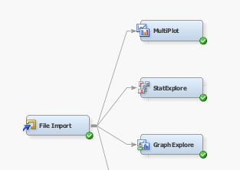

File import node was used to import excel file data set from the main foler of project.

The following is extracted from the Stat Explore node’s Results window:

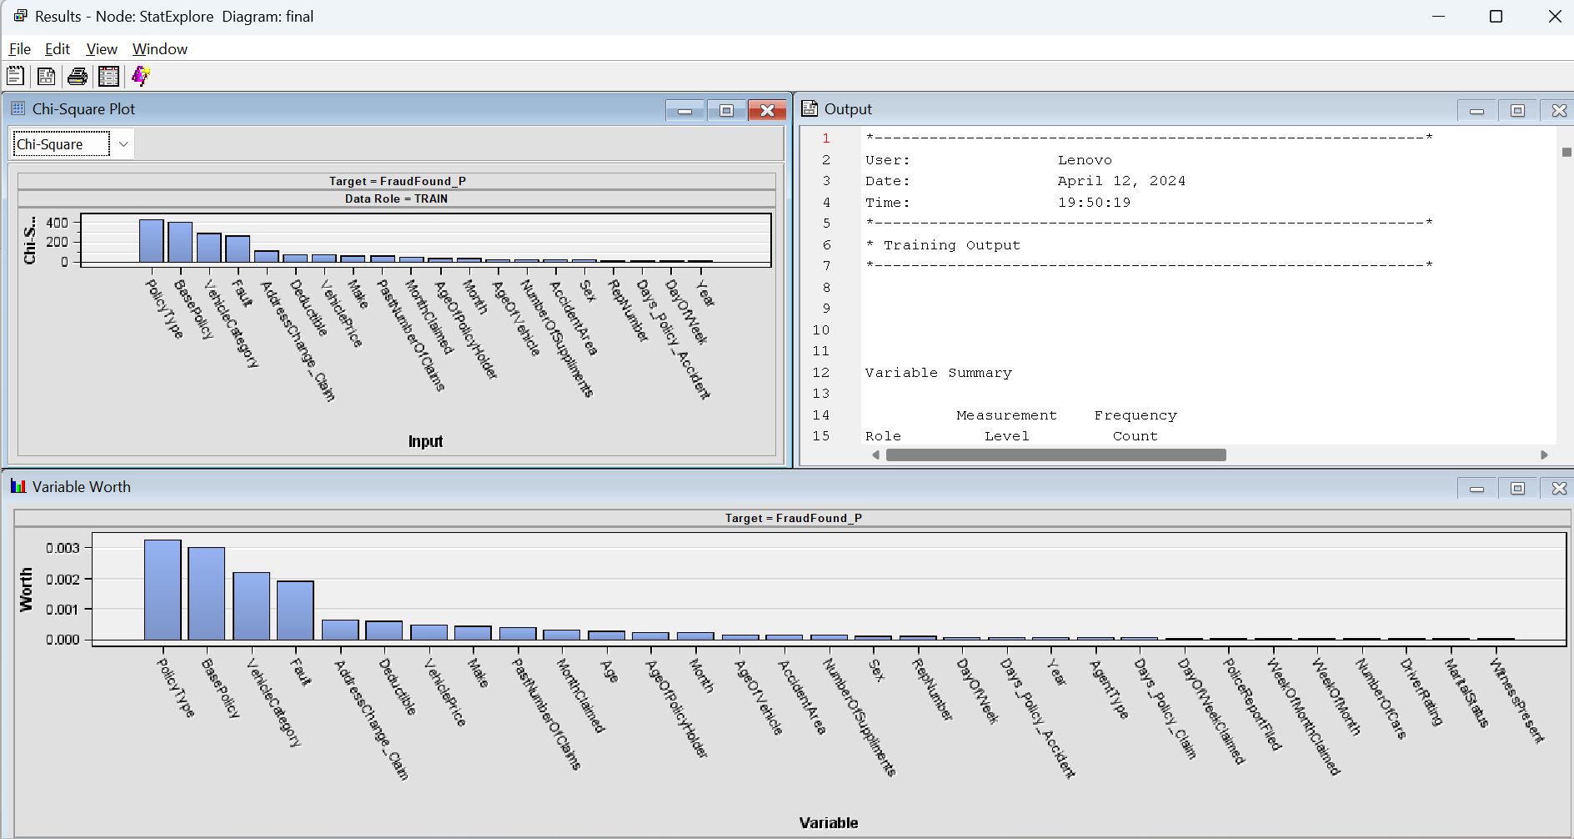

Highest variable worth means selected input variables which has maximum correlation or influence on our selected target variable i.e. Fraud_Found_P.

Here top 3 worth variables for our fraud target variables are:
- Policy Type – with 8 degrees of freedom (mode1: “sedan-policy”, mode2: “sedan-collision”)
- Base Policy – with 3 degrees of freedom (mode1: “collision”, mode2: “liability”)
- Vehicle Category – with 3 degrees of freedom (mode1: “Sedan”, mode2: “Sport”)

Let’s take one more variable next in worthiness since Policy type is like a combination of next two Base Policy and Vehicle Category.

- Fault – with 2 degrees of freedom (policy holder and third party)
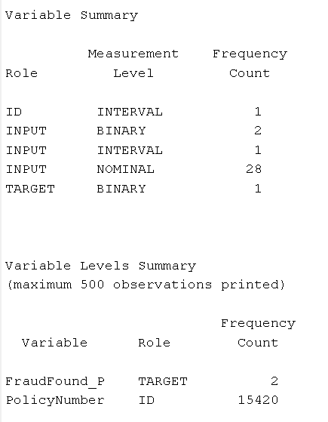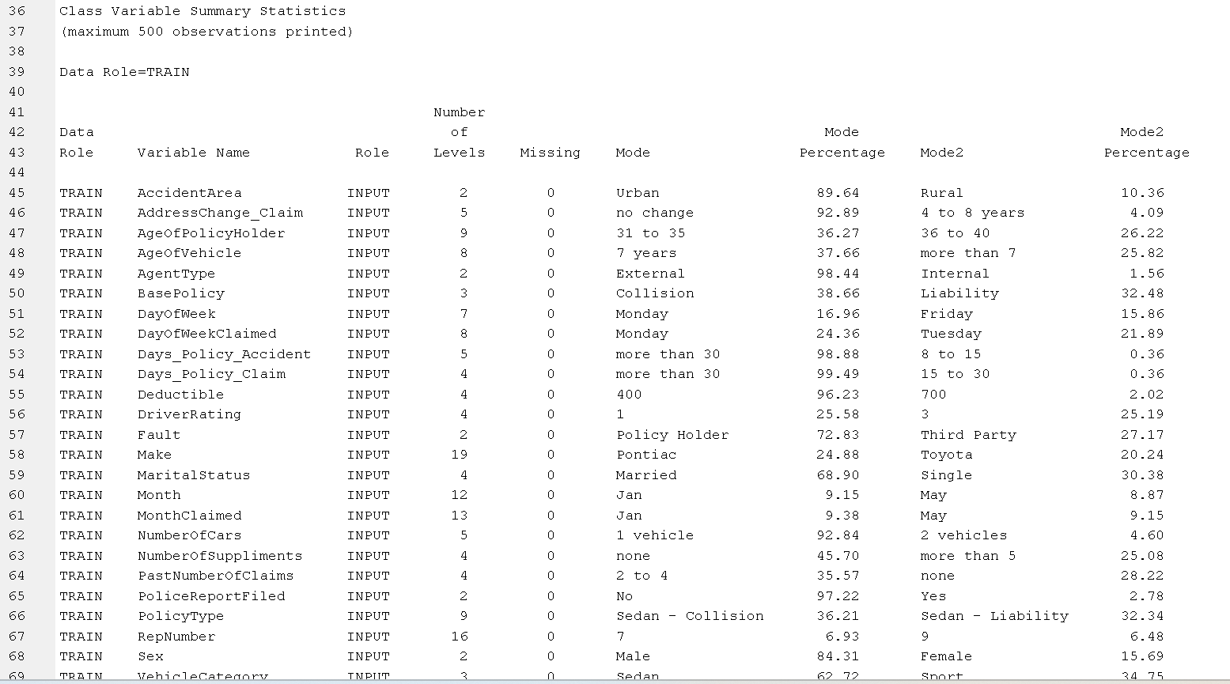

The data set has no missing values for all variables. It has more numbers of categorical variables such as AgeofPolicyHolder, BasePolicy, Days_Policy_Claim etc. some of which are seen to have high var worth.

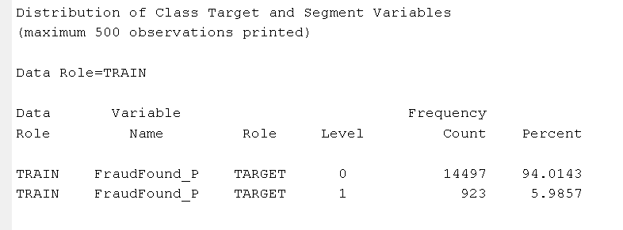
Only 5.99 % of the target values are ones, making value of 1 a rare event.
Standard practice in this situation is to separately sample the zeros and ones. The Sample tool, used below, enables us to create a stratified sample in SAS Enterprise Miner.
The following is extracted from Multiplot node’s Results window:

It shows bar charts for all individual variable’s level/intervals and distribution of target variable 0/1 for each interval/bin categories.

For example, we take for top 3 unique worthy variables:

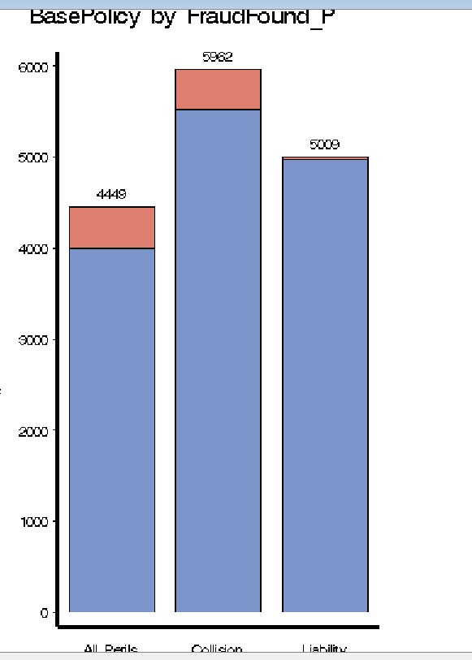

Liability has the least positive cases from other categories of Base Policy such as Collision and All Perils. These 2 categories have fair number of positives from total cases under them considering the overall dataset has Fraud_Found_P with only 6% positives.

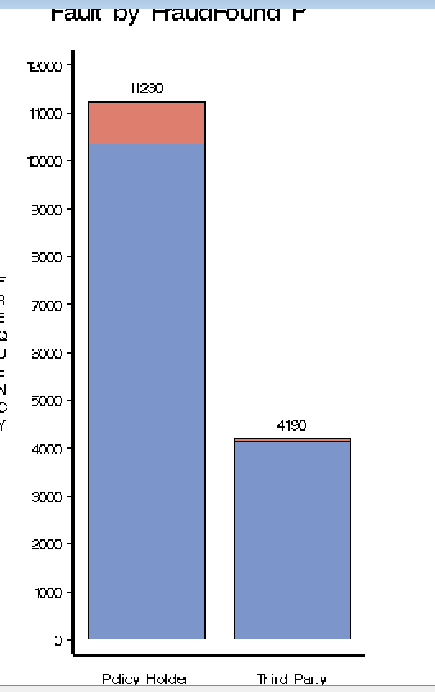
Here there are two major observations- Most cases are skewed towards Policy holder category in this variable. Also, Third Party category has overall less no of total cases by huge margin and less positive cases compared to 6% data average. While % of positives are somewhat fair distributed in the region of 6%.

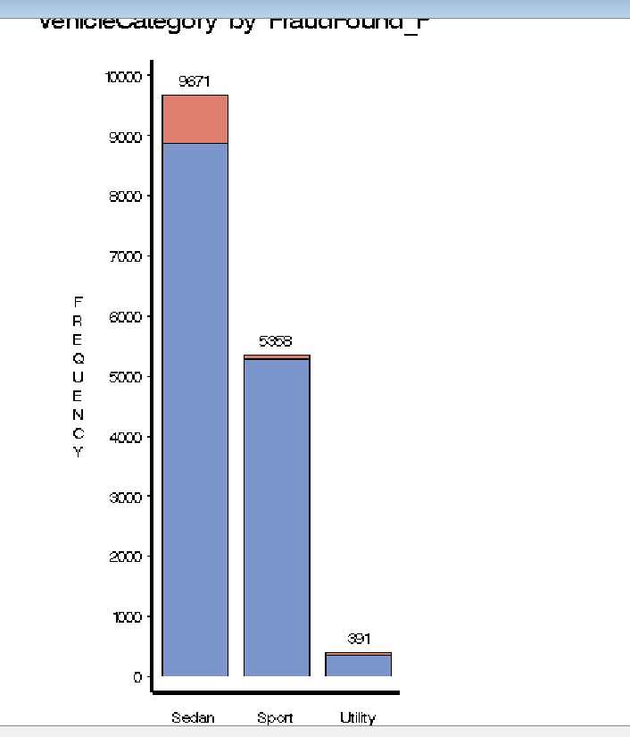

Skewed heavily with maximum datapoints for sedan which has high % of positives also, followed by Sport category with less than average % of positives and very a smaller number of utility vehicles in the claim again with very few positives (lesser than 6% average).

Note: Here we have skipped Policy Type which is a combination of Base Policy and Vehicle category.

The following is extracted from the Graph Explore node’s Results window:

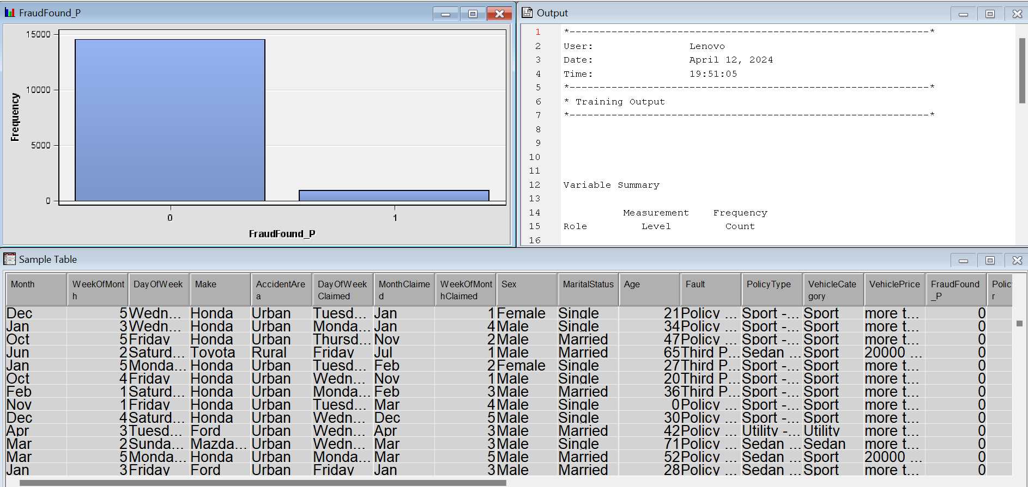
The Explore window from edit variable at file import node was used to study:

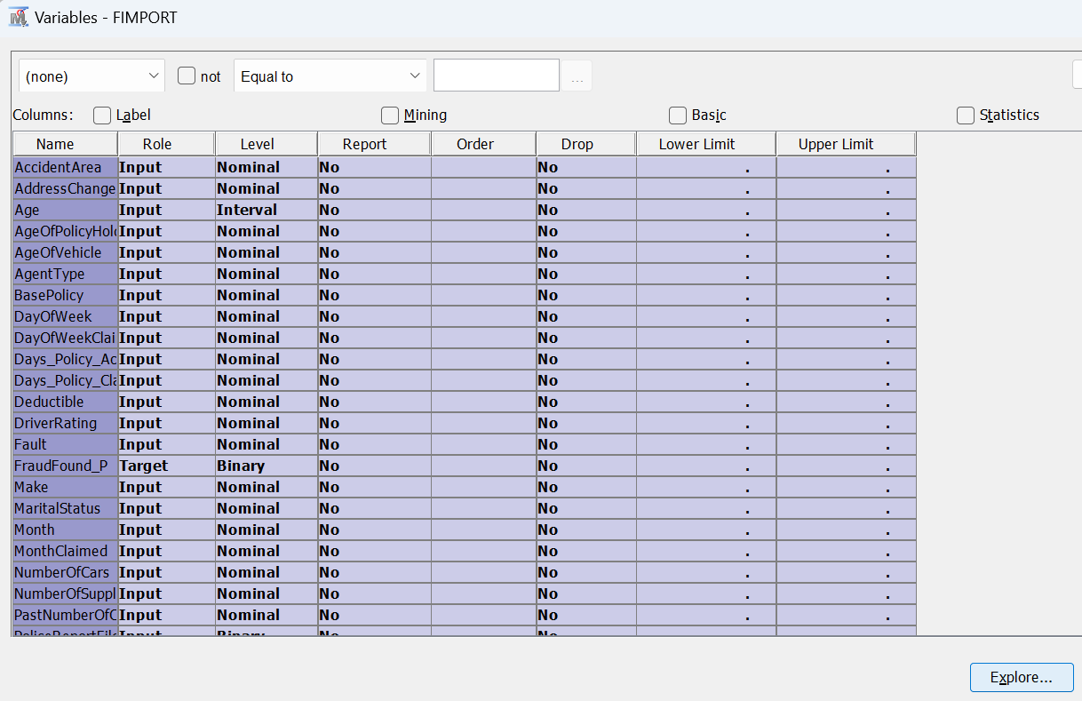

Graphical presentation:

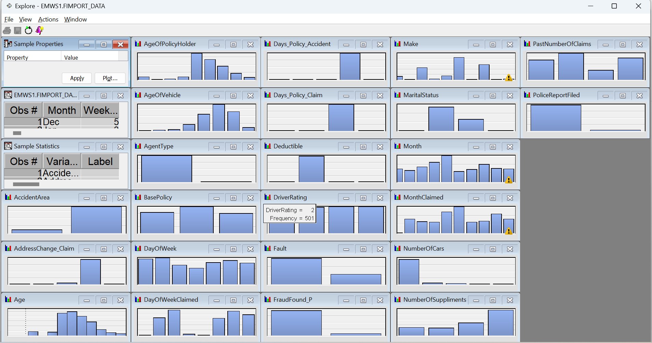

The apparent skewness of all inputs suggests that some transformations might be needed for regression models.
Sample Stats:

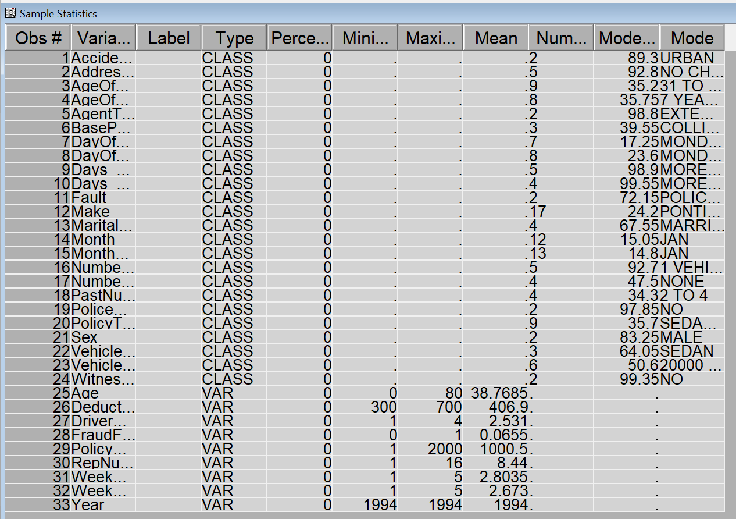

Note we now reject some variables (mostly which are transformations of interval to nominal levels) and appear as duplicate, or combination of categories taken as separate variables.

Final levels and roles taken for modelling the prediction of target Fraud_Found_P variable is as below.

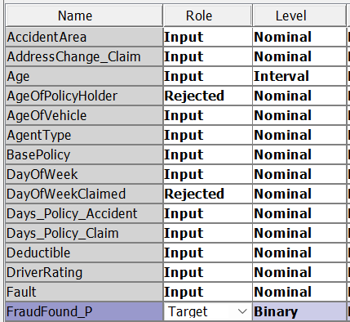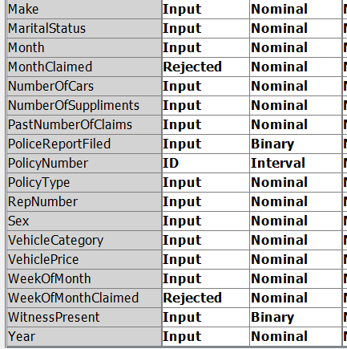

2.4 Creating training Sample:

Cases from each target level were separately sampled. All cases with the primary outcome were selected. For each primary outcome case, seven secondary outcome cases were selected. This created a training sample with a 12.5% overall fraud found rate.
The Sample tool was used to create a training sample for subsequent modeling.

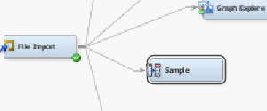

To create the sample as described, the following modifications were made to the Sample node’s Properties pane l:

1. Enter 100 as the Percentage value (in the Size property)
2. Select Criterion Level Based (in the Stratified property group)
3. Enter 12.5 as the Sample Proportion value (in the Level Based Options property group)

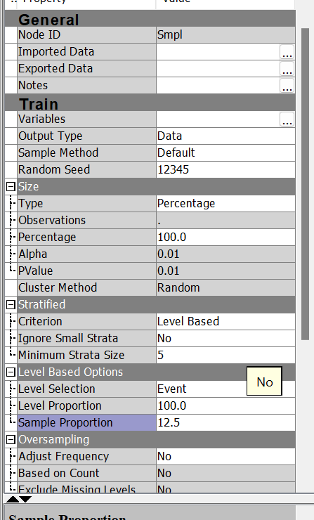

The Sample node Results window shows all primary outcome cases that are selected and enough secondary outcome cases that are selected to achieve the 12.5% primary outcome proportion:

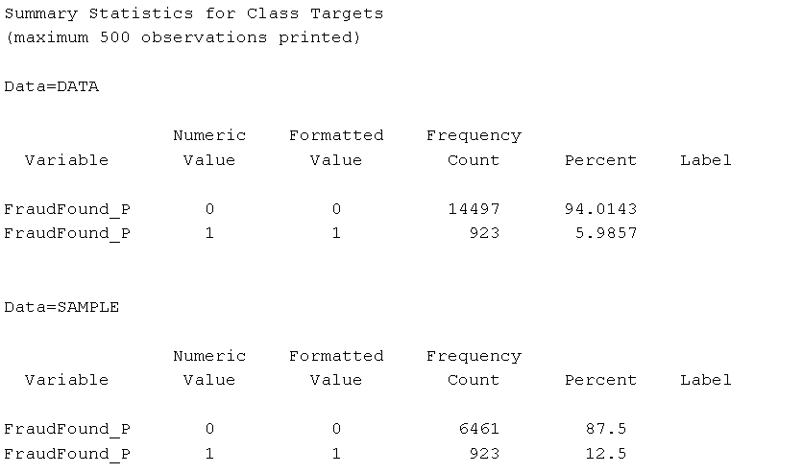

2.5 Configuring Decision Processing:

This is required to get right results from modelling prediction since we sampled the data to different positives and negatives ratio as from original data. And the prediction modelling node does not know that so we need to do the process to get right validation results.

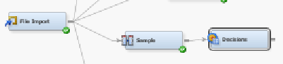

These steps were followed to configure the Decisions node:

- In the Properties panel of the Decision node, set Decisions to Custom. Then select Custom Editor and click three dots (…)

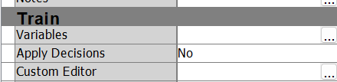
Build on target.
Click Default with Inverse Prior Weights.

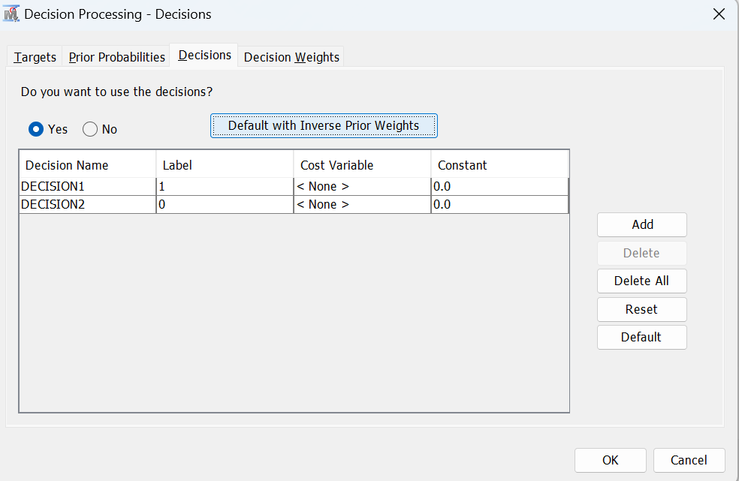

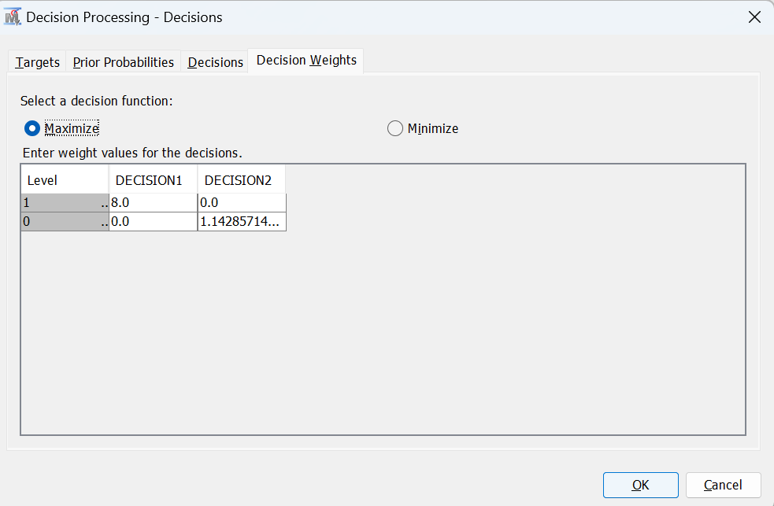

Click on OK.
2.6 Creating Prediction Model:

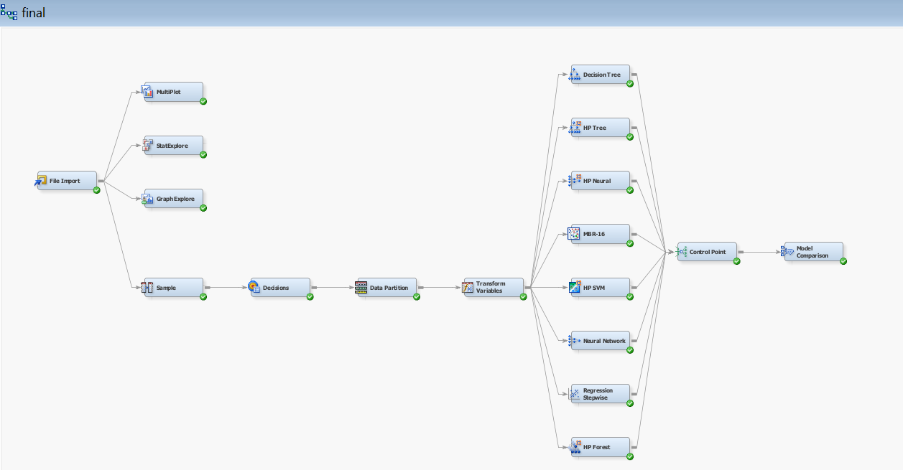

First without variable selection and using almost all type of models available:
- Decision Tree with default settings
- HP Tree
- HP Neural (3 hidden layers and 3 neurons in each hidden layer)
- MBR (16 neighbors KNN)
- HP SVM with default settings
- Neural Network (1 hidden layer and 3 neuron)
- Stepwise Logistic Regression
- HP Forest

Setting models with variable selection and different combination of models to test and reach best results.
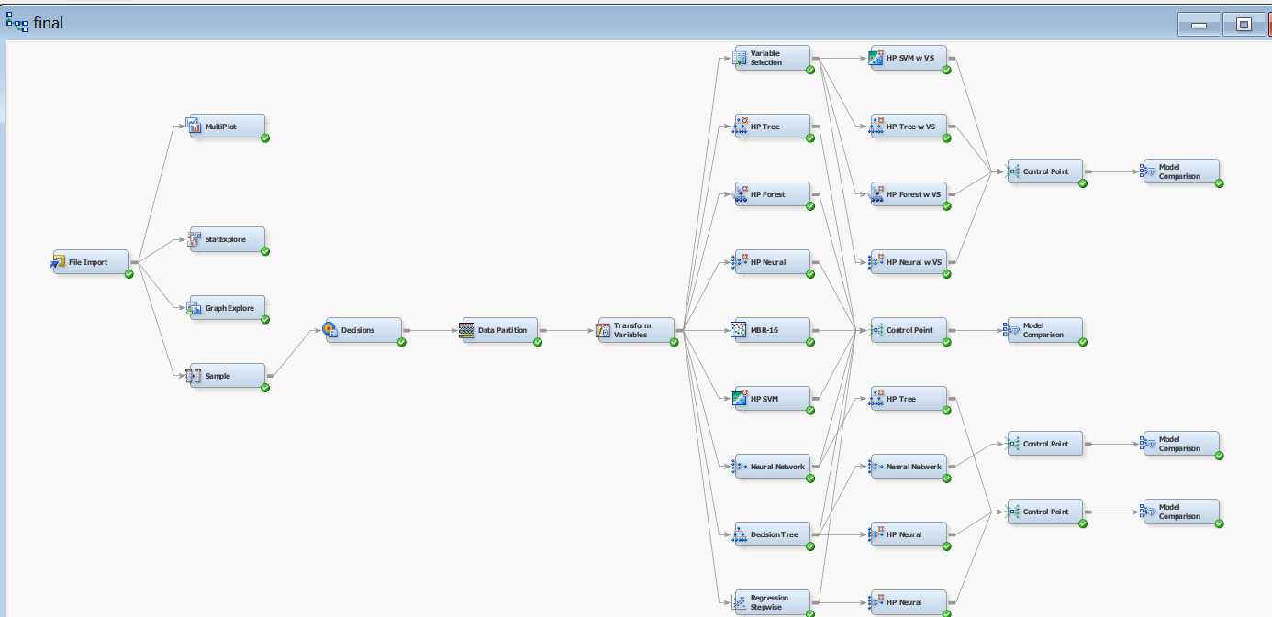
But basically, no results were obtained with variable selection models
2.6 Assessing the Prediction models:

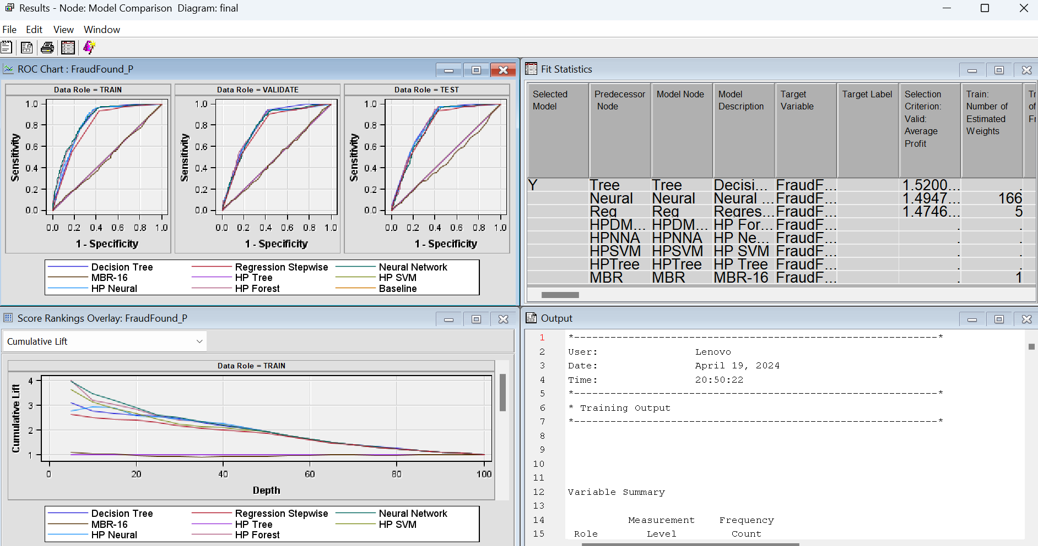

Now we assess models on ROC and Lift charts for validation set.

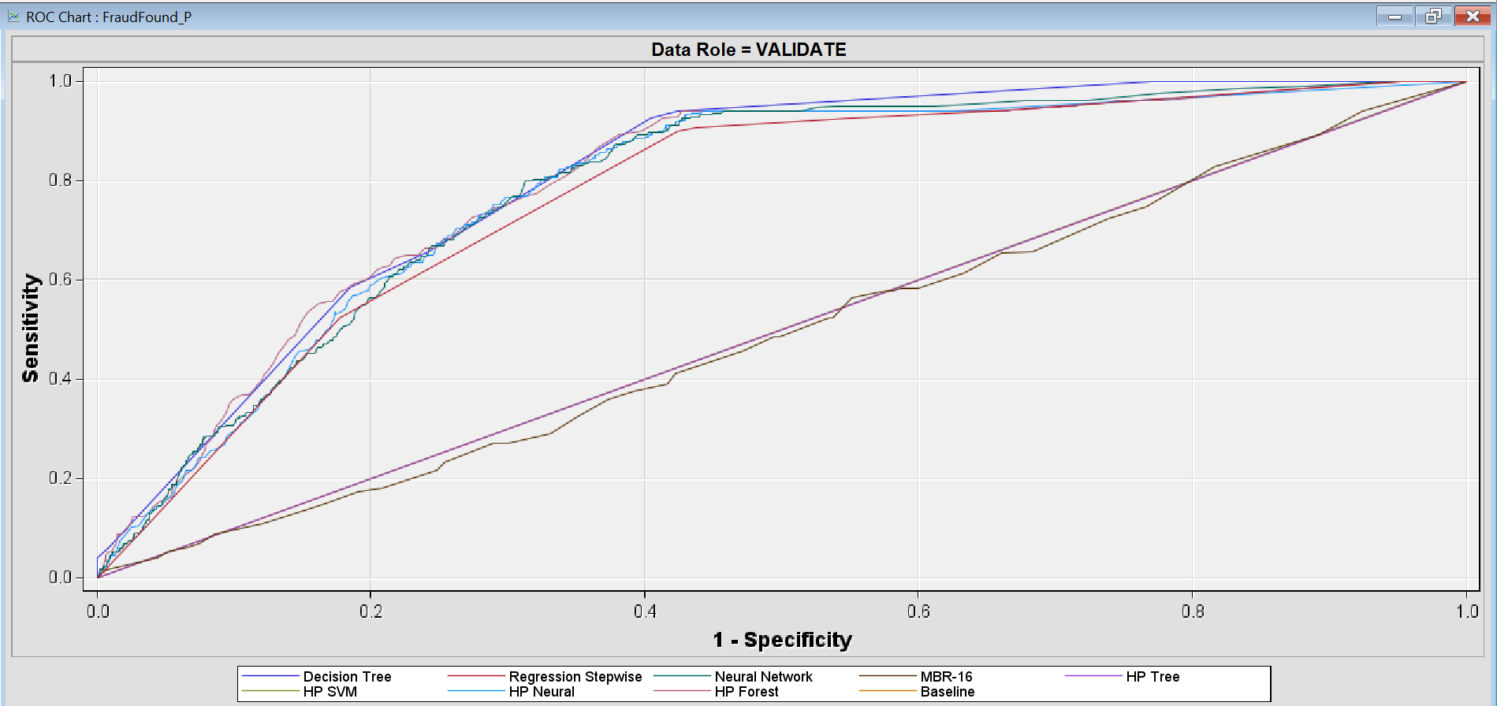

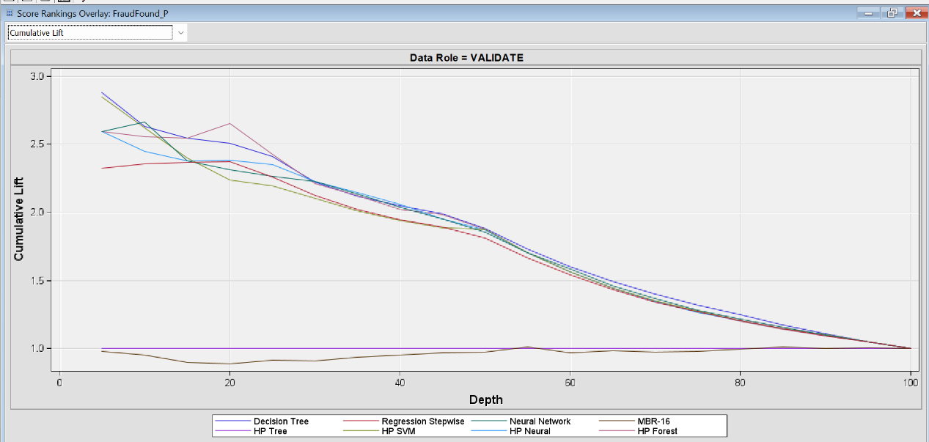

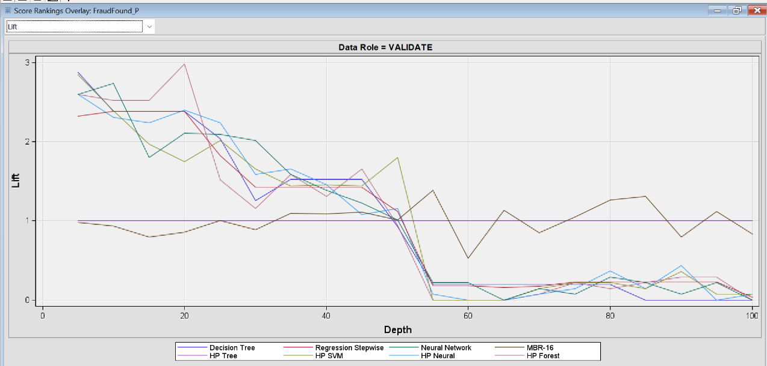

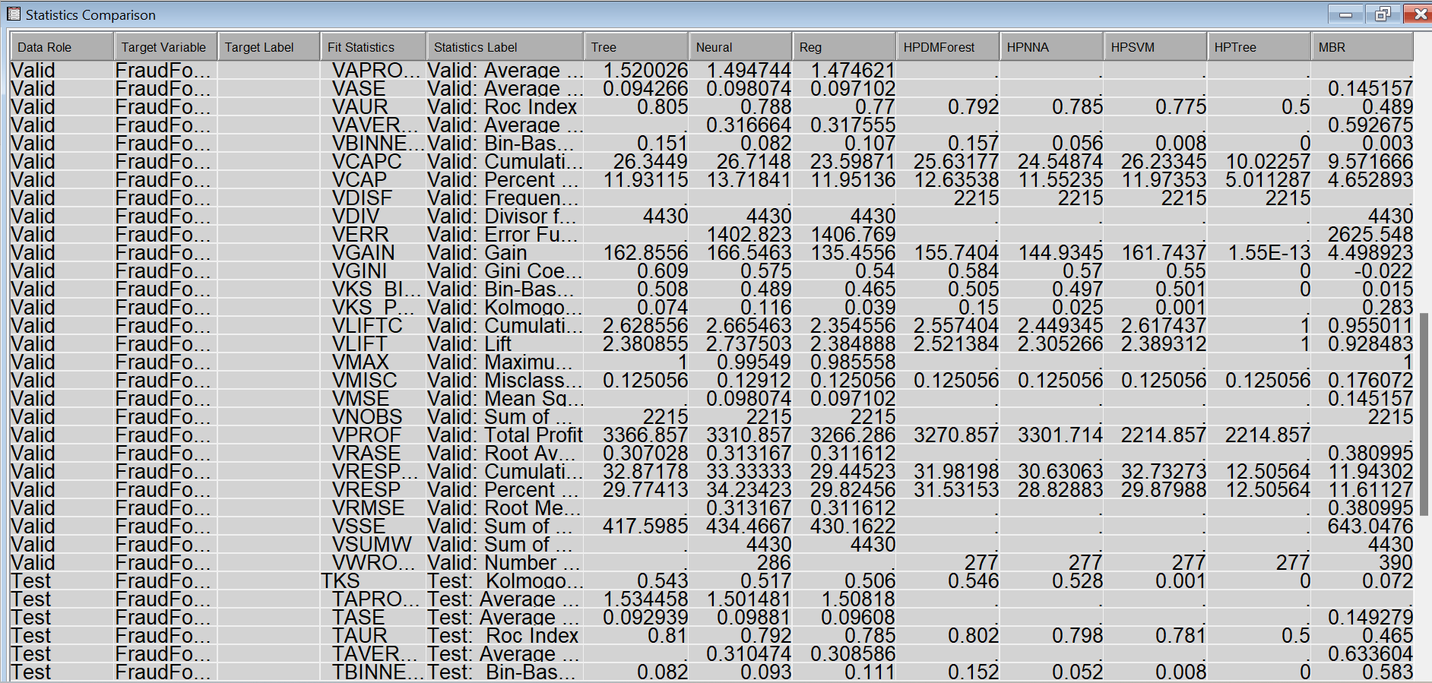
Best model with highest ROC Index and AUC is Decision Tree. Based on highest lift in first decile is also Decision tree. From maximum average profit also Decisoin tree is best for our selection criteria.

2.7 Results and Outcome:

For detecting fraud claim made the insurance company “XYZ” starts implementation of Decision tree to model its predictions of fraud cases aiding and abetting in crime reduction.

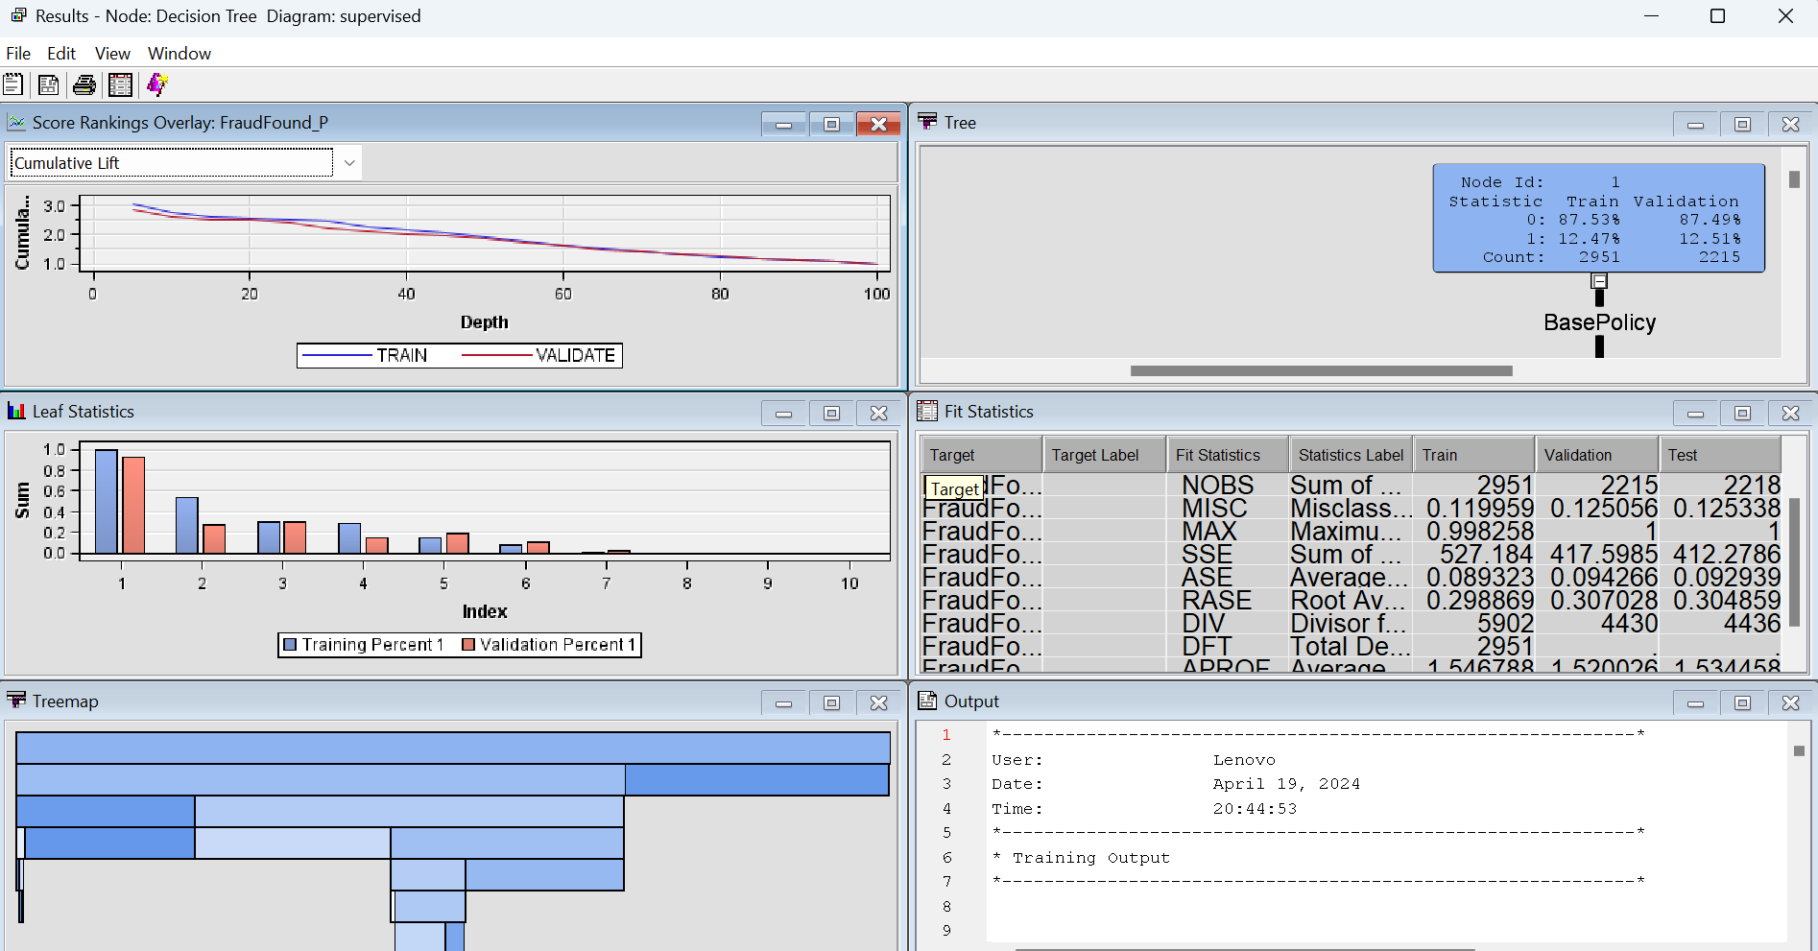

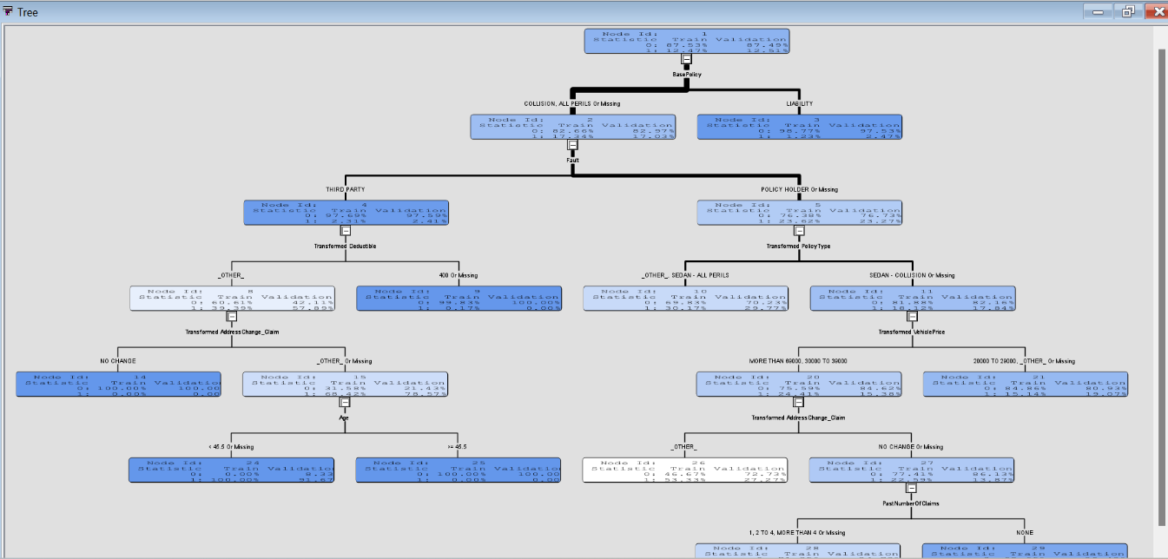
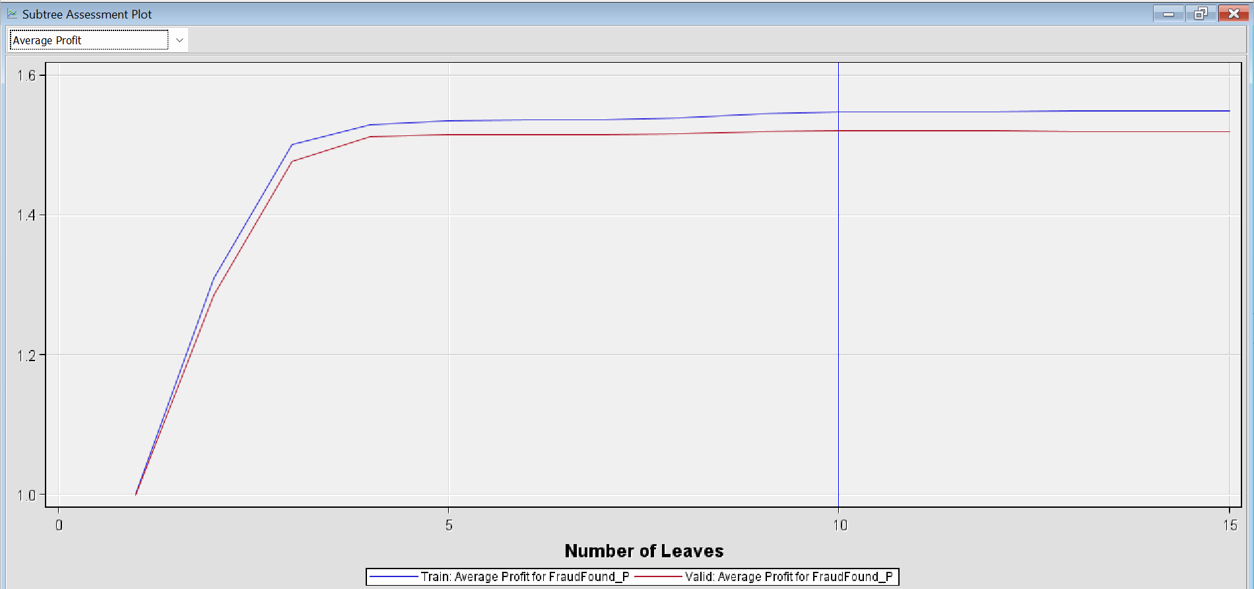

The tree provides insight into the strength of model fit. The Subtree Assessment plot shows the highest profit having 10 leaves. However, most of the predictive performance is provided by the initial splits.

The implementation of robust fraud detection measures yielded significant results for Company “XYZ”:

- Substantial reduction in fraudulent claims payouts, leading to cost savings and improved profitability.
- Enhanced accuracy in identifying suspicious claims, minimizing false positives and false negatives.
- Streamlined claims processing workflows, resulting in faster settlements for genuine claimants.
- Strengthened reputation as a trustworthy insurer committed to combating fraud and protecting policyholder interests.

2.9 Unsupervised Learning

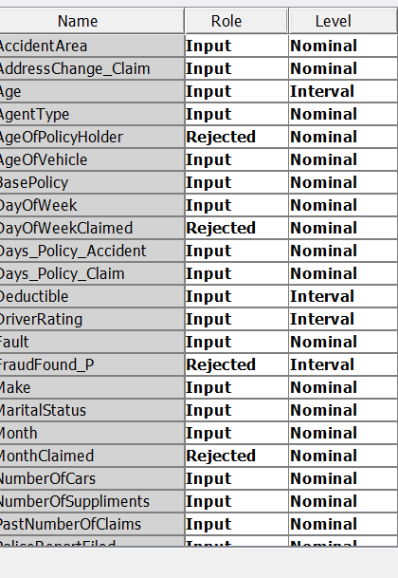

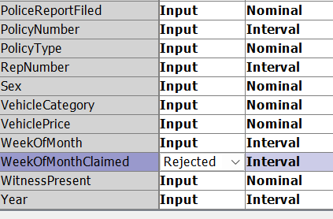

We cluster on auto mode (for number of clusters) but for each step such as:

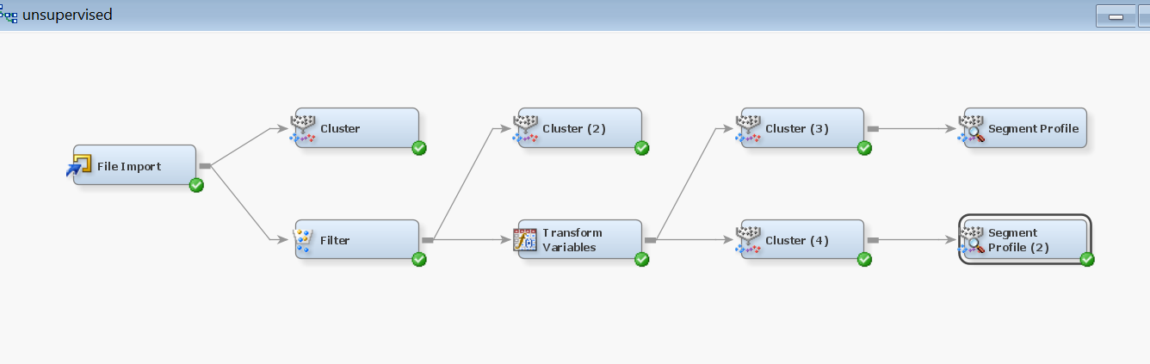

Running the Cluster node (4) which is standardized also and viewing the Results window confirmed the creation of 3 clusters with maximum observations in one cluster and few in other 2 as well which carries well with our supervised learning results since we have very few fraud cases in this dataset and which must have grouped together in one of the smaller clusters.

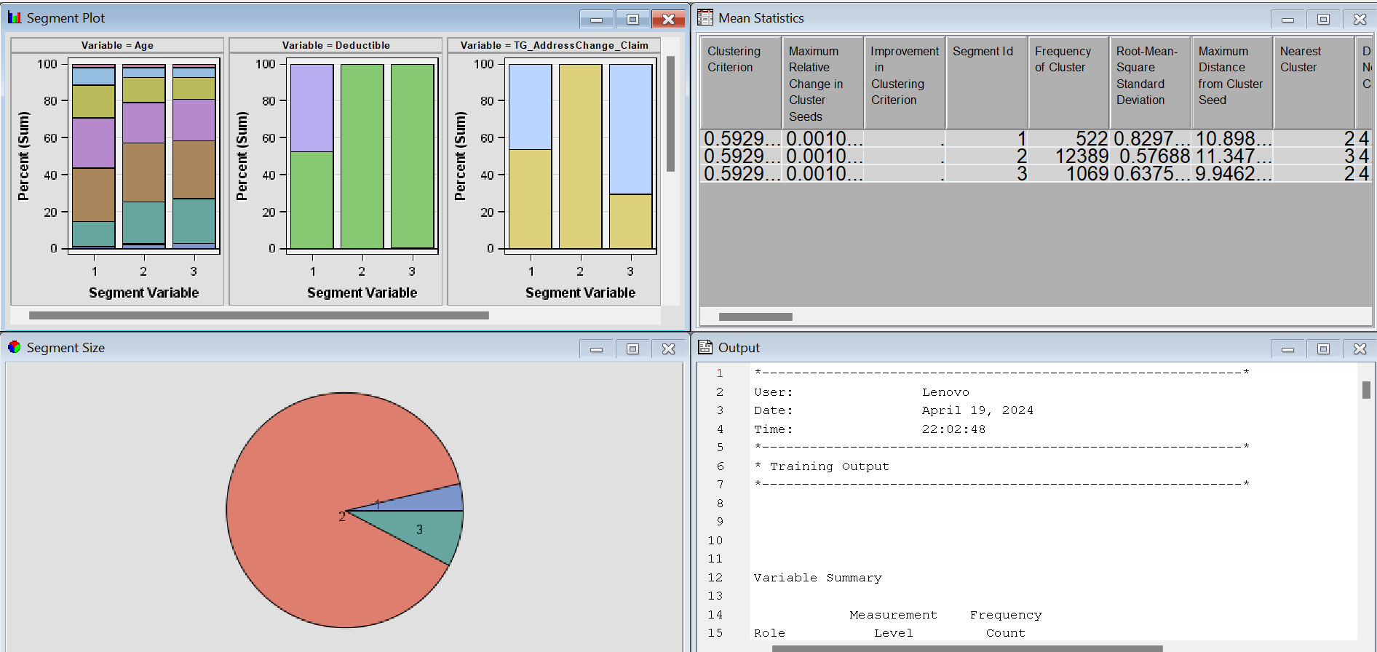

Additional cluster interpretations were made with the Segment Profile tool.

Segment Profile node attached to the Cluster node was run to helped interpret the generated segments.
Interpreting Components of Segment Profile node:

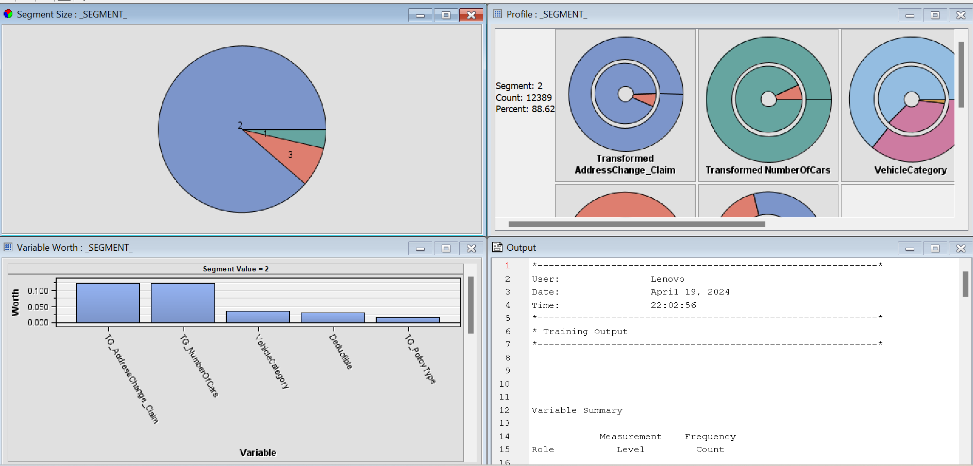

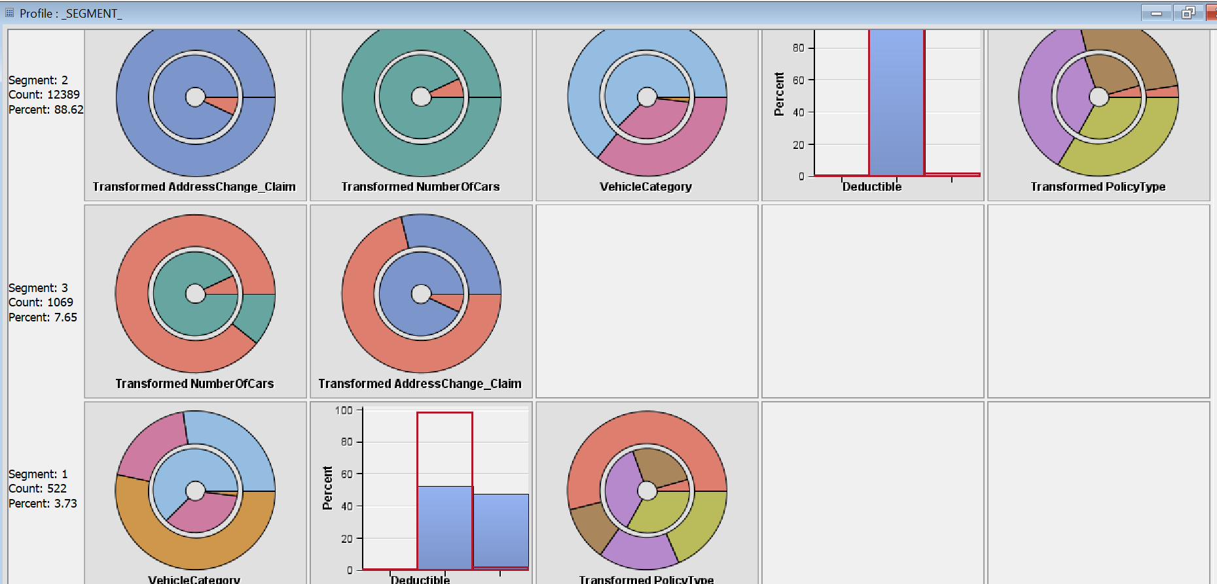

- CONCLUSION
By leveraging data analytics, machine learning, and strategic partnerships, Company XYZ successfully developed a final model to detect and mitigate car insurance claim fraud, safeguarding its financial interests and maintaining the trust of its policyholders. The paper also demonstrates the importance of proactive fraud detection measures in combating fraudulent activities within the insurance industry and serves as a blueprint for other insurers seeking to enhance their fraud prevention capabilities. The model needs to continuously be tested on fed data in same format weekly or monthly to keep training the models on regular basis improving its efficiency and relevance to updated database and detect fraud cases on real time basis at lower costs. There still might be some scope of unsupervised learning binning, segmentation, clustering, etc. and different structure of decision trees with depth of leaf, number of bifurcation from each node, not explored in this study which may be deemed possible in scenarios / data points collected in different environment over different sets of time and may be limited to the same.

The company may also choose to leverage the decisions tab to change its ratio of prior positives to mimic an overall better model which balances false positives and false negatives number to convert higher F1 value.
REFERENCES
Book
John D. Kelleher, et al., 2015. Fundamentals of Machine Learning for Predictive Data Analytics: Algorithms, Worked Examples, and Case Studies. The MIT Press, 314 Main Street Cambridge, MA 02142 USA.

Journal or Article

Imane Sadgali, et al., 2019. Performance of machine learning techniques in the detection of financial frauds, Procedia Computer Science, Volume 148(2019), pp45-54.

Conference paper or contributed volume

Sharmila Subudhi and Suvasini Panigrahi, 2018. Effect of Class Imbalanceness in Detecting Automobile Insurance Fraud, 2nd International Conference on Data Science and Business Analytics (ICDSBA) Changsha, China.

Tessy Badriyah, et al. 2018. Nearest Neighbour and Statistics Method based for Detecting Fraud in Auto Insurance, International Conference on Applied Engineering (ICAE) Batam, Indonesia.

