ABOUT ROBOTS AND AUTOMATONS

The word robot comes from a theatre play that showed some humanoid machines. According to 列子 (LieZi) in the 10th century B.C. Yan Shi made an humanoid that could move like we do. According to the roman legends, the God Vulcan created mechanical machines that could talk. The greek has stories about Talos, that was built with bronze to protect their city. It is one of the best well known tradition that the jewish has a mythological automaton called “Golem”.

There is something that inspire humans and keeps us dreaming about animated creatures that will do our work and help us to explore other worlds. We have all been exposed to different movies and “crazy” ideas about what robots are going to do.

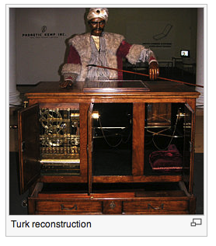
But the future is here and now. Somewhere in the year 1770 there are several documents about the first robot that could play chess. It resembles a huge calculator with a manequen on top, but it is not so important how clumsy was it or how other fantasy stories have been told about automaton. The key point to remember is that in 1996 the Chess World Champion Kasparov barely won to the computer artificial intelligence Deep Blue. The designers at IBM updated the self-learning machine and in 1997 the world saw the first time a machine that could do something better than the best of us.

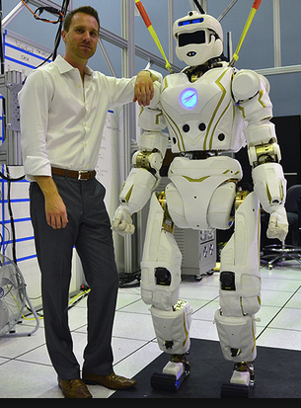
A big jump awaits for us about how we will interact with robots in the future. We can see the president of USA playing with ASIMO with a ball. Or we can watch Valkyrie from NASA introduced as te new Mars pioneer. But if we look closely, you will find that robots bake your bread, open doors and sweep your floor everyday!

As we are more familiar with humans, we will be borrowing concepts from biology to illustrate how a robot is composed. For a robot to move, it needs some sort of muscles. And they work in a structure that what a skeleton is to us. That in a whole should be the mechanical component of a robot. All of us is also familiar with our nerves, that ends up somehow in the brain. This in a robot is replaced by the electronics. And finally we can identify the way that we behave, the orders we give to our body in what we call control.
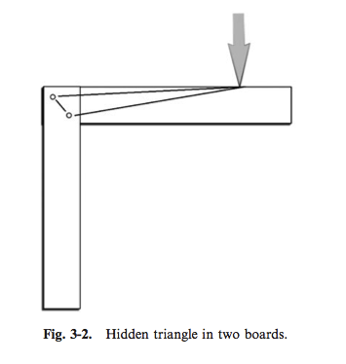

In any robot you will see, as in humans, a skeleton. An excellent approach to decide how to build up a robot is to analyze each part as a set of triangles. No matter if it's a square or a very long shape, a force applied to it will be decomposed in triangles.

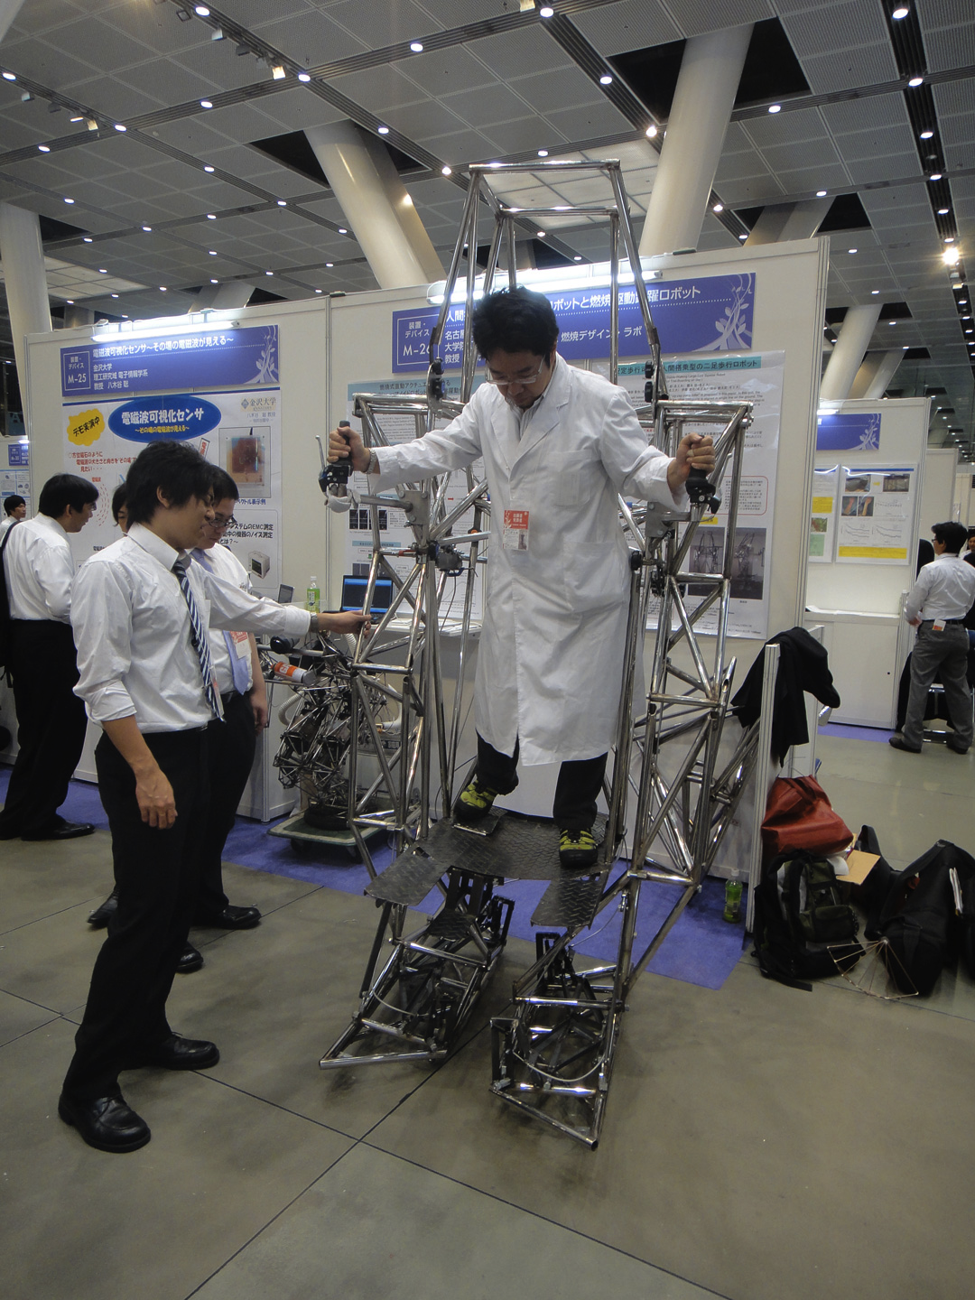
As a general rule, you always want your skeleton to be stable. So all you need is to compensate triangles with triangles. And one triangle pulling in one direction will not be compensated by a contrary force in other direction than exactly the opposite.

This is the same that holds up antennas, buildings or bicycles. If you pay attention, all they have are actually triangles!

The resultant stable structure will have a center of gravity (C.o.G.) , that you want to keep in the center. And for the time being, as close as the floor as possible. In regular small robots, the key factor for the C.o.G. are the batteries due to their heavier weight.

So, here we get to some general rules about what we need to follow to assemble stable wheel based robots that will be easy to program:

- keep in mind that weight force gets distributed whatever structure it supports it. If you see it as a mathematical thing, there are tiny triangles everywhere that will decompose those tensions. So you need to equilibrate the triangles.
- don´t forget to ask constantly where is the gravitational center of your robot. A quick tip, by the way: batteries are usually the heaviest component
- both wheels should be aligned both in height and position, so then programming becomes easier
- use one or two caster wheels because you move freely in any direction

SUGGESTED QUESTIONS FOR THE USE IN CLASSROOM
- which robots do you know ?
- are all autonomous ?
- which parts do they have ?

Watch these two videos of the most advanced robots being used today and answer:
http://v.youku.com/v_show/id_XMjQ3OTc2NzQw.html
http://v.youku.com/v_show/id_XNTgyMzU2MDc2.html
- where are the motors ?
- what power source does it have ?
- where is the C.o.G. ? is it static ?

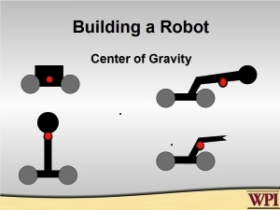

Analyze the following four figures at the left and decide which ones could make a good robot skeleton according to their C.o.G. ( detailed answers and other materials to study at http://simplerobotics.org/Center_of_Gravity.htm )

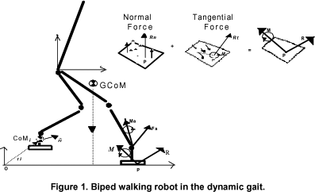
Analyze what scientist call “dynamic gaist movement” in order to allow a biped move. Tip: how many movements do YOU need in order to make one complete step ?

ADDITIONAL MATERIAL

Watch a video of the explanation of sensors and actuators of last robot used in the NASA:
http://v.youku.com/v_show/id_XNjQ2OTAzMTk2.html

Take a look at how complicated it gets when you want to optimize a biped walking robot:
http://gaips.inesc-id.pt/~fmelo/Papers/TAROS10FNAC.pdf

See details of classification of robots and their parts:
http://www.mind.ilstu.edu/curriculum/medical_robotics/parts_of_robots.php

Watch a video of one of the top scientist explaining what sci-fi robot could do:
http://curiosity.discovery.com/question/basic-components-of-a-robot

multiplo is an Open Source Robotic Platform. It helps to design and build prototypes and provides the tools for educators to awake the interest in science. Let us know how you are using it!

