OBJECTIVES:
Download new software to the robot. Get familiar with actuators in a robot: LEDs, SPEAKER and MOTORS.

MATERIALS:
Any multiplo robot kit and a computer. At least, each participant should count with the following:

Duinobot
Battery case
(2) DC motors
(2) Red cables
(2) Wheels with tires
USB cable
Computer running Ardublock, Minibloq or Arduino

TIME:
45 minutes to 1 hour.

INSTRUCTIONS:
According to which platform has been chosen, the proper setup on the computer should be done in order to use it's drivers on the operative system. You can choose in Arduino IDE or MiniBloq IDE the proper board under Tools/Boards. Your board number is laser engraved in the case.

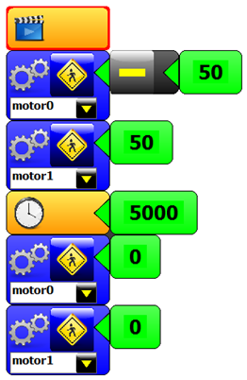
Using the USB cable, you will be programming sequences that increase in complexity the actions. We attach some basic blocks in Minibloq but you can use any other IDE as well. You can find different Code Examples inside of the folder “ EXAMPLES ”.

Our recommended order would be:
LED ON + DELAY + LED OFF
SPEAKER
MOTOR
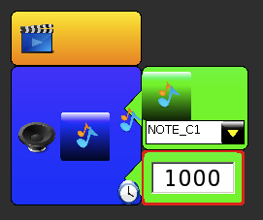
MOTOR + DELAY + MOTOR

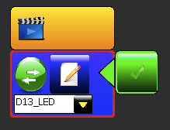

TIPS:
Long installation time of softwares and drivers, it is recommended that the instructor verifies that each board / computer is working.
The most common version of Duinobot up to 2014 is the HID version. Please pay attention that it doesn't show a communication port neither in Control Panel or System Preferences.
Setting up a challenge like go in circles, an eight figure or draw a square helps participants to understand the concepts.

