INSIDE OF A ROBOT: SENSORS AND EFFECTORS

Let's talk first about the muscles and how this can be implemented easily. There are several kind of “robot muscles”, like the air pumped, hydraulic or others. But let's focus in the ones moved by electricity. Ones that are quite easy to approach are the ones called “Direct Current Motors”, that is the fancy way to call something that you already know. Most of toys have these D.C. Geared Motors.

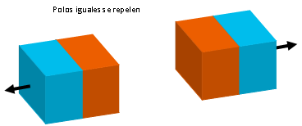
Inside of the motors there are magnets. Through a cable attached to it you can make current flow into it. The current flowing creates magnetic field that makes the motor spin really fast. They have attached a gearbox that reduces by a ratio according to your desired speed. Easy, right ?

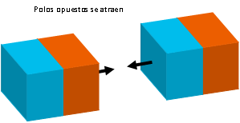
If in the inverse sense, the motor spins, it will force magnets to produce an electrical field that will be induced into the cable attached to them. So, if a motor is forced to spin, it is not a motor anymore... it is a generator !

You don't need to believe me, just attach two motors and see the result. What you are seeing is one motor behaving as a motor and the other as a generator. And if you change the sense of rotation of the generator, the motor inverses it's direction as well. As faster you generate current, the motor goes faster. This gives us some conclusions about how they work!

So, without knowing it, we already learned about effectors. That is simply put, the outputs a robot has. We were talking about muscles before and there you have them, in the motors.

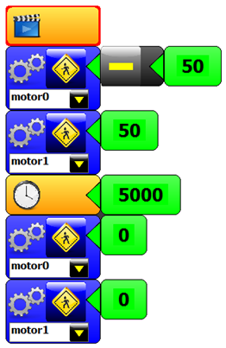


We already saw that a robot needs a structure, electronics and a brain. That brain can be seen as a control that will be applied locally and it will take decisions. In the most advanced systems with artificial intelligence, playing chess or recognizing a dangerous element in another planet.

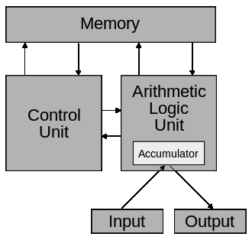
See the picture of the famous toy Robosapien. His creator was one of the founder of these robot concepts called BEAM.

But how does this work, it´s a different topic. We will see in detail how a computer works, because we can use that approach in order to see how to control a robot. We all know computers and we know that there is software inside of them, somewhere, but the specifics are somehow tricky.

We all have memory about things, we remember things. So may be that's the most intuitive part from a robot brain. But when you see that it has inputs and outputs, how do things get done there ? There are two other parts that execute the orders in the memory and also can make mathematical operations.

And this is all terrific but how does this work in my robot brain ? How do I get it to do the things I want? Using simple blocks, we will create different softwares that will go directly to the robot memory. We will use a laptop computer for this. And through the USB cable we will put in the robot memory our program. And... Voilá! Your robot will be running your program.

In the software Minibloq, the gear block will represent the motor. Once you select something, anything in red should be filled in. So remember to fill in the motor number you want to move and then the # icon will allow you to input a number. Put a number as 50 to start with.

If you want to allow that once that you assigned a speed, the robot will execute that order for so many milliseconds, you have a clock icon in order to wait.

Remember to press the green icon in Minibloq in order to upload your new software. And if you disconnect the computer, press the button RUN to execute the program from the robot memory.

Anybody can guess that the number setting for a motor indicates speed. But not everybody know how a robot brain can adjust the speed of a motor. This is done with a technique called Pulse Width Modulation (P.W.M.)
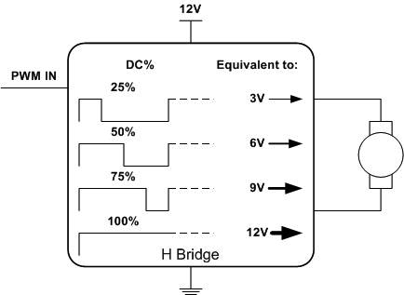
If you pay attention carefully, you will see that our robot has many outputs. And we just saw that when selecting MOTOR0 in the software, will make the motor connected to M0 to move. This is cool but now we are also seeing that changing speed variable also changes the speed.

One way of seeing this is thinking as a signal coming out of the brain. The “stronger” the signal is, the faster your motor will move.

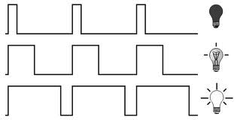
But everybody knows that robots only see 0's and 1's. Because that is the digital way that thinks work. How could we possibly send a “stronger signal if we only are robots. We can only say no or yes, open the valve or close it. Nobody taught a robot yet how to think in terms of send a “half of your signal”. There are some of this creations now getting more popular, but it is something that we only read in magazines. Like when people talk about the “quantic computers”.

The way it works is that it will be, indeed, is like a switch. ON or OFF. Nothing else. But it will be doing it many times per second and showing this way an average of it's output. More time in the ON position means faster. And the shorter it is, the slower speed the motor will turn. You will even find that with very low values ( try 10 or 20 ), the signal is not even strong enough to move the motor.

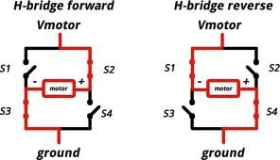
Now we are capable of understanding what will be happening with the current going through the motor, it is also important to understand that the motor can also be commanded to go forward and backwards. Because our brain has many outputs but they are all switches. So we need to be able to make the current flow in both directions only with switches.

See the diagram to the left, where S2 and S3 are closed, the motor will move in one direction. But if S1 and S4 are closed, the motor will go in another direction. This configuration is called H bridge and is one of the basic strategies to move DC motors. Even the ones a bit bigger, like in the electrical vehicles have something quite similar to this.

Now your robot can move in any direction and at any speed. That's an improvement!

SUGGESTED QUESTIONS FOR THE USE IN CLASSROOM

How would you set up the motor speed in order to make a circle ?

What do the LEDs on the board indicate when the robot is moving ? Why?

What happens if you connect your motors on the opposite way ? Try switching M0 by M1. What happened ? Why ?

ADDITIONAL MATERIAL

Read about classifications of robots according to the way they move:
http://www.robotshop.com/blog/en/how-to-make-a-robot-lesson-2-choosing-a-robotic-platform-2-3706

Read about different kind of motors:
http://www.robotplatform.com/knowledge/actuators/dc_motors.html

Read about RC-5, infrared communication protocol:
http://en.wikipedia.org/wiki/RC-5

Read about the infrared sensor TSOP4038 that is inside of Multiplo Infrared Sensor:
http://www.vishay.com/docs/81926/tsop4038.pdf

There are other kind of robot brains, designed in the BEAM principle:
http://en.wikipedia.org/wiki/BEAM_robotics

Know Mark Tilden, one of the current best roboticist worldwide and :
http://www.robotspodcast.com/podcast/2012/09/robots-beam-robotics/#transcript

Read about the Von Neumann Structure, the almost sole structure for computer hardware existent in
the world. All computers work with this:
http://en.wikipedia.org/wiki/Von_Neumann_architecture

Read an introduction to Pulse Width Modulation and DC motors: http://www.allaboutcircuits.com/vol_3/chpt_11/1.html

See what is inside of one common H bridge motor controller. Where are the switchs ?
http://arduino.cc/documents/datasheets/L293D.pdf

multiplo is an Open Source Robotic Platform. It helps to design and build prototypes and provides the tools for educators to awake the interest in science. Let us know how you are using it!

