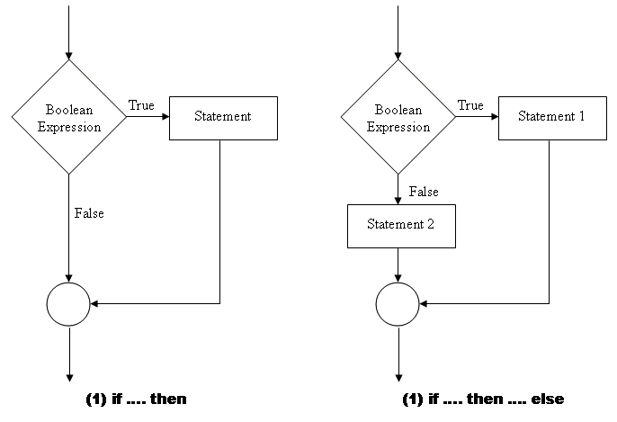

ABOUT ROBOT SOFTWARE

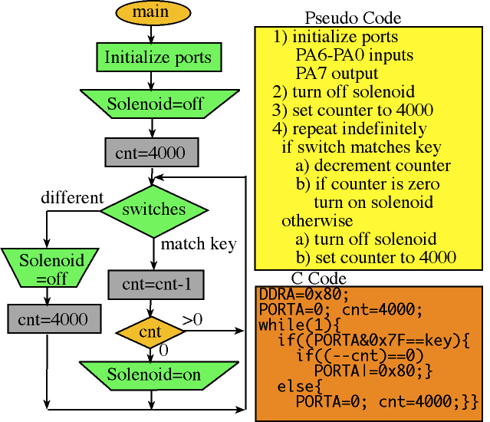
Now that we understand what a motor is, how it works for the robot and also that the robot has a memory that we can program... Let's program it! But.. wait a second, what is a program ? How can we put instructions in a robot? We think like humans but if we want the robot to understand us, we might need to think as robots!

Even for the simplest tasks, humans make simplifications, conclusions, assumptions. But robots are very different in this sense. They will execute instructions in the order given by their memory and they will find themselves doing the most crazy thing if the program didn't anticipate it. If you don't believe me, try to figure out a set of actions that you would execute in order to make it for you.

Let's see this in detail. We put orders in our brain in a natural way, and that order could be drawn as the picture here. We do one thing, then another and at some point we check how things are going. Sounds easy!

A robot could not immediately understand this diagram. That's why we humans also use something that we call pseudocode. A set of instructions, one after another that will make us follow them in order. And what we can put in the robot program is robot instructions that can be processed by it's control unit. So the only thing that we need to make sure is that we are able to transform the pseudo-code into real machine code. One way of doing this is to write the orders in C code, while there are many languages of programming that can be used.

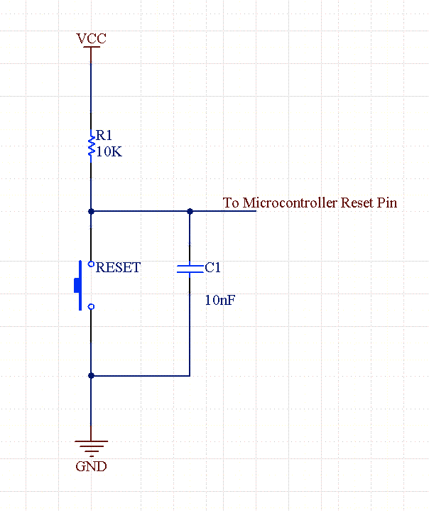
We already saw how to control outputs like motors, but what could be better than having our robot intelligently decide what actions to take ? We need the robot to sense the outside world through inputs and that is why we will be seeing in detail what a BUMPER SENSOR is.

In the picture we can see the electrical circuit of a button that when is not pressed, it will be read as a signal Vcc. That is generally the batteries, the power supply or whatever high value you have as a reference for your robot brain.

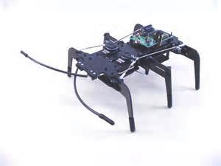
If you press the button, suddenly there is a closer signal and is called GROUND. That is the lowest value available for the robot brain. Making an LED light ON and OFF together with the button should not be a challenge by now.

But what if you see the robot as an intelligent system and it is actually changing it´s behaviour when you press the button? I think it´s more complicated to explain than to see it. We have a picture at the right showing a robotic insect. And there are two switches connected to it´s antennas. A bug that avoids obstacles would go ahead all the time but in the case that one of it´s antennas detected a wall, it would change it´s path.

SUGGESTED QUESTIONS FOR THE USE IN CLASSROOM


How to make an omellette ? Check with your classmates what could be a robot instruction set in order to make an omelette. Write the sentences of a pseudocode for these actions.

Write a simple code for making tones. Follow the instructions at http://blog.minibloq.org/p/tutorials-and-examples.html

Make a sequence of movements using the control structures WHILE and FOR

Make your own remote control piano program using the IF structure.

ADDITIONAL MATERIAL

Check these tutorials for each of the control structures using Arduino IDE for programming: http://wiki.animusoft.com/tutorials/arduino-tutorials/arduino-control-structures-tutorials/

See the “Bible” of Arduino robot programmers. Identify the control structures mentioned in this guide: http://arduino.cc/en/Reference/HomePage

multiplo is an Open Source Robotic Platform. It helps to design and build prototypes and provides the tools for educators to awake the interest in science. Let us know how you are using it!

