ABOUT ROBOT SENSORS: LDR

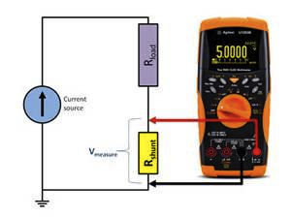
Inside of the robot brain there are many components. One of the most numerous is the resistors. We can use a tool called multimeter to measure them. The number it show us is how much resistance a component has. That unit for resistance is called ohms.

That is pretty awesome but it is a fixed value. We have seen that infrared sensors have an output that we can measure with the robot brain. That measure was the reflection of light.

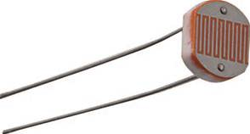
There are other components that are also resistors but they contain a special material on them. That makes them variate their value according to the input of visible light they receive. If we look at them carefully, we can see that actually both pins end up in a surface of some orange / yellow color where this magic happens.
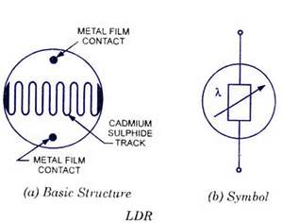

Repeating the steps we did to measure a resistor, we can actually measure light with our multimeter. The value will be again in ohms and it will indicate how big is the resistance at that level of light.

This is why we call them Light Detecting Resistors (L.D.R.)

We can use this value to make our robot follow a strong light or actually get scared and run away from it.

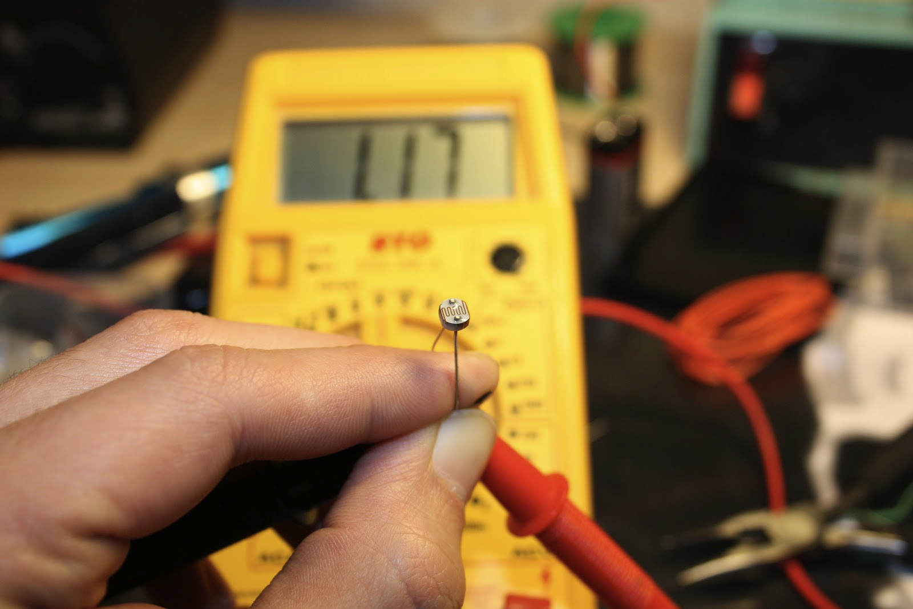

It is feasible to make a robot that follows light with only one sensor. Think about it for one second. The robot is so intelligent that memorizes the current status of the LDR sensor and then moves around comparing and choosing which path is optimal.

But if you count with two sensors and both of them are sending you their status, the software simplifies to the point that each sensor commands one motor. Let's see a diagram of that structure:

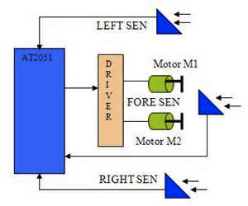

SUGGESTED QUESTIONS FOR THE USE IN CLASSROOM

Measure with a multimeter the value of resistance of your L.D.R.. What units are being measured by the multimeter ? What do they represent ?

This kind of light sensors can be used also in solar panel installations. What would their use be?

What other kind of light sensors do you know? What are their uses?

ADDITIONAL MATERIAL

Read about the light we can see and what is the total spectrum:
http://en.wikipedia.org/wiki/Visible_spectrum

Watch a video of an innovative modular robotics, where different type of sensors are used:
http://www.ehow.com/video_12328855_moss-modular-robots-anyone-can-build.html

multiplo is an Open Source Robotic Platform. It helps to design and build prototypes and provides the tools for educators to awake the interest in science. Let us know how you are using it!

