ABOUT ROBOT COMMUNICATIONS

We accept the fact that the robot can “ think “, in other terms than ourselves. And that it can decide to move or make sounds. But that would be very dumb if it cannot communicate in any way with the external world. We are going to see all around the world different machines and they have some inputs and outputs in order to interact with the world.

One of the communication protocols that are widely used is called USB. That it is a fancy way of saying that bits know how to go, one after the other, on a data line. And that you can connect all things there without a lot of explanations about how to do it. We will see that this Universal Serial Bus is nothing else than another machine communication and we will be using it as a tool to see what is going on inside of the robot brain.

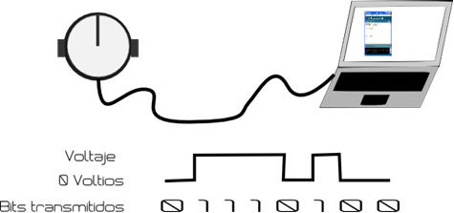
So, if we are able to see what is going on inside of the brain, we could eventually see all those 0´s and 1´s that the robot is thinking. One of the things we will notice is that the robot brain is even faster than the USB communication impletemented, so we need to wait some time between value and value.

Seeing DIGITAL inputs from the robot brain, we would be able to see ¨0¨ or ¨1¨. This is a nice try. Nevertheless, real values in real life are not always ON-OFF. Those are ANALOG values.

The way that the robot sees these values is comparing with somehing that

Each position within the byte is a power of 2. The following table represents the structure of a Byte. In the first row shows the number of each bit position, it is important to note that it starts counting from the zero position. The second row shows the power of 2 which corresponds to the position. Finally, the third row shows the result of multiplying a bit value 1 by the power of 2 in the position in which it is located.

Position 7 | Position 6 | Position 5 | Position 4 | Position 3 | Position 2 | Position 1 | Position 0
27 | 26 | 25 | 24 | 23 | 22 | 21 | 20
128 | 64 | 32 | 16 | 8 | 4 | 2 | 1

Then, the maximum value that can be expressed using a byte is:
128 + 64 + 32 + 16 + 8 + 4 +2 + 1 = 255. This is very common to see, for example, when configuring a network because the IP addresses that are used consist of 4 numbers of 8 bits, giving a total length of 32 bits for each IP address.

SUGGESTED QUESTIONS FOR THE USE IN CLASSROOM

What other kind of communications besides of USB do you know ?

How often do robots communicate in outer space ?

New robots in assembly lines have a screen with a face? Which kind of communication are they trying to achieve? To improve which interactions?

ADDITIONAL MATERIAL

Read more details about what the control structures are and how to implement them:
http://www.thevbprogrammer.com/Ch05/05-03-SelectionStructure.htm

See in detail all the things that an Arduino IDE can accept as orders:
http://arduino.cc/en/Reference/HomePage

multiplo is an Open Source Robotic Platform. It helps to design and build prototypes and provides the tools for educators to awake the interest in science. Let us know how you are using it!

