ABOUT ROBOT MOTORS
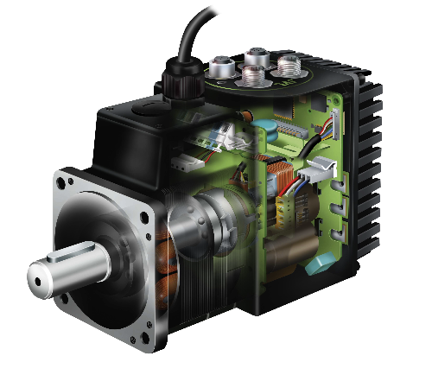
Now that we know how important are feedback loops, we can see in detail one of the most interesting devices specially designed for robotics. It is a motor. But it is a sensor. It has a motor controller and it´s own feedback loop as well. It´s a SERVOMOTOR!

Servomotors are beautiful inside, but from the perspective of robotics, the only thing you need to know is that it is an intelligent device. That means that when we were using DC motors, a quite dumb but powerful way of making something spin, we needed a motor controller. And we needed to send a signal to adjust the speed. We even saw that connecting two motors together was enough to drive them.

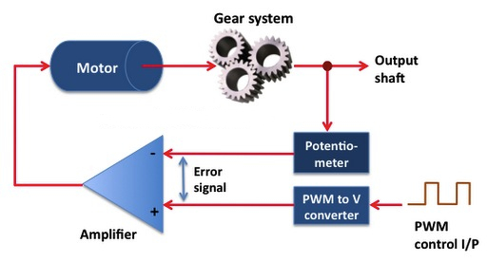
But with servo-motors, if we use power to feed it, that is not enough. Because it´s an intelligent unit and we need to instruct it with an intelligent order. A very simple way of seeing this: DC motors have only two cables to power them up, but servos have three because they need power and they need signal.

We will be sending a control signal to them, great! But.. what will we control ?

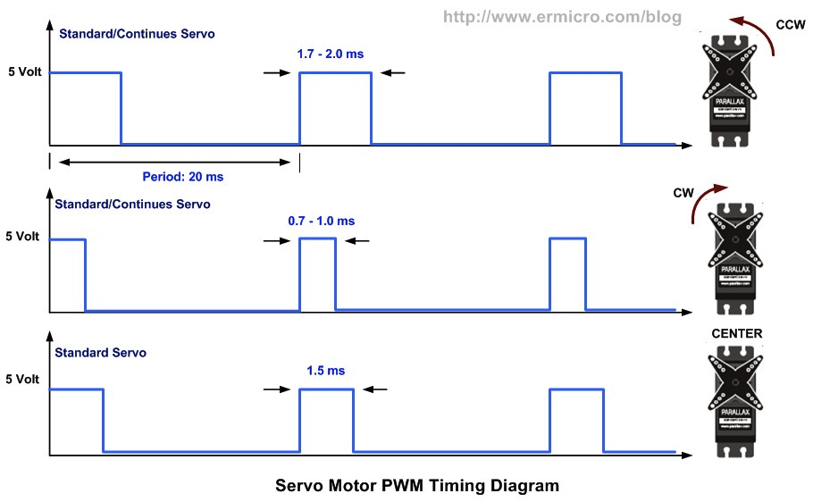

In order to be able to make the servo-motor rotate, you probably want to test it in each position. And give some time to it, so it adjusts itself to the new instruction.
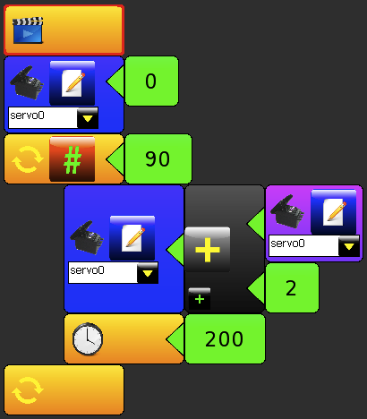

SUGGESTED QUESTIONS FOR THE USE IN CLASSROOM

What is the main difference between a regular DC motor and a servo-motor?

How many degrees of freedom a biped should have ? And an hexapod?

ADDITIONAL MATERIAL

Details about how a servo motor works:
http://www.jameco.com/jameco/workshop/howitworks/how-servo-motors-work.html

Check out Arduino Servo Library:
http://arduino.cc/en/reference/servo

Follow the tutorial in C++ of Arduino in order to use a servo:
http://arduino.cc/en/Tutorial/sweep

Follow another tutorial with explanations and videos about how to command a servo:
http://www.robotshop.com/blog/en/arduino-5-minute-tutorials-lesson-5-servo-motors-3636

multiplo is an Open Source Robotic Platform. It helps to design and build prototypes and provides the tools for educators to awake the interest in science. Let us know how you are using it!

