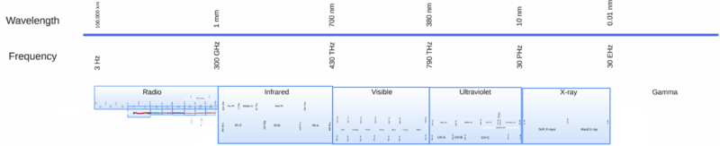

ABOUT INFRARED COMMUNICATIONS

We now know how to build robots and how to program them. Also we have been able to make autonomous robots, but it would be really cool that besides of sensing the environment they could also receive commands from us.

Sensors are what allow a robot to have an input. The first example we are going to see in detail is an Infra-Red Decoding Sensor. This is a little thing that you already know perfectly but you might not be even aware of. I bet that at your own house you have even more than one. A clue for this is that TV´s, Air conditioners and many Audio equipment normally has one. Yes, I am talking about the remote control ! How does that work ?

We see light with our eyes, but that is not all light that exists. One simple exercise is to use a cheap cellphone camera and take a look at any regular remote control. You will notice that at the front of it flashes when you press the buttons. That is something quite obvious because there has to be something out there, if not how could you possibly explain that your TV switches ON when you press a command in a little box? Let´s leave magic for the movies and see what is going on inside of the sensor of our robot.

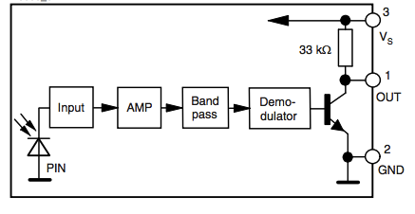
As an analogy, during daytime your eyes-sensors detect light. In the same way, the infrared sensor detects some sort of light. But what could happen if you do have sun and also a remote control working both together? How could the sensor distinguish regular light from this special light that is sending a command?

As you can imagine now, the sensor is not only a piece of plastic. There are many components inside. There is a diagram here of all the functions that are performed inside of it. Quite a beautiful thing that inside of a such a tiny three legged chip still we have a lot of things going on.

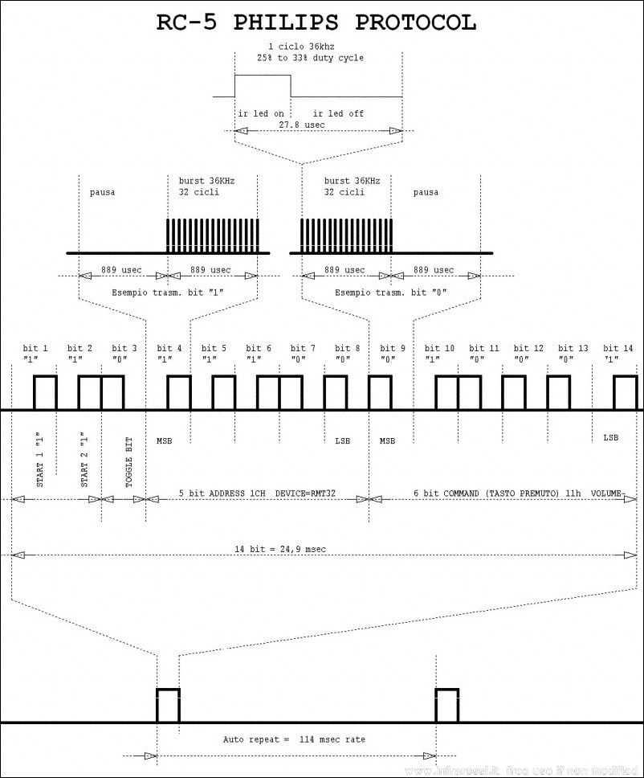
We then need some coding in order to make sure that the information from a remote control arrives to the sensor. You can see that this is simple... for an engineer! Take a look at the chart of the most common protocol for encoding infrared communication. It has been designed by Philips and is what we will be using with the sensors. It´s quite a thing that each bit inside of it´s bytes blinks 38 THOUSAND times in one second. Now is time not to be surprised if you didn´t see it with your eyes.

The important things to remember is that sensors are inputs that will be processed by the robot brain. If we connect a sensor will be able to detect this special light and the way it has been coded will trigger in the software an action.

SUGGESTED QUESTIONS FOR THE USE IN CLASSROOM

Do all remote controls work with the RC5 protocol?

Why does the sun does not obstruct the communications between the control and the receiver?

ADDITIONAL MATERIAL

Explore one of the most professional IR libraries for Arduino, community generated:
https://github.com/shirriff/Arduino-IRremote

Read about some other projects executed with the same hardware:
http://www.instructables.com/id/Laser-Ball/step7/IR-remote-control/

multiplo is an Open Source Robotic Platform. It helps to design and build prototypes and provides the tools for educators to awake the interest in science. Let us know how you are using it!

