ABOUT ROBOT INFRARED DETECTORS

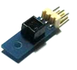
IR sensors work by emitting a beam of invisible infrared light. This, after bouncing off an object, returns to the sensor, which captures the intensity of the return. This intensity is converted into a real number with which to work on the activities outlined below.

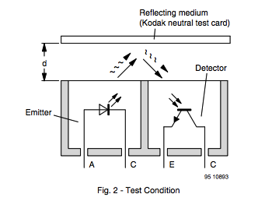
IR sensors which use robots Multiplo are composed of three parts: a small plate which is mounted on the sensor, the sensor chip itself and the sheet with which it is connected through a cable to the plate. As for the sensor, you can see their user interfaces in the data sheets provided by the manufacturer. A simplified drawing below shows what is going on and how the infrared reflects and comes back to your robot.

Now, consider the sensor along with its data sheet and see a little what we have. If you look very closely at the IR sensor using our robots, you can see that in the center of the black cube have two small circles next to each other. These are separated from each other by a distance of 2.8 mm and both point towards the same place. One is a diode which acts as transmitter and the other is a phototransistor operates as a receiver.

The diode is in charge of issuing a beam of infrared light. This beam of light bounces off any object it stands. Then, the reflection produced by the Robot to be captured by the phototransistor. It should be noted that not all IR sensors emit a beam of light. Those who do not do it are called passive; while those who use our robots are called active.

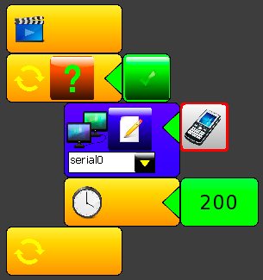
The output of the phototransistor is analog and ranges between 0 and 5 volts. Then the captured value will be converted to a digital value by the converter of the processor and is stored in a register of 8 bits. Calling the function analogRead (n) is referring to the value stored in the register. In the case of our robots, the "n" which takes as parameter analog Read function (n) represents the input to which is connected to the sensor.
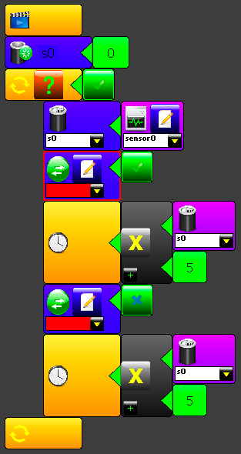

As a simple exercise you can make the LED (d13) blink according to the value of your sensor reading.

Then, when you are already familiar with the values you can obtain, you can jump into some robotic tasks like avoiding a black line on the floor... or following it! We will be looking these into more detail into our next episode...

SUGGESTED QUESTIONS FOR THE USE IN CLASSROOM

Search by yourself the datasheet of the infrared sensor CNY70, the one that is used by multiplo robots. You can use the website http://www.datasheetcatalog.com/ for that.

Get your serial interface show you what is the value read by the sensor. Try with different surfaces. Why do the values are different according to the material ? Is it based on the color or other property?

Draw a circle with a black marker or tape and make all the robot movements to stay inside of it. Compare this behavior with a common domestic vacuum cleaner robot.

ADDITIONAL MATERIAL

Read about the light we can see and what is the total spectrum:
http://en.wikipedia.org/wiki/Visible_spectrum

Watch a video of an innovative modular robotics, where different type of sensors are used:
http://www.ehow.com/video_12328855_moss-modular-robots-anyone-can-build.html

multiplo is an Open Source Robotic Platform. It helps to design and build prototypes and provides the tools for educators to awake the interest in science. Let us know how you are using it!

