ABOUT ROBOT BEHAVIOR

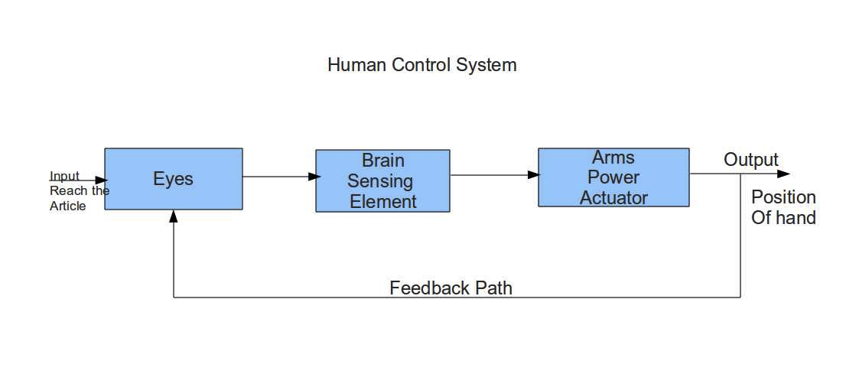
Without entering into too many details, we can see humans as a control system as well. What are the sensors when we run ? What makes us accelerate ? When do we decide to stop and when to turn ? Those are interesting questions to make but also complicated ones.

One very accurate example of control theory is how elevators work. They behave differently with different scenarios. Let´s see that in detail:

1. You are at floor 1, you press floor 10: they go full speed !
2. When you are at full speed and you are almost there, 7th floor, 8th floor, 9th.... they decrease speed!
3. You are at floor 1, you press floor 2: they go slowly!
4. They know how to accelerate according to how many people are inside!

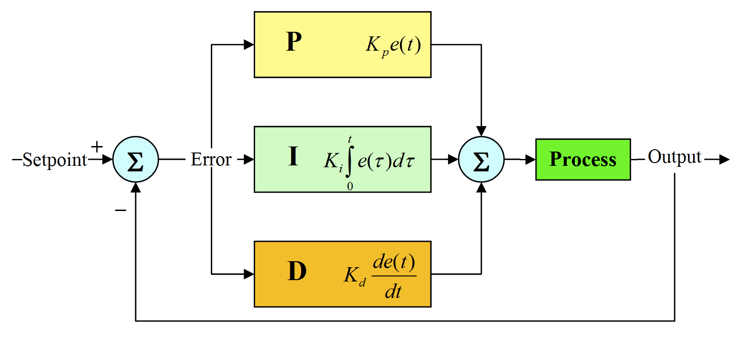

That is what a complete Proportional Integral Differential Control . This means that the system will react to a an input in a very intelligent way, getting to the result by combination of three different compensations:

- a bit according to the difference of where it wants to be and where does the robot see itself.
- an accumulation of all the former positions it has to go till the getting to the correct result.
- a coeficient that we can see as the acceleration to get to the objective.

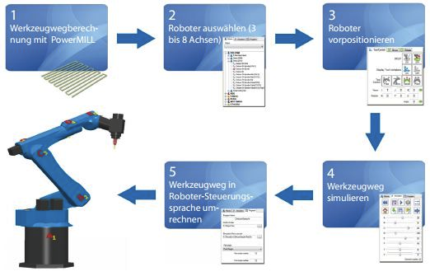
The reason that we would care about PID control and other feedback loops is simple. Without them, our robot would be only a remote control toy. But if we are able to allow it to control with precision each one of it´s actions, it will perform better than humans.

We are able to make the 16000000 cycles in our small robot brain. And every time it gets the expected input, it will execute perfectly the ordered task. Us, humans, have other qualities... but it´s more likely that we are distracted after working 24hs....

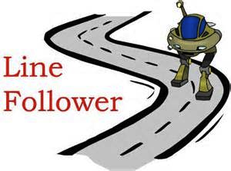
In other order, making the robot follow a line, optimizing it´s acceleration in order to avoid stopping on each curve, it´s already a robot behavior that needs to dedicate some thought to it.

Introducing hysteresis cycle to the algorithm would make it improve both in speed and accuracy, but that was something we couldn´t foresee when we were just getting started into robotics.

SUGGESTED QUESTIONS FOR THE USE IN CLASSROOM

How do big machines move heavy things without breaking their gears ?

What other examples of hysteresis loops do you know ?

If you do NOT introduce hysteresis neither acceleration to a line follower loop, what would you expect it to do ?

ADDITIONAL MATERIAL

Check out some multiplo robots following lines:
https://www.youtube.com/watch?v=i0husZ2Tj2M USA – Air Force
https://www.youtube.com/watch?v=bfX5mar99qg Argentina

Fun application of line followers:
https://www.youtube.com/watch?v=gEqghokSw9U

An intuitive explanation full of examples of PID control:
https://www.youtube.com/watch?v=XfAt6hNV8XM

An introduction of the PID using robots as an example:
https://www.youtube.com/watch?v=UR0hOmjaHp0

multiplo is an Open Source Robotic Platform. It helps to design and build prototypes and provides the tools for educators to awake the interest in science. Let us know how you are using it!

