multiplo is an Open Source Robot Prototyping Platform. It has been used in education and adapted to several different official curriculum. Below there is a guide to help teachers understand the capabilities of the system.

ACTIVITY GUIDES OVERVIEW

- Robot Assembly & command through remote control
- Linear actions with sounds, LEDs and motors
- Loop actions and if statements. Bumper Sensor.
- LDR sensors: light follower
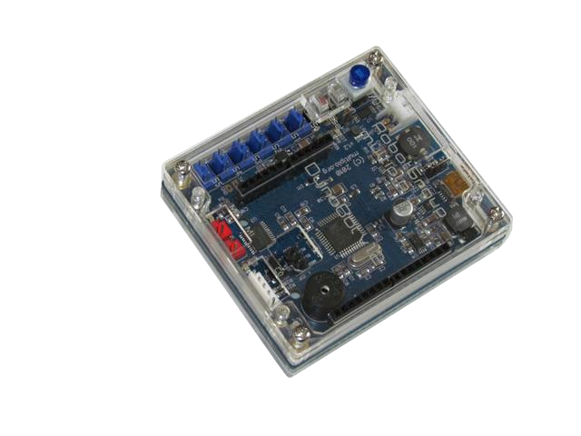
- Serial communication
- Servo Motors
- Remote control commanded robot
- Infrared Active Sensor Basic
- Infrared Active Sensor Advanced
- Ultrasound sensor

ACTIVITY CONTENTS

- Detailed practical instructions of the ACTIVITY
- EXAMPLE of Example Code and Assembly Guides that can be used
- Related content to LEARN

