**Part I**

1. Host a static website on Blob Storage: build and deploy a static Hello

World website to Azure Storage.

2. Verify that the default web page has the Hello World! page.

3. Provide the steps and results.

1. Firstly we create a storage

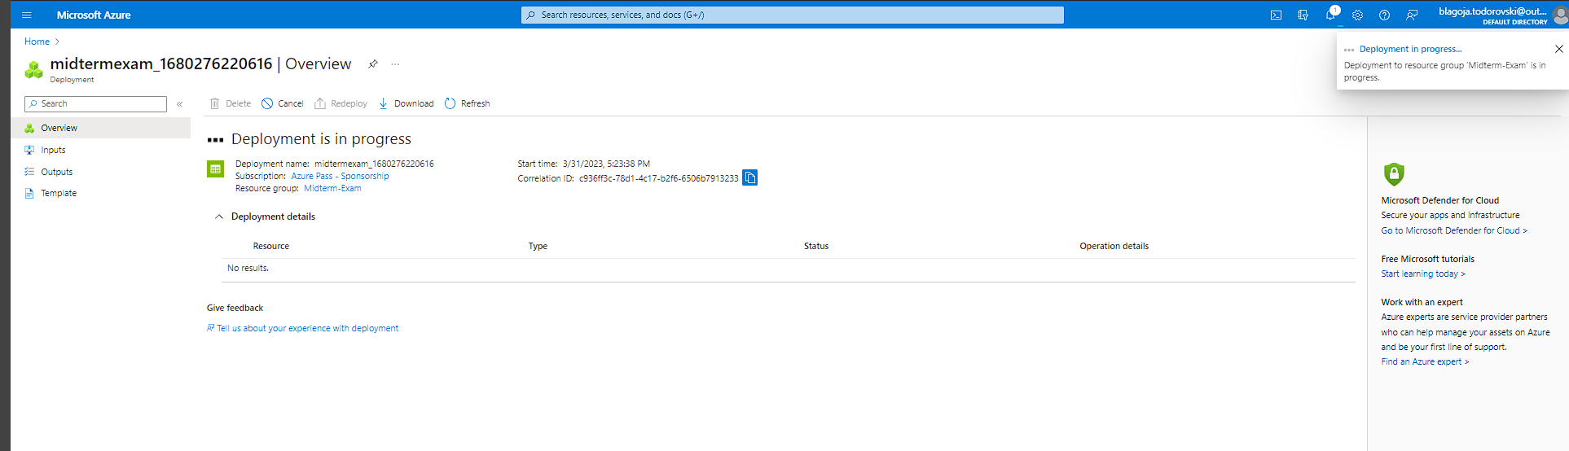

Then we go the storage and go to Data Management and Static website where we enable the Static Website. For the Index Document Name we input index.html . The default index page is displayed when a user navigates to the root of this static website. And for the Error Document path we input 404.html where a user tries to access a page that does not exist.

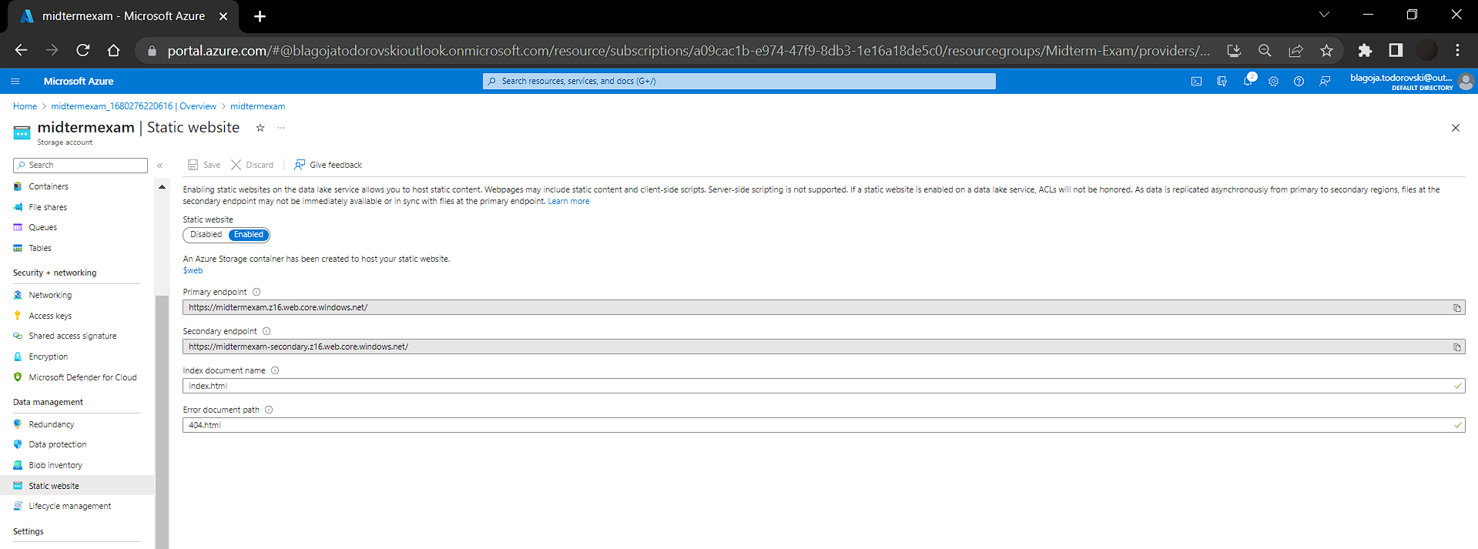

Then we go to VS code and we create a new folder, and then create an html file that will display the Hello World text.

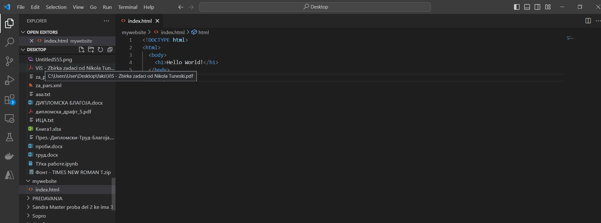

We also create a 404 file in order to display an error message then the user tries to access a page that does not exist

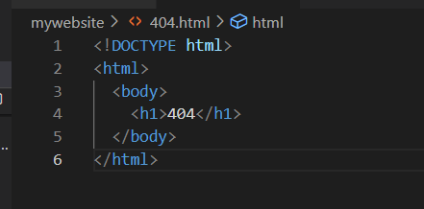

Then we right click on our folder and clikc deply to static website where we log in to our Azure account.

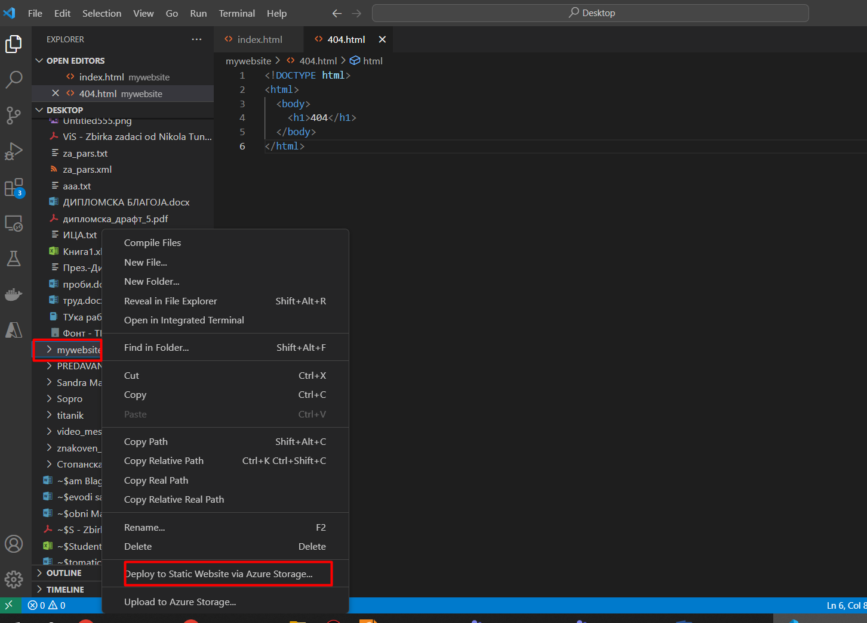

We are also prompted to select the subscription and the storage account. I select the Sponsored one and then the newly created storage.

And now that we have done that, we can access the website where we can see the message Hello World!

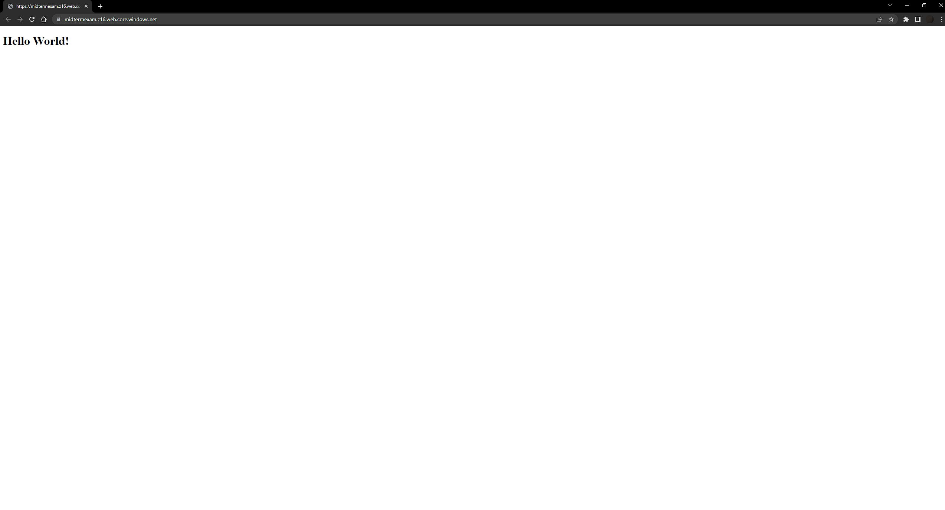

Part II

In this exercise we will setup a Linux based web server and will

deploy a web page on it.

1. Create a Virtual Network where you will deploy your Linux Based

Web Server.

2. Modify the network security group for your virtual machine that will

allow you to remotely manage your machine only from your local

machine and nowhere else.

3. Create a Linux Virtual Machine that will be your Web Server which is

publicly available for web publishing (not SSL) only from your

machine and nowhere else.

4. Connect to the VM.

5. Install Apache Web Server.

6. Deploy the “Hello World” web page.

7. Provide Testing from your cellphone.

8. Provide the steps and results.

1.Firsly we go in the Virtual machines tab , create and the Virtual Machine. We set up the configuration as given on the image below

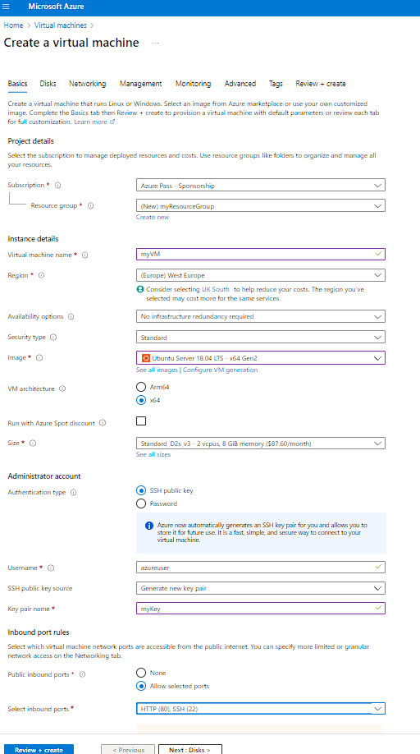

ssh -i myKey.pem azureuser@40.114.219.152

Here is the Virtual Machine created

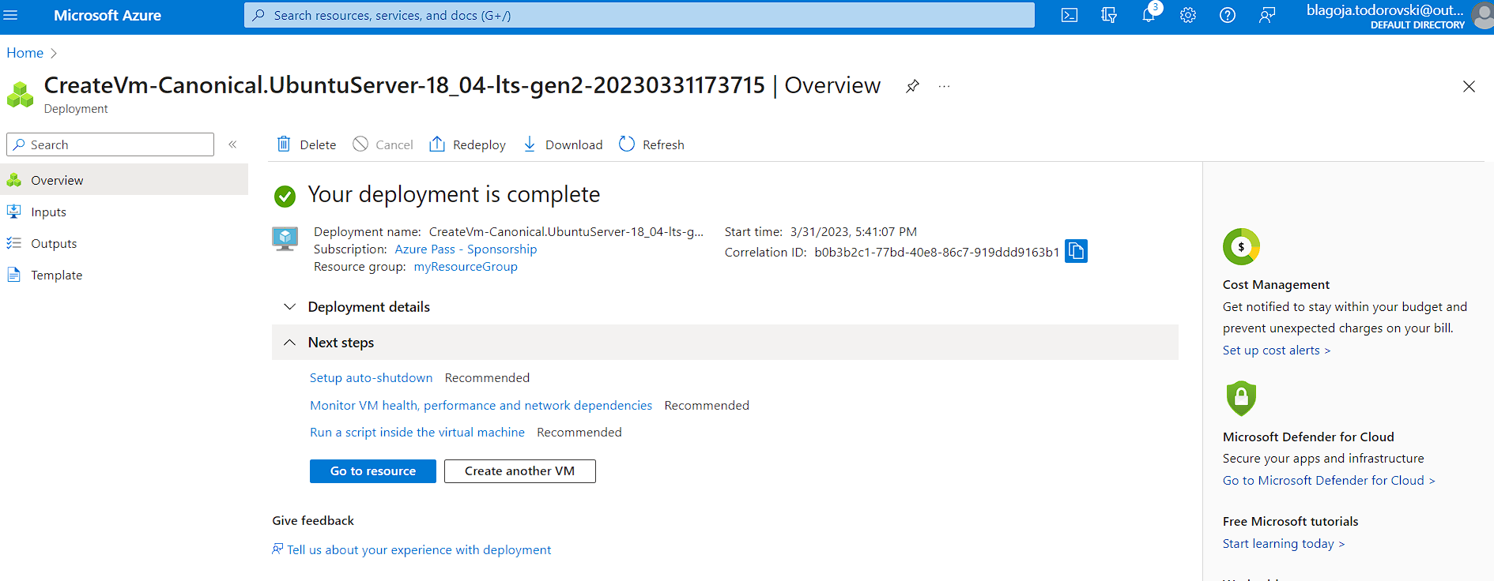

40.114.219.152

Here we modify the network security group for your virtual machine that will allow you to remotely manage your machine only from your local machine and nowhere else.

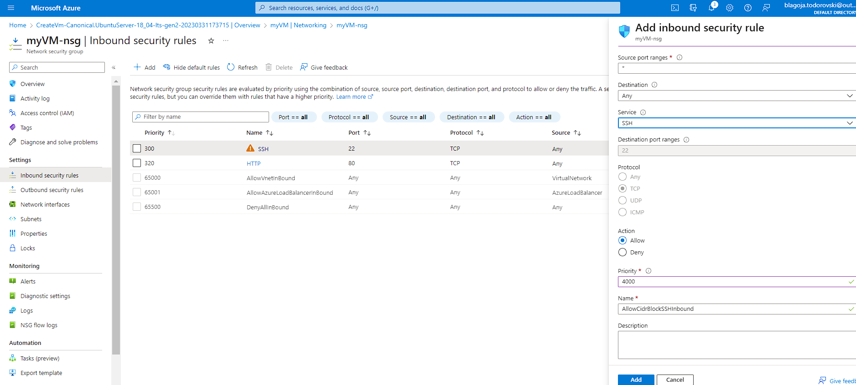

Create a Linux Virtual Machine that will be your Web Server which is

publicly available for web publishing (not SSL) only from your

machine and nowhere else.

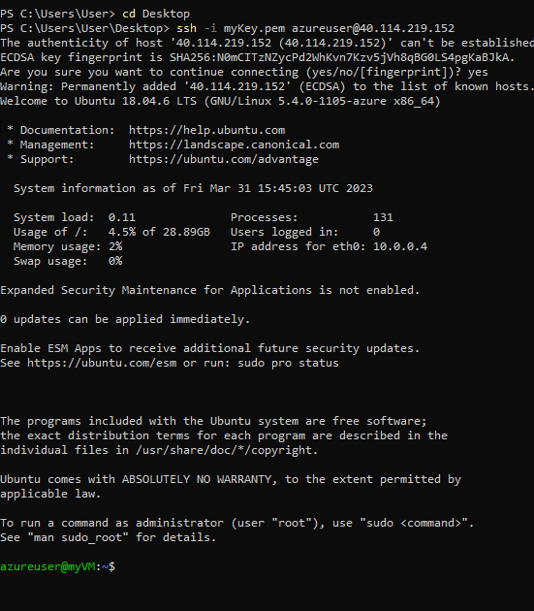

Then we did install the apache and did an update , the commands were:

Sudo apt –get update

Sudo apt-get install apache2

Then we went into the index.html file and changed it

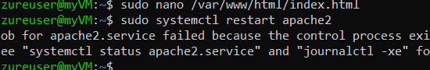

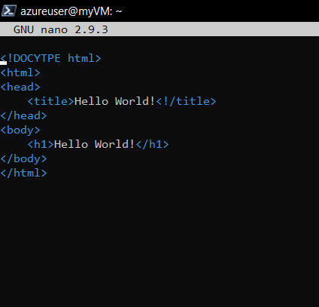

After that we tested to see if the page worked on the browser . It did as we can see from the picture

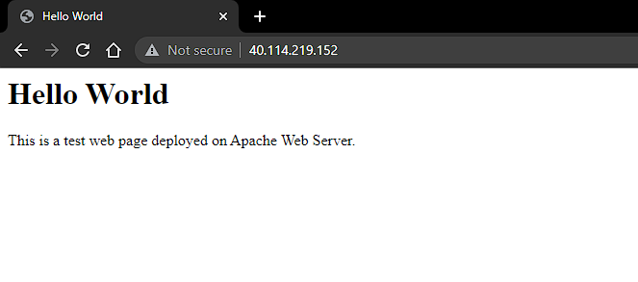

We can also see that tested on my cellphone , this page also works.

