Implementation status • PurePolyglot PBL prototype • 13 October 2026

Factory Relay
Technical report
An animated, two-role communication testbed for smart-factory workflows. Current status: working browser prototype with local-network multiplayer and deterministic scenario scoring.
Factory Relay asks an operator and a maintenance player to combine different facts before choosing a simulated factory action. Six fictional scenarios cover equipment identity, negation, units, unclear references, local shorthand and conditional procedures. The current implementation supports structured check-back, typed conversation, animated feedback and exportable session records.
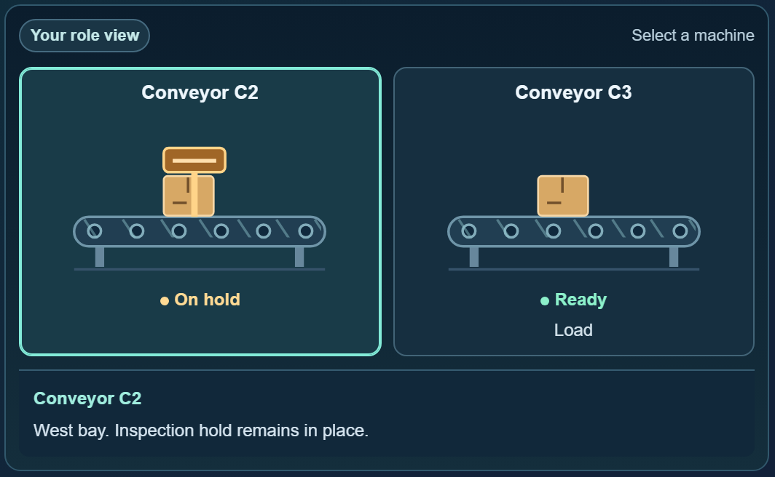
Figure 1. Current factory scene in PurePolyglot. Equipment can be inspected; displayed facts depend on the player’s role. Fresh browser capture, 13 October 2026.

What this report establishes
The inspected implementation supports pass-and-play, paired tabs in one browser profile, and two separate browser clients through a local HTTPS host. The LAN game requires no internet or cloud account once the host is prepared. Automated translation, speech recognition, local model training and physical machine control are not implemented.
Verification on 13 October 2026: 41 unit/integration tests and 145 asserted browser checks passed. These are software checks, not participant-study results or evidence of industrial effectiveness. Separate browser contexts emulate two devices; a physical phone/router trial remains pending.
Reading guide: scope and scenarios p.2; architecture p.3; interaction p.4; LAN protocol p.5; storage/privacy p.6; metrics/export p.7; verification p.8; screenshots p.9; risks/next work p.10; references and reproduction p.11.

1 · Problem, scope and scenario design
The smart-factory connection is coordination around production and material-handling tasks: identifying an asset, preserving a hold instruction, interpreting a label quantity, or waiting for approval before a full run. The prototype represents the human communication layer around those processes; it is not a sensor-connected digital twin or production control system.
HSE guidance identifies reliable transfer of task information and cross-checking as central to handover, including communication between operations and maintenance [1]. This supports the problem framing; it does not validate Factory Relay’s training effectiveness. An informal account of multilingual warehouse support helped motivate the project, but no company deployment, validated incident dataset or measured loss is claimed.
Capability | Current implementation
Communication | Unicode typed messages; optional clarification tag; guided asset/action/condition/timing check-back. UI and scripted briefs are English.
Interaction | Role-specific facts, selectable machines, animated outcomes, manual replay stages and reduced-motion support.
Play modes | Pass-and-play; paired tabs sharing a browser profile; two-client local HTTPS rooms.
Measurement | Scripted decision correctness, message/tag counts, attempts and elapsed round time; JSON export.
Outside current build | Translation, dialect detection, ASR, model download/inference/fine-tuning, federated learning, cloud multiplayer and PLC control.

Six fixed scenarios
Round / scenario | Ambiguity being exercised
1 · Which conveyor? | Reconcile a dispatch location with conveyor identity and inspection state.
2 · Cleared or not cleared? | Preserve “not cleared” and match it to the correct batch and station.
3 · Labels or bundles? | Confirm individual-label demand and convert it into printer bundles.
4 · What does “that one” mean? | Use task context and observations to identify the intended tote.
5 · Decode the local shorthand | Expand HLD/FST using the fictional site glossary; these are not asserted industry standards.
6 · The right version, in order | Combine order ID, template version and the sample-approval sequence.

The same scenarios run in the same order in both communication modes. They are teaching fixtures rather than an unseen evaluation benchmark. Repeated play creates familiarity and answer leakage; a controlled study needs matched scenario variants and counterbalanced mode order.

2 · Architecture and runtime
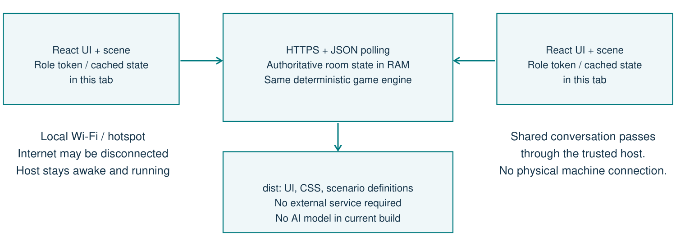
Figure 2. Implemented LAN architecture. Browser clients share events through a local host; the internet is outside the required path.
React renders the game and Vite supplies built assets. The audited installation uses Node.js 22.22.0, npm 10.9.4, React 19.2.7 and Vite 8.0.16. These are observed installed versions, not a tested compatibility range. The local server uses Node’s built-in HTTPS support [2].
Component / source | Responsibility
src/index.jsx; FactoryLanShell.jsx | Select an isolated PurePolyglot-branded LAN entry. Separate dynamic loaders prevent normal App/cloud workflows from preloading in LAN mode.
FactoryGame.jsx / .css | Setup, roles, dialogue, check-back, decision controls, review, export and connection status.
factoryEngine.js | Immutable scenario fixtures; pure state transition, scoring, summary and export functions. Shared by browser and server.
factorySceneModel.js; FactoryScene.jsx / .css | Map state and role to SVG equipment, captions, inspection detail and before/action/after animation.
factorySession.js; factoryLanClient.js | Local storage transports or authenticated fetch polling; recovery state, revisions and pending-request handling.
scripts/factory-lan-server.mjs | Serve dist; keep authoritative rooms in memory; validate roles, event order and request IDs.
scripts/start-factory-lan.mjs | Build locally, prepare TLS materials, start the host and display network URLs.

Code paths in this report are relative to PurePolyglot/. The interface label “Maintenance” maps to the internal role “coordinator.” In LAN mode, the server holds the authoritative session; animation is a client view of that state, not a second independently evolving plant.

3 · Interaction and state transitions
The operator creates a room; maintenance joins it. Each sees complementary facts. Guided check-back adds four text fields, while Original messages keeps the same facts and decisions without that form. The form formats a restatement; it neither interprets language nor verifies agreement.
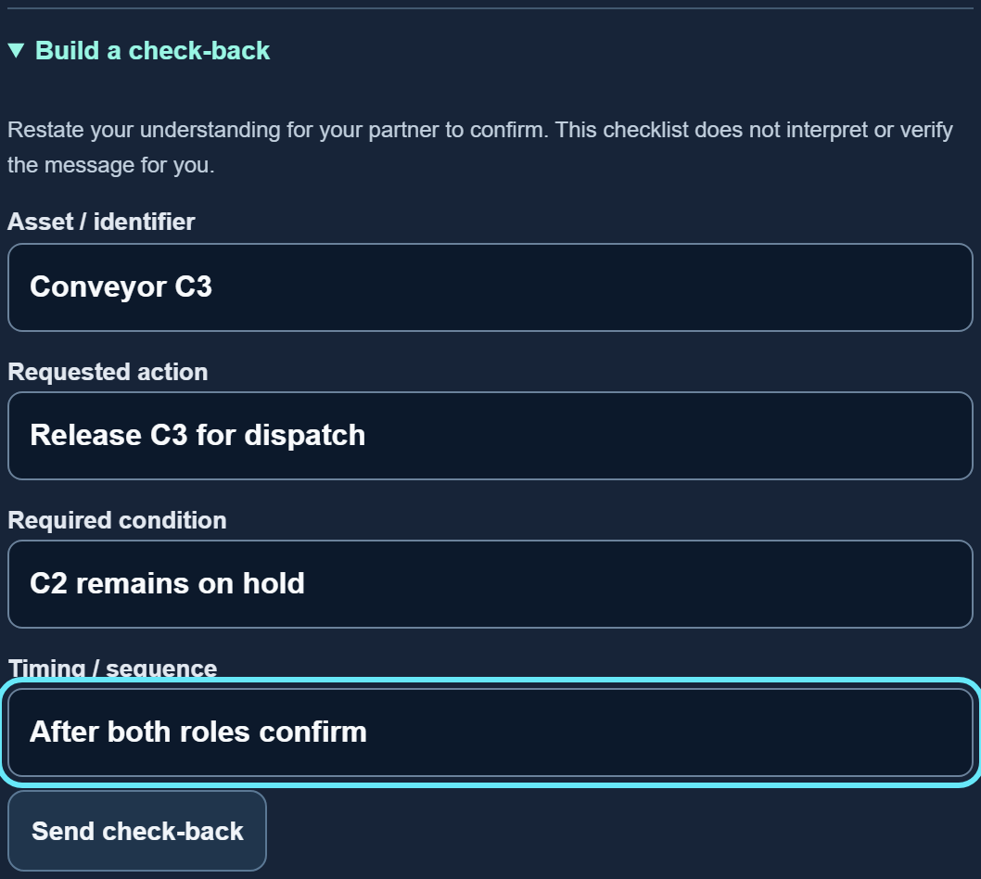
Figure 3. Structured check-back in the current interface. Any filled field permits submission; unknown fields remain “not specified.”

Authoritative round flow
create → playing → decision → review → next round
└→ complete after round 6
Message events append a role, text, tag and timestamp. Before a decision, both roles must have sent at least one message in that round. Only maintenance can submit a decision; only the operator advances shared play. A valid option is checked against the scenario answer ID. Correct actions execute the simulated outcome; wrong actions are recorded as attempted and held. Both paths enter review immediately, with no second scoring attempt in that round.
The engine returns the same state for invalid or premature transitions. The LAN layer also checks the submitted round and phase to reject stale actions. State includes session/room IDs, mode, round, status, messages, attempts, outcomes and timestamps.

Visual behavior
Accepted outcomes use Before / Action / After; rejected attempts use Before / Blocked / Unchanged. Automatic review advances every 2.5 seconds and then holds the final frame. Machine selection, replay and manual stage controls support inspection. Pause changes visual motion only; it does not stop elapsed-time measurement. Reduced-motion preferences disable automatic movement. These features have targeted checks, not a complete accessibility certification.

4 · LAN protocol and host operation
Two-device play uses HTTPS requests and polling through one local laptop. It does not use WebRTC, WebSocket signaling, STUN/TURN or an internet rendezvous service. Both browsers load the host’s current network URL on a router or hotspot that permits peer traffic.
Method and path | Purpose / input
GET /factory-lan/health | Host availability, protocolVersion: 1, TLS flag and available URLs.
POST /factory-lan/rooms | Create operator seat; body sets guided or baseline mode.
POST /factory-lan/rooms/:code/join | Claim the maintenance seat with an empty JSON body.
GET /factory-lan/rooms/:code | Authenticated current snapshot and heartbeat.
POST /factory-lan/rooms/:code/events | Authenticated {requestId, round, status, event}.
POST /factory-lan/rooms/:code/leave | Authenticated closure of the shared room.

Room envelopes contain the caller’s connection credential, state, revision, peer-presence flags and ready status. A role receives a random bearer token; tokens are not placed in join URLs or exposed as the partner’s credential. Eight-character hexadecimal room codes identify the room. Either participant can end it.

Synchronization and failure recovery
A client polls 800 ms after its previous request finishes, with a 4.5-second request timeout. These configuration values are not measured message latency. Both peers must have heartbeats within 6 seconds for shared actions. Disconnects pause actions until polling restores readiness. Revision checks discard older snapshots.
Each mutation uses a request ID. Successful repeats return current state without replaying the action; reusing an ID with changed content is rejected. An uncertain network/server failure retains the pending request for explicit retry. Definitive client errors clear it. Typical error classes include unauthorized/forbidden, missing or expired room, stale/invalid transition, oversized body, unsupported content type and rate limit.

Deployment defaults
The launcher listens on 0.0.0.0:5180, builds from installed dependencies and creates or reuses a local certificate. The default certificate has a 90-day lifetime and covers localhost/current local IPv4 addresses. Verify the printed address and SHA-256 fingerprint, or provide a matching trusted certificate. The launcher does not install trust roots or alter firewall rules. Start one host instance per port.
Capacity and guard limits: 64 rooms; 16 KiB JSON bodies; 240 requests/minute/IP; 12 room creations/minute/IP; up to 1,024 remembered request IDs per role. These are implementation limits, not load-tested capacity claims.

5 · Data, privacy and offline boundaries
Location | Data and lifetime
Pass-and-play tab | Session and connection in sessionStorage (pure_factory_active_v1). Same-tab reload can recover it; explicit end clears it.
Same-profile paired tabs | Shared room in localStorage (pure_factory_room_v1_<code>), active role in sessionStorage. Room expires when read after 24 hours without an update.
LAN host process | Messages, authoritative state, tokens, heartbeats, revisions and deduplication records in RAM. No game-message disk database. Rooms expire 24 hours after creation; restart loses them.
LAN player tab | Credential, latest snapshot and pending request in sessionStorage (pure_factory_lan_active_v1). Ordinary unsent textarea drafts are not refresh-persistent.
Downloaded JSON | User-managed unencrypted file: session, metrics and decided-round scoring. No transport credential is included; ending a room cannot revoke the file.
Host TLS files | Certificate and private key in ignored .factory-lan directory. Persistent operational material; the private key must not be distributed.

sessionStorage is scoped by origin and tab and survives ordinary reloads [3]. Recovery is supported in the original tab while the room exists; a new device without its credential cannot reclaim an occupied role. Paired tabs synchronize through browser storage events and use Web Locks to serialize writes [4]; this mechanism cannot connect separate devices.

Implemented protections and their limits
The host checks membership, role, origin/host, JSON content type, round and phase; applies request/body limits; restricts static files to dist; and uses a same-origin content-security policy. Camera, microphone and geolocation permissions are disabled on the LAN host. Its shell omits the full app’s account and cloud hooks. These controls have regression coverage but do not constitute a penetration test or production security approval.
HTTPS protects transport, but the trusted host and recipients can access the shared conversation. There is no application-level encryption at rest or end-to-end secrecy from the host. Role facts are separated in the normal UI; all scripted scenarios and answers still ship in the browser bundle. Use this as cooperative teaching software, not a confidential assessment system.

Exactly what “offline” means
Internet-free LAN play works while the local host and Wi-Fi remain reachable. The LAN entry skips service-worker registration and its CSP disallows workers; it is not a guaranteed host-free offline installation. A loaded page can start a separate pass-and-play session if the host disappears. That session does not resume the shared room. Initial dependencies and a usable build must be available before the internet is disconnected.

6 · Metrics and exported records
The evaluator scores the selected action ID against a fixed answer. It does not score the meaning or fluency of typed messages. Unicode input may contain any language or dialect that the participants can type, but storage of that text does not imply model support, translation or automatic understanding.
Exported metric | Definition and interpretation
completed / total | Number of decided rounds / 6. An unfinished round is not counted as a completed outcome.
correct; accuracy | Correct outcomes; correct ÷ completed. Accuracy is null if no round has been decided. accuracyPercent is rounded to a whole percentage.
firstDecisionCorrect | Same as correct in this implementation, because each round accepts only one decision.
messages; clarifications; checkbacks | Counts of message records and explicit kind tags. clarificationCount is an alias of clarifications. Questions sent as ordinary messages are not inferred.
attempted / executed / rejected | All decision attempts; correct simulated actions; incorrect actions held by the scenario guard.
Round elapsed time | Decision timestamp − roundStartedAt, clamped to zero. Includes reading, discussion, waiting and connection interruption.
decisionTimeMs | Sum of decided-round elapsed times. UI displays rounded seconds as Round time total.
elapsedMs | completedAt, or lastActivityAt if incomplete, minus startedAt. Includes inter-round activity; not identical to decisionTimeMs.

Export contract
schemaVersion: "1.0"
simulation, method, limitations
session: IDs, modes, round, messages, attempts, outcomes, times
metrics: summarized decision and communication counts
scoring: facts, options, answer and explanation for decided rounds
Messages retain typed content after leading/trailing whitespace trimming. Each round permits up to 100 messages, each up to 1,200 characters; check-back input fields permit 200 characters each. The exported session is a deep copy. Credentials reside in the connection envelope, outside that export. The interface has no JSON import or save-game restoration feature.
Known analysis caveat: both LAN and same-browser paired sessions export playMode: "paired". Transport kind is not explicitly exported. Record the play setup separately when collecting pilot data.
WER, CER, SAER, translation quality, inference latency and dialect identification are not computed. The simulator’s blocked wrong actions cannot be interpreted as measured real-world accident prevention. Any later language study needs a defined semantic annotation protocol and human-reviewed references before claiming such results.

7 · Verification at the current snapshot
All results below were rerun on 13 October 2026 against the inspected source or the existing production build, which was newer than the game source. Fresh screenshots use synthetic play messages. No participant or company conversation was inserted into these demonstrations.
Suite | Passed | What it checks
Engine + local sessions + scene model | 29 tests | Scenario outcomes; invalid transitions; storage recovery; role restrictions; deterministic visual states.
LAN client + server | 12 tests | Authentication, membership, event order, idempotency, retry/revision handling and server boundaries.
Gameplay browser suite | 65 checks | Six-round flow, exports, paired tabs, recovery and responsive layouts.
Animation browser suite | 48 checks | All scenario outcomes, held wrong actions, role facts, replay/manual stages and reduced motion.
LAN browser suite | 32 checks | Independent browser storage, Unicode, all rounds, refresh, disconnect/reconnect, pending controls, mobile containment and isolated asset loading.

Totals: 41 unit/integration tests + 145 asserted browser checks passed. No uncaught browser errors were reported. Extra report entries describing viewport geometry are not counted as additional test assertions.

Test conditions and evidence
Browser automation used Chromium/Playwright. The two LAN participants were separate contexts with independent storage. Requests outside the local host were blocked; the isolated LAN suite recorded zero outside-origin request attempts. The full PurePolyglot gameplay/animation fixtures blocked unrelated app requests, so their results do not establish that the full app is cloud-free.
Earlier and current responsive checks cover desktop, tablet, phone, 320-pixel small-phone and landscape layouts. Fresh report captures include a 390-pixel phone viewport and readable component crops. Assertions test horizontal containment and control reachability; long screens still require vertical scrolling.

What remains unverified
No two physical devices were exercised with an actual router WAN link disconnected. Browser certificate warnings were bypassed only inside automation, so that suite does not validate a phone’s trust workflow. The documents do not establish Safari/iOS support, real WLAN timing, long-session/battery behavior, load capacity, accessibility conformance or educational efficacy. A classroom rehearsal on the intended devices is still needed.
Evidence files accompany this report: audit.json, test-summary-2026-10-13.json, dated gameplay/animation reports, the LAN QA report and screenshot manifest. Their records distinguish simulated network faults from physical-device verification.

8 · Interface evidence
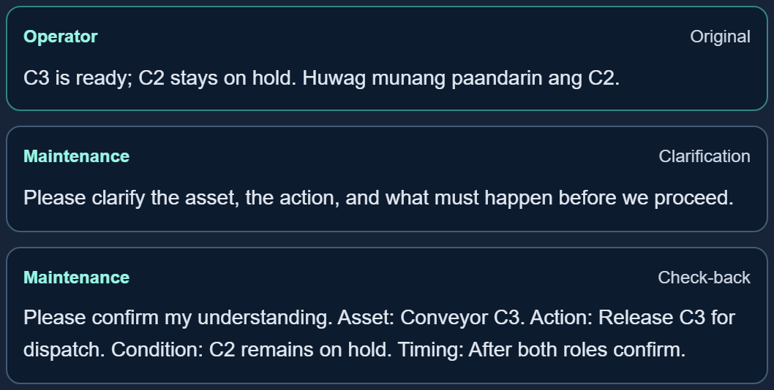
Figure 4. Shared message board. Entries are role-labelled; clarification and check-back are explicit user-selected tags. The program does not infer their semantic accuracy.
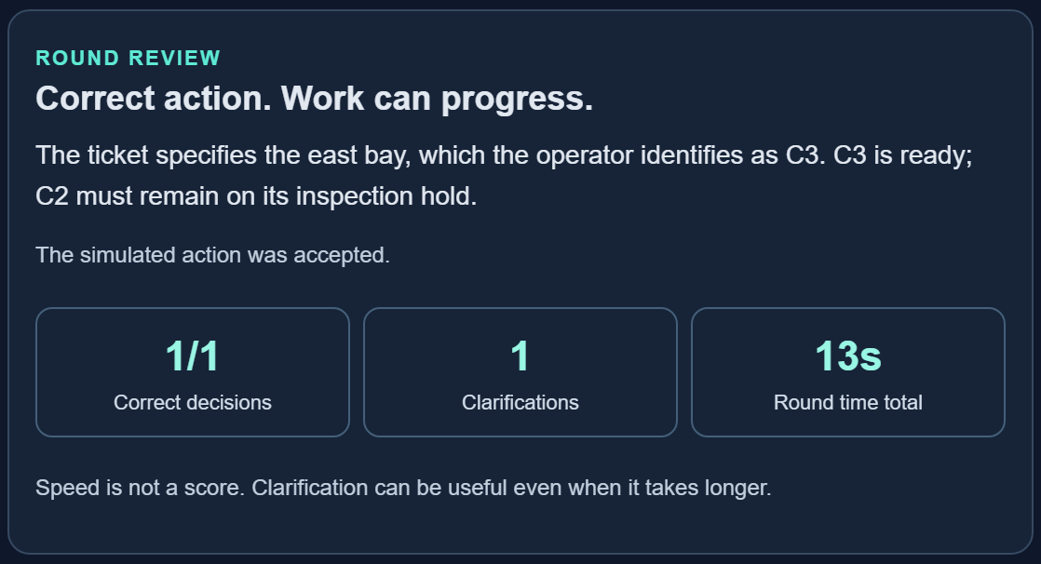
Figure 5. Recorded decision and explanation in review. An incorrect selection is held by the deterministic simulator; a correct selection authorizes only the scripted visual outcome.
Images are direct browser captures of the current build on 13 October 2026. Crops remove surrounding browser whitespace; they do not alter game content. Room codes shown are synthetic demonstration rooms, not reusable participant credentials.

9 · Risks, limitations and next deliverables
Risk / gap | Current effect | Next validation or deliverable
Training validity | Six fixed answer fixtures can be memorized; no participant benefit has been measured. | Review cases with a manufacturing/warehouse supervisor; create matched variants; pilot counterbalanced mode order.
Linguistic support | Typed dialect text is retained but not translated, identified or semantically scored. | Define one language/dialect pair and target task; collect consented, human-validated examples before adding a language model.
Device-local adaptation | No model runtime, download UI, dataset review or training pipeline exists. | First add a capability check, model/license/size selection, local correction store and held-out evaluation; gate any adapter promotion with rollback.
Network and recovery | Host sleep/restart, client isolation or lost tab credentials interrupt play; rooms are not durable. | Run a two-physical-device WAN-disconnected rehearsal; test certificate acceptance, resume and export on chosen devices.
Research data handling | Host and recipients see text; exports persist; LAN transport is not identified in JSON. | Use synthetic or approved data; define retention/consent and add explicit transport/build metadata before data collection.
Industrial connection | No equipment telemetry, PLC commands, digital-twin calibration or physical interlocks. | Treat any later hardware demo as a separately reviewed integration with independent controls and a bounded test rig.

Current deliverable set
The working deliverables are the six-scenario browser game, animated/inspectable factory scene, guided and original-message conditions, local play transports, HTTPS LAN launcher/server, export format and automated verification suites. This technical report and the companion illustrated user manual document that build.

Recommended immediate demonstration
Use two actual devices on the intended classroom router, disconnect WAN while keeping Wi-Fi active, complete one round, briefly interrupt a participant connection, reconnect in the original tab, finish and export. Record browser/OS, network setup, certificate handling and any failure. This closes the largest gap between the automated evidence and the intended classroom use.
The next research milestone is a supervisor-reviewed communication problem and a small usability pilot. Translation, adaptive models and real machine control should be evaluated as explicit new work packages, with their own measured acceptance criteria. This report makes no novelty, patentability or deployment-readiness claim.

10 · References and reproduction
[1] Health and Safety Executive. Shift handover. Guidance on two-way information exchange and cross-checking. Accessed 13 October 2026.
https://www.hse.gov.uk/humanfactors/topics/shift-handover.htm
[2] Node.js. HTTPS documentation: HTTPS server and TLS configuration. Accessed 13 October 2026.
https://nodejs.org/api/https.html
[3] MDN Web Docs. Window: sessionStorage property. Page-session storage, reloads and lifetime. Accessed 13 October 2026.
https://developer.mozilla.org/en-US/docs/Web/API/Window/sessionStorage
[4] MDN Web Docs. Web Locks API. Coordination among same-origin tabs and secure-context requirement. Accessed 13 October 2026.
https://developer.mozilla.org/en-US/docs/Web/API/Web_Locks_API

Primary implementation evidence
The status claims are grounded in the local source snapshot, not inferred from the research proposal. The accompanying audit.json indexes exact functions and source lines. source_manifest.json records SHA-256 hashes of the game, transport, host, launcher and test files so this report can be matched to the inspected implementation.
Evidence | Location relative to PurePolyglot/
State, fixtures, scoring and export | src/factoryEngine.js
UI and visual model | src/FactoryGame.jsx; src/FactoryScene.jsx; src/factorySceneModel.js
Transport and persistence | src/factorySession.js; src/factoryLanClient.js
Host/security/launch | scripts/factory-lan-server.mjs; scripts/start-factory-lan.mjs; FACTORY_LAN.md
Automated verification | src/*.test.mjs; scripts/factory-lan-server.test.mjs; tests/factory-*-browser.cjs

Reproduce from the prepared project
npm.cmd run test:factory
npm.cmd run test:factory:lan
npm.cmd run factory:lan
# In a second terminal, while the host is running:
node tests/factory-lan-browser.cjs
For the other browser suites, serve the production build with the existing Vite preview command, set FACTORY_BASE_URL to that preview address, then run tests/factory-game-browser.cjs and tests/factory-animation-browser.cjs. The tests use the repository’s existing local Playwright installation. Starting the LAN host does not install missing dependencies.
Document preparation: screenshots, current source audit and test evidence dated 13 October 2026. The PDF is the visually inspected layout; the editable Word edition carries the same content and figures. No application feature changes were made to prepare this report.

