A practical guide to the current PurePolyglot prototype · 13 October 2026

1 · Prepare and start the local host
Factory Relay is a cooperative, six-round communication game. An operator and a maintenance player combine different information to choose the next simulated action. This guide starts with two-device play on a local network; one-device alternatives are on page 6.

What you need
• A host laptop with the PurePolyglot project, Node.js and its npm dependencies already installed. The launcher does not install or download them.
• OpenSSL for the first local certificate, or a matching certificate and private key supplied by your institution. The launcher can use OpenSSL included with Git for Windows.
• Two browser devices on the same Wi-Fi router or hotspot that permits communication between devices. The host laptop can also be one player's device.

Start on Windows
npm.cmd run factory:lan
1. Open the PurePolyglot folder and double-click Start Factory Relay.cmd. Alternatively, run the command shown above in a terminal opened in that folder. Start only one host instance on this port.
2. Wait for the build and the message that Factory Relay is ready. Keep this terminal open and the laptop awake throughout play.
3. Copy the network HTTPS address printed by the launcher. Open it on both devices. Use your laptop's current network address; a phone must not use localhost or 127.0.0.1.
4. If the browser shows a certificate warning, inspect the certificate details and compare its SHA-256 fingerprint and address with the host terminal before accepting this specific local certificate. If you cannot verify it, use an institution-trusted certificate or ask the facilitator for help.
Internet access is not required once the project is prepared. Wi-Fi is still required for two-device communication. Keep the host running: this version does not continue a shared room after the host stops.
The default port is 5180. If Windows Firewall prompts, the facilitator may need to allow Node on the private network. The launcher does not change firewall or device trust settings. Do not forward this port to the internet.
On the host laptop, open https://127.0.0.1:5180/?factoryLan=1 after launch. On another device, use the current network address printed by the launcher instead. The address shown in screenshots is an example and may change.

2 · Create a room and connect your partner
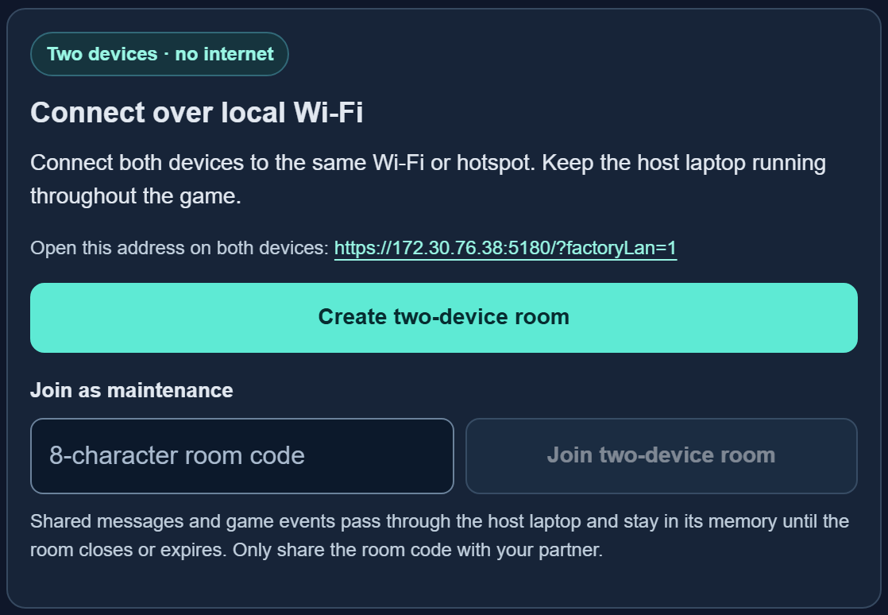
Setup: choose a communication mode, then use the local Wi-Fi controls for two separate devices.
1. On the first device, choose Guided check-back or Original messages. The selected mode applies to the room.
2. Under Connect over local Wi-Fi, select Create two-device room. This device becomes the Operator.
3. Select Copy join address and room code. Share the displayed address and eight-character code with your partner. If copying fails, copy them manually.
4. On the second device, open the same host address. Under Connect over local Wi-Fi, enter the code in Join as maintenance and select Join two-device room. A join link may prefill the code; the player must still join.
5. Wait until the status says Both players connected. Shared actions are paused while either player is missing.
Guided check-back adds an asset/action/condition/timing form. Original messages uses free text without that form. Both modes use the same facts and decisions; neither automatically translates or interprets messages.
Each room accepts one operator and one maintenance player. Keep each player's original tab open. The paired-tab Join room control is a separate, same-device mode; it cannot join a two-device room.

3 · Read your role and coordinate the next action
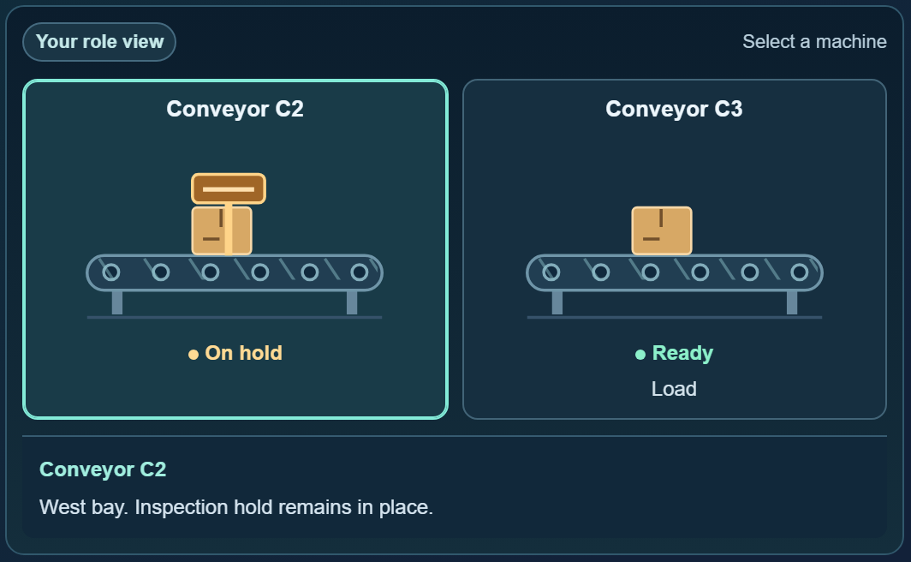
Factory view: select a machine to inspect its state. Read the private brief below the scene for your role-specific facts.
The Operator sees floor observations. Maintenance sees work orders, quality notes or definitions. Your partner has facts you do not have. Select a machine to inspect its detail, then read your private brief. “Not known” means your role must ask; it is not a machine fault.
1. Share the relevant facts through the Message board. Both roles must send at least one message during the current round.
2. Clarify missing information and agree on an action. Maintenance selects one option under Maintenance decision, then selects Confirm decision & review.
3. Read the round review together. The Operator selects Next round, or Finish session after round 6. In pass-and-play, the same device performs these steps.
Round | Communication focus
1 · Which conveyor? | Match a bay to its equipment ID and status.
2 · Cleared or not cleared? | Preserve negation and identify the batch.
3 · Labels or bundles? | Distinguish a quantity from its unit.
4 · What does “that one” mean? | Resolve a reference to the intended item.
5 · Decode the local shorthand | Use the fictional site's glossary.
6 · The right version, in order | Confirm version, sequence and approval condition.

These are fictional teaching cases. The interface separates role information during play, but it is a cooperative exercise rather than a secure examination.

4 · Exchange clear messages
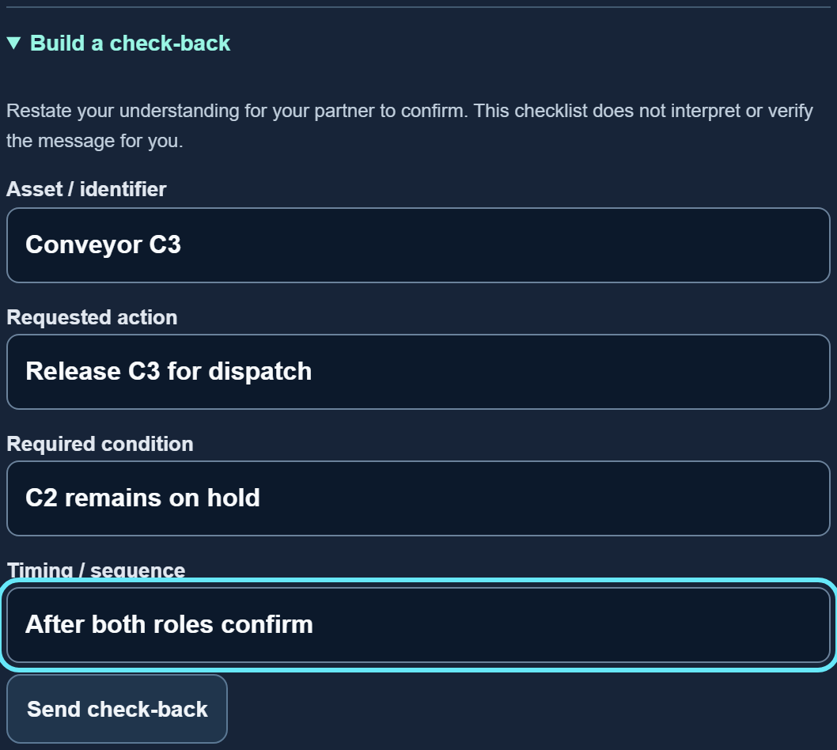
Guided check-back: use the four fields to restate the asset, action, condition and timing.
1. Type in Your message as operator or Your message as maintenance, then select Send message. Use starter message fills an editable example; it does not send it.
2. To request more information, type your question and select Ask for clarification. With an empty text box, the button sends a general clarification request.
3. In Guided check-back, open Build a check-back. Fill the Asset / identifier, Requested action, Required condition and Timing / sequence fields as far as you know them.
4. Select Send check-back and ask your partner to confirm or correct it. At least one field must contain text. Blank fields appear as “not specified.”
You may type in any language or dialect your keyboard supports. The game preserves typed text but its interface and briefs remain English; your partner must understand it because no automatic translation is available.
A check-back restates your understanding; it does not prove that understanding is correct. The game does not infer missing facts, translate text, or automatically verify a message. Your partner supplies the confirmation.
Messages allow up to 1,200 characters, with 100 messages per round. Check-back fields allow 200 characters each. Clarification totals count messages sent with Ask for clarification; a question sent as an ordinary message is not automatically counted.
Before Maintenance confirms, check identifiers, quantities, words such as “not,” and conditions such as “after approval.” The game records the first decision and then closes that round for review, including when the choice is wrong.

5 · Review the outcome and keep your record
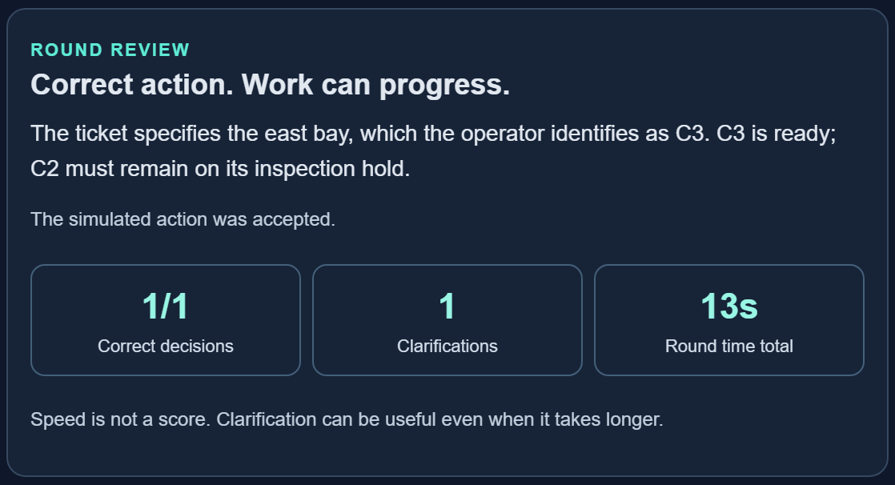
Round review explains the recorded decision and reveals the facts available to both roles.

Inspect the animation and explanation
A correct action plays through Before, Action and After. An incorrect attempt shows Before, Blocked and Unchanged: it is recorded but no simulated action executes. Select the timeline steps or Replay outcome to inspect the sequence. Select machines for details.
Pause and Resume control scene motion, not the session timer or network connection. With the device's reduced-motion preference enabled, Motion off is shown; use the manual steps. Compare the facts and your messages reveals why the action was accepted or held.

Finish, export and end
1. After the sixth review, the Operator selects Finish session. Open Review all rounds to revisit decisions and message records.
2. Select Export session JSON to download the current record. During an unfinished round, select End session / return to setup, then Export before ending. Keep playing cancels the end confirmation.
3. When both players are finished and any needed export is saved, select End & return to setup. For shared rooms, this ends the room for both players.
Correct decisions, Clarifications and Round time total describe this simulation. Speed is not a score; round time includes waiting. Exported JSON contains messages, attempts, outcomes and summary metrics, with answer explanations for decided rounds. It is a data file, not a PDF report or a loadable game save.

6 · Reconnect or use a one-device option
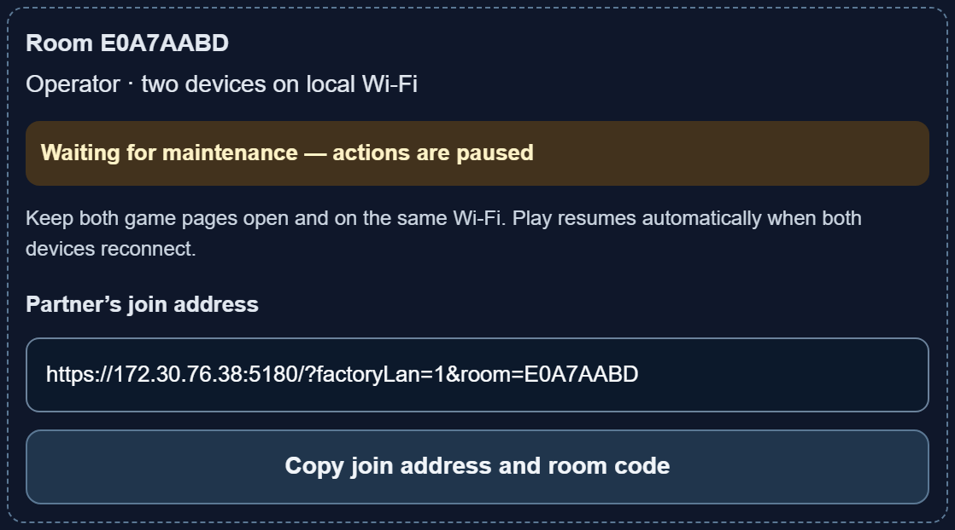
Connection status and any pending-action notice explain why shared actions are temporarily paused.

If a connection pauses
1. Keep the host awake and running. Return both devices to the same Wi-Fi and bring their game tabs to the foreground. Wait for Both players connected.
2. If Retry pending action appears, select it after reconnection. It checks the original request and avoids recording it twice. Resolve it before sending another action.
3. Refresh the original tab if needed. Its stored role credential can reconnect while the host room still exists. Ordinary unsent drafts are not saved across refresh; a pending submitted request is retained for retry.
Closing a tab does not end the room; the partner waits for that role to return. A new tab or cleared browser storage may lose that role credential. Host restart, explicit room closure or the 24-hour LAN room lifetime requires a new room. There is no import/resume from exported JSON.

One-device alternatives
Option | How to use it
Pass-and-play | Select Start pass-and-play. Use Pass to maintenance / Pass to operator, hand over the device, then select Reveal my brief. You may also practice both roles yourself.
Paired tabs | Select Create a paired-tab room. In a fresh tab at the same address and browser profile, enter its code under Join as maintenance and select Join room. This mode needs HTTPS or localhost with Web Locks; it does not connect separate devices.

A loaded game can use pass-and-play if the host becomes unavailable. This starts a separate local session; it does not continue or synchronize the disconnected shared room.

7 · Troubleshooting and facilitator reference
Symptom | Check or next step
Phone cannot open the page | Use the host's current network HTTPS address, not localhost. Check Wi-Fi, host power, private-network firewall permission and whether guest-network isolation blocks device-to-device traffic.
No Create two-device room button | Start the local host and open its printed address. A separately hosted PurePolyglot page is not automatically connected to your laptop's room server.
Certificate warning or changed fingerprint | Verify the current address and SHA-256 fingerprint against the host terminal. Changing networks can cause certificate regeneration. Use a matching institution-trusted certificate when verification or acceptance is unavailable.
Room already has maintenance | Return to the original maintenance tab. A second player cannot claim an occupied role; otherwise end the existing room and create a new pair.
Confirm decision & review is disabled | Select a decision and ensure both roles sent a message in this round. In LAN play, also check connection status and resolve any pending action.
Room closed or expired | Create a new room. LAN host restarts clear rooms. Paired-tab rooms expire after 24 hours of inactivity; LAN rooms expire 24 hours after creation.

Data and current limits
LAN messages and game events pass through the host laptop's memory to the players. The local room server does not write game messages to disk or send them to a cloud service. Browser session storage retains the role token, cached session and any pending action. Tokens are not included in join URLs. The host and recipients can access the conversation; this is not secrecy from the host.
Exported JSON is a separate persistent copy. Use fictional identifiers and share room codes and exports only with intended participants. Scenarios repeat on replay. This prototype has no automatic translation, voice capture, model training or physical-machine control, and no guarantee of shared play after the host stops.

Host commands · run from the PurePolyglot folder
• Normal start/build: npm.cmd run factory:lan
• Reuse a current build: npm.cmd run factory:lan -- --no-build
• Use a trusted certificate: npm.cmd run factory:lan -- --cert "C:\path\host-cert.pem" --key "C:\path\host-key.pem"
• Stop the host: press Ctrl+C in its terminal after players have exported and ended their sessions.
On macOS/Linux, use npm instead of npm.cmd. Keep the certificate's private key private. For more host details and test commands, read PurePolyglot/FACTORY_LAN.md. This manual describes the inspected implementation as of 13 October 2026.

