# Introduction

## Background of the Pandora jewelry Company and its data processing

PANDORA is a national jewelry manufacturer and retailer founded in 1982. It headquartered in Ground floor, Unit # 01-010, Junction City, corner of Bogyoke Aung San Road, Yangon. PANDORA distributes charm bracelets, rings, necklaces, etc. PANDORA designs and manufactures hand-finished and contemporary jewelry with high quality materials. Then, PANDORA distributes to the market with affordable prices.

PANDORA has a number of different sectors in different locations. It employs many sale staffs in all shops. Customers need to go to the PANDORA shop when they have to buy jewelries. Then, customers can buy products that they want. Moreover, the company offers the ordering system via telephone. If customers want to order products, they have to call to Pandora Company and make ordering process. But customers need to give their times and efforts to get the products that they want. PANDORA intended for women whom want to get hand-finished, modern jewelry products that are not only reasonable prices but also high quality.

## Problems of Existing System

The possibilities problems are:

* The data might store with paper, so it is difficult to find quickly and easily.
* Data can destroy cause of flooding, burning, earthquake and so on.
* It can face data losing and inaccurate data.
* Moreover, data duplication and data missing are often happened in ordering system.
* Appointing many staff, so the range of cost effective can higher.
* If the phone line is busy, customers can’t make ordering processes.
* Customers can’t easily know about the products information.
* It takes time and efforts from both customers and staffs.
* An organization information’s can be lost if there is lacking of data security.
* Other competitors are also developed computer based system and market competitions are increased.
* The company needs to hire buildings for the shop and can effect on the products.
* The company has other additional costs such as maintenance costs, advertising costs, staff costs, etc.
* So finance problems are often happened because of the manual system.
* Customers can feel unsatisfied about the lack of products.
* Manual system can have misunderstanding between customers and staffs.
* Sometimes, staffs aren’t focus on their works or they go out during their duties.
* So, the company needs a manager to manage staffs.
* It can difficult to manage variety of staffs.

## 1.3 Proposed System

The proposed system will be developed by analyzing the business environments. The company target for the youth. Nowadays, every people use social media. The company wants to implement web base system to increase their sale rate. The advantage of web-based system is the company can manage data processing structurally and systematically. The company also gets data security and routine can fast.

The online ordering system can provide many services for the organization. Computerized system can store the organization data, display product information, checking the stock level. It can also help to produce management level reports. It will make easy for customers and it can also save time. It also promotes the products worldwide. It reduces other additional costs such as maintenance costs, advertising costs, staff costs, etc. It enhances data duplication and gives data security. As a conclusion, computerized system gives many advantages for the organization.

## 1.4 Aim and objectives

### Aim

This project target is to implement computerized system. Thee system apparent in every country and many people know about our system. Customer can order the items quickly, easily and trustfully.

### Objectives

* To store data effectively
* To reduce data duplication and data concurrency
* To save time and cost effectively
* To reduce staff costs, advertising costs and operating costs
* To produce reports quickly and easily
* To reduce financial problems and other management problems
* To prevent data losing
* To provide organization information securely
* To provide quick and effective services

## 1.5 Scope and Reports of the project

### Scope of the project

* Registration by customer
* Editing their detail
* Login by customer
* Display jewelry information
* Search jewelry item by type, and price range
* Add or remove jewelry item to cart
* Ordering jewelry and recording order details
* Canceling order
* Display invoice
* New jewelry item registration
* New jewelry type registration
* Updating jewelry item information
* Updating jewelry type information
* Edit staff details
* Produce report by manager
* Staff registration by manager

**Report**

Monthly income report

Best seller jewelry item report

# 1.6 Required tools and techniques

* A computer with window 7 above
* Microsoft Word 2007
* Microsoft Office Visio 2007
* Microsoft PowerPoint 2007
* XAMMP Control Panel
* Browser
* Notepad++
* MySQL database management system

# Chapter 2

# Choice of System development Life Cycle Model

## 2.1 Survey of various System Development Life Cycle model (SDLC)

SDLC is a conceptual framework which describes all activities in a project from planning to maintenance. This model is an iterative process which is structure in methodology way. The purpose of SDLC is to deliver a quality system that align with business expectations and can help decision making progression. It has several stages which include planning, analysis, design, building, testing, deployment and maintenance. Some types of commonly used SDLC models are:

* Waterfall Model
* V-shaped Model
* Spiral Model
* Dynamic System Development method (DSDM)

### 2.1.1 Waterfall Model

It is a cascade SDLC model in which the flow of development process is step by step from the beginning of analysis, projecting, realization, testing, implementation, and maintenance. Since the flow of the processes is step by step, any phase of the development process can perform when the previous phase is complete. The requirement of this model should be stability. Changes are difficult in this phase. If the previous requirements are changes, this model can negatively impact on the cost of production.

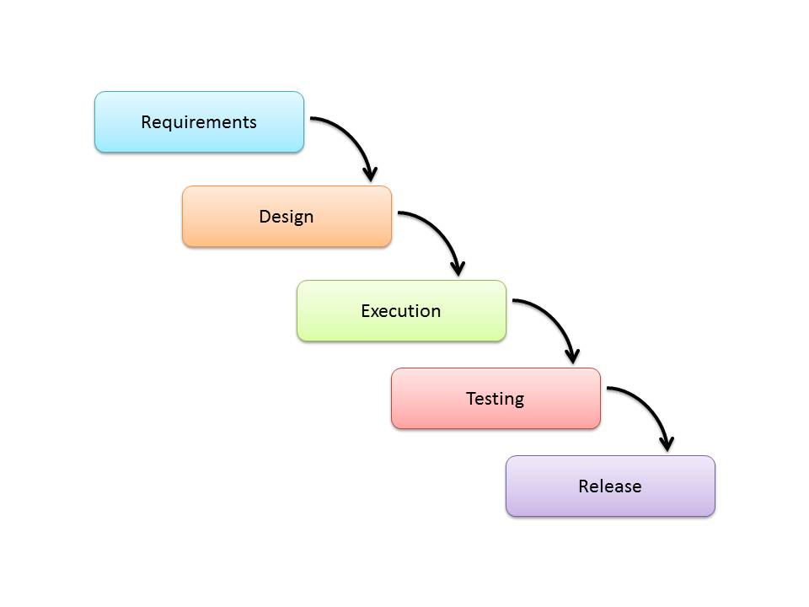

Fig 2.1 – Waterfall Model

### 2.1.2 V-shaped model

V-shaped model is an extension of a classical waterfall model but it emphasizes verification and validation of the product. In this model, every stage of development process is associated with testing. Unlike waterfall model, V-shape model is emphasized on early testing planning.

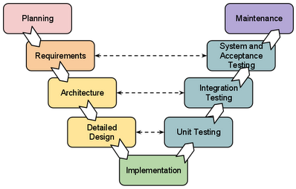

Fig 2.2 – V-shaped Model

### 2.1.3 Spiral Model

Spiral model combines both iterative and waterfall models especially the benefits of top-down and bottom-up concepts. It makes the right movement before going to the next stage. It is especially for large, expensive, and complicated projects. Some phases of the model are like waterfall model especially in the stage of planning, risk assessment and the building of prototypes and simulations.

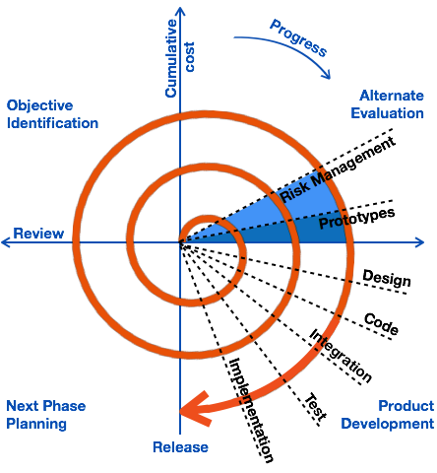

Fig 2.3 – Spiral Model

### 2.1.4 Dynamic Systems Development Method (DSDM)

It is a people-oriented methodology that focuses on the user participation in the specification review stage. In the analysis and specification, DSDM focus on usability for user rather than the functionality of the system. It encourages users’ involvement by developing prototyping. It also uses timeboxes to produce its products faster with a higher quality standard.

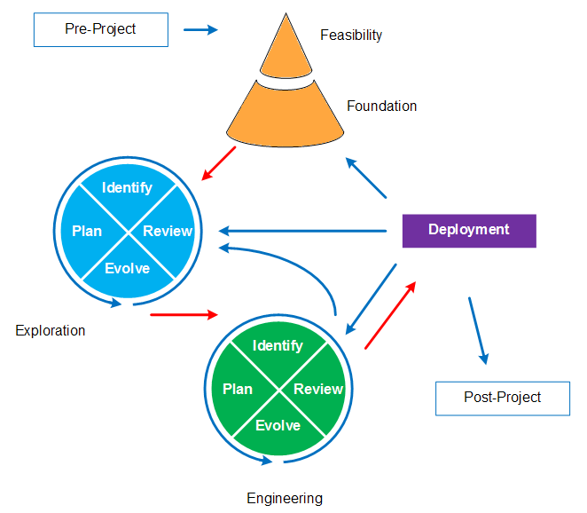

Fig 2.4 – Dynamic Systems Development Method

## 2.2 Choosing a life cycle model to be used in the system development project

Dynamic Systems Development Method is used for the system development.

## 2.3 Reasons for choosing Dynamic Systems Development Method

DSDM can give many advantages:

* DSDM increases quality through the involvement of users in the analysis and design stages.
* DSDM involves use of reusable software components. So, it can save costs
* It allows customers to encourage with development teams.
* Customers’ feedback can get through development processes so it can reduce maintenance costs.
* It can make quick initial reviews.
* It reduces development times.
* It aligned with IT and business teams.
* It can reduce development time by making reuse of processes and supporting tools.
* DSDM separates the whole project into prototypes. This helps easier to find bugs and can deliver project in-time.

## 2.4 Description of Dynamic Systems Development Method (DSDM)

DSDM is produced to support some additional discipline to the rapid application development method. RAD is a software development methodology that focuses on rapid prototypes and iterative delivery. Prototyping is performed when the requirements are not known exactly. DSDM divided the whole project into incremental prototypes and deliver incrementally. It supports to reuse of code, processes and tools. So, it can save development time and cost. It emphasizes to get high quality with enough system investment cost with sufficient time. It encourages user involvement throughout the development life cycle. But it needs resources with high business skills. It needs talented designers and engineers so it also required sufficient budget. DSDM focus on usability for user rather than the functionality of the system.

# Chapter – 3

# Choice of system development approaches

## 3.1 Survey of various System Development approaches

The process of implementing new software or modifying or upgrading the existing software is called system development. There are many ways to design and develop for system. The development approach is a limited planning approach which performs to provide better planning and management.

* Prototyping
* Iterative approach
* Incremental approach

### 3.1.1 Prototyping

Prototyping is creation of virtual system quickly with small amount of expenditures. So, users can identify information requirements for the system development. It encourages iteration and that is used when system area is not well defined. It can be used when the organization is not familiar with technology.

### 3.1.2 Iterative development approach

Iterative development approach breaks down the software development of large application into iterations. Each iteration develops with planning, design, development and testing steps. The goal of iterative approach is to develop small projects within the allocated time and constantly do builds and updates as soon as possible.

### 3.1.3 Incremental development approach

In incremental development approach, the software development model is designed, implemented and tested incrementally. It provides not only development but also maintenance. This model is a combination of elements from the waterfall model and makes iteration and prototyping incrementally.

## 3.2 Choosing a system development approach to be used in the system development project

Iterative and incremental development approach is used for the system development.

## 3.3 Reason for choosing iterative and incremental development approach

* By dividing project into iterations, testing is conducted simultaneously to coding and design in every iteration. It can reduce the development and testing time.
* All team members can focus on deliver within the allocated time.
* There is a high degree of collaboration between customer and project team. So, the project team will fully understand the customer’s vision.
* It allows user collaboration and can increases productivity and efficiency.
* Customers can review on work products during review sessions. It reduces the confusion between what the client wants and what the developers are going to provide.
* It delivers products incrementally so that customers can access the products throughout the development life cycle.
* It focuses on the user interaction rather than the functionality of the system. It needs good interaction between customers and developers.
* It focuses on high priorities first so that increases productivity.
* Easier to manage all possible risks during each stage of iteration.

## 3.4 Description of iterative and incremental approach

Iteration and incremental development approach combines of iterative method and incremental build model. It develops iterations which is developing the software within a short period timeboxes and helps to minimize risks. Each iteration involves all development stages such as planning, analysis, design, coding and testing. It improves quality and enhances product development agility by using specific tools and techniques.

In incremental development approach, the software development model is designed, implemented and tested incrementally. It provides not only development but also maintenance. This model is a combination of elements from the waterfall model and makes iteration and prototyping incrementally.

# Chapter – 4

# System Investigation (Fact Finding Method)

## 4.1 Fact Finding Methods

Fact finding methods combines requirements, facts about the systems by using techniques. It is an effective method of gathering information. A system analyst needs to define requirement analysis that is analyzing the requirement of a system. Some types of fact finding methods are:

* Interviews
* Questionnaires
* Observation of the work environment
* Workshop
* Document study

### 4.1.1 Interviews

Interviews are used to collect information from the manual system of the potential uses. Analysts identify requirements and gather ideas and opinions by making interviews. Interviews need good communication interaction between system analyst and users. The analyst can examine the more feedbacks from interviews. But interview is time consuming and more costly technique.

### 4.1.2 Questionnaires

Questionnaires are one of the fact finding technique that collect information from large amount of users. An analyst gives questions to users then users fill up the questions and give answers back to the analyst. A system analyst does not spend a lot of time when collecting information with questionnaires. It does not need to interview to each users. So that questionnaires is more useful than interviews. But it is difficult to prepare to become fixed-format which is predefined format of questions.

### 4.1.3 Observation of the work environment

Observation also contains in the fact finding techniques. An analyst needs to participate with the organization and analysis the documents flow. In this technique, user interaction is important and that system analyst should have user point of view. The analyst should be a good observer and also identifies the workflow of the departments between organizations. The analyst can monitor to their employees in which how they spend their work times.

### 4.1.4 Workshop

The project team can define the organizational requirements by making facilitated workshop. It allows interaction between organizations. So stakeholders can define their requirements in the workshop. The goal of facilitated workshop is to solve problems, gather requirements and to make decisions with team-based approach. It can reduce the time of requirements gathering and support stakeholders’ engagement.

### 4.1.5 Document Study

Document study is a quantitative research of reviewing and evaluating documents. It collects available documents that are related with business procedures and extract relevant data.

## 4.2 Choosing fact finding methods to be used in the system development project

Observation of the work environment, workshops and document study are used for the system development.

## 4.3 Reason for choosing the following fact finding methods

### 4.3.1 Observation of the work environment

The analyst can know the real situations of users by making observation. Some users will not filling their actual visions about the system. . The analyst can monitor to their employees in which how they spend their work times. So, the analyst can deeply understand about the users and the organization. It is an inexpensive technique rather than other fact finding techniques.

### 4.3.2 Workshops

By making workshops, project team can reduce the time required for gathering information. It allows user commitment so all stakeholders and project team can make decision together at the start of the project. The project team can get better ideas with different points of views. It defines all possible problems and possible solutions. So product quality will be improved and can get user agreements.

### 4.3.3 Document Study

It is the good way of requirements gathering because of documents are practical and manageable resources. It is also accessible and reliable source of data. It can save both time and cost required for information gathering. It can give grater quality because some documents are extremely details and collects important information.

## 4.4 Description of these fact finding methods

### 4.4.1 Observation of the work environment

Observation also contains in the fact finding techniques. In this technique, user interaction is important and that system analyst should have user point of view. The analyst should be a good observer and also identifies the workflow of the departments between organizations. The analyst can monitor to their employees in which how they spend their work times.

The purpose of observation is to define actual problems and conditions of the work environment. Analysts make observations to know what types of information are working in the organization and the flow of the organization. The analyst is working with a lot of people so that he will need good communication skills

By making observation, the analyst can know the real situations of users. Some users will not filling their actual visions about the system. The system analyst can monitors to their employees which is how they spends their times on work. So, the analyst can deeply understand about the users and the organization. It is an inexpensive technique rather than other fact finding techniques.

### 4.4.2 Workshops

Workshops allow interaction of their people so the project team can gather information and make decision quickly within the organization. It is effective information of information gathering, solving problems, generating ideas and action-planning. All group members are collaborating in facilitated workshops. The organization can get different ideas and their goals and objective will be performed under the agreement. The goal of facilitated workshop is to solve problems, gather requirements and to make decisions with team-based approach. It can reduce the time of requirements gathering and support stakeholders’ engagement.

### 4.4.3 Document Study

Document study is a quantitative research by reviewing and evaluating documents. Types of documents are:

Public records – It records the organization activities such as understudy transcript, reports annually, policy manuals, student notebooks, etc.

Personal documents – A person creates his own documents with his experiences, actions and beliefs. For examples: date-books, messages, scrapbooks, online journals, occurrence reports, etc.

Physical evidence - Physical objects that were founded with artifacts such as publications, plans, handbooks and training materials, etc.

# Chapter – 5

# Feasibility Study

## 5.1 Feasibility Study

Feasibility study determines the project is technically feasible with the estimated costs. It also determines how it will be profitable. It also indicates that project is possible or not i.e. if it can produce an equal or a higher rate of investment per as well as the level of expenditure. Feasibility study includes all relevant factors such as economic, technological, legal factors. By making feasibility study, a project manager can determine potential positive and negative outcomes of a project. A feasibility study can identify logistical problems and all related problems. So, the organization can determine possible solutions of related problems. Some common feasibilities types are:

* Technical feasibility
* Legal feasibility
* Financial feasibility
* Operational/social feasibility

### 5.1.1 Technical feasibility

Technical feasibility identifies hardware and software resource of an organization and also identifies the additional technical requirements that will require completing the whole project within the allocated time and budget. It determines the current technical resources that can be sufficient or not for the system implementation. It determines that the company has the technological resources to undertake the project. It also identifies all organizational processes and procedures can help the project success. The software development team can upgrade or add in the software to accomplish specified user requirements.

### 5.1.2 Legal feasibility

Legal feasibility study determines the legal implication and corporate structure of the business. It protects the organization form legal confliction. The data processing of the organization must be under the local data protection regulations. It also includes ownership of the system, information about the founders of the business and their influence. The organization need to follow the legal and ethical consideration. It also determines the other ethical issues of the organization.

### 5.1.3 Financial feasibility

` Financial feasibility examines how much the organization will spend to start up the project. It evaluates the required software can develop within the given budget of the company. It evaluates total cost of the project and its return on investment. It determines the cost of employing software development team, cost of technical requirements, cost of process and tools and cost of performing feasibility study, etc. It is also considers the profits that can be get by developing the software. The financial feasibility decision is usually made using cost benefit analysis.

### 5.1.4 Operational/social feasibility

Operational feasibility identifies opportunities of the proposed system and how much the requirements will be needed for the system development. Good design and development is necessary to get the desired operational outcomes. The organization must monitor people to make organizational changes. Social feasibility anticipates the users’ satisfaction upon the development project.

# Chapter – 6

# Choice of System Analysis and Design Method

## 6.1 System Analysis and Design Method (SADM)

SADM is a system approach to improve the business process.

* Structured system analysis and design method (SSADM)
* Object-oriented analysis and design method (OOADM-UML)

### 6.1.1 Structured system analysis and design method (SSADM)

SSADM are used as a development approach in the analysis and design stage. It is a formal approach and that base on waterfall model. SSADM combines text and diagrams in the system design stage. SSADM are used in commercial business, educational establishments and CASE tool developers. SSADM divides an application project into modules, stages and individual tasks. It also supports a framework to manage the project.

SSADM is commonly used in large system as it can manage and control a project with plan. It also can deliver project within the allocated time. SSADM emphasizes on the analysis of user needs. It uses common modelling and diagramming tools. So, the organization doesn’t need experiences staffs and can reduce the error rates. But SSADM can have a greater amount of costs. Some techniques of SSADM are:

Logical data modelling – This model identifies the requirements of the system and documents that data for system development. Then, data are classification into entities, attributes and relationships.

Data flow modelling – This model identifies the flow of the information system and documents that data for the system development. And also defines the system processes, external entities and its data stores.

Entity behavior modelling – This model identifies and documents the events that influence each entity and their associated sequences. It also designs each event of the process to coordinate entity life histories.

### 6.1.2 Object-oriented analysis and design method (OOAD-UML)

OOAD-UML is a structure method analyzes the requirements for the system development. It designs the system with object oriented concepts. It considers in good communication between stakeholders. It develops visual modelling of development process to get a good quality product.

## 6.2 Choosing a system analysis and design method to be used for system development project

In this system development, I used OOAD-UML method.

## 6.3 Reasons for choosing OOAD-UML

* OOAD-UML supports maintainability by making it objects are encapsulation. So it can identify errors quickly.
* It is structured modelling in which objects are combined into classes and associated with behaviors. It is focus on objects rather than the process and functions.
* New object can be built at any time because objects can be accessed with inheritance. Behaviors may be inherited from super classes and can add without effecting existing system functions. So, OOAD-UML provides reliability and flexibility.
* The codes of OOAD-UML can be reusable because objects are encapsulated which contain both data and functions.
* OOAD-UML is more scalable than their structures programming roots. All objects can be reused in new software without affecting other code.
* It can reduce the complexity level with the virtue of modularity.
* It can upgrade form smaller systems to larger systems rather than SSADM.
* It reduces the development time and costs and it is easy to understand.

## 6.4 Description of OOAD-UML

OOAD-UML is a structure method analyzes the requirements for the system development. It designs the system with object oriented concepts. It considers in good communication between stakeholders. It develops visual modelling of development process to get a good quality product. Objects Oriented Analysis (OOA) is the investigation of objects and the relationship of identified objects are called Objects Oriented Design (OOD).

OOA defines the requirements of the software and develops an object model for software specifications. The requirements of OOA are organized into objects, which integrate both data and functions.

Objects Oriented Design (OOD) implements and produces a conceptual model during object oriented analysis. This describes all objects (by creating class diagram form conceptual diagram), their attributes and interactions. The output of OOA is the input of OOD. But OOA and OOD are run parallel and the results can be used by each other.

By performing with OOAD-UML, the organization can get competitive advantages within the allocated time and costs. OOAD-UML uses the following components:

Requirements modeling – It represents actors (people or entities), use cases (expected action) and scenarios (specific requirements) of the system.

Information modelling – It represents entities, attributes and their relationships of the system.

Life cycle modelling – It represents the model than an object response to the environment within different conditions.

# Chapter – 7

# System Design

## 7.1 Activity Diagram for order processing



## 7.2 Use Case Diagram

### 7.2.1 Use case for Pandora jewelry online ordering system



### 7.2.2 Use case for reports



## 7.3 Use case description

### 7.3.2 Use case description for order processing

|  |  |  |  |  |
| --- | --- | --- | --- | --- |
| Number: | UC007 | Reg Doc Ref: | |  |
| Name: | Make order process | | | |
| Status: | Make ordering process | | | |
| Actor(s): | Customer | | | |
| Pre-requisites: | Customer must login to make ordering process | | | |
| Goal: | To order the jewelry | | | |
| Use case  relationships: | Extend | |  | |
| Include: | |  | |
| Association: | | Customer | |
| Generalization: | |  | |
| Description | | | | |
| Index | Actor Event | | | |
| 1 | Login into the page by using email and password | | | |
| 2 | Search jewelry item by jewelry type, theme and price | | | |
| 3 | Add jewelry item to the cart and make order | | | |
| 3 | Fill order information in order detail | | | |
| 4 | Confirm the order | | | |
| Alternative | | | | |
| Index | Actor Event | | | |
| A1 | Wrong email and password | | | |
| A1.1 | Go back to the step 1 and fill valid email and password | | | |
| A2 | Ordering unavailable or out of stock jewelry item | | | |
| A2.1 | Go back to the step 2 and remake order process | | | |

### 7.3.3 Use case description for producing reports

|  |  |  |  |  |
| --- | --- | --- | --- | --- |
| Number: | UC016 | Reg Doc Ref: | |  |
| Name: | Produce reports | | | |
| Status: | Produce reports | | | |
| Actor(s): | Admin | | | |
| Pre-requisites: | Admin must login to produce reports | | | |
| Goal: | To produce reports | | | |
| Use case  relationships: | Extend | | Monthly income report, Best seller jewelry item report | |
| Include: | |  | |
| Association: | | Admin | |
| Generalization: | |  | |
| Description | | | | |
| Index | Actor Event | | | |
| 1 | Login into the page by using email and password | | | |
| 2 | Choose the type of report | | | |
| 3 | Check view button | | | |
| Alternative | | | | |
| Index | Actor Event | | | |
| A1 | Wrong email and password | | | |
| A1.1 | Go back to the step 1 and fill valid email and password | | | |

## 7.4 Sequence diagram

### 7.4.1 Sequence diagram for ordering process



### 7.4.2 Sequence diagram for new jewelry item registration



## 7.5 Detail class diagram for Pandora jewelry online ordering system

## 7.6 State Diagram for ordering process



# Chapter – 8

# Choice of Developer Tools and Programming Languages

## 8.1 Choice of developer tools

Developer tools are used to support the functionality of the browsers.

Developer tools help to find and fix issues in layouts and to provide functionality of the browsers. These tools are commonly used together with the browser. For example, these tools can solve when a button isn’t working. By using these tools, a developer can create, debug, maintain, and support other programs and applications. Common types of developer tools are:

* Notepad++
* NetBeans
* Eclipse

### 8.1.1 Notepad++

A free source code editor that runs in the MS Window environment is known as Notepad++. That is based on powerful editing component Scintilla and supports several programming languages. It is a very light weight application that loads quickly. It is referenced on Notepad to edit text. It contains a tabbed interface, auto correction and can make highlighting and other programming-specific features.

### 8.1.2 NetBeans

NetBeans is used to make developing software application with java, PHP, C++ and other programming languages. The IDE provides integrated support all steps of project life cycle from the project creation through deployment. NetBeans support cross-platform and also work on any operating system like Linux, Mac OS, Solaris and Windows etc. The application provides latest java technologies for robust code analyzers, converters, and editors etc. It also enables smooth and fast code editing and it supports multiple languages. A developer can refactor code easily by using the code editor. It can develop world-class web, mobile and desktop applications quickly and easily.

### 8.1.3 Eclipse

Eclipse is one of the open source software development tool which is based on java. It is a combination of plug-in components. It is used to make developing software application with java, PHP, C++ and other programming languages. It can be used not only software development but also other type of basic application such as content management systems.

## 8.2 Choosing a developer tool to be used in the system development project

Notepad++ is used for the system development as a developer tool.

## 8.3 Reasons for choosing Notepad++ tool

* Notepad++ contains line numbering which can help easy to find or edit code.
* Users can see better by making zoom in and out that depends on screen.
* When modifies a files, users can prompt reload the original file or over write the changes. So, notepad++ can record the current files before changes.
* User can search the words by clicking control + F and can also make multiple replacements of words. So, users can make editing code with effectively and easily.
* Users can highlight text when they want to review it. So, they don’t need to search that text individually. Syntax highlighting is provided with various colors.
* It offers auto-completion that allows a program to predict source codes before the user types in the entire word.
* Multiple views of features are supported in the notepad++. So users can view and edit function at the same time.
* When opening multiple files, they will found at the vertical or horizontal tabs on the screen.
* Documents can be opened using the drag-and-drop feature. And it is also open source software.

## 8.4 Choice of Programming Languages

Programming languages are used to give instructions to computer to perform specific tasks. Computers can only understand binary language. S, programming languages can help to compile into binary languages. Programming languages are used to perform large and complex tasks with computers. Common types of programming languages are:

* Java
* Python
* PHP(Hypertext Preprocessor)

### 8.4.1 Java

Java contains one of the programming languages which support multiple platforms software. Java is object oriented programming model that is used to build server sites application such as video games, mobile app etc. Java is commonly used to develop android applications. Many programmers are familiars with java. Java derives much of its syntax from the C and C++ programming languages. It supports multiple operating systems such as Windows, Mac OS, etc.

### 8.4.2 Python

Python is high level programming language and that is based on object-oriented. It is made up of a combination of dynamic typing and dynamic binding. Python is easy to understand that emphasizes on code readability. It also reduces maintenance costs because it prefers reuse of code. It encourages program modularity by supporting modules and packages. It is open source software that is available on many operating systems. Python offers edit-test-debug cycle that makes debugging easily by adding a few print statements to the source. So it is effective to use because of easy to find to the source code and can edit quickly.

### 8.4.3 PHP (Hypertext Preprocessor)

PHP is a server-side scripting language that is used for creating dynamic webpages. PHP is a HTML-embedded Web scripting language. It is free source of code and commonly used on Linux web servers. It is usually used in conjunction with MySQL database. The PHP function is implemented into the HTML, so the output of PHP function will be seen within the output of html code. Web developers can produce webpages quickly and easily by using PHP programming language.

## 8.5 Choosing a programming language to be used in the system development project

PHP will be used for the system development as a programming language.

## 8.6 Reasons for choosing PHP programming language

* PHP is open source software and free. Developers can use without purchasing expensive licenses or software. So it is cost effective.
* It can runs on various platform including Windows, Linux and Mac OS, etc. Users can find hosting service providers easily.
* Most severs support PHP by default unlike other languages such as Apache, IIS, etc.
* It can run quickly on the web servers. Users easy to use and understand within a short period of time.
* PHP is familiar with C programming language. The syntax of programming in PHP is a little similar to the C programming language.
* PHP supports the speed of loading time. Speed is very vital in web development.
* PHP consider stability that has been in existence for about twenty-two years.
* By using PHP, developers can connect to the database easily and quickly since many websites are data driven. It also supports a wide range of database.
* It can work efficiently with different databases, such as MySQL, Apache and PostgreSQL.
* PHP offers creating of attractive dynamic websites. So the website is able to attract more users and reduce maintenance for a long time.
* PHP provides better security for malicious attacks.

# Chapter – 9

# Choice of Database Management System (DBMS)

## 9.1 Choice of DBMS

DBMS is used to manage database effectively. The DBSM provides users and programmers to select, insert, update and delete data systematically. DBMS is the interaction between the database and application programs that make ensure that data is easily accessible and consistently organized. Some common types of DBMS are:

* Oracle Database
* MS-Access
* MySQL

### 9.1.1 Oracle Database

Oracle database is produced by Oracle operation and that are used to effectively manage database. It is a collection of data organized by type with relationships being maintained between the different types. The data within the databases is logically stored with tablespaces and physically stored with data files. It is high performance database. It is also support online data processing, warehousing and business analytics. It also protected from the unauthorized access with high security. It is support for recovery of database failure.

### 9.1.2 MS-Access

A DBMS system that combines graphical user interface and software development tools is known as MS-Access. It is produced by Microsoft and based on relational Microsoft Jet database engine. It can help to analyze a large amount of information and can manage related data effectively. By using MS-access, users can produce report and stored information securely. It is combination of Microsoft so that it includes Microsoft features such as word, outlook and excel and among others.

### 9.1.3 MySQL

MySQL is a structure query language that is used to manage relational database. It is free source of code that is written with C and C++. It is support for all operating systems. MySQL ca runs on various platforms UNIX, Linux, Windows, etc. MySQL is an essential part of almost even open source PHP application.

## 9.2 Choosing a database management system to be used in the system development project

MySQL is used for the system development.

## 9.3 Reasons for choosing MySQL system

* MySQL supports security and reliability for database management system. It support for transaction processing. So if it is an ecommerce business, the company can get greatly benefits.
* It is easy to use because it is only need with a basic knowledge of SQL.
* It can work on multiple development interfaces include JDBC, ODBC and scripting (PHP and Perl).
* It can run on various platforms UNIX, Linux, Windows, etc.
* It is cost effective because of it is open source and free to use software.
* MySQL stored procedures that can be reusable and transparent by developers. So, developers do not need to develop functions.
* The flexibility of open source helps to maintain, debug and upgrade easily with end-user experience.

# Chapter – 10

# System Testing

## 10.1 Testing

Testing is the process of identifying errors or gaps in a program or application. It can help to fine errors and missing requirements in a system. User can make testing by using automated tools or manually. Common types of testing are:

* Unit Testing
* Black Box Testing
* White Box Testing
* Regression Testing

### 10.1.1 Unit Testing

Unit testing tests smallest unit of software design. The purpose of unit testing is to test the software that is working as designed.

It is usually tested by programmers by using sample input and observing its expected output. Unit testing is usually cheap to automate and can be run very quickly by a continuous integration server.

### 10.1.2 Black Box Testing

Black box testing is functional testing which is commonly tested on system behaviors. The purpose of black box testing is to identify the client requirements and specifies high-level design strategies. When making black box testing, the tester doesn’t need to know what is happening within the system. The tester only needs to generate responses to test actions.

### 10.1.3 White Box Testing

White box testing is tested on the internal coding of the software infrastructures. A tester needs to understand internal coding of the system when he was using with white box testing. It is tested the internal structures and codes of a system. A tester must have knowledge of coding and internal flow of system. Tester also needs to examine the outputs before he makes testing. It can help to improve system design and usability.

### 10.1.4 Regression Testing

Regression testing is tested on a program in which that program is still working or not when it was modifying. It is performed before a new version of a software product is released. Change is inevitable and every time new module is added leads to changes in program. The purpose of regression testing is to make sure new code changes of the system do not side effects on the existing functionalities. Automation testing tools are used to recover all system modifications.

## 10.2 Test Plan

### Test Case for online jewelry order processing system

|  |  |  |  |  |
| --- | --- | --- | --- | --- |
| **No** | **Test Form** | **Input** | **Expected Result** | **Tester** |
| 1 | Customer registration page | Fill customer details | Stored in customer data and display registration success | Shwe Sin Toe |
| 2 | Customer registration page | Fill incorrect format data type or click register without filling data | Display to fill data | Shwe Sin Toe |
| 3 | Customer login page | Fill valid email and password | Login Successful | Shwe Sin Toe |
| 4 | Customer login page | Fill wrong email and password | Login unsuccessful | Shwe Sin Toe |
| 5 | Search jewelry page | Click search button | Display search jewelry item | Shwe Sin Toe |
| 6 | Search jewelry page | Click add to cart button | Show that jewelry in the cart page | Shwe Sin Toe |
| 7 | Cart Page | Click clear button | Remove all jewelries in the cart page | Shwe Sin Toe |
| 8 | Cart Page | Click remove button to remove jewelry | Remove that jewelry in the cart page | Shwe Sin Toe |
| 9 | Cart Page | Click order button | Display that jewelries in order details page | Shwe Sin Toe |
| 10 | Order detail page | Fill quantity and address click order button | Order Successful and show view invoice page | Shwe Sin Toe |
| 11 | Order detail page | Click cancel button | Remove all jewelries in the order page | Shwe Sin Toe |
| 12 | Profile Page | Fill edit information | Update customer data and display that information | Shwe Sin Toe |
| 13 | Admin login | Fill email and password | Login successful | Shwe Sin Toe |
| 14 | Admin login | Fill wrong email and password | Login unsuccessful and make login again | Shwe Sin Toe |
| 15 | Jewelry registration Page | Fill jewelry information | New jewelry item registration successful | Shwe Sin Toe |
| 16 | Jewelry type registration Page | Fill jewelry type data | New jewelry type registration successful | Shwe Sin Toe |
| 17 | Jewelry page | Edit jewelry item information | Edit successful | Shwe Sin Toe |
| 18 | Produce report page | Select a report by manager | Successfully produce report | Shwe Sin Toe |
| 19 | Staff registration page | Insert staff information by manager | Registration successful | Shwe Sin Toe |

## 10.3 Test Log

|  |  |  |  |  |  |  |
| --- | --- | --- | --- | --- | --- | --- |
| **No** | **Test Form** | **Input** | **Expected Result** | **Actual Result** | **Tester** | **Comments** |
| 1 | Customer registration page | Fill customer details | Stored in customer data and display registration success | Registration successful | Shwe Sin Toe |  |
| 2 | Customer registration page | Fill incorrect format data type or click register without filling data | Display to fill data | Display to fill data | Shwe Sin Toe |  |
| 3 | Customer login page | Fill valid email and password | Login Successful | Login Successful | Shwe Sin Toe |  |
| 4 | Customer login page | Fill wrong email and password | Login unsuccessful | Login unsuccessful | Shwe Sin Toe |  |
| 5 | Search jewelry page | Click search button | Display search jewelry item | Display successful | Shwe Sin Toe |  |
| 6 | Search jewelry page | Click add to cart button | Show that jewelry in the cart page | Show that jewelry in the cart page | Shwe Sin Toe |  |
| 7 | Cart Page | Click clear button | Remove all jewelries in the cart page | Remove all jewelries in the cart page | Shwe Sin Toe |  |
| 8 | Cart Page | Click remove button to remove jewelry | Remove that jewelry in the cart page | Remove that jewelry in the cart page | Shwe Sin Toe |  |
| 9 | Cart Page | Click order button | Display that jewelries in order details page | Display that jewelries in order details page | Shwe Sin Toe |  |
| 10 | Order detail page | Fill quantity and address click order button | Order Successful and show view invoice page | Order Successful and show view invoice page | Shwe Sin Toe |  |
| 11 | Order detail page | Click cancel button | Remove all jewelries in the order page | Remove all jewelries in the order page | Shwe Sin Toe |  |
| 12 | Profile Page | Fill edit information | Update customer data and display that information | Update customer data and display that information | Shwe Sin Toe |  |
| 13 | Admin login | Fill email and password | Login successful | Login successful | Shwe Sin Toe |  |
| 14 | Admin login | Fill wrong email and password | Login unsuccessful and make login again | Login unsuccessful and make login again | Shwe Sin Toe |  |
| 15 | Jewelry registration Page | Fill jewelry information | New jewelry item registration successful | New jewelry item registration successful | Shwe Sin Toe |  |
| 16 | Jewelry type registration Page | Fill jewelry type data | New jewelry type registration successful | New jewelry type registration successful | Shwe Sin Toe |  |
| 17 | Jewelry page | Edit jewelry item information | Edit successful | Edit successful | Shwe Sin Toe |  |
| 18 | Produce report page | Select a report by manager | Successfully produce report | Successfully produce report | Shwe Sin Toe |  |
| 19 | Staff registration page | Insert staff information by manager | Registration successful | Registration successful | Shwe Sin Toe |  |

# Chapter – 11

# System Implementation

## Web Design

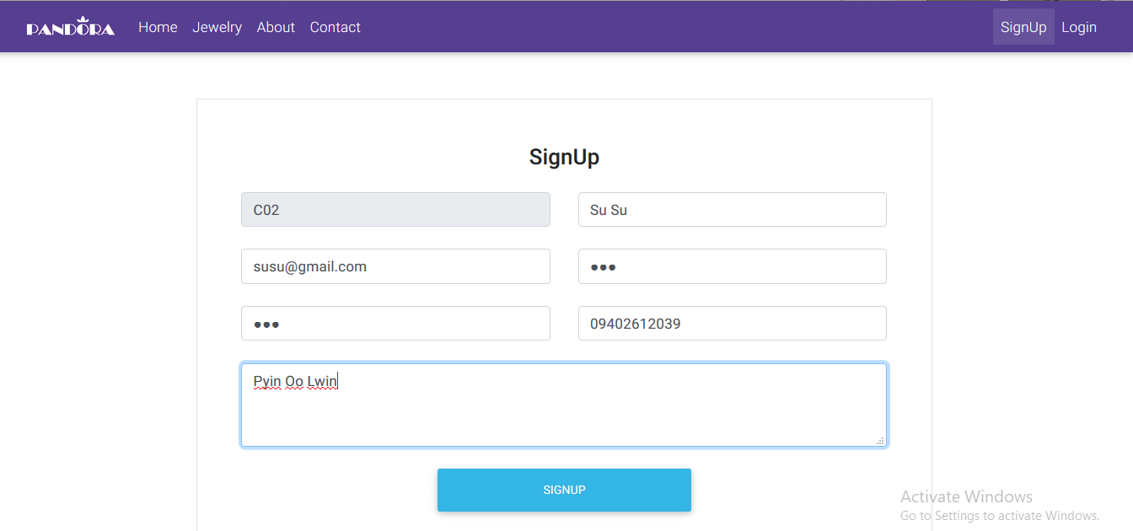

Fig – Customer Signup

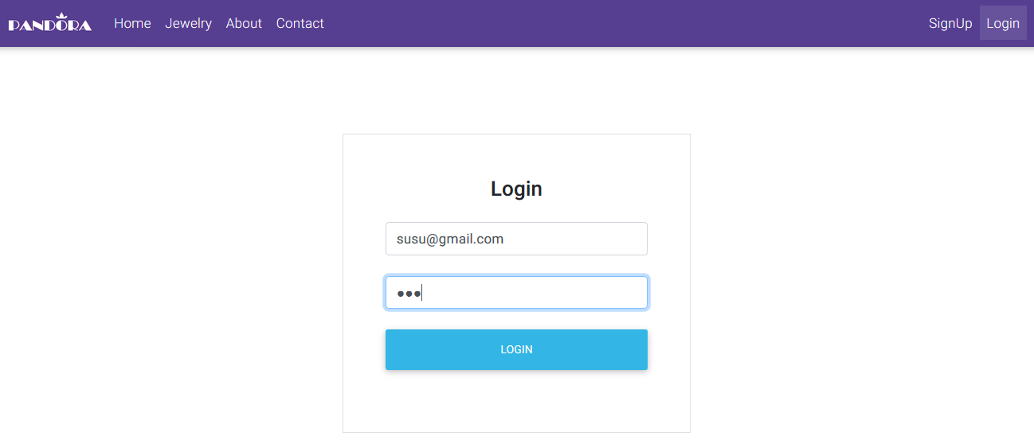

Fig – Customer Login



Fig – Customer home page

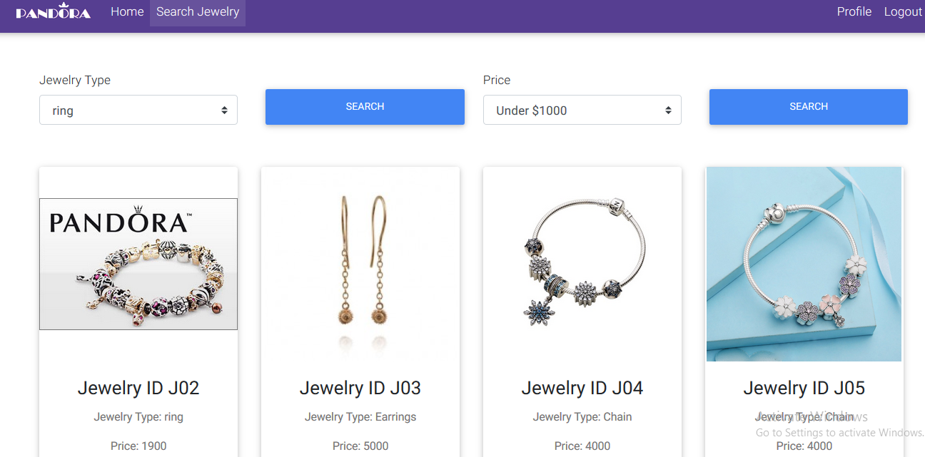

Fig – Search jewelries page

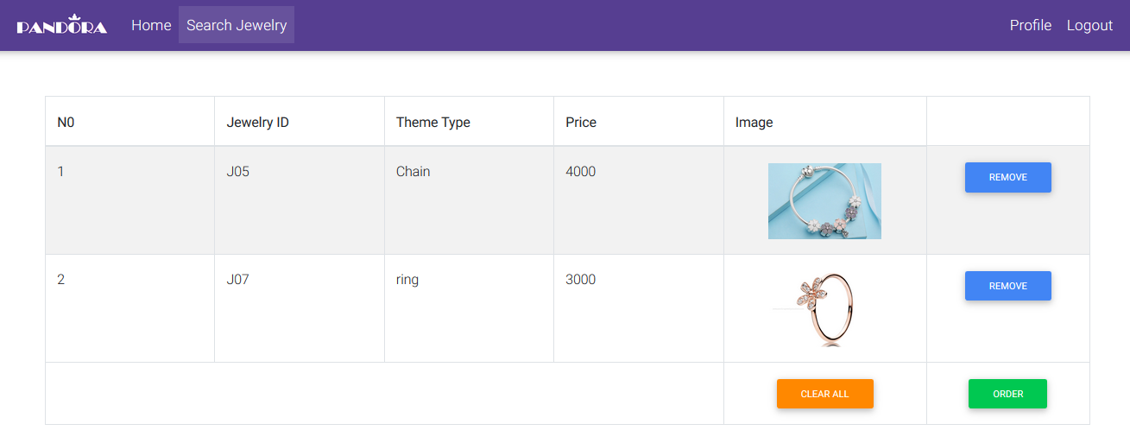

Fig – Add jewelry item to cart

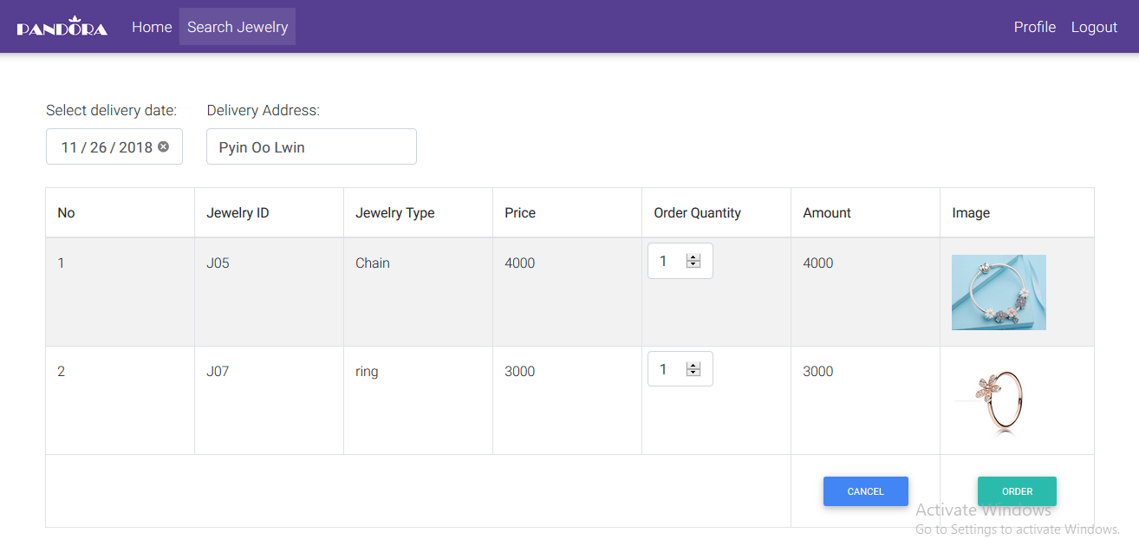

Fig – Order jewelry item with order details

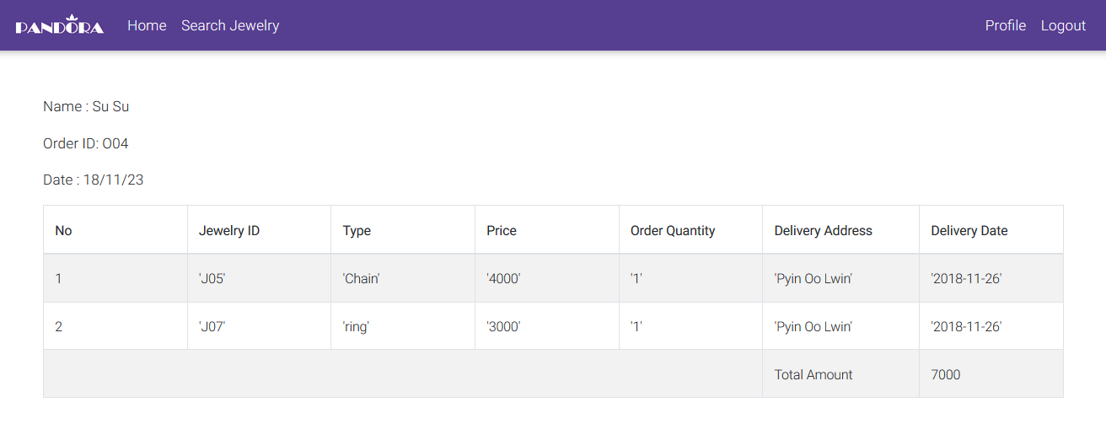

Fig – View invoice with total amount

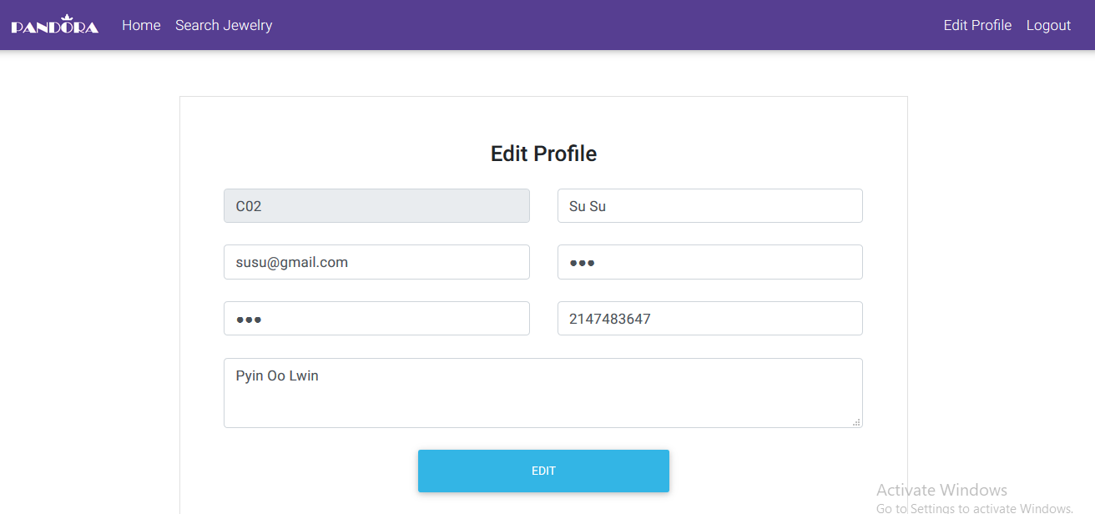

Fig – Customer can edit their information



Fig – Staff home page

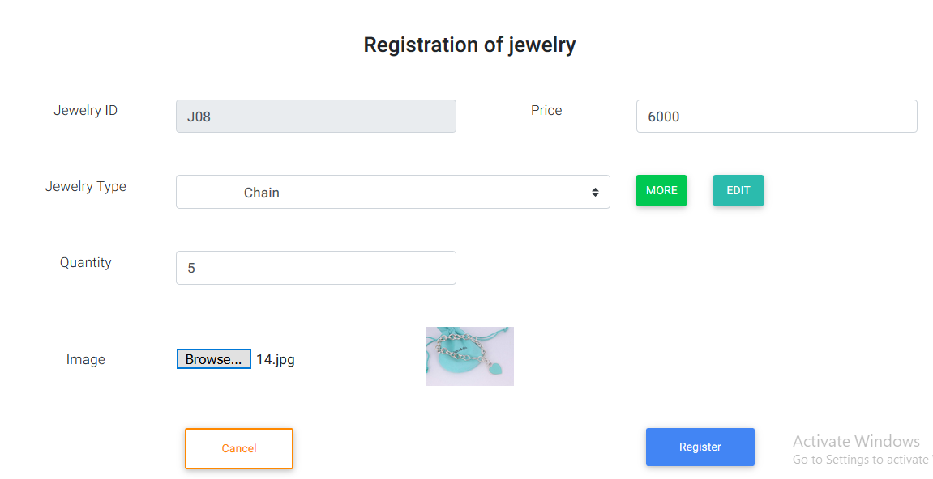

Fig – Jewelry registration page

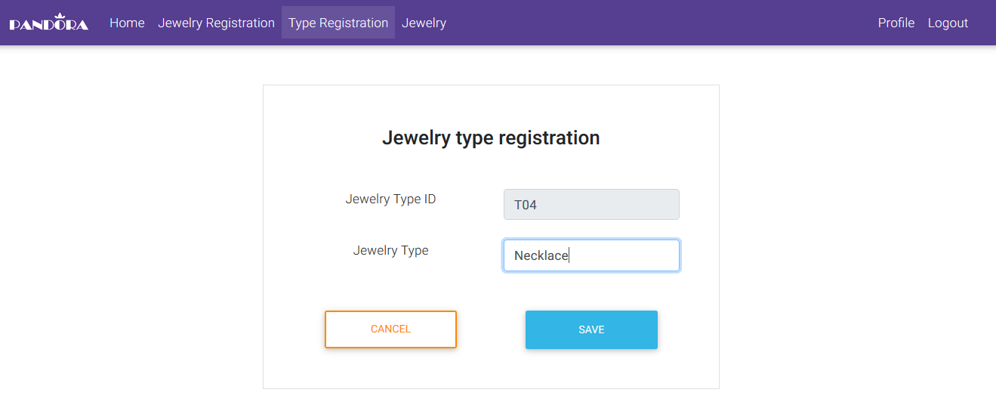

Fig – Jewelry type registration

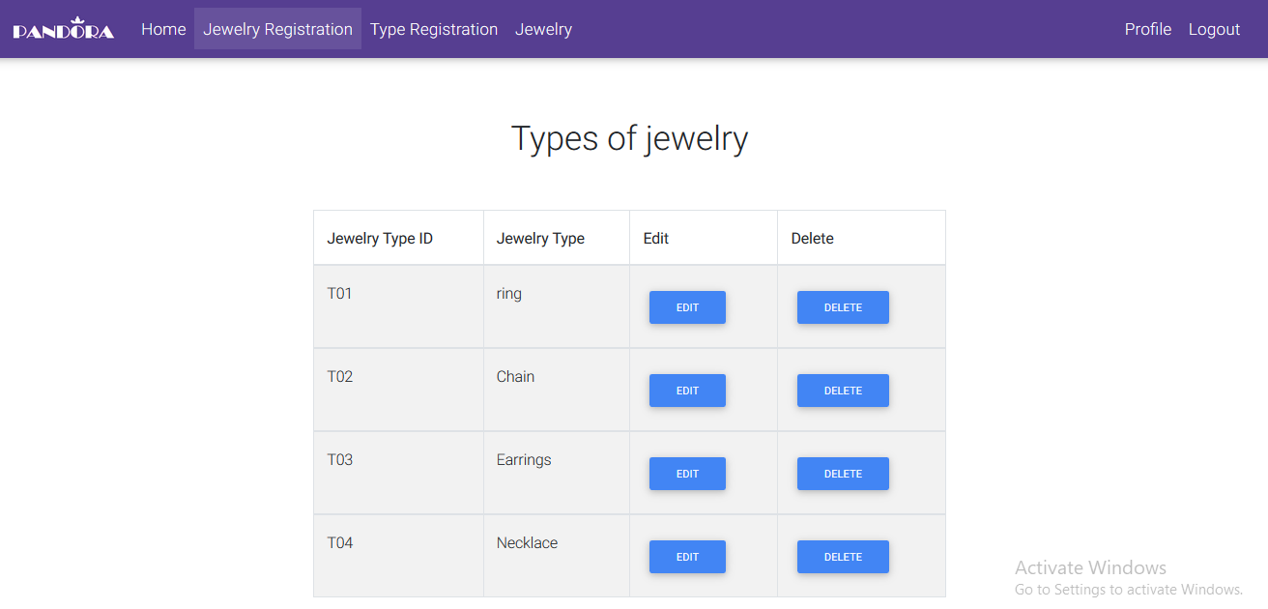

Fig – Staffs can make edit or delete jewelry type

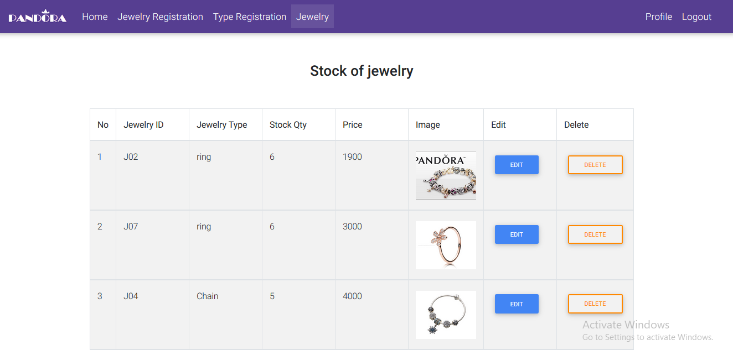

Fig – Staffs can make edit or delete jewelry

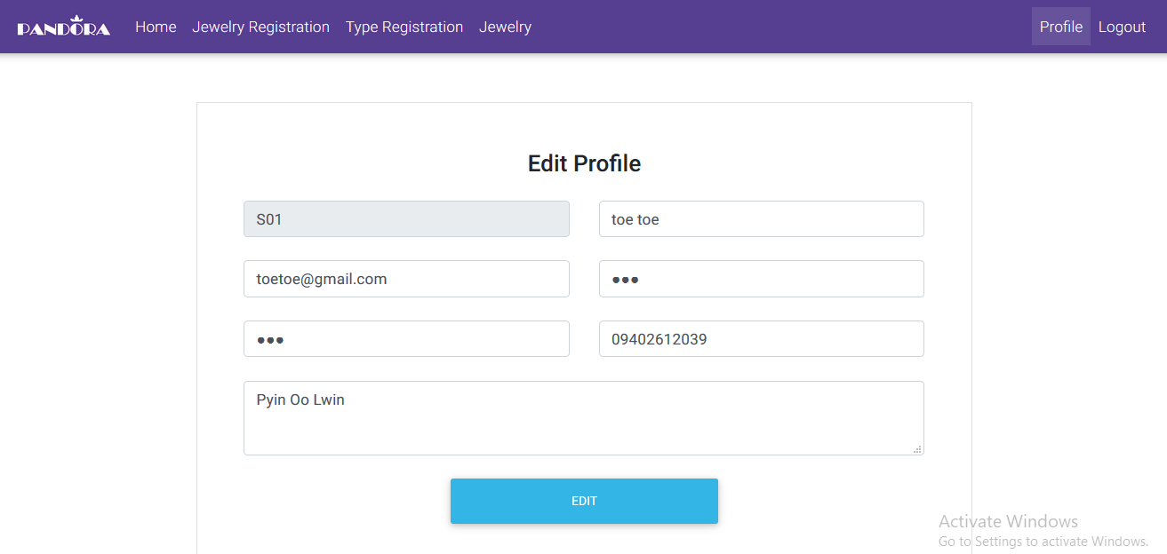

Fig – Staffs can edit on their profile

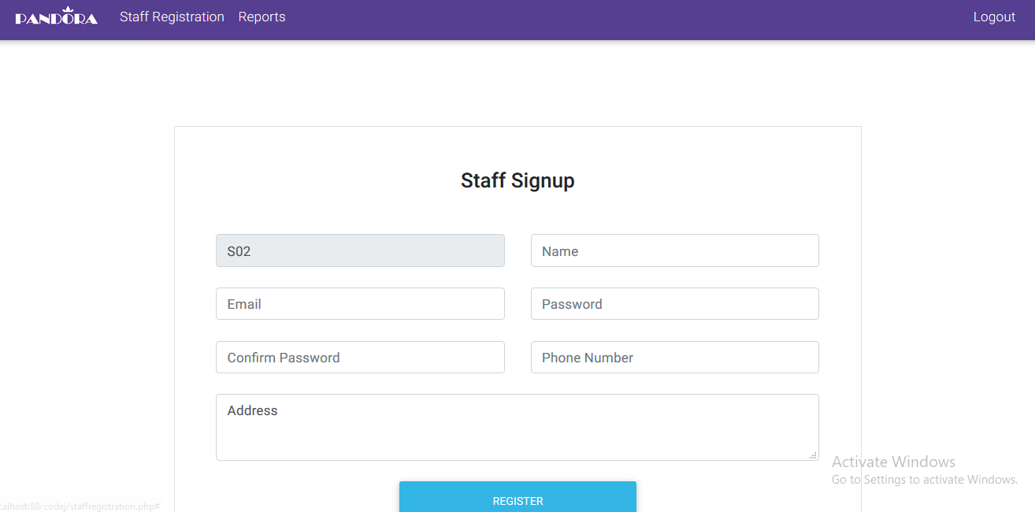Fig – Staff registration by manger



Fig – Produce reports by manager

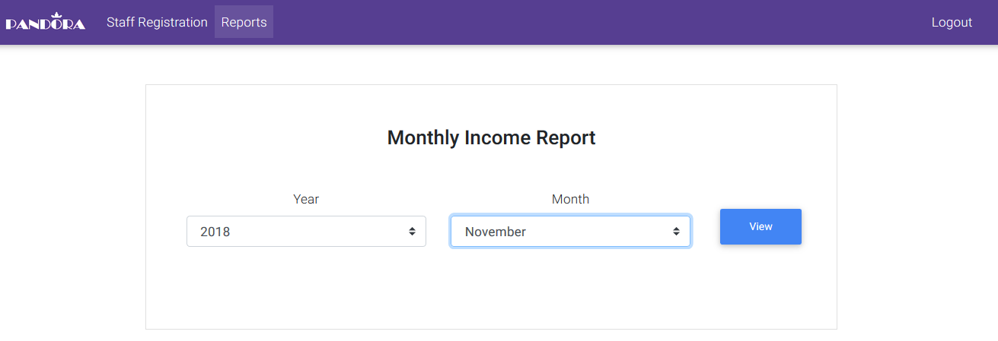

Fig – Select year and month to produce monthly income report

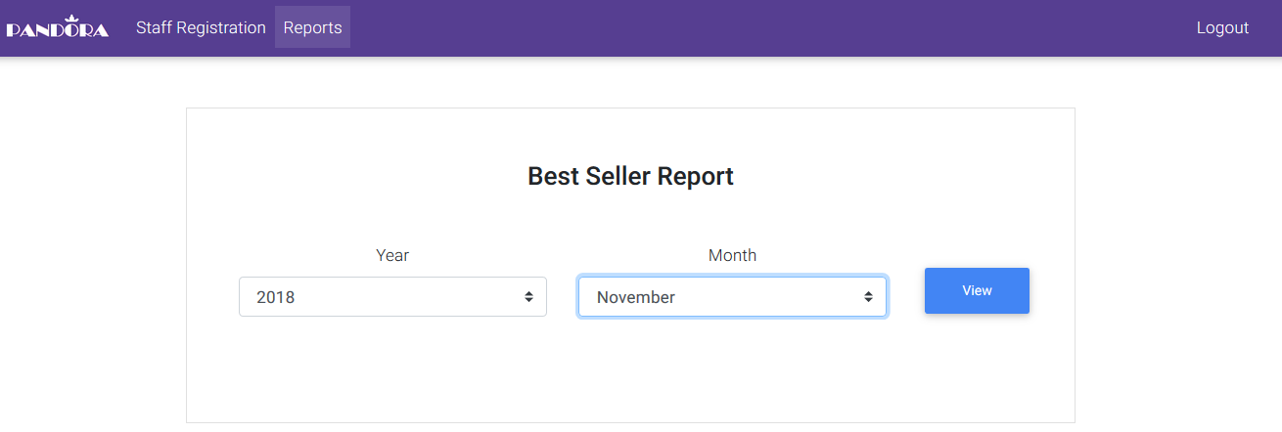

Fig – Select year and month to produce best seller report

## Database Structures

**Attributes and data of customer table**

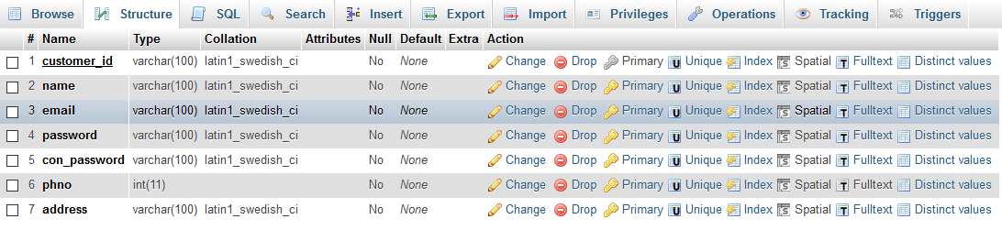

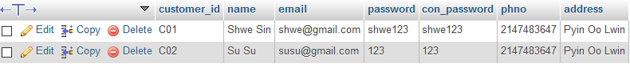

**Attributes and data of staff table**

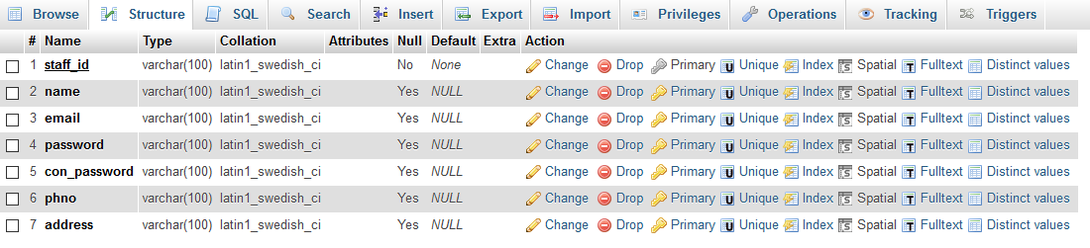



**Attributes and data of jewelry table**

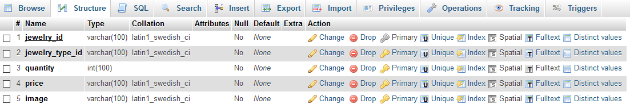



**Attributes and data of jewelry_type table**

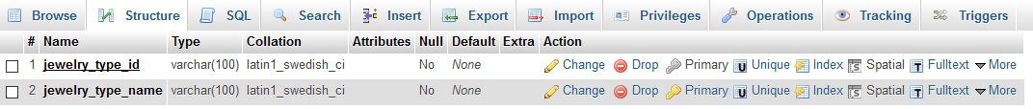



**Attributes and data of order table**

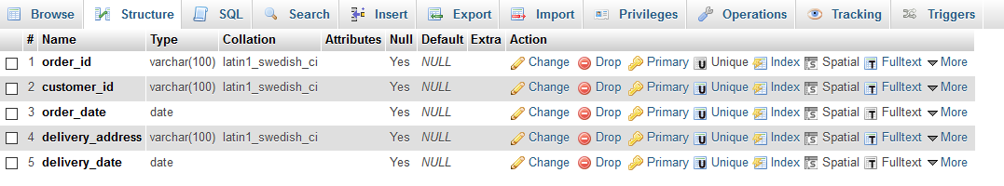



**Attributes and data of order_detail table**



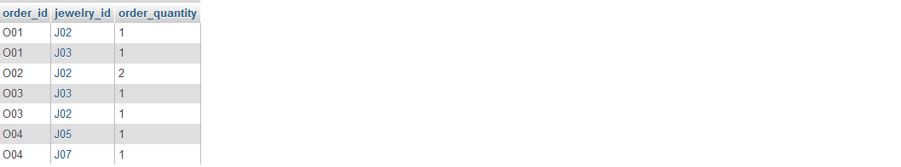

# Chapter – 12

# Human Computer Interface

## 12.1 Human computer interface

Human computer interface focuses on the interaction between humans and computers especially the design of computerized system. It is a community of people who study user experience design, user research, and software development, etc. It is also include the input/output devices when performing with computerized system. The goals of HCI are to produce usability system. It is aim to provide acceptable design for all users such as displaying with good resolution, choice of color and design, etc. Good design can attract more people to use the system. So, developer should develop attractive, clear to understand, easy to use and responsive design. Most HCI systems are safe, easy, effective and useable.

## 12.2 User analysis

In system design, user analysis identifies the kinds of users who will used the development of software system. The developers can identify the gaps between what a person needs form a system and what the system actually provides. In this process, developers use interviews, observations, questionnaires and other forms of research to gather information about users of their system. User analysis is made with developing use cases that are stated the actual flow of system development. So, users can easily know their roles in system. There are many types of users when using the software system. Some of the common user types are:

End users – They have experience of the computer system. They understand particular concepts of the computer such as files, folders, saving and deleting, etc.

Casual users – They have knowledge of the computer system. They only consider the goals of using that computer system. They are familiar with technology development.

Trained users – They are trained for the system. Especially, they are staffs, managers of the system.

Novices – They need to know how to use the system. They are common not familiar with computers and lack of knowledge about with software systems.

## 12.3 Choice of dialogs

In this system, the developers should focus on casual users and trained users as part of design process. The goal of user interface is to get good interaction between users and the software. When choosing dialogs, the system must be useable for casual users and the system must improve speed and power for trained users. Choices of dialogs are:

Form Building – this is one of the process of gathering user requirements. It can see as a type of form and it can found in many office and database applications.

Questions and answers – The system should develop with clear questions and answers. But avoid apologies, alarm and ambiguity usage.

Menus – A collection of possible user actions on the screen. Users will select one option by clicking them.

Buttons – The button labels should be understandable name.

Shortcut key – it is a special key that combines specific keys for interact with computerized system. For examples computerized ticket machines, computer games, etc.

Command line – Users make input into command line. The system produces output to the users. These are commonly used by trained users who are familiar with computerized system.

# Chapter – 13

# System Security

## 13.1 System Security

System security protects a computerized system from hacking or viewing private data. Lack of security system may lead to a project failure. Some factors of system security are: hardware security, software security and web security. The countermeasure of these security factors includes controlling the access of physical devices, protecting from unauthorized network access, data and code injection, etc.

Antivirus protection, form authentication and keep software up-to-date should perform as a security key. Risk assessment must be performed to identify the potential risks of the system. Business continuity planning and disaster recovery planning are other fact of system security. Developers should consider what could happen if a major business disruption occurs and they need to plan to run the business immediately.

As part of web based system, the system can be faces the following kinds of threads:

Unauthorized access – This is one of the common security risks to obtain confidential data. Unauthorized access is attempted by hackers, unwanted intruders who want to find weaknesses of the system.

Computer viruses – Virus is small piece of software that gives negative effectives for computer. Viruses are used to enter a computer without a user’s permission and continuing to spread. Viruses are transmitted over network or via USB drives and other portable media. The virus could steal, delete, corrupt data on the infected computer. Most common types of virus are worms and Trojan horses, etc.

Spyware Threads – Spyware are infected through software download. Spyware are used to monitor user activities that can capture personal information.

Phishing – Phishing attempts to obtain private information that is created by cybercriminals. The goal of phishing is to attempt for getting private information via fraudulent email or instant messages.

Malware – Malware is an acronym of “malicious software”. Malware is created cybercriminals to show their skills or to spy on their victims.

## 13.2 Counter measure to potential threats to the system

The counter measure action will need to perform to reduce the effect of threads. The system security threats can counter by using firewalls, encryption methods. A firewall are used as an interaction between an internal computer network and the internet. The system administrator can limit users can access particular files by using firewall.

The organization must have local security measure. The organization should install antivirus software to protect against viruses. The organization should perform form validation to protect from unauthorized access. The system should use **detection and prevention systems for protect against denial of service attacks**.

Encryption also can help from unauthorized access. This is often used when data is transmitted over the internet that data can see by others. Encryption encodes messages with a decryption key. So that message can only be seen by individuals. It can be used in e-commerce system especially internet banking, where the database contain credit card information.

These security countermeasures include controlling the access of physical devices, protecting from unauthorized network access, data and code injection, etc. Antivirus protection, form authentication and keep software up-to-date should perform as a security key. Risk assessment must be performed to identify the potential risks of the system. Business continuity planning and disaster recovery planning are added measures of system security. Developers should consider what could happen if a major business disruption occurs and they need to plan to recover and have continuously the business immediately.

# Chapter – 14

# Critical Appraisal

There are many difficulties during the development of life cycle. In the analysis stage, I need to consider what type of ways will be used to gather the data. I used observation which is one type of fact finding techniques to gather information about the manual system. Then I develop and implement workshops with the Pandora’s employees.

When developing workshops, I have faced a lot of conflicts with some staffs. They didn’t want to give time for corporation. They are busy with their works. So, I asked all information to manager to implement the new system.

Then, I developed the workshop within a week. I got all information required for the system from this workshop. Then, I produced the project proposal for the system development and shown to my supervisor. He gave other ideas that will need for the system and highlighted some problems. I make correction iteratively. After the scope is confirmed, I started to develop the system. Then, I listed functional and non-functional requirement.

When choosing in system development method, I don’t clearly understand the difference between method and approach. So, I made research from online and lectures. Finally I choose Dynamic system development method and iterative and incremental approach.

Then, I considered that project is technically, legally, financially and operationally feasible. I was confused these feasibility factors. I made research these feasibility factors form lectures and online. And I made system analysis and design by using OOADM-UML.

As part of diagramming, I drew use case, class diagrams for systems design. I drew sequence and activity diagrams for detail design. But I was misunderstanding with these diagrams. So, I research about that diagrams and how to draw that diagram. Then I used Microsoft Visio to draw that diagrams. But I had learned how to use Microsoft Visio and how its functions work. After all, I send to my supervisors to get confirmation.

Then, I choose the developer tools for the system development. I choose Notepad++ as a developer tools to develop the system. But I don’t know details functions of Notepad++ so I was search about notepad++ information on online.

As part of programming language, I choose PHP that is familiar with me. Then I considered about DBMS and I choose MySQL database management system for the database. I had faced a lot of query errors. So, I studied about DBMS from the websites. I got many guidance from my technical lecture when writing the code.

As part of system design, I used HTML and CSS programming language. I made user analysis. I need to know what kinds of users will be used the computerized system. Then, I developed the system design with the objective of good usability. But, I faced misunderstanding with HTML and CSS codes. SO, I learned about HTML and CSS code from the websites.

When all system implementation phased is performed, I need to test on the functions and need to check that system can produce the expected results. When choosing the testing types, I don’t understand some types of testing so I learned from lectures. I performed testing by comparing actual results and expected results. If there is an error, I made correction and test again.

By implementing the project, I got a lot of knowledge about the tools and techniques of development project. And I also had known programming language and DBMS system. I tried all the best for this project.