[sst_title_page]
class | Clsss - 10
subject | Social Science
chapter_number | Chapter - 3
chapter_name | Making of a Global World
lesson | Lesson - 5
topic | Modern World

[sst_homework_page]
Question goes here

[math_content_page]
$${\left(x+a\right)}^{n}=\sum_{k=0}^{n}{\left({n \atop k}\right)x^{k}a^{n-k}}$$

[sst_activity_static_page]

[sst_homework_question_page]
This is the question for home work

[sst_deafult_page]
*add content here from the orginal script*
- Hfjkdfhd
  - jkdhjfkdhjf
- dfhjkdf

thid | dfd | dfd
df | df | df

[sst_activity_page]
Here is the question for activity page


[sst_activity_page]
With Your Partner, Discuss:
- This is the question
- This is antoerh qutseion is antoerh qutseion is antoerh qutseion
- Thd is antoerh qutseion is antoerh qutseion is antoerh qutseion is antoerh qutseion


[sst_homework_question_page]
- This is the qusion

[sst_homework_question_page]
- This is the qusion one
- This is the qustn 2

[sst_previous_page] [add_syr]
- This is the previous page text
  - Sub bullet
- This ist he previeow page text 3
- This tiehs tpreive

[sst_lo_page] [ask_question this is qureiondfnkdfjkdfh?)]
- Who runs a gram panchayat? How do they do it?
- Detejr

[final_quiz_page]
Question | Answer
What is the capital of India? | Delhi
Who is the prime minisitro fo Indian? | Narendra Modi
dfdfd | dfd
dfd
dfdf | dfd

[sst_summary_page]
- The Pre-Modern world saw the beginnings of globalization.
  - Jkdhjfkd
- Silk routes were crucial historical links connecting Asia with Europe.
- 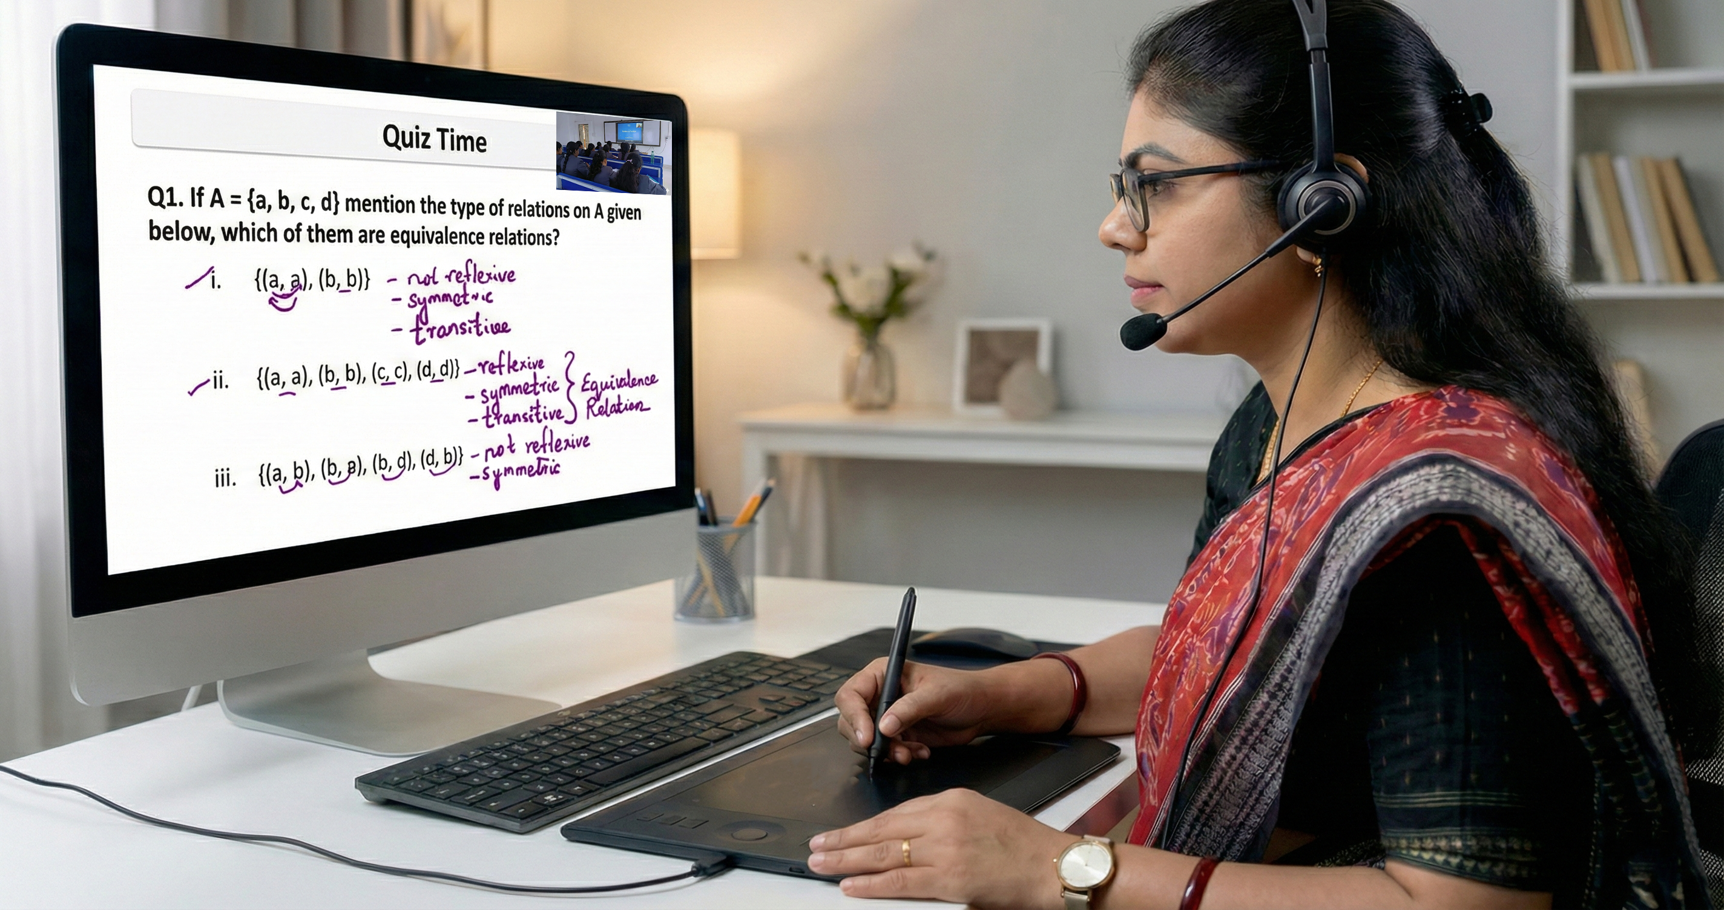

[sst_quiztime_page]
Which of the following was NOT a factor in the making of a global world?
- Industrial Revolution
- Invention of the Internet
- Silk Routes
- Silk Routes

[sst_quiztime_page]
Which of the following was NOT a factor in the making of a global world?

[sst_quiztime_page] [add_syr]
Which of the following was NOT a factor in the making of a global world?
- Industrial Revolution jkdljfd
- Invention of the Internet
- Silk Routes jdkljfd uodth dljf
- Silk Routes jkdjfkd kjkljfdlk kldfdf

[sst_content_page]
topic: This is the one of the topic anme
subtopic: economic
- The steam engine transformed manufacturing and transport.
- Fgfgf
- Fgghg



[sst_content_page]
topic: Multiple image
subtopic: math is the one of the big hjdhfkjd kjhdf
- The steam engine transformed manufacturing and transport.
- Djflkdjflkd
- jlkdjf

[sst_content_page]
topic: Multiple image
subtopic: math is the one of the big hjdhfkjd kjhdf
- The steam engine transformed manufacturing and transport.
- Djflkdjflkd
- jlkdjf


[sst_notedown_page]
This is the heading
- This is the subheading
- This is also the subheading 2
  - This is another subheading

[sst_discussion_page]
- Why did industrialization begin in Britain?

[sst_discussion_page]
- Why did industrialization begin in Britain?
- This is another cu
- Jkljdf

