Traverse CPA
KPI and Calculation Reference
Every KPI, gate and calculation in the Control Loop Performance module: what it means, the formula behind it, its thresholds, and where it appears on screen.

Item | Value
Document | kpi-documentation.docx
Scope | CPA / CPLM module: Flink calculation jobs, cplm-api, /cpm pages
Code baseline | branch feat/v25-next-release @ 97ce20f9 (SME review batch, CHG-040 … CHG-064)
Date | 7 October 2026
Audience | Process / control engineers, plant reviewers, support and commissioning engineers
Method | Formulas transcribed from source code (file and line references in Appendix A); screenshots from the lab system

Contents
1. How to read this document 3
2. Where every number comes from 3
2.1 Sample qualification (applies to every job) 4
2.2 Window specification (every window the engine evaluates) 4
3. Gate tiers and status vocabulary 5
4. Loop performance KPIs and gates G0–G4 (short windows) 6
5. Diagnostic evidence G5–G11 and G13 (long windows) 6
6. G12 System response (step response) 7
7. G14 valve confirmation and G15 fused diagnosis 7
7.1 Evaluation order 7
7.2 Detector scores and family scores 8
7.3 G14 valve-position confirmation 8
7.4 Confidence bands, severity and the evidence score 8
7.5 Persistence 9
7.6 Observations and possible causes (v2 verdict) 9
8. Episodes (Loop Events) 9
9. Instrument health (NAMUR NE107) 10
10. Default thresholds per loop class 10
11. Page-by-page KPI reference 10
11.1 Operations overview (/cpm) 11
11.2 Performance (/cpm/performance) 13
11.3 Loop Explorer (/cpm/explorer) 14
11.4 Investigation (/cpm/investigation) 15
11.5 Evidence Workbench (/cpm/evidence) 17
11.5b Evidence Replay (/cpm/replay) 18
11.6 Window Inspector (/cpm/windows) 19
11.7 Calculations (/cpm/calculations) 20
11.8 System Response (/cpm/response) 21
11.9 Historical (/cpm/historical) 22
11.10 Loop Events (/cpm/events) 23
11.11 Loop Registry, Gate Configuration, Pipeline Health 24
12. Calculation catalogue (CPLM IDs) 25
13. Alarm KPIs (AMS, outside the CPA pages) 26
14. Known gaps and inconsistencies 26
Appendix A — Source index 27
Appendix B — Short-window field dictionary (1m … 60m) 27
Appendix C — Long-window field dictionary (4h / 12h / 24h) 30

1. How to read this document
Sections 2–10 explain how the engine computes each number; Section 11 walks through every page and says which number is shown where and how it is formatted; Section 2.2 specifies every window; Section 12 lists the calculation catalogue; Section 14 lists known gaps; Appendices B and C list every stored short-window and long-window value. Formulas are written as plain arithmetic; monospace names are the stored field or configuration key.
Term | Meaning
Window | A time slice of samples evaluated as one unit. Short windows 1m–60m (KPIs, G0–G4); long windows 4h / 12h / 24h (diagnostics); fused verdicts on 12h and 24h only.
Gate (G0–G15) | One check or detector with a status (PASS, WARN, FAIL, STRONG, …). Gates are grouped in tiers: eligibility, performance, diagnostic evidence, confirmation, fusion.
Verdict / diagnosis | The G15 fused result for a window, e.g. CONFIRMED_OSCILLATION. Its prefix is the confidence band; its suffix is the fault family.
Evidence score | The fused confidence (0–1) shown as 0–100. How completely the observed symptoms match a family's signature; uncalibrated, not a probability (GUM).
Severity | LOW / MEDIUM / HIGH, derived only from the evidence-score band.
Priority | High / Medium / Low = loop criticality × severity (ISA-18.2 / EEMUA 191 style).
Episode | One continuous fault of one family on one loop (Loop Events), opened and closed from LIVE verdicts.
Observability flag | A missing input or limitation on a window (NO_VP, HEALTH_NOT_CONFIGURED, NO_UPSTREAM_LINKS, NO_STEP_TEST, NO_VALID_CYCLE, …).
Good-error band | ±0.5 % of the declared PV span around SP (0.5 engineering units when no PV range is declared).
PV / SP / OP / VP / MODE | Process variable, setpoint, controller output (0–100 %), valve position (optional), controller mode.

2. Where every number comes from
Every CPA KPI is computed once, in Apache Flink, from the loop's own samples (PV, SP, OP, MODE, optional VP, each with an OPC quality). The .NET service cplm-api stores the results, builds episodes and fleet roll-ups, and the React pages only format them. No page recomputes an engine number.
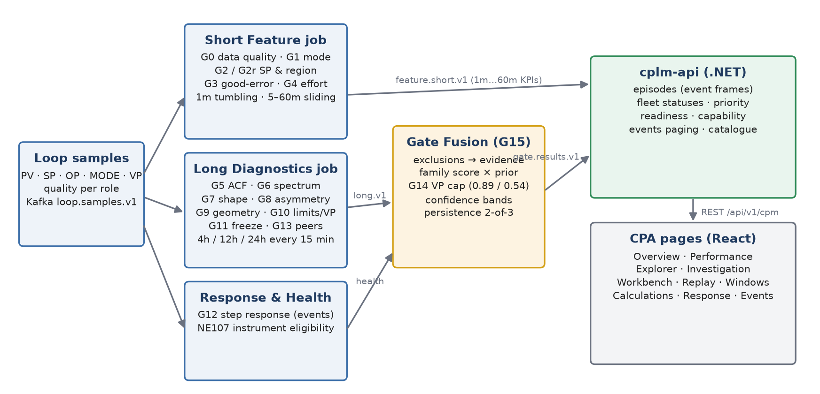
Figure 1 — Calculation pipeline (samples → Flink jobs → cplm-api → pages)
Stage | Job / component | Computes | Window and cadence | Output
Short features | CplmShortFeatureStreamJob | G0, G1, G2, G2r, G3, G4 and the loop KPIs (MAE, IAE, good-error time, effort…) | 1m tumbling; 5m (1 min slide), 10m (2 min), 15m / 30m / 60m (5 min slide) | feature.short.v1
Long diagnostics | CplmLongDiagnosticsStreamJob | G5–G11, G13, VP tracking (G14 input), plus an aligned G0–G4 recompute | Sliding 4h / 12h / 24h, re-evaluated every 15 min; slice needs ≥ 32 samples | feature.long.v1
Gate fusion | CplmGateFusionStreamJob | Exclusions, G12 flag, G13 status, G14 confirmation, G15 diagnosis + evidence score | Fires on 12h and 24h only (every 15 min per kind) | gate.results.v1
System response | CplmResponseAnalysisJob | G12 step response: observed metrics, process model, validation | Event-driven (each qualifying SP / OP step) | response.results.v1
Instrument health | CplmInstrumentContextJob | NE107 eligibility per loop role | Per observation + 60 s freshness timer | context.instrument-health.v1
Episodes, fleet KPIs | cplm-api (C#) | Event frames, operating picture, priority, readiness, capability | Per fused record / per request | PostgreSQL traverse_cplm + REST /api/v1/cpm

Important: the G0–G4 values on a fused 12h / 24h verdict come from a recompute over that same 12h / 24h window, not from the 1m–60m short windows. The two can legitimately differ (the Calculations page labels each value with its window).

2.1 Sample qualification (applies to every job)
Rule | Definition
Valid sample | PV, SP and OP finite and parsed; otherwise dropped at ingest. A non-finite VP becomes "no VP" (the sample stays).
Good quality | Only the normalised token GOOD. UNCERTAIN, BAD, missing and UNKNOWN are not good. Bad samples stay in the arrays and only count in bad_quality_pct.
Automatic mode | AUTO, AUT, A, AUTOMATIC, NORMAL, NORM, CAS, CASC, CASCADE, RSP, DDC, SUP, SUPERVISORY (or containing AUTO / CASCADE). Manual tokens (MAN, IMAN, LO, OFF, TRACK, …) win.
Eligible VP | VP present, quality GOOD and not a held value older than 60 s (vpMaxAgeS).
Sample period Ts | Median observed interval between samples (5 s if fewer than 2 samples).
Statistics | σ is the population standard deviation; OP is normalised to 0–100 % of the declared OP range when one is declared.

2.2 Window specification (every window the engine evaluates)
Short windows carry the loop KPIs and gates G0–G4; long windows carry the diagnostics G5–G11 and G13 (and an aligned G0–G4 recompute); only the 12h and 24h long windows produce a fused verdict (G12, G14, G15). All windows are event-time, half-open [start, end).
Window | Tier | Type | Size / slide (new result every) | Allowed lateness | Minimum data | Gates | Fused verdict
1m | short | tumbling | 1 min / — | 30 s | ≥ 10 samples and G0 not FAIL | G0–G4 | no
5m | short | sliding | 5 min / 1 min | 60 s | same | G0–G4 | no
10m | short | sliding | 10 min / 2 min | 90 s | same | G0–G4 | no
15m | short | sliding | 15 min / 5 min | 2 min | same | G0–G4 | no
30m | short | sliding | 30 min / 5 min | 2 min | same | G0–G4 | no
60m | short | sliding | 60 min / 5 min | 3 min | same | G0–G4 | no
4h | long | rolling buffer | 4 h / 15 min | n/a (recomputed) | slice emitted only with ≥ 32 samples | G5–G11, G13 (+ G0–G4) | no
12h | long | rolling buffer | 12 h / 15 min | n/a (recomputed) | same | G5–G11, G13 (+ G0–G4) | yes → G12, G14, G15
24h | long | rolling buffer | 24 h / 15 min | n/a (recomputed) | same | G5–G11, G13 (+ G0–G4) | yes → G12, G14, G15

Rule | Definition
Short window declined | sufficient_data = false when G0 = FAIL or n < 10: metrics are null, G1–G4 = NOT_EVALUATED; shown as DECLINED
Long window unqualified | long_metrics_qualified = false when the aligned G0 failed; shown as UNQUALIFIED / Insufficient data
Expected samples | round(window seconds / grid); grid = declared acquisition grid, else the median observed interval (5 s fallback)
Overlap | sliding windows overlap the previous one (e.g. 60m / 5 min shares 55 min); each emission is a separate stored row
Long buffer | 24 h + 10 min of samples per loop, re-evaluated on a 15-min event-time timer; every 15 min a new 4h, 12h and 24h row
Fused verdict | 12h and 24h long rows only; its G0–G4 come from the same 12h / 24h window, not from a short window

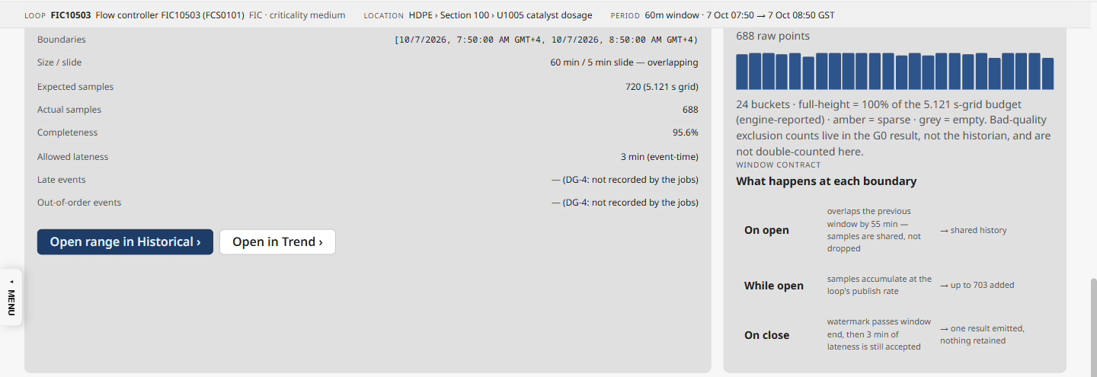
Window Inspector — the contract of one 60m window (boundaries, expected vs actual samples, lateness) and its raw sample density
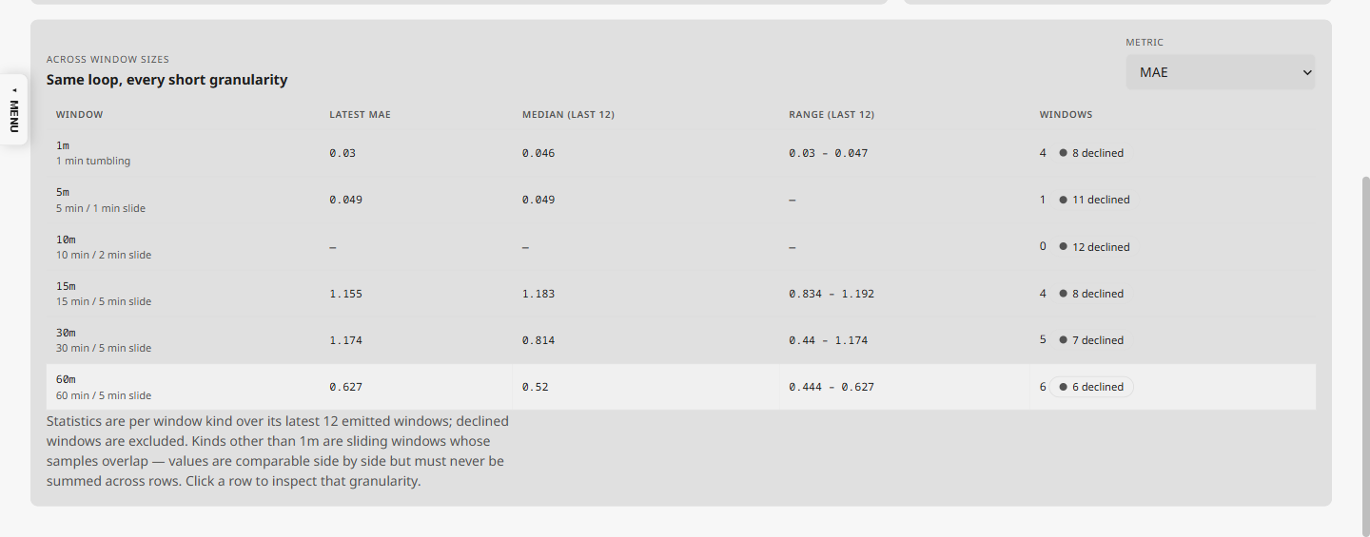
Window Inspector — one KPI (MAE) across every short window size: latest, median and range of the last 12, and windows declined

3. Gate tiers and status vocabulary
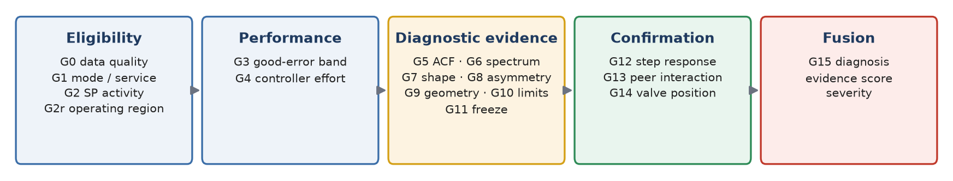
Figure 2 — The sixteen gates, by the question they answer
Mark on screen | Engine status | Meaning | Colour
✓ OK | PASS (eligibility, performance, confirmation tier) | Check passed on full inputs | Green
✓ OK on available data | PASS while one of the gate's inputs is missing (CHG-064) | Passed, but judged without e.g. VP, a health source, peers or a step test | Grey
! Attention | WARN / REVIEW (check tiers) | Check needs attention | Amber
✕ Failed | FAIL (performance / confirmation) | Check failed | Red
⊘ Not usable | FAIL on an eligibility gate, EXCLUDED_* | Window cannot be judged | Grey
◯ Not seen | PASS on a diagnostic gate (G5–G11) | Symptom not seen by this method | Grey
◐ Seen | WARN on a diagnostic gate | Symptom seen | Amber
⬤ Strong | STRONG / FAIL on a diagnostic gate | Strong symptom evidence | Amber
△ Suspected / ▲ Confirmed | SUSPECTED / CONFIRMED (G14, G15) | Condition suspected / confirmed | Amber / Red
— No verdict | NOT_EVALUATED, PENDING, N/A, INSUFFICIENT_* | Not evaluated | Grey

ISA-101: colour is never the only cue (shape + word), and red is reserved for a failed performance check or a confirmed condition. Marks come from gateStatus.ts; the fleet "Needs attention" counts use the older grouping reviewSeverity (FAIL / STRONG / EXCLUDED / CONFIRMED = bad; WARN / REVIEW / SUSPECTED = warn).

4. Loop performance KPIs and gates G0–G4 (short windows)
Computed in ShortFeatureCalculator for every 1m … 60m window. If G0 fails or the window has fewer than 10 samples, the window is marked insufficient: its metrics are null and G1–G4 read NOT_EVALUATED.
Core loop KPI formulas
e(i) = SP(i) − PV(i) control error, PV units
MAE = mean |e| RMSE = sqrt(mean e²) (sample means)
IAE = Σ |e(i)|·Δt(i) ISE = Σ e(i)²·Δt(i) Δt(i) = t(i+1) − t(i)
ITAE = Σ (t(i) − t_start)·|e(i)|·Δt(i)
band = 0.005 × (PV_max − PV_min) 0.5 EU if no PV range declared
good_error_pct = count(|e| ≤ band) / n "% in band", "Good-error time"
auto_pct = count(mode is automatic) / n "Time in auto" (per sample)
saturation_pct = count(OP ≤ 5 % or OP ≥ 95 %) / n
OCE = auto_pct × good_error_pct × (1 − saturation_pct)
effort_ratio = σ(OP) / σ(PV)
activity = (σ(OP)/100) / (σ(PV)/(PV_max − PV_min)) (else effort_ratio)

Gate | Calculated values | Status rule (default thresholds) | Configuration keys
G0 Data quality | completeness = n / round(window / grid); bad_quality_pct = non-GOOD / n; duplicates; gaps (Δt > 1.5·Ts) | FAIL if bad ≥ 0.50; PASS if completeness ≥ 0.98 and bad < 0.05 and no duplicates; WARN if completeness ≥ 0.95; else FAIL | G0.coverage_min 0.95, G0.bad_fraction_max 0.05 (0.98 and 0.50 are fixed)
G1 Mode / service | auto_pct, mode_changes_per_h | PASS ≥ 0.90; WARN ≥ 0.70; else EXCLUDED (window excluded from diagnosis) | G1.auto_fraction_min 0.70 (0.90 fixed)
G2 SP activity | sp_range = max SP − min SP; band = 1 % of PV span (5 % for averaging loops) | PASS if sp_range < band, else WARN (never FAIL) | G2.stability_band_span_fraction, G2.stability_band_pv_eu
G2r Operating region | share of samples with PV or OP outside the commissioned region | PASS ≤ 0.05; WARN ≤ 0.20; else FAIL (→ EXCLUDED_OPERATING_REGION) | region bounds G2r.* (0.05 / 0.20 fixed)
G3 Base performance | good_error_pct, MAE, RMSE, IAE, ISE, ITAE, OCE | PASS if good_error_pct ≥ 0.50 (0.30 for averaging loops), else WARN | G3.error_band_span_fraction 0.005; G3.objective_compliance_min (×100)
G4 Controller effort | activity_ratio_norm (or effort_ratio), OP travel/day, reversals/h, saturation, freeze run | STRONG if activity > 8; WARN if > 3; else PASS | G4.activity_warn_ratio 3, G4.activity_high_ratio 8

5. Diagnostic evidence G5–G11 and G13 (long windows)
Computed in LongDiagnosticsCalculator on 4h / 12h / 24h windows every 15 minutes. The shape signal x is PV for integrating loops (level, gas pressure) and OP otherwise; it is detrended before the oscillation methods.
Long-window formulas
ACF ρ(k) = [Σ x(i)·x(i+k)/(n−k)] / γ0, γ0 = Σ x²/n, k = 1 … min(n/2, 2000)
period P = median of 2·(z(j+1) − z(j))·Ts over ACF zero crossings (acf_period_s)
regularity r = min(1, P / (3·σ(periods))) (acf_regularity)
spectrum Welch PSD, Hann, 50 % overlap; peak_ratio = peak-lobe energy / total
harmonics HAR = (A2 + A3 + A5) / A1 HER = (A2² + A3² + A5²) / A1²
shape cycle score = SSE_sine / (SSE_sine + SSE_tri); triangularity = mean
asymmetry φ±(k) = xcorr of standardised OP, PV
oddness = Σ|φ+ − φ−| / (Σ|φ+ − φ−| + Σ|φ+ + φ−|)
geometry area_norm = mean |shoelace area per cycle| / (ΔPV_range · ΔOP_range)
limits saturation = count(OP ≤ 5 or OP ≥ 95 pp) / n; dwell = longest run at limit
freeze freeze_index_s = longest run of |ΔPV| ≤ 1e-9, × Ts
material freeze ⇔ ≥ 60 s and ≥ 10 % of the window

Gate | Question | Status rule (defaults) | Notes
G5 Oscillation (ACF) | Is there a regular cycle? | WARN when any ACF period exists, else PASS | Period validation (band τmin–τmax, regularity ≥ 0.10, ≥ 8 samples/period) is separate and feeds G7 / G9 / fusion
G6 Spectrum | Is one frequency dominant? | WARN if peak_ratio > 0.5, else PASS | Fallback period source (FFT, harmonic fold k = 2…5)
G7 Shape | Triangular (stick-slip) rather than sine? | NOT_EVALUATED without a valid period; STRONG if triangularity > 0.8; else PASS | G7.shape_score_high 0.8
G8 Asymmetry | Is the PV/OP lag asymmetric? | STRONG if oddness > 0.7; else PASS | Needs ≥ 202 samples; G8.asymmetry_display_threshold 0.7
G9 Phase geometry | Does the PV–OP loop have stiction corners? | NOT_EVALUATED without valid cycles, area above band, effort or OP travel below floor; PASS if area below band; STRONG if area > 0.30; else PASS | Area band 0.05–1.5 (2.0 slow / integrating); role per class
G10 Limits / valve | Is OP stuck at or cycling against a limit? | WARN if occupancy ≥ 0.05, or dwell ≥ 30 samples × Ts, or limit cycling (≥ 3 exits, ≥ 2 %) | Also computes VP tracking: |OP − VP| mean / P95, non-following dwell
G11 Sensor freeze | Is the measurement frozen? | WARN MATERIAL_FREEZE (→ EXCLUDED_SENSOR) or WARN FREEZE_EPISODE; else PASS | G11.freeze_dwell_s 60, tolerance G11.freeze_tolerance_pv_eu
G13 Interaction | Does a peer loop move with this one? | WARN if a peer has coherence ≥ 0.6 and |xcorr| ≥ 0.5 within ±600 s (support ≥ 1800 s); PASS if none; NOT_EVALUATED without peers | Up to 12 peers; direction leads / follows / simultaneous

6. G12 System response (step response)
The Response Engine watches each loop in automatic mode with good quality for a setpoint or output step, captures the response, computes observed metrics and fits a process model. On the fused verdict, G12 is only a registry flag (PASS when an approved step test is recorded, else NOT_EVALUATED with flag NO_STEP_TEST).
System response formulas
trigger T = max(1.0 EU, 0.01 × 100, 4 × 1.4826 × MAD(pre-window)) pre-window 120 s
step |x − median(pre)| ≥ T and the new level holds within T/2 for 30 s
capture ≥ 180 s, ≤ 4 h; censored on a gap > 60 s, mode change or newer step
progress p(t) = (y(t) − y0) / (yss − y0)
t10, t50, t63, t90 = first crossing held ≥ 5 s
rise time t90 − t10 overshoot % = 100·(max p − 1) decay = (p2 − 1)/(p1 − 1)
settling PV stays within max(0.1 EU, 2 % of |Δy|, 0.05) of yss
servo gain Δy / (r1 − r0) steady error = r1 − yss IAE / ISE / ITAE
model FOPDT (LIC: IPDT): gain Kp, dead time θ, time constant τ; AICc
validate improvement = 1 − RMSE_free / RMSE_baseline (on the next event)
≤ 0 → REJECTED; RMSE or bias above noise → CANDIDATE; else VALIDATED

Output | Shown as | Unavailable when
baseline_pv / endpoint_pv | Start and settled PV (robust medians) | Baseline not stable, or no stable tail
t10 / t50 / t63 / t90, rise time | Response timing (s) | Censored capture, or response < 0.5 EU
settle_response / settle_target | Settling time (s) | Never settled inside the capture
overshoot / undershoot / decay ratio | % and ratio | No qualified peak
process_gain Kp, dead_time θ, time_constant τ | Process model card (with standard errors) | No excitation, fit failed, budget (20 s) exceeded
model_state | CANDIDATE / VALIDATED / REJECTED | First event is always WAITING (needs an independent event)

Not produced in this build: stability margins and SIMC tuning advice (the job has no controller parameters), and set-point steps on integrating (LIC) loops (marked UNSUPPORTED).

7. G14 valve confirmation and G15 fused diagnosis

7.1 Evaluation order
- Insufficient short window → INSUFFICIENT_DATA.
- Blocking exclusions, first match wins: G0 FAIL → EXCLUDED_DATA_QUALITY; G1 EXCLUDED → EXCLUDED_MODE; G2r FAIL → EXCLUDED_OPERATING_REGION; PV health INELIGIBLE → EXCLUDED_INSTRUMENT_HEALTH; material freeze → EXCLUDED_SENSOR.
- Context gates G12, G13 and the observability flags (NO_VP, HEALTH_NOT_CONFIGURED, NO_UPSTREAM_LINKS, NO_STEP_TEST, …).
- Detector scores → evidence predicates → qualified families → selected family → confidence → band → persistence.

7.2 Detector scores and family scores
Score | Formula (clamped 0–1) | Source gate
oscillation | acf_regularity | G5
fft | fft_peak_ratio | G6
effort | effort_ratio / 8 | G4
stiction | triangularity | G7
horch (asymmetry) | horch_oddness | G8
geometry | corner_score_qualified (if a valid period) | G9

Fusion arithmetic
family_stiction = max(stiction, horch) × prior_stiction (if stiction qualified)
family_oscillation = max(oscillation, fft) × prior_oscillation (if oscillation qualified)
family_effort = effort × prior_effort (if effort qualified)
family_geometry = corner_score_qualified × prior_geometry (if geometry selectable)
selected = argmax over qualified families
(ties: stiction, oscillation, effort, geometry)
confidence = min(family score, G14 cap) (cap on valve claims only)
qualified ⇔ score ≥ 0.55 or a related gate is STRONG / WARN

Stiction additionally needs oscillation evidence, a shape cue (G7 strong, stiction ≥ 0.55 or a qualified corner ≥ 0.5) and actuator stress, with at least two independent non-geometry evidence groups. A detected peer interaction with oscillation but no actuator stress blocks stiction (DISTURBANCE_CONTEXT → leading cause "external disturbance").

7.3 G14 valve-position confirmation
State | Condition | Cap on a valve claim
CONFIRMED | VP does not follow OP: |OP − VP| ≥ 5 pp for ≥ 60 s (non-following dwell) | 1.00
CONTRADICTED | ≥ 30 eligible VP samples, P95 |OP − VP| < 5 pp, dwell < 60 s (valve tracks) | 0.54
NOT_CONFIRMED | No VP, or no positive evidence | 0.89
NOT_APPLICABLE | Selected family is oscillation or effort | —

7.4 Confidence bands, severity and the evidence score
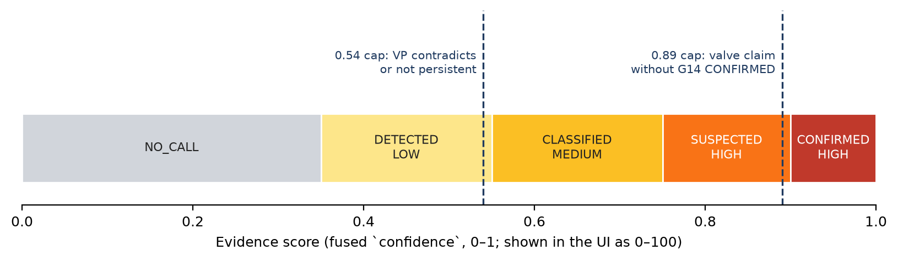
Figure 3 — G15 bands: diagnosis prefix and severity follow from the evidence score
Evidence score c | Diagnosis | G15 status | Severity
c < 0.35 | NO_CALL | INSUFFICIENT_EVIDENCE | LOW
0.35 ≤ c < 0.55 | DETECTED_<family> | SUSPECTED | LOW
0.55 ≤ c < 0.75 | CLASSIFIED_<family> | SUSPECTED | MEDIUM
0.75 ≤ c < 0.90 | SUSPECTED_<family> | SUSPECTED | HIGH
c ≥ 0.90 | CONFIRMED_<family> (valve family only with G14 CONFIRMED, else SUSPECTED at 0.89) | CONFIRMED | HIGH

Families: stiction / geometry → FINAL_ELEMENT_NONLINEARITY; oscillation → OSCILLATION; effort → EXCESSIVE_EFFORT. The UI shows c × 100 as "evidence score N" (never "% confidence"): it is an uncalibrated match score, not a probability. Severity depends only on the band.

7.5 Persistence
need = 2, window = 3 (persistenceMinAgree, persistenceWindows)
agree = 1 + last 2 fused results (same window kind) with the same elevated family
if agree < need and the result is SUSPECTED / CONFIRMED:
diagnosis → DETECTED_<family>, severity LOW, confidence ≤ 0.54
flag PERSISTENCE_CAP

7.6 Observations and possible causes (v2 verdict)
Observation | Present when | Score | Role
OSCILLATION | oscillation qualified | max(osc, fft) | Primary
SHAPE_TRIANGULARITY | G7 STRONG/WARN or stiction ≥ 0.55 | stiction | Primary
LAG_ASYMMETRY | G8 STRONG/WARN or horch ≥ 0.55 | horch | Supporting
PHASE_GEOMETRY | geometry evidence valid | geometry | Per class
ACTUATOR_STRESS | G4 / G10 STRONG/WARN, effort ≥ 2× floor, OP travel ≥ floor, cycling, ≥ 3 reversals | effort | Supporting
LIMIT_OCCUPANCY | G10 STRONG/WARN or open limit condition | min(1, 2 × saturation) | Supporting
FREEZE | material freeze or freeze episodes | 1.0 / 0.5 | Primary
PEER_INTERACTION | G13 interaction detected | max coherence | Supporting

Leading cause: stiction/geometry → Valve stiction; oscillation → Controller tuning (or External disturbance when DISTURBANCE_CONTEXT); effort → Excessive actuator effort. ACTUATOR_LIMIT and SENSOR are scored and shown, but never lead. The pages list Observed / Possible cause / Ruled out / No evidence from this structure.

8. Episodes (Loop Events)
An episode (event frame) is one continuous fault of one family on one loop and window kind. Built in cplm-api from LIVE fused results; replays never touch episodes.
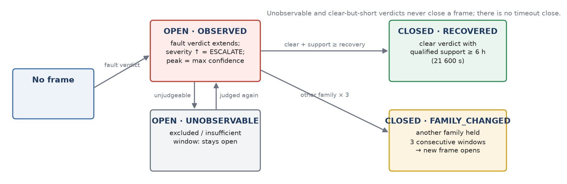
Figure 4 — Episode lifecycle
Field | Rule
Open | First fault verdict (any diagnosis except NO_CALL, INSUFFICIENT_*, EXCLUDED_*); opened_at = window end
Peak / last | peak = highest evidence score seen for the episode's family; last = newest verdict
Escalate | Severity band rises (LOW → MEDIUM → HIGH)
qualified_support_ms | Union of judged time (overlapping 15-min re-evaluations counted once)
window_count | +1 only for a non-overlapping window (≈ once per 12 h / 24 h)
Unobservable | Excluded / insufficient window: availability = UNOBSERVABLE, the condition stays OPEN
Close RECOVERED | Clear verdict with qualified support ≥ 21 600 s (6 h, G15.recovery_support_s)
Close FAMILY_CHANGED | Another family held for 3 consecutive windows; a new episode opens
Shelving | Separate lifecycle (ISA-18.2): SHELVED until shelve_until, then EXPIRED by a 60 s sweeper; acknowledging never ends a shelf

9. Instrument health (NAMUR NE107)
Condition (first match wins) | Eligibility | Shown as
No device bound | NOT_CONFIGURED | Not configured · not checked
No health interval yet | UNKNOWN | Unknown · not checked
Collection STALE / OFFLINE / UNKNOWN | LIMITED | Limited
F (failure) affecting the signal, or measurement INVALID | INELIGIBLE → window EXCLUDED_INSTRUMENT_HEALTH | Fault
C (check) affecting the signal | INELIGIBLE | Fault
S (out of spec) affecting the signal; M with degraded measurement; impact unknown | LIMITED → flag HEALTH_LIMITED | Limited
M only, flags on another variable, or no active diagnostic | ELIGIBLE | OK

Freshness window = max(3 × scan interval (30 s), 120 s). Health never raises or lowers the evidence score; it only excludes a window (INELIGIBLE PV) or adds a flag. No health source means a sensor fault is not checked.

10. Default thresholds per loop class
Resolution order: class pack → loop-dynamics-profiles.yaml → governed bundle (factory-layer.json, edited on Gate Configuration). Values below are the factory defaults.
Setting | FIC | PIC liquid | PIC gas | PIC vapour | LIC | TIC | Unknown
Dynamic class | fast self-reg | fast self-reg | integrating | slow self-reg | integrating | slow self-reg | fast self-reg
Objective | tight | tight | averaging | tight | averaging | tight | tight
Period band τmin–τmax (s) | 10–900 | 5–1 800 | 120–14 400 | 300–28 800 | 120–14 400 | 300–28 800 | 5–86 400
Min valid cycles | 5 | 5 | 3 | 3 | 3 | 3 | 5
G3 PASS min good-error | 0.50 | 0.50 | 0.30 | 0.50 | 0.30 | 0.50 | 0.50
G2 SP band (fraction of span) | 0.01 | 0.01 | 0.05 | 0.01 | 0.05 | 0.01 | 0.01
G9 corner angle (°) | 65 | 60 | 50 | 45 | 50 | 45 | 65
G9 area band | 0.05–1.5 | 0.05–1.5 | 0.05–2.0 | 0.05–2.0 | 0.05–2.0 | 0.05–2.0 | 0.05–1.5
G9 role / geometry prior | supporting / 0.5 | supporting / 0.5 | display / 0.3 | primary / 1.0 | display / 0.3 | primary / 1.0 | display / 0 (off)
Min OP travel for G9 (pp) | 2.0 | 2.0 | 1.5 | 1.0 | 1.5 | 1.0 | 2.0
Shape signal | OP | OP | PV | OP | PV | OP | OP

All classes: G4 WARN > 3 / STRONG > 8; G10 limit tolerance 5 pp, occupancy 0.05; VP non-following 5 pp for 60 s; persistence 2 of 3; recovery support 21 600 s; good-error band 0.5 % of PV span.

11. Page-by-page KPI reference
Screenshots from the lab (7 October 2026, day theme, 1440 px). Values on the screenshots are lab data and illustrate the layout only.

11.1 Operations overview (/cpm)
Which loops need attention first, and why. Fixed to the 24h window kind; server cache 15 s, UI refresh 60 s.
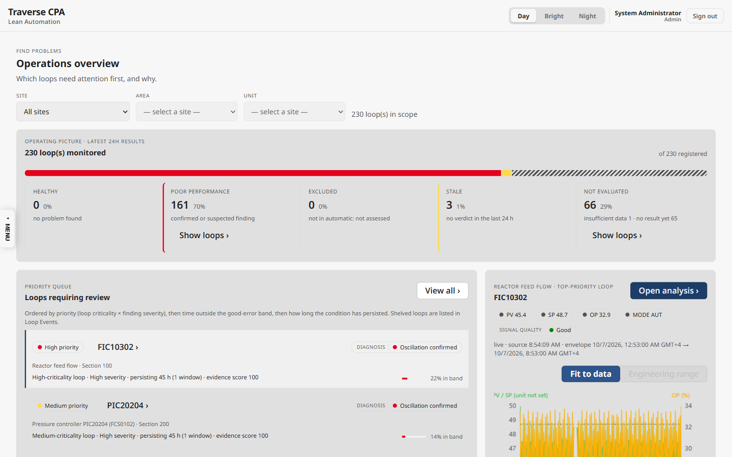
Overview — operating picture, priority queue, loop focus
KPI on screen | Logic / formula | Display and thresholds | Endpoint
Loops in scope / monitored | in scope = registered loops in the plant scope; monitored = monitoring.enabled = true | integers | fleet/summary
Operating picture (5 tiles + bar) | each monitored loop in exactly one state, from its newest LIVE real verdict: none → Not evaluated (insufficient / no result); window ended > window size ago → Stale; EXCLUDED_* → Excluded; NORMAL/NONE/HEALTHY → Healthy; CONFIRMED/SUSPECTED/DETECTED/CLASSIFIED_* → Poor performance; else unclassified (counted in Not evaluated) | count + round(count / monitored × 100) %; Healthy green, Poor red, Stale amber, others grey | fleet/summary → statuses
Priority queue (6 rows) | current findings only (verdict within one window size, finding diagnosis), minus actively shelved episodes; level = criticality × severity matrix (Figure 5) | High red · Medium amber · Low grey | fleet/rankings?orderBy=priority
Queue order | level → lowest good-error % → oldest open episode → highest evidence score → loop id | — | same
Reason line | "{criticality} loop · {severity} severity · persisting {age} ({n} windows) · evidence score N" | N = round(confidence × 100) | same
% in band bar | good_error_pct (0–1) × 100 | ≥ 80 green, ≥ 50 amber, < 50 red | same
N shelved › | current findings whose open episode is actively shelved | shown when > 0 | same
Loop focus (PV/SP/OP/MODE, signal quality) | live Sparkplug values; quality GOOD/UNCERTAIN/BAD (OPC ≥ 192 good, ≥ 64 uncertain); no update for > 10 min → "Uncertain · last value {age}" | 1 dp | MQTT live plane
Event trail | newest 3 episodes, opened_at desc, active shelves hidden | date-time + diagnosis | events?sort=recent&limit=3

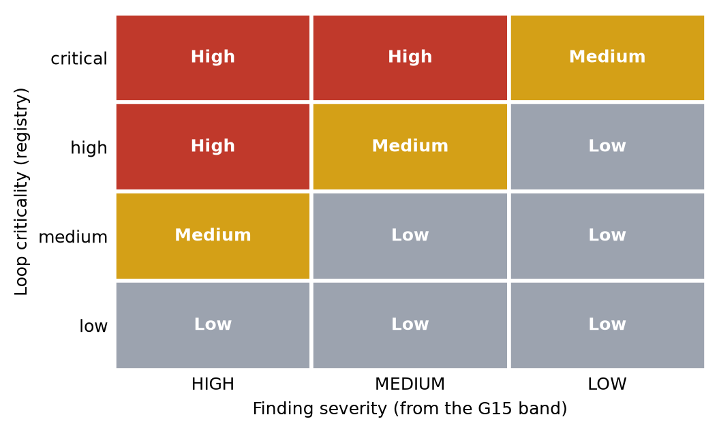
Figure 5 — Priority level = loop criticality × finding severity (ISA-18.2 / EEMUA 191 style)
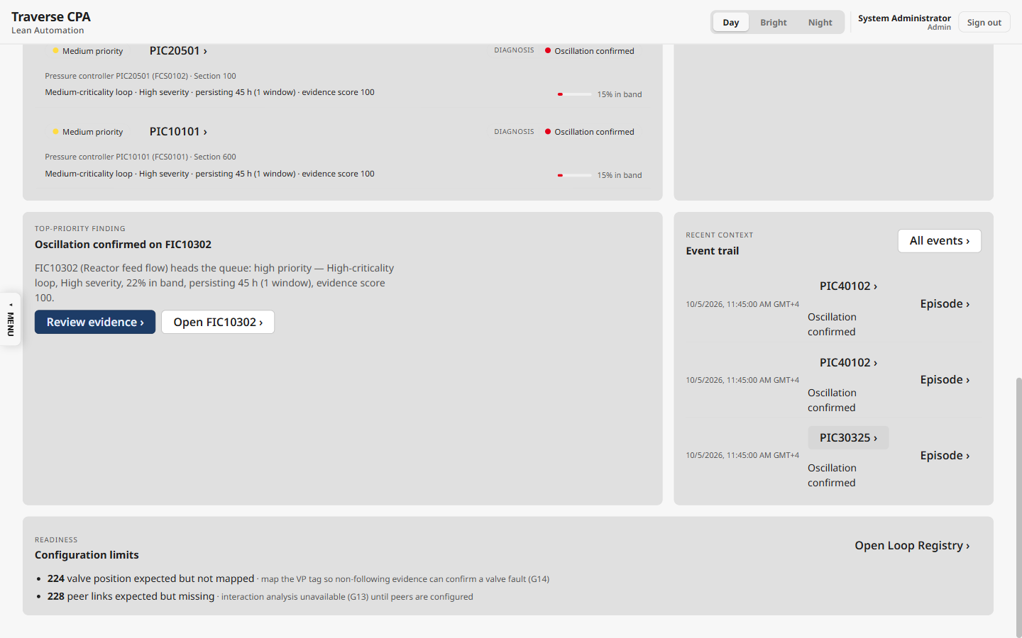
Overview — top-priority finding, event trail and readiness strip
KPI on screen | Logic / formula | Display and thresholds | Endpoint
VP expected but not mapped | registry loops with no vp tag and VP applicability EXPECTED (declared, else command path: OP_TO_VFD / OP_TO_PV → not applicable) | count + remedy text | fleet/summary → capability
Peer links expected but missing | no configured peer links and peer applicability EXPECTED | count | same
Plant facts | VP not installed / not applicable; peers not applicable — counted apart, never as gaps | grey sentence | same

11.2 Performance (/cpm/performance)
Compare every loop gate by gate and see where the plant is failing. Window toggle 12h / 24h.
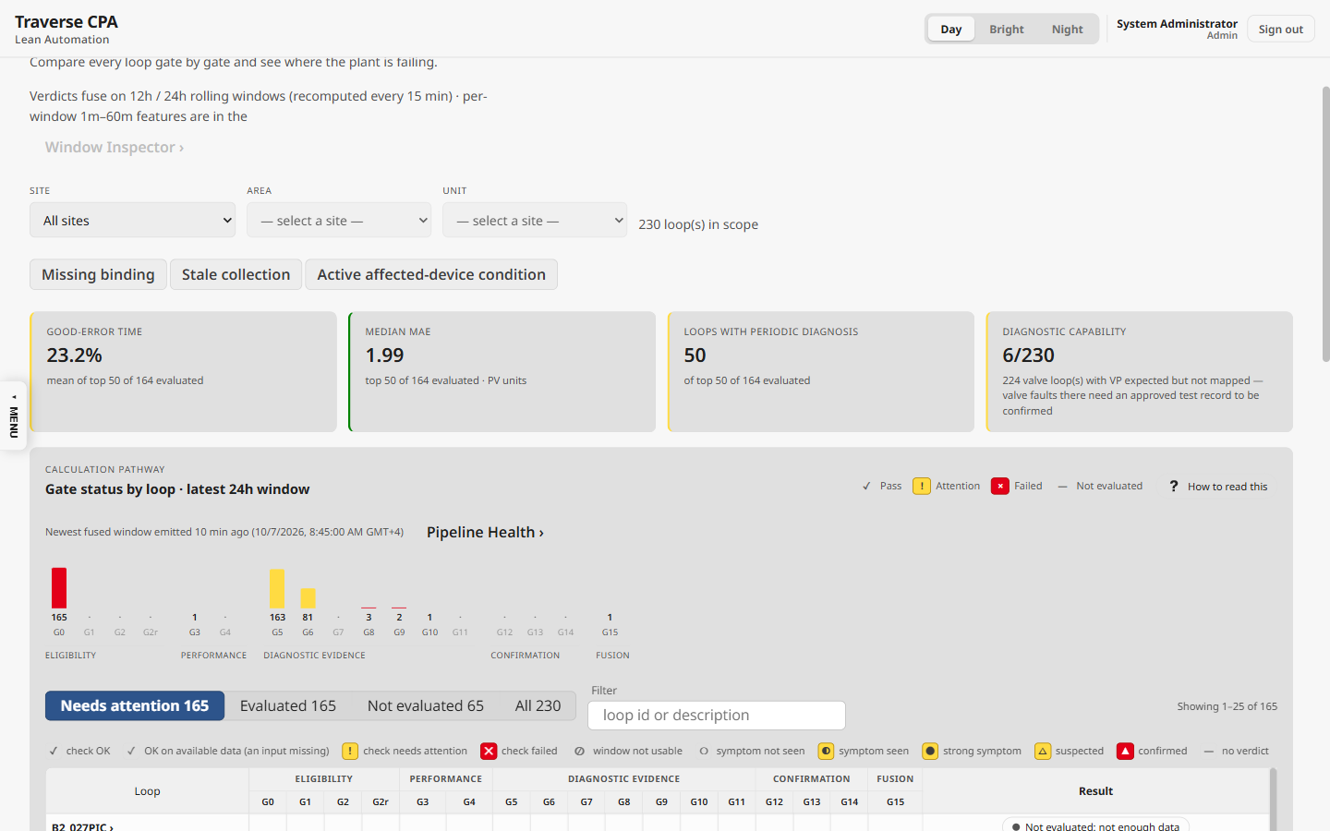
Performance — KPI tiles, gate roll-up and gate matrix
KPI on screen | Logic / formula | Display and thresholds | Endpoint
Good-error time | 100 × mean(good_error_pct) over the evaluated loops of the top-50 ranking | 1 dp %; green ≥ 80, else amber | fleet/rankings
Median MAE | median of MAE (> 0) over the same loops | 2 dp, PV units (mixed units across loops) | same
Loops with periodic diagnosis | evaluated loops whose diagnosis contains OSCILLATION or FINAL_ELEMENT | amber if > 0 | same
Diagnostic capability N/M | M = loops with a valve (registered − VP not applicable); N = M − VP expected-unmapped − VP not installed | amber if any expected-unmapped | fleet/summary
Gate roll-up bars | per gate: loops whose status is bad (FAIL, STRONG, EXCLUDED, CONFIRMED) or warn (WARN, REVIEW, SUSPECTED) | stacked red / amber | fleet/heatmap
Needs attention / Evaluated / Not evaluated / All | attention = any gate bad or warn; evaluated = diagnosis ≠ NOT_EVALUATED | counts | same
Gate matrix cell | gate mark from status (Section 3) | glyph + tone | same
Freshness | now − newest fused window end | stale styling after 3 h | same
Attention list | top 12 by evidence score, or by good-error % ascending | "evidence score N" / "N% in band" | fleet/rankings

11.3 Loop Explorer (/cpm/explorer)
One loop's current condition, trend and gate results; the Loop summary card heads every tab.
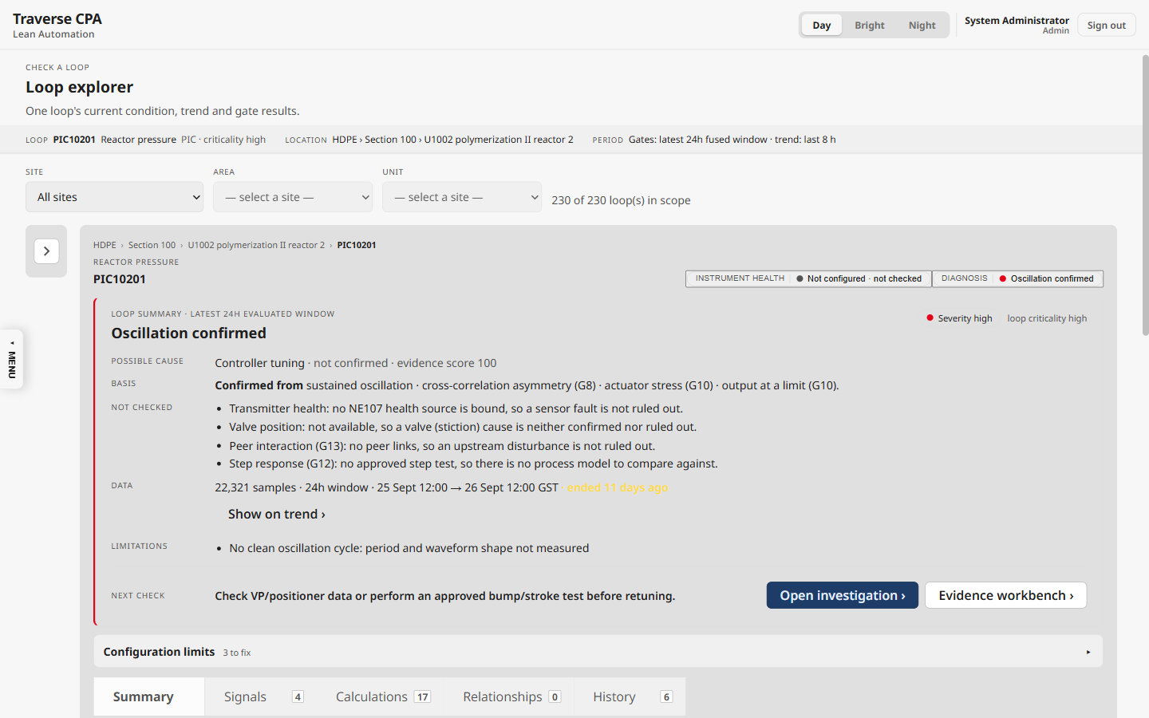
Loop Explorer — facet pills and Loop summary card (Basis / Not checked)
KPI on screen | Logic / formula | Display and thresholds | Endpoint
Instrument health pill | no data → Unknown; no role configured → Not configured; any INELIGIBLE → Fault; any LIMITED → Limited; else OK | "· not checked" when not configured / unknown; Fault red, Limited amber, OK green | instrument-health
Diagnosis pill / Condition | latest fused window's diagnosis → words (e.g. CONFIRMED_OSCILLATION → "Oscillation confirmed") | tone by band | gates/latest
Severity | engine band LOW / MEDIUM / HIGH (finding only) + loop criticality | pill | same
Possible cause · evidence score | leading hypothesis label; score = round(confidence × 100); cap text when at 54 (not persistent) or 89 (no VP) | "evidence score 89 (capped at 89: …)" | same
Basis | "Confirmed from" (CONFIRMED) / "Based on": present observations, citing only gates that fired | sentence | same
Not checked | inputs the verdict was judged without (health, VP, peers G13, step test G12), skipping those that do not apply to the loop | bullets | same + health + registry
Data | sample count · window · "ended {age}" when older than one window | locale integer | same
Limitations | remaining observability flags as sentences (max 2 + "and N more") | bullets | same
Readiness banner | failing readiness checks: Blocking (registry, monitoring, jobs, PV/SP/OP/MODE tags), Configuration, Waiting for data; plant facts listed apart | "N to fix · N plant fact(s)" | readiness
PV / SP / OP / MODE tiles | live → newest trend bucket → last stored value | 2 dp; source line "live (RBE)" / "last stored {age}" | live + historian

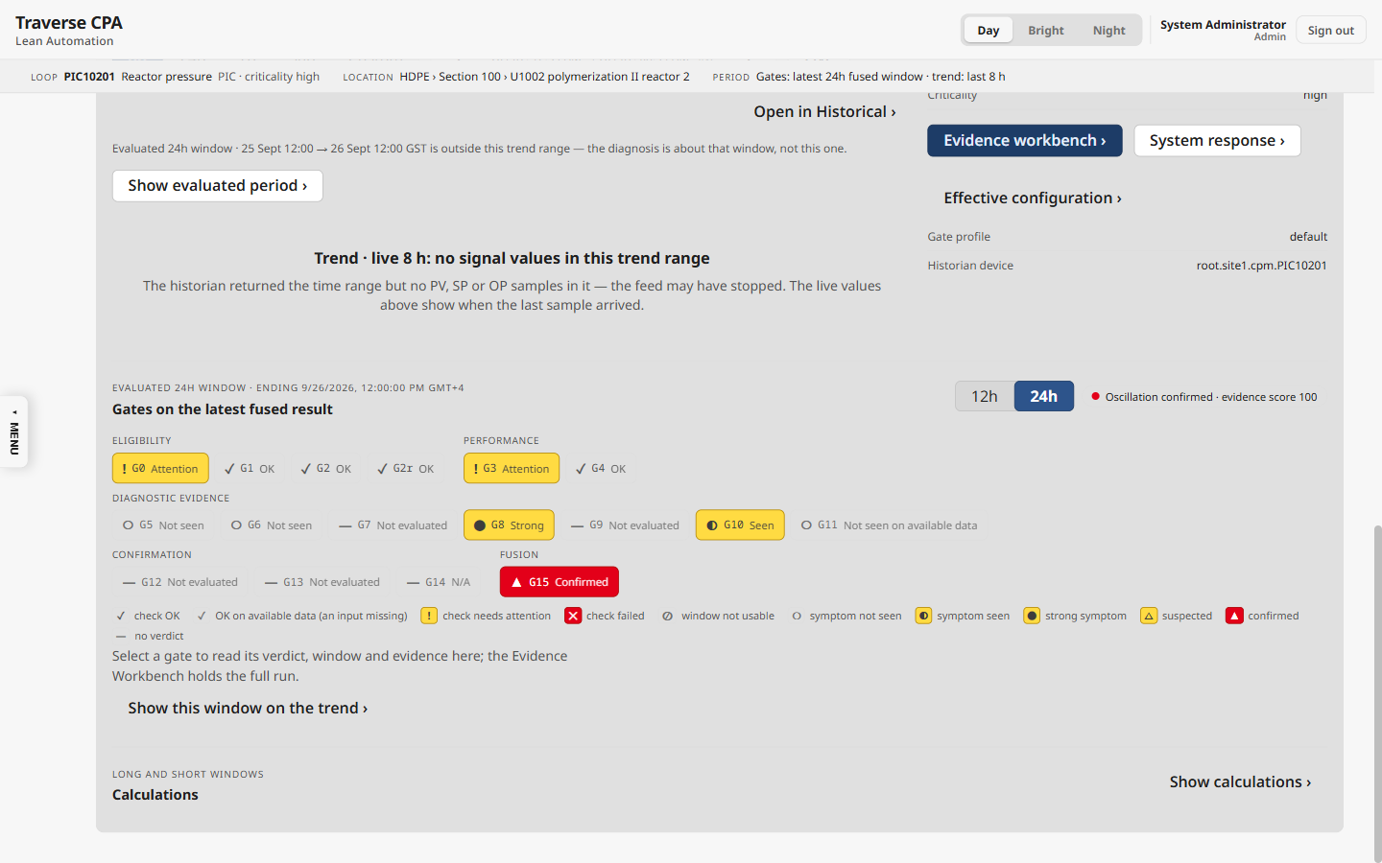
Loop Explorer — gate strip by tier with the mark legend

11.4 Investigation (/cpm/investigation)
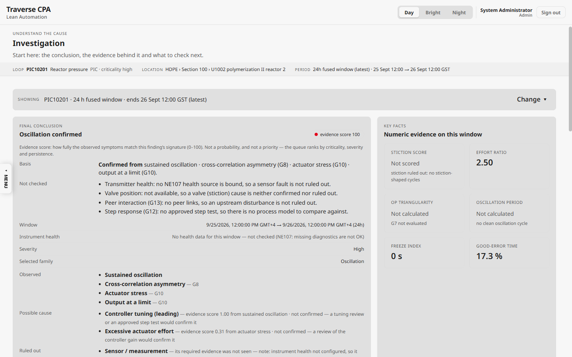
Investigation — final conclusion
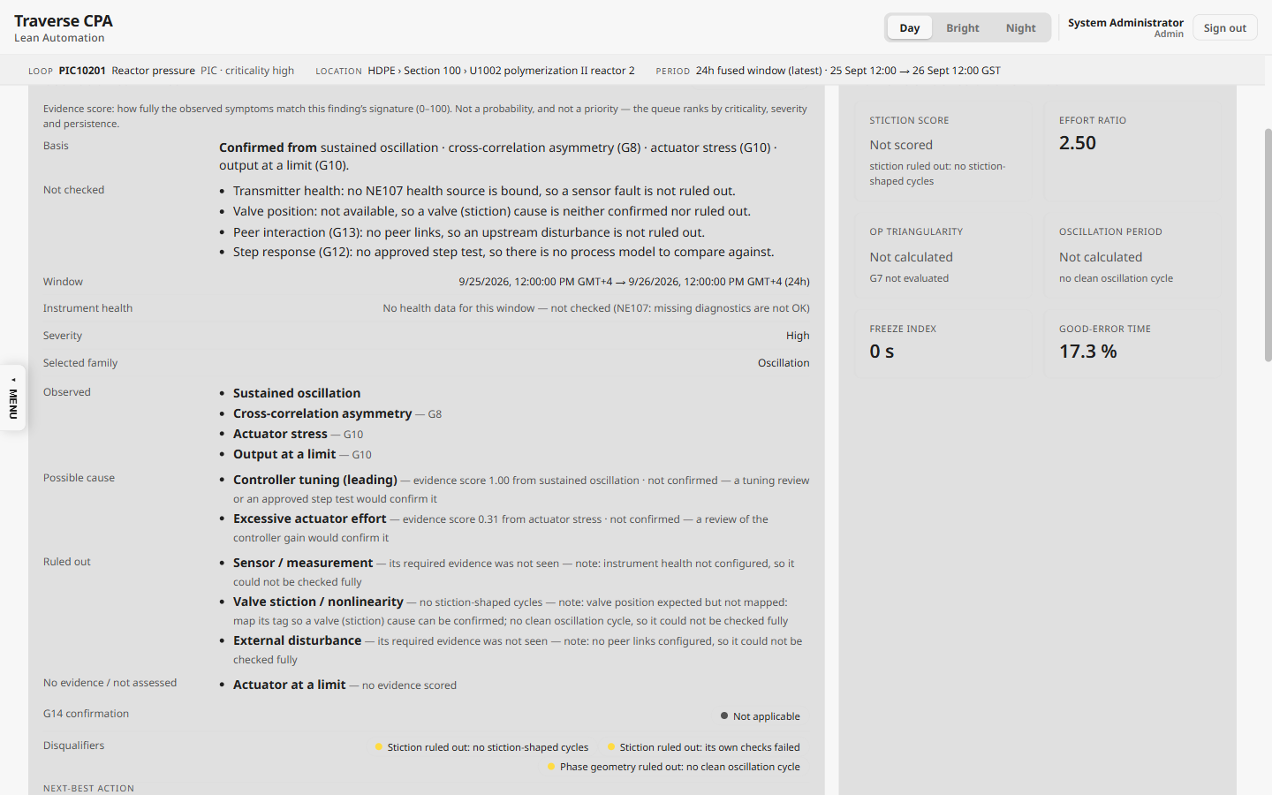
Investigation — basis, cause breakdown and key-fact tiles
KPI on screen | Logic / formula | Display and thresholds | Endpoint
Evidence score pill + note | round(confidence × 100) when the diagnosis is a verdict, with the meaning and any cap | "evidence score N" | gates/latest
Observed / Possible cause / Ruled out / No evidence | v2 verdict: present observations; QUALIFIED hypotheses (score desc) with how to confirm; DISQUALIFIED with reasons; the rest | hypothesis score 0–1 (2 dp) | same
G14 confirmation | Confirmed / Contradicted / Not confirmed / Not applicable | Confirmed red, Contradicted green | same
Stiction score | stiction_score (= triangularity) | 2 dp; "Not scored" when stiction is disqualified | same
Effort ratio | σ(OP)/σ(PV) | 2 dp | same
OP triangularity | mean per-cycle SSE_sine/(SSE_sine + SSE_triangle) | 2 dp; "Not calculated" without G7 | same
Oscillation period | acf_period_s | s / min / h; "Not calculated — no clean oscillation cycle" when ≤ 0 | same
Freeze index | freeze_index_s | duration | same
Good-error time | good_error_pct × 100 | 1 dp %; "N/A" on an excluded window | same
Window browser Δ | current − previous window: evidence score in points, key facts in their units | "+N pt" | gates history

Availability rule for every metric (metricAvailability.ts, first match wins): excluded window → N/A; insufficient → Insufficient data; G0 unusable → Insufficient data; missing → Not calculated; stiction disqualified → Not scored; period ≤ 0 → Not calculated; method not qualified → Not calculated / Not qualified; owning gate has no verdict → Not calculated; otherwise the measured number.

11.5 Evidence Workbench (/cpm/evidence)
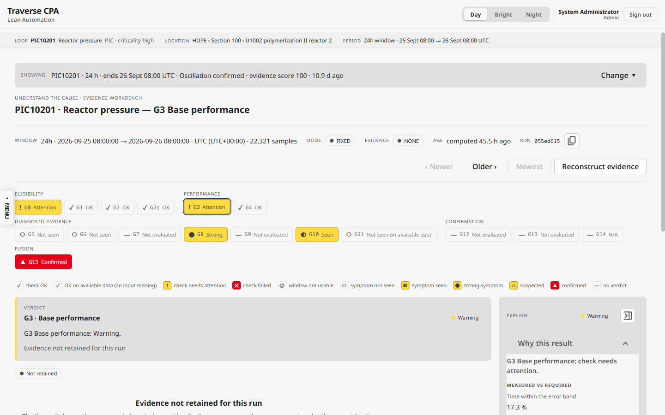
Evidence Workbench — one method run, gate chips, verdict and Explain
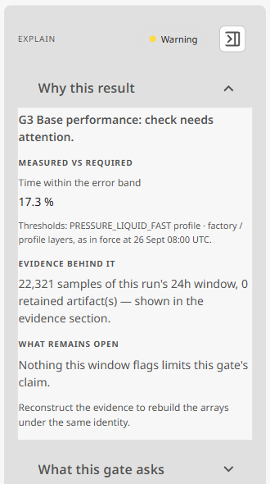
Explain › "Why this result": measured vs required, with the profile in force
KPI on screen | Logic / formula | Display and thresholds | Endpoint
Window / samples / age | run support from → to, sample count, now − computedAt | site time zone | method-runs/{id}
Evidence readiness | NONE / COMPLETE / PARTIAL / PENDING / FAILED / EXPIRED (every chunk present and SHA-256 verified) | pill | method-runs/{id}/evidence
Headline tiles | per-gate provenance numbers, e.g. G0 accepted samples a of b; G5 ACF period, regularity, cycles; G9 cycle polygons + mean area | value + unit | evidence chunks
Why this result | measured value vs the threshold in force at the run's time (engine copy, else effective configuration) | ✓ / ✕ per requirement | configuration/effective?at=
G15 why | evidence score of the selected family; agreeing windows vs required (persistence) | "N of 100" | fused row

11.5b Evidence Replay (/cpm/replay)
The raw historian samples behind one fused 24h verdict, and a re-run of the calculation.
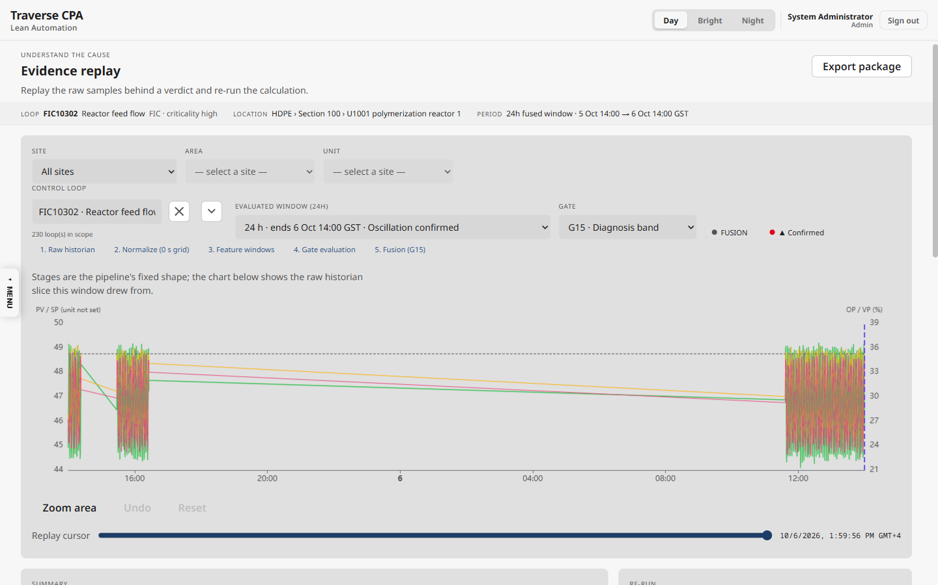
Evidence Replay — raw PV / SP / OP / VP slice of the evaluated window with the replay cursor
KPI on screen | Logic / formula | Display and thresholds | Endpoint
Evaluated window / gate | fused 24h windows (newest first) and the gate result for the selected gate | "24 h · ends …"; gate mark | loops/{id}/gates
Summary metrics | the long-tier (24h) row of the same window: completeness, AUTO fraction, MAE, IAE, good-error, effort, reversals, travel, ACF period / regularity, harmonics, triangularity, oddness, corner score | raw value, 3 dp (fractions not × 100) | kpis?resolution=24h
Raw slice | historian raw points for the window (PV, SP, OP, VP); shape gates G7–G10 also as a PV–OP phase plane | 2 dp; truncated note at the point budget | /api/hist/raw/cursor
Re-run | recompute the loop through Flink and poll the replay until finished | FINISHED / FAILED | loops/{id}/recompute

11.6 Window Inspector (/cpm/windows)
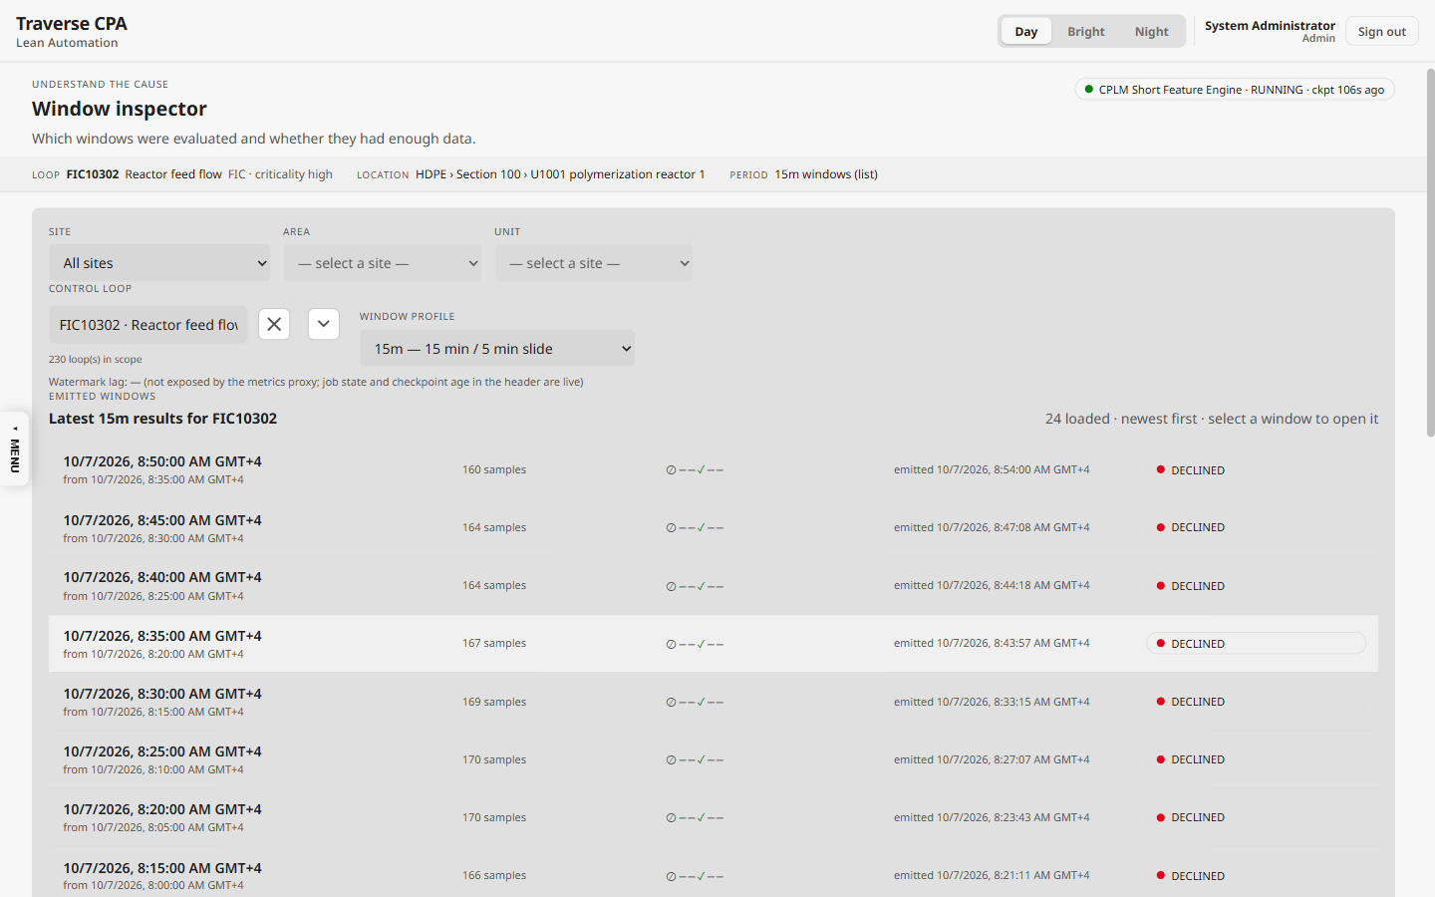
Window Inspector — emitted short windows with completeness and gate glyphs
KPI on screen | Logic / formula | Display and thresholds | Endpoint
Completeness pill | completeness, else sample_count / expected (window / grid, 5 s fallback); DECLINED when sufficient_data = false | "N% full"; ≥ 90 green, ≥ 50 amber, < 50 red | kpis?resolution=15m
Short gate glyphs | G0, G1, G2, G2r, G3, G4 status per window | gate marks | same
Metrics | MAE, RMSE, IAE, ISE, good-error %, effort ratio, OP travel/day, reversals/h, in AUTO %, completeness % | fractions × 100 (1 dp %); else 4 significant digits | same
Sample density | 24 buckets: raw PV points per bucket / expected per bucket | bar; < 0.6 sparse | historian raw
Compare across window sizes | per short kind, last 12 qualified windows: latest, median, range, count, declined | — | kpis/latest
Runtime chip | CPLM job state + last checkpoint age | RUNNING green | pipeline-metrics

11.7 Calculations (/cpm/calculations)
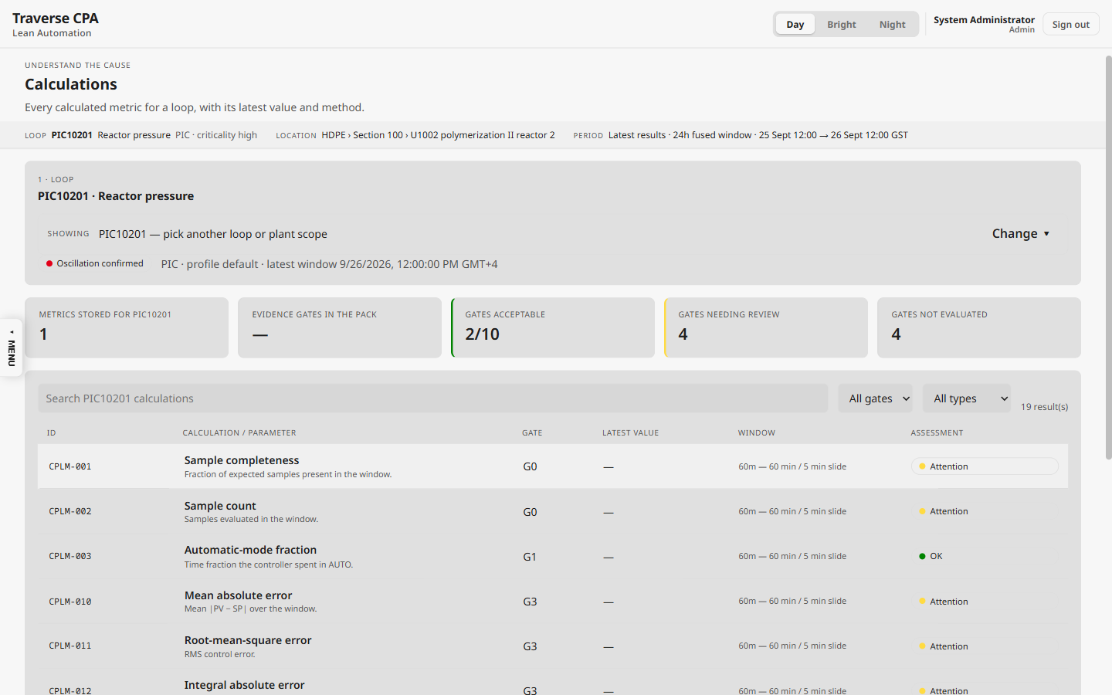
Calculations — every calculated metric for a loop, its latest value, window and assessment
KPI on screen | Logic / formula | Display and thresholds | Endpoint
Metrics stored | catalogue metrics with a value (latest 60m short row, latest 24h long row, fused confidence) | integer of 19 | kpis, gates/latest
Gates acceptable g/t | distinct catalogue gates (t = 10) whose assessment is green | "g/t" | gates/latest
Gates needing review / not evaluated | assessment amber or red / grey | counts | same
Latest value | ratio / fraction 3 dp; count integer; seconds 1 dp; others 4 significant digits + unit; G15 shown as N / 100 | availability word when not measured | same
Evidence-score band (G15 drawer) | first band with value ≤ max: NO_CALL 0.35, DETECTED 0.55, CLASSIFIED 0.75, SUSPECTED 0.90, CONFIRMED 1.00 | band name | calculations

11.8 System Response (/cpm/response)
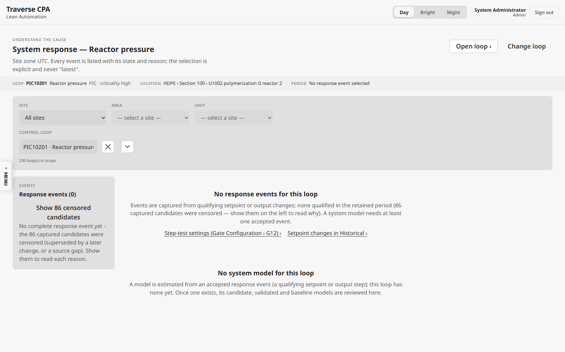
System Response — response events, censored candidates and the system model
KPI on screen | Logic / formula | Display and thresholds | Endpoint
Response events (N) | captured G12 events, newest first, censored ones hidden unless shown | count | loops/{id}/response-events
Censored candidates | captures with capture_state = CENSORED (superseded, gap, mode change, too long) | count + reason | same
Model card | family (FOPDT / IPDT) · model state; Kp, θ, τ (± std. error) | 2 dp or exponential | response-events/{id}
Key results | t63, rise time 10–90, settling, overshoot, steady error, IAE / ISE / ITAE | value ± uncertainty + unit | same
Validation (subgate E) | fit improvement, free-run RMSE, bias, whiteness | 3 dp | same
Model history | every model per parameter; review sets VALIDATED / REJECTED / ACTIVE_BASELINE | chart + table | loops/{id}/models

11.9 Historical (/cpm/historical)
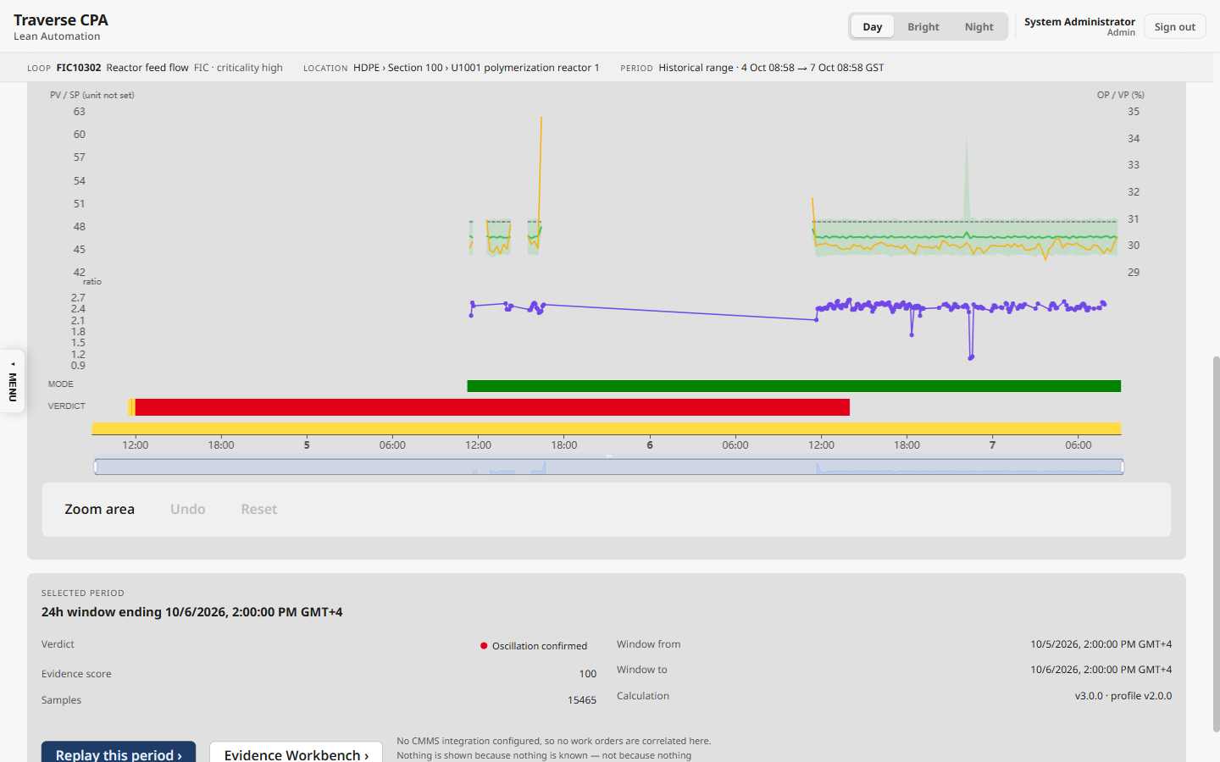
Historical — signals, KPI overlay, mode and verdict on one time axis
KPI on screen | Logic / formula | Display and thresholds | Endpoint
Signal lanes | historian PV (min–max envelope), SP, OP, VP; optional normalise ÷ own span | 2 dp; PV unit from registry | /api/hist/trend
KPI overlay | one of effort ratio (15m), IAE (15m), good-error time (15m), triangularity (24h), harmonic energy ratio (24h) over the range | raw value (good-error as 0–1) | kpis (≤ 500 rows)
Mode lane | automatic / manual segments from the mode signal | green / amber | historian
Verdict lane | 24h fused verdicts: Suspected (CONFIRMED / SUSPECTED), Developing (DETECTED / CLASSIFIED), Normal, Not evaluated | red / amber / green / grey | gates history (≤ 100)
Selected window | verdict, evidence score, samples, from / to, calculation and profile versions | — | same

11.10 Loop Events (/cpm/events)
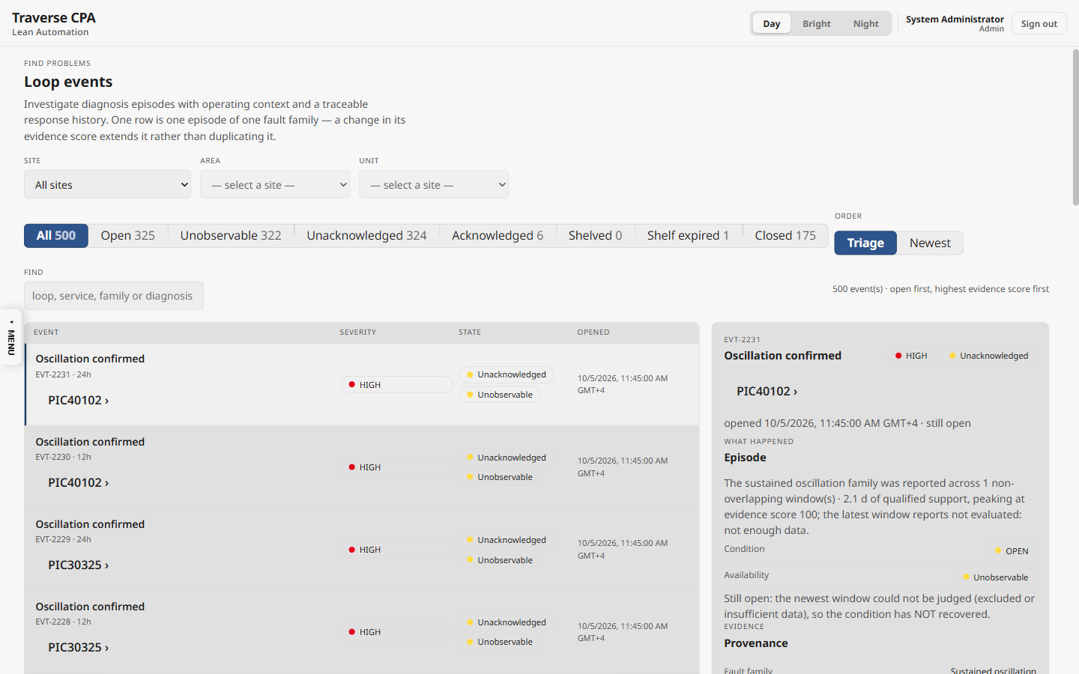
Loop Events — server-paged episodes with tab counts
KPI on screen | Logic / formula | Display and thresholds | Endpoint
Tab counts | All; Open (not closed); Unobservable (open + UNOBSERVABLE); Unacknowledged (open, not acked, not actively shelved); Acknowledged; Shelved (shelve_until > now); Shelf expired; Closed | counts under the same loop / scope / search | events/page
Order | Triage: open first, highest peak evidence score, newest; or newest first | caption | same
Severity | episode severity band (latest of its own family); fallback from peak score ≥ 0.9 / ≥ 0.55 | HIGH red, MEDIUM amber, LOW green | same
State | Closed · Closed unacked · Shelved (expires in …) · Shelf expired (unreviewed) · Acknowledged · Unacknowledged | pill | same
Episode sentence | window_count non-overlapping windows · qualified support (h / d) · peak evidence score | 1 dp | same
Conditions (G10 / G11) | fast limit / freeze conditions; stale when open with no update for 10 min | duration, since | conditions

11.11 Loop Registry, Gate Configuration, Pipeline Health
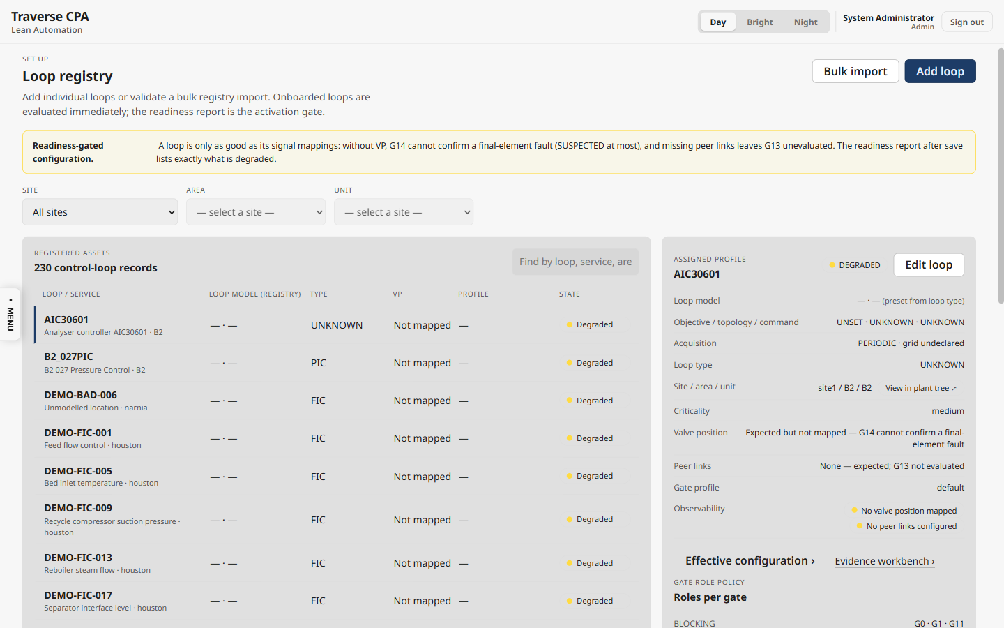
Loop Registry — loop records, VP state and assigned profile
KPI on screen | Logic / formula | Display and thresholds | Endpoint
State | Inactive / Registered (not monitored) / Degraded (NO_VP or no links) / Active | pill | loops
VP column | Mapped / Not mapped / Not installed / No valve (applicability) | word | same

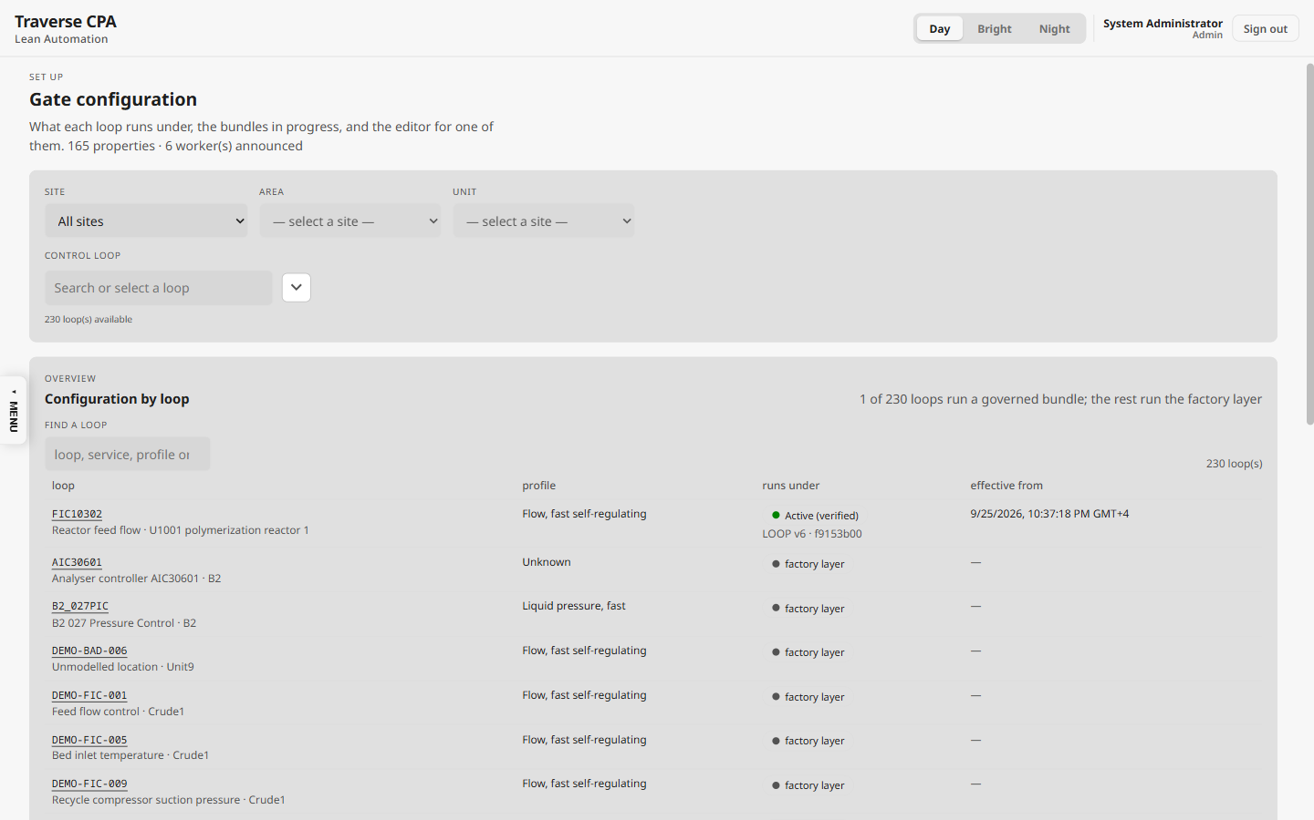
Gate Configuration — which configuration layer each loop runs under
KPI on screen | Logic / formula | Display and thresholds | Endpoint
Governed loops | loops whose LOOP / PROFILE / SITE bundle is active (first hit wins), else factory layer | "N of M loops run a governed bundle" | configuration/effective/summary
Layer stack | properties per source layer (factory / profile / site / loop) | counts | configuration/effective
Shadow comparison | symptoms removed / added per gate between a draft and LIVE results | counts | drafts/{id}/shadow

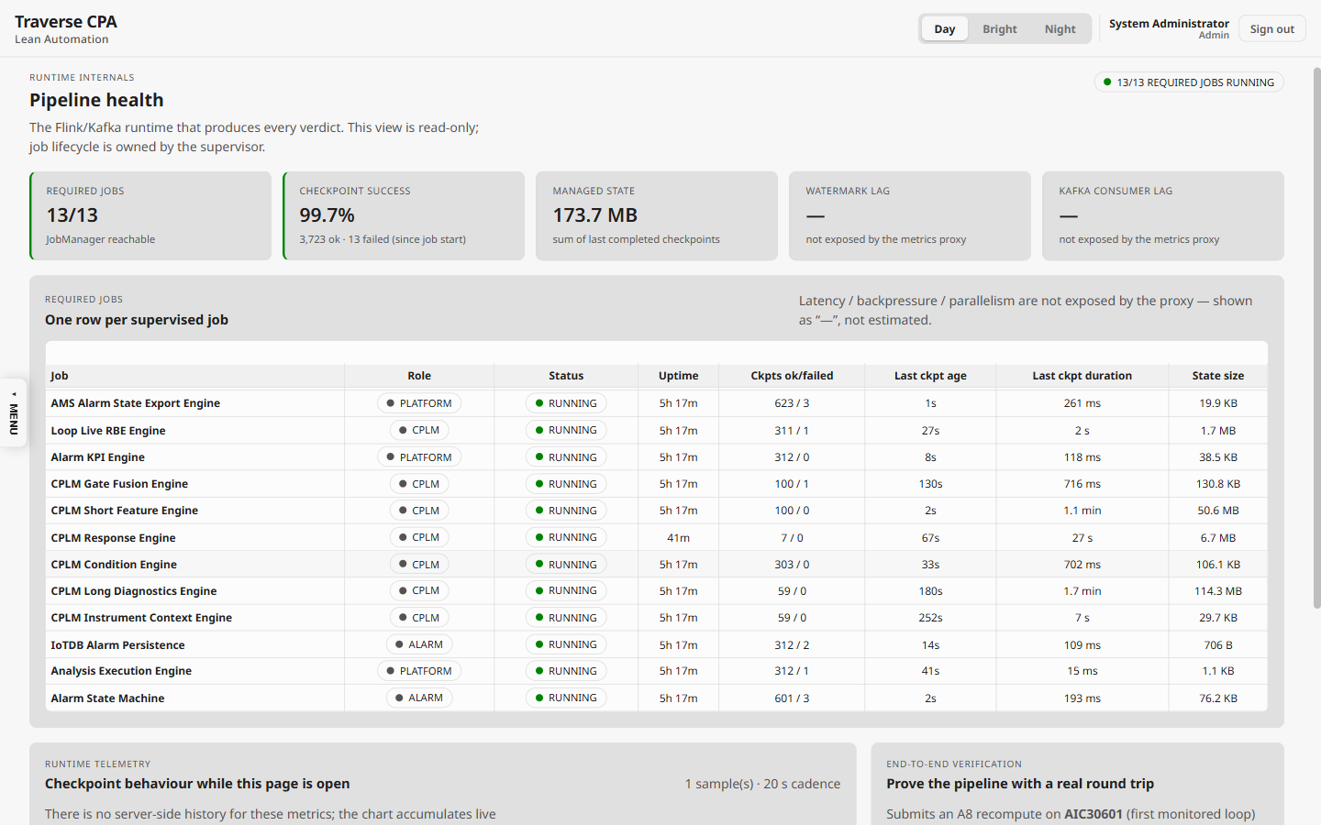
Pipeline Health — required jobs, checkpoints and the delivery path
KPI on screen | Logic / formula | Display and thresholds | Endpoint
Required jobs r/n | required Flink jobs RUNNING (n = 13) | green when all running | pipeline-status
Checkpoint success | 100 × Σ completed / (Σ completed + Σ failed) | 1 dp %; ≥ 99 green | pipeline-metrics
Managed state | Σ last checkpoint state size | B / KB / MB | same
Last fused verdict | now − newest fused window end | min / h | fleet/rankings

12. Calculation catalogue (CPLM IDs)
The identifiers used on the Calculations page (calcCatalogue.ts). "Source" says which tier stores the value: short = 1m–60m windows, long = 4h–24h windows, gate = fused verdict.
ID | Calculation | Field | Gate | Unit | Source | Definition
CPLM-001 | Sample completeness | completeness | G0 | ratio | short | Fraction of expected samples present in the window.
CPLM-002 | Sample count | sample_count | G0 | count | short | Samples evaluated in the window.
CPLM-003 | Automatic-mode fraction | auto_pct | G1 | ratio | short | Time fraction the controller spent in AUTO.
CPLM-010 | Mean absolute error | mae | G3 | PV units | short | Mean |PV − SP| over the window.
CPLM-011 | Root-mean-square error | rmse | G3 | PV units | short | RMS control error.
CPLM-012 | Integral absolute error | iae | G3 | PV·s | short | Accumulated absolute error.
CPLM-013 | Integral squared error | ise | G3 | PV²·s | short | Accumulated squared error.
CPLM-014 | Good-error time | good_error_pct | G3 | fraction | short | Time fraction (0-1) the error stayed inside the good band.
CPLM-020 | Actuator effort ratio | effort_ratio | G4 | ratio | short | OP travel relative to the error it corrects.
CPLM-021 | OP travel per day | travel_per_day | G4 | %/day | long | Total actuator travel extrapolated to a day.
CPLM-022 | OP reversals per hour | reversals_per_hour | G4 | per h | long | Direction changes of the actuator.
CPLM-030 | Oscillation period (ACF) | acf_period_s | G5 | s | long | Dominant period from the autocorrelation.
CPLM-031 | Oscillation regularity | acf_regularity | G5 | ratio | long | How regular the oscillation is (0–1).
CPLM-040 | Harmonic amplitude ratio | harmonic_amplitude_ratio | G6 | ratio | long | Harmonics vs fundamental amplitude.
CPLM-041 | Harmonic energy ratio | harmonic_energy_ratio | G6 | ratio | long | Spectral energy in harmonics.
CPLM-050 | OP triangularity | triangularity | G7 | score | long | Triangular-wave similarity of the actuator trace (stiction shape).
CPLM-060 | Horch oddness | horch_oddness | G8 | score | long | Odd-symmetry of the PV–OP cross-correlation.
CPLM-070 | Phase-portrait corner score (raw) | corner_score | G9 | score | long | Sharp-corner evidence in the PV–OP phase plot. CAUTION: the raw statistic reads high (~0.9) even on healthy noisy data; treat it only alongside the G9 verdict and phase-area band, never alone.
CPLM-090 | Fused evidence score | confidence | G15 | score | gate | How fully the observed symptoms match the selected family (0–1; shown 0–100). Uncalibrated — not a probability.

13. Alarm KPIs (AMS, outside the CPA pages)
Computed by AlarmKpiStreamJob from alarm lifecycle events and pushed to the alarm dashboard over SignalR.
KPI | Formula | Window | Thresholds
Alarm rate | count of lifecycle events with state ACTIVE | 10 min sliding, every 1 min | > 10 minor flood, > 20 major flood, > 50 severe flood (fixed)
Standing alarms | +1 on ACTIVE, −1 on CLEARED (floored at 0) | running count | —

14. Known gaps and inconsistencies
Found while documenting. None changes a stored value; they affect wording, consistency or configurability. Listed so readers do not mistake them for intended behaviour.
# | Area | Observation | Effect
1 | Persistence | "2 of 3 windows" counts consecutive 15-min re-evaluations of a sliding 12h / 24h window — about 45 min of mostly identical data; the configuration key assumes 12 h per window | Persistence is weaker than its name
2 | G5 status | WARN whenever any ACF period exists, even out of band or irregular (band and regularity only gate period validation) | G5 "Seen" more often than expected
3 | G12 on the verdict | PASS only from the registry flag "has step test"; not joined to the Response Engine's results | G12 chip does not reflect captured step responses
4 | Response Engine | Stability margins and SIMC advice never produced (no controller parameters); LIC set-point steps unsupported; trigger span fixed at 100 EU | Some System Response panels stay empty
5 | Hard-coded thresholds | G0 0.98 / 0.50, G1 0.90, G2r 0.05 / 0.20, G6 0.5, G9 0.30, G11 60 s / 10 %, G13 xcorr 0.5, bands 0.35 / 0.55 / 0.75 / 0.90, caps 0.89 / 0.54 | Not adjustable on Gate Configuration
6 | Causes | ACTUATOR_LIMIT and SENSOR hypotheses are scored but never become the leading cause or the diagnosis | Shown only as possible causes
7 | Display units | Hypothesis scores 0–1 (2 dp) vs evidence score 0–100; Explorer History "peak N%"; Replay and Historical overlay show good-error as 0–1 | Same quantity in two scales
8 | Historical verdict lane | CONFIRMED_* labelled "Suspected" | Under-states confirmed findings
9 | Performance tiles | Health filter changes the tiles only; tiles count INSUFFICIENT and EXCLUDED loops as evaluated; "in scope" counts all registered loops in one place, monitored loops in another | Tile denominators differ from the matrix
10 | Missing confidence | A missing fused confidence is stored as 0.0 | Can read "evidence score 0"
11 | Alarm KPIs | Standing count is a global counter not reconciled with state; oldest-standing duration always 0 | Approximate standing count after restarts
12 | Engine applicability | The fusion job does not read VP / peer applicability (CHG-059); the UI words the flag per loop | A valve cause can still rank on a declared "no valve" loop
13 | Replay stepper | "Normalize (0 s grid)" when the window row carries no sample period | Cosmetic

Appendix A — Source index
Topic | Source files (repo-relative)
Short KPIs, G0–G4 | src/flink/.../cplm/engine/ShortFeatureCalculator.java, SignalMath.java, LimitMath.java, ShortWindowSpecs.java
Long diagnostics G5–G11, G13 | .../cplm/engine/LongDiagnosticsCalculator.java, OscillationMath.java, WelchPsd.java, ShapeMath.java, VpTrackingMath.java, InteractionGate.java, InteractionMath.java
Fusion G14 / G15 | .../cplm/CplmGateFusionEngine.java, fusion/FusionEvidence.java, fusion/Confirmation.java, fusion/DiagnosisBands.java, fusion/VerdictAssembly.java, fusion/GeometryEvidence.java
Defaults | .../cplm/CplmLoopDynamicsProfilePacks.java, resources/cplm/loop-dynamics-profiles.yaml, resources/cplm/gate-config/factory-layer.json, config/BundleProfileMapper.java
G12 response | .../cplm/response/* (ResponseEventDetector, ResponseCapture, metrics/*, estimation/*, validation/ModelValidator)
Instrument health | .../cplm/health/HealthEligibilityPolicy.java, DeviceStateMachine.java
Episodes | src/services/cplm-api/Services/EventFrameLifecycle.cs, BackgroundServices/CplmEventFrameService.cs, CplmShelfExpirySweeper.cs
Fleet KPIs | src/services/cplm-api/Data/FleetLatestSql.cs, FleetPrioritySql.cs, EventPageSql.cs, Controllers/CpmFleetController.cs, Services/Registry/OptionalInputs.cs
Display rules | src/frontend-ob/src/components/Cpm/gateStatus.ts, evidenceScore.ts, metricAvailability.ts, conclusionBasis.ts, causeAnalysis.ts, calcCatalogue.ts, windowLabel.ts
Alarm KPIs | src/flink/.../AlarmKpiStreamJob.java

Appendix B — Short-window field dictionary (1m … 60m)
Every value stored for each short window (cplm_short_feature_results, topic feature.short.v1). On screen: WI = Window Inspector · CALC = Calculations page · EXP = Explorer › Show calculations · INV = Investigation key facts · HIST = Historical KPI overlay · REP = Evidence Replay summary · WB = Evidence Workbench · API = stored and served by /loops/{id}/kpis, not shown as its own number.
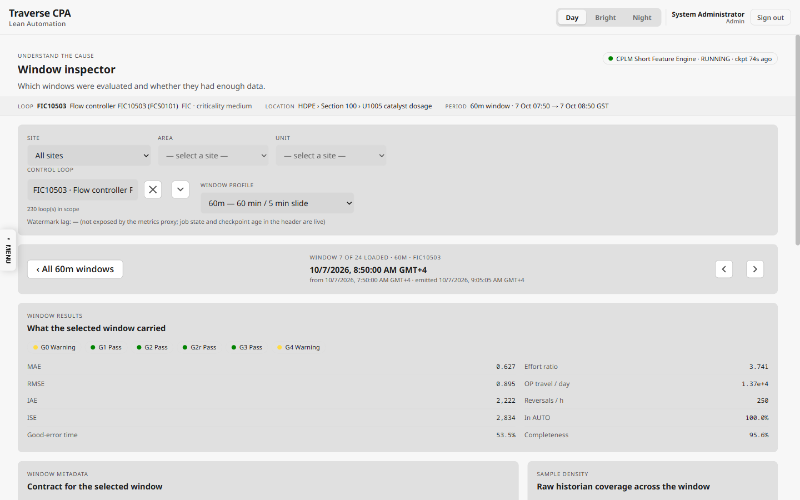
Window Inspector — one 60m window of FIC10503: G0–G4 statuses and the short-window KPIs
Field | Gate | Formula / definition | Unit / range | On screen
expected_sample_count | G0 | max(1, round(window s / grid)) | count | WI
sample_count | G0 | samples with t in [start, end) | count | WI, CALC (CPLM-002), REP
completeness | G0 | sample_count / expected_sample_count (can exceed 1) | fraction | WI, CALC (CPLM-001), REP
bad_quality_pct | G0 | count(quality ≠ GOOD) / n | 0–1 | API
unknown_quality_pct | G0 | count(quality = UNKNOWN) / n | 0–1 | API
duplicate_timestamps | G0 | count of repeated timestamps (must be 0 for PASS) | count | API
sampling_jitter | G0 | σ(Δt) / median(Δt) | ratio | API
gap_count, max_gap_s | G0 | intervals Δt > 1.5·Ts; the longest Δt | count, s | API
gate0_status / reason | G0 | FAIL bad ≥ 0.50 · PASS completeness ≥ 0.98 ∧ bad < 0.05 ∧ no duplicates · WARN completeness ≥ 0.95 · else FAIL; reason BAD_QUALITY / QUALITY_UNKNOWN / INCOMPLETE | enum | WI glyph, EXP, WB
auto_pct | G1 | count(mode automatic) / n | 0–1 | WI (In AUTO %), CALC (CPLM-003), REP
manual_pct | G1 | 1 − auto_pct | 0–1 | API
mode_changes_per_h | G1 | mode changes / window hours | 1/h | API
gate1_status | G1 | PASS ≥ 0.90 · WARN ≥ 0.70 · else EXCLUDED | enum | WI glyph, EXP, WB
sp_min, sp_max, sp_range | G2 | min, max and max − min of SP | PV units | API
sp_changes_per_h | G2 | count(|ΔSP| > 1e-6) / hours | 1/h | API
gate2_band_eu, band source | G2 | declared band, else span fraction × PV span (0.01 tight / 0.05 averaging), else 1.0 | PV units | API
gate2_status | G2 | PASS if sp_range < band, else WARN | enum | WI glyph, EXP
region_out_of_band_pct | G2r | share of samples outside PV / OP region bounds | 0–1 | API
gate2r_status, operating_region_valid | G2r | PASS ≤ 0.05 · WARN ≤ 0.20 · else FAIL (invalid) | enum, bool | WI glyph, EXP
mae | G3 | mean |SP − PV| | PV units | WI, CALC (CPLM-010), REP, compare table
rmse | G3 | sqrt(mean (SP − PV)²) | PV units | WI, CALC (CPLM-011)
iae | G3 | Σ |e|·Δt | PV·s | WI, CALC (CPLM-012), HIST, REP
ise | G3 | Σ e²·Δt | PV²·s | WI, CALC (CPLM-013)
itae | G3 | Σ (t − start)·|e|·Δt | PV·s² | API
good_error_pct | G3 | count(|e| ≤ 0.005 × PV span) / n (0.5 EU band without a declared range) | 0–1 (shown ×100 %) | WI, CALC (CPLM-014), HIST, INV, Overview / Performance
oce | G3 | auto_pct × good_error_pct × (1 − saturation_pct) | 0–1 | API
gate3_status | G3 | PASS if good_error_pct ≥ 0.50 (0.30 averaging), else WARN | enum | WI glyph, EXP, WB
pv_std, op_std | G4 | σ(PV), σ(OP) | PV units, % | API
effort_ratio | G4 | σ(OP) / σ(PV) | ratio | WI, CALC (CPLM-020), HIST, INV
effort_ratio_normalized | G4 | (σOP / OP observed range) / (σPV / PV observed range) | ratio | API
activity_ratio_norm, basis | G4 | (σOP/100) / (σPV / declared PV span); null without a declared range (then G4 judges effort_ratio) | ratio | WB (Why G4)
op_travel | G4 | Σ |ΔOP| | % | API
travel_per_day | G4 | op_travel × 24 / window hours | %/day | WI, CALC (CPLM-021), REP
reversal_count, reversals_per_hour | G4 | OP direction changes; ÷ hours | count, 1/h | WI, CALC (CPLM-022), REP
saturation_pct | G4 | count(OP ≤ 5 % or ≥ 95 %) / n | 0–1 | API
freeze_index_s (short) | G4 | longest run of unchanged PV × Ts | s | API
gate4_status | G4 | STRONG activity > 8 · WARN > 3 · else PASS | enum | WI glyph, EXP, WB
sufficient_data | — | false when G0 FAIL or n < 10 (metrics null) | bool | WI (DECLINED)

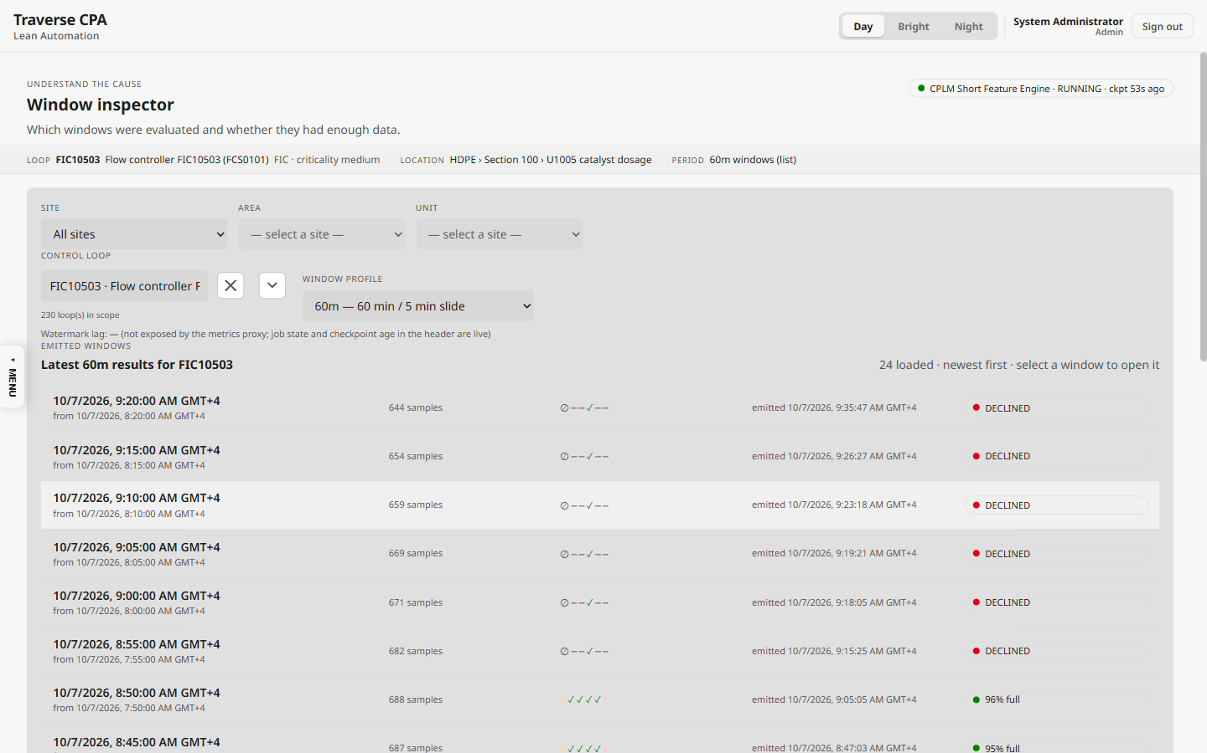
Window Inspector — the emitted 60m windows: samples, G0–G4 glyphs and completeness (DECLINED when not qualified)

Appendix C — Long-window field dictionary (4h / 12h / 24h)
Every value stored for each long window (cplm_long_feature_results, topic feature.long.v1); the long record also embeds the aligned short features (Appendix B) for the same window. On screen: WI = Window Inspector · CALC = Calculations page · EXP = Explorer › Show calculations · INV = Investigation key facts · HIST = Historical KPI overlay · REP = Evidence Replay summary · WB = Evidence Workbench · API = stored and served by /loops/{id}/kpis, not shown as its own number.
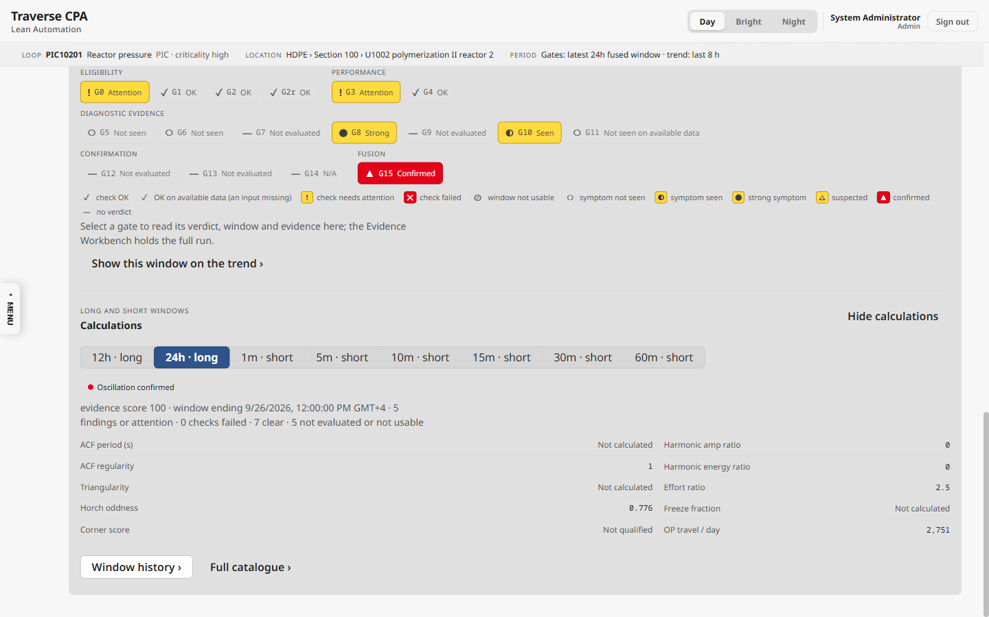
Loop Explorer › Show calculations — the 24h long-window metrics behind a fused verdict, with availability words (Not calculated / Not qualified)
Field | Gate | Formula / definition | Unit / range | On screen
method_eligibility.{G5,G6,G12} | G5/G6/G12 | grid ≤ τmin / 8 for G5, G6 (≤ τmin / 4 for G12): ELIGIBLE, else LIMITED (bandwidth) | enum | WB, flag BANDWIDTH_LIMITED
acf_gamma0 | G5 | Σ x² / n (detrended shape signal) | signal² | API
acf_zero_crossing_count | G5 | sign changes of the ACF | count | API
acf_period_s | G5 | median of 2 × (spacing of ACF zero crossings) × Ts | s | EXP, CALC (CPLM-030), INV, REP, WB
acf_regularity | G5 | min(1, P / (3·σ(periods))) | 0–1 | EXP, CALC (CPLM-031), REP, WB
gate5_status | G5 | WARN when any ACF period exists, else PASS | enum | EXP strip, WB
fft_peak_period_s, freq, amplitude | G6 | largest in-band Welch PSD peak; period = 1/f | s, Hz | API, WB
fft_peak_ratio | G6 | peak-lobe energy / total energy | 0–1 | WB
fft_peak_to_median | G6 | A_peak / median in-band amplitude (≥ 3 validates an FFT period) | ratio | WB (Why G6)
harmonic_amplitude_ratio | G6 | (A2 + A3 + A5) / A1 | ratio | EXP, CALC (CPLM-040), REP
harmonic_energy_ratio | G6 | (A2² + A3² + A5²) / A1² | ratio | EXP, CALC (CPLM-041), HIST, REP
spectral_entropy | G6 | normalised Shannon entropy of the spectrum | 0–1 | API
gate6_status | G6 | WARN if peak_ratio > 0.5, else PASS | enum | EXP strip, WB
period_status, validated_period_s, cycle_source | G5/G6 | ACF period in band and regular → VALID (ACF); else FFT period in band with peak/median ≥ 3 (FFT or harmonic fold k = 2–5); else NO_VALID_CYCLE | enum, s | INV ("no clean oscillation cycle")
period_reject_reason | G5/G6 | PERIOD_OUT_OF_BAND or NO_VALID_CYCLE | enum | flags
cycle_samples | G7/G9 | round(validated period / Ts) | count | API
completed_cycles, valid_cycles | G7/G9 | whole cycles in the window; accepted (non-flat) cycles | count | WB (G7, G9 headlines)
triangularity | G7 | mean per cycle of SSE_sine / (SSE_sine + SSE_triangle) | 0–1 | EXP, CALC (CPLM-050), INV, HIST, REP
first_cycle_sse_sine, …_triangle | G7 | fit residuals of the first accepted cycle | — | API
gate7_status | G7 | NOT_EVALUATED without a valid period · STRONG > 0.8 · else PASS | enum | EXP strip, WB
horch_odd_sum, horch_even_sum | G8 | Σ|φ+ − φ−|, Σ|φ+ + φ−| over lags 1…200 | — | API
horch_oddness | G8 | odd / (odd + even) | 0–1 | EXP, CALC (CPLM-060), REP
gate8_status | G8 | STRONG > 0.7, else PASS | enum | EXP strip, WB
phase_bbox_area | G9 | (PVmax − PVmin) × (OPmax − OPmin) | PV·% | API
phase_area_norm_per_cycle / window_area_norm | G9 | mean |shoelace area per cycle| / bbox area | 0–1 | WB (mean area)
phase_path_area | G9 | Σ |cycle area| | PV·% | API
corner_score (raw) | G9 | share of turning angle at corners ≥ class angle | 0–1 | EXP, CALC (CPLM-070), REP
corner_score_qualified | G9 | same, only corners with an OP move ≥ deadband | 0–1 | fusion (geometry score)
gate9_status / reason | G9 | NOT_EVALUATED (no cycles / area above band / effort or travel below floor) · PASS (area below band) · STRONG area > 0.30 · else PASS | enum | EXP strip, WB
limit_low_pp, limit_high_pp, limit_source | G10 | 5 pp and 95 pp of the declared (or 0–100) OP range | % | WB
saturation_pct (long) | G10 | count(OP at a limit) / n | 0–1 | WB (Why G10)
sat_limit_dwell_samples, sat_limit_dwell_s | G10 | longest run at a limit (samples, seconds) | count, s | WB (Why G10)
dwell_events[] | G10 | each contiguous same-side run: start, end, duration, side | s | WB (dwell events)
sat_cycling_pattern | G10 | ≥ 3 exits and ≥ 2 % occupancy | bool | API
limit_dwell_warn_s | G10 | configured dwell, else 30 samples × Ts | s | WB
gate10_valve_output | G10 | WARN occupancy ≥ 0.05 or dwell ≥ warn or cycling, else PASS | enum | EXP strip, WB
vp_available, vp_eligible_samples | G10/G14 | any VP sample; GOOD and fresh (≤ 60 s) VP samples | bool, count | readiness, flags (NO_VP)
vp_tracking_error_mean_pp, …_p95_pp | G10/G14 | mean and P95 of |OP − VP| | pp | INV (G14 prose)
vp_nonfollowing_dwell_s | G14 | longest run with |OP − VP| ≥ 5 pp | s | INV (G14 prose), WB
vp_tracking_healthy | G14 | ≥ 30 eligible samples ∧ P95 < 5 pp ∧ dwell < 60 s | bool | G14 CONTRADICTED
freeze_run_samples, freeze_index_s | G11 | longest run of unchanged PV; × Ts | count, s | INV (freeze index)
freeze_fraction | G11 | freeze_run_samples / n | 0–1 (shown %) | EXP
freeze_material | G11 | freeze ≥ 60 s ∧ ≥ 10 % of the window (→ EXCLUDED_SENSOR) | bool | diagnosis
freeze_events[] | G11 | runs within tolerance lasting ≥ 60 s | s | WB (freeze events)
pv_quantization_count | G11 | distinct round(PV × 1000) values | count | WB
pv_drift_per_day | G11 | least-squares PV slope × 86 400 | PV/day | API
delta_pv_mean, delta_pv_std, spike_count | G11 | ΔPV statistics; spikes = |ΔPV − mean| > 3σ | PV, count | API
gate11_status / reason | G11 | WARN MATERIAL_FREEZE or FREEZE_EPISODE, else PASS | enum | EXP strip, WB
interaction.peers[] | G13 | per peer: support_s, peak_xcorr, lag_s, coherence_band_max, associated, direction | s, −1…1, 0–1 | WB (G13 headlines)
interaction.state | G13 | NOT_CONFIGURED / UNAVAILABLE / NO_INTERACTION / INTERACTION_DETECTED | enum | EXP strip (G13), WB
effort_ratio, op_range_pct (long) | G4/G9 | σ(OP)/σ(PV); max OP − min OP | ratio, % | EXP, INV
travel_per_day, reversals_per_hour (long) | G4 | as short, over the long window | %/day, 1/h | EXP, CALC (long rows)
long_metrics_qualified | — | false when the aligned short G0 failed | bool | WI (UNQUALIFIED)

