1. Linked Lists (read)
state of list after code is done running:

front -> [5] -> [20] -> [7] -> [6] -> [8] -> [13] -> [15] /

2. Linked Lists (write)
// solution 1
void clump(ListNode*& list, int max) {
if (max <= 0) {
throw max;
}

ListNode* clump = list;
while (clump != nullptr) {
ListNode* curr = clump;
int count = 1;

while (curr != nullptr && curr->next != nullptr) {
if (curr->next->data == clump->data) {
// this node may belong in the current "clump"
count++;

if (count > max) {
// exceeded max, so remove
ListNode* trash = curr->next;
curr->next = curr->next->next;
delete trash;
} else if (curr->next == clump->next) {
// already in right place; don't touch, move onward
curr = curr->next;
} else {
// less than max, so remove and add it to clump
ListNode* temp = curr->next;
curr->next = curr->next->next;
temp->next = clump->next;
clump->next = temp;
clump = temp;
}
} else {
// not part of same "clump"; move onward
curr = curr->next;
}
}

// done with this clump; move forward to next one
clump = clump->next;
}
}
3. Binary Trees (read)
(a) after adding all values:

____49____
/ \
__36__ __72__
/ \ / \
24 42 55 77
/ \ / \ / \
21 27 40 60 75 86
/ /
39 82

(b) after removing 42, 77, 49, and 60: Either of the trees below are acceptable.
____55____  / \  __36__ 72  / \ \  24 40 82  / \ / / \  21 27 39 75 86 | ____40____  / \  __36__ __72__  / \ / \  24 39 55 75  / \ \  21 27 86  /  82

(c) If they have the left tree above: No, overall tree is not balanced. Unbalanced node: 72 (and 55)
If they have the right tree above: No, overall tree is not balanced. Unbalanced node: 75 (and 72, 40)

4. Binary Trees (write)
// solution 1: post-order traversal
void stretch(TreeNode*& node, int k) {
if (k < 1) {
throw k;
} else if (k == 1) {
return; // nothing to do if k = 1
}
stretchHelper(node, k, /* useLeft */ true);
}

// Recursive helper to stretch the given node and its subtrees by factor of k.
// useLeft parameter indicates whether to stretch to left or right side.
void stretchHelper(TreeNode*& node, int k, bool useLeft) {
if (node == nullptr) {
return; // base case: empty/null node (do nothing)
}

// recursively visit child subtrees (must be post-order traversal, current node last)
stretchHelper(node->left, k, /* useLeft */ true);
stretchHelper(node->right, k, /* useLeft */ false);

node->data /= k;
TreeNode* newNode = new TreeNode(node->data);
if (useLeft) {
// stretch by a factor of k to left side
newNode->left = node;
for (int i = 2; i < k; i++) {
newNode = new TreeNode(node->data, newNode);
}
} else {
// stretch by a factor of k to right side
newNode->right = node;
for (int i = 2; i < k; i++) {
newNode = new TreeNode(node->data, nullptr, newNode);
}
}
node = newNode;
}

// solution 2: pre-order traversal with curr / walking during stretching process
void stretch(TreeNode*& node, int k) {
if (k < 1) {
throw k;
} else {
helper(node, k, "left");
}
}

void helper(TreeNode*& node, int k, string dir) {
if (!node) { return; }

node->data /= k; // replicate node k times, walking down as we go
TreeNode* curr = node;
for (int i = 0; i < k - 1; i++) { // very important to use 'curr' and not 'node'
if (dir == "left") {
curr->left = new TreeNode(node->data, curr->left, curr->right);
curr->right = nullptr; // avoid replicating Right subtree in clones
curr = curr->left;
} else {
curr->right = new TreeNode(node->data, curr->left, curr->right);
curr->left = nullptr; // avoid replicating Left subtree in clones
curr = curr->right;
}
}

helper(curr->left, k, "left"); // recursive stretch L/R (note 'curr' here)
helper(curr->right, k, "right");
}

5. Graphs (read)

a) topological sort (one correct answer):
{A, C, B, G, H, I, F, E, D}

b) Minimum spanning tree (Kruskal's): MUST be exactly the graph below.

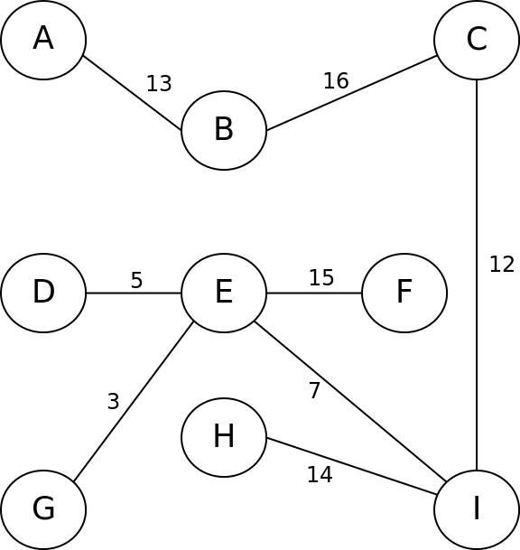

6. Graphs (write)

// solution 1
bool colorHelper(BasicGraph& graph, Vector<string>& colors,
Map<Vertex*, string>& map, Vertex* v) {
if (map.size() == graph.size()) {
return true; // base case 1: colored every vertex
} else if (map.containsKey(v)) {
return false; // base case 2: already colored
} else {
// create subset of available legal colors for this vertex
Set<string> availColors;
for (string color : colors) {
availColors.add(color);
}
for (Vertex* neighbor : graph.getNeighbors(v)) {
if (map.containsKey(neighbor)) {
availColors.remove(map[neighbor]);
}
}

// choose-explore-unchoose each of these colors for this vertex
// (if there are no available colors, loop will be skipped)
for (string color : availColors) {
map[v] = color; // choose
for (Vertex* neighbor : graph.getNeighbors(v)) {
if (colorHelper(graph, colors, map, neighbor)) { // explore
return true;
}
}
}
map.remove(v); // unchoose
return false;
}
}

Map<Vertex*, string> colorGraph(BasicGraph& graph, Vector<string>& colors) {
Map<Vertex*, string> map;
for (Vertex* v : graph.getVertexSet()) {
if (colorHelper(graph, colors, map, v)) {
break;
}
}
return map;
}

7. Hashing (read)

[ 0]:
[ 1]:
[ 2]:
[ 3]:
[ 4]: -> 44:46 -> 4:11
[ 5]: -> 5:22
[ 6]:
[ 7]: -> 7:8 -> 47:100
[ 8]: -> 28:3
[ 9]: -> 9:181
[10]:
[11]: -> 11:100
[12]:
[13]:
[14]:
[15]:
[16]:
[17]: -> 77:1
[18]:
[19]: -> 19:108

size = 10
capacity = 20
load factor = 0.5

8. Inheritance (read)

Call | Result
var1->m1();  var1->m2();  var1->m3();  var2->m1();  var2->m2();  var2->m3();  var3->m2();  var4->m1();  ((Frosty*) var1)->m1();  ((Frosty*) var1)->m4();  ((Grinch*) var1)->m4();  ((Grinch*) var2)->m4();  ((Rudolph*) var3)->m2(); | // Frosty m1  // COMPILER ERROR  // Frosty m3  // Frosty m1  // COMPILER ERROR  // Grinch m3 Frosty m3  // COMPILER ERROR  // Rudolph m3 Santa m3 Santa m1  // Frosty m1  // COMPILER ERROR  // CRASH (RUNTIME ERROR)  // Grinch m4 Grinch m3 Frosty m3  // CRASH (RUNTIME ERROR)

Copyright © Stanford University, M. Stepp, V. Kirst. Licensed under Creative Commons Attribution 2.5 License. All rights reserved.

