**ENEMIES:**

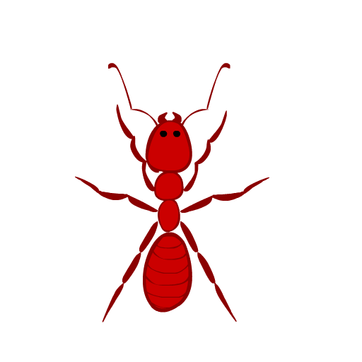

**Horrendous Abhorr-ant:** This horrendous and abhorrent ant is the superorganism that raids your sweets! Never let the colonies bite!